

PEBA QA/IT OPERATIONAL PROCEDURES MANUAL

***Version: Draft 2.1***

***Date: November 29, 2021***

TABLE OF CONTENTS

1. Purpose of Document 4

2. PENFAX V5 5

A. PENFAX 5 Functionality- MEPP and PEPP 5

B. Batch Processing- this section is based on Version 1.0- Batches and Reports JEA Training Guide- April, 2020. 5

3. PLANet Employer Web (DCT) – 49

4. PLANet Member Web (PENWEB) – 50

5. QA Daily Task Activities 59

6. TROY Application: 59

7. Queries and Reports 65

8. Procedure document for the Monthly RT Extract 381

9. General procedures to add a tax adjustment in PENFAX on a member’s account 391

10. Refund Tax Over Deduction to Members 394

11. Procedures for Payments Cancelled in Error 405

12. TO ADD new TD1 claim amounts in TD1 claim amount tables in PENFAX V5 408

13. TO ADD new tax rates in tax tables in PENFAX V5 411

14. Procedure document for the Terminated, Retired and Deceased Members with Balance report 416

15. Procedure document for Provincial HST Attribution Percentages 418

16. Procedure document for PEPP Matters Newsletters 424

17. Procedure document for the Monthly Tax Jurisdiction report 427

18. Procedure document for Payment Approval Report 432

19. Procedure document for VPB Payment Test Data Refresh 436

20. Procedure document for PEPP Statement/Newsletter Email Blast on e-Comm 440

21. Procedure document for E&E team for distinct Employer Remittance Info. 447

22. Add Employers to PENFAX & PLANet 457

23. Quality Assurance Procedures for Commuted Value Updates(Average Industrial Wage Update) 464

24. PENFAX 5 - MEPP – Blackout Dates 468

25. Quality Assurance Procedures for Commuted Value Holdback Rules 472

26. Quality Assurance Procedures for Commuted Value Updates 477

27. PENFAX 5 - MEPP - Countries Maintenance 488

28. Quality Assurance procedures for Federal Government Rules Update 494

29. Federal Government - Payment Rates 499

30. Processing MEPP Pension Indexation in PENFAX 5 504

31. How to update Blackout dates in PENFAX V5 Test 516

32. How to Update the Commuted Value Age Assumptions effective date: 517

33. How to Update TD1 rates in PENFAX V5: 519

34. Quality Assurance procedures for Interest Rates Update 526

35. OSFI Anti-Terrorism Financing Batch 533

36. PENFAX User Setup & Maintenance 538

37. MEPP Membership Quarterly Report Information Query 545

38. Quality Assurance procedures for SPAF Quarterly Report 550

39. Quality Assurance procedures – Updating Contribution Rates 556

# Purpose of Document

The Operational Procedure Manual acts as the main support document for QA and IT Front Line Staff for the purpose of supporting the PEBA operating environment. As new functions or services are introduced into the environment, this manual will continue to be updated to serve as a reference point. The owner of this manual is the PEBA QA Department and future updates and publishing of new versions will be the responsibility of the PEBA QA Department.

# PENFAX V5

## PENFAX 5 Functionality- MEPP and PEPP

**Overview**

Throughout the course of the MEPP Renewal Project and the PEPP Renewal project, PENFAX manuals have been created which provide oversight on how to access and use the PENFAX modules, in addition to any business procedures which may be relevant. Rather than rebuilding these sections, links are being included for these manuals and the procedures can be accessed by QA or IT for complete instructions. As the MEPP and PEPP manuals are updated, the link in this document will need to be changed to reflect the new information. Updating the MEPP and PEPP manuals is a business responsibility and they will advise when the manuals have been updated so the new links can be updated by QA in this document.

For MEPP PENFAX 5 functionality the associated link is: MEPP Procedures Manual\MEPP PENFAX Procedure Manual Working Copy August 2020.docx

For PEPP PENFAX 5 functionality the associated link is: PEPP Procedures Manual\PEPP PENFAX Procedure Manual Draft.docx

## Batch Processing:

**Batch Cycles and Processing:**

|  |  |
| --- | --- |
| **Procedure Number:** | Batch-001 |
| **Procedure Name:** | Batch Cycles and Processing |
| **Purpose of the Procedure:** | To provide information to help understand batch cycles and processing |
| **Original Date:** | December 28, 2020 |
| **Revised Date:** |  |

|  | **Name/Title** | **Signature** | **Date** |
| --- | --- | --- | --- |
| **Reviewed by** | <Person who reviews the work> |  | <dd/mm/yyyy> |
|  |  |  |  |
|  |  |  |  |
| **Approved by** | <Senior Management / Business Area Manager> |  | <dd/mm/yyyy> |

**Overview:**

Each different batch allows the user to set the parameters required for that particular batch.

1. From the Main Menu, select **Batches** and then **Add Batch Process**

Figure 1 – Add Batch Process screen

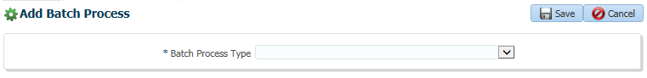

1. From the **Batch Process Type** drop-down menu, select the required batch process

Once the batch process is selected, PENFAX will display the fields required to outline the parameters for that particular batch. For more information on specific batch process parameters and results, see Lessons 2 through 5.

Figure 2 – Sample Batch parameters (Actuarial Reporting Batch)

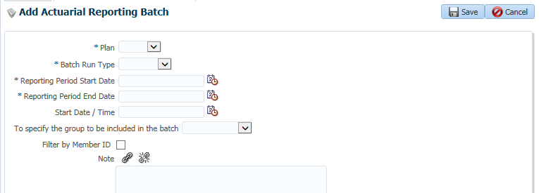

Although some parameters may be specific to a particular batch type, many parameters exist across the majority of batch types. These include:

* **Plan** – you must select a single Plan for the batch process. This will ensure the batch process is only applied to data (i.e. member accounts, employer accounts, accounting entries, etc.) within that Plan.
* **Batch Run Type** – you may select either **Test** or **Production** from the drop-down list. Running the batch process in test does not update system data and allows you to check for errors before making the updates to production data.
* **Start Date / Time** – allows you to enter a future date and time to run the batch. If this is left blank, the batch will run immediately after you click the **Save** button.

Once the parameters have been selected, click the **Save** button to initiate the batch process or, if a future date and time were entered, save the parameters to run at that time.

**Viewing a Batch Process:**

Once the batch process is saved, the screen updates to display the progress of the **Batch Process**.

Figure 3 – Batch Processes screen

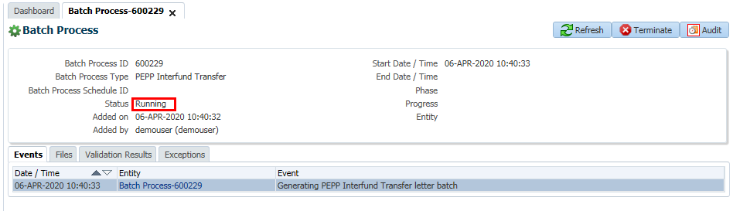

The batch **Status** field will initially display **Added** (for batch process that haven’t started or those set for a future date and time) or **Running** (for batch processes starting immediately).

1. Click the **Refresh** button to update the **Status**

Each batch contains one or more events that are triggered by running the batch process. The **Refresh** button updates the list of completed events.

Figure 4 – Batch Process Events (Process Investment Transactions batch)

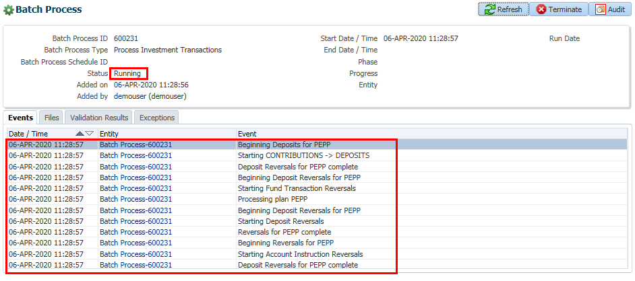

If the batch process still displays a **Status** of **Running**, then all **Events** have not yet been completed.

1. Click the **Refresh** button until the **Status** is **Completed**

Once the **Status** is **Succeeded**, the list of **Events** displays all the completed parts of the batch process.

Figure 5 – Succeeded Batch Process (Process Investment Transactions batch)

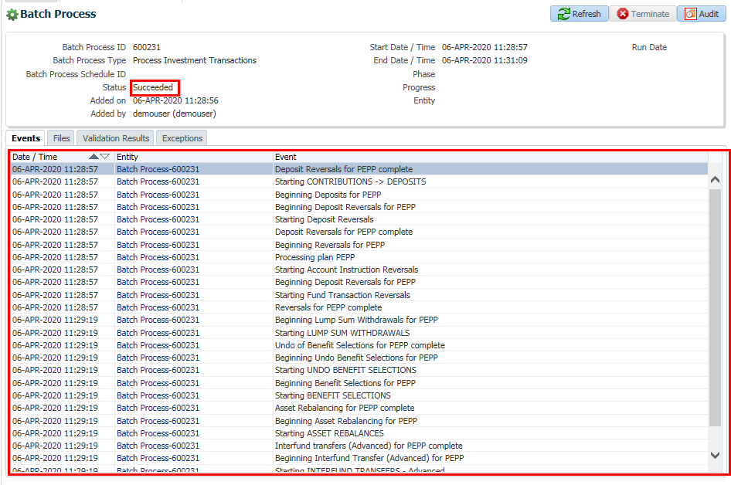

Note that some batch processes may only have a single event.

Figure 6 - Succeeded Batch Process (PEPP Welcome Letter batch)

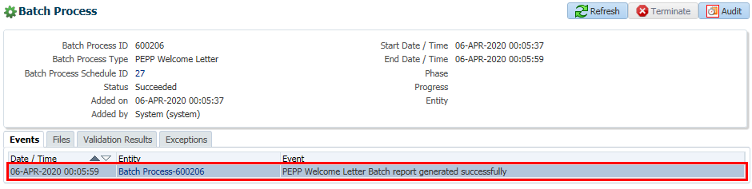

Some batch process will generate a file as part of an event.

1. Click the **Files** tab

Figure 7 – Files tab

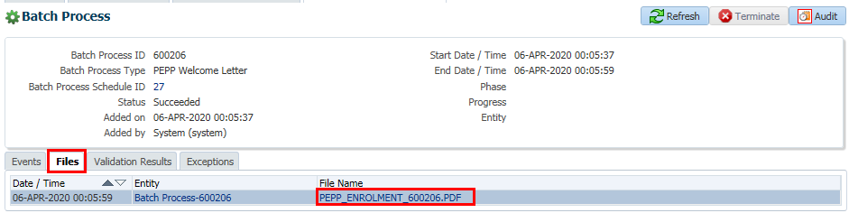

The file may be created as a PDF or a CSV file, depending on the requirements.

1. Click the **File Name**
2. Follow your browser’s prompts to open or view the file

**Viewing Batch Errors and Warnings:**

Any validation errors encountered during the running of the batch process will be listed on the **Validations Results** tab. The validations applied will depend on the specific batch process being run.

Click the **Validation Results** tab

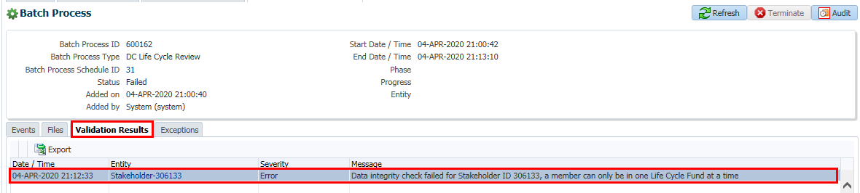

The list of validation errors includes the **Severity** of the error and a **Message** explaining the validation error.

The **Entity** column will contain a hyperlink to the screen required to view and/or correct the error. In many cases this will be to a stakeholder’s record.

The **Exception** tab displays any unexpected conditions in the execution of the batch process that were not prevented using the validation rules. When an exception occurs the batch process will show a status of **Failed**.

Figure 8 – Exceptions tab (Declaration of Unit Values batch)

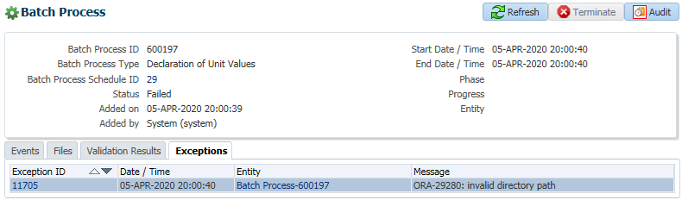

**Workflow:**

Not Applicable.

**Establishing Batch Schedules:**

**Overview:**

|  |  |
| --- | --- |
| **Procedure Number:** | Batch-002 |
| **Procedure Name:** | Establishing Batch Schedules |
| **Purpose of the Procedure:** | To provide information on how to schedule jobs and existing established jobs |
| **Original Date:** | December 28, 2020 |
| **Revised Date:** |  |

|  | **Name/Title** | **Signature** | **Date** |
| --- | --- | --- | --- |
| **Reviewed by** | <Person who reviews the work> |  | <dd/mm/yyyy> |
|  |  |  |  |
|  |  |  |  |
| **Approved by** | <Senior Management / Business Area Manager> |  | <dd/mm/yyyy> |

Batch processes can be scheduled so that they run automatically without a user having to manually initiate the process.

1. From the **Main Menu**, select **Batches** and then **Add Batch Process Schedule**

Figure 9 - Add Batch Process screen

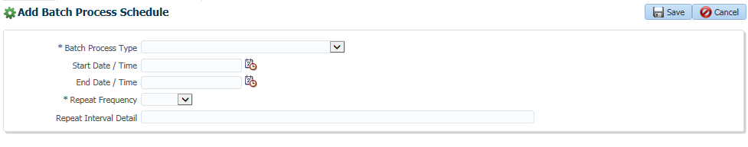

1. Select the **Batch Process Type**

Once the batch process is selected, additional fields may appear on screen to allow you to add any additional parameters. For more information on specific batch process parameters and results, see Lessons 2 through 5.

1. If required enter a **Start Date / Time** for the batch process to begin
2. If required enter an **End Date / Time** for the batch process to stop

Many batch processes are run at night and scheduled in a staggered manner (i.e., at different times of the night and on different days of the week) to ensure maximum resources are available. If these fields are not entered, the schedule is assumed to start immediately and will have no end date.

Dates and times should be selected by clicking on the calendar icon beside the appropriate field and then clicking to select the date and then the time.

Figure 10 – Select Date and Time window

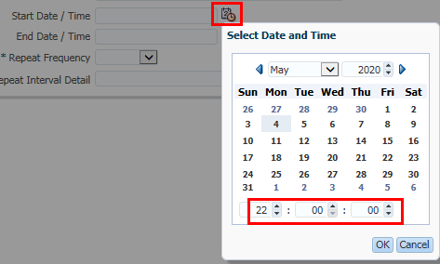

1. Enter a **Report Frequency** from the drop-down list:

* **Daily**
* **Hourly**
* **Minutely**
* **Monthly**
* **Secondly**
* **Weekly**
* **Yearly**

The **Repeat Interval Detail** field allows for custom repeat intervals to be created by using Oracle’s calendaring syntax.

Figure 11 – Add Batch Process Schedule screen updated

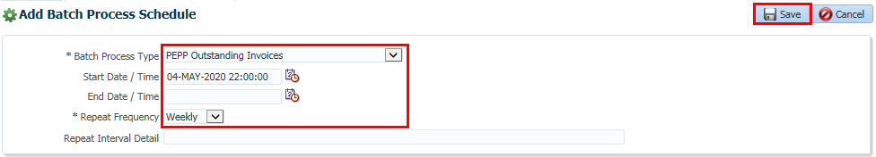

1. Once all the parameters have been entered, click the **Save** button

Figure 12 – Batch Process Schedule screen

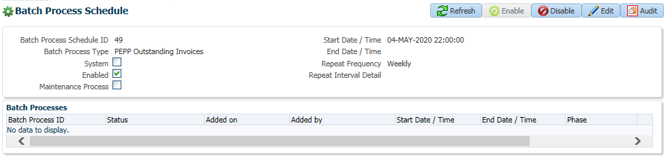

Once the schedule is saved, it is displayed in the **Batch Process Schedule** window. Each batch process is assigned a **Batch Process Schedule** ID and a summary of the batch process parameters are displayed.

The **Batch Processes** region at the bottom of the screen will display a list of all times the process has been run.

**Viewing and Editing Batch Process Schedules:**

If required, changes can be made to the batch process schedule.

1. From the **Main Menu**, select **Batches** and then **Batch Process Schedules**

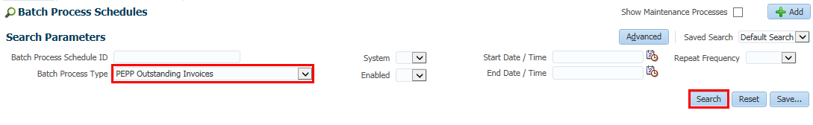

1. Enter your search criteria

By default, maintenance processes are hidden but can be displayed by checking the **Show Maintenance Processes** checkbox.

1. Click the **Search** button

For information on the **Advanced** search or **Saved Search**, see the module **PENFAX Navigation**.

Figure 13 – Batch Process Schedules Search Results

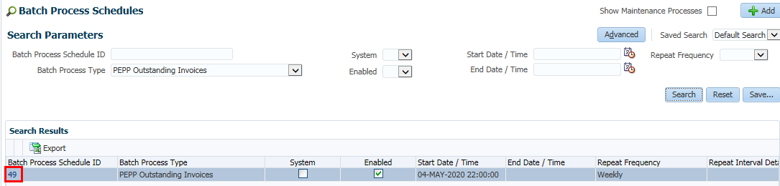

1. Click the required **Batch Process Schedule ID**

Figure 14 – Batch Process Schedule screen

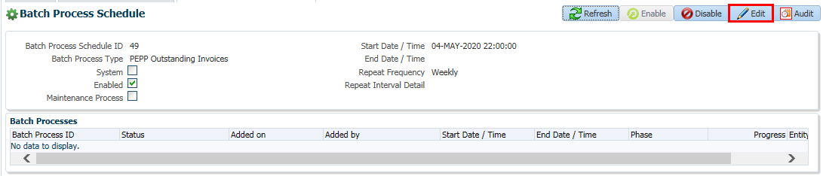

1. Click the **Edit** button to update the parameters of the batch process schedule

Figure 15 – Batch Process Schedule

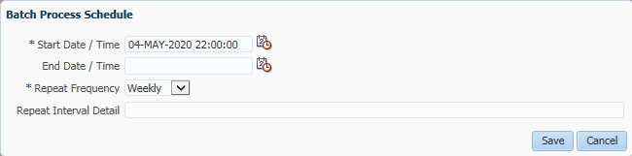

Any parameters that can be edited for that particular batch are displayed.

1. Make any required updates
2. Click the **Save** button

All changes can be viewed by clicking the **Audit** button. For more information on viewing audit records, see the module **PENFAX Navigation**.

In addition to editing batch process parameters, you can also disable a batch process from this screen by clicking the **Disable** button.

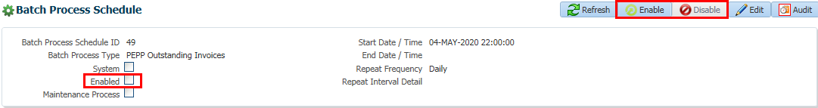

Once you click the **Disable** button, the Enabled checkbox is deselected and the **Enable** button is activated. If required, **Enable** button will active the batch process schedule again.

The Batch Processes list in PENFAX displays batches that are specific to MEPP and PEPP as well as batches applicable to both plans. The table below indicates which plan(s) apply to which batch processes. If the **Plan** column shows PEBA, this means that the batch process applies to both plans.

Batch jobs can fall into three categories: maintenance, automated and manual. Maintenance jobs are established and added by JEA only through maintenance releases. PEBA is not able to change these batches.

Automated batches are those batches for which a batch job has been set up in PENFAX and are scheduled to run either on a specific day; time; and month. PEBA has discretion over these jobs to set up the schedule as it is required to support the daily batch processing. An original schedule has been established on January 1, 2021 but further schedule updates can be adjusted if required.

Manual batches are not scheduled and are run on an ad hoc basis through the Batch tab in the PENFAX interface. To run these batch jobs, an individual must have the proper role authority. This role authority has been established by the PEBA Managers to ensure designated individuals may access the jobs based on their operational function.

To see a complete list of all scheduled batch jobs, dates and times, please access the following link: [PEBA - Master list of batches, reports and letters December 28, 2020 Based on V2.9xlsx](../Batch/1.%20Batch/PEBA%20-%20Master%20list%20of%20batches,%20reports%20and%20letters%20December%2028,%202020%20Based%20on%20V2.9xlsx.xlsx)

Additionally, the following calendar has been created to identify at a simple glance the batch jobs which are scheduled within a daily 24 hour period. To access the summary calendar access the following link:[..\Supporting Documentation\1. Batch\Batch Calendar 2021.xlsx](../Batch/1.%20Batch/Batch%20Calendar%202021.xlsx)

Additional information regarding batches may be found in the JEA Batch Configuration Guide. To access this document click on the following link: [..\Configuration Guides\PEBA Batch Process Management Configuration Guide 2.9 (1).docx](../../Configuration%20Guides/PEBA/Batch/PEBA%20Batch%20Process%20Management%20Configuration%20Guide%202.9%20(1).docx)

**Workflow:**

Not Applicable.

**Terminating Batch Schedules:**

|  |  |
| --- | --- |
| **Procedure Number:** | Batch-003 |
| **Procedure Name:** | Terminating Batch Schedules |
| **Purpose of the Procedure:** | To provide information on how to terminate a batch schedule |
| **Original Date:** | December 28, 2020 |
| **Revised Date:** |  |

|  | **Name/Title** | **Signature** | **Date** |
| --- | --- | --- | --- |
| **Reviewed by** | <Person who reviews the work> |  | <dd/mm/yyyy> |
|  |  |  |  |
|  |  |  |  |
| **Approved by** | <Senior Management / Business Area Manager> |  | <dd/mm/yyyy> |

**Overview:**

The ability to terminate a batch process with the **Terminate** button depends on the **Status** of the batch process.

Figure 16 – Terminate button

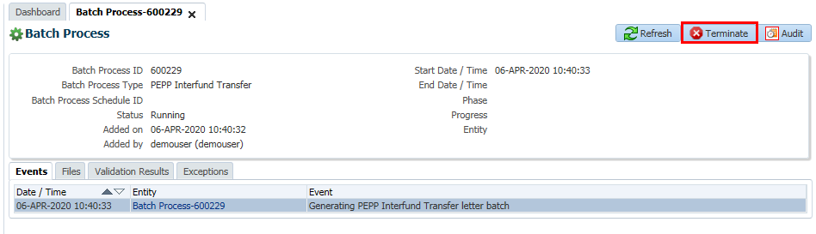

If the batch process has a status of **Added** it will immediately be updated to **Terminated** as the batch process has not actually started. However, if the batch process is **Running**, the status will be updated to **Termination Requested**. If the batch process has not already completed, and if it supports early termination, the batch process **Status** will be updated to **Terminated**.

**Workflow:**

Not Applicable.

**Searching and Viewing Completed Batches:**

|  |  |
| --- | --- |
| **Procedure Number:** | Batch-004 |
| **Procedure Name:** | Searching and Viewing Completed Schedules |
| **Purpose of the Procedure:** | To provide information on how to terminate a batch schedule |
| **Original Date:** | December 28, 2020 |
| **Revised Date:** |  |

|  | **Name/Title** | **Signature** | **Date** |
| --- | --- | --- | --- |
| **Reviewed by** | <Person who reviews the work> |  | <dd/mm/yyyy> |
|  |  |  |  |
|  |  |  |  |
| **Approved by** | <Senior Management / Business Area Manager> |  | <dd/mm/yyyy> |

**Overview:**

PENFAX maintains a searchable list of batch processes that have been run. The list includes those run on a schedule and those initiated on an ad hoc basis.

1. From the **Main Menu**, select **Batches** and then **Batch Processes**
2. Enter the required search criteria

By default, maintenance processes are hidden but can be displayed by checking the **Show Maintenance Processes** checkbox.

1. Click the **Search** button

For information on the **Advanced** search or **Saved Search**, see the module **PENFAX Navigation**.

Figure 17 – Batch Processes Search Results

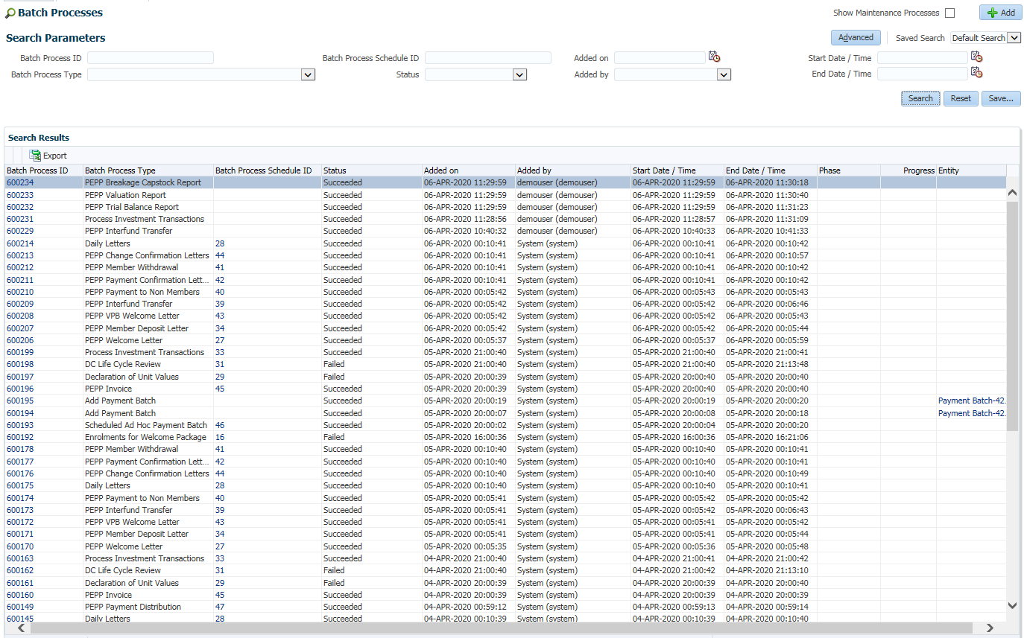

Click on the **Batch Process ID** to navigate to the **Batch Process** screen for that particular batch or click on the **Batch Process Schedule ID** to view and manage the schedule parameters.

Table 1 – Batch Processes screen field descriptions

| Label\Column | Field Type | Description |
| --- | --- | --- |
| Batch Process ID | Number | The unique identifier of the batch process |
| Batch Process Type | Selection List | The type of the batch process |
| Batch Process Schedule ID | Number | The unique identifier of the batch process schedule that started this process |
| Status | Selection List | The current status of the batch process   * Added * Running * Succeeded * Failed * Termination Requested * Terminated |
| Added on | Time | The date / time the batch process was added |
| Added by | Number 0 | The user who added the batch process |
| Start Date / Time | Time | The date and time the batch process was started |
| End Date / Time | Time | The date and time the batch process completed |
| Phase | Selection List | The current processing phase of the batch process   * PH1 - Phase 1 * PH2 - Phase 2 * PH3 - Phase 3 * PH4 - Phase 4 |
| Progress | Decimal | The progress of the current phase shown in percentage (e.g. 50.0403%) |
| Entity | Text | The description of the entity that the batch process created (i.e., payment batch). Not all batch processes result in creation of an entity. |

**Workflow:**

Not Applicable.

**Suspending Batch Cycles for Blackout Periods:**

|  |  |
| --- | --- |
| **Procedure Number:** | Batch-005 |
| **Procedure Name:** | Suspending Batch Cycles for Blackout Periods |
| **Purpose of the Procedure:** | To provide information on how to terminate a batch schedule |
| **Original Date:** | December 28, 2020 |
| **Revised Date:** |  |

|  | **Name/Title** | **Signature** | **Date** |
| --- | --- | --- | --- |
| **Reviewed by** | <Person who reviews the work> |  | <dd/mm/yyyy> |
|  |  |  |  |
|  |  |  |  |
| **Approved by** | <Senior Management / Business Area Manager> |  | <dd/mm/yyyy> |

**Overview:**

Most PENFAX processes are blocked from running during a blackout period, including batch processes. There is no requirement to separately set blackout dates for batch processes as they are governed by the system blackout dates.

1. From the **Tools** menu, select **Blackout** **Dates**

**Figure 18 – Blackout Dates screen**

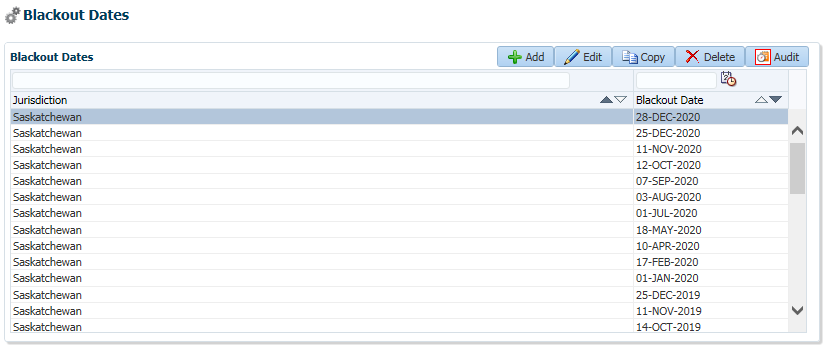

1. Click the **Add** or **Edit** buttons to create a new date or modify an existing one

Figure 19 – Blackout Date window

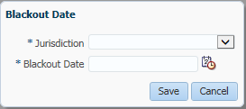

1. Select a **Jurisdiction** from the list of provinces
2. Enter or select the **Blackout Date**
3. Click the **Save** button

The **Delete** button will remove an existing date and the **Copy** function allows you to quickly copy and edit an existing date (i.e. to add a new blackout date for next calendar year).

**Restricting Web Activity During a Batch Run:**

Validations within PENWEB will automatically prevent members from updating information and/or running calculations during certain batch runs.

**Workflow:**

Not Applicable.

**Suspending Batch Cycles for Blackout Periods:**

|  |  |
| --- | --- |
| **Procedure Number:** | Batch-006 |
| **Procedure Name:** | Purging Batch Files |
| **Purpose of the Procedure:** | To provide information on how to terminate a batch schedule |
| **Original Date:** | December 28, 2020 |
| **Revised Date:** |  |

|  | **Name/Title** | **Signature** | **Date** |
| --- | --- | --- | --- |
| **Reviewed by** | <Person who reviews the work> |  | <dd/mm/yyyy> |
|  |  |  |  |
|  |  |  |  |
| **Approved by** | <Senior Management / Business Area Manager> |  | <dd/mm/yyyy> |

**Overview:**

A system setting will ensure that older batch files are purged from the system to allow for efficient searching of recent activity.

From the **Tools** menu, select **System Settings**

Figure 20 – System Settings screen

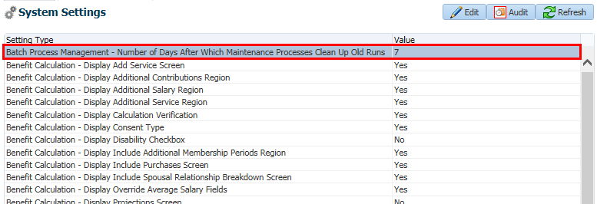

Locate the **Setting Type** of **Batch Process Management – Number of Days After Which Maintenance Processes Clean Up Old Runs** (list is alphabetized so will appear at or near the top of the list)

To modify the number of days, click the **Edit** button

Figure 21 – System Setting window

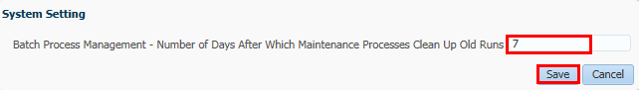

Update the number of days

Click the **Save** button

**Workflow:**

Not Applicable.

**Batch Monitoring:**

|  |  |
| --- | --- |
| **Procedure Number:** | Batch-007 |
| **Procedure Name:** | BATCH MONITORING |
| **Purpose of the Procedure:** | Instructions for Monitoring and Reporting batch fails |
| **Original Date:** | December 28, 2020 |
| **Revised Date:** |  |

|  | **Name/Title** | **Signature** | **Date** |
| --- | --- | --- | --- |
| **Reviewed by** | <Person who reviews the work> |  | <dd/mm/yyyy> |
|  |  |  |  |
|  |  |  |  |
| **Approved by** | <Senior Management / Business Area Manager> |  | <dd/mm/yyyy> |
|  |  |  |  |

**Overview:**

In the JEA Batch process there are very few dependencies between jobs. Any dependencies are identified on the Batch job spreadsheet PEBA - Master list of batches, reports and letters December 28, 2020 Based on V2.9xlsx. For MEPP, there are no batch jobs which require nightly monitoring. Each day PEBA branches will review their applicable jobs and if any have failed will either restage the job to run or will log a QA ticket to investigate.

However, PEPP has two critical jobs which are dependent upon each other- the IMPORT_UNIT_VALUES (on PENFAX Batch window appears as Declaration of Unit Values) job and the PROCESS_INV_TRANSACTIONS. These jobs must be monitored on a nightly basis due to the critical nature of the valuation of PEPP pension assets. Monitoring consists of reviewing the Batch Schedule screen in PENFAX 5 to see whether the batch has successfully completed or if it failed. Please see previous sections for information on how to perform this task.

There are four complete steps involved which support the PEPP batch processes described above:

1. Investment Services creates the Rate file and uploads into in the Investment Services Frate folder (H:\Investment Services\DailyFrate)
2. IT will confirm the file has been delivered and then the file is automatically uploaded from the Investment file to the PENFAX server
3. The IMPORT_UNIT_VALUES batch job runs in PENFAX to pick up the file and have it available for;
4. The final step which is the PROCESS_INV_TRANSACTIONS job running.

The monitoring of these Investment file and running of the required batch jobs has been assigned to the IT Group and daily follow up of the processed PIT batch will be the responsibility of QA.

**Investment Services Responsibility:**

To ensure the Frate file is uploaded to the H:\Investment Services\DailyFrate folder by 7:30 Regina time each evening. If not, the material below outlines the steps and contact information to follow for resolution.

**QA Responsibility:**

Additionally, QA will have a daily role to review the PROCESS_INV_TRANSACTIONS batch job to determine if any steps caused concern due to data which must be communicated to the appropriate business branch for clean up. Each morning, the “Validation” and “Exception “tabs of the Batch Schedule screen should be viewed to determine if there is any concerning information in these tabs.

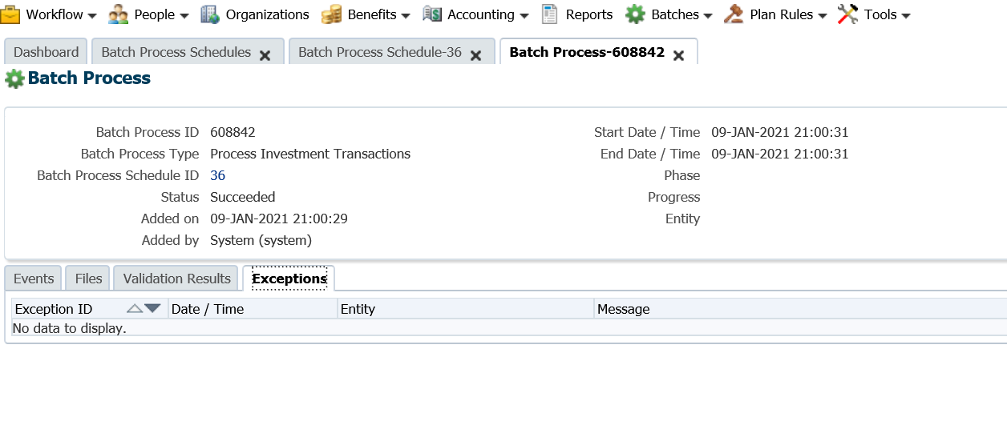

If there is nothing to report, “No data to display” will show and no further action is required.

**IT Responsibility:**

IMPORT_UNIT_VALUES is the most critical job as it takes in the Frate file that Investment Services provides and processes the valuations on the member data. It must run successfully before the PROCESS_INV_TRANSACTIONS job runs. Here are the following steps for the IMPORT_UNIT_VALUES process:

1. Investment Services prepares the Daily Frate File (frate.dat) by 7:30 pm and uploads it into the following directory: H:\Investment Services\DailyFrate
2. At 8:00 pm an IT job runs to search for the frate.dat file in this folder and if a file exists, will take an upload this file on the PENFAX server. **Please note:** there is no check in place to ensure it is the correct data file. The frate.dat file gets overwritten each time Investment Services uploads the file. If Investment Services has not uploaded a file; or if the file contains old data, the file will still be successfully uploaded to the server by the Oracle job.

Once the file is uploaded, there is a message that is sent out by Oracle. This is the message:

PEPP Frate Copy program

======================

Date: 01-Jan-21

Region: Production

getting file \Investment Services\DailyFrate\frate.dat of size 827 as frate.dat (269.2 KiloBytes/sec) (average 269.2 KiloBytes/sec)

Destination file contents:

::::::::::::::

/ora_exports/fuvd/frate.dat

::::::::::::::

PRIHDRPEP2020123120201231

DLRDTLPRIOPEPAF 2020123121646002000

DLRDTLPRIOPEPBFU 2020123125772861900

DLRDTLPRIOPEPBF 2020123113071128500

DLRDTLPRIOPEPCF 2020123119335841100

DLRDTLPRIOPEPGF 2020123121706967000

DLRDTLPRIOPEPMMF 2020123110774828600

DLRDTLPRIOPEPMF 2020123120672045300

DLRDTLPRIOPEPPS1 2020123121645696800

DLRDTLPRIOPEPPS2 2020123121938380700

DLRDTLPRIOPEPPS3 2020123121706641100

DLRDTLPRIOPEPPS4 2020123121538385300

DLRDTLPRIOPEPPS5 2020123125983748700

DLRDTLPRIOPEPPS6 2020123121338014900

DLRDTLPRIOPEPPS7 2020123121190456200

DLRDTLPRIOPEPPS8 2020123120831332400

DLRDTLPRIOPEPPS9 2020123120488655200

DLRDTLPRIOPEPPS10 2020123120294146900

DLRDTLPRIOPEPPS11 2020123119370055300

DLRDTLPRIOPEPPS12 2020123119409469100

DLRDTLPRIOPEPPS13 2020123111150901400

PRITRLPEP000000020

When the file is uploaded it must be checked by IT to ensure it contains the correct date in the file. This can be accomplished by looking at the header record and the first detail record:

PRIHDRPEP2020123120201231

DLRDTLPRIOPEPAF 2020123121646002000

The header date highlighted and all the detail records **must be** the same date as the current business day. If it is not, then a follow up action must occur. **IT will have until 8:45 pm** to resolve the issue before the PROCESS_INV_TRANSACTIONS batch job kicks off (which runs at 9 pm. PIT batch job runs seven days a week but knows not to expect a valid frate.dat file for non-business days. If the correct file is not in place or the date is incorrect, **the wrong valuation will occur** or the PROCESS_INV_TRANSACTIONS (known as PIT job) will fail and **cause valuations to fail**. If the file is going to be late (after 7:30 pm), it will be Investment Services responsibility to advise IT this file will be late. IT will need to ensure to pick up the correct file manually (or rerun the Oracle job) so the correct file can be loaded onto the server and be ready for the PIT job.

If Investment Services is going to be later than 7:30, a more serious escalation is required and that escalation is noted in the summary below.

Once the Frate file is validated and uploaded, the PROCESS_INV_TRANSACTIONS is the next batch job to run. As noted above it runs at 21:00- 7 days a week. The batch takes very little time to complete and if completed successfully, then NO further monitoring is required by IT.

In summary the following situations can occur and here are the corresponding steps:

* 1. **Frate.dat file contains the correct date and is uploaded successfully for PIT to use. PIT completes successfully**

No further action is required.

* 1. **Frate.dat file contains the incorrect date or file is corrupted**

The workflow for this is:

1. Frate.dat file is checked once IT support Oracle job runs
2. IT determines a date or file issue
3. IT contacts Investment Services using the following calling tree and explains the issue

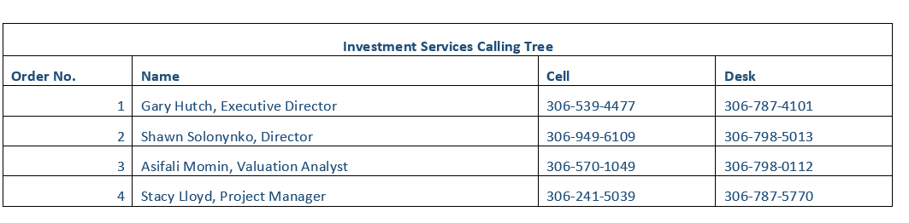

1. Investment Services uploads a New corrected file into the H:\Investment Services\DailyFrate and advises IT this is completed
2. IT uploads the new file onto the server in time for the PIT job at 9:00 pm
3. **Frate.dat file will not be supplied by Investment Services prior to 8:45 PIT job**

The workflow for this is:

1. Investment Services contacts IT Support through on call phone number at **306-787-9263** to advise what time the file will be delivered at.
2. If the file will be delivered before 21:45 IT will follow steps in (A) above. If not, then IT will contact QA Support (~~Michael Mead at 306-531-9723~~ or Pana Wiegers at 306-526-1938). An email should also be sent to Tech Support to create a ticket to track the event and advise the QA team the file is going to be late.
3. QA will reach out to Investment Services (using the calling tree above) to determine when the file can be received and the necessary actions which may be required. QA will need to determine:
   1. What batch jobs will be impacted and if new batch jobs for the current date need to be created to pick up the file at some point in the current day. See Batch Procedure 002 for establishing new batch schedules.
   2. If file will not be available until the next morning, then IMPORT_UNIT_VALUES will run with last business date but PIT will fail. Next morning, the unit values must be input directly into PENFAX as early as possible and the PIT batch must be run manually to process the valuations. Any subsequent jobs following the PIT batch in the schedule must be re-examined to determine if they have processed or must also be manually re-run. Please note letters and reports may not be generated out of the manually run jobs and must wait until the next normal system cycle to generate the documents.

**If this scenario happens where the file will not be available until next business day, a Sev 1 ticket should be raised with JEA and a support call opened to obtain JEA’s assistance in walking through the process and ensuring all jobs have been reviewed and a proper course of action taken. This is especially important if this situation occurs on a Friday night as no PENFAX processing happens on the weekend and specific actions will need to be take with JEA’s guidance to ensure proper valuation and processing of jobs.**

**Daily and Weekly Reporting and Processing:**

|  |  |
| --- | --- |
| **Procedure Number:** | Batch-008 |
| **Procedure Name:** | Daily and Weekly Reporting and Processing |
| **Purpose of the Procedure:** | Information on how reports are set up to run and be managed |
| **Original Date:** | December 28, 2020 |
| **Revised Date:** |  |

|  | **Name/Title** | **Signature** | **Date** |
| --- | --- | --- | --- |
| **Reviewed by** | <Person who reviews the work> |  | <dd/mm/yyyy> |
|  |  |  |  |
|  |  |  |  |
| **Approved by** | <Senior Management / Business Area Manager> |  | <dd/mm/yyyy> |
|  |  |  |  |

**Overview:**

Each batch listed in the following lessons includes the following:

* Batch name
* Brief description
* Screen shot of the **Add Batch Process** screen
* Screen shot of the **Events** run for that batch process

**Daily Processing:**

The batches listed below are run daily at the close of each business day.

**Declaration of Unit Values:**

The Declaration of Unit Values batch process imports fund unit values for the current business day.

The batch process requires the import of a .dat file with the new fund values.

Figure 22 – Declaration of Unit Values batch process parameters

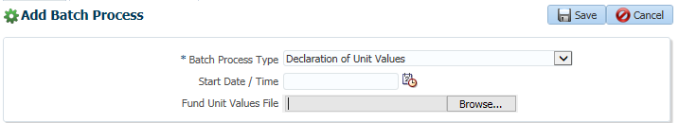

Batch process **Events** confirms processing and adding of values for each individual fund.

Figure 23 –Declaration of Unit Values batch events

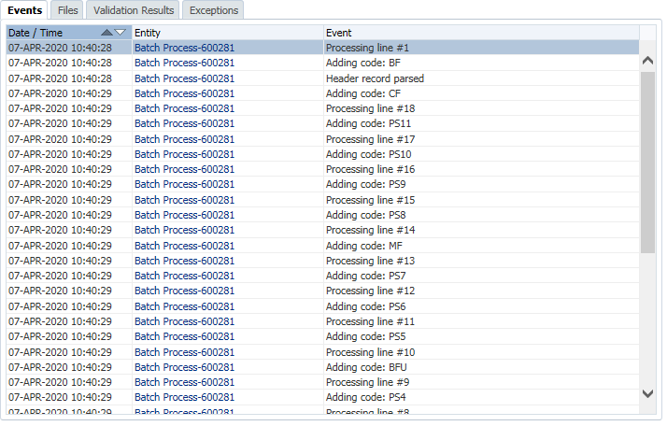

**Process Investment Transactions**:

All pending investment transactions for the current date are valued, based on the declared fund unit value and are completed in the following processing order:

* 1. **Reversals** - reversing of investment transactions that have been identified by a pension administrator as needing to be undone
  2. **Deposits** - payroll contributions and external transfers into PEPP
  3. **Fees** - interfund, withdrawal, and processing
  4. **Asset Rebalances -** redistribution of member investments amongst currently invested funds
  5. **Interfund Transfers Out -** internal transfers out of a fund including rollovers out of PEPP Step funds. For all members that are invested in the PEPP Steps fund, the batch will update the PEPP Steps deposit allocation instruction and transfer PEPP Step funds into the next step once the member's age reaches the next age band.
  6. **Interfund Transfers In -** internal transfers into a fund including rollovers of PEPP Step funds
  7. **Withdrawals** - death, termination, retirement, VPB lump sum payments, marital breakdown, or other payments including transfers to VPB accounts

The batch also creates the Capstock report which provides a daily extract of net unit movement (may be negative values) of all transactions processed by the PEPP fund and the closing balance in units.

Figure 24 – Process Investment Transactions batch parameters

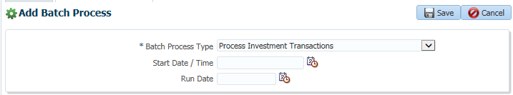

Figure 25 – Process Investment Transactions batch events

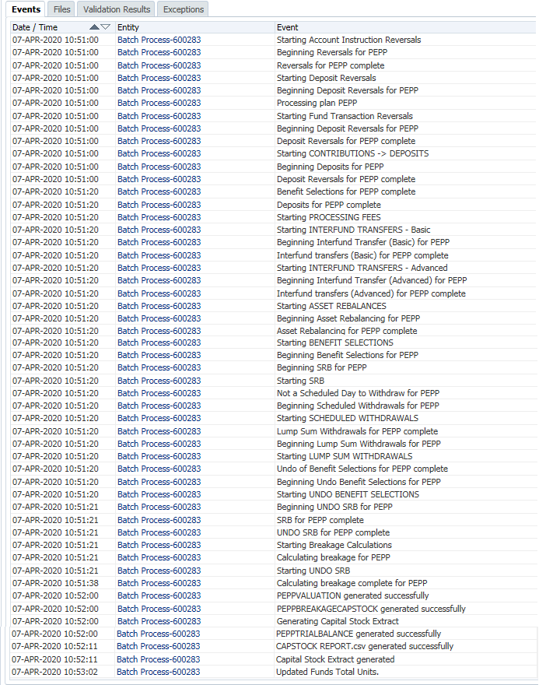

The **Capstock Report** can be accessed from the **Files** tab.

Figure 26 – Process Investment Transactions files (Capstock Report)

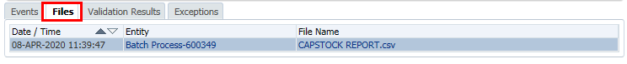

Figure 27 – Sample Capstock Report

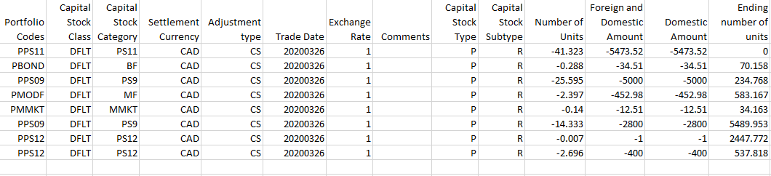

**PEPP Breakage Capstock Report:**

The **PEPP Breakage Capstock Report** calculates administrative and employer for any backdated transactions.

Figure 28 – PEPP Breakage Capstock Report parameters

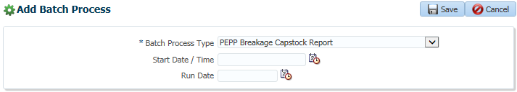

Figure 29 - PEPP Breakage Capstock Report events

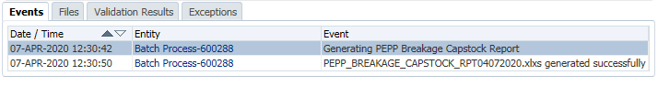

The Excel spreadsheet generated by the batch can be viewed on the **Files** tab.

**DC Life Cycle Review:**

The **DC Life Cycle Review** batch process is a daily check for DC members that have reached the top of a life cycle age band. Once applicable members are identified, PENFAX initiates an account instruction for an interfund transfer to the next appropriate Fund and creates any required account instructions for ongoing deposit allocations.

Figure 30 – DC Life Cycle Review parameters

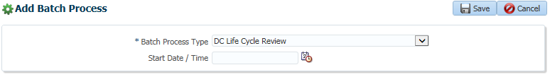

Figure 31 – DC Life Cycle Review events

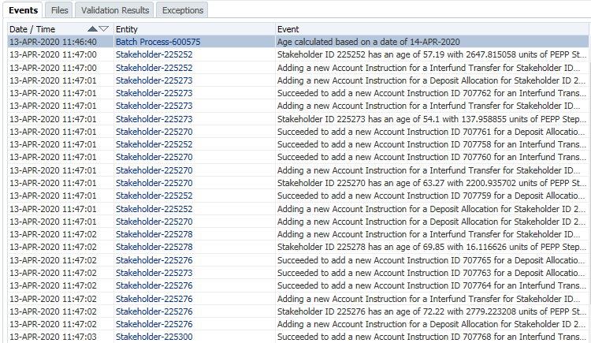

**Producing Daily Reports:**

**PEPP Valuation Report:**

The **PEPP Valuation Report** lists the dollar amount and units purchased and surrendered for the day.

Figure 32 – PEPP Valuation Report parameters

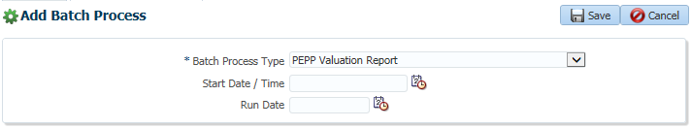

The batch process produces two Excel spreadsheets – one for accumulation accounts and one for decumulation accounts.

Figure 33 - PEPP Valuation Report events

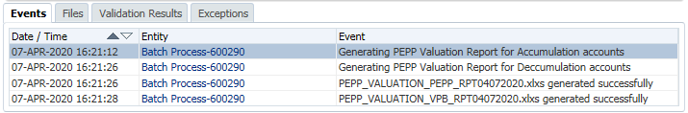

The Excel spreadsheets generated by the batch can be viewed on the **Files** tab.

The reports summarize the dollar amounts and units by the following transactions:

1. **Contributions** - by cash amount received and allocated
2. **Inter-fund Transfers** – both in and out of PEPP funds
3. **Unit Adjustments**
4. **Payments and Refunds**
5. **Breakage** - by employer and administration incurred for each of the above transaction types

**PEPP Remittance Receipt Report:**

The **PEPP Remittance Receipt Report** produces a report of all remittances received within the parameters entered.

Figure 34 – PEPP Remittance Receipt Report parameters

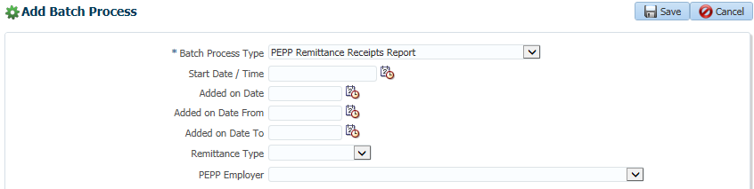

Figure 35 - PEPP Remittance Receipt Report events

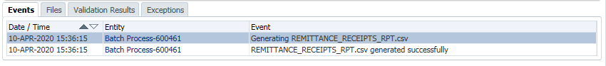

The CSV can be viewed on the **Files** tab.

**Producing Daily Letters:**

**PEPP Welcome Letter:** The PEPP Welcome Letter batch produces letters confirming member enrolment in PEPP.

Figure 36 – PEPP Welcome Letter parameters

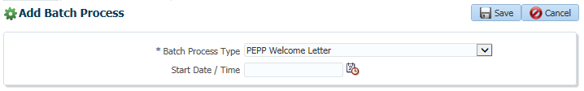

Figure 37 - PEPP Welcome Letter events



The PDF generated by the batch can be viewed on the **Files** tab.

**PEPP VPB Welcome Letter:**

The PEPP VPB Welcome Letter batch produces letters confirming member enrolment in a VPB investment account.

**Figure 38 – PEPP VPB Welcome Letter parameters**

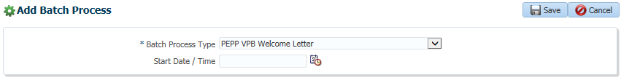

Figure 39 - PEPP VPB Welcome Letter events



The PDF generated by the batch can be viewed on the **Files** tab.

**Transaction Confirmation Letters:**

Transaction Confirmation Letters are generated when financial transactions completed. There are four types of letters that are each created by a separate batch process. Each batch process creates a PDF file that can be located on the **Files** tab.

**PEPP Member Deposit Confirmation Letter:**

The PEPP Member Deposit batch process creates letters to members confirming lump-sum contributions (i.e., external transfers into the plan and leave of absence lump-sum contributions).

Figure 40 - PEPP Member Deposit parameters

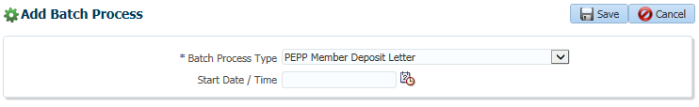

**PEPP Interfund Transfer Confirmation Letter:**

The PEPP Interfund Transfer batch process creates letters to members confirming all interfund transfers that have been processed.

Figure 41 – PEPP Interfund Transfer parameters

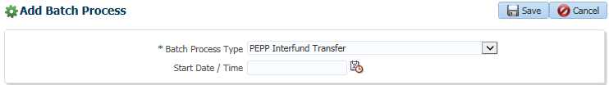

**PEPP Member Withdrawal Confirmation Letter:**

The PEPP Member Withdrawal batch process creates letters to both members and to receiving institutions (when applicable) to confirm gross and net amount of payments from a member’s account (with the exception of scheduled VPB withdrawals where no confirmation is issued).

Figure 42 – PEPP Member Withdrawal parameters

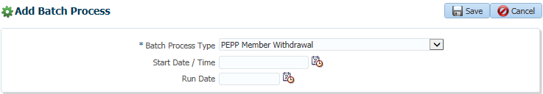

**PEPP Payment to Non- Members Confirmation Letter:**

The PEPP Payment to Non- Members batch process creates letters to non-members confirming all payments that have been processed.

Figure 43 – PEPP Payment to Non-Members parameters

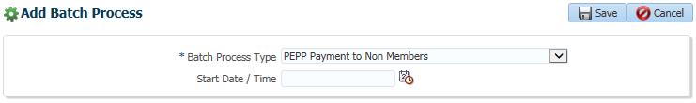

**PEPP Change Confirmation Letters:**

The PEPP Change Confirmation Letters batch produces letters to members when their name, address, email, or beneficiaries are modified or banking information is changed. This includes payment schedule changes to withdrawal frequency, amounts, or fund withdrawal orders.

Figure 44 - PEPP Change Confirmation Letters parameters

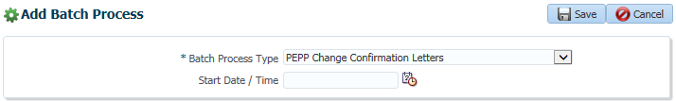

Figure 45 - PEPP Change Confirmation Letters events

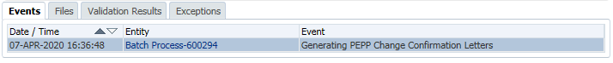

The PDF generated by the batch can be viewed on the **Files** tab.

**PEPP Invoice**

The PEPP Invoice batch creates invoices for employer breakage generated by backdated contributions.

Figure 46 – PEPP Invoice parameters

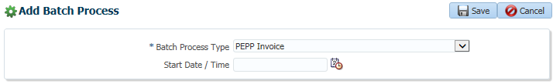

Figure 47 - PEPP Invoice events

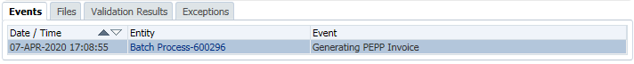

The PDF generated by the batch can be viewed on the **Files** tab.

**Producing Daily Extracts:**

1. **Extract Journal Entry Data:**

The Extract Journal Entry Data produces a data file for Financial Services containing information on general ledger entries.

You have the option of running the extract on all plans or selecting one specific plan.

Figure 48 – Extract Journal Entry Data parameters

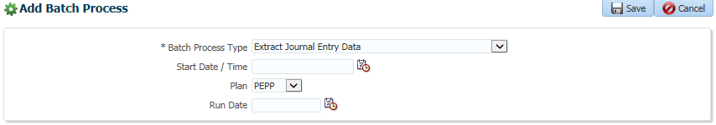

Figure 49 - Extract Journal Entry Data events

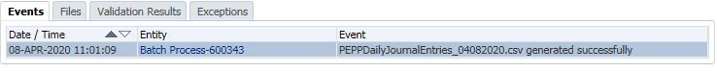

The CSV file generated by the batch can be viewed on the **Files** tab.

1. **Extract Journal Entry Data for Daily Payments:**

The Extract Journal Entry Data for Daily Payments produces a data file for Financial Services containing information on payments to employers and members.

Figure 50 - Extract Journal Entry Data for Daily Payments parameters

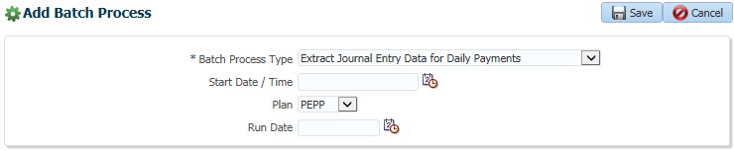

Figure 51 - Extract Journal Entry Data for Daily Payments events

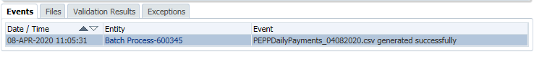

The CSV file generated by the batch can be viewed on the **Files** tab.

1. **Extract Journal Entry Data for Daily Deposits:**

The Extract Journal Entry Data for Daily Deposits produces a data file for Financial Services containing information on deposits from employers and members.

Figure 52 - Extract Journal Entry Data for Daily Deposits parameters

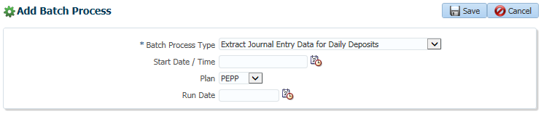

Figure 53 - Extract Journal Entry Data for Daily Deposits events

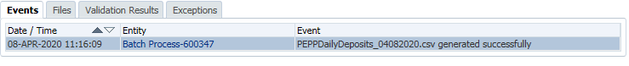

The CSV file generated by the batch can be viewed on the **Files** tab.

**Daily Administrative Reporting:**

**Daily Letters:**

The Daily Letters batch produces a summary report that provides the total count of letters by type, cheques, EFT payments, that were generated from the daily batch processing.

Figure 54 – Daily Letters parameters

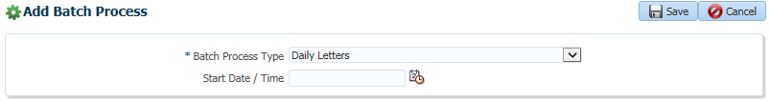

Figure 55 – Daily Letters events

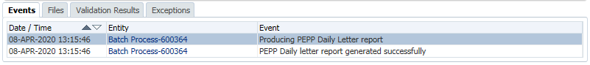

The PDF file generated by the batch can be viewed on the **Files** tab.

**Producing Weekly Reports:**

**PEPP Outstanding Invoices Report:**

The PEPP Outstanding Invoices Report batch produces a report, by employer, of any outstanding (unpaid) invoices for breakage and late fees.

Figure 56 – PEPP Outstanding Invoices parameters

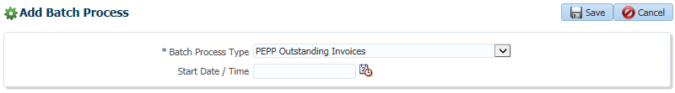

Figure 57 – PEPP Outstanding Invoices events

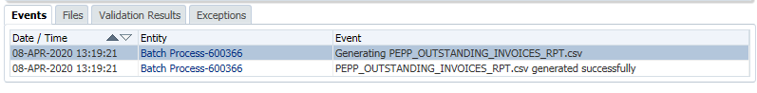

The CSV file generated by the batch can be viewed on the **Files** tab.

**Producing Weekly Extracts:**

**e-Comm Extract:**

Once a week an extract of members by plan is used to create a view of the system for e-Comm purposes. e-Comm is an application provided by a third-party vendor to PEBA which allows members of PEPP and MEPP to sign up for paperless statements and/or newsletters.

The e-Comm application uses this view to look up individuals that register for the service and confirms they are valid plan members. The view contains member name, member number, and plan (e.g. PEPP, MEPP).

**Monthly Reporting and Processing:**

|  |  |
| --- | --- |
| **Procedure Number:** | Batch-009 |
| **Procedure Name:** | Monthly Reporting and Processing |
| **Purpose of the Procedure:** | Information on how reports are set up to run and be managed on a Monthly basis |
| **Original Date:** | December 28, 2020 |
| **Revised Date:** |  |

|  | **Name/Title** | **Signature** | **Date** |
| --- | --- | --- | --- |
| **Reviewed by** | <Person who reviews the work> |  | <dd/mm/yyyy> |
|  |  |  |  |
|  |  |  |  |
| **Approved by** | <Senior Management / Business Area Manager> |  | <dd/mm/yyyy> |
|  |  |  |  |

**Overview:**

**Producing the Retire@Ease Extracts and Reports:**

The Retire@Ease is a third-party application provided to PEPP members to perform pension projections and retirement calculations, via a web interface from the PENFAX member web.

**PEPP Retire@Ease Extract:**

The PEPP Retire@Ease Extract is run monthly and produces information on active, deferred, and pensioned (VPB) members, including demographic information, investments, account balances, contributions and pension amounts. Some of the fields on the extract are calculated (e.g. total contributions for a 12-month period).

**PEPP Retire@Ease Report:**

A copy of the PEPP Retire@Ease Extract is also saved as an Excel spreadsheet.

Performing Monthly Batch Processes

Producing Monthly Reports

**PEPP Member Arrears Report:**

The PEPP Member Arrears Report lists members by employer that are in an active employment status with no contributions allocated to PEPP. The parameters screen allows you to determine a timeline of the last 30, 60 or 90 days.

**Figure 58 – PEPP Member Arrears Report parameters**

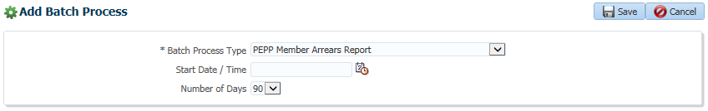

The **Events** region shows each individual member reviewed for the report.

Figure 59 - PEPP Member Arrears Report events

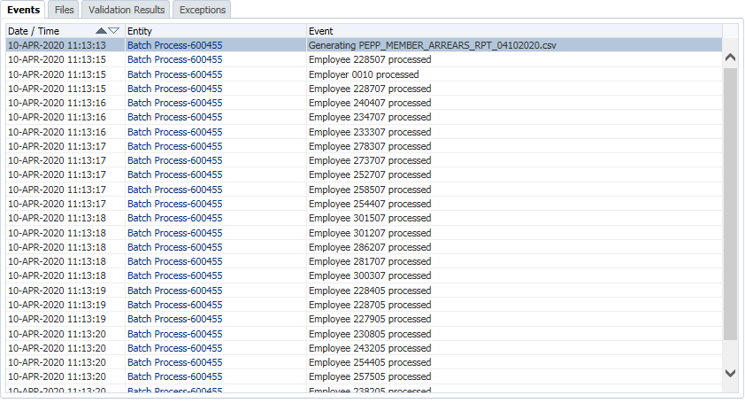

The CSV generated by the batch can be viewed on the **Files** tab.

**PEPP Employer Arrears Report:**

The PEPP Employer Arrears Report lists active employers that have not submitted contributions for over 30 days or have gaps between pay periods.

**PEPP Default Investment Instruction Report:**

The Default Investment Instruction Report lists all active members that have not made an investment instruction.

**PEPP Financial Services Payment Summary Report:**

The Financial Services Payment Summary Report lists all payments made for the month, summarized by transaction date and by account (PEPP and VPB).

**PEPP New Pending Report:**

The New Pending Report lists all PENFAX stakeholder accounts created by posting process (i.e. contributions are received prior to an enrolment).

**Quarterly and Semi-Annual Reporting and Processing:**

|  |  |
| --- | --- |
| **Procedure Number:** | Batch-010 |
| **Procedure Name:** | Quarterly and Semi -Annual Reporting and Processing |
| **Purpose of the Procedure:** | Information on how reports are set up to run and be managed on a Quarterly and Semi-annual basis |
| **Original Date:** | December 28, 2020 |
| **Revised Date:** |  |

|  | **Name/Title** | **Signature** | **Date** |
| --- | --- | --- | --- |
| **Reviewed by** | <Person who reviews the work> |  | <dd/mm/yyyy> |
|  |  |  |  |
|  |  |  |  |
| **Approved by** | <Senior Management / Business Area Manager> |  | <dd/mm/yyyy> |

**Overview:**

**Producing Quarterly Reports:**

**PEPP Demographic Report:**

The PEPP Demographic Report lists total and average account balances by member age band and years of contributory service.

**Operations Reports:**

**PEPP Interfund Transfers Report:**

The PEPP Interfund Transfers Report lists all interfund transfers by source and by fund.

**PEPP External Transfers by Source:**

The PEPP External Transfers by Source report lists all external transfers by source.

**PEPP Asset Retention Report:**

The Asset Retention Report provides the percentage of members and assets retained based on number of terminating and retiring members that keep funds in PEPP compared to all terminating and retiring members in a specified time period.

**Running Semi-Annual Extracts:**

**PEPP Statements:**

The PEPP Statements extracts provides details of member account activity during statement period (as of March 31st and Sept 30th) provided to third party vendor for production and print of statements.

**Annual Reporting and Processing:**

|  |  |
| --- | --- |
| **Procedure Number:** | Batch-011 |
| **Procedure Name:** | Annual Reporting and Processing |
| **Purpose of the Procedure:** | Information on how reports are set up to run and be managed on an Annual basis |
| **Original Date:** | December 28, 2020 |
| **Revised Date:** |  |

|  | **Name/Title** | **Signature** | **Date** |
| --- | --- | --- | --- |
| **Reviewed by** | <Person who reviews the work> |  | <dd/mm/yyyy> |
|  |  |  |  |
|  |  |  |  |
| **Approved by** | <Senior Management / Business Area Manager> |  | <dd/mm/yyyy> |

**Overview:**

**Performing Annual Reporting – Calendar Year:**

**PEPP Tax Reconciliation Report:**

The Tax Reconciliation Report lists amounts withdrawn (gross and tax withheld) by the member on the system for a calendar year which is used to reconcile payments and taxes as recorded on the general ledger.

**PEPP VPB Minimum Payment (Age 72) Report:**

The VPB Minimum Payment (Age 72) Report identifies VPB members that require a minimum payment for the current year by Dec 31st.

**PEPP Contributions Exceed Limit Report:**

The PEPP Contributions Exceed Limit Report identifies members by employer with total annual contributions in excess of the CRA dollar maximum. The batch produces a summary report and the letters to members.

The parameters screen allows you to identify the **Reporting Year** and set the **Money Purchase Limit Override**. When the **Produce PDF** checkbox is selected, the letters to employers will be created in PDF format.

Figure 60 – PEPP Contributions Exceed Limit Report

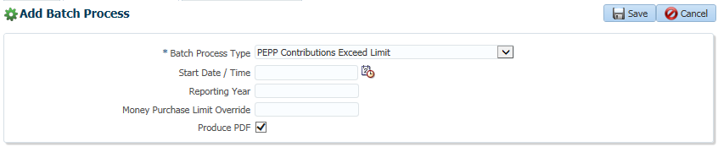

Figure 61 – PEPP Contributions Exceed Limit Report events

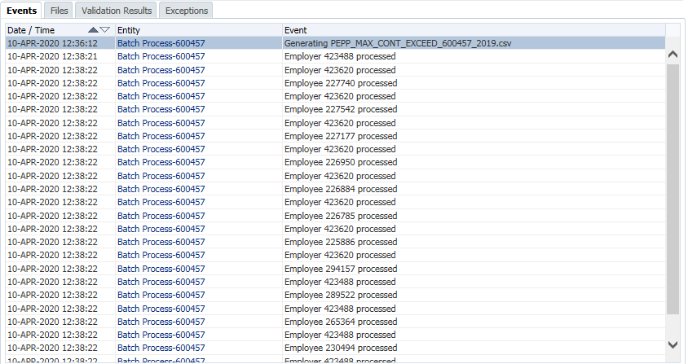

Both the report and letters can be viewed on the **Files** tab.

**Performing Annual Reporting – Fiscal Year:**

**PEPP Employer Fiscal Year Contributions Report:**

The Employer Fiscal Year Contributions Report lists total contributions received by individual employers for the previous fiscal year.

**PEPP Joint Annual Information Return Report:**

The Joint Annual Information Return Report is filed with the CRA within 180 days of the end of the plan’s fiscal period. The report includes total contributions, transfers, value of assets, number of active members, and participating employers.

**PEPP Membership Activity report:**

The **Membership Activity Report** provides details of the change in membership for the fiscal year (new enrolments less exit from the plan) reported by PEPP and VPB accounts.

**PEPP Average Age Report:**

The Average Age Report provides the average age of active members as of end of fiscal plan year.

**PEPP Average Age at Retirement:**

The Average Age at Retirement report provides the average age of members as of retirement date as of end of the fiscal year.

**Creating Annual Extracts:**

**PEPP VPB Member Statements:**

The VPB Member Statements extract is an annual extract of VPB member account activity during the calendar year (as of December 31st), provided to third party vendor for the production and print of annual statements.

**PEPP MLA Extract for Conflict of Interest Report:**

The MLA Extract for Conflict of Interest Report is an extract of active Member of Legislative Assembly (MLA’s) PEPP account balances and contact information as of Dec 31st each year. File is merged with Supplementary Retirement Program (SRP) account balances file to create an annual Conflict of Interest letter for MLAs.

**PEPP MLA Statement Extract:**

The MLA Statement Extract lists all Member of Legislative Assembly (MLA’s) contact information as of March 31st each year. The file is merged with their SRP account balances file to create an annual MLA member statement.

**Creating Annual Letters:**

**PEPP Age 71 Letters:**

The PEPP Age 71 Letters batch creates separate PDFs to each employer with a list of all their employees reaching age 71 by December 31st of the current year. In addition, the batch creates a single PDF with a copy of all letters to employers and letters addressed to each individual employee meeting the criteria.

Figure 62 – PEPP Age 71 Letters parameters

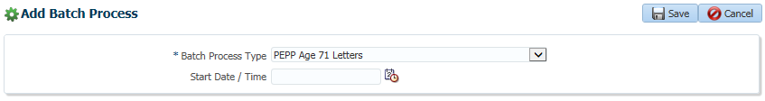

Figure 63 – PEPP Age 71 Letters events

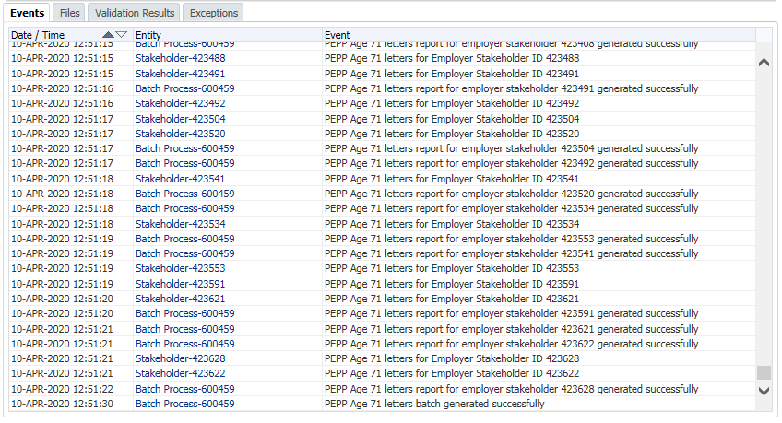

All PDFs can be accessed from the **Files** tab.

**PEPP VPB November Letters:**

The VPB November Letters creates letters to all VPB members advising them of the minimum required payment for the following tax year, and age/factor used for calculation.

**Ad Hoc Reporting and Processing:**

|  |  |
| --- | --- |
| **Procedure Number:** | Batch-012 |
| **Procedure Name:** | Ad Hoc Reporting and Processing |
| **Purpose of the Procedure:** | Information on how reports are set up to run Ad Hoc Reports |
| **Original Date:** | December 28, 2020 |
| **Revised Date:** |  |

|  | **Name/Title** | **Signature** | **Date** |
| --- | --- | --- | --- |
| **Reviewed by** | <Person who reviews the work> |  | <dd/mm/yyyy> |
|  |  |  |  |
|  |  |  |  |
| **Approved by** | <Senior Management / Business Area Manager> |  | <dd/mm/yyyy> |

**Overview:**

**Generating Ad Hoc Reports:**

To generate the following Ad Hoc Reports, you will need to go into the Batches screen of the PENFAX interface. You will need to have the correct role permissions to be able to do this.

**PEPP Missing Address Report:**

The Missing Address Report identifies active and deferred members with no valid address.

**PEPP Beneficiary Follow Up Report:**

The Beneficiary Follow Up Report identifies all Active and Deferred members who have not designated a valid beneficiary.

**PEPP Mailing Lists:**

The Mailing Lists report allows an export of mailing addresses for mailing of communication materials generated outside of the system.

**Task Inquiry Reporting:**

**PEPP Service Standards – Cancelled:**

The Service Standards – Cancelled report is used to identify cancelled tasks, and used for measurement of ability to meet stated task service standards.

**PEPP Service Standards – Completed:**

The Service Standards – Completed report is used to identify completed tasks, and used for measurement of ability to meet stated task service standards.

**PEPP Service Standards – Overdue Reports:**

The Service Standards – Cancelled report is used to identify overdue tasks, and used for measurement of ability to meet stated task service standards.

**PEPP Service Standards – Work Assignments:**

The Service Standards – Work Assignments report is used to identify tasks that have been to each individual staff member, and used for measurement of ability to meet stated task service standards.

**Generating Auditor Reports:**

**PEPP Auditor Report - Contributions Allocated by Employer:**

The Auditor Report – Contributions Allocated by Employer reports all contributions allocated by employer, pay period, source and transaction date.

**PEPP Auditor Report - Payments by Type:**

The Auditor Report – Payments by Type reports all payments made for the requested time period.

**A PEPP Auditor Report – Members by Fund:**

The Auditor Report – Members by Fund reports all member account balances within a specific Fund as of a specific date.

**PEPP Auditor Report - New VPB Enrolments:**

The Auditor Report – New VPB Enrolments reports all enrolments processed for the requested time period.

**PEPP Auditor Report - Banking Change Report:**

The Auditor Report – Banking Change Report reports all EFT additions and changes.

# PLANet Employer Web (DCT) –

**Overview:**

Throughout the course of the MEPP Renewal Project and the PEPP Renewal project, PLANet employer manuals have been created which provides detailed information and instruction on how employers and PEBA will use the Employer Web application. While it is one web application, throughout the course of the two projects, there are differences between the configuration and file set ups for each group. It is important to reference the correct manual if needing to understand processes for either.

Rather than rebuilding these sections, links are being included for these manuals and the procedures can be accessed by QA or IT for complete instructions. As the MEPP and PEPP manuals are updated, the link in this document will need to be changed to reflect the new information. Updating the MEPP and PEPP manuals is a business responsibility and they will advise when the manuals have been updated so the new links can be updated by QA in this document.

PEPP PLANet Employer Web Link: ..\..\PLANet-Employer (DCT)\PEPP\PEPP PLANet Employer Administrator Guide Draft.docx

MEPP PLANet Employer Web Link: To be provided by business

# PLANet Member Web (PENWEB) –

**Overview:**

The PLANet application is one single application which is used for both MEPP and PEPP. There are different functional uses for each plan which are driven through system configurations and therefore separate procedures must be maintained.

Content Management is owned by PEBA Communications Branch. The Communications team is responsible for ensuring landing pages, branding and terminology are aligned to PEBA standards. Any changes to these pages are driven from the business to Communications who will make the changes; forward them to QA for verification; to Change Management for approval; and then to IT for production installation.

**MEPP Procedures:**

|  |  |
| --- | --- |
| **Procedure Number:** | Member Web -001 |
| **Procedure Name:** | PLANet Member Web User Setup & Maintenance |
| **Purpose of the Procedure:** | Information on how reports are set up to run AD Hoc Reports |
| **Original Date:** | December 28, 2020 |
| **Current Version:** | 1.0 |
| **Revised Date:** |  |

|  | **Name/Title** | **Signature** | **Date** |
| --- | --- | --- | --- |
| **Reviewed by** | <Person who reviews the work> |  | <dd/mm/yyyy> |
|  |  |  |  |
|  |  |  |  |
| **Approved by** | <Senior Management / Business Area Manager> |  | <dd/mm/yyyy> |

**1.0 New User Setup:**

When we receive a new user setup form for PLANet, QA will be responsible for setting up internal staff. Employer staff will be set up by the MEPP team.

1. Log into PLANet

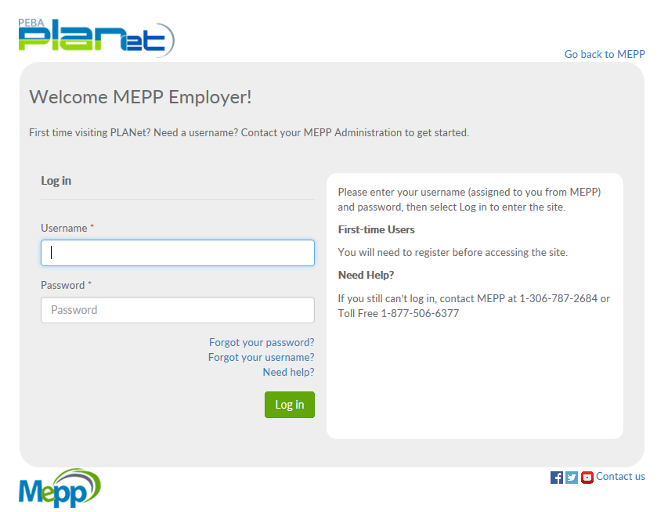

1. Go to Admin >> Security

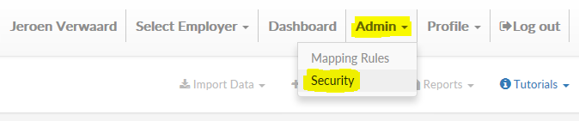

1. Click the Users >> Add button

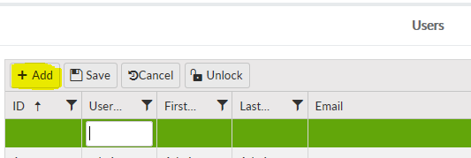

1. Enter the Username, First Name, Last Name and email, and the Organization if the user will be restricted to process for only one Employer (which should not be the case for PEBA staff)
2. Click Save

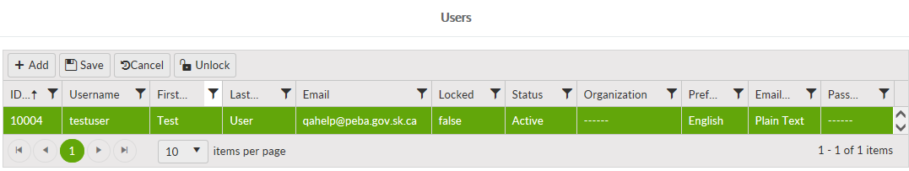

1. Click the Add button in the User Roles area
2. Select the applicable Role for the user – note that users can only have 1 role in PLANet, if more than one is selected it may mess up their access

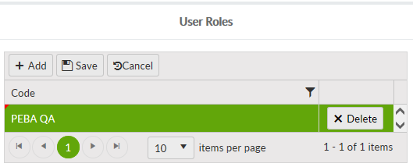

1. Click Save
2. Enter a Password in the Reset Password area

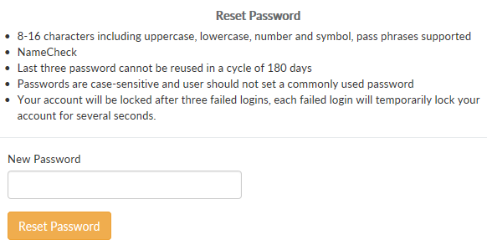

1. Click the Reset Password button

Note that the Password Policy is set at the Role level and not at the User Level so the “Password Policy” column in the Users area remains blank (-----).

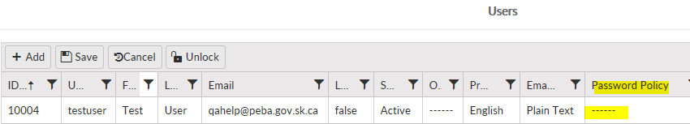

1. When you are done in PLANet, log out of the system



**1.1 Maintaining existing Users:**

Maintaining existing users is when you need to make changes to the user’s details such as name, email address and user roles, or reset when the user has locked their account and need a password reset (although they should be doing this using the “Forgot Password” link on the login page).

1. Log into PLANet and go to Admin >> Security



1. Locate the user
2. Click in the field you want to change; these are the ones you are able to edit:
3. First Name
4. Last Name
5. email
6. Status (Active or Inactive, “Created” will not be used)
7. Organization (if applicable)
8. email Format (Plain Text or HTML)
9. Click Save

**1.2 Unlock Account:**

When a user enters the incorrect password 3 times their account will become locked. At this point the user cannot use the “Forgot Password” procedure any longer until the account has been unlocked.

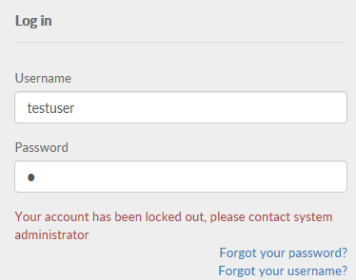

To unlock a user account:

1. Log into PLANet and go to Admin >> Security
2. Locate the user, the value in the Locked field will be “true”

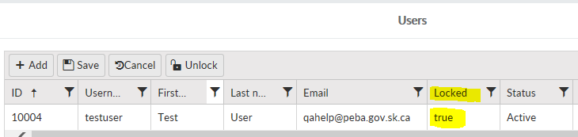

1. Select the user and click the “Unlock button

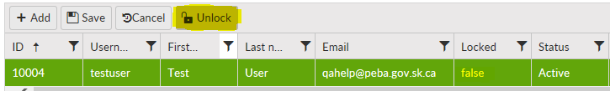

1. The Locked field changes back to “false”, which means it is not locked
2. At this point the user can try using their current password, use the “Change Password” link on the login page or have MEPP Admin or QA reset the password manually

**1.3** **Reset Password:**

When the user has forgotten their password, they can reset it on the PLANet login page but there may be cases where you need to reset it for the user.

1. Log into PLANet and go to Admin >> Security
2. On the Users screen, select the user
3. In the Reset Password area, enter a new password and click the Reset Password button



**Note**: Advice the user to change their password after they log in (Profile >> Change Password)

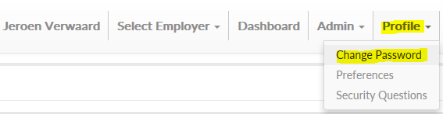

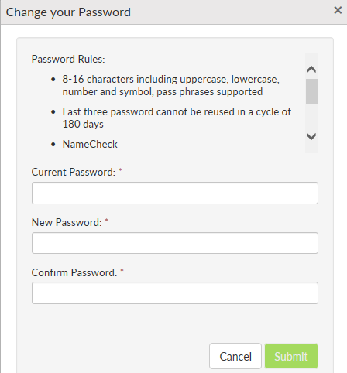

**1.4 Change User Role:**

When we get the request from business to change the user role, we have to change this on the user profile. Be aware that users cannot have multiple user roles selected, doing this will cause issues with their access to PLANet.

1. Log into PLANet and go to Admin >> Security
2. On the Users screen, select the user
3. Scroll down to the User Roles area
4. Click the Delete button for the current User Role

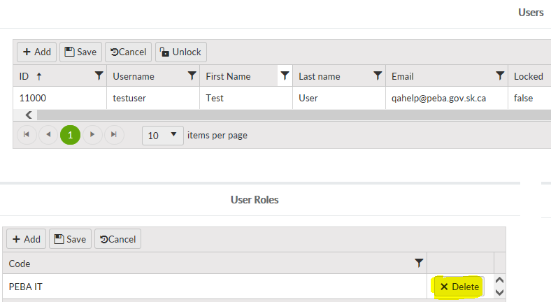

1. Click the Add button and select the new role

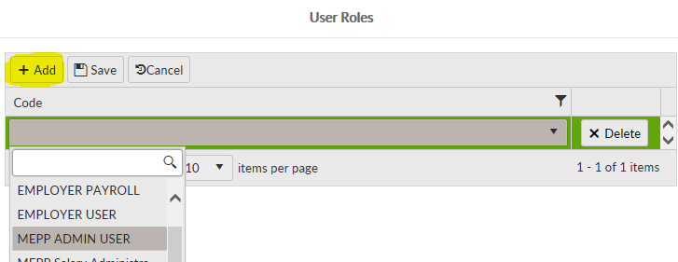

1. Click Save

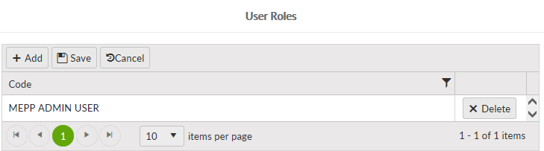

**Document Review Frequency:**

The Document Owner is responsible to ensure this procedure is reviewed at least once a year.

Any suggestions for improvements can be submitted to the Document Owner for review and consideration. Approved changes will be prioritized and included in the next release of this document.

**BCP requirements:**

1. Do you need this procedure during disaster recovery or business continuity planning?

(Yes / No)

* Yes

1. Please share the list of things you would need for fulfilling the procedures

(E.g. printer, system, internet, phone, process document, etc.)

* PLANet application up and running
* Process Document available

**Document References:**

Not applicable.

# QA Daily Task Activities

**Overview:**

On a daily basis, QA has a number of tasks or queries it may perform to support PEBA operations. These include activities which may or may not be associated with the JEA system and may include other applications or process as well.

The task list for 2021 has been updated and can be found at the following link: ..\QA Daily Tasks\QA Daily Task List 2021.xlsm

Each activity has an associated procedure that can be further accessed from within this document for detailed instructions. QA has responsibility to review and update as required when procedures or instructions need to change.

# TROY Application:

|  |  |
| --- | --- |
| **Procedure Number:** | TROY -001 |
| **Procedure Name:** | Adding a new plan cheque style into TROY PEBA AssurePay |
| **Purpose of the Procedure:** | To inform QA on how to build a new plan cheque style if required. |
| **Original Date:** | January 15, 2020 |
| **Current Version:** | 1.0 |
| **Revised Date:** |  |

|  | **Name/Title** | **Signature** | **Date** |
| --- | --- | --- | --- |
| **Reviewed by** | <Person who reviews the work> |  | <dd/mm/yyyy> |
|  |  |  |  |
|  |  |  |  |
| **Approved by** | <Senior Management / Business Area Manager> |  | <dd/mm/yyyy> |

**Overview:**

The Troy Application by AssurePay is used for the printing of cheques from the PENFAX application. Each time a new plan type is added the Troy Application must be updated to reflect the new plan. The following provides the instruction for doing this.

1. If it is a production implementation
   1. Create a Change Request and have Finance and QA manager sign off on the Change
   2. Determine the data that the change will be completed
   3. Contact Finances to confirm that they have completed printing of all cheques for the day before the change will be made.
   4. Send an Email to the Finance and QA that you will be completing the build of the new plan cheque style and advise them not to use the application until they are advised that it is completed.
   5. Send a PEBA IT request to ask that a backup of the AssurePay Database be done before proceeding with the build.
      1. For Production: ask IT to make a backup of the databases found in folder H:\Apps\Troy Prod and have then labeled with the date the backup was done
      2. For Test: ask IT to make a backup of the databases found in folder H:\Apps\Troy Test and have then labeled with the date the backup was done
2. Once IT has advised you that the backup is completed then proceed to the next steps.
3. Open the Assurepay (Troy) application by clicking on the icon on the desktop and log in with your username and password
   1. When the application opens you will see the Import Window:
      1. Confirm that the AssurePay (Troy) application is pointed to the correct database where you need to build the new cheque style
         1. To confirming the database, review the File name for the imported batches that you see display on the window when the application opens.

**Note**: You may need to expand the File Name Column to see the full file name.

* + - * 1. A Production batch file name will start with H:\Apps\Troy Prod Import Files
        2. A Test batch file name will start with H:\Apps\Troy Test Import Files

IMPORTANT: If you do not see the correct batch file name for the database you need to build your cheque style in. STOP!!! AND CONTACT PEBA IT BEFORE MOVING ONTO THE NEXT STEP

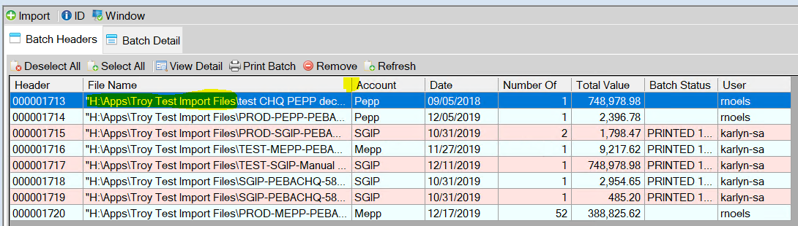

1. Select Menu Item “Accounts”
   1. In the “Name” drop-down list select the account you will copy to create your new plan account (For the SGI plan select WCB from the drop-down list)
   2. Press the “Copy” button in the tool bar – to make a copy of the WCB account
      1. Make the following field updates to the “copied account”
         1. Edit the name field from: “Copy …” To: SGIP
         2. On the Address Tab – make the following updates:

|  |  |  |
| --- | --- | --- |
| Field | Current | Update to |
| Account Number | 1726581 | 1019256 |
| Company | Saskatchewan WCB Pension Plan | SGI Superannuation Plan |
| Bank ID | WCB | SGIP |

* + - 1. On the Numbering Tab – make the following Updates:

|  |  |  |
| --- | --- | --- |
| Field | Current | Update to |
| Use Account Name | WCB | SGIP |

* + - 1. On the Parameters Tab – make the following Updates:

|  |  |  |
| --- | --- | --- |
| Field | Current | Update to |
| Memo | Pension Plan for the Employees of Saskatchewan Workers’ Compensation Board | SGI Superannuation Plan |

* + 1. After the updates are complete Press the “**Save**” button in the tool bar – to save your new plan account
    2. Close the window by pressing the X in the upper right corner.

1. Select Menu Item “File Integration”
   1. In the “Source Name” drop down list select the name that you will copy to create your new plan File Integration (For the SGI plan select WCB from the drop-down list)
   2. Press the “Copy” button to make a copy of the File Integration
      1. Then make the following field Updates to the “Copied File Integration”
         1. Edit the Name from “Copy ….” To SGIP,
         2. Update the Account Name from WCB to SGIP - this should automatically update the account number from 1726581 to 1019256
      2. Once you review the account details of account number and address and phone number on the window to ensure all data is correct Press the “**Save**” button in the tool bar to save your new plan file integration
      3. Close the window using the x in the upper right-hand corner

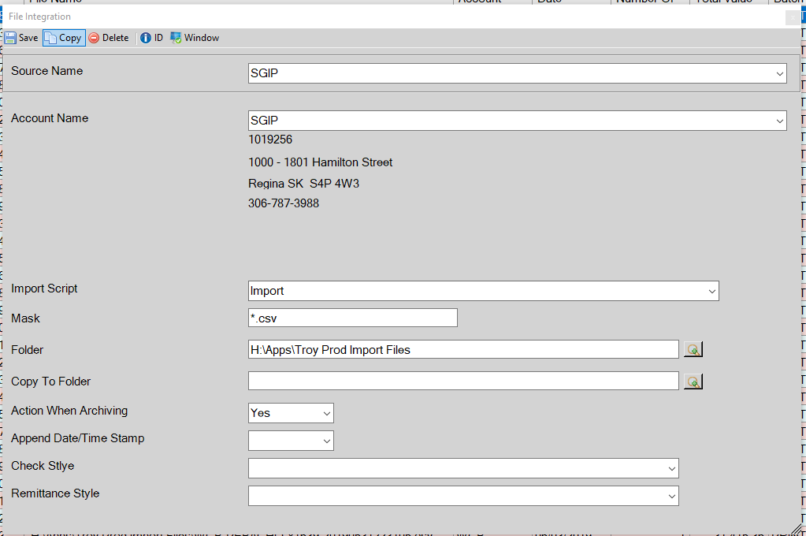

* + 1. Confirm that the new plan file integration has been saved by pressing the Import Button on the tool bar on the middle screen. Your new plan should appear in the list. Use the X in the upper right corner to close the window.

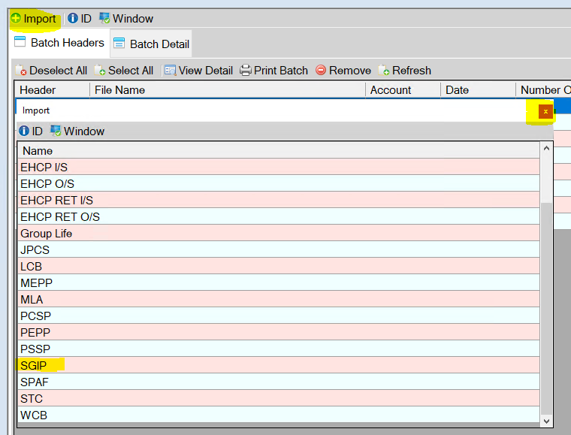

1. Select Menu Item “Settings” and assign the new account to all user groups
   1. On the setting window, Group Tab, Double click on the user group Senior Accountants to open the Group Setting Window
      1. Ensure that the newly added account is checked;
         1. If it is not check you will have to check it then press the “Save” Button in the tool bar, and the window will close.

**Note**: All accounts should be checked for this User Group

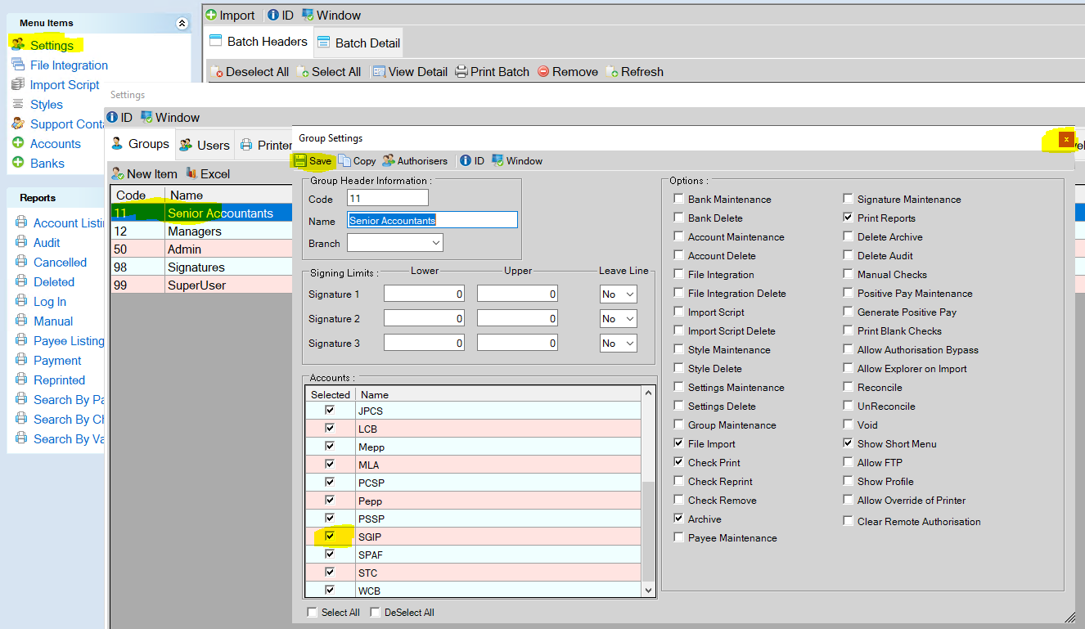

* 1. Double click on the user group Managers to open the Group Setting Window
     1. Ensure that the newly added account is checked;
        1. If it is not check you will have to check it then press the “Save” Button in the tool bar.
        2. Close the window using the Red X in the upper right corner.

**Note**: All accounts should be checked for this User Group

* 1. Double click on the user group Admin to open the Group Setting Window
     1. Ensure that the newly added account is checked; because this is the group that is adding the plan – the new plan will probably already be checked. Confirm and use the X in the upper right corner to close the window.
        1. If it is not check you will have to check it then press the “Save” Button in the tool bar.
        2. Close the window using the Red X in the upper right corner.

**Note**: All accounts should be checked for this User Group

* 1. The Signatures Group does not require an update.
  2. Double click on the user group SuperUser to open the Group Setting Window
     1. Ensure that the newly added account is checked;
        1. If it is not check you will have to check it then press the “Save” Button in the tool bar.
        2. Close the window using the Red X in the upper right corner.

**Note**: All accounts should be checked for this User Group

1. Close the Troy AssurePay Application
   1. Press the X in the upper Right corner



* 1. Press Yes on the System Message

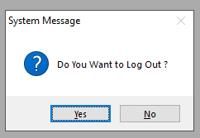

* 1. Press the Stop button on the Log In screen

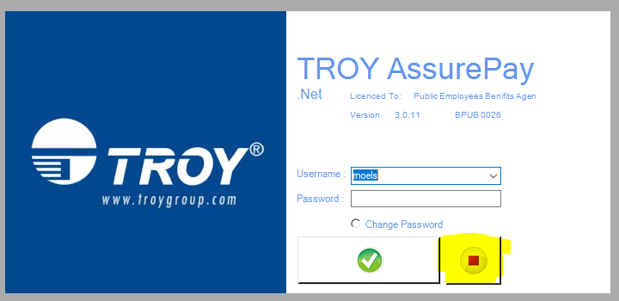

1. Create a Manual Cheque Template for the new plan and save it to H:\Apps\Troy Prod Manual Cheque Templates or H:\Apps\Troy Test Manual Cheque Templates depending on if you are building for production or for test
   1. Navigate to either H:\Apps\Troy Prod Manual Cheque Templates or H:\Apps\Troy Test Manual Cheque Templates depending on where you are building
   2. Copy an existing manual cheque template file, and paste it into the folder



* 1. Rename the copied file – by removing the copy and changing the plan reference to match the plan you just built in the steps above.



* 1. Open the template and update the plan name to match the plan you just built
     1. Save the change you made to the template and close.



Advise Finance that the build is completed and they can use the APPLICATION.

# Queries and Reports

|  |  |
| --- | --- |
| **Procedure Number:** | Query-001 |
| **Procedure Name:** | Defining and building a new Business Query |
| **Purpose of the Procedure:** | To outline the workflow associated with defining and developing a business query |
| **Original Date:** | June, 2021 |
| **Current Version:** | 1.0 |
| **Revised Date:** |  |

|  | **Name/Title** | **Signature** | **Date** |
| --- | --- | --- | --- |
| **Reviewed by** | QA Team |  | June 16, 2021 |
|  | Business Branches |  |  |
|  |  |  |  |
| **Approved by** | Sheryl Britton |  | June 16, 2021 |
|  |  |  |  |

**Overview:**

A formal process has been established with the business branches to accept requests; define and develop the business query; participate in a formal review and approval process. The purpose of this business practice is to ensure business requirements are met; data is scrutinized before providing to the business; and business has been involved in validating and approving the build. This will ensure a high quality of delivery

1. **Workflow:**

The following diagram denotes the workflow.



1. **Procedure:**
2. Once the service desk ticket is received with the attached, approved form, a Business Intelligence team member will reach out to schedule time with the requestor to walk through the form and confirm the information and validate any additional information that may be required.  If the requestor is satisfied, then approval through the DocuSign process is to be used. Once approval is received, the requestor may go to the next step. IF APPROVAL IS NOT RECEIVED, the requestor is not to move forward and will focus on amending or validating until requestor provides approval.
3. Once approval is obtained, BI team member builds the query and reviews it. The review takes place individually by
   1. reviewing the data output to validate the query structure matches the output;
   2. the data is complete- all data fields have been provided;
   3. the data appears reasonable- if possible review of previous reports; validating information on the PENFAX system, etc.
4. Once the individual review takes place, an internal peer review will occur. Internal review should look for the same check points as 2) above.
5. When the review has been completed, the query/report will be provided to the requestor and an additional meeting will be set up to step through the information to ensure the requestor is satisfied with what has been delivered. If the requestor is satisfied, then formal approval through DocuSign is requested. When the formal approval is received back, the internal service desk ticket can be updated, noting the delivery and attaching the formal approval document. If the requestor is not satisfied and does not provide approval, Go back to Step 1.
6. In addition to these process changes, we will also be reviewing any requests that will fall into a category of “will be required more than once”.  In these situations, a ticket will be logged with JEA to create a report that can be delivered in a future release and made available for branches.  The reports can be set up to run on a scheduled basis or ad hoc by the branch.  In doing this it is hoped we can bring a better level of service around delivery (as you won’t need to wait for us to go through the above process) and ensure consistency around the data. Please note we will continue to support the request until such time JEA can deliver the ticket.

­­

**Account Instruction Adjustment:**

|  |  |
| --- | --- |
| **Procedure Number:** |  |
| **Procedure Name:** |  |
| **Purpose of the Procedure:** |  |
| **Original Date:** |  |
| **Revised Date:** |  |

|  | **Name/Title** | **Signature** | **Date** |
| --- | --- | --- | --- |
| **Reviewed by** | <Person who reviews the work> |  | <dd/mm/yyyy> |
|  |  |  |  |
|  |  |  |  |
| **Approved by** | <Senior Management / Business Area Manager> |  | <dd/mm/yyyy> |

**Overview:**

**ISSUE**: There is a situation that happened with a PEPP member in production. They had SK-locked in funds and BC-locked in funds in their PEPP account. The member had taken retirement and wanted to transfer ONLY the SK funds to VPB account. However due to a user error and system flaw all of the funds were withdrawn from PEPP account making it INACTIVE and transferred all of the funds to their newly created VPB account. On the next day, the monthly schedule withdrawal also ran and withdrew funds prorated from both the SK -locked in and BC locked- in money when the expected would have been to withdraw ONLY SK-funds if the transfer process had indeed gone correctly.

**Proposed solution:** To rectify the error the DC benefit selection (that led to transfer of money from PEPP to VPB account) could be reversed however this would incur a large breakage if the transferred units were large initially and would reverse all the money from both funds, but we only want to reverse the BC-locked in funds. Additionally, we also have the second incorrect transaction that was processed on the member with the monthly schedule withdrawal batch that withdrew BC funds instead of what was expected to only withdraw their SK funds. Considering these conditions and complexity of the UNDO option that this stage, (final solution) we instead would go for adjustments on their VPB account and PEPP account. Current PENFAX behaviour does **not** allow adjustments to be done from INACTIVE account, so we would use a workaround instead to activate the PEPP account. (Please note: This workaround is a temporary solution, a JEA fix later would resolve this in future where we can then do adjustments from INACTIVE accounts)

High level steps for proposed solution with adjustments to this specific scenario:

1. DAY 1: Activate PEPP account by adding $0.01 so that adjustments can be performed ( this step is a temporay work around to be followed now until JEA provides a fix that will let us add adjustments on INACTIVE ACCOUNTS)
2. DAY 1: Adjustment #1 and 2- VPB account -Schedule withdrawal transactions -Add back BC locked in units withdrawn from schedule withdrawal (positive adjustment) and instead withdraw SK locked in funds from sch withdrawal (negative adjustment)
3. DAY 2: Adjustment #3 and 4- withdraw all BC locked in funds from VPB (negative adjustment) and Put the same units back to the PEPP account (positive adjustment)
4. Day 2: Negative adjustment (#5) of $0.01 which was added previously to activate PEPP account or ask business to do manual cleanup to remove this amount from member’s account ( this step will not be needed if JEA fix is provided from step 1 above)

Low level steps :

**Day 1**

**[Please note**  step 1 and step 2 is a temporay work around to be followed until JEA provides a fix that will let us add adjustments on INACTIVE ACCOUNTS. Once we have the fix in place , step 1&2 are not required. Move to step 3 directly]

**Step 1** : Go to member profile>investments> select the PEPP account investment Id 331519

Take member screenshot for PEPP ACCOUNT and verify the account is Inactive

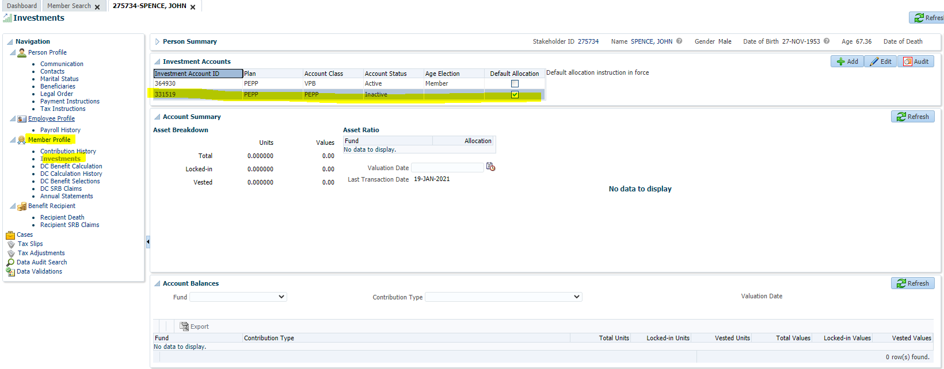

**Step 2** : Go to member profile> Contribution history and click ADD

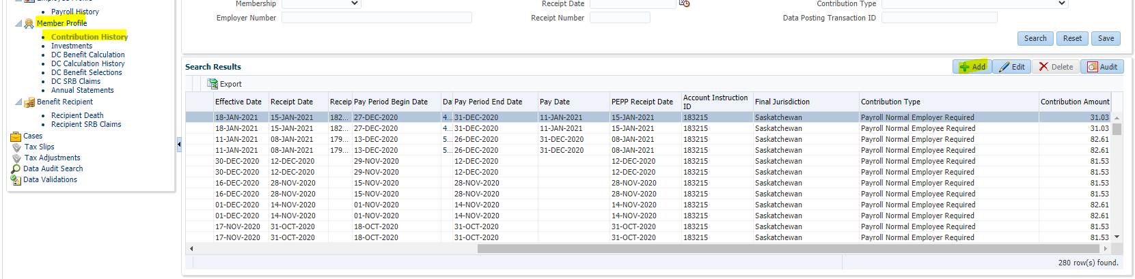

Enter the details as below and click save:

Select membership = PEPP 01 Oct 2007 (i.e. the membership period for PEPP account)

Contribution type= payrol Normal Employee Required

Effective date= current date

Receipt date= current date

Amount= $0.01

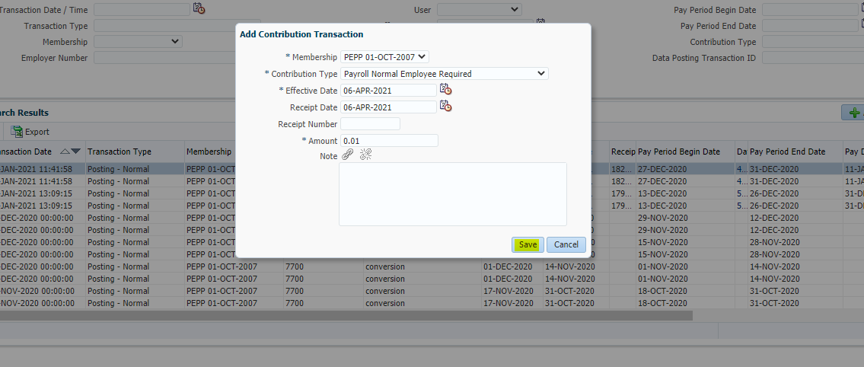

The record will be saved as online correction deferred adjustment



**Step 3**: Go to member profile>investments> select the VPB account investment Id 364930

Take screesnhots of VPB investment account and account activity screens

**Investment account**

Please note total BC units and total SK units for this day

BC total units=134.464368

SK total units= 169.220020

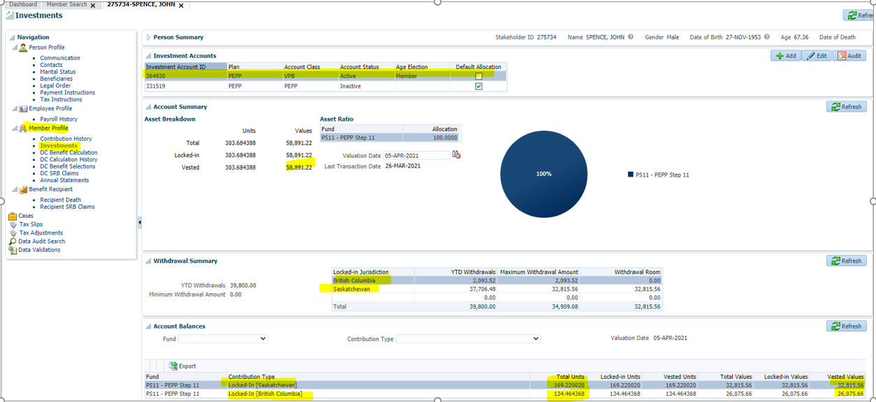

Account activity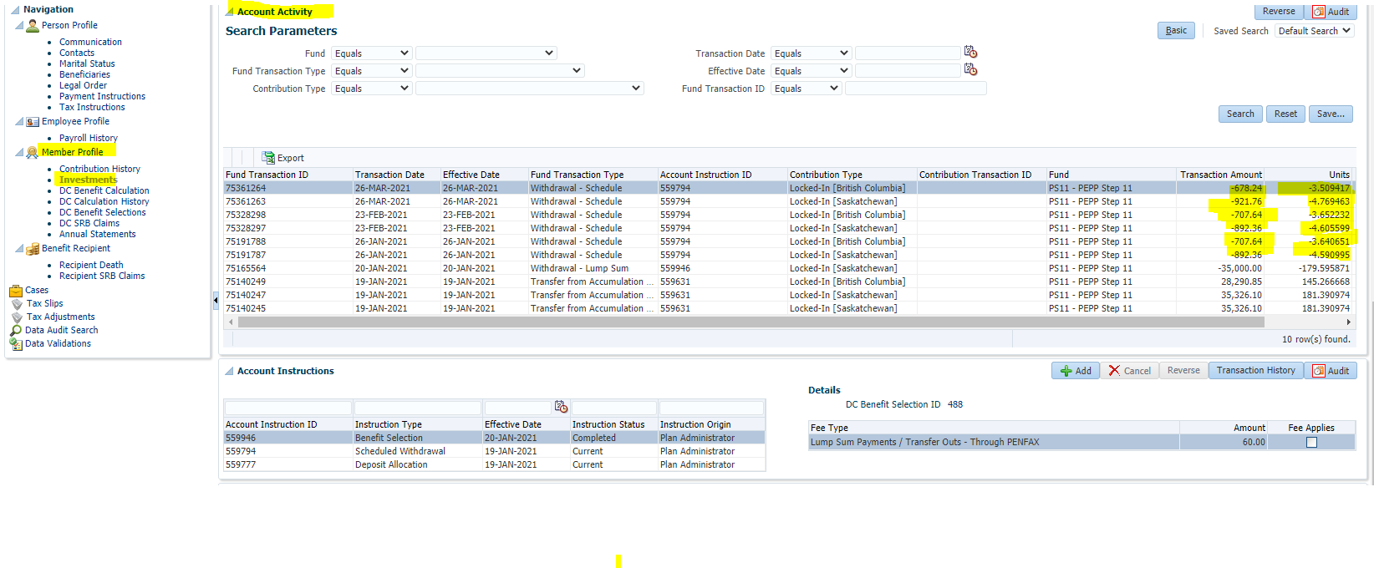

**Step 4**. From the account activity export the results by clicking the “export” option

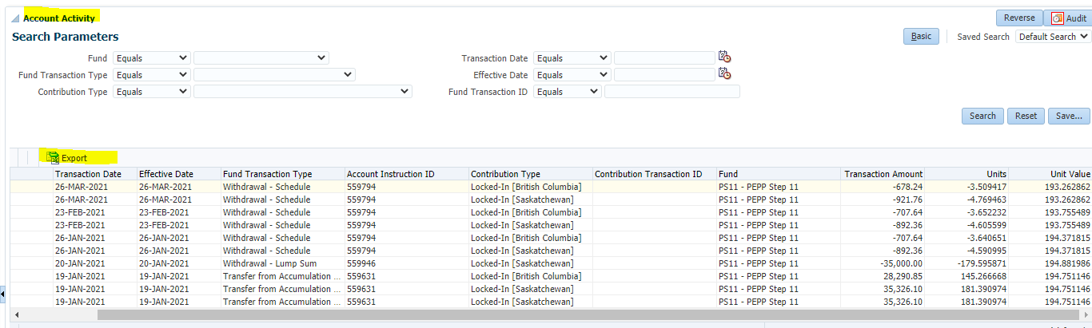

From the exported excel spreadsheet filter the **fund transaction type= Withdrawal -schedule**

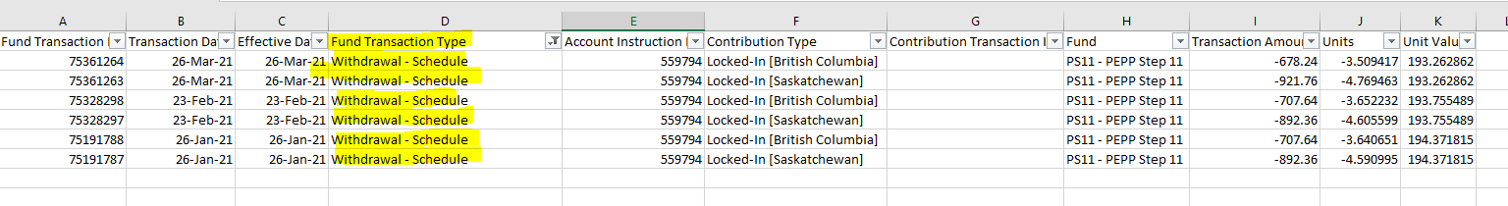

Find out the total BC units from the filtered export:

BC units= 10.802300

**Step 5**: Do a Positive adjustment(#1) for BC units calculated in step 4 to put back BC units in member account

Go to member profile>investments> select the VPB account investment Id 364930

Click add under account instructions

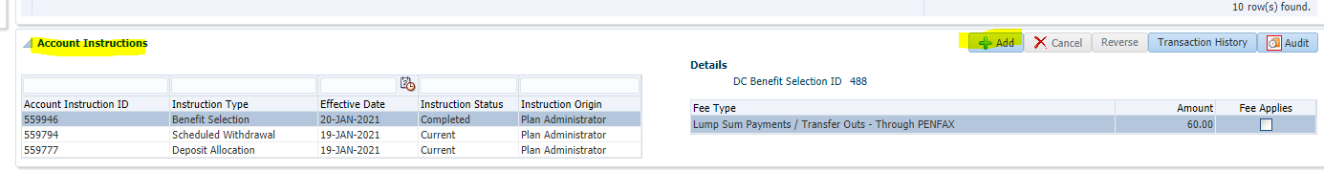

In the pop up window that opens enter the following details and click save

Intruction type= adjustment

Effective date: defaults to current date

Fund= PS11-PEPP step 11

Contribution type= Locked -in( British Columbia)

Units = 10.802300

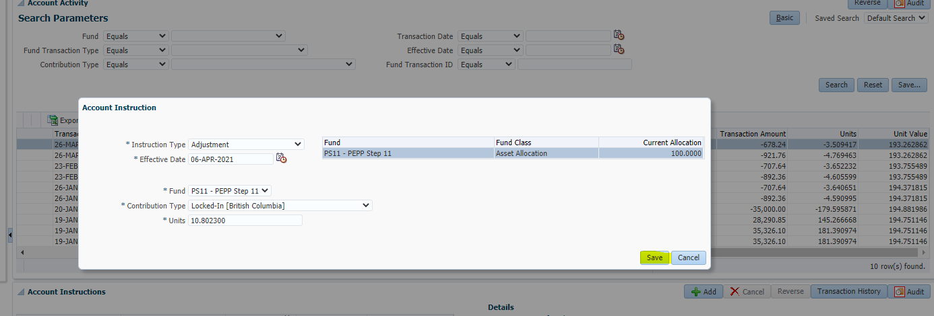

**Step 6**: Do a Negative adjustment (#2) for BC units calculated from step 4 so that these are withdrawn from SK funds instead

Go to member profile>investments> select the VPB account investment Id 364930

Click add under account instruction

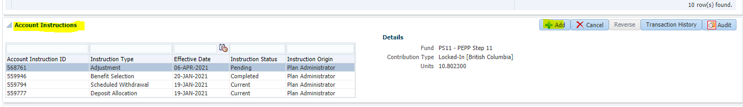

In the pop up window that opens enter the following details and click save

Intruction type= adjustment

Effective date: defaults to current date

Fund= PS11-PEPP step 11

Contribution type= Locked -in( Saskatchewan)

Units = **--** 10.802300 ( make sure to include negative sign before the units)

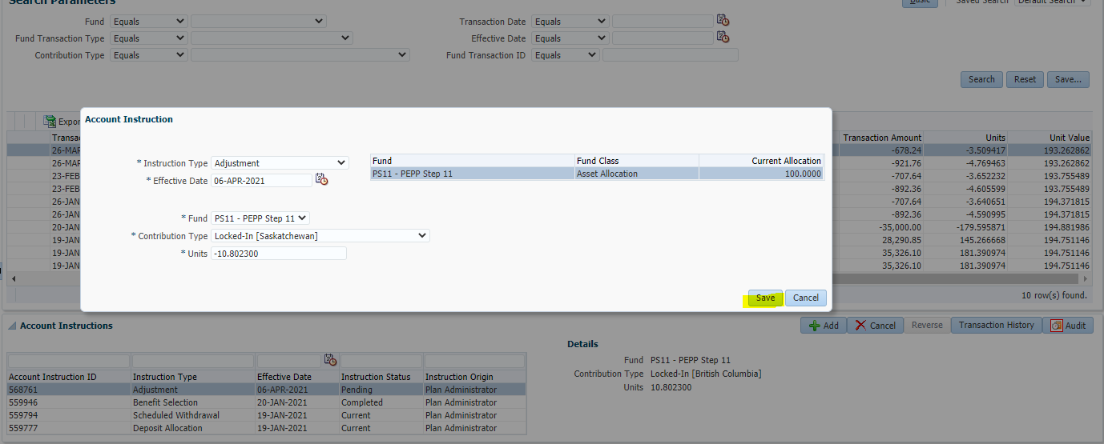

After save, you would see 2 account instructions in pending status, like below

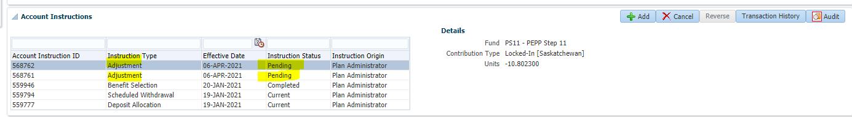

**Close the member tab and come back on next day**

**DAY 2**

**[Please note** : STEP 7 is not required if STEP 1 and STEP 2 were not performed]

**Step 7**: Go to member profile>investments> select the PEPP account investment Id 331519

Verify PEPP account became active and account balance= $0.01

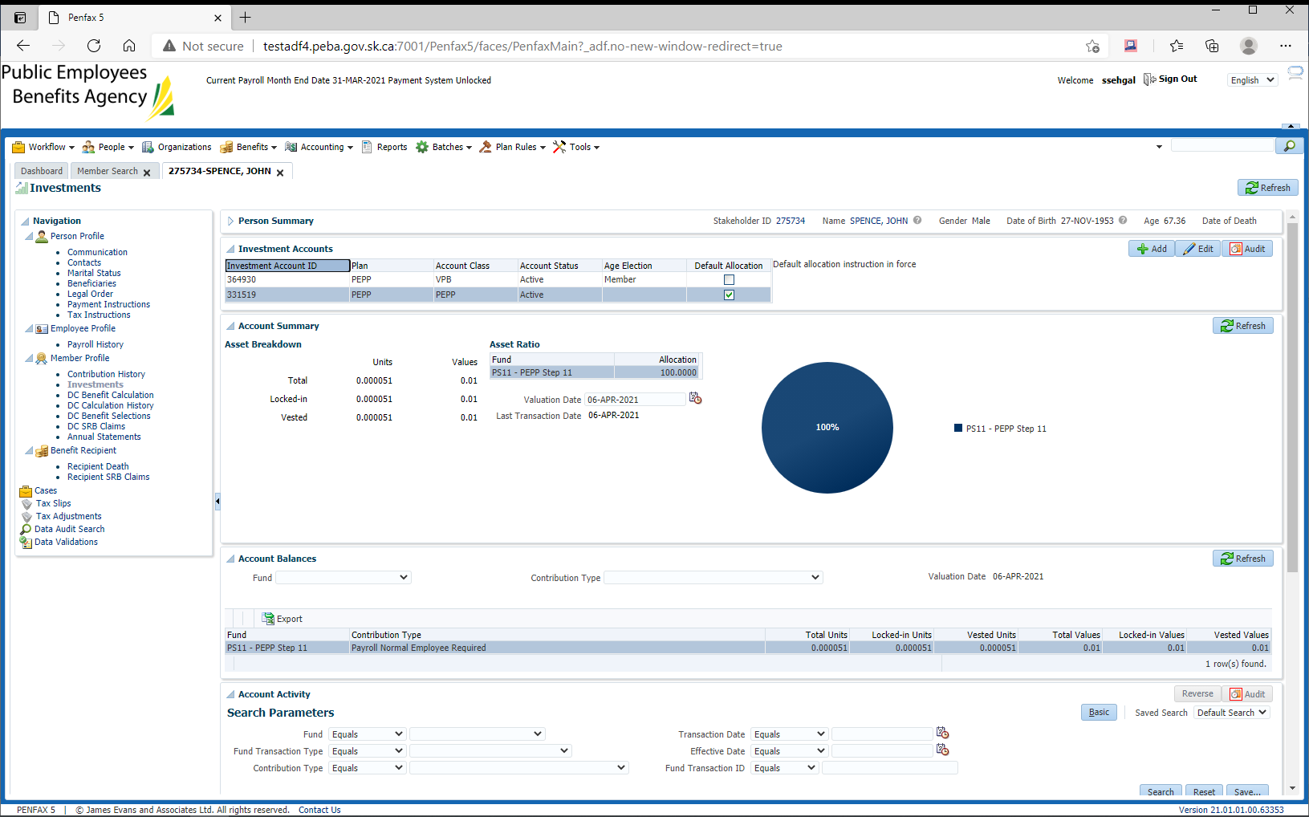

**Step 8**: Verify VPB account has units adjusted

Go to member profile>investments> select the VPB account investment Id 364930

Ensure the values are matching as calculated below-

BC Units = 134.464368 (from step 3) +10.802300= 145.266668 (matching)

SK Units = 169.220020 (from step 3) - 10.802300= 158.417720 (matching)

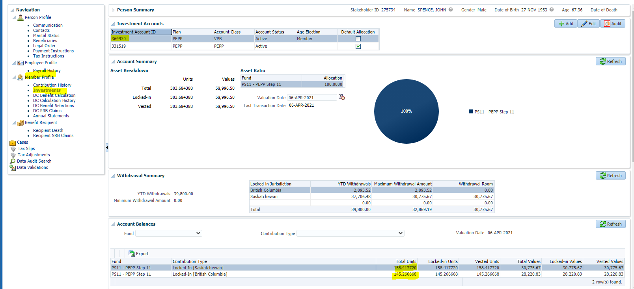

**Step 9**. Negative adjustment (#3) for BC from VPB

Go to member profile>investments> select the VPB account investment Id 364930

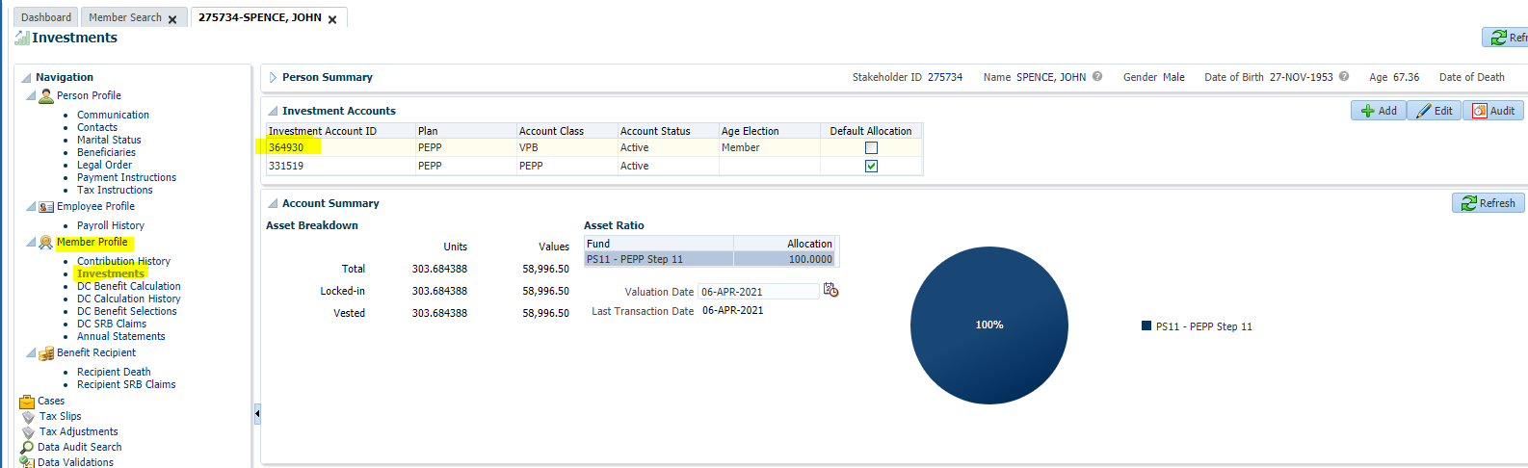

Click add under account instruction

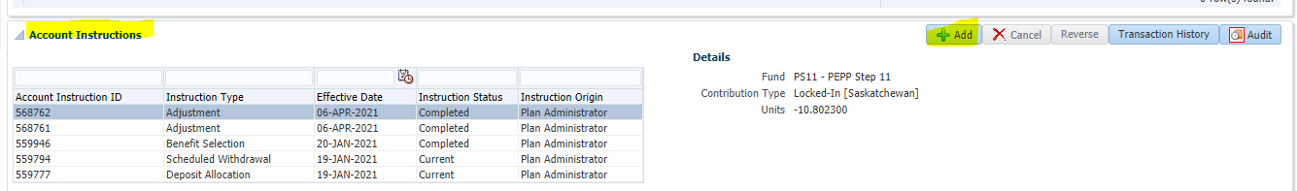

In the pop up window that opens enter the following details and click save

Intruction type= adjustment

Effective date: defaults to current date

Fund= PS11-PEPP step 11

Contribution type= Locked -in( British Columbia)

Units = **--** 145.266668 ( units from step 8) -- make sure to include negative sign before the units

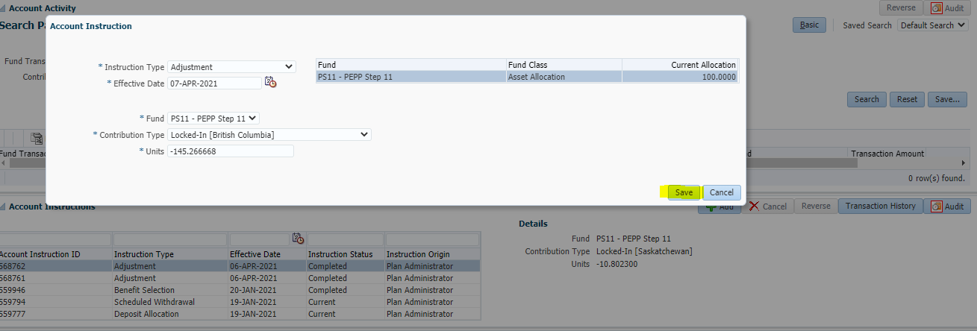

**Step 10**: Positive adjustment (#4) in PEPP account

Go to member profile>investments> select the PEPP account investment Id 331519

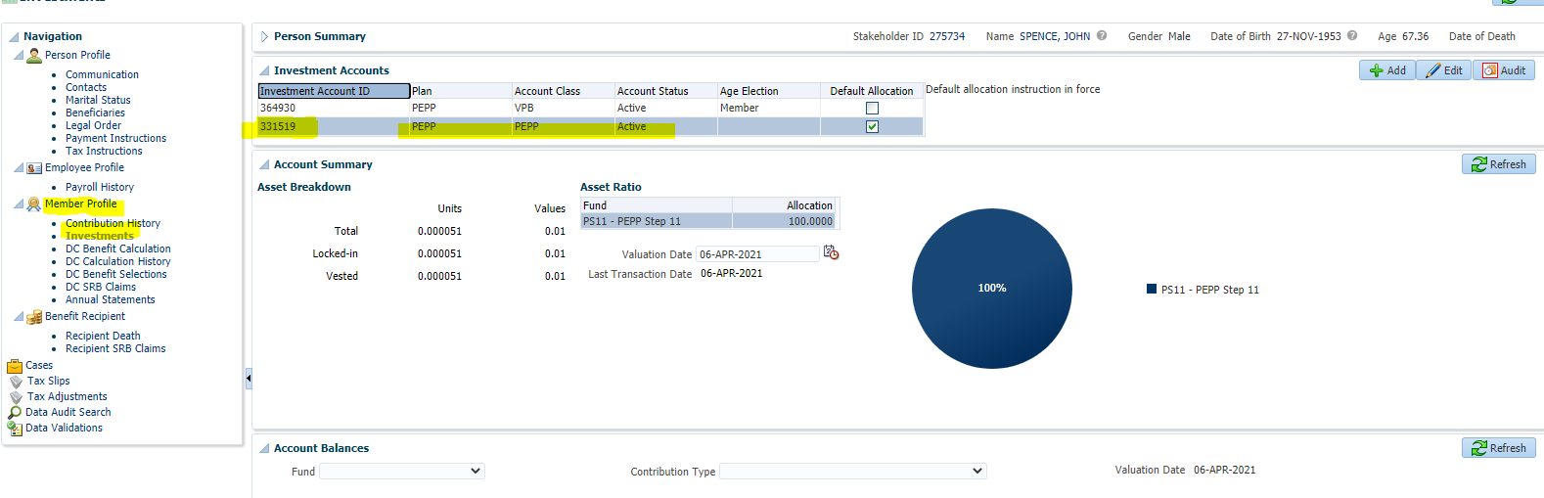

Click add under account instruction

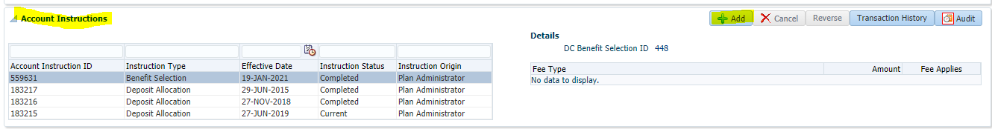

In the pop up window that opens enter the following details and click save

Intruction type= adjustment

Effective date: current date

Fund= PS11-PEPP step 11

Contribution type= Locked -in( British Columbia)

Units = 145.266668 ( units from step 8)

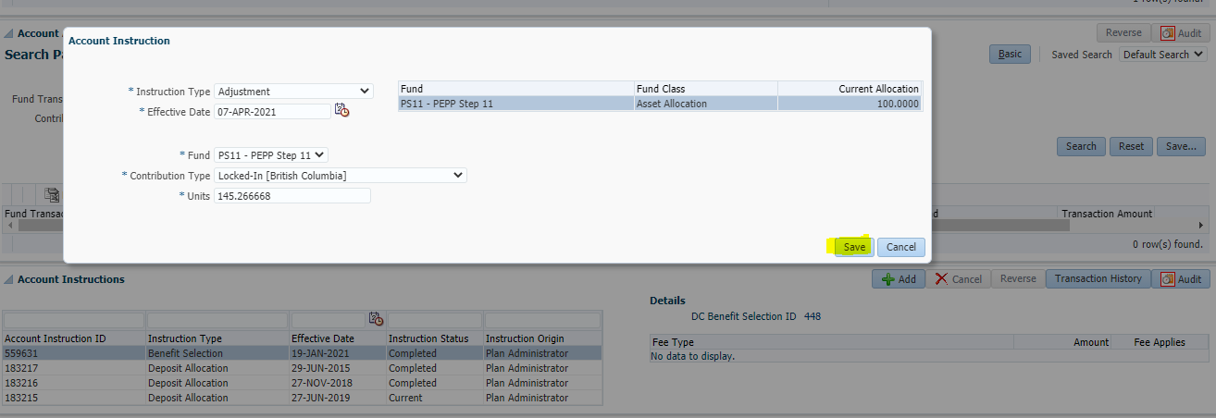

**STEP 11**:

[**Please note**: Step 11 is not required if Step 1 and Step 2 and step 7 were not performed] , ELSE

cleanup of $0.01 payroll normal employee required contribution type that were added to activate the PEPP account previously

Go to member profile>investments> select the PEPP account investment Id 331519

There are two ways to do the cleanup

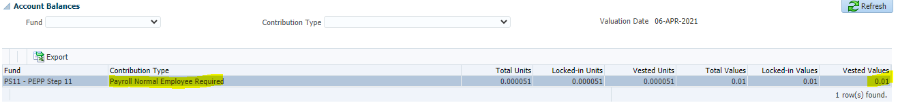

1.manual cleanup of 0.000051 units of payroll normal employee required from PEPP account- preferable (check with Heather/Jordon)

**OR**

2. Do a negative adjustment (#5)

Go to member profile>investments> select the PEPP account investment Id 331519

Click ADD account instruction and enter the following details and click SAVE

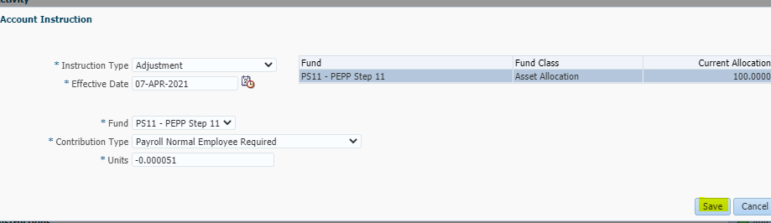

**Close the member tab and come back on next day**

**Day 3:**

**Step 12**:

Go to member profile>investments> select the VPB account investment Id 364930

Verify Withdrawal summary is removed of BC funds

Verify account balance is removed of BC funds

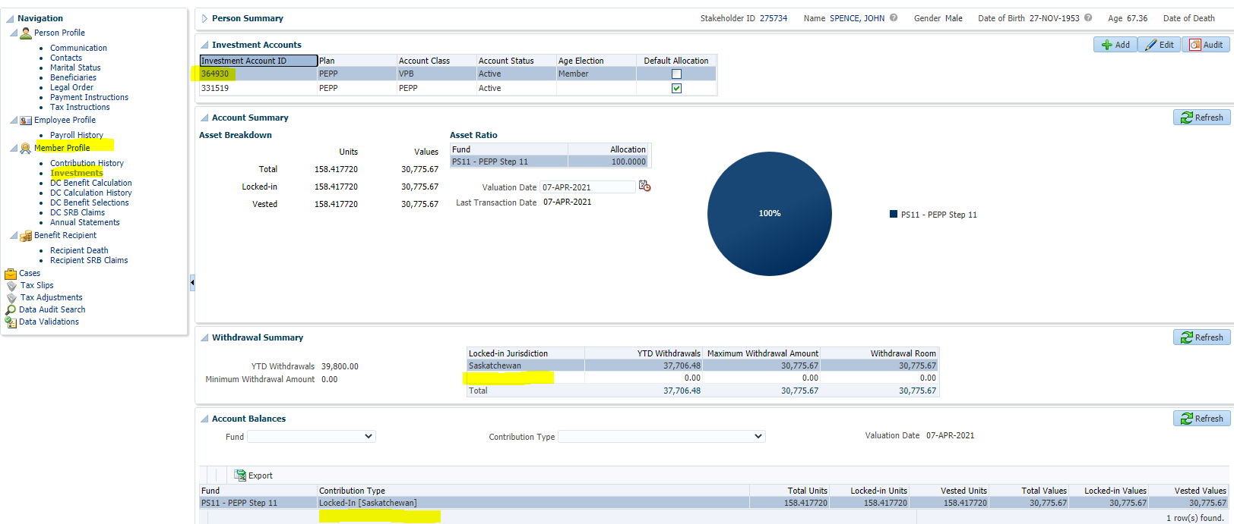

**Step 13**: Go to member profile>investments> select the PEPP account investment Id 331519

Verify 145.266668 units have been added to the PEPP account

Verify 0.000051 units payroll normal employee required are removed from PEPP account- No need to verify this part if STEP 1 and Step 2 and step 7 and step 11 were not performed

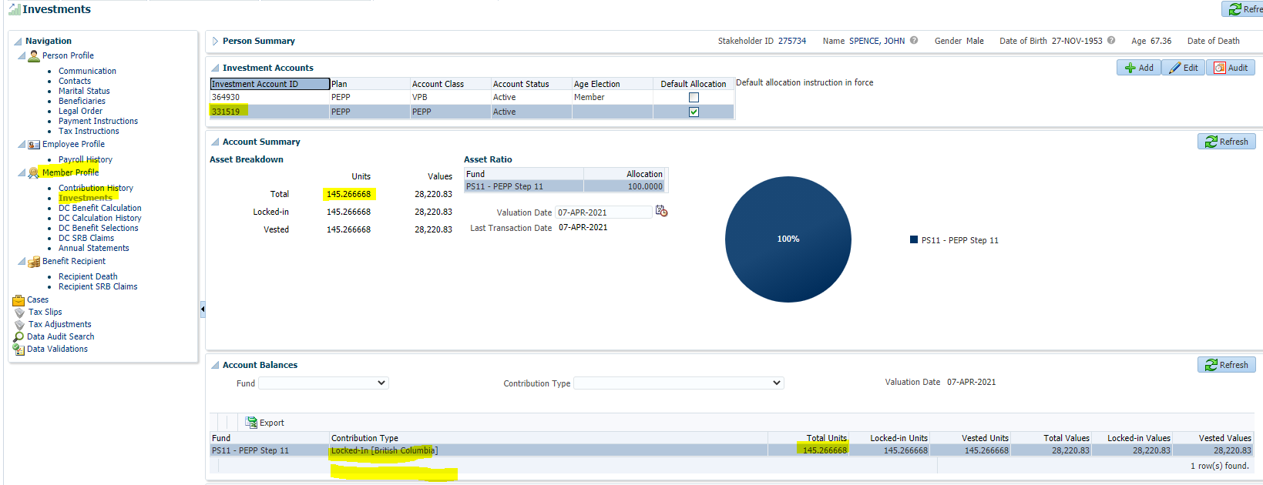

**Create the Weekly Performance Ticket:**

|  |  |
| --- | --- |
| **Procedure Number:** |  |
| **Procedure Name:** |  |
| **Purpose of the Procedure:** |  |
| **Original Date:** |  |
| **Revised Date:** |  |

|  | **Name/Title** | **Signature** | **Date** |
| --- | --- | --- | --- |
| **Reviewed by** | <Person who reviews the work> |  | <dd/mm/yyyy> |
|  |  |  |  |
|  |  |  |  |
| **Approved by** | <Senior Management / Business Area Manager> |  | <dd/mm/yyyy> |
|  |  |  |  |

**Overview:**

Every Monday a Performance Ticket is created in order to track performance issues in PENFAX V5.0

1. Send an email to Tech Support to create the ticket number

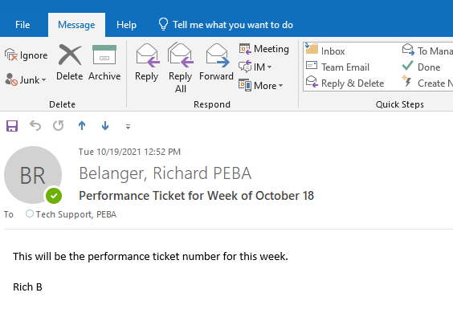

1. This will initiate a Ticket Number in Service Desk. This ticket number will be the Performance Ticket Number

* In this case, the Ticket Number for the week of October 18 is #38359

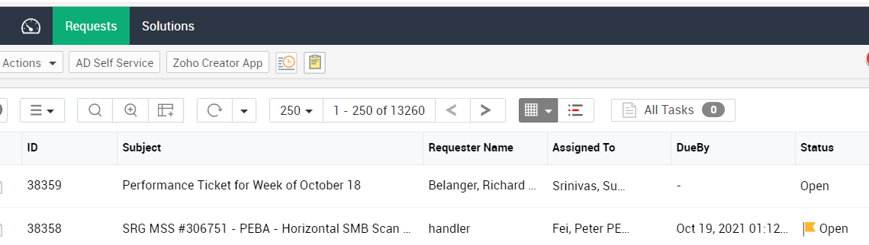

1. When the email reaches Service Desk it will be assigned the Number.

Forward from Service Desk to… Debby Parks (MEPP); Heather Culetta, Leanne Toth, Leslie Huxted, Marney Reeve (PEPP)

**C.C** to Pana, Sheryl, bussupport@peba.gov.sk.ca

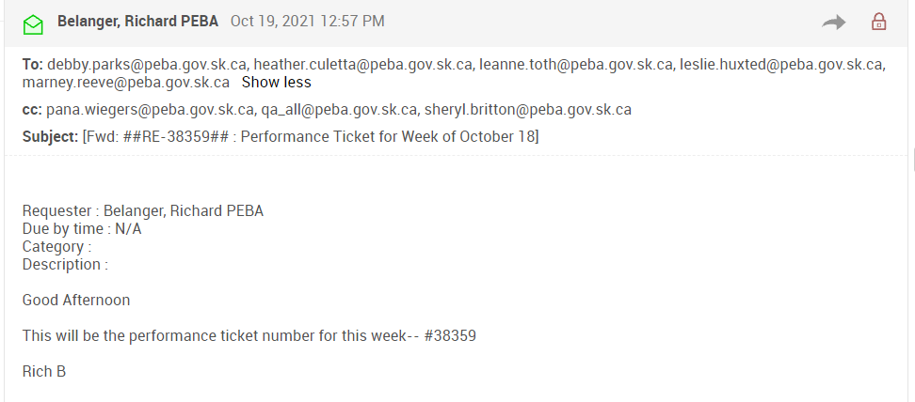

**Event Planner Daily Verification Process:**

|  |  |
| --- | --- |
| **Procedure Number:** |  |
| **Procedure Name:** | Event Planner Verification |
| **Purpose of the Procedure:** | The Event Planner software needs to be checked every morning to ensure that the application is indexed to the database properly |
| **Original Date:** |  |
| **Revised Date:** |  |

|  | **Name/Title** | **Signature** | **Date** |
| --- | --- | --- | --- |
| **Reviewed by** | <Person who reviews the work> |  | <dd/mm/yyyy> |
|  |  |  |  |
|  |  |  |  |
| **Approved by** | <Senior Management / Business Area Manager> |  | <dd/mm/yyyy> |

**Overview:**

Go to PEBANET (<http://pebanet.peba.gov.sk.ca/home.html>) and locate the ***Agency Websites*** area

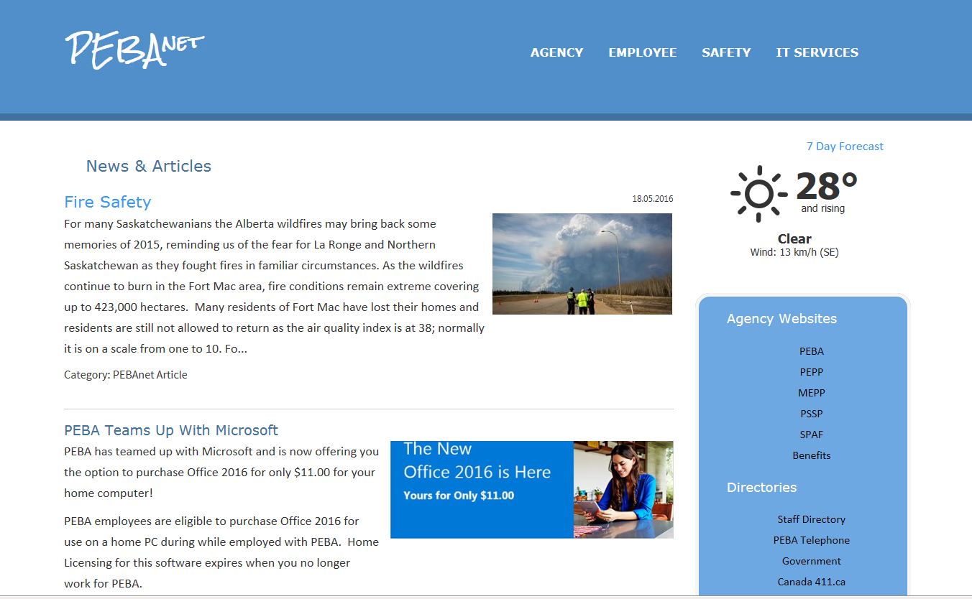

Click on all the available *Agency Websites*links to verify the Event Planner links work

**PEBA**

Click the PEBA hosted retirement planning workshops picture



Verify the Register, Edit Registration and Unregister links

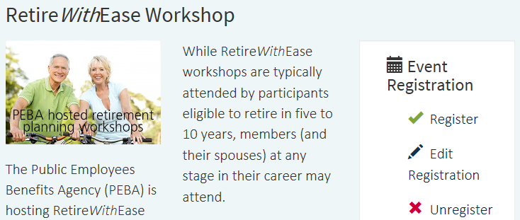

Verify the Calendar page opens when clicking the **Register** link and you can select any of the workshops

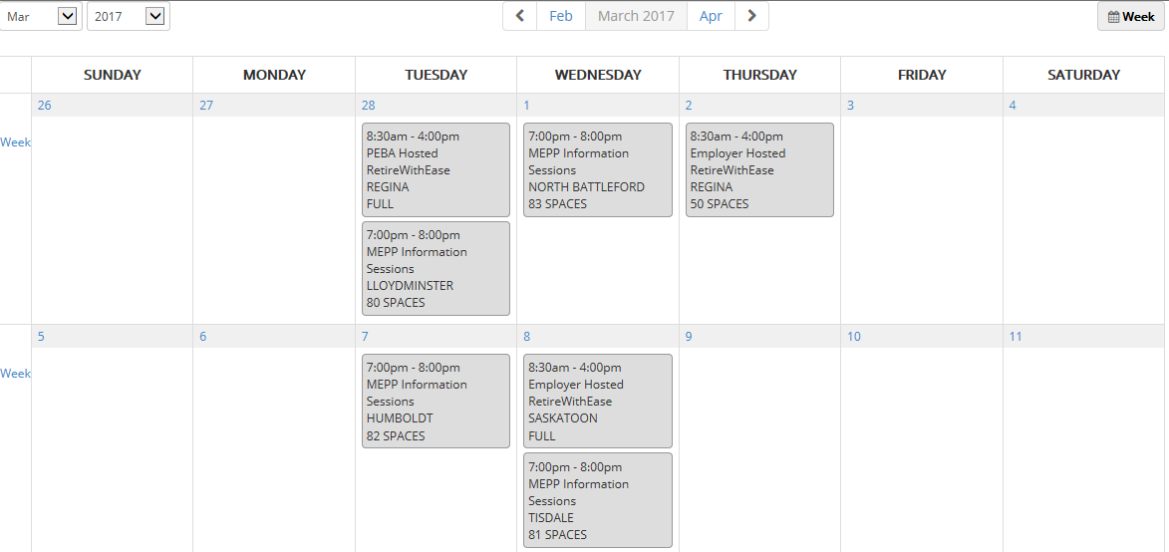

If the calendar does not display and you receive the Error message below, contact IT Support; they need know the environment (Production or Test). They may have to either clear the Cache, or

re-index and send Groveware the Event Planner logs for their review.

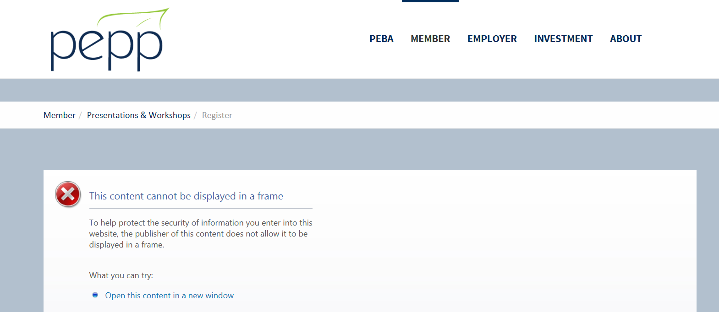

**Note:** Even when the application needs to be indexed, the Edit and Cancel Registration links will still work so there is no need to click these

Verify the Edit Registration Form opens when clicking the **Edit Registration** link

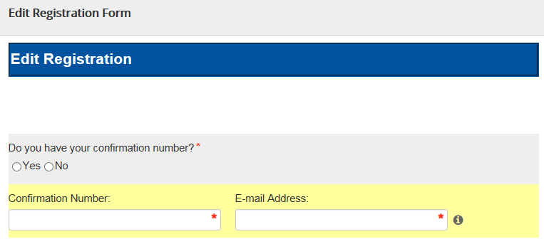

Verify the Cancel Registration Form opens when clicking the **Unregister** link

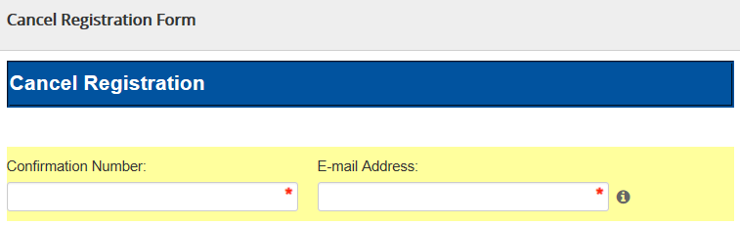

**PEPP**

Click on Presentations and Workshops

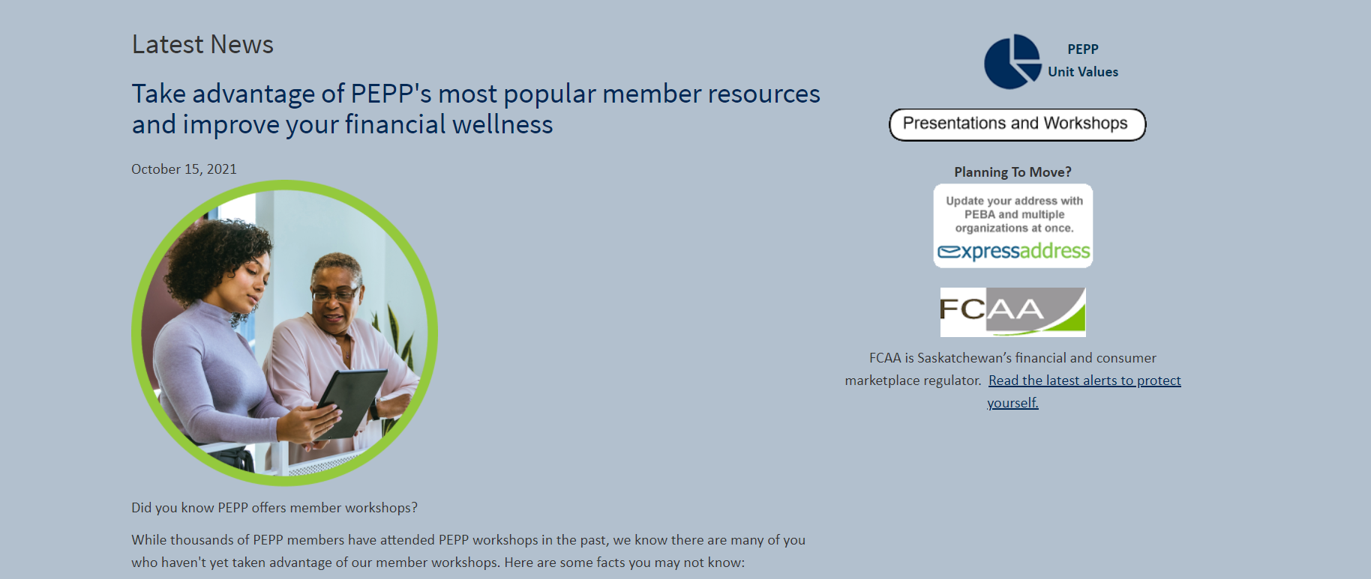

Click - I want to attend a virtual webinar & presentation

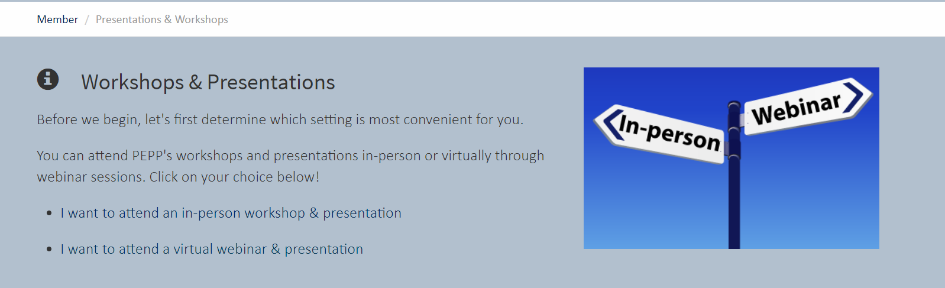

Choose a Webinar to test-Learn will be used here as an example

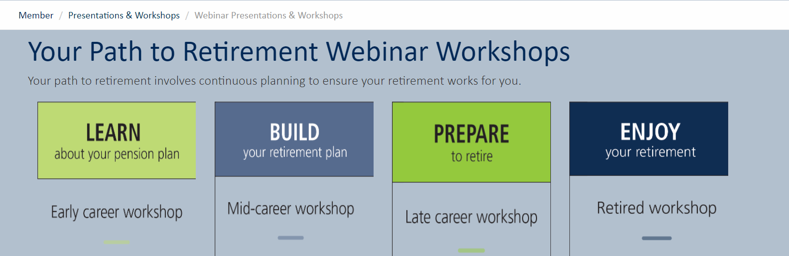

Test each Event Registration Option

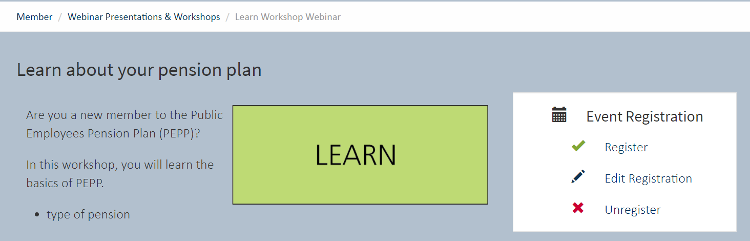

Register will be used as an example-Click on Day in Calendar View

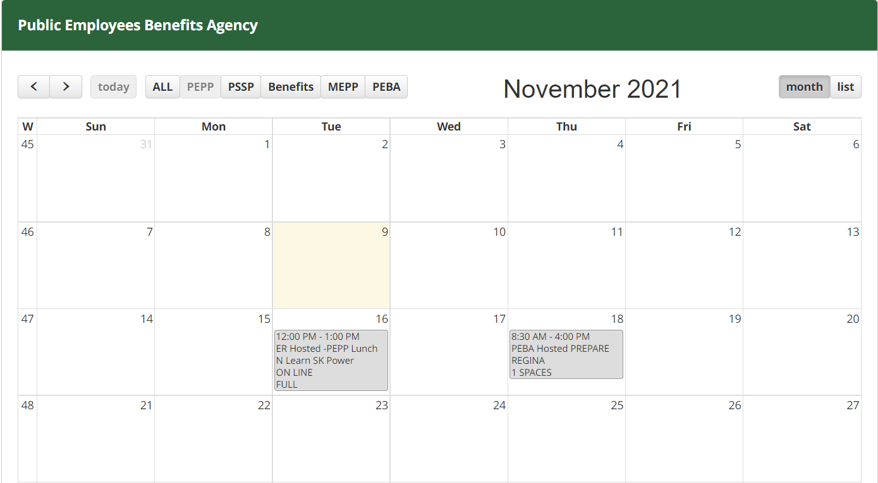

After verifying click Back to Calendar View and test the other two options- Edit and Cancel My Registration

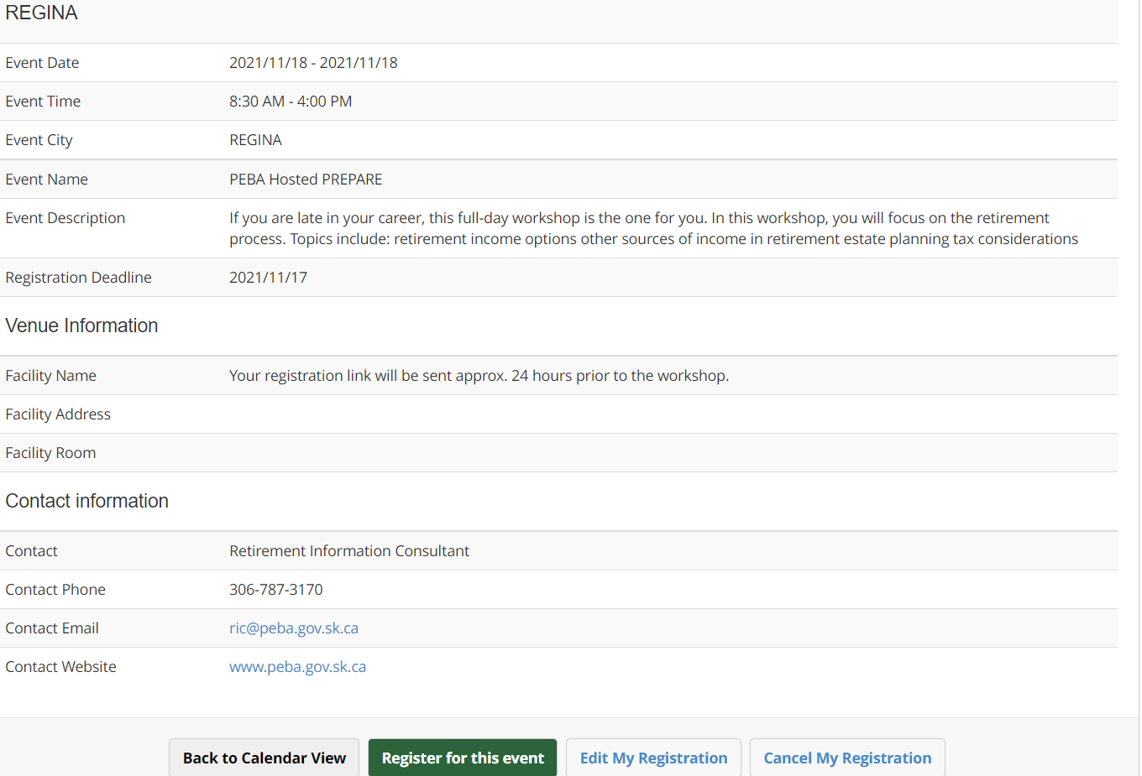

**MEPP**

On the MEPP main page click Presentations and Workshops



Click - I want to attend a virtual webinar & presentation



Choose a Webinar to test-Learn will be used here as an example



Test each Event Registration Option

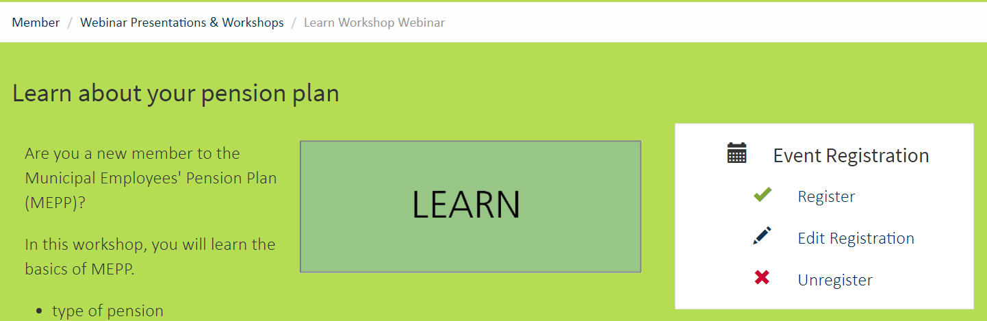

Follow same testing as seen in the PEPP section, starting at Step 12

**PSSP**

On the PSSP main page click “Your Path to Retirement…Series”

This will lead you back to PEPP



Go to PEBANET (<http://pebanet.peba.gov.sk.ca/home.html>) and locate the ***Agency Websites*** area



Click on all the available *Agency Websites*links to verify the Event Planner links work

**PEBA**

Click the PEBA hosted retirement planning workshops picture



Verify the Register, Edit Registration and Unregister links



Verify the Calendar page opens when clicking the **Register** link and you can select any of the workshops



If the calendar does not display and you receive the Error message below, contact IT Support; they need know the environment (Production or Test). They may have to either clear the Cache, or

re-index and send Groveware the Event Planner logs for their review.



**Note:** Even when the application needs to be indexed, the Edit and Cancel Registration links will still work so there is no need to click these

Verify the Edit Registration Form opens when clicking the **Edit Registration** link



Verify the Cancel Registration Form opens when clicking the **Unregister** link



**PEPP**

Click on Presentations and Workshops



Click - I want to attend a virtual webinar & presentation



Choose a Webinar to test-Learn will be used here as an example



Test each Event Registration Option



Register will be used as an example-Click on Day in Calendar View





After verifying click Back to Calendar View and test the other two options- Edit and Cancel My Registration

**MEPP**

On the MEPP main page click Presentations and Workshops



Click - I want to attend a virtual webinar & presentation



Choose a Webinar to test-Learn will be used here as an example



Test each Event Registration Option



Follow same testing as seen in the PEPP section, starting at Step 12

**PSSP**

On the PSSP main page click “Your Path to Retirement…Series”

This will lead you back to PEPP



**Express Address How To:**

|  |  |
| --- | --- |
| **Procedure Number:** |  |
| **Procedure Name:** |  |
| **Purpose of the Procedure:** | Express Address Procedure |
| **Original Date:** |  |
| **Revised Date:** |  |

|  | **Name/Title** | **Signature** | **Date** |
| --- | --- | --- | --- |
| **Reviewed by** | <Person who reviews the work> |  | <dd/mm/yyyy> |
|  |  |  |  |
|  |  |  |  |
| **Approved by** | <Senior Management / Business Area Manager> |  | <dd/mm/yyyy> |

**Overview:**

**Express Address Procedure:**

1. Open Internet Explorer and go to the Express Address website; [**www.expressaddress.com**](http://www.expressaddress.com)

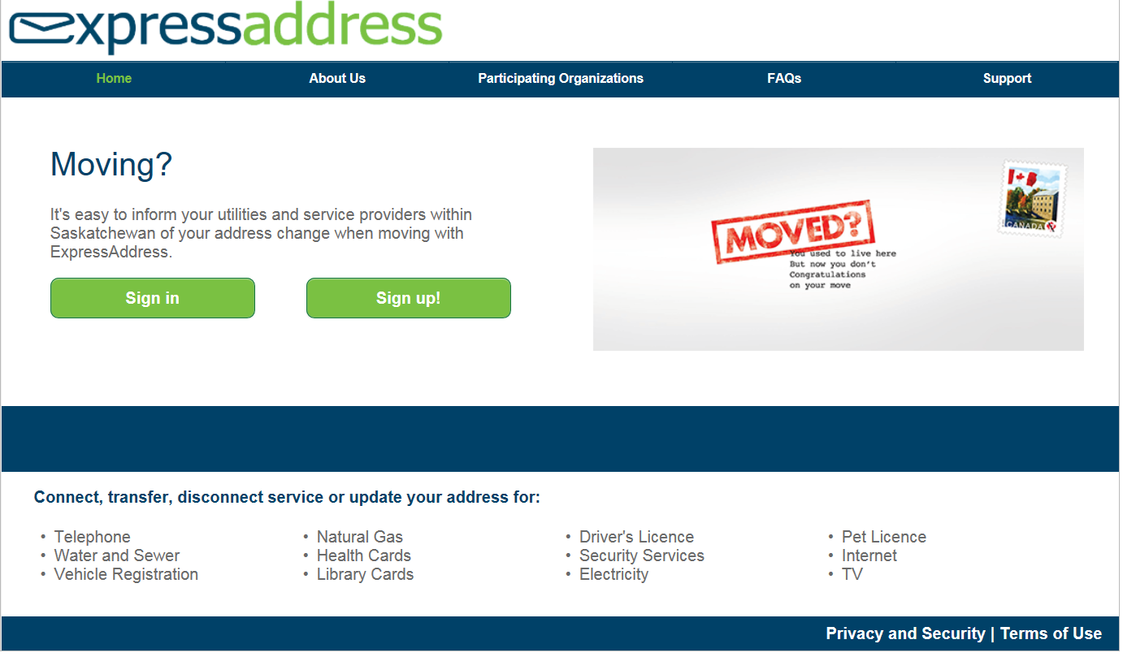

1. Log into the site by entering the user details and hit the “Log In” button
   * Username: enter your user ID
   * Password: enter your password

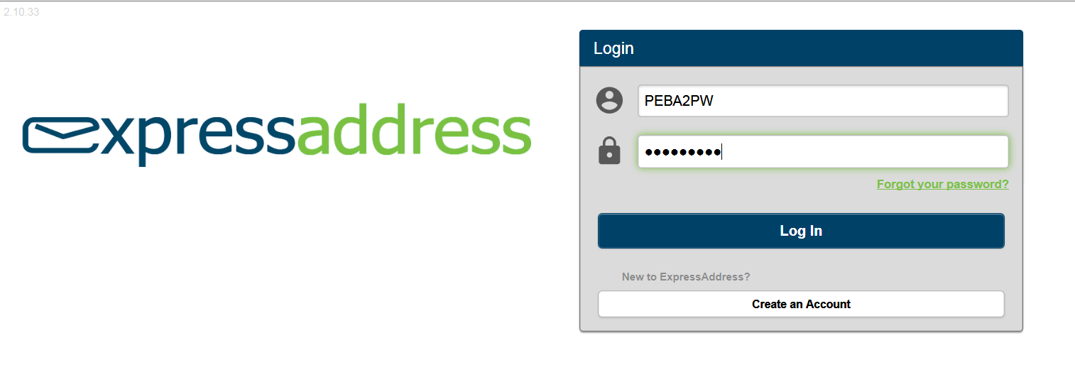

1. Once logged in, the following screen will display and a token email will be sent to your PEBA email address.

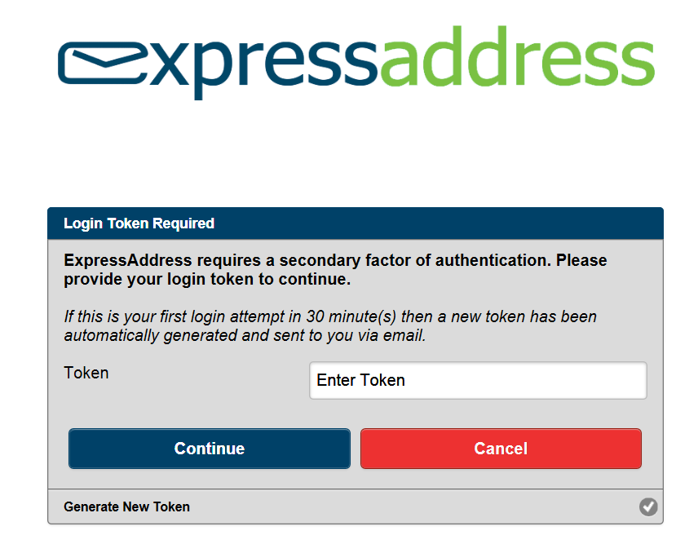

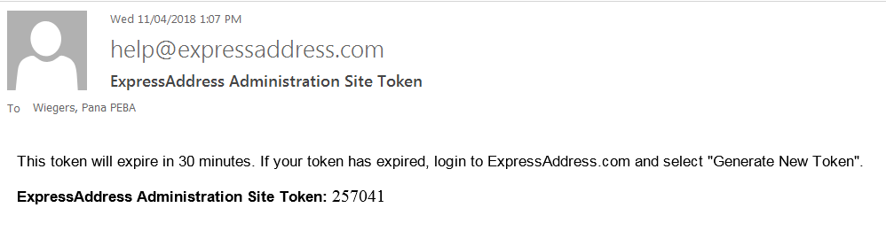

1. Enter the Token number in the Login Token Required screen

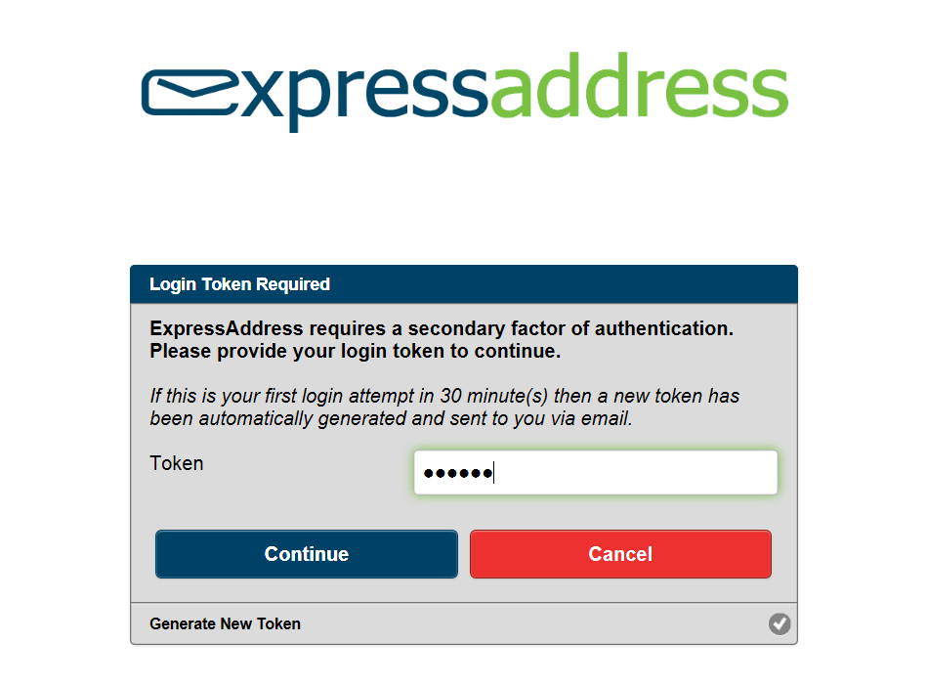

1. Click on the “Continue” button

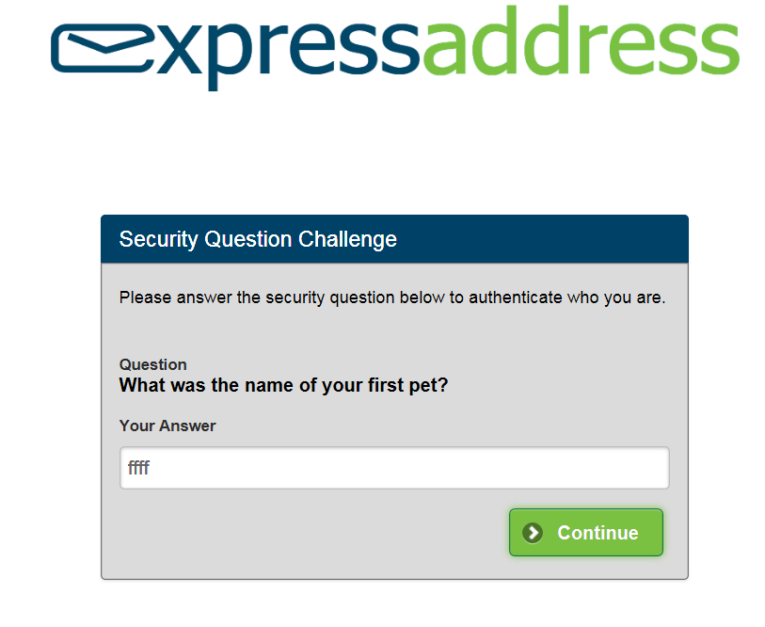

1. Enter your security answer and click “**Continue**”.

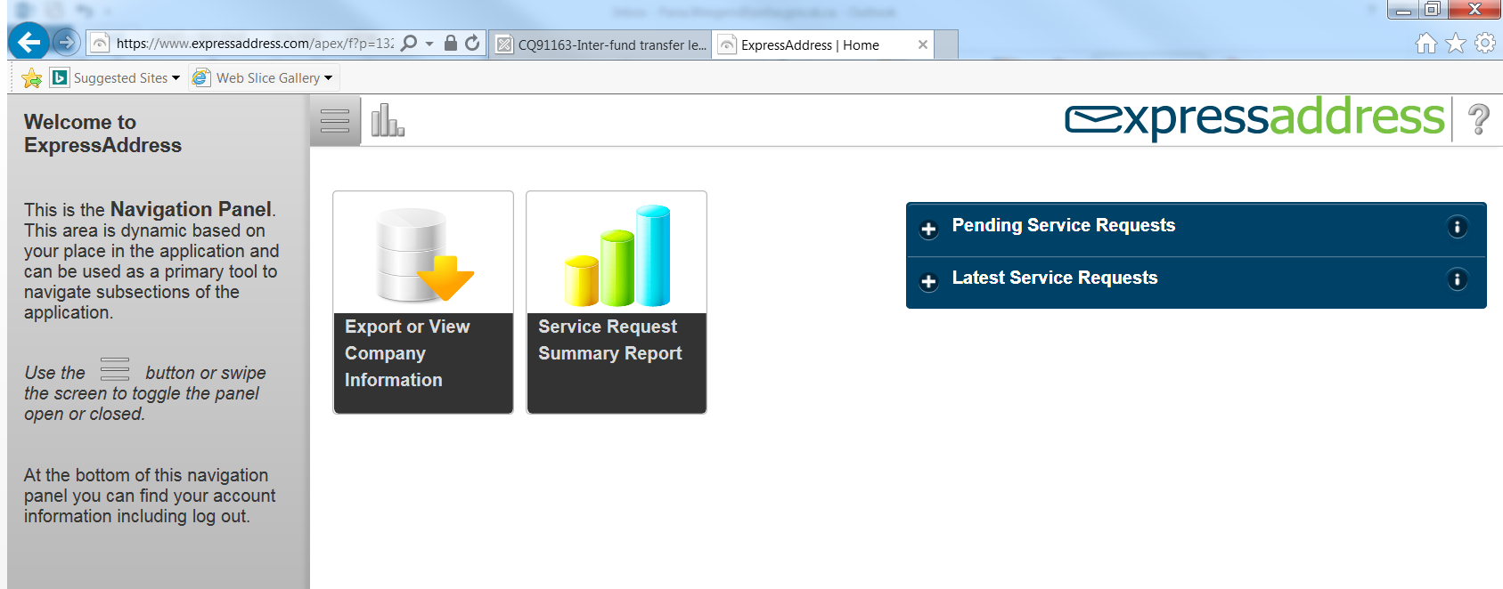

1. Click on “**Export or View Company Information**”

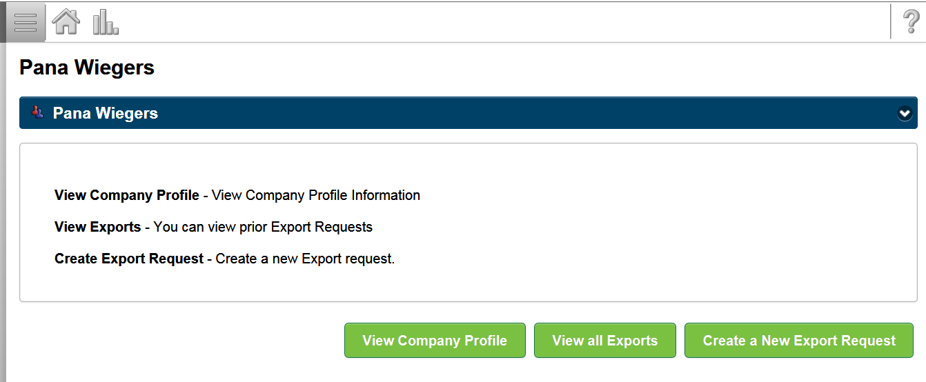

1. Click on “Create a New Export Request”

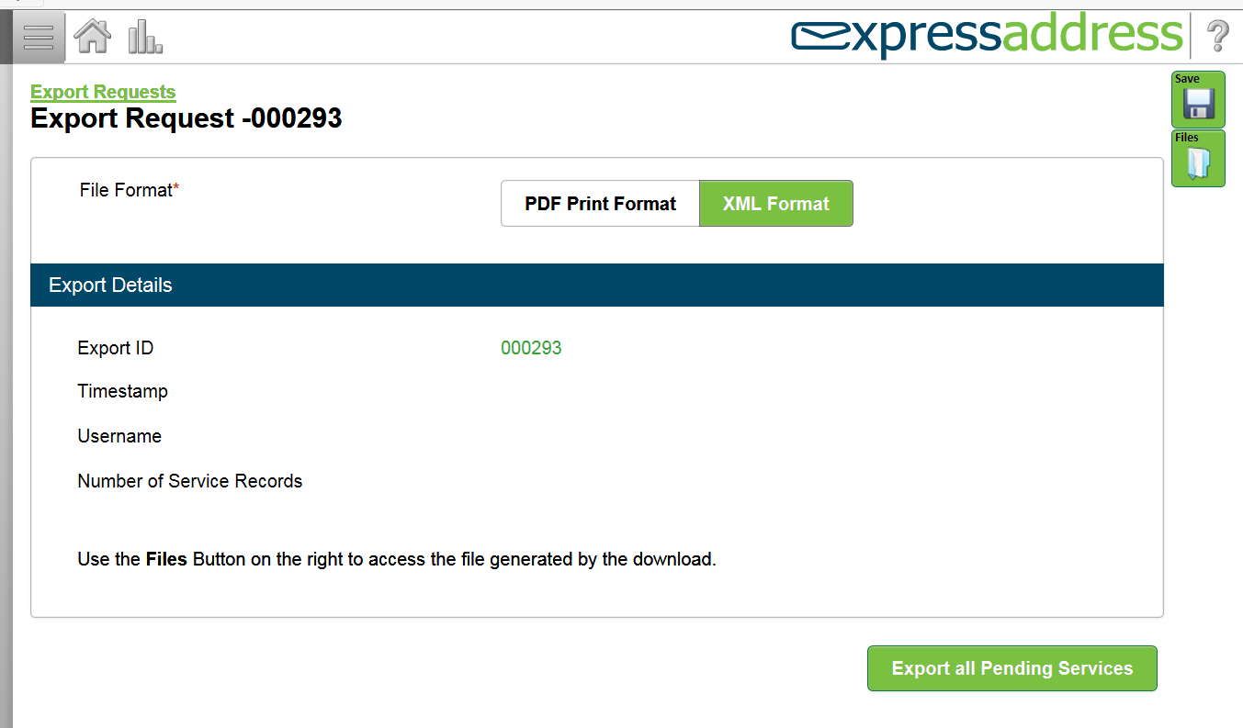

1. On this page the system will default to “XML Format” tab. It is important that you change the file format from XML format to PDF Print Format. To do so, click on the “**PDF Print Format**” tab.

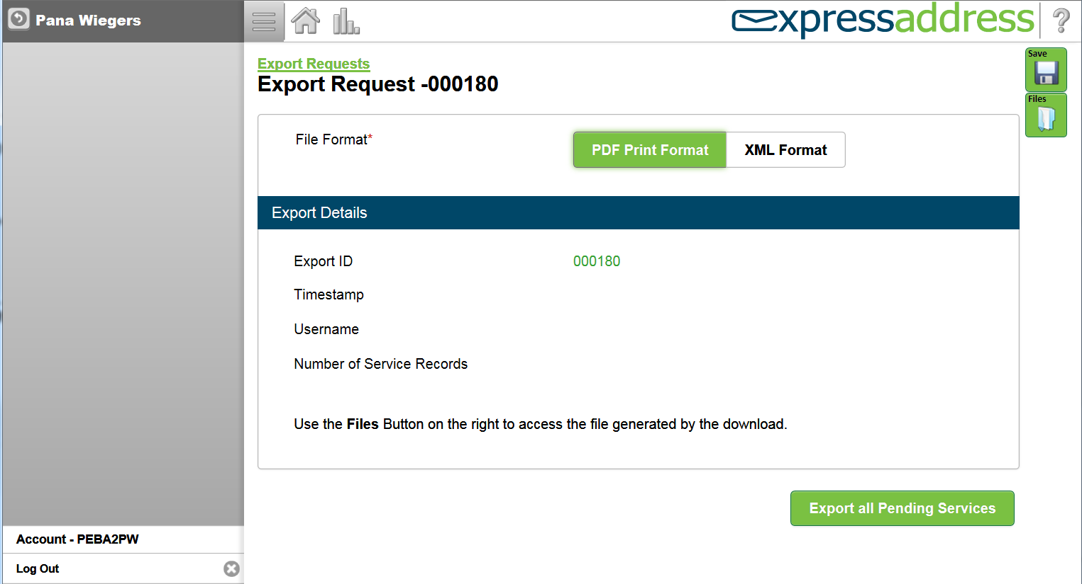

1. When the “PDF Print Format” tab is green, this means that you have selected the PDF format.
   * Click on the “Export all Pending Services” tab

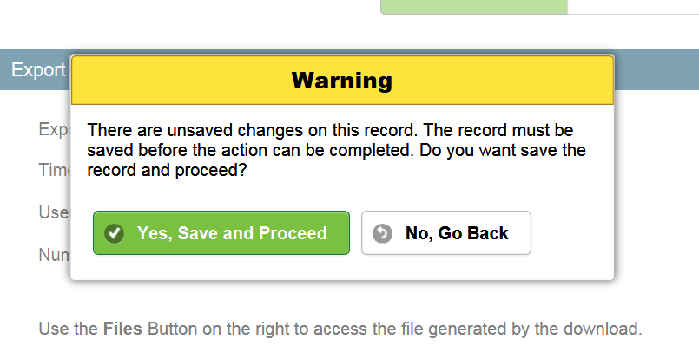

1. The warning screen will appear, click on “**Yes, Save and Proceed**” button.

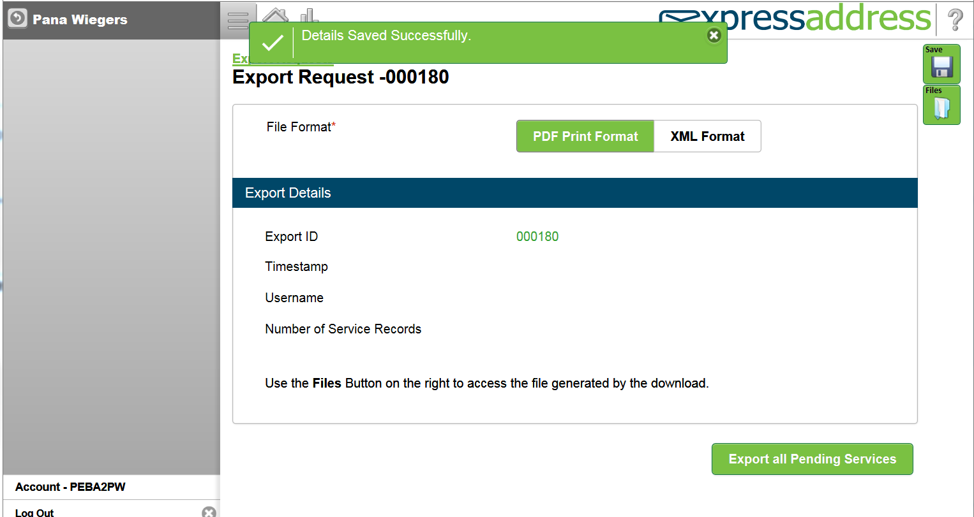

1. A popup message will appear. Indicating that details file has been save successfully. Click on the “X” button to close the message.

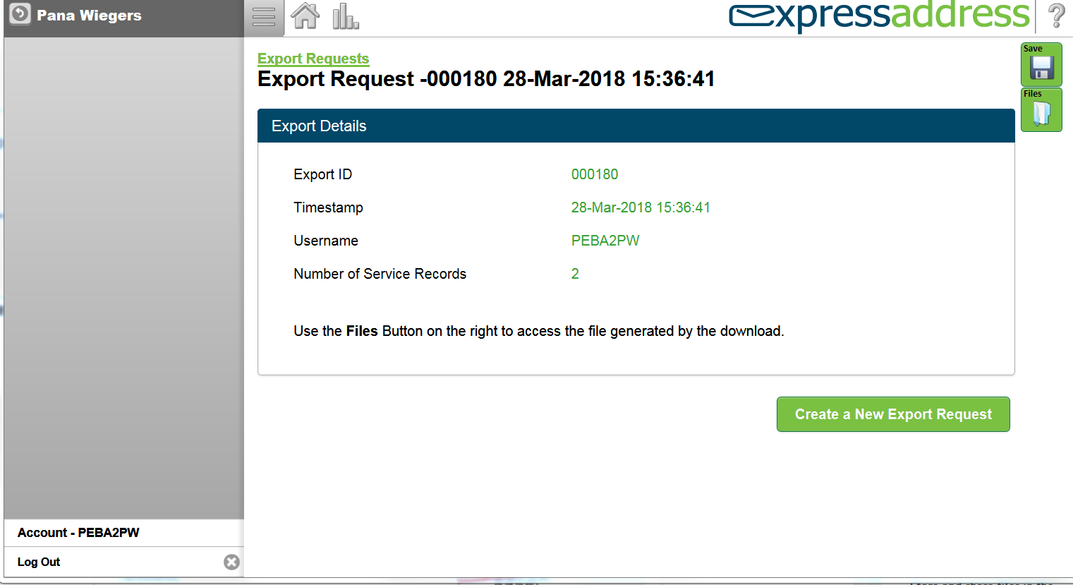

1. Click on the file folder to open the exported file.

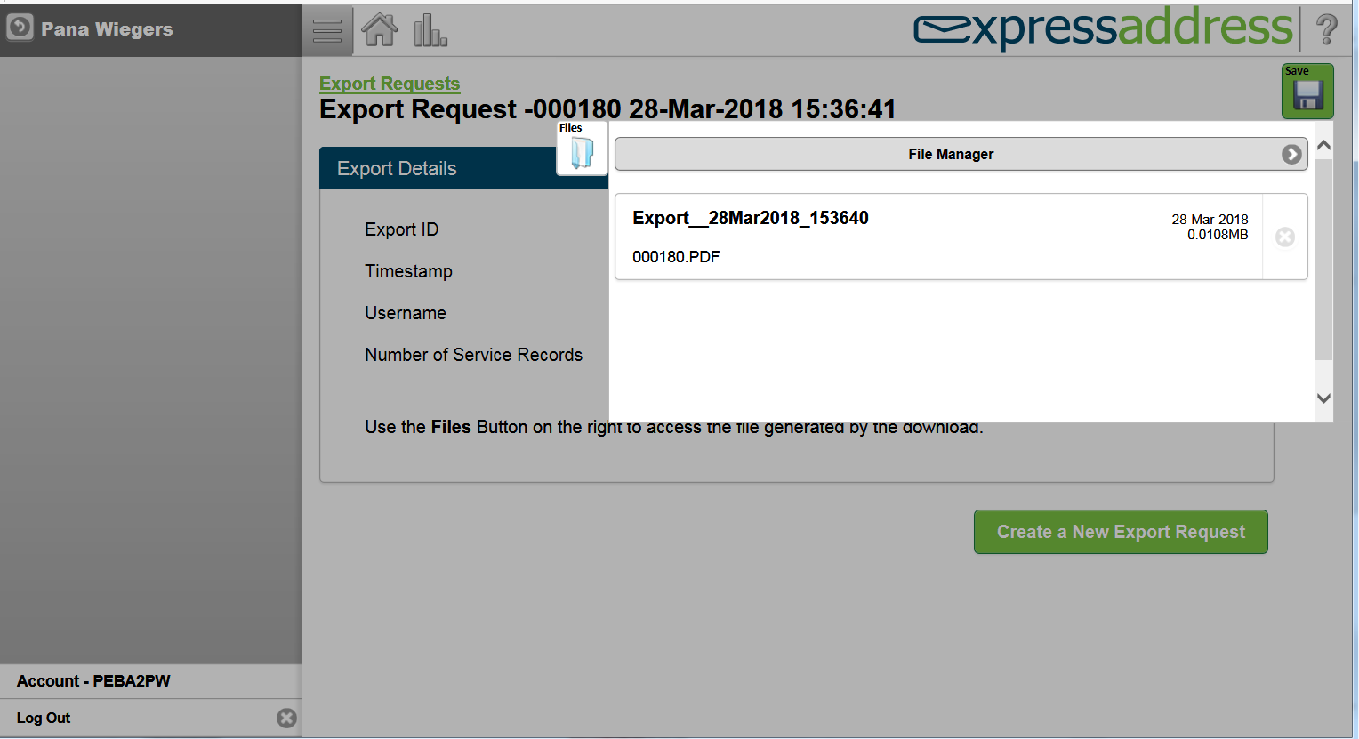

1. A file window will open for you to select the exported file. Click on the exported file.

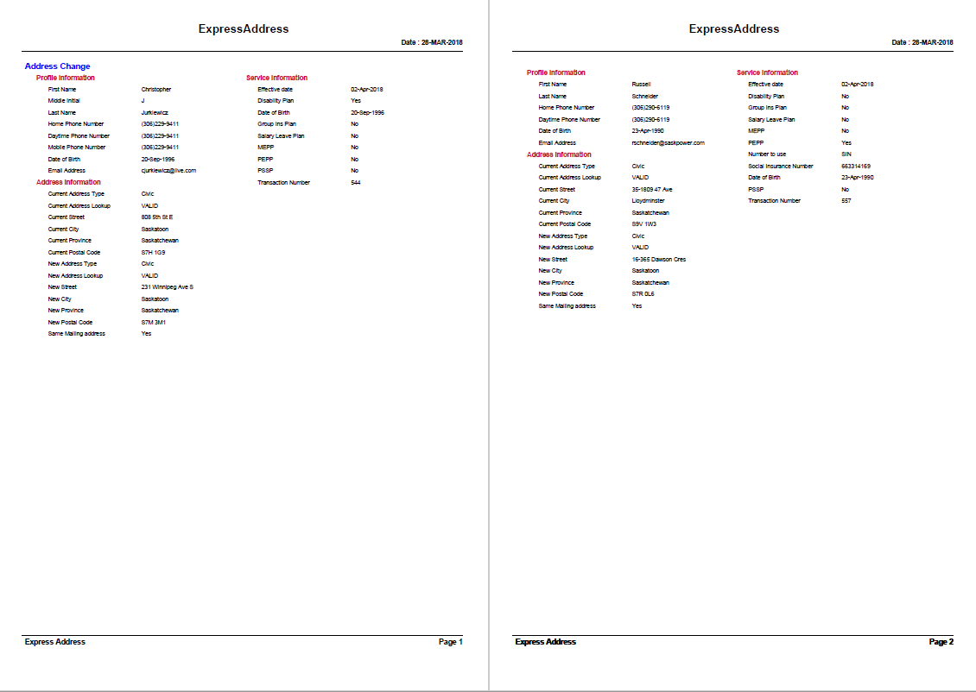

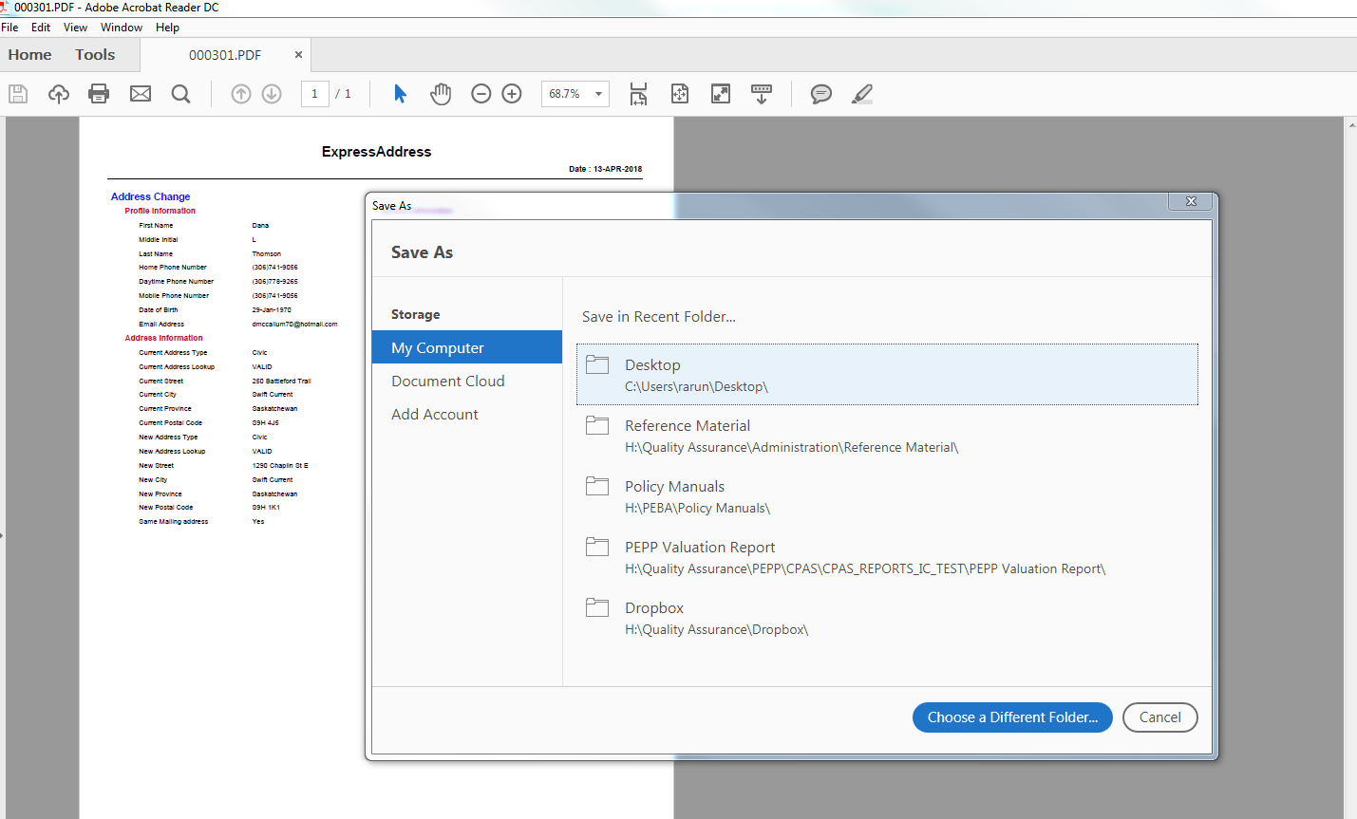

1. Click on File – Save As
2. Save file to H:\PEBA\Express Address\ExpressAddress YYYYMMDD
3. Log out of express address

Sometimes exported files are not being viewed. At that time, do the following:

1. You will get the screen like:

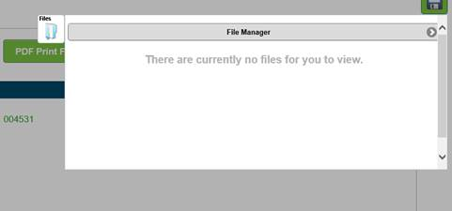

1. Go back to Home and click on ‘Export or View Company Information’

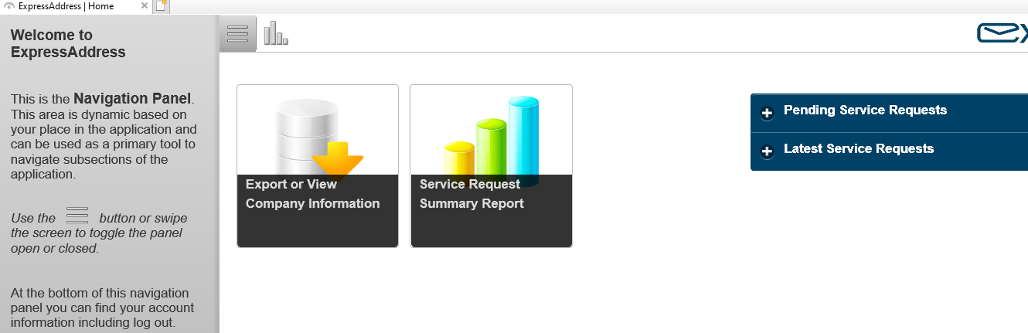

1. Click on ‘View all Exports’

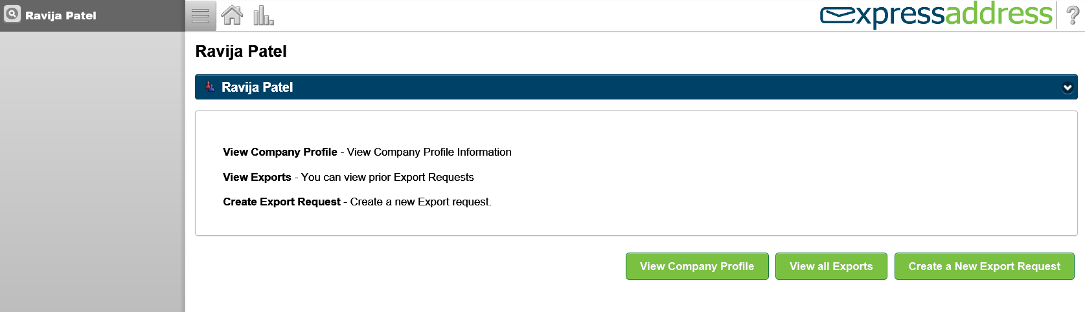

1. Click on ‘Back’ button

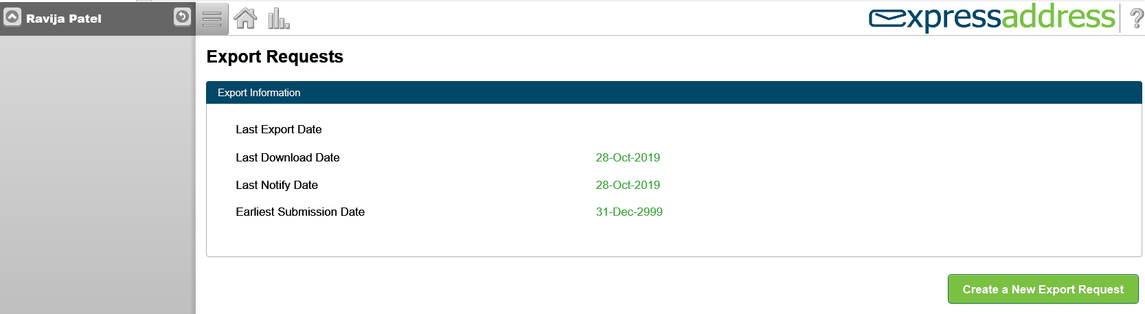

1. Click on ‘Export Requests’ so that all the exported files will be shown on the menu.

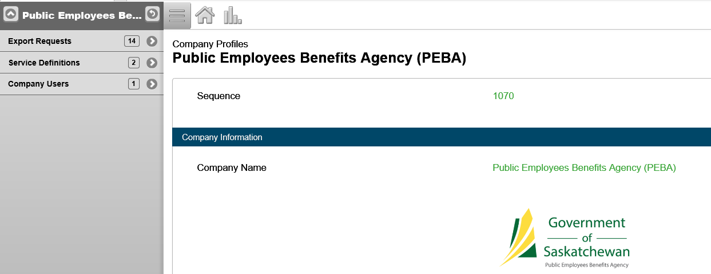

1. Now, click on the Export Request for whatever date you want:

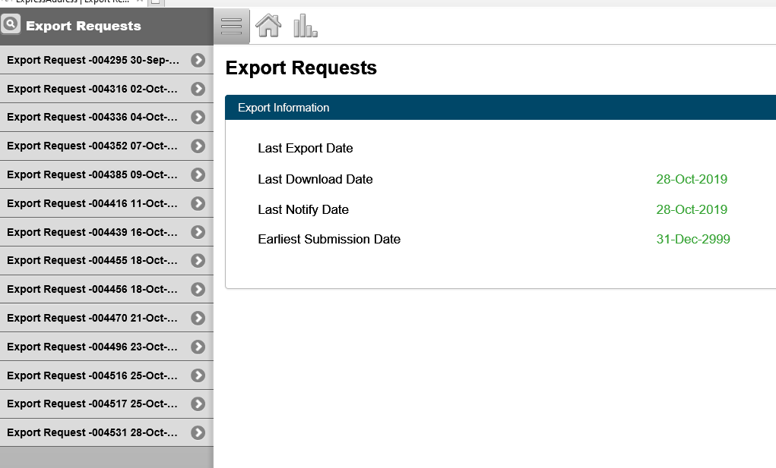

Sometimes, you might face the following situation.

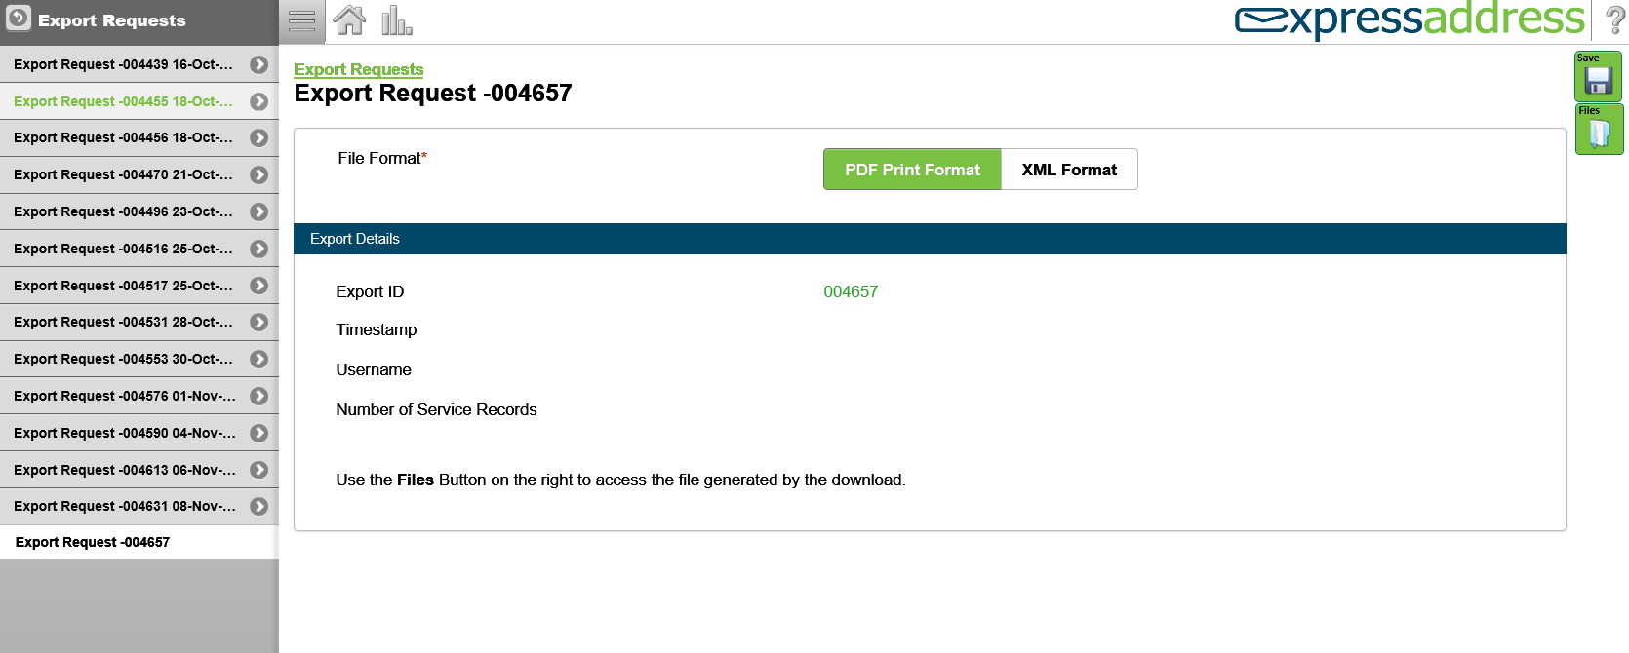

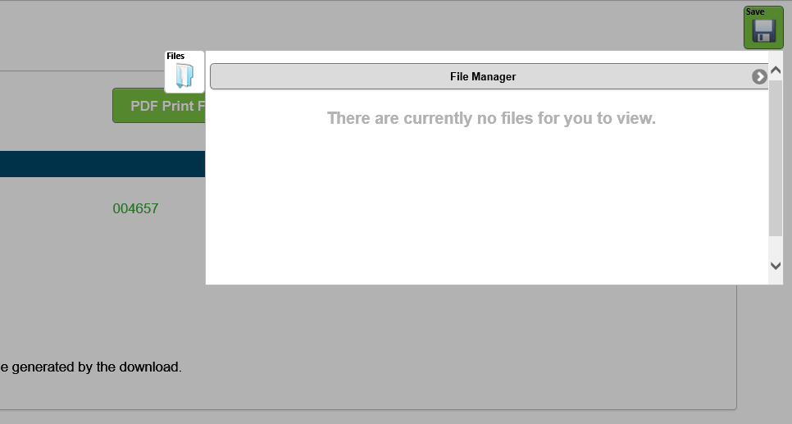

Follow steps 19 to 22.

It will show you the export details for the date you selected.

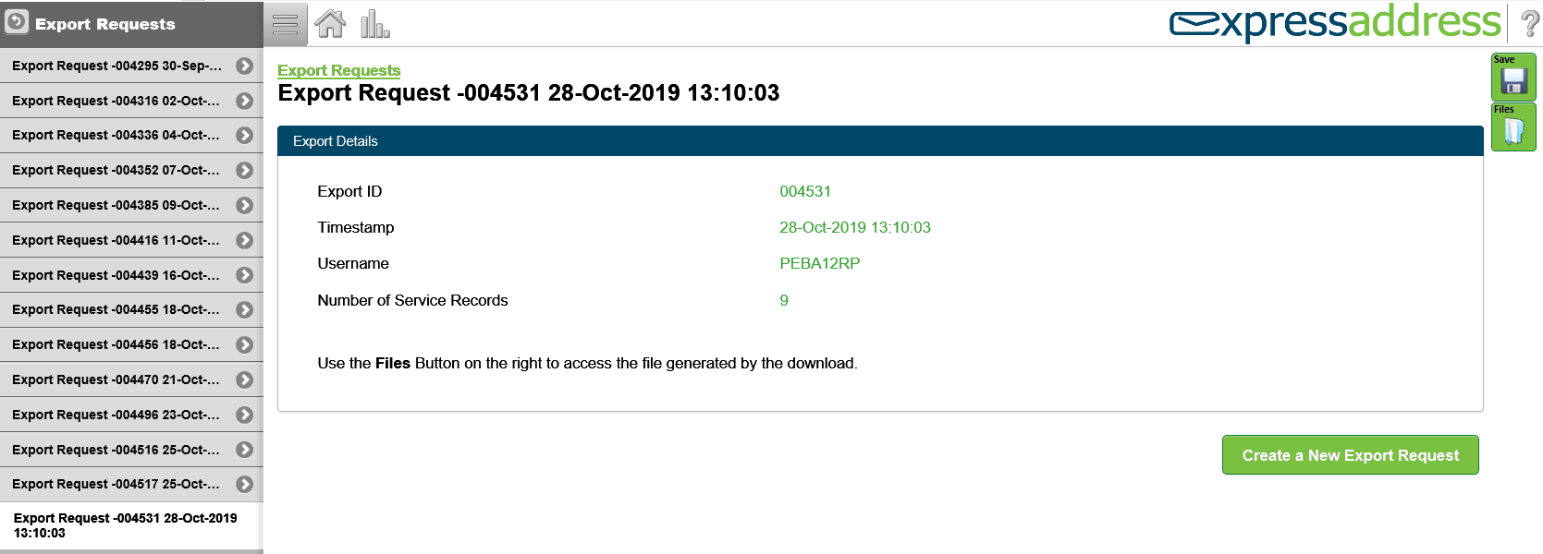

Then, follow steps 12 to 17.

**How to Calculate Claim Amount on Payment Screen:**

|  |  |
| --- | --- |
| **Procedure Number:** |  |
| **Procedure Name:** |  |
| **Purpose of the Procedure:** | Claim amount calculation on payment screen |
| **Original Date:** |  |
| **Revised Date:** |  |

|  | **Name/Title** | **Signature** | **Date** |
| --- | --- | --- | --- |
| **Reviewed by** | <Person who reviews the work> |  | <dd/mm/yyyy> |
|  |  |  |  |
|  |  |  |  |
| **Approved by** | <Senior Management / Business Area Manager> |  | <dd/mm/yyyy> |

**Overview**

**Section 1. Federal, Yukon**

**Basic type of tax instruction**

Formula: claim amount = BPA + claim code exemptions

**Section 1.a BPA**

For **BPAF/BPAYT calculation** refer below calculation formula(this can change each year, so look out for updates from CRA/Finance/JEA)

2020

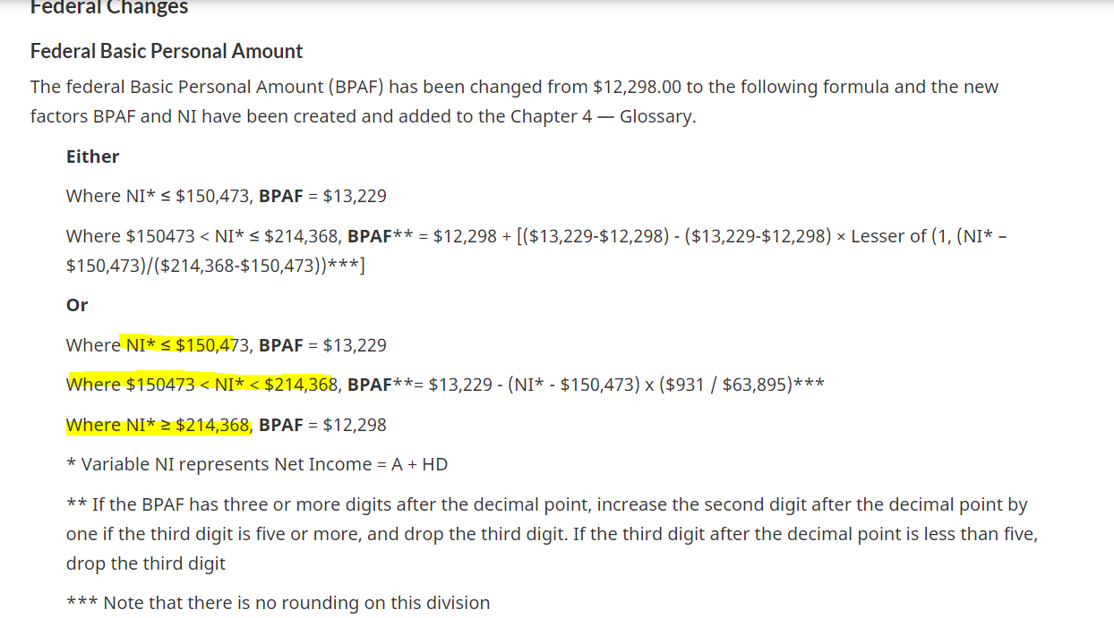

2021

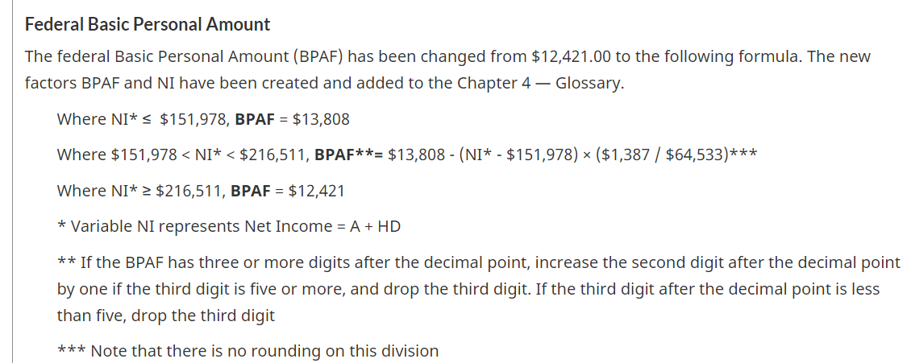

2020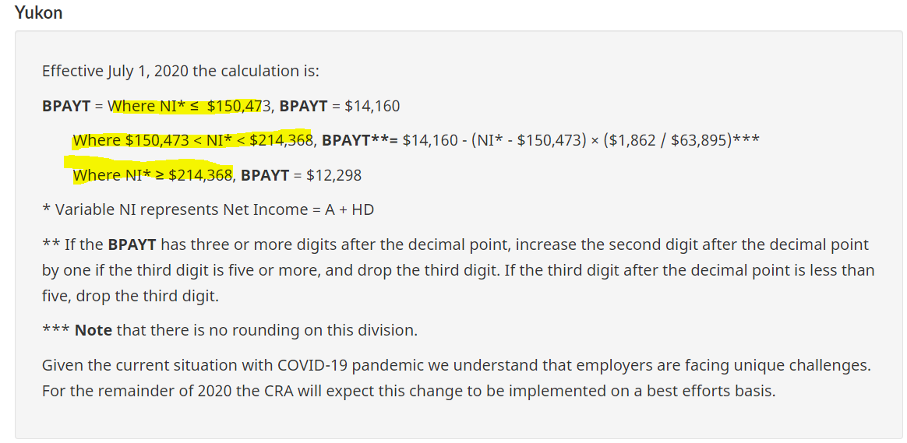

2021

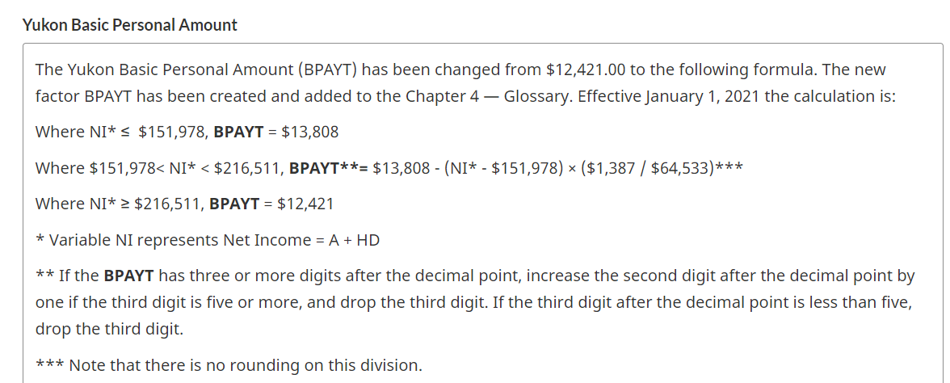

**Section 1.b claim code exemptions**

For **Claim code exemption** calculation refer below tax parameter table and look for “Claim code chart income range”

Federal

Claim code 1= $0

Claim code 2= claim range/2

Claim code 3= claim range

Claim code 4= claim range and so on until claim code 10 is reached

2020

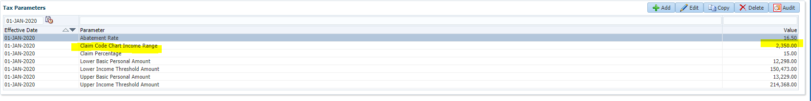

2021

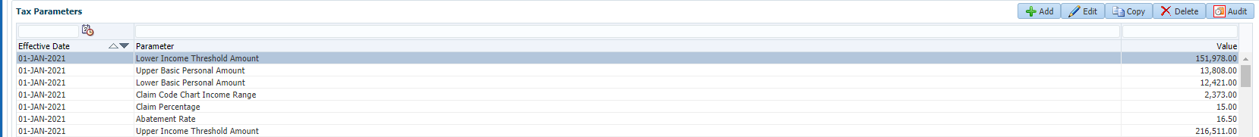

Yukon

Claim code 1= BPA

Claim code 2= claim range /2

Claim code 3= claim range

Claim code 4= claim range and so on until claim code 10 is reached

2020

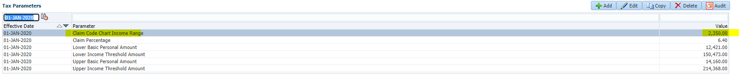

2021

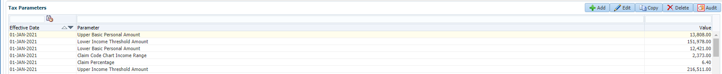

Tax calculation for tax year 2020 Example

**Basic tax instruction**

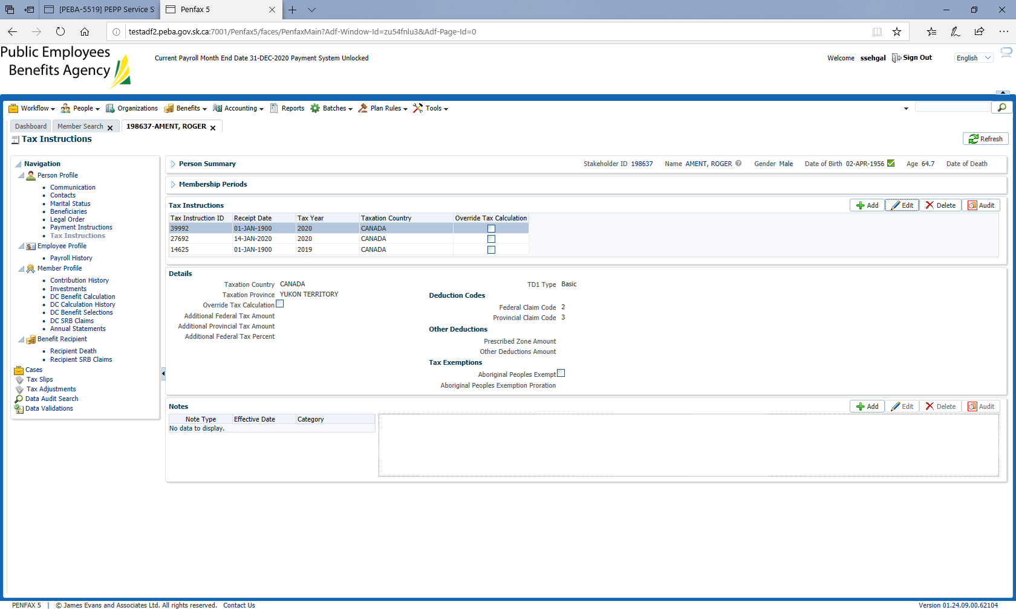

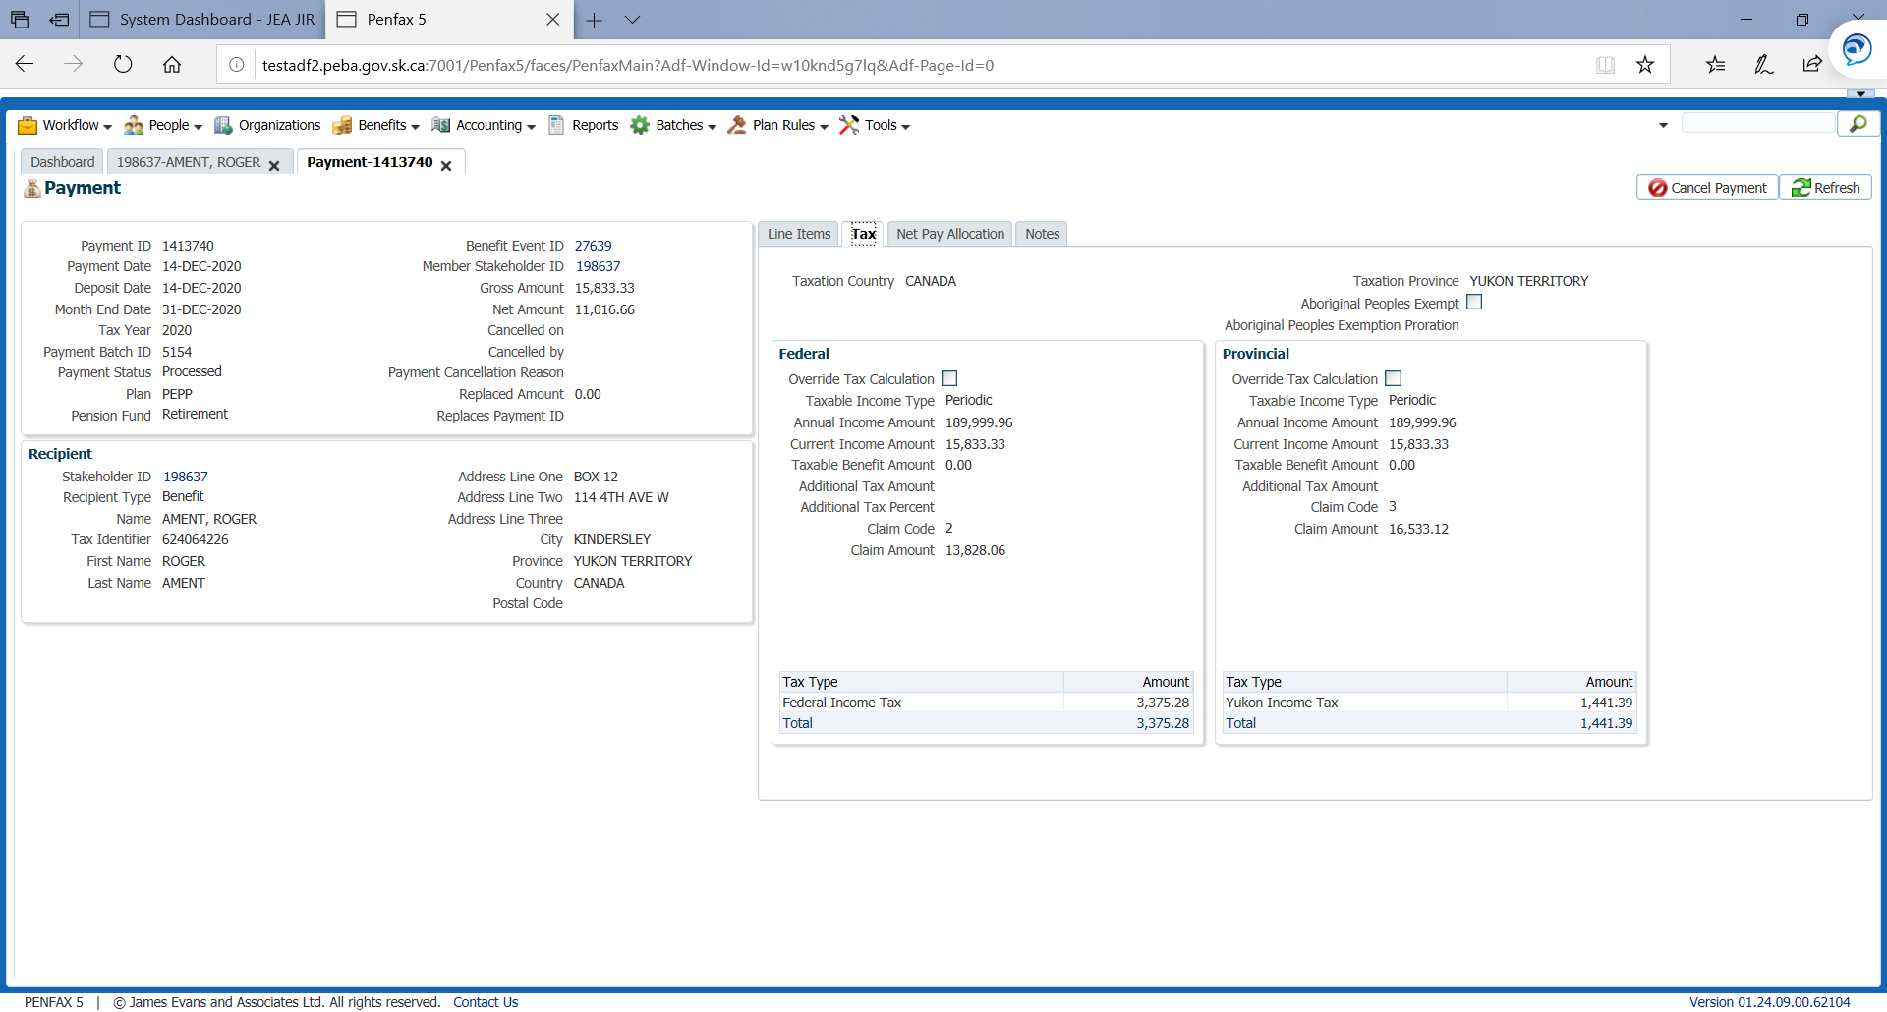

Since the NI (net income or annual income) is $189999.96 in the above example the BPAF calculation will lie within this bracket (refer section 1.a)

$150473 < NI* < $214,368, **BPAF**\*\*= $13,229 - (NI* - $150,473) x ($931 / $63,895) ***

BPAF= $13229-( $189999.96-$150473) *($931/$63895) = $12653.06

BFAYT will lie within

$150,473 < NI* < $214,368, **BPAYT**=**$14,160 - (NI* - $150,473) × ($1,862 / $63,895) ***

BPAYT= $14160-( $189999.96-$150473) *($1862/$63895) = $13,008.12

Claim code exemptions (refer section1.b above)

For federal code 2 = (claim percentage/2) = $2350/2 = $1175

For Yukon code 3= (claim percentage/2) + claim percentage= $2350/2 + $2350= $3525

Hence,

Claim amount federal= BPAF+ claim code exemptions= $ 12653.06+ $1175= $13,828.06

Claim amount Yukon= BPAYT + claim code exemptions = $ 13,008.12+ $3525= $16,533.12

**Advance type of tax instruction**

Formula: claim amount= BPA + other claim exemptions

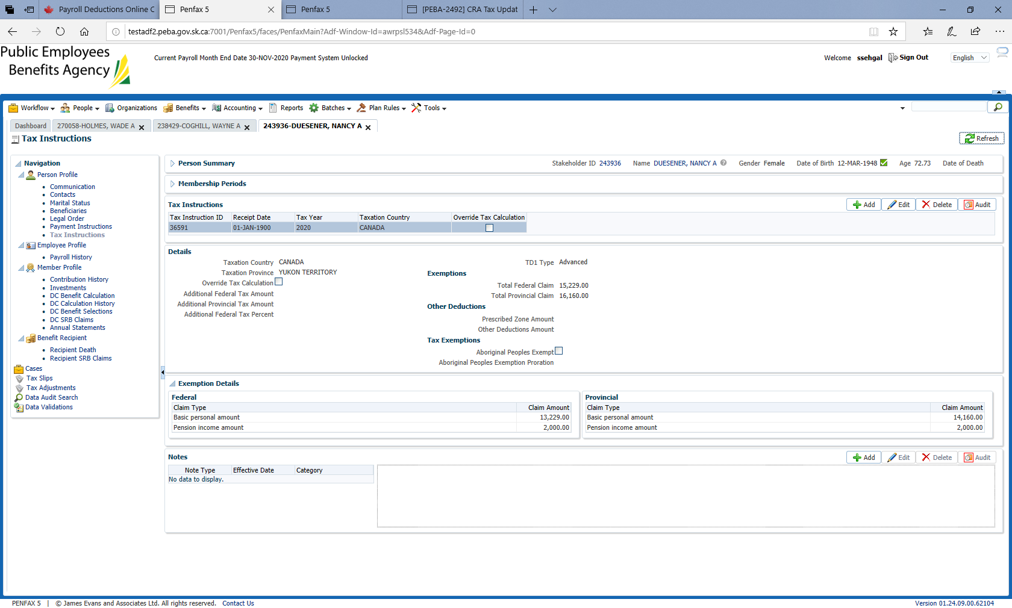

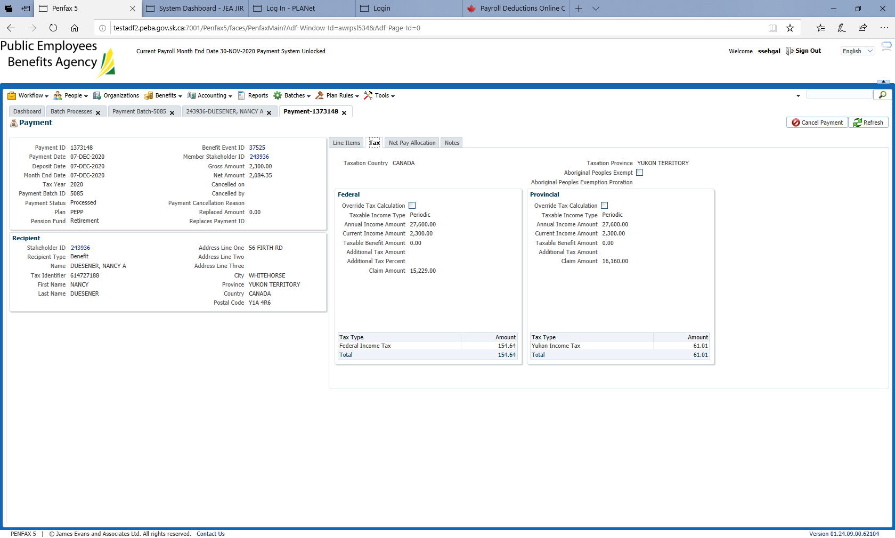

For federal since annual income/NI is < $ 151473 BPAF= $13229 (refer section 1.a)

For Yukon since annual income/NI is < $ 151473 BPAYT= $14160 (refer section 1.b)

BPAF= $13229

BPAYT= $14160

Federal claim amount= BPAF+ other claim exemptions= $ 13229+ $2000= $15229

Yukon claim amount= BPAF+ other claim exemptions= $ 14160+ $2000= $16160

**Section 2. Nova scotia**

**Basic type of tax instruction**

Formula: claim amount= BPA + claim code exemptions

2020

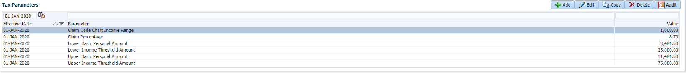

2021

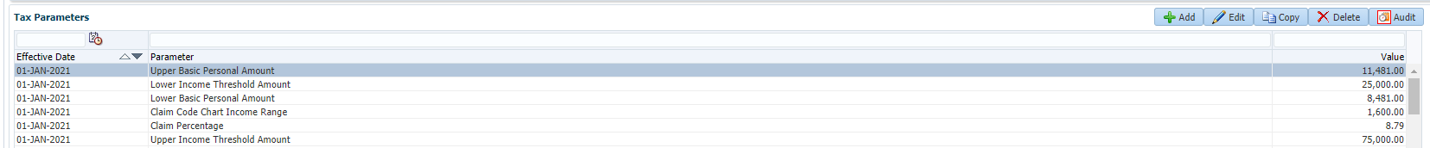

2020

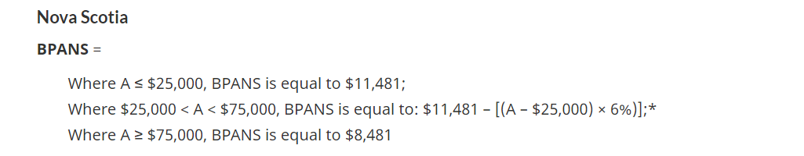2021

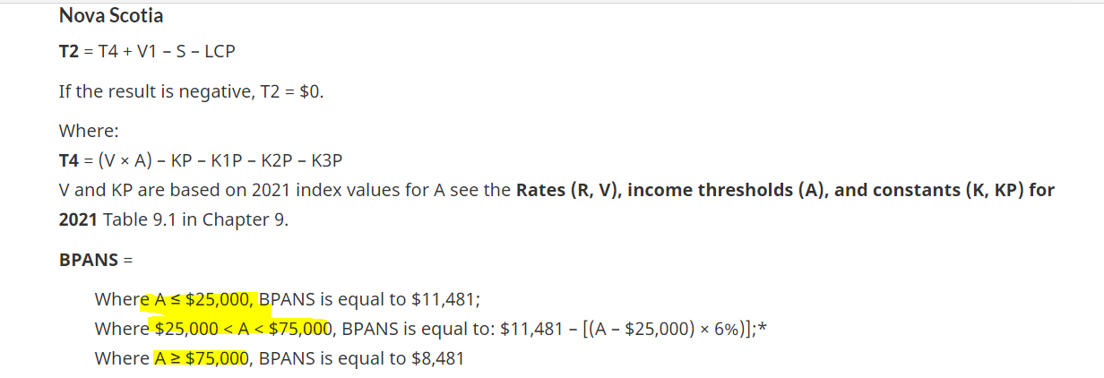

**Basic tax instruction tax year 2020 example**

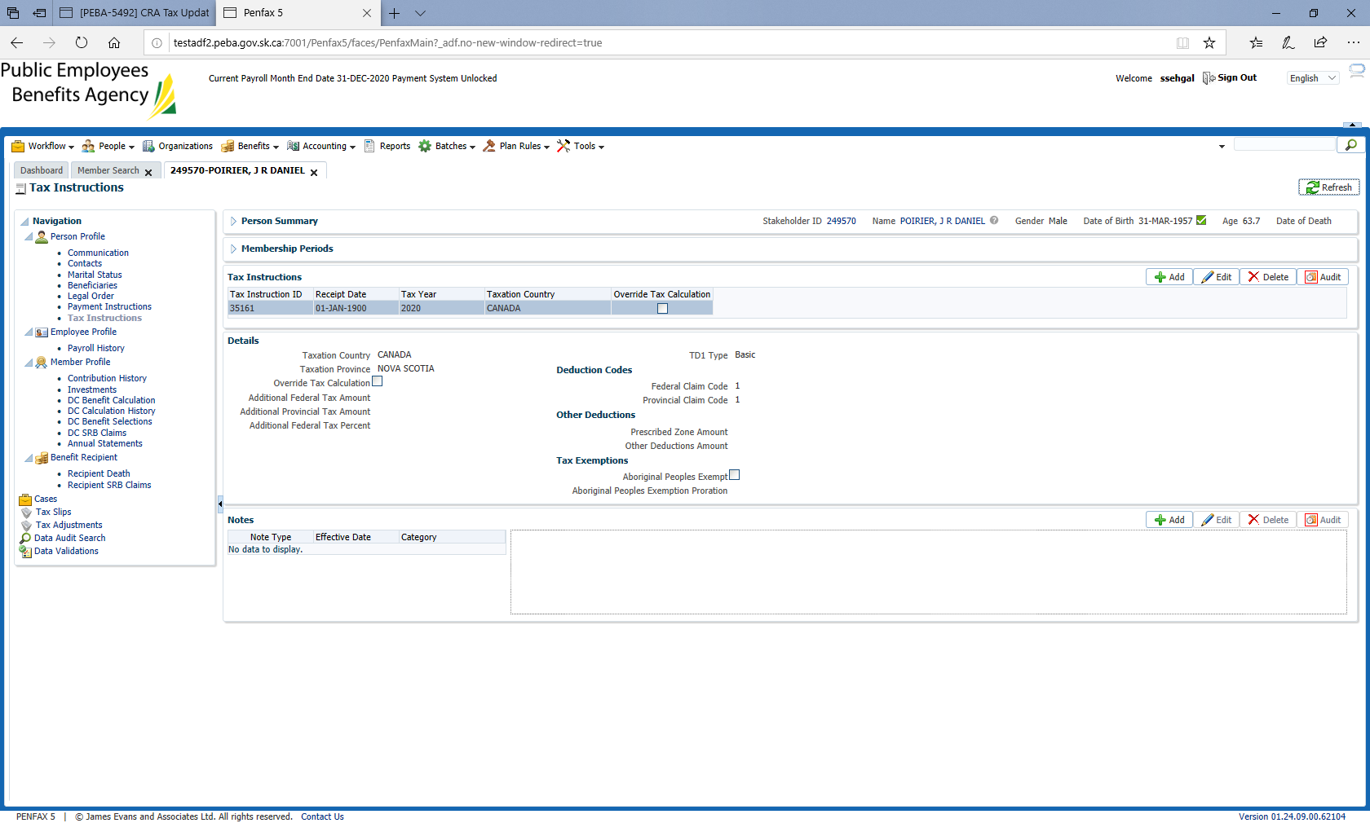

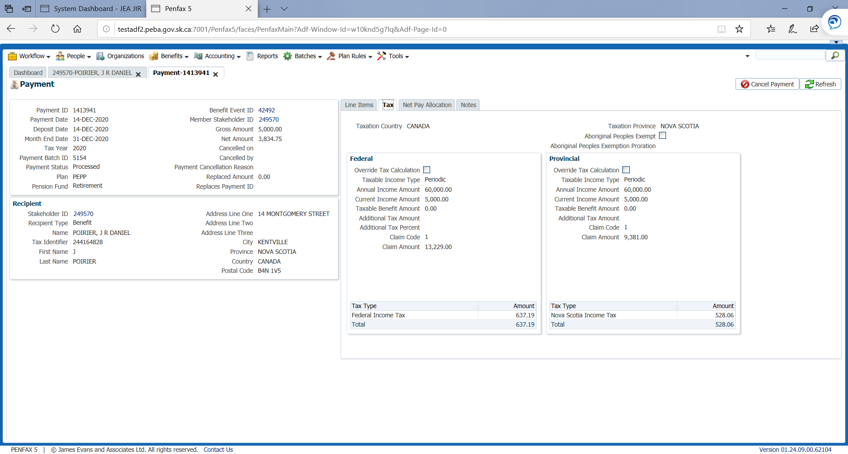

Annual income= $5000*12= $60000

BPAF = $13229(refer section 1.a)

BPANS will lie within- Where $25,000 < A < $75,000, BPANS is equal to: $11,481 – [(A – $25,000) × 6%)]; *

BPANS= $11481- (60,000-25,000) *6%= $9381

Federal claim amount= $13229+$0(claim code 1) = $13229

NS claim amount= $9381+$0(claim code 1) = $9381

**Advance type of instruction tax year 2020 example**

Formula: claim amount= BPA + other claim exemptions

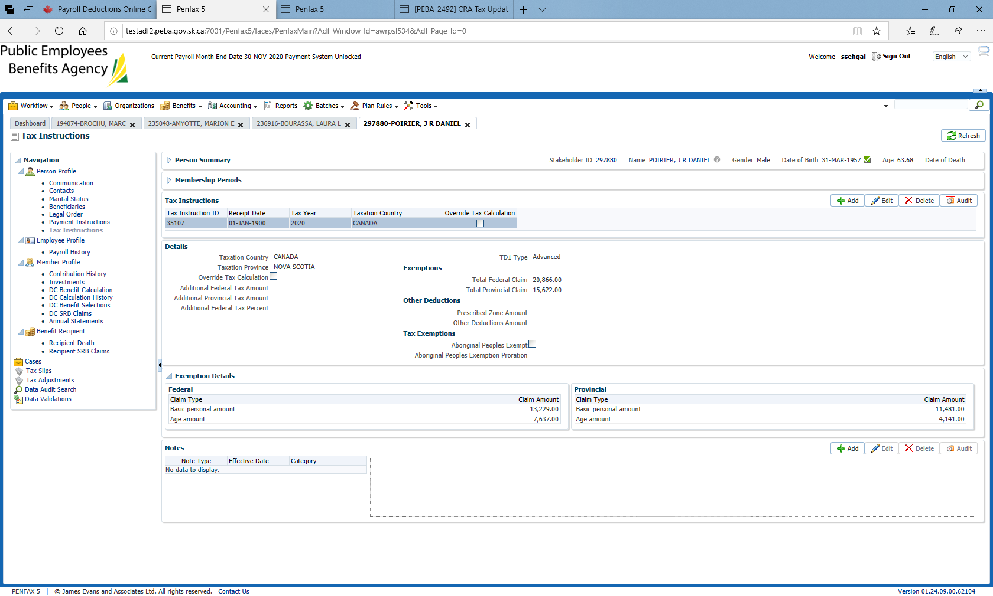

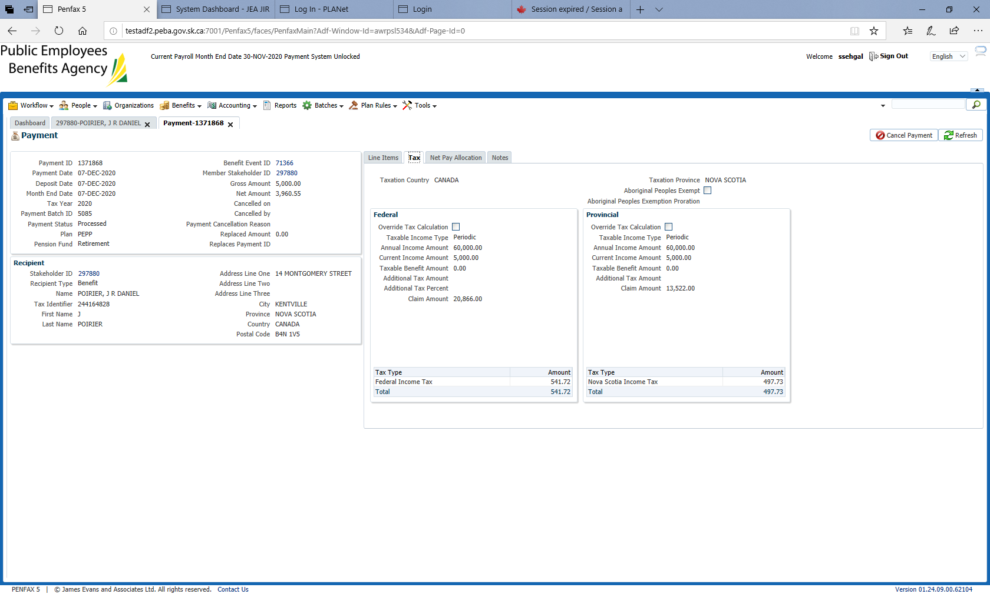

BPAF= $13229 (refer section 1.a)

BPANS will lie within Where $25,000 < A < $75,000, BPANS is equal to: $11,481 – [(A – $25,000) × 6%)]; *

BPANS= $11481- (60000-25000) * 6%= $9381

Federal claim amount= $13229(BPAF)+ other exemptions= $13229+ 7637= $20866

Nova scotia claim amount= BPANS +other exemptions= $9381 + $ 4141= $ 13,522

**Section 3. ALL Other Provinces (except Yukon and Nova scotia)**

**Basic type tax instruction**

Refer claim code amount from TD1 claim amounts table

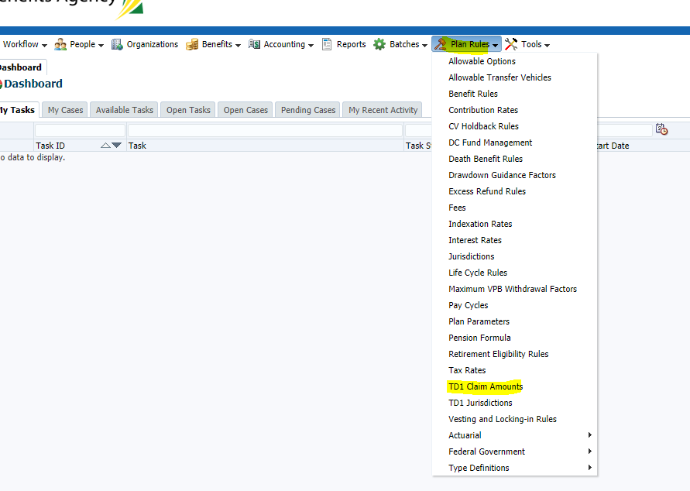

Look for TD1 claim amount corresponding to the TD1 claim code for the effective tax year

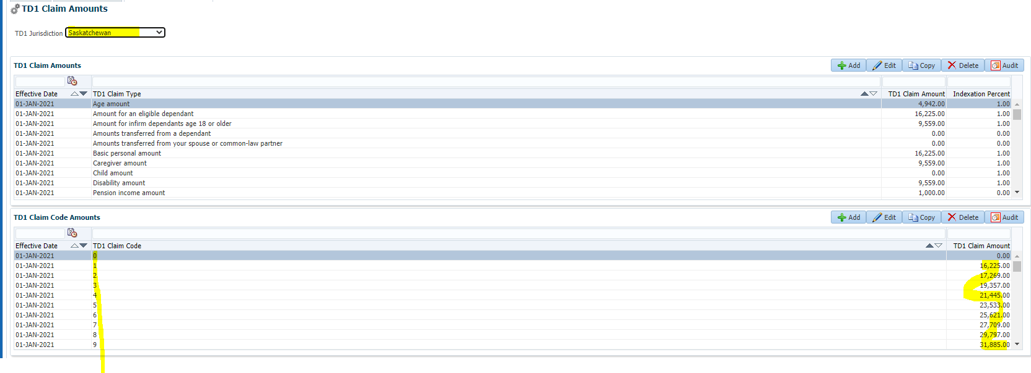

**Basic instruction tax year 2021 example**

Tax year 2021

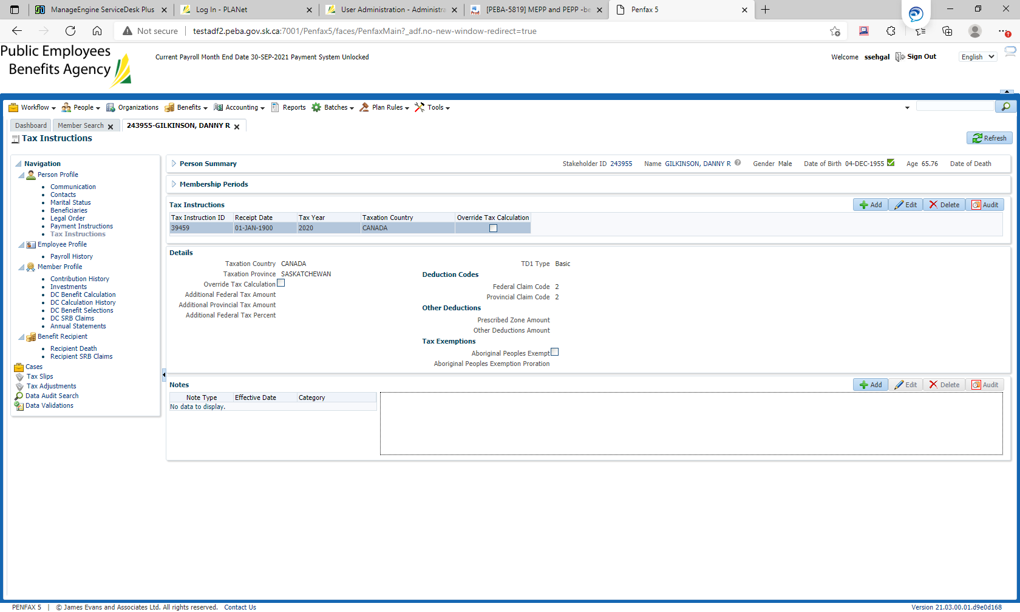

2021 payment

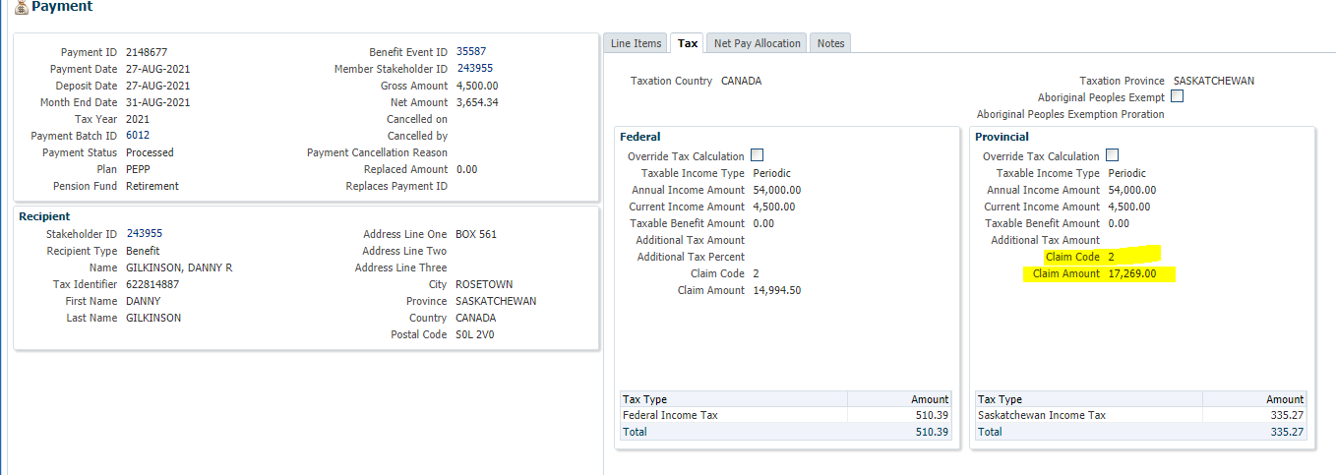

**Advance type tax instruction**

Refer to the Total Provincial claim amount on person profile>Tax instruction for the effective tax year

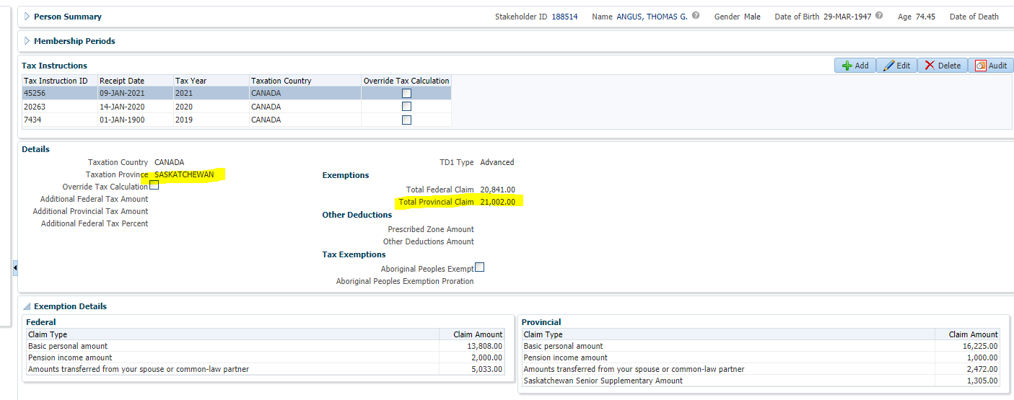

**Advance instruction tax year 2021 example**

Tax year 2021

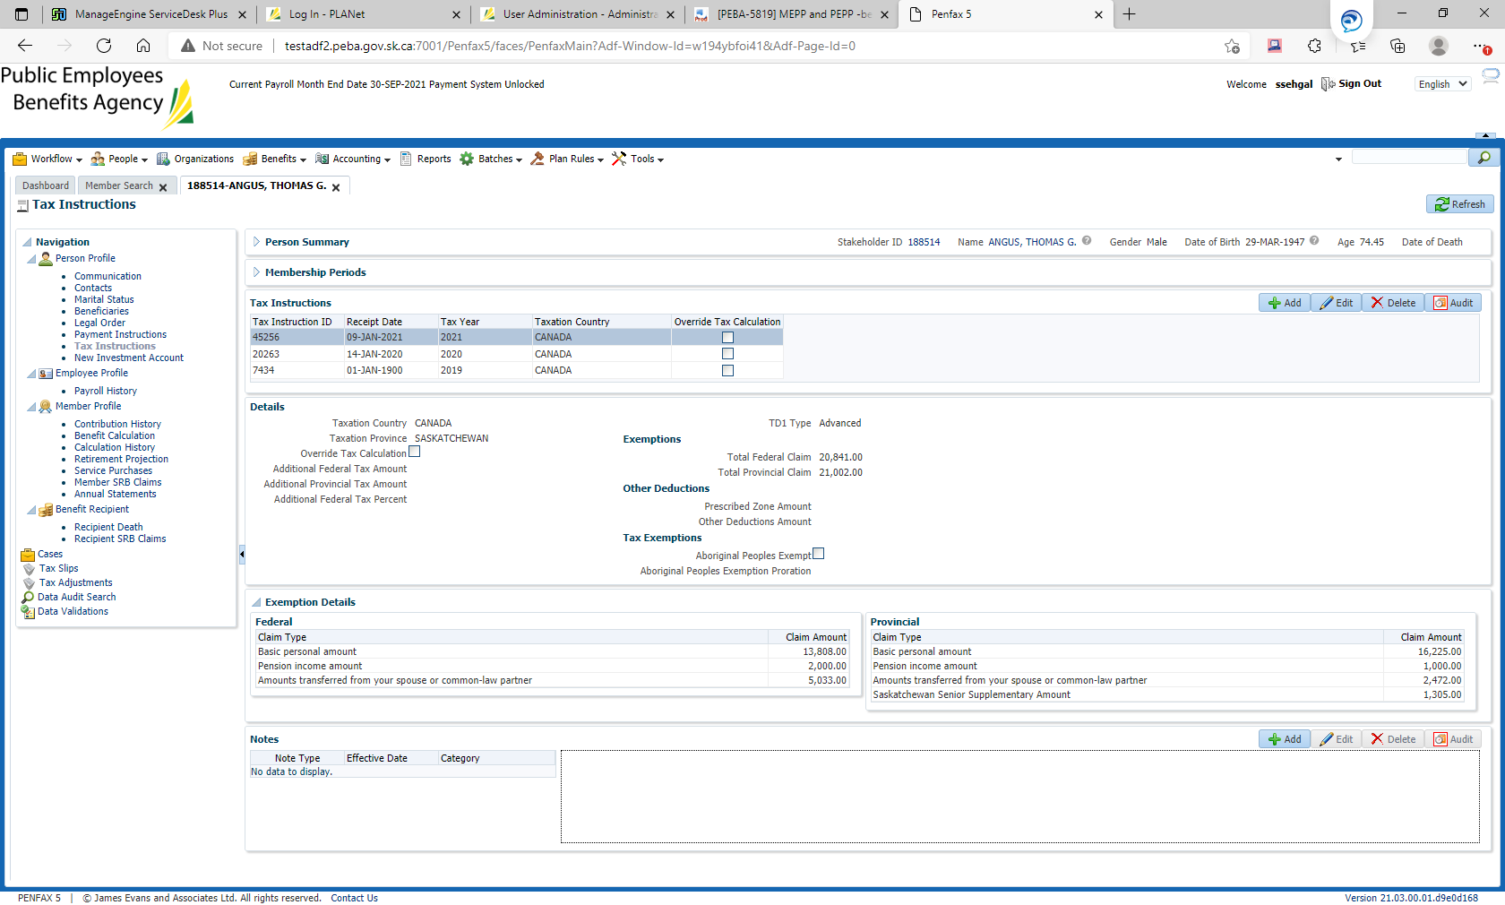

**2021 payment**

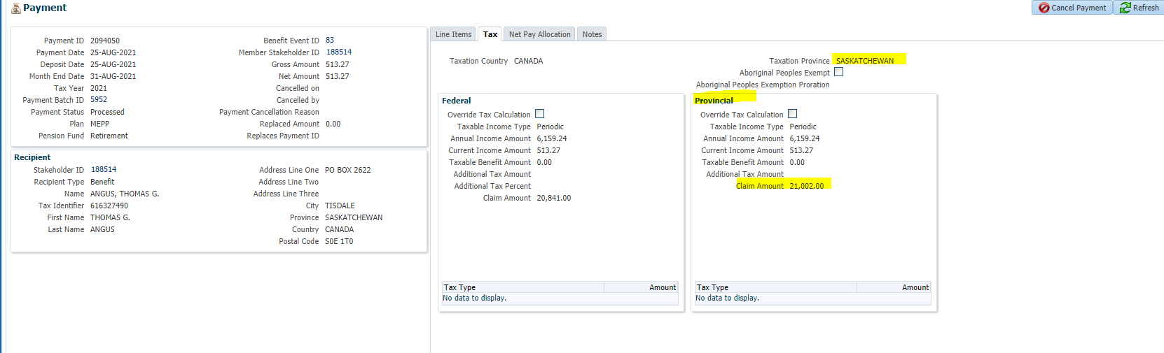

**Appendix**

1.BPA: basic personal amount, this is what the tax instructions would be displayed with

This document refers BPA for federal as BPAF, for Yukon BPAYT and for Nova Scotia BPANS

2.taxable income type on payment screen

Periodic: for schedule monthly payment

bonus: for Ad hoc bonus lump-sum payment

lump-sum: for Ad hoc lump-sum payment

**How to delete an imported batch file from Troy AssurePay application Import window listing:**

|  |  |
| --- | --- |
| **Procedure Number:** |  |
| **Procedure Name:** |  |
| **Purpose of the Procedure:** |  |
| **Original Date:** |  |
| **Revised Date:** |  |

|  | **Name/Title** | **Signature** | **Date** |
| --- | --- | --- | --- |
| **Reviewed by** | <Person who reviews the work> |  | <dd/mm/yyyy> |
|  |  |  |  |
|  |  |  |  |
| **Approved by** | <Senior Management / Business Area Manager> |  | <dd/mm/yyyy> |

**Overview**

How to delete an imported batch file from Troy AssurePay application Import window listing

1. Log into the troy application
2. By default, the import window will open and will display a list of all batch files that have

been imported to the application.

* 1. The Batch Headers tab needs to be selected to see this listing, by default the batch headers tab is selected when the window opens.

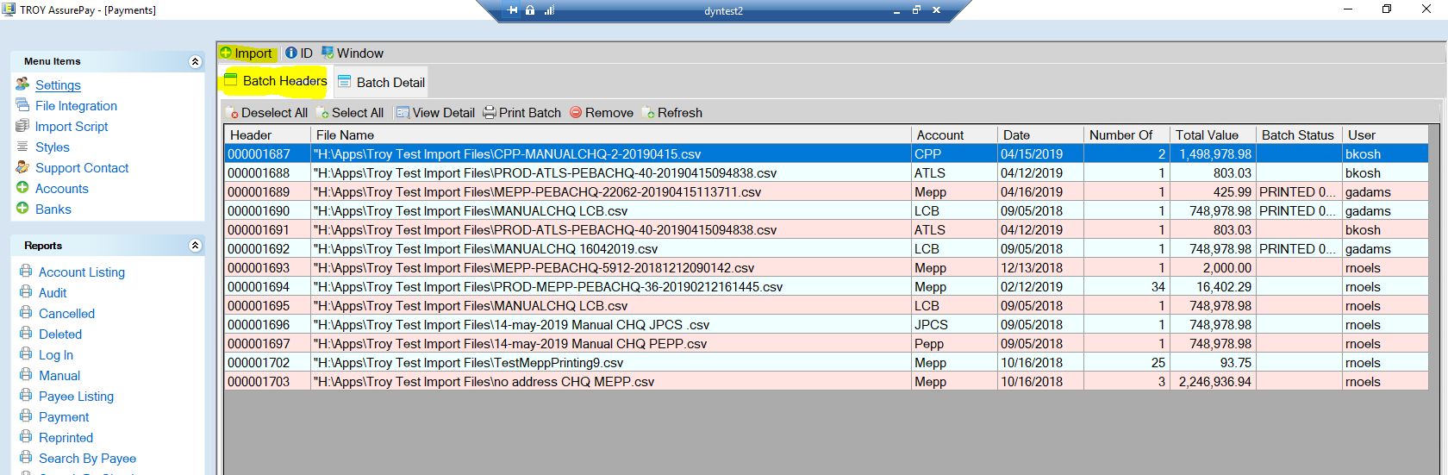

1. Select the batch you want to remove. This is the batch that has the Header Number documented in the Request Summary section above. Once the batch is highlighted, then press the remove button located in the tool bar below the tabs.

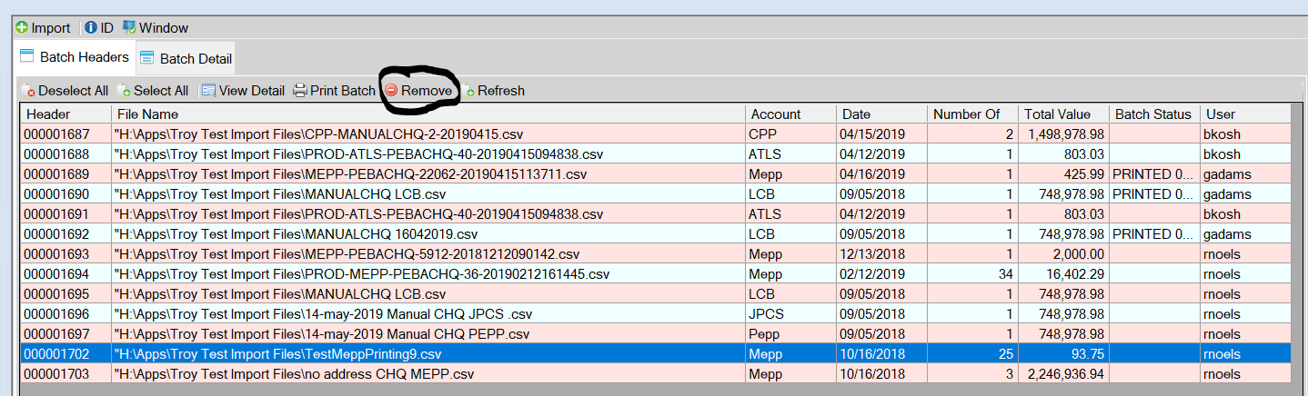

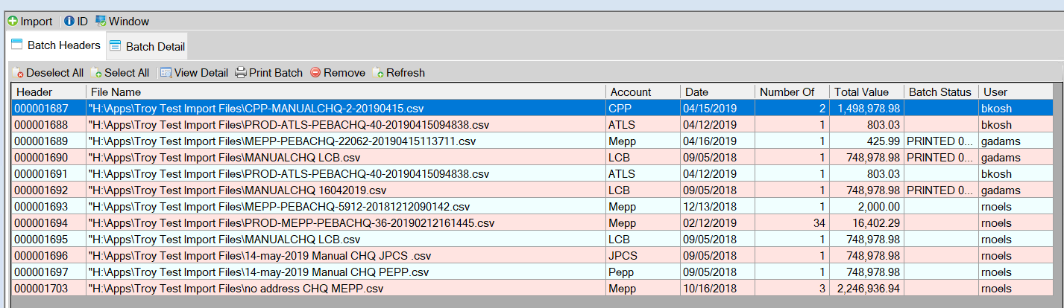

The file will be removed from the Import window display listing:

1. Continue step 3 until all files noted in the Request Form have been removed from the

import window listing then close the application.

1. The removal should be scheduled to happen when business is not using the application.

**How to Identify Duplicate Contribution Data Posting Patch:**

|  |  |
| --- | --- |
| **Procedure Number:** |  |
| **Procedure Name:** |  |
| **Purpose of the Procedure:** |  |
| **Original Date:** |  |
| **Revised Date:** |  |

|  | **Name/Title** | **Signature** | **Date** |
| --- | --- | --- | --- |
| **Reviewed by** | <Person who reviews the work> |  | <dd/mm/yyyy> |
|  |  |  |  |
|  |  |  |  |
| **Approved by** | <Senior Management / Business Area Manager> |  | <dd/mm/yyyy> |

**Overview:**

This is a scheduled report for QA to verify duplicate contribution postings if any. This has been scheduled weekly – Monday 8:00 AM. IT sends the list of duplicate batches in PENFAX production till date.

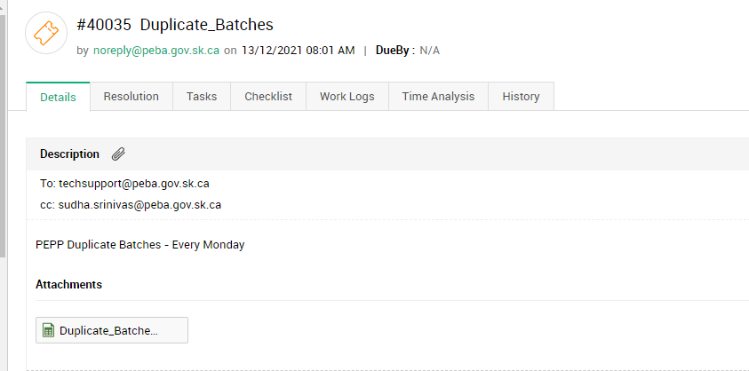

Save the attached spreadsheet to H:\Quality Assurance\Prod Apps\Prod Support\V5 PEPP\Reversal Files\Potential Duplicate Batches.

Rename the spreadsheet as “Potential duplicate batches found by JEA query_<current date>”.

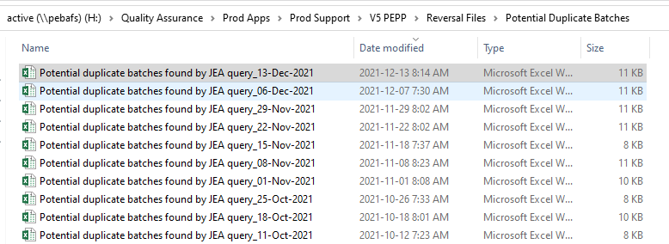

Open today’s spreadsheet and the previous Monday’s spreadsheet. Verify the count and see if any new batches have been added to the list. If you find any new batches, prepare checklist and send email to PEPP notifying them about this. If you find none new, close the tech support ticket.

You can find the sample checklist in H:\Quality Assurance\Prod Apps\Prod Support\V5 PEPP.

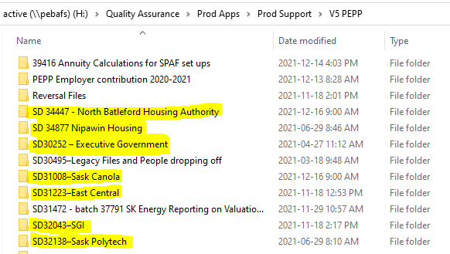

Or in H:\Quality Assurance\Prod Apps\Prod Support\V5 PEPP\Reversal Files.

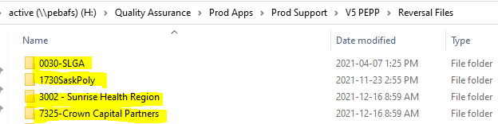

**How to Review Batches vs Journal Entries Query:**

|  |  |
| --- | --- |
| **Procedure Number:** |  |
| **Procedure Name:** |  |
| **Purpose of the Procedure:** |  |
| **Original Date:** |  |
| **Revised Date:** |  |

|  | **Name/Title** | **Signature** | **Date** |
| --- | --- | --- | --- |
| **Reviewed by** | <Person who reviews the work> |  | <dd/mm/yyyy> |
|  |  |  |  |
|  |  |  |  |
| **Approved by** | <Senior Management / Business Area Manager> |  | <dd/mm/yyyy> |

**Overview:**

QA has created the MEPP Query:

Original Query attached



Request has to be sent to IT to run the query in the Penfax Production Environment

Example of request email:

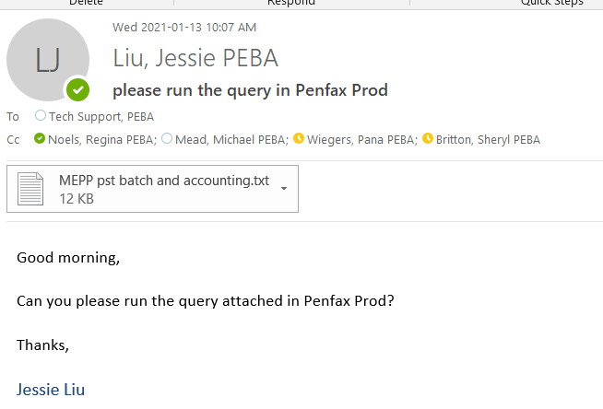

Query will be returned to us in excel format: Example of the query attached.



Apply a data filter to the work book, then for column “Suspense VS Batch, deselect 0

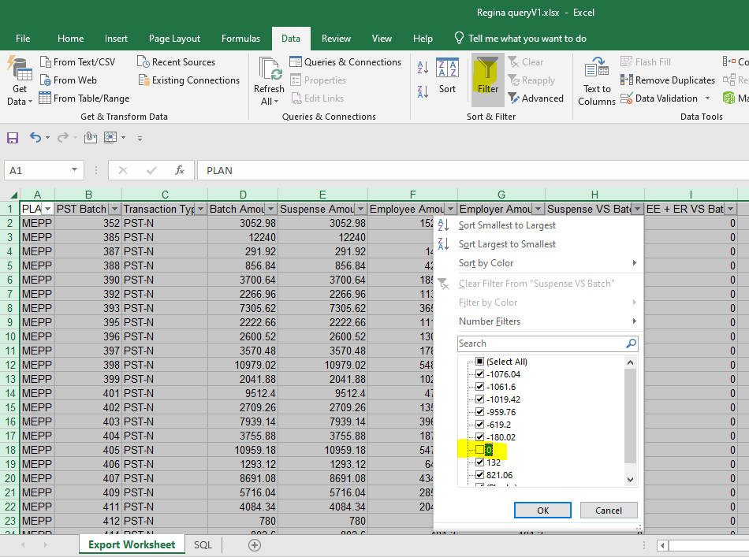

You now have a listing of all the closed data posting batches where the suspense accounting does not match to the posting batch. These batches require review to see what needs to be done to correct the accounting entries.

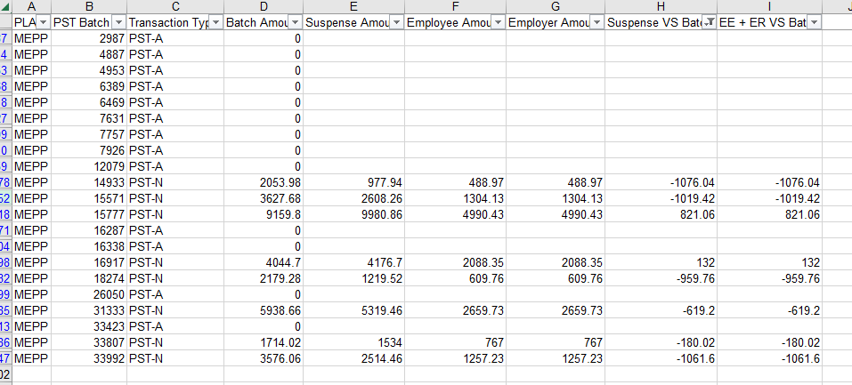

**How to Start PENPIPES:**

|  |  |
| --- | --- |
| **Procedure Number:** |  |
| **Procedure Name:** |  |
| **Purpose of the Procedure:** | Procedure document for PuTTY Penpipes |
| **Original Date:** |  |
| **Revised Date:** |  |

|  | **Name/Title** | **Signature** | **Date** |
| --- | --- | --- | --- |
| **Reviewed by** | <Person who reviews the work> |  | <dd/mm/yyyy> |
|  |  |  |  |
|  |  |  |  |
| **Approved by** | <Senior Management / Business Area Manager> |  | <dd/mm/yyyy> |

**Overview:**

**How to check if PENPIPES is up and running for POP:**

Last update: 3-Jul-19

Revised by: Pana Wiegers

PENPIPES runs the batch jobs in PENFAX, Postings, Audits, etc. If PENPIPES is down it will need to be re-started. A good indicator that PENPIPES is down is if you try to run an Audit in MEPPTEST and it takes longer than a minute or two to start, there is a good chance that PENPIPES is down.

1. Log into PuTTY by clicking the link within your Windows Start menu

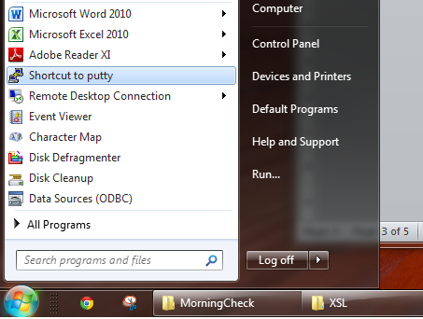

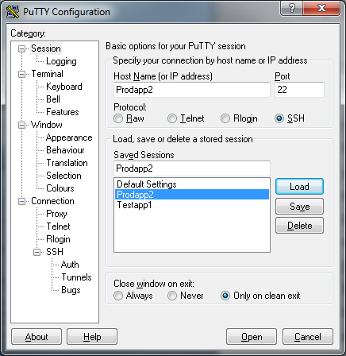

1. Select the *Prodapp2* session
2. Click the *Load* button
3. Enter the login username: PSSP
4. Enter the password, these change regularly so check the Test Passwords spreadsheet
5. Enter the following and press the Enter key: ps –f
6. Verify PROD is running: *penpipes batch/batch@popbatch batch*

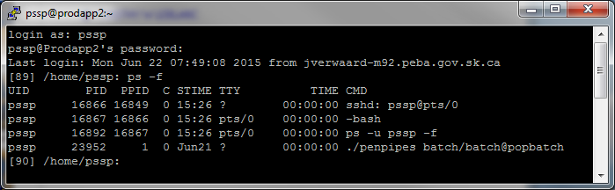

1. Type Exit
2. Open PuTTY again
3. Load the Testapp1 session

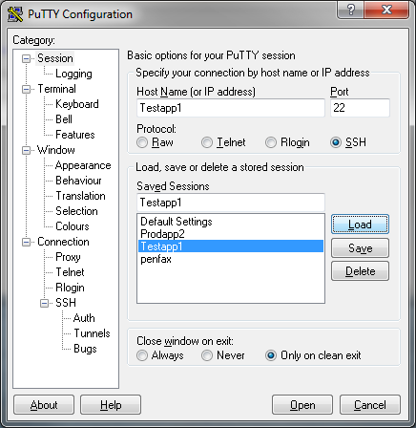

1. Click Open
2. Enter the login username: PSSP
3. Enter the password, which is the same as the Production one (See Test Passwords spreadsheet)
4. Enter the following and press the Enter key: ps –f
5. Verify TEST is running: *penpipes testuser/Testuser@pbtest*

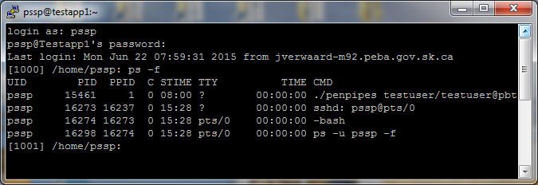

1. If it’s running, enter exit
2. When the *Test User* is not running, enter:
   1. *cd test*
   2. *cd penpipes*
   3. *cd bin*
   4. *ppstart.sh*
3. Enter *ps –f* again to verify it is running now

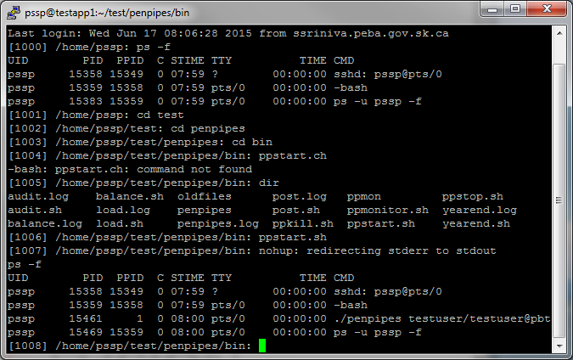

1. When the *Production User* is not running, enter the same as above except change step *a.* to *cd prod*

**How to fix multiple sessions**

When you notice that there are more than one active PENPIPES session running, they (all) need to be ended and the service has to be restarted. ****PENPIPES test – Before killing the sessions please check with other QA or IT to see if someone is running jobs in PENFAX 3. If you’re unsure it is better to wait to confirm if it is safe to kill the sessions.

**** PENPIPES production - Never kill the sessions in Production but you can let IT know about them. If the PENPIPES session is down you can bring it up using the procedure above. ****

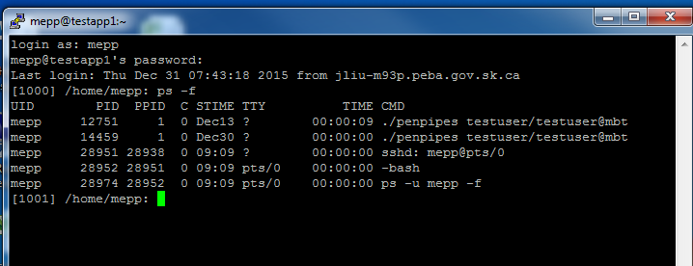

To kill a user process in Linux, enter the command **kill PID** with PID being the number from the

ps -f for the processes you want to kill (in the screenshot above; 12751 and 14459).

After this is done, enter *ps -f* to verify the sessions are gone and enter the following to start a new session:

1. *cd test (or prod)*
2. *cd penpipes*
3. *cd bin*
4. *ppstart.sh*

Enter *ps -f* again to verify a single session is running now.

**How to Check PENPIPES is running**

* PENPIPES runs the batch jobs in PSSP V3.5 PENFAX
* This check is done in TEST and PRODUCTION

1. Log into PuTTY by clicking the link within your Windows Start menu or Icon on desktop



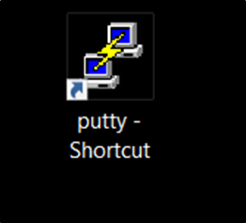

1. Check **TEST**
2. With PuTTY Configuration window open, click on TESTAPP1

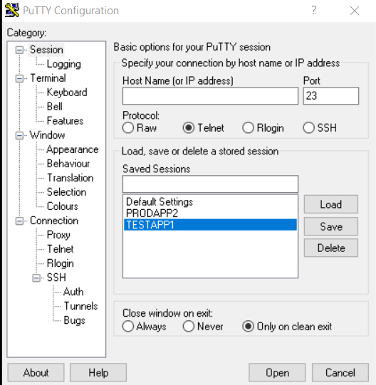

1. Click Load, this will bring up TESTAPP1 to the Host Name window

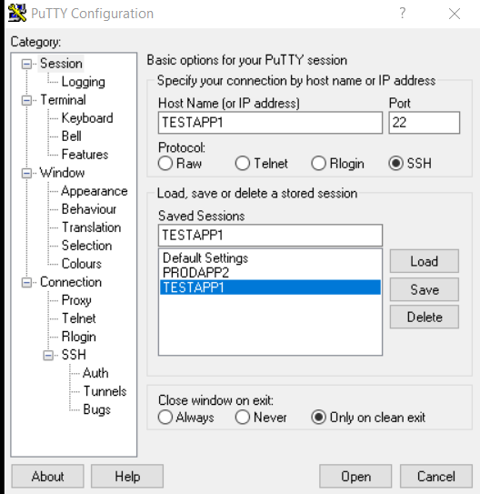

1. With Host Name window populated- Click Open



1. When Open is clicked the TESTAPP1 PuTTY window will open

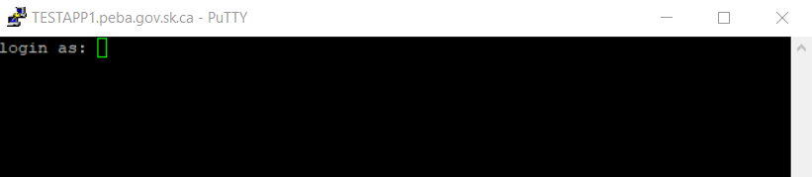

1. Login as pssp**;** Input Password – **Sm0ke27!** – (The 0 is a Zero); Click Enter

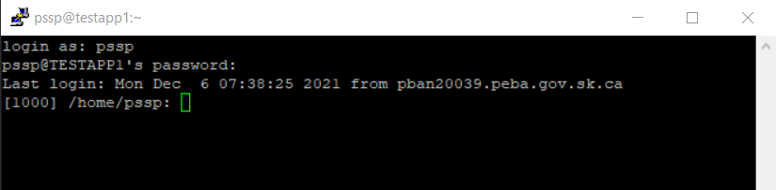

1. Enter ps **–f** (space between ps and -f) and press the Enter key

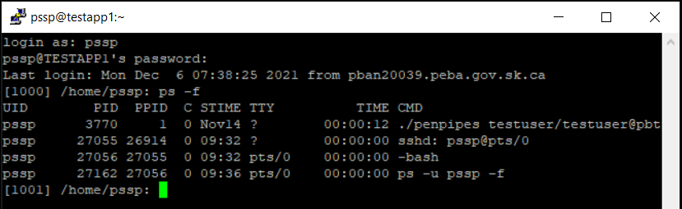

TEST PENPIPES is running in this instance

1. To Log Out type exit and hit Enter to close the session

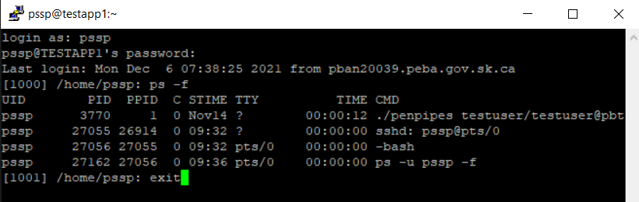

1. PRODUCTION PuTTY (PENPIPES) check

The procedure is the same as the TEST check

1. Log in to PuTTY PROD as seen in the TEST procedure, the icon and method of sign in are the same as TEST
2. With PuTTY Configuration window open, click on PRODAPP2

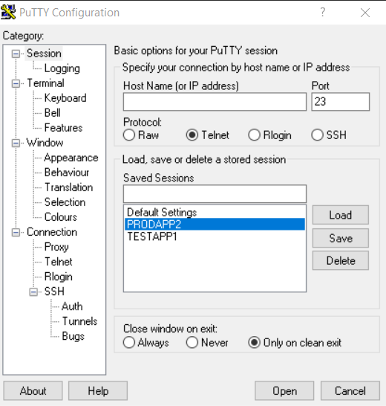

1. Click Load, this will bring up PRODAPP2 to the Host Name window
2. With Host Name window populated- Click Open

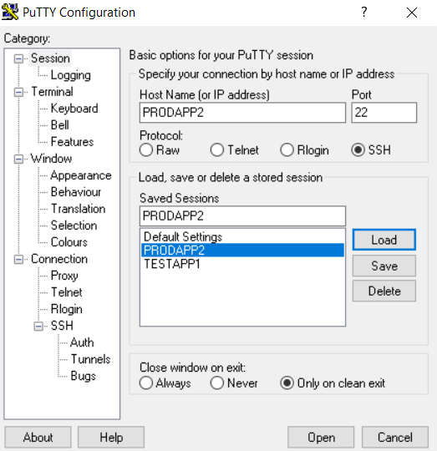

1. When Open is clicked the PRODAPP2 PuTTY window will open

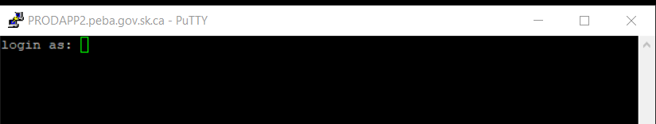

1. Login as pssp; Input Password – Sm0ke27! – (The 0 is a Zero); Click Enter

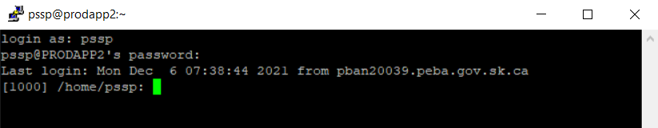

1. Enter ps **–f** (space between ps and -f) and press the Enter key
2. TEST PENPIPES is running in this instance

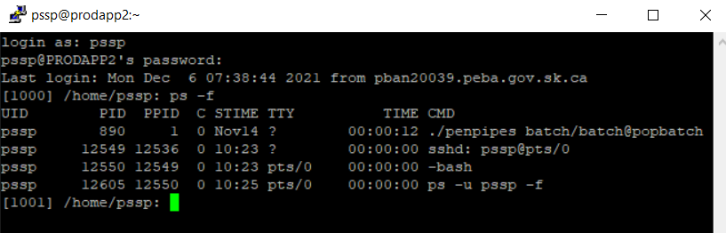

1. To Log Out type exit and hit Enter to close the session

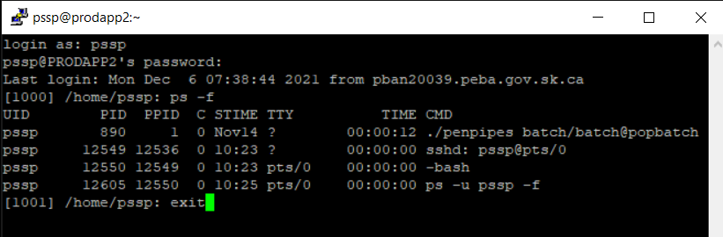

**Integration Builds Procedures for MEPP Renewal Project:**

|  |  |
| --- | --- |
| **Procedure Number:** |  |
| **Procedure Name:** |  |
| **Purpose of the Procedure:** |  |
| **Original Date:** |  |
| **Revised Date:** |  |

|  | **Name/Title** | **Signature** | **Date** |
| --- | --- | --- | --- |
| **Reviewed by** | <Person who reviews the work> |  | <dd/mm/yyyy> |
|  |  |  |  |
|  |  |  |  |
| **Approved by** | <Senior Management / Business Area Manager> |  | <dd/mm/yyyy> |

**Overview:**

Pre-Request to building Integrations in Integrations

Make a Back Up of the current Integration Manager Database.

Navigate to the folder that holds the integration database that is currently being used in the region that you are going to build the integration.

Make a copy of the current integration database.

Rename the copy of the database to identify the date and that it is a backup.

## 

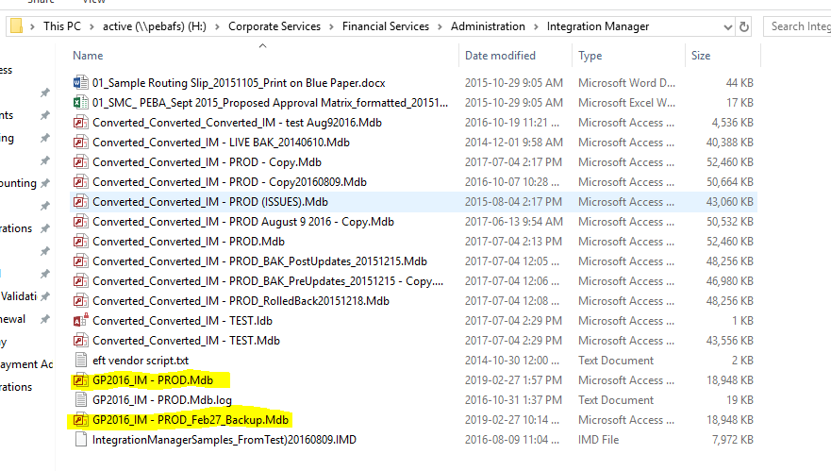

Ensure that Integration Manager is pointed to the correct database where you want to build the integration

From the start menu search and Open “Integration Manager”

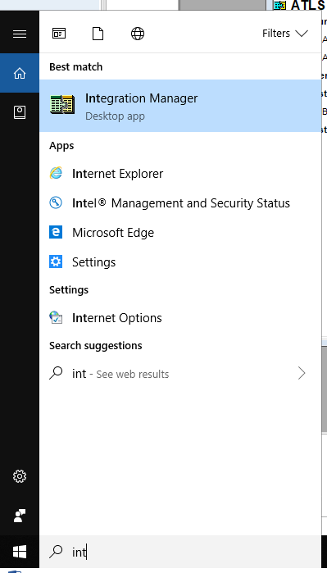

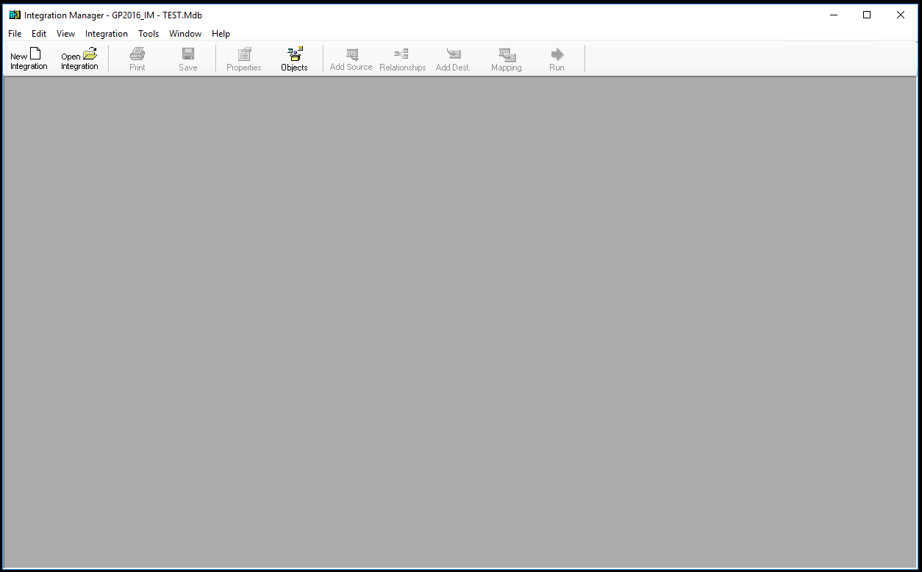

From the Integration Manager - menu bar select “Tools” “Options”

Use the folder selection button to the right of the field to open explore and navigate to the correct database if you are not currently pointed to the right one.

*Note:*

1. Test should be pointed to integration database GP2016_IM – TEST.Mdb located in LAN Folder H:\PEBA\Documentation\Great Plains Test **New LAN folder location TBD**
2. Production should be pointed to integration database GP2016_IM.Mdb located in LAN Folder H:\Corporate Services\Financial Services\Administration\Integration Manager

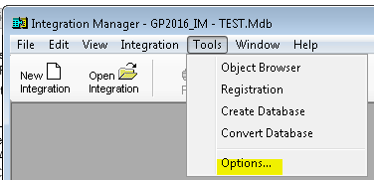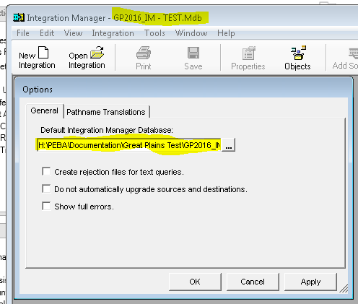

**Building Integrations:**

**Pre-Prerequisites:**

* Determine what GP Module/Window you need to integrate Transaction details into:
  + Payment Integrations will integrate into the Bank Transaction Entry Window in GP
  + Journal Entry Integration will Integrate into the General Journal Window in GP
  + Deposit Integrations will integrate into the Bank Transaction Entry Window in GP
* Determine if you will use script in your integration build, if you will use script you may need to enlist Encore to help with building the integrations.
  + We choose no script for the MEPP Renewal Project integrations.
* Determine what details are in the file you will be integrating into GP.
  + For the MEPP Renewal Project we did not use an existing file. Instead we requested PENFAX v5 to create the file as we needed it to be.
  + Three Files are Created by PENFAX in the Batch Process
    - Extract Journal Entry Data
    - Extract Journal Entry Data for Daily Payments
    - Extract Journal Entry Data for Daily Payments

**Building of Integration for the MEPP Renewal Project:**

1. A file sample for the integrations you are building must be created and saved to the LAN Folder location that you will be mapping to your integration.
   1. For testing of GP the Integration folder is located in H:\PEBA\Documentation\Great Plains Test\Penfax V5 Integrations
   2. See Appendix A for example of File Details for the MEPP Renewal Integration Builds.
2. For additional information on how the system must create the files for the integrations X-Reference the following MEPP Renewal Documents

..\..\..\..\Design Build\Integration Points\Accounting\MEPP Daily Deposit Extract TS v1.7.docx

..\..\..\..\Design Build\Integration Points\Accounting\MEPP Daily Payments Extract TS v1.6.docx

..\..\..\..\Design Build\Integration Points\Accounting\MEPP Journal Entries Extract TS v1.5.docx

1. A separate Integrations was built for each Plan. The integrations are an exact copy from one plan to the other.

**Step 1:** Log into Dyntest or Dyntest 2, and Open the GP Application, and Open Integration Manager Ensure that the Title Bar displays the name of the Integration Data base that you will be building the integrations in if not go back to 1.7 above and change it to the correct database.

**Step 2:** Press the New Integration Button, to open a new integration build window:

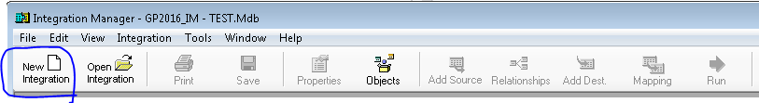

* By default, a new integration build is automatically created, which includes assigning of a default integration name, and the folder creation under the integration for Sources, Destination and Destinations Mapping. Note: as you work through the process of the build you will define additional information under each of these folders.
* A properties Window is automatically opened with this process which requires your input of information.

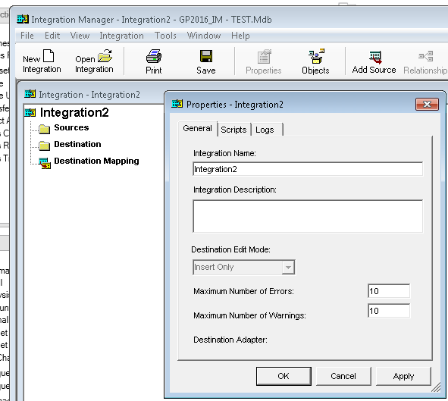

**Step 3.** Define your integration build - On the properties window enter the following details on the General Tab:

3.1 In the Integration Name Field: Enter the name that you want to call the integration you are building

3.2 In the Integration Description field: Enter a description of what your integration you are building

For MEPP Renewal Project the Integrations Names and Descriptions are as follows:

|  |  |
| --- | --- |
| **Integration Name** | **Integration Description** |
| ATLS Daily Payments | ATLS Daily Payments |
| JUDGES Daily Payments | JUDGES Daily Payments |
| LCB Daily Payments | LCB Daily Payments |
| MEPP Daily Journal Entries | MEPP Daily Journal Entries |
| MEPP Daily Payments | MEPP Daily Payments |
| PSSP Daily Payments | PSSP Daily Payments |
| SPAF Daily Payments | SPAF Daily Payments |
| STC Daily Payments | STC Daily Payments |
| WCB Daily Payments | WCB Daily Payments |
| **MEPP Daily Deposits | **MEPP Daily Deposits |

**This integration was built in Test database but was not moved to the Production Database.

3.3 “Destination Edit Mode” defaults to Insert Only

3.4 “Maximum Number of Errors” defaults to 10

3.5 “Maximum Number of Warnings” defaults to 10

3.6 *“*Destination Adapter” will be blank at this point and will update/set to the GP Module/Window you need to integrate Transaction details into, once the destination mapping process is completed as defined in the step 4

*Notes: for Maximum Number of Errors and Warnings fields:*

* For an integration destined to the General Journal in GP (Journal Entry Integration) the Error numbers will not matter because Journal Entries integrate as batches so if the integration fails at any point in the process you simply delete the batch and re-run the integration.
* For an Integration destined to the Bank Transaction Entry in GP (Payment Integration) Encore recommends that the Errors number be set to 999 because bank transactions do not integrate as a batch, so you want as many records as possible from the file to integrate because the resolution for reintegrating a failed bank transaction batch is to identify the records that integrated successful and remove them from the file, leaving only the failed records in the file. Subsequently integrate only the failed records.
* **Important Business Process** - If you plan on reintegrating the whole failed bank transaction integration again. You must first post the transactions that successfully integrated from the failed batch to the GL as these records will have been created in the GL as part of the integration. Then from the Bank Transaction window you must void the successful transactions (I.E. Void at the source of entry). Voiding the transactions will create a new batch, which you must post to remove the voided entries from the GL. Now you can reintegrate the entire failed integration again.

*Notes for Destination Adaptor field Update:*

* For Payment Integrations the “Destination Adaptor” sets to Bank Transaction Entry
* For Journal Entry Integrations the “Destination Adaptor” sets to General Journal

Screen print of the Properties Window General Tab after all Fields have been entered (for each type of integration build)

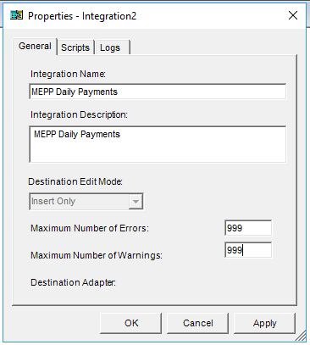

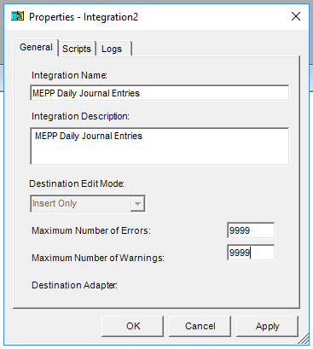

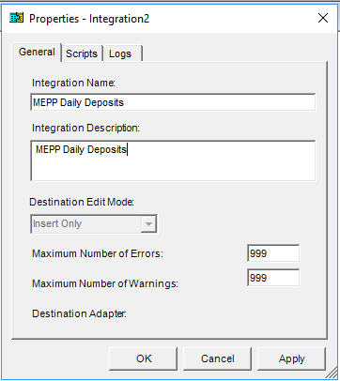

* 1. On the properties window Click on the Scripts Tab, nothing is required here, unless you are implementing scripting for your integration build then you will need to enlist Encore to help with the scripting required. For our builds no scripting will be used.

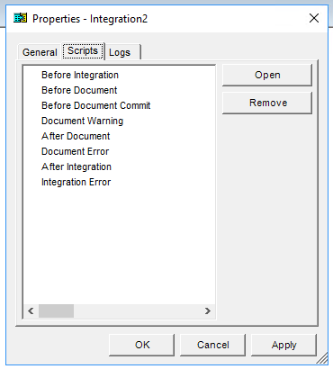

3.8 On the properties window Click on the Logs Tab, nothing is required here. The “Level” Field automatically defaults to Summary and the “Storage Type” Field automatically defaults to Database.

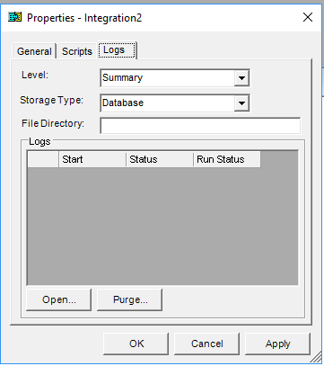

3.9 On the properties window Press the Apply button and then press the OK Button

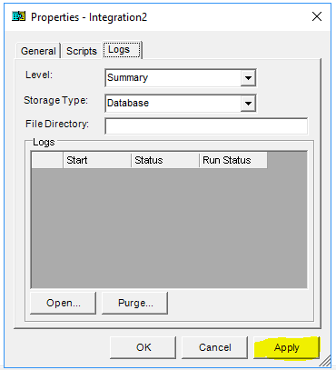

**Step 4**. Add sources to your Integration

* 1. Select the Source folder, then either click the Opposite Mouse Button and select Add Source or Select Add Source button in the tool bar.

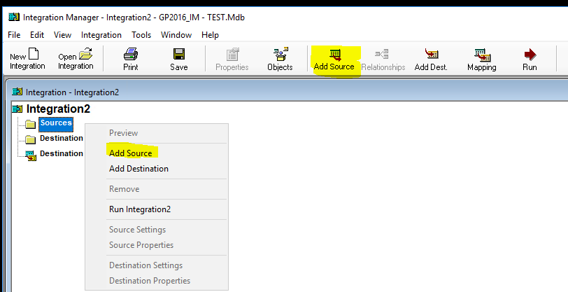

**4.2** On the Add Source Window, open the ODBC/Text folder and select Text, then press “Define New Text” under the sources listings. The Sources Properties window opens

* A Sources properties window opens which defaults the name to Query 28, and defaults the selected tab to General.

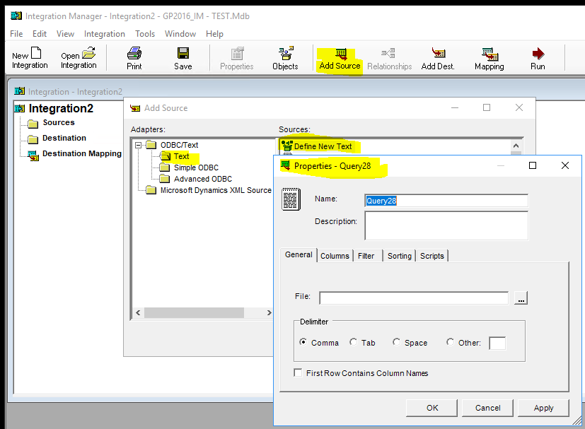

**4.3** On the Source Properties Window General Tab define the source of the data in your file.

***Note:*** our source files all have a header record and detail lines. Therefore, you will be required to add one source for each of the file contents

4.3.1 Name field: Enter the name of your source naming convention should be “Integration Name” Header

4.3.2 File field: use the navigation button on the right side of the file field and select the name of file that will contain your data to integrate.

4.3.3 Delimiter: Leave this set to Comma

4.3.4 Check the “First Row Contains Column Names” check box Press “Apply” the Header Title updates to display your new name

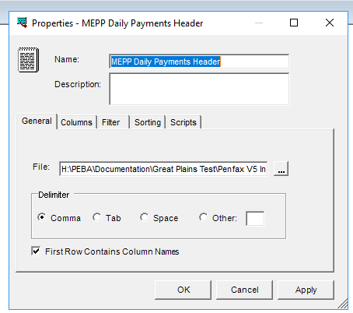

4.3.5 On the Source Properties Window - Columns Tab All the column names from the file that you mapped to in step 4.3.4 will be displayed and checked to show – nothing is required here.

***Note***: Depending on the integration you are building the details in this tab will be different.

Example a Payments Header Source Columns and a Deposits Header Source Columns these are both the same

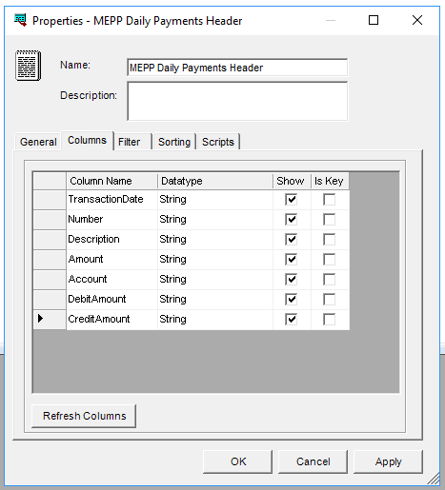

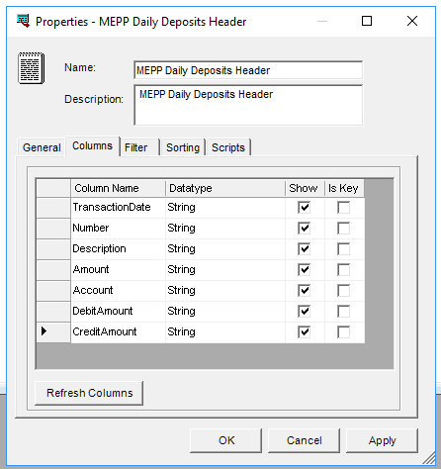

Example of a Journal Entry Header Source Columns

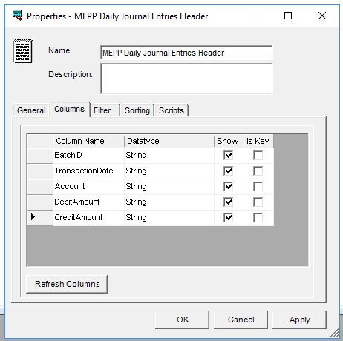

4.3.6 On the Source Properties Window - Filter Tab nothing is required here

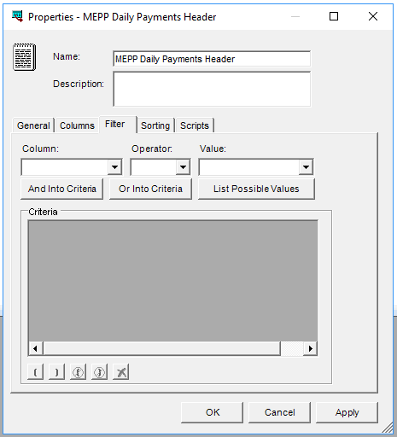

4.3.7 On the Source Properties Window - Sorting Tab you will have to apply the sorting you require the integration to look for in the file when creating the journal entry records in GP.

* For Payment Integrations apply a sorting of Group By: Transaction Date; Number; Description and Amount

To add the Group By sorting simply click in the empty field and a selection list will be populate for you to make your selections.

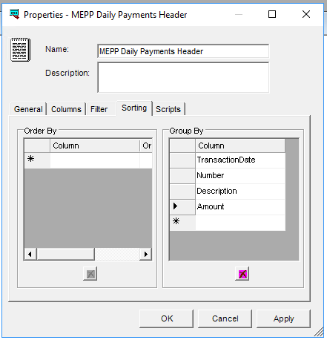

* For Journal Entry Integrations apply a sorting of Group By, BatchID and Transaction Date

To add the Group By sorting simply click in the empty field and a selection list will be populate for you to make your selections.

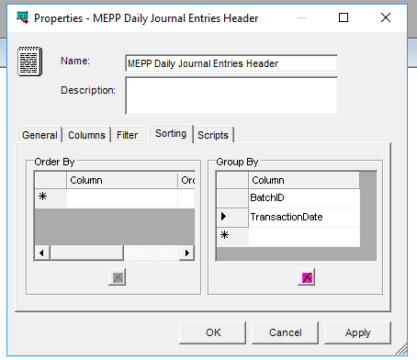

* For Daily Deposits Entry Integrations apply a sorting of Group By, Transaction Date, Number, Description and Amount

To add the Group By sorting simply click in the empty field and a selection list will be populate for you to make your selections.

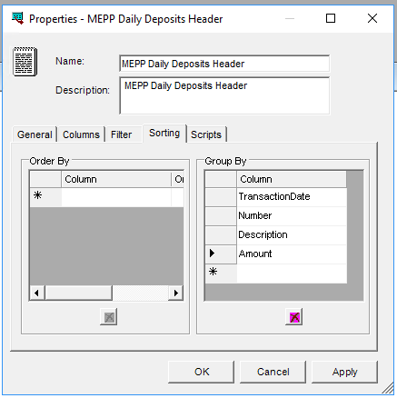

* On the Source Properties Window - Scripts Tab do nothing as we are not building integrations with scripts.

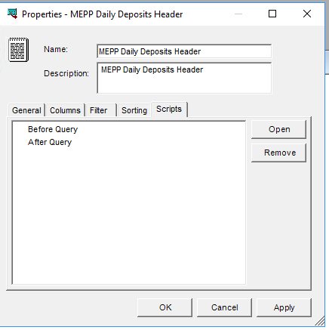

4.3.8 On the Source Properties Window – after you have entered all required information press the apply button and move on to the next step.

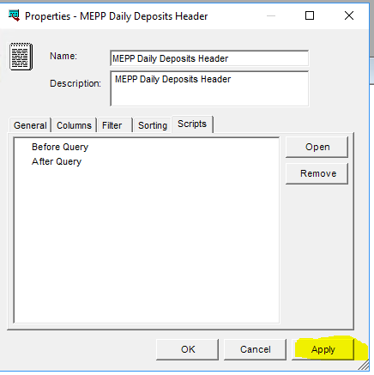

Press ok on the message

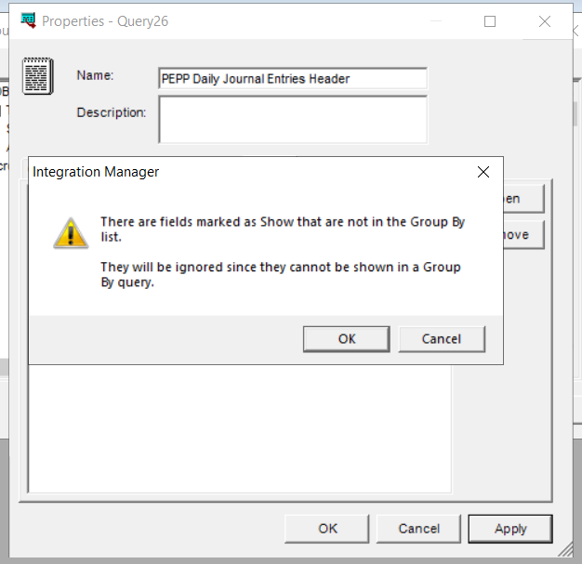

Press OK on the properties window to close the window

4.3.9 Repeat the steps identified in Step 4 to added the source information for the Lines details from your integration file, with the following differences:

* 4.3.1 Name field: Enter the name of your source naming convention should be “Integration Name” Lines

*4.3.7 On the Source Properties Window - Sorting Tab you will have to apply no sorting

You will receive this message

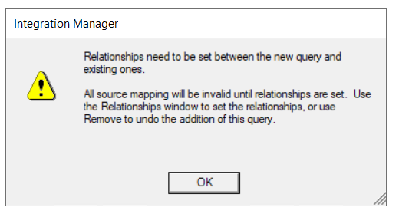

**Step 5**. Build the integration Query Relationships:

1. Click “Relationships” in the menu bar
2. Match the Heater columns to the Lines columns, by clicking beside the first header column to create the arrow then dragging the arrow across to the matching lines column. Link all the fields from the Header to the Lines.

For Deposit integrations make the following connections:

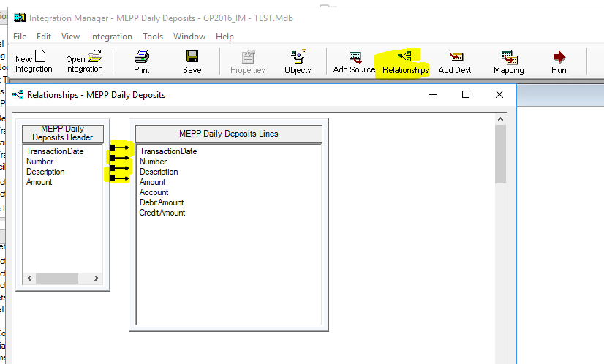

For Payments Integrations make the following connections:

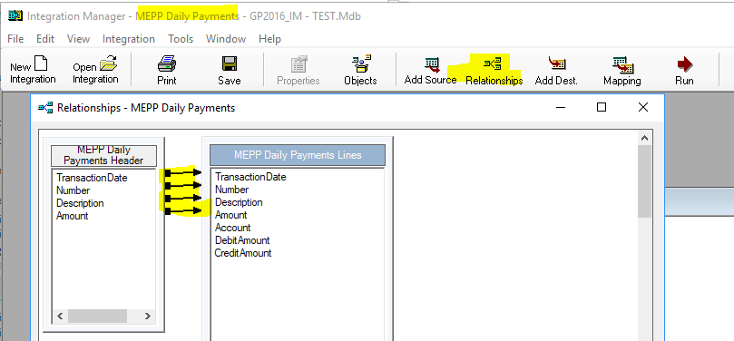

For Journal Entry integrations make the following connections:

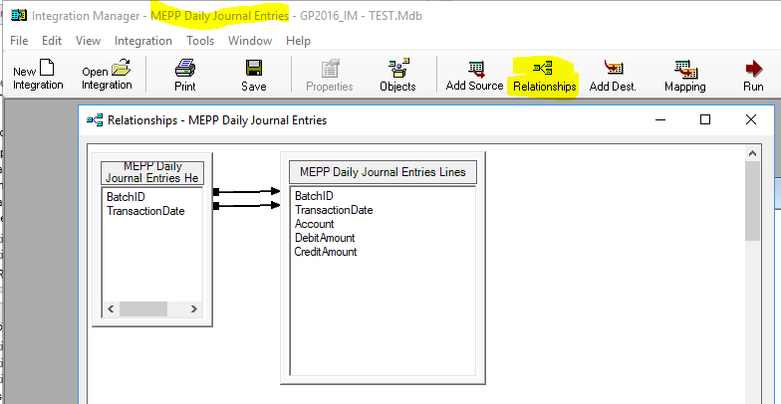

**Step 6.** Build the Destination for the integrations. The destination is the window in GP that the file will integrate and make entries in.

1. Click “Add Dest.” in the menu bar or select the Destination folder and Opposite Mouse Click and select the Add Destination option.

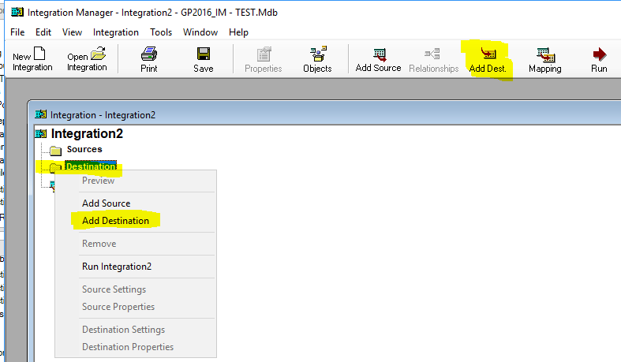

1. The add destination window will open, expand the Microsoft Dynamics GP folder.

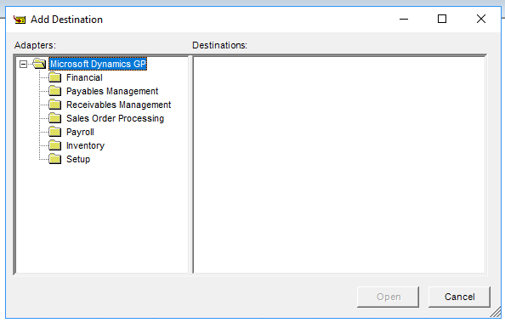

1. Select the folder (GP module) that the integrations will make entries to. For all integrations the selections are “Financial”.

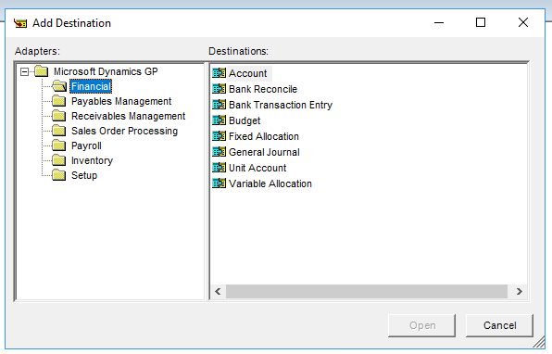

1. Select the GP accounting window where you want your transactions to be created. The destination folder in the integration is updated with your selection

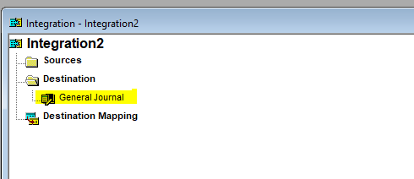

For Journal Entry Integrations select General Journal

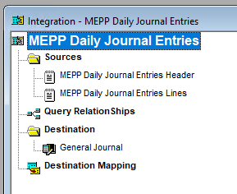

For Payment Integrations select Bank Transaction Entry

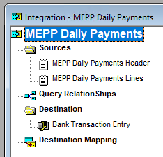

For Deposit Integrations select Bank Transaction Entry

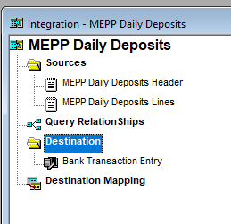

**Step 7.** Build the Destination Mapping for the integrations. This is the place that GP will look for the information for the fields on the GP window that need to be filled in for the type of transaction the integration is creating.

1. Click “Mapping” button in the menu bar or double click the destination mapping folder in the integration.

* When the Integration Mapping window opens the default, selected tab is Fields and the default selected row is the first row (arrow in first column)
* You need to apply mapping at folder level General Journal and folder level Entries

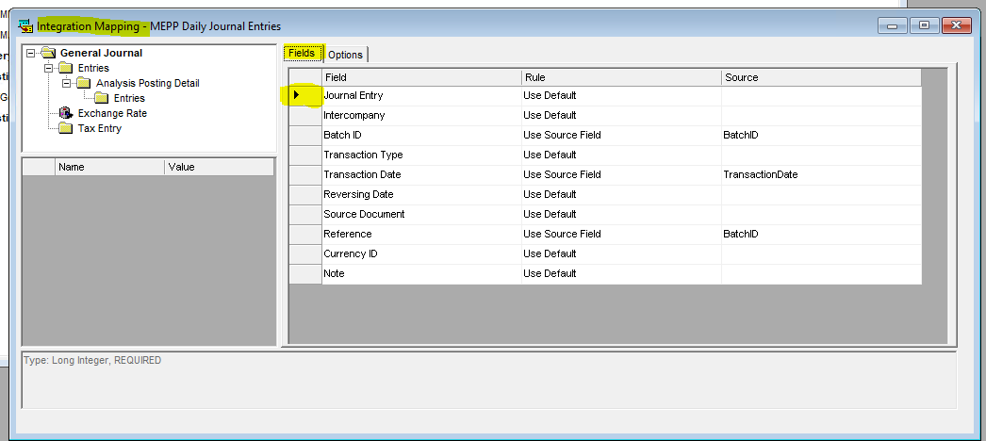

* If you need to make a rule change you must select the field under the rule column in line with the field you want to apply the rule to. This will open up a drop-down selection box so you can select the rule you want to apply. Rules that can be applied are Use Default; Use Source Field; Use Input; Use Constant; Use Script

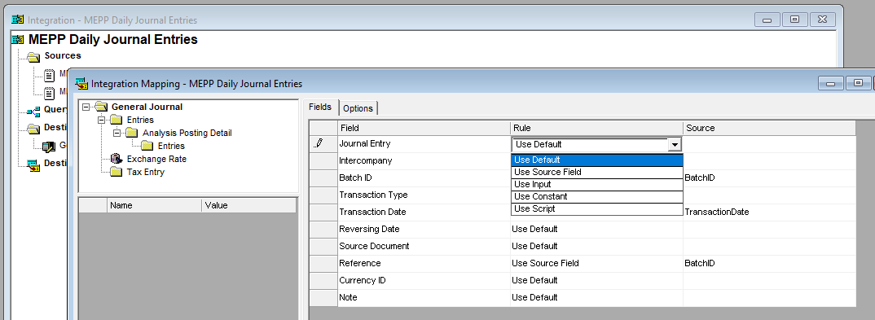

* If your rule is to use Source Field then you also have to set the source field to use in the source column. First select the rule Use source field, then select the field under source to enable an object selection button, press the selection button to open the object window and select your source object in the objects window. The source field is updated with your selection.
* If the rule comes from the source file then you have to add the source field. (I.E. Batch ID, comes from the Use Source Field, and the Source field is “BatchID”)

**Note**: When a source field is required when you click in the field a search button is seen, clicking on that search button, opens a Source Objects window, where you can pick the file part in the top (either header or lines) and the field in the bottom. Be sure to pick the correct top source because both may have the same field.

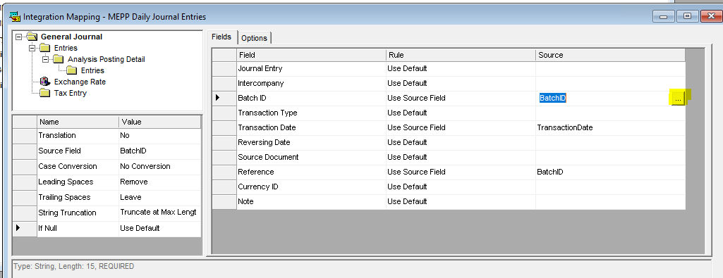

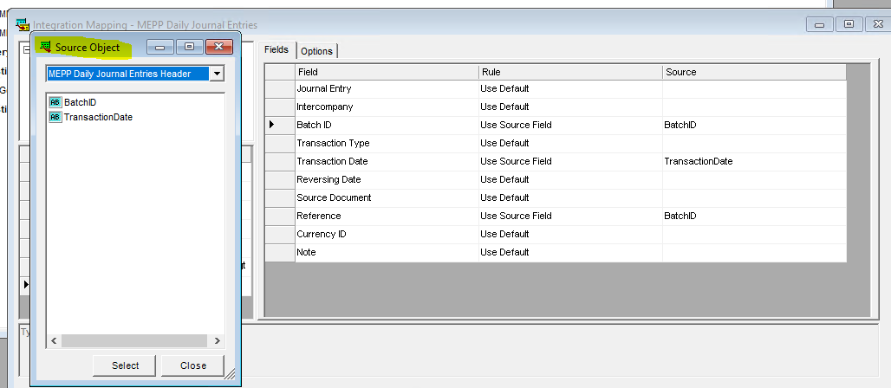

When using Use Source Field Rule, additional rules for that field are auto populated on the left side of the window. These rules can be changed if required.

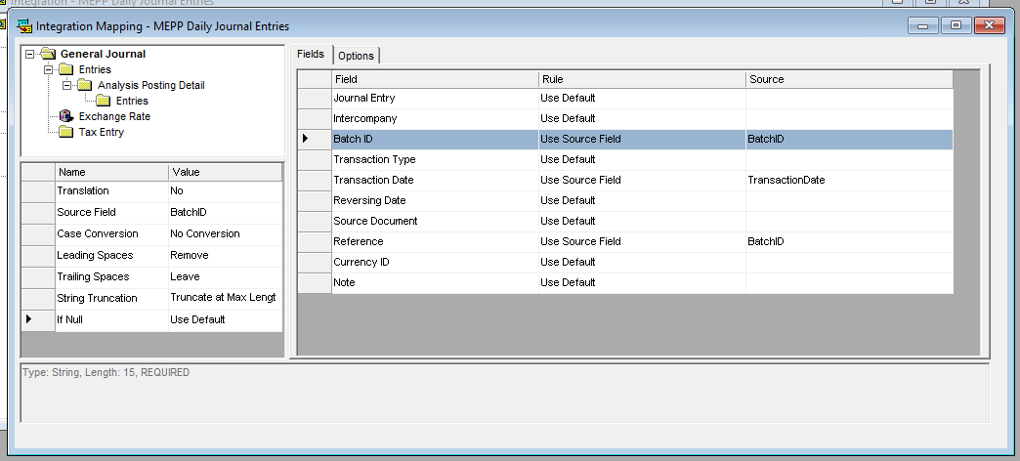

Entries folder rules

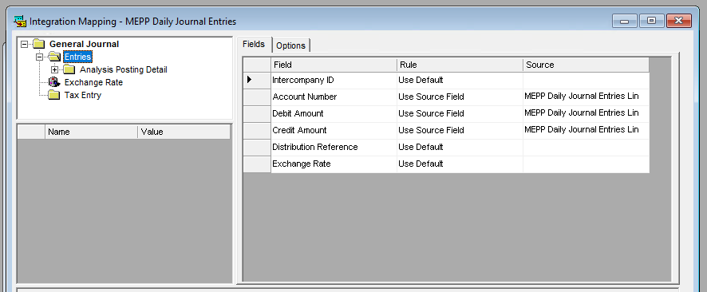

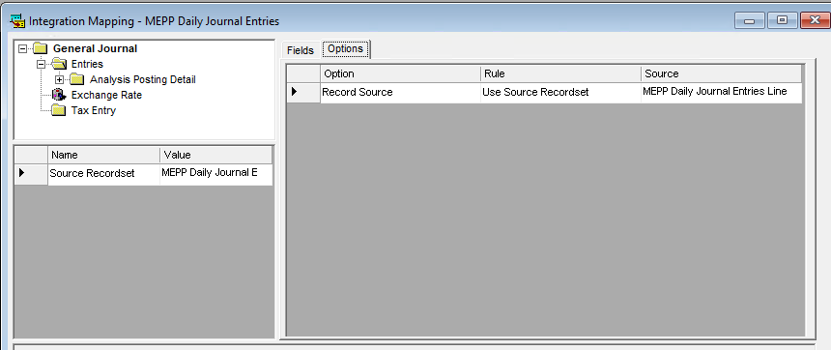

1. On the Integration Mapping window – Fields Tab apply the following Field Rules for each type of Integration

* For Journal Entry Integrations set Field Rules to the following:

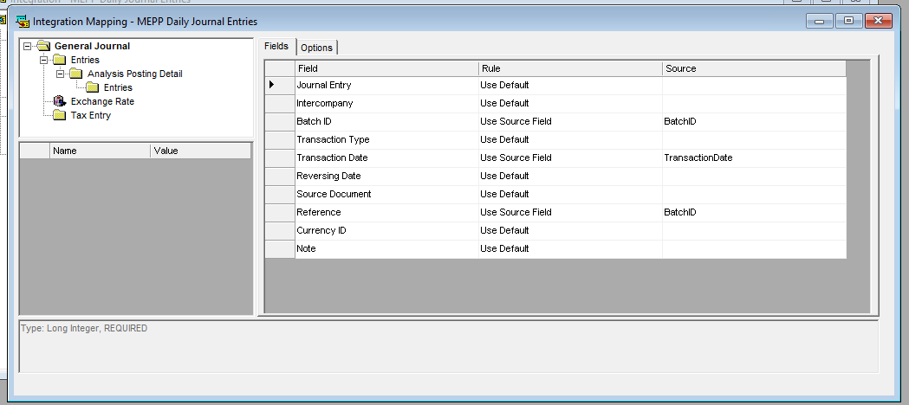



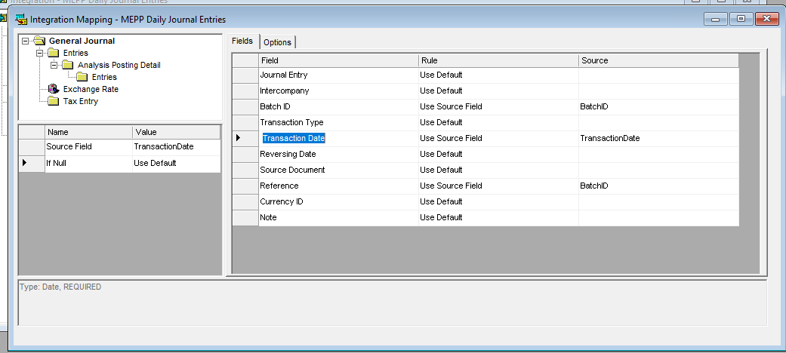

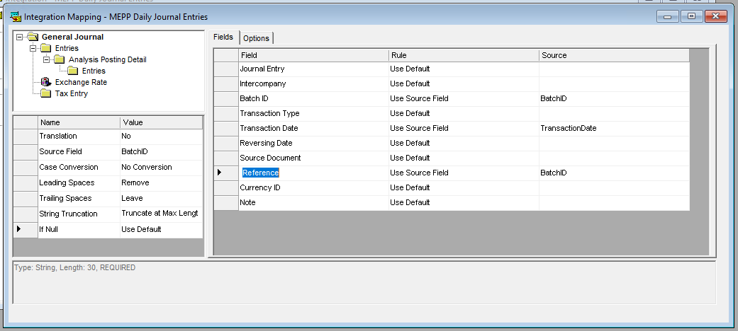

* For Payment Integrations – field tab rules

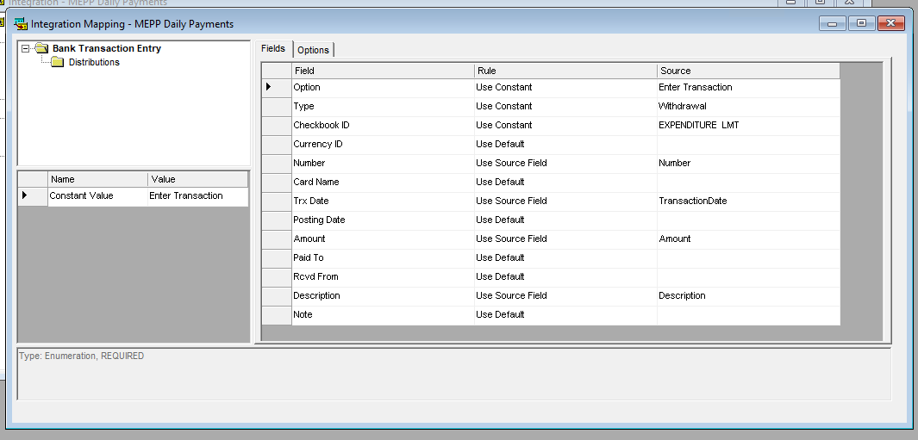

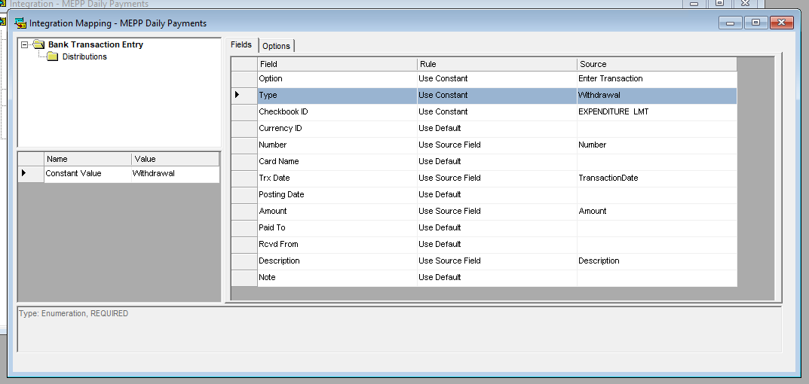

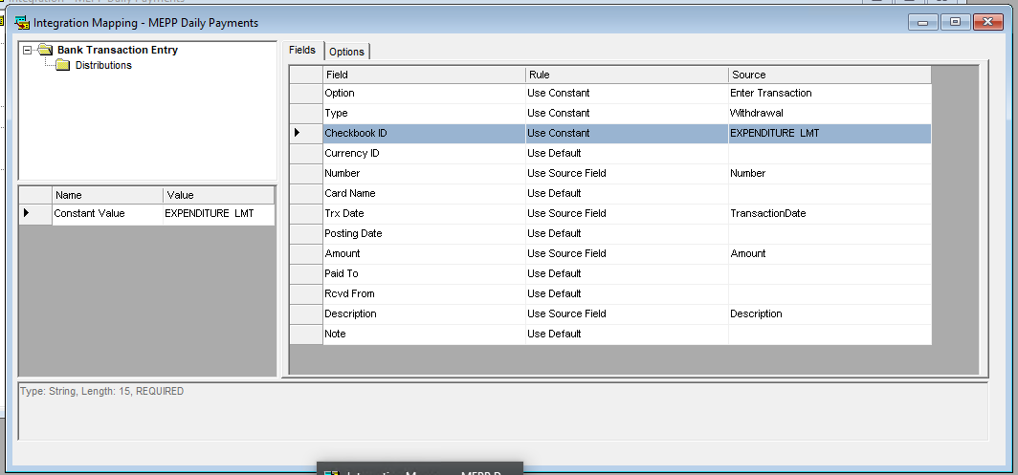

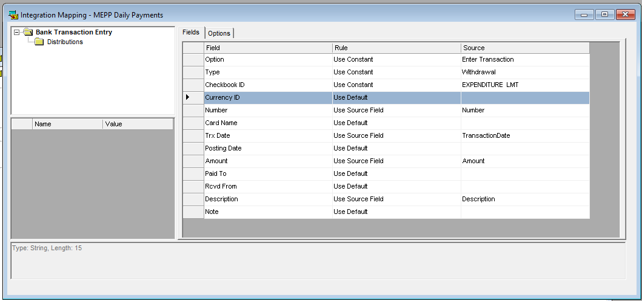

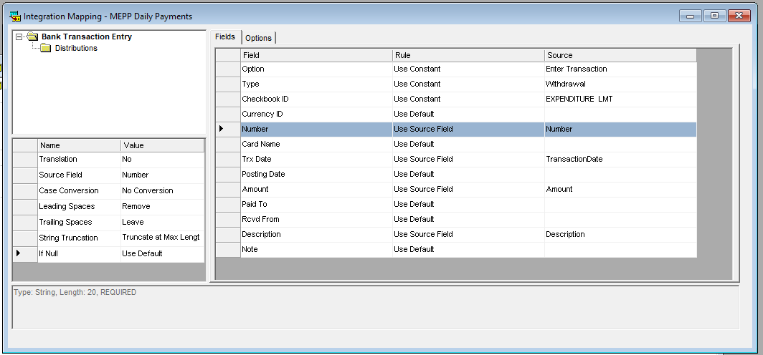

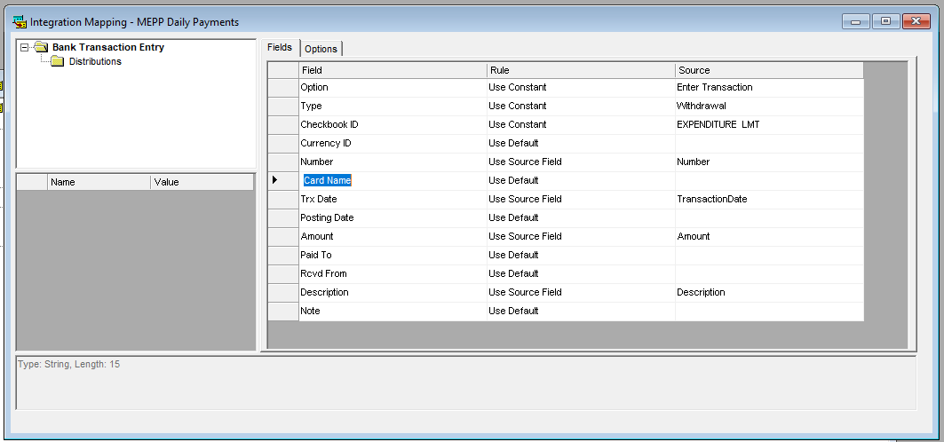

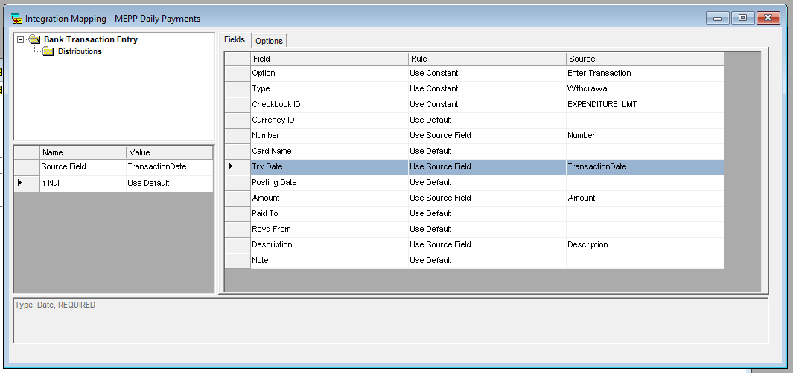

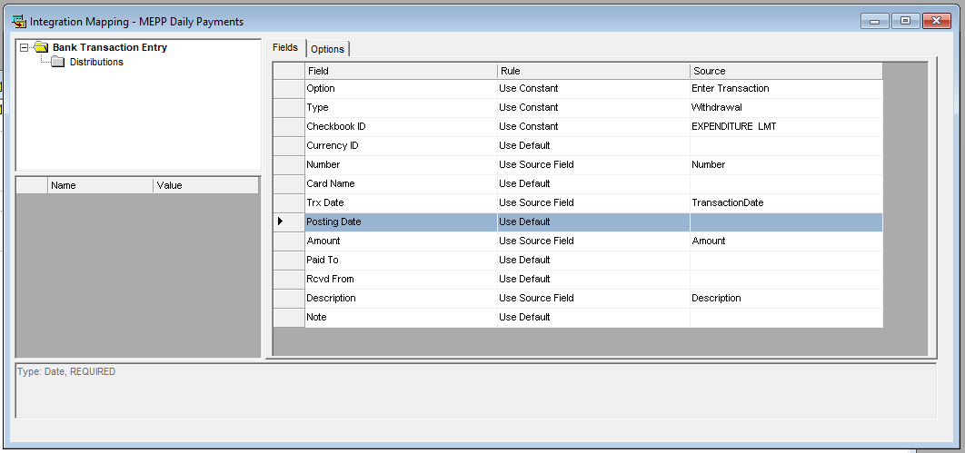

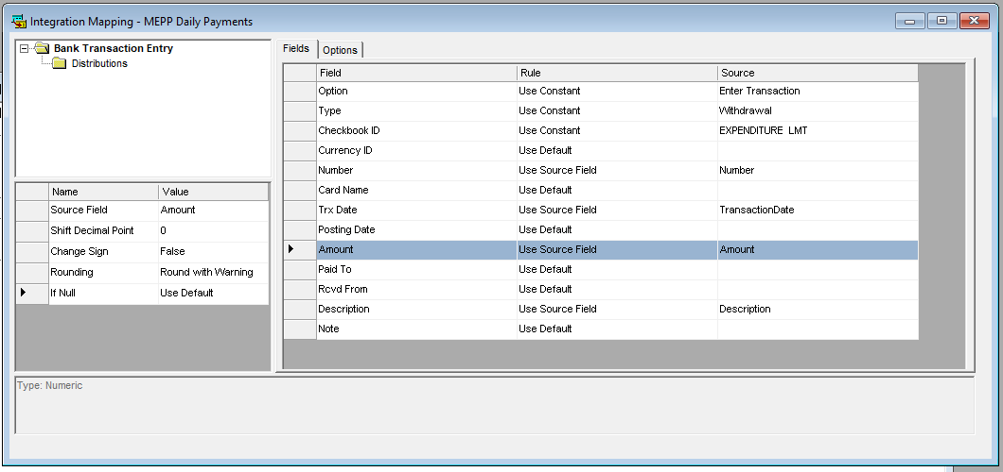

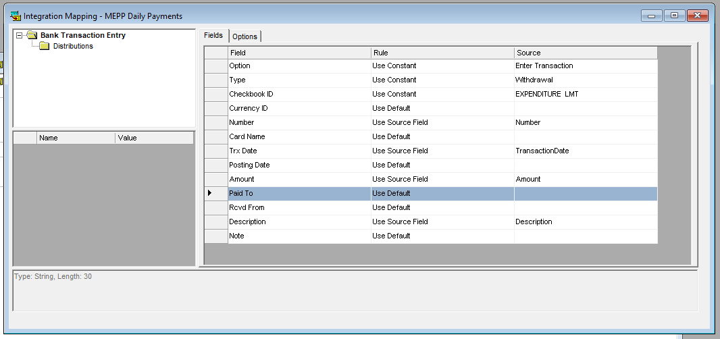

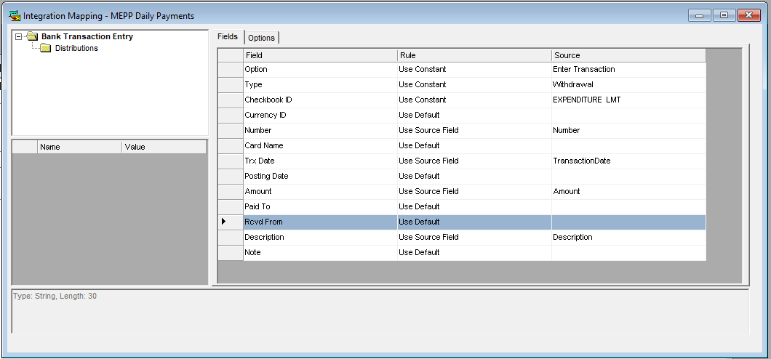

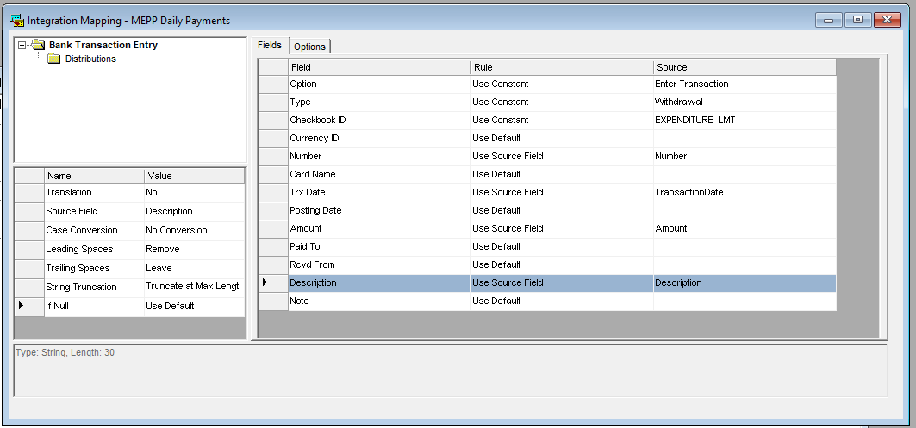

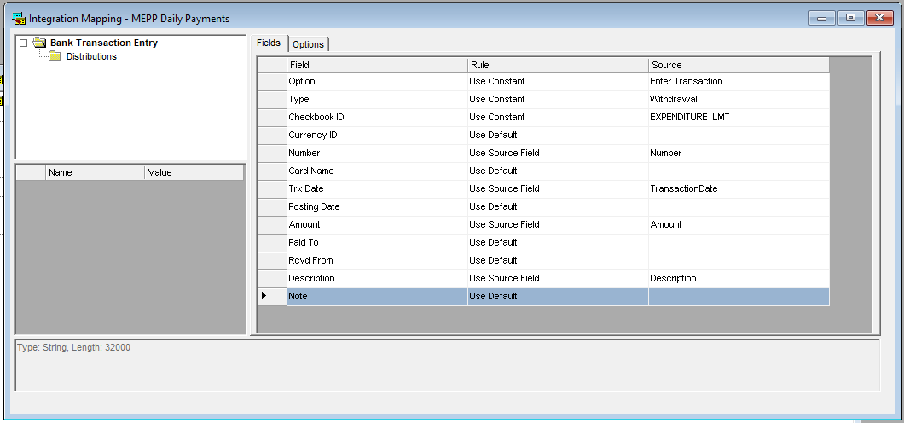

* For Deposit Integrations set field rules to the following:
  + Chequebook ID will be selected based on the plan integration you are building

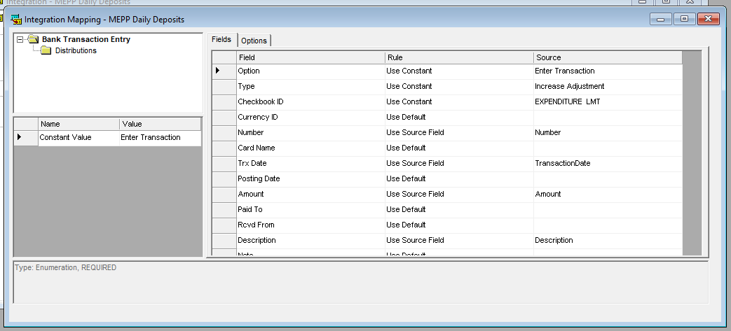

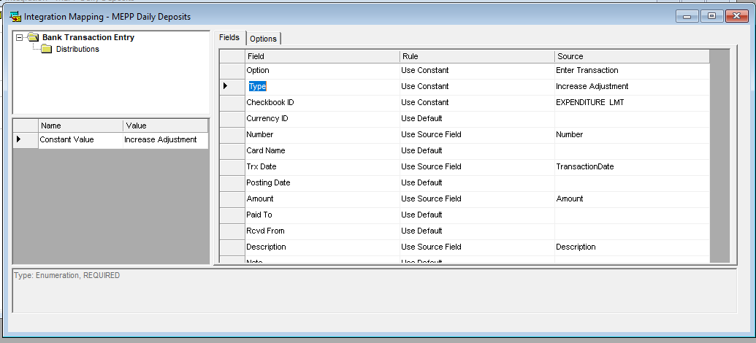

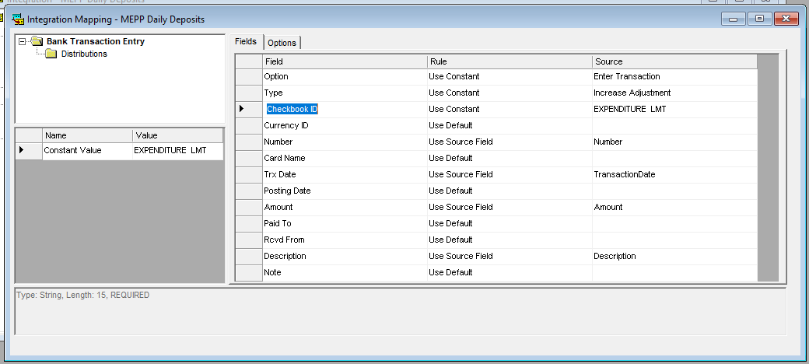

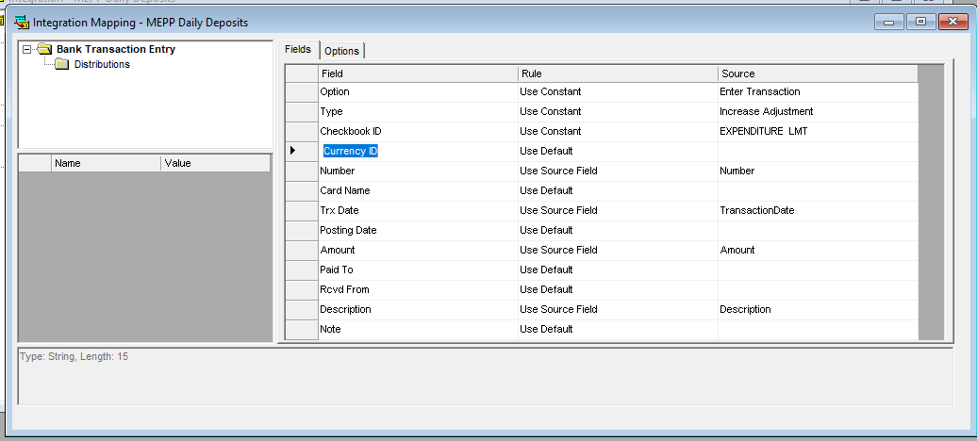

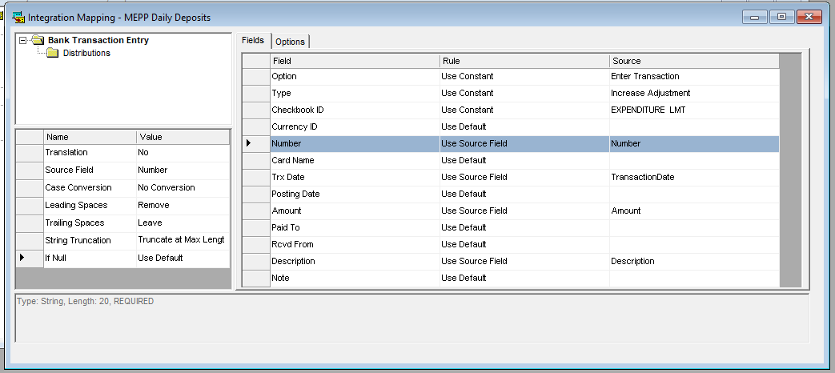

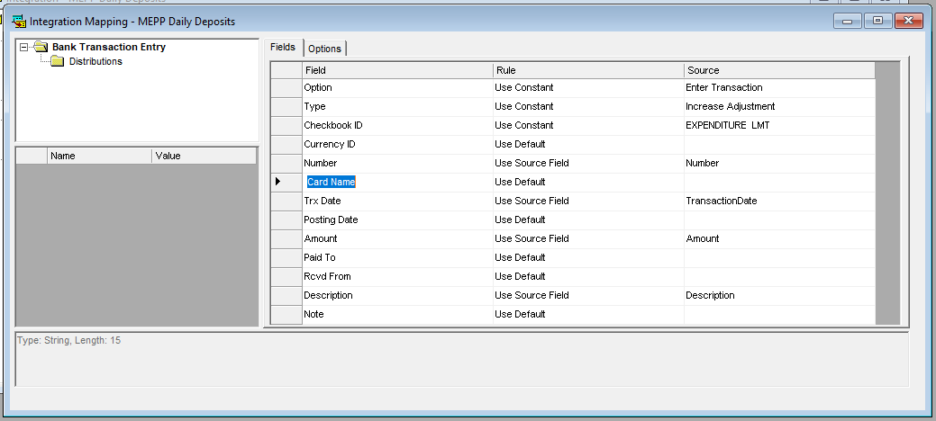

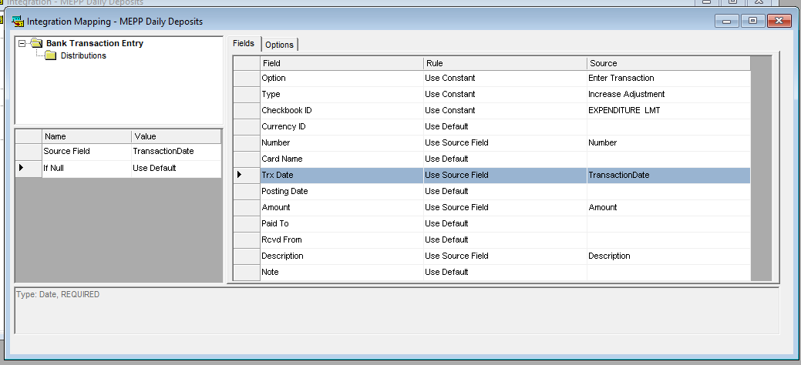

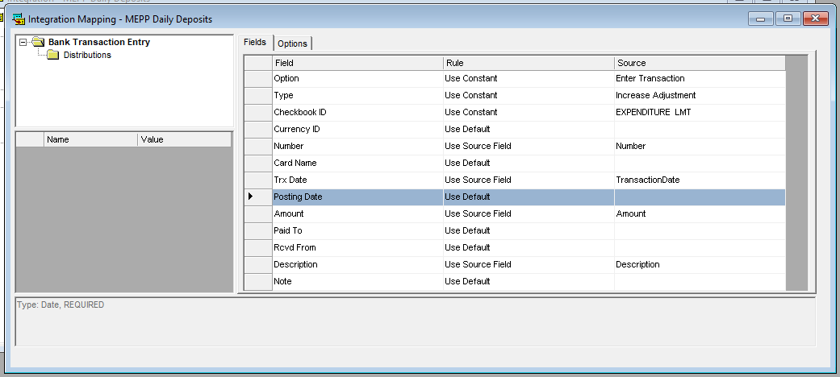

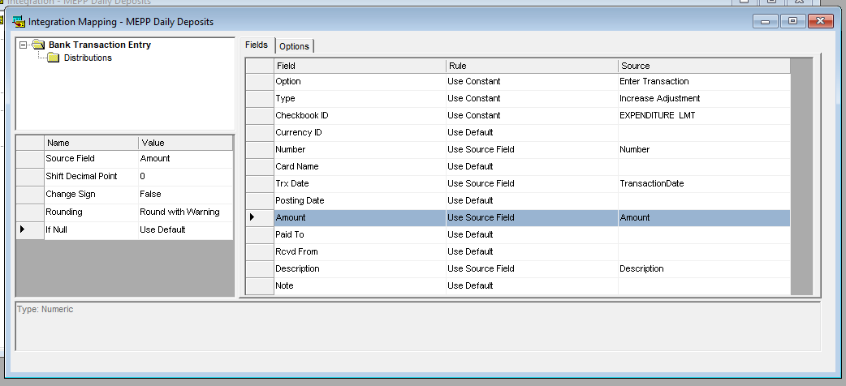

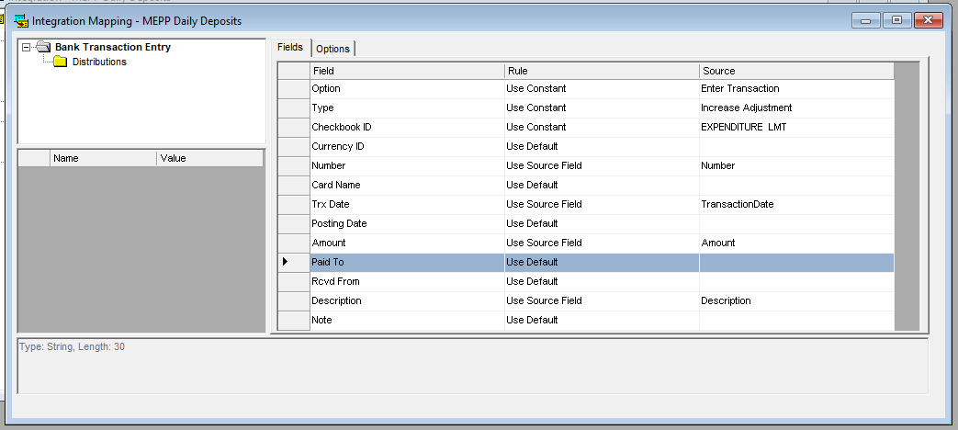

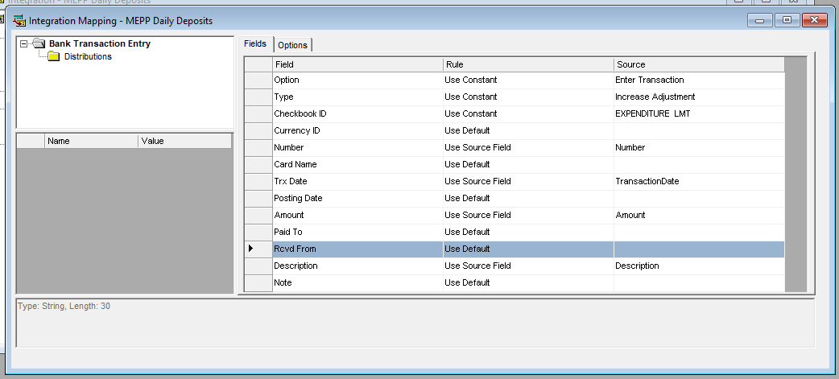

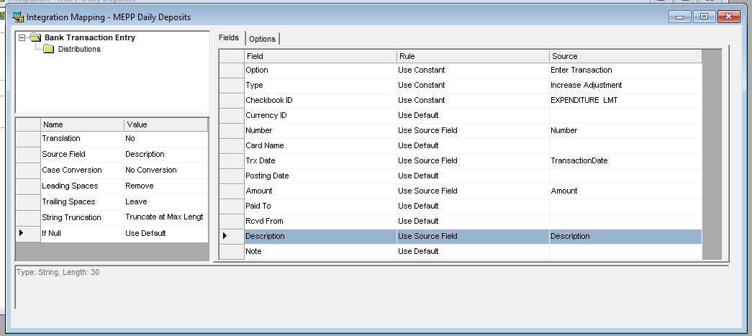

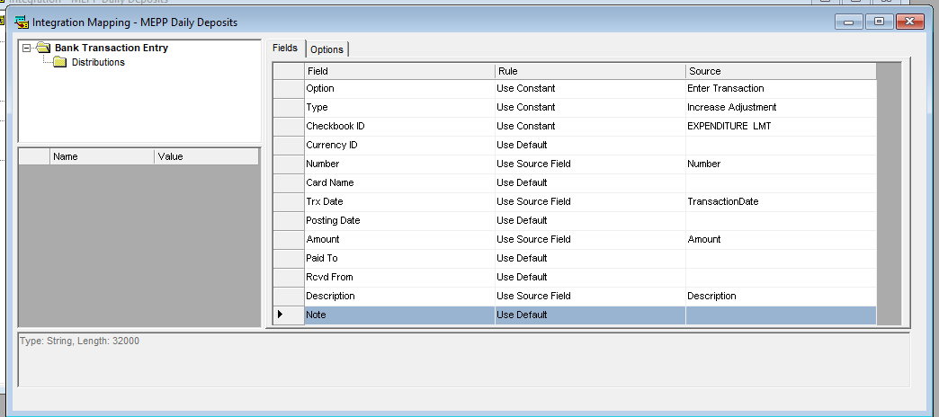

1. On the integration Mapping window after setting the Field Rules click the Options Tab and enter the correct options settings. The following options should be set by integration
   * Options for Journal Entry Integrations: Missing Batch should be set to “Add New Batch”

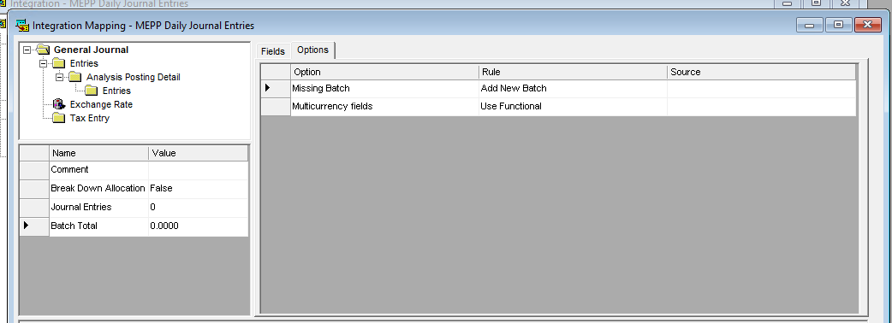

* Options for Deposit Integrations:

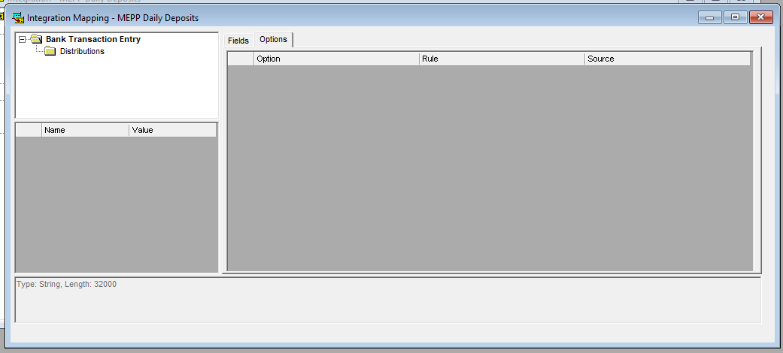

* Options for Payment Integrations:

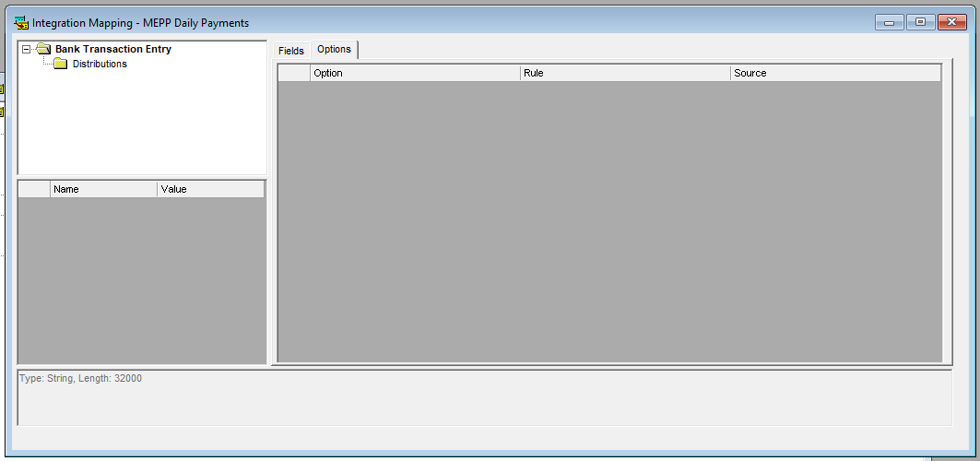

**Step:8** Ensure to Save all the changes/updates you made to the integration by pressing the Save button in the tool bar. Close Integration Manager and reopen it to ensure your integration build is completed.

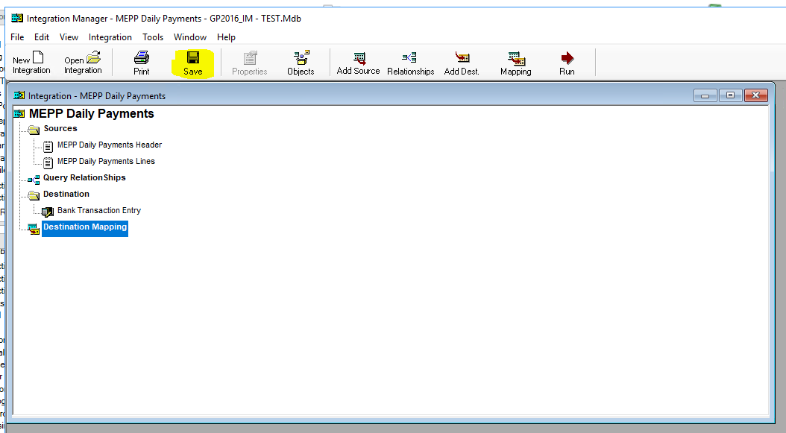

Appendix A: File Samples

1) Daily Payments file

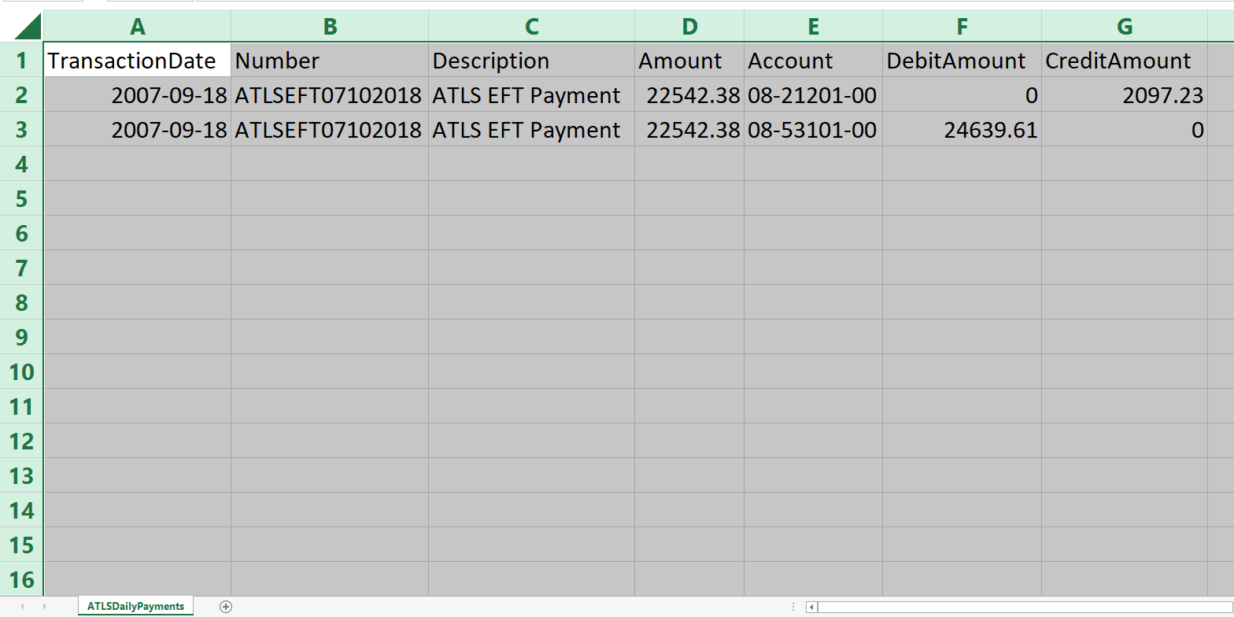

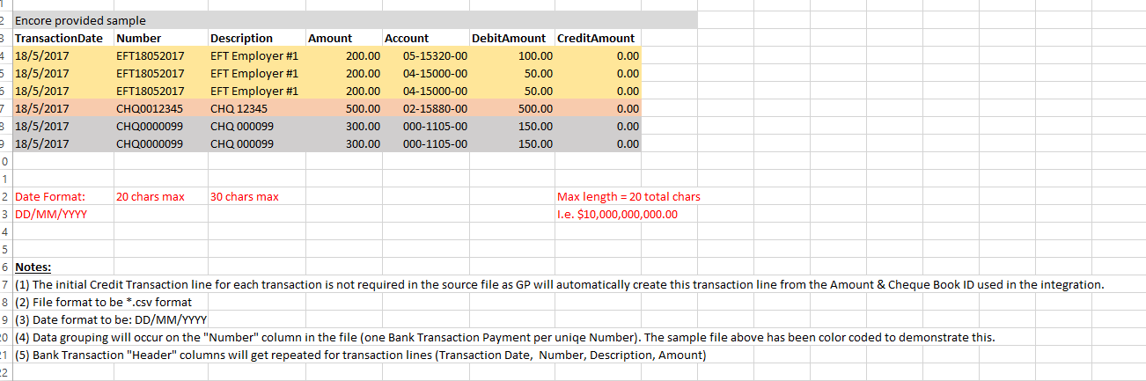

2) Daily Deposits file

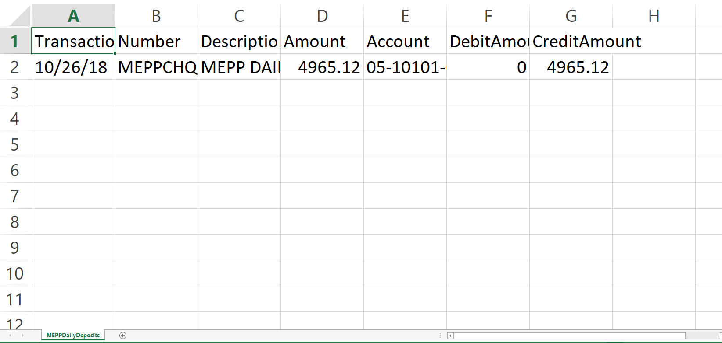



3) Daily Journal Entries file:

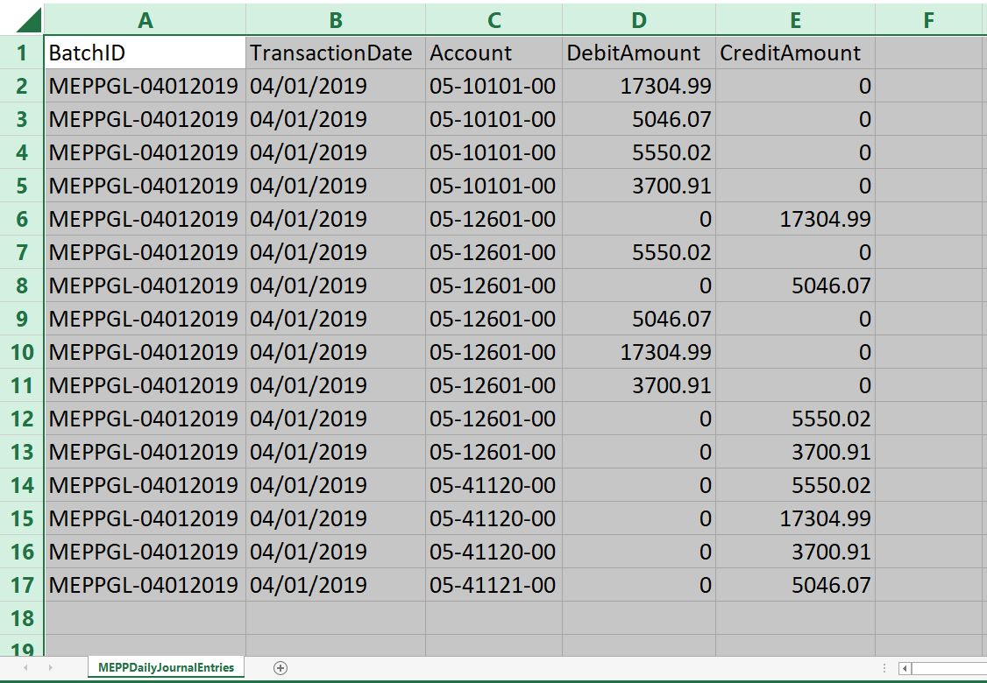

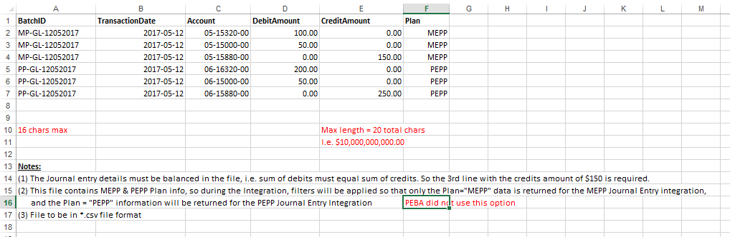

**Integration Manager - Journal Entry Integration Build with No Script:**

|  |  |
| --- | --- |
| **Procedure Number:** |  |
| **Procedure Name:** |  |
| **Purpose of the Procedure:** |  |
| **Original Date:** |  |
| **Revised Date:** |  |

|  | **Name/Title** | **Signature** | **Date** |
| --- | --- | --- | --- |
| **Reviewed by** | <Person who reviews the work> |  | <dd/mm/yyyy> |
|  |  |  |  |
|  |  |  |  |
| **Approved by** | <Senior Management / Business Area Manager> |  | <dd/mm/yyyy> |

**Overview:**

**Dynamics Great Plains/Integration Manger:**

**Journal Entry Integration Build (No Scripting):**

|  |  |
| --- | --- |
| **Procedures Documentation** |  |
| **Department:** | Business Application and Quality Assurance |
| **Prepared by:** | Regina Noels |
| **Date:** | October 26, 2020 |
| **Version:** | Draft 1.0 |

**Document Administration:**

1. **Revision History:**

| **Version** | **Date** | **Author** | **Change Description** |
| --- | --- | --- | --- |
| Draft 1.0 | Oct. 26, 2020 | Regina Noels | Initial Draft |

1. **Distribution:**

Information contained within this document is deemed confidential and is intended for use by the specific departments, business work groups, or project team members identified in the chart below. Please do not distribute without the express consent of PEBA

1. **Contributors:**

|  |  |  |
| --- | --- | --- |
| **Name** | **Title** | **Company/Department** |
| Brian |  | Encore |
| Regina | Business Analyst | Application Management and Quality Assurance Services, PEBA |
| Janine Klotz |  |  |
| Dan Gudmundson |  |  |

1. **Approval:**

|  |  |  |
| --- | --- | --- |
| **Name** | **Title** | **Company/Department** |
| Regina Noels | Business Analyst | Application Management and Quality Assurance Services, PEBA |
| Janine Klotz | Senior Manager | Finance and Planning. PEBA |
| Michael Mead |  | Application Management and Quality Assurance Services, PEBA |

1. **Purpose of Document:**

The Procedures document is a mandatory document in the Execution phase of the PEBA Change Management Process. It defines the specific procedures for this initiative at the date of testing and delivery into production. This document can be used on a go forward basis in the event that upgrades are made to our financial services dynamics’ great plains/integration manger applications or if modifications are required to the existing integration build.

**Background:**

* **Executive Summary**

Public Employees Benefits Agency uses Dynamics Great Plains application as our accounting application for recording of financial account activities. Integration Manager is part of the Dynamics suite of products which provides the ability to created custom define integrations which will automatically create journal entries in Great Plains by mapping a file from a business application to the Journal entry window in Great Plains. Using the automatic process of creating journal entries rather then a manual process reduces the risk of data entry errors. In the past we have enlisted the help of Encore to created integrations which include scripting as part of the integrated process which have caused some issues. As part of the MEPP Renewal Project implemented in Spring 2019 PEBA has decided to move forward with replacing some of these previously built scripted integrations with non-scripted integrations with the help of Encore which we can maintain inhouse on a go forward basis. As of October 2020, we have production built the MEPP journal entries from PENFAX v5 in Production, we have built the PEPP Journal entries integration from PENFAX V5 in test and we are working on building of the CIBC Mellon Investment journal integration in test.

**Overview:**

* **In Scope****:**

|  |  |  |
| --- | --- | --- |
| **ID** | **In Scope** | **Priority**  **H,M,L** |
| HLR01 | Define the file requirements for a Journal Entry integration file | H |
| HLR02 | Define the Naming Convention of the Integration file | H |
| HLR03 | Define the PEBA LAN Location of the file | H |
| HLR03 | Define the Integration Build Steps | H |

* **Out of Scope:**

|  |  |
| --- | --- |
| **ID** | **Out of Scope** |
| OS01 | Automated accounting from PENFAX for Journal entry accounting for SPAF, PSSP, STC, WCB, ATLS, LCB, JPSC, SGIP |

* **Assumptions:**

1. Maintenance (adds/deletes) of procedures are completed regularly.
2. PENFAX Scheduled Batch process is reviewed with changes to ensure this batch remains scheduled at the appropriate time.
3. MEPP Daily Journal Entries Integration file has been delivered to PEBA Dyntest as part of the MEPP renewal project and to PEBA GP production in May 2019 when PEPP renewal project went live.
4. JEA has built Daily Journal Entry Files for SPAF; PSSP; STC; WCB; ATLS; LCB; JPCS and SGIP but no mapping has been done for these plans and no GP integrations have been built for these plans. Any journal entry accounting entries for these plans is done manually.
5. PEPP Daily Journal Entries Integration file has been delivered to PEBA Dyntest in 2019 for testing of the PEPP renewal Project. The Integration build will move forward into production when PEPP renewal project is scheduled for go live
6. CIBC Mellon Investment Journal Entries integration file is being delivered

* **Constraints:**

1. Availability of internal resources (SMEs) to complete required documentation.
2. Integration builds can not be exported from one region to another due to unexplained errors which encore is not able to resolve so they have to be built net new in each region.

* **Dependencies:**

1. Upgrades to applications will require review of these procedures’ documents.
2. Upgrades to applications will require review to see if new integration manager database version is required.

* **Risks:**

Upgrades to application miss procedures documentation updates.

* **Related Documents and/or Links:**

**Terms and Abbreviations:**

| Term | Definition |
| --- | --- |
| GL | General Ledger |
| GP | Dynamics Great Plains |
| GPIF | Great Plains Integration File |
| MEPP | Municipal Employees Pension Plan |
| PEBA | Public Employees Benefits Agency |
| PEPP | Public Employees Pension Plan |
| SME | Subject Matter Expert |

**Environment:**

This section describes the technical requirements to support the Great Plains Integrations and Great Plains Application

* **Regions and databases:**

| **#** | **Application** | **Region** | **Access** | **Date Release/Refreshed** | **Database used** |
| --- | --- | --- | --- | --- | --- |
| 1 | GP | Production | Finance, IT and Encore | 2016 |  |
| 2 | GP | Remote Desktop to Dyntest or Dyntest2-M920 | Finance,  IT, QA and Encore |  |  |
| 4 | Integration Manager | Production |  | 2016 | GP2016_IM - PROD |
| 5 | Integration Manager | Remote Desktop to Dyntest or Dyntest2-M920 | Finance,  IT, QA and Encore |  | GP2016_IM-Test |
| 6 | Production remote access | DYNAMICS7 | IT, Encore |  |  |

* **PEBA LAN folders:**

Request for Lan folders are sent to Managers

| **#** | **Plan** | **Integrations from** | **Region** | **Folder Location** | **Integration Source File Name*this is a constant name and can not be changed\*** |
| --- | --- | --- | --- | --- | --- |
| 1 | MEPP | Penfax | Test | H:\PEBA\Documentation\Great Pains Test\Penfax V5 Integrations | MEPPDailyJournalEntries.csv |
| 2 | MEPP | Penfax | Production | H:\Corporate Services\Financial Services\GP Integrations | MEPPDailyJournalEntries.csv |
| 3 | PEPP | Penfax | Test | H:\PEBA\Documentation\Great Pains Test\Penfax V5 Integrations | PEPPDailyJournalEntries.csv |
| 4 | MEPP | CIBC | Test | H:\PEBA\Documentation\Great Pains Test\CIBC Investment Integrations | MEPPInvestmentJE.csv |
| 5 | PEPP | CIBC | Test | H:\PEBA\Documentation\Great Pains Test\CIBC Investment Integrations | PEPPInvestmentJE.csv |

* **GP Test Accounts:**

Test accounts are shared by Finance and QA the Account user ID’s and Passwords are maintained by QA and stored in the QA Test systems spreadsheet

**Application and Components:**

1. **Applications:**

| **#** | **Application** | **Current Version** | **Date Release** | **Question/Issue** |
| --- | --- | --- | --- | --- |
| 1 | GP | 16.00.0439 | 2016 |  |
| 2 | Integration Manager | 16.00.0406 | 2016 |  |
|  |  |  |  |  |

1. **Application Components:**

| **#** | **GP Components** | **Current Version** | **Date Release** | **Question/Issue** |
| --- | --- | --- | --- | --- |
| 1 | Mekorma |  | 2016 |  |
| 2 | Doc link |  | 2019 |  |
|  | F9 |  |  |  |

1. **Application Companies and Checkbooks/Plans by Company:**

| **#** | **Companies** | **Checkbooks/Plans** | **Question/Issue** |
| --- | --- | --- | --- |
| 1 | December 31 Funds/Plans | Benefits; LIQ, RAF, SGIP, WCB, MEPP/expenditure |  |
| 2 | March 31 Funds/Plans | ATB, Judges, PSSP, RAF, SPAF, STC |  |
| 3 | PEBA Revolving Fund | expenditure |  |
| 4 | Public Employees Pension Plan | PEPP |  |

1. **Application Release Schedules:**

| **#** | **Release Schedules** |  |  |  | **Question/Issue** |
| --- | --- | --- | --- | --- | --- |
| 1 | What are they and what is the frequency |  |  |  |  |
| 2 |  |  |  |  |  |
|  |  |  |  |  |  |

* **Release Schedules Dependencies:** When GP is upgraded the applications, do all applications components within GP get upgraded as well?
* **Release Schedules Constraints:** What other projects are in progress Availability of SME(s) for coordination and testing?

1. **Support Services:**

You have noted the vendor’s name in the contact, but I would put as much information in here that you can about what the maintenance arrangement is with the vendor; how you log tickets; how you prioritize, etc.

When a refresh of test environment is completed any existing integration builds that have any script builds in the integration have to be configured to comment out the script that points to the production region and add a comment to point to the test region. If this is not done then when an integration is tested it will update data in the production environment.

1. **Sign Off:**
2. Janine Klotz, Senior Manager, Finance and Planning, PEBA
3. Regina Noels, Business Analyst, Application Management and Quality Assurance Services, PEBA

| **#** | **Project** | **Region** | **Date** |  | **SIGN OFF** |
| --- | --- | --- | --- | --- | --- |
| 1 | MEPP Renewal | Test | 2018 |  | Regina/Janine |
| 2 | MEPP Renewal | Production | 2019 |  | Regina/Natalia/Janine |
| 3 | PEPP Renewal | Test | 2019/2020 |  | Regina/Natalia/Brittany |
| 4 | CIBC Investments | Test | Oct 2020 |  | Regina/Janine |

**Open Items/Questions/Notes:**

| **#** | **Date Raised** | **Status** | **Question/Issue** |
| --- | --- | --- | --- |
| 1 |  |  |  |

**GP Integration File Output Specifications and File Lay out Specifications by Project:**

This section is divided into GP Integration File Output Specifications by project and GP Integration File Layout

Defining the details of the file output specifications and the file lay out specifications is a joint effort between Finance/QA/Vendor

* **ID**: A unique identification number given to a requirement in order to make it traceable throughout the development process.
* **Specification**: Provides a description to explain the business requirement. It should be correct, feasible, prioritized within its section, unambiguous, verifiable and highlight any related requirements.
* **Priority**: Ranking of business priority for the requirement:
  + **H** = High = Critical and needs to be delivered;
  + **M** = Medium = Seen as adding value to the offering and would be good to include;
  + **L** = Low = Not critical to the delivery of the project and can be delivered at a later stage.

| **Field Number** | **Field** | **Type** | **Max Length** | **Data source: from PENFAX** | **Comments** |
| --- | --- | --- | --- | --- | --- |
| 1 | BatchID | Format name = %-GL-MMDDYYYY where % equals 4 digits plan code and date equals the transaction date | 16 | coded | Example: MEPPGL-10232020 |
| 2 | TransactionDate | Format Date (MM/DD/YYYY) | 10 | Equal to the Journal Entry Date column on the General Ledger screen in PENFAX | E.g. 09/30/2020 |
| 3 | Account | Format as they were provided to JEA (i.e. Include dashes) include hyphens; E.g. 05-41201-60 | 11 | Equal to the Entity Account column on the General Ledger screen in PENFAX | Based on PEBA’s mapping documentation |
| 4 | DebitAmount | Numeric (2 decimals) | 20 | Equal to the Debit Amount column on the General Ledger screen in PENFAX | *see note below |
| 5 | CreditAmount | Numeric (2 decimals) | 20 | Equal to the Credit Amount column on the General Ledger screen in PENFAX |

**MEPP Renewal Project:**

**MEPP Daily Journal Entries Extract GP Integration File Output Specifications:**

This batch process will include journal entries that do not debit or credit the 05-11101-00 Bank – GRF account.

| **ID** | **Specification** | | **Priority** |
| --- | --- | --- | --- |
| 9.1.01 | Filename | PLANDailyJournalEntries_MMDDYYYY.csv where PLAN = Plan ID which is equal to Plan short name – **Note**: JEA has hard coded a plan ID equal to plan short name configuration – see PEBA -1433 changes to short name do not get updated in the extract files.  Example: MEPPDailyJournalEntries_09302020.csv | H |
| 9.1.02 | File Header | File header record is not required on the output file. The first row of the file should identify the name of the field(s) that will be integrated into Dynamics GP. They are BatchID, TransactionDate, Account, DebitAmount and CreditAmount. | H |
| 9.1.03 | File Data -Content | Body of file records will be sourced from PENFAX V5 Journal entries that do not that do not debit or credit the 05-11101-00 Bank – GRF account | H |
| 9.1.04 | File Data -Zero activity | n/a | L |
| 9.1.05 | File Data - Accounts | MEPP Accounts Mapping Document completed | H |
| 9.1.06 | File Trailer | File trailer record is not required on the output file. | H |
| 9.1.07 | File Format | File must be in ‘csv’ format with comma as the delimiter. No quotations are required around the data within the file unless the data, for a specific field, contains a comma “,” as part of the data, in this case quotations around that data would be required. | H |
| 9.1.08 | File Delivery Method | File is produced in the PENFAX scheduled batch process | H |
| 9.1.09 | File Delivery Frequency | The batch process will run every morning at 12:30am. If the prior day was a business day which are identified as being a weekday that is not on the list of blackout dates (i.e. statutory holidays), then the process will include transactions for all previous days until it reaches the first business day and include them in the extract file. For example, it will run at 12:30 am on Saturday and include Friday's transactions, and then not again until 12:30 am on Tuesday where it will include Monday's transactions plus any that occurred on Sunday or Saturday. If there are no journal entries for a given day, an empty file will be produced. | H |

**MEPP Daily Journal Entries Extract GP Integration File Layout - Body (Content) Records:**

All required fields in the body records are mandatory.

* All amounts in Canadian currency.

Report one (1) dollar amount per line either as debit or credit.

Report one (1) offsetting 0.00 amount per line either as debit or credit.

Report only positive amounts in the file.

**PEPP Renewal Project - PEPP Daily Journal Entries Extract GP Integration File Output Specifications**:

This batch process will include journal entries that do not debit or credit the 05-11101-00 Bank – GRF account.

| **ID** | **Specification** | | **Priority** |
| --- | --- | --- | --- |
| 9.2.01 | Filename | PLANDailyJournalEntries_MMDDYYYY.csv where PLAN = Plan ID which is equal to Plan short name – **Note**: JEA has hard coded a plan ID equal to plan short name configuration – see PEBA -1433 changes to short name do not get updated in the extract files.  Example: MEPPDailyJournalEntries_09302020.csv | H |
| 9.2.02 | File Header | File header record is not required on the output file. The first row of the file should identify the name of the field(s) that will be integrated into Dynamics GP. They are BatchID, TransactionDate, Account, DebitAmount and CreditAmount. | H |
| 9.2.03 | File Data -Content | Body of file records will be sourced from PENFAX V5 Journal entries that do not that do not debit or credit the 02-11101-00 Bank account | H |
| 9.2.04 | File Data -Zero activity | n/a | L |
| 9.2.05 | File Data - Accounts | MEPP Accounts Mapping Document completed | H |
| 9.2.06 | File Trailer | File trailer record is not required on the output file. | H |
| 9.2.07 | File Format | File must be in ‘csv’ format with comma as the delimiter. No quotations are required around the data within the file unless the data, for a specific field, contains a comma “,” as part of the data, in this case quotations around that data would be required. | H |
| 9.2.08 | File Delivery Method | File is produced in the PENFAX scheduled batch process | H |
| 9.2.09 | File Delivery Frequency | The batch process will run every morning at 12:30am. If the prior day was a business day which are identified as being a weekday that is not on the list of blackout dates (i.e. statutory holidays), then the process will include transactions for all previous days until it reaches the first business day and include them in the extract file. For example, it will run at 12:30 am on Saturday and include Friday's transactions, and then not again until 12:30 am on Tuesday where it will include Monday's transactions plus any that occurred on Sunday or Saturday. If there are no journal entries for a given day, an empty file will be produced. | H |

**PEPP Renewal Project - PEPP Daily Journal Entries Extract GP Integration File Layout - Body (Content) Records:**

All required fields in the body records are mandatory.

| **Field Number** | **Field** | **Type** | **Max Length** | **Data source: from PENFAX** | **Comments** |
| --- | --- | --- | --- | --- | --- |
| 1 | BatchID | Format name = %-GL-MMDDYYYY where % equals 4 digits plan code and date equals the transaction date | 16 | coded | Example: MEPPGL-10232020 |
| 2 | TransactionDate | Format Date (MM/DD/YYYY) | 10 | Equal to the Journal Entry Date column on the General Ledger screen in PENFAX | E.g. 09/30/2020 |
| 3 | Account | Format as they were provided to JEA (i.e. Include dashes) include hyphens; E.g. 05-41201-60 | 11 | Equal to the Entity Account column on the General Ledger screen in PENFAX | Based on PEBA’s mapping documentation |
| 4 | DebitAmount | Numeric (2 decimals) | 20 | Equal to the Debit Amount column on the General Ledger screen in PENFAX | *see note below |
| 5 | CreditAmount | Numeric (2 decimals) | 20 | Equal to the Credit Amount column on the General Ledger screen in PENFAX |

* All amounts in Canadian currency.

Report one (1) dollar amount per line either as debit or credit.

Report one (1) offsetting 0.00 amount per line either as debit or credit.

Report only positive amounts in the file.

**CIBC Custodian Project – Investment GP Integration File Output Specifications:**

| **ID** | **Specification** | | **Priority** |
| --- | --- | --- | --- |
| 9.4.01 | Filename | PLANInvestmentJE_MMDDYYYY.csv where PLAN = PEPP or MEPP  Example:  PEPPInvestmentJE_09302020.csv  MEPPInvestmentJE_09302020.csv | H |
| 9.4.02 | File Header | File header record is not required on the output file. | H |
| 9.4.03 | File Data -Content | Body of file records will be sourced from IAS using the NEXEN report called General Ledger Detail. Reference Section 4.2. | H |
| 9.4.04 | File Data -Zero activity | NEXEN/IAS General Ledgers with zero activity will be omitted from the file. | H |
| 9.4.05 | File Data - Accounts | PEPP and MEPP accounts; A NEXEN group account will be used to capture accounts. | H |
| 9.4.06 | File Trailer | File trailer record is not required on the output file. | H |
| 9.4.07 | File Format | File must be in ‘csv’ format with comma as the delimiter. No quotations are required around the data within the file unless the data, for a specific field, contains a comma “,” as part of the data, in this case quotations around that data would be required. | H |
| 9.4.08 | File Delivery Method | Secure file delivery of 2 files (one for PEPP and one for MEPP) via SFTP to PEBA required. NEXEN Scheduling and Distribution functionality will be used. | H |
| 9.4.09 | File Delivery Frequency | Prior Month end Period, When Accounting is Final | H |

**GP Integration File Layout - Body (Content) Records:**

All required fields in the body records are mandatory.

| **Field Number** | **Field** | **Type** | **Max Length** | **Data source: Column Name from NEXEN General Ledger Detail Report** | **Comments** |
| --- | --- | --- | --- | --- | --- |
| 1 | BatchID | Format “PLANMMDDYYYY” E.g. MEPP09302020 | 16 | Reporting Account Number |  |
| 2 | TransactionDate | Date (MM/DD/YYYY) | 10 | End Date | Last day of the month being reported; E.g. 09/30/2020 |
| 3 | Account | Text in the following format: TT-TTTTT-TT; include hyphens; E.g. 05-41201-60 | 11 | Gen Ledger Acct | Based on PEBA’s Chart of Accounts which will be mapped to NEXEN/IAS GL Accounts |
| 4 | DebitAmount | Numeric (2 decimals) | 20 | GL Activity | *see note below |
| 5 | CreditAmount | Numeric (2 decimals) | 20 | GL Activity |

* All amounts in Canadian currency.

Report one (1) dollar amount per line either as debit or credit.

Report one (1) offsetting 0.00 amount per line either as debit or credit.

Report only positive amounts in the file.

DebitAmount column represent increases in Asset/Expense GLs or decreases in Liability/Income/Capital GLs.

CreditAmount column represent decreases in Asset/Expense GLs or increases in Liability/Income/Capital GLs.

**GP Journal Entry Integration Build:**

**User:**

**Request the PEBA Lan Folder be created if it has not already been created**

This is the folder where you will save your source file in so it can be linked to your integration build. Folders are noted in item 5.2 above must be created if they do not already exist **PEBA LAN folders**

**Create the source journal entry file**

This is the file which will be linked to your integration build that will hold the journal entry details that will integrate into GP. This file must be saved to the appropriate folder noted in item 5.2 above. **PEBA LAN folders**

To create a source file, you can copy an existing source file; then rename the file to suit your build purposes; then modify the details of the file based on the file output specifications and file lay out specification for the project that get outlined in item 9 above. GP Integration File Output Specifications and File Lay out Specifications by Project (Example: When building the MEPPInvestmentJE source file I copied the MEPPDailyJournalEntries.csv file to the folder H:\PEBA\Documentation\Great Plains Test\CIBC Investment Integrations, then had finance modify the details of the file to add records as per item 9.5 and 9.6 above

**Begin Building the integration.**

Integrations can not be copied from one environment to another. They have to be built new in each PEBA environment. You must build the integration first in the test environment, have finance test it and once they provide signoff and approve for move to production you can build in production after it passes through the appropriate PEBA change management process.

**Test Integration Build**

Make a back up of the current integration manager database, if one has not yet been made

The integration databases are identified in item 5.1 above Regions and databases

Open H:\PEBA\Documentation\Great Plains Test. 1. Make a copy of file GP2016_IM-TEST.Mdb and save to the save folder. 2. Rename the copy to include BAK and the date that you made the copy “GP2016_IM - TEST - BAK_YYYYMMDD. Mbd”. 3. Move any older BAK files into the Archive folder as we should only ever have one BAK up file of the current database.

64 copy the current database and save to the same folder

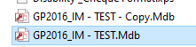

65 Rename the copy to be BAK_YYYYMMDD

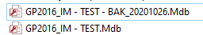

66 Move any old BAK files into the Archive folder

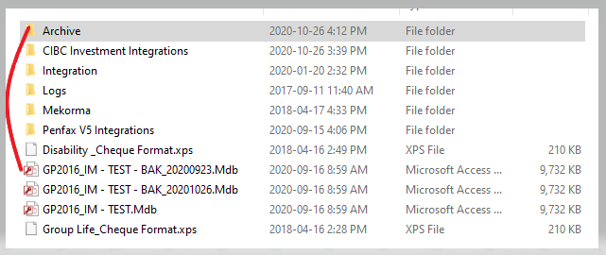

Use Remote Desktop to log into either Dytest or Dyntest2-M920 machine.

User name is PEBA LAN user name.

Password id PEBA LAN password

Use the show/hide Options selections on the bottom left corner to enter your user name.

If you do not have access to the test machines send a request to IT Help with a CC to Michael.

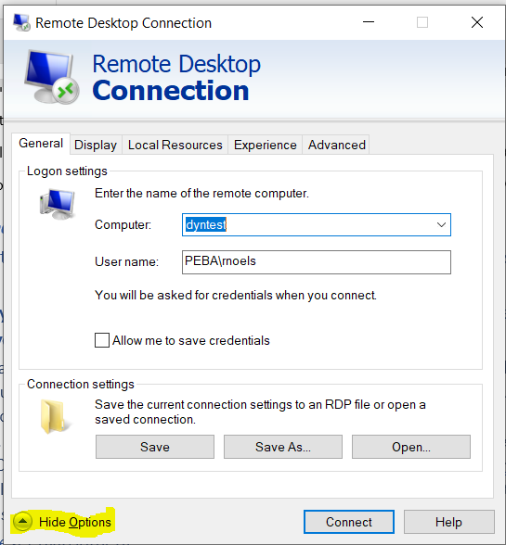

Select Ok to the Security Disclaimer

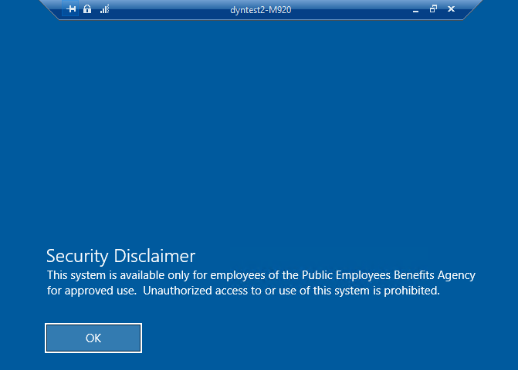

Search for Integration Manager application and open it confirm that it is Version 16

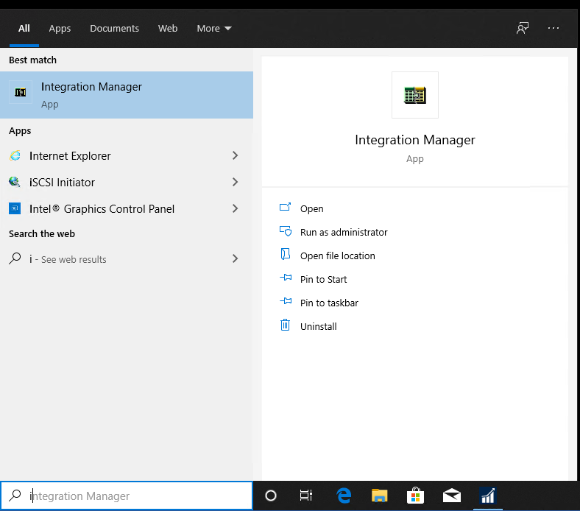

Be sure that you are pointed to the correct data base before proceeding with the integration build

The database is configured by individual user id, so every employee who logs into the application has to point to the correct database. The data base is reported in the title of the window. **For a test build** if it does not read “GP2016_IM-TEST.Mdb do not proceed until you have changed the data base as instructed below.

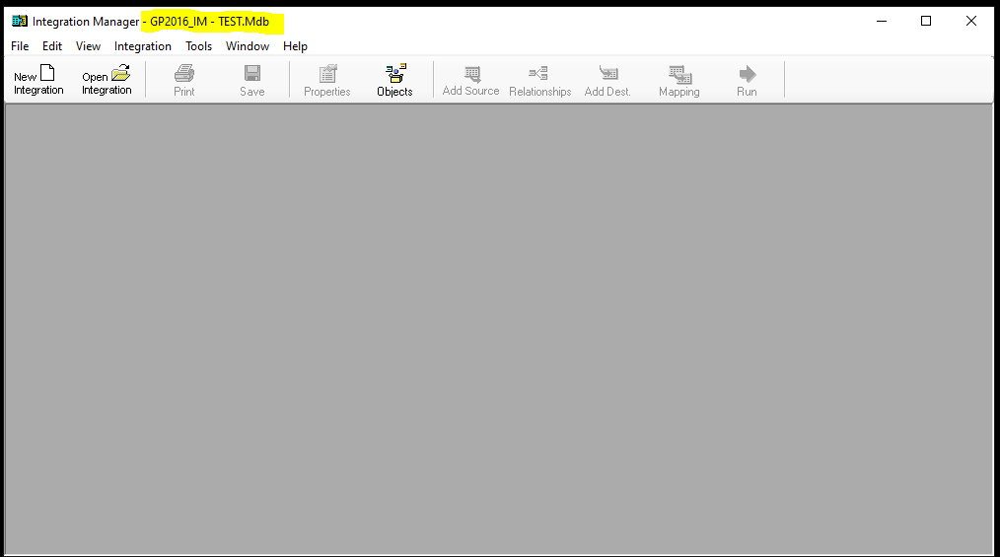

**To point to the correct database**, 1 select tools, options; 2 using the search file path search button navigate to the correct database and select it; 3 once selected press the apply button and the ok button on the options window; 4 close Integration Manager application and re-open to see the database change to the correct one.

* + - 1. Select Tools, Options

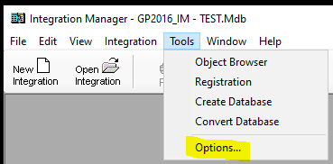

* + - 1. Using the search file path search button navigate to the correct database and select it

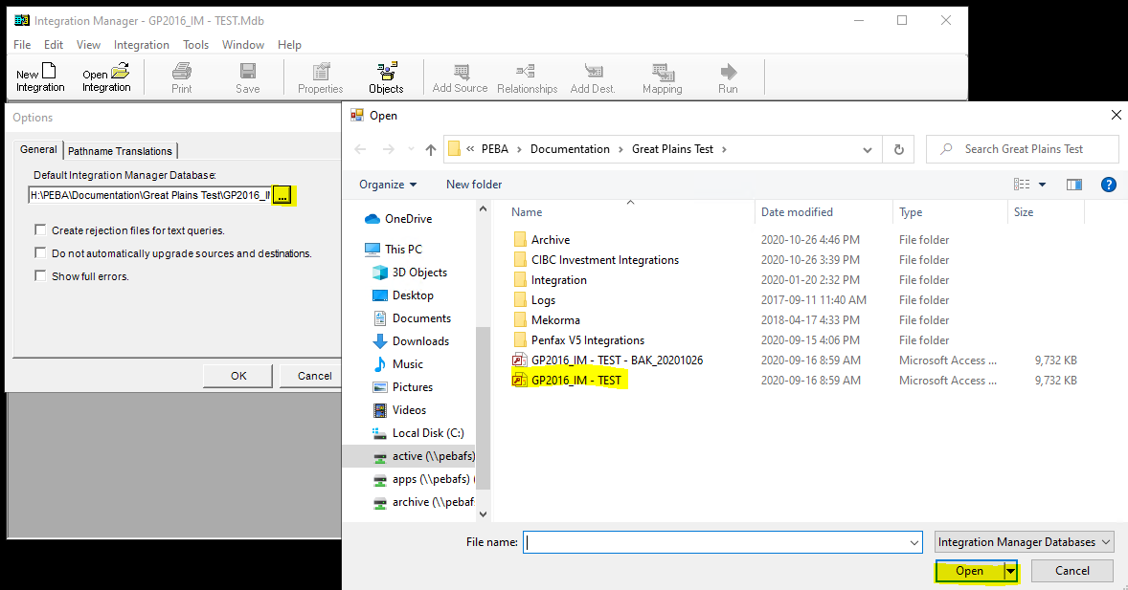

1. Press “Apply” button and “Ok” button

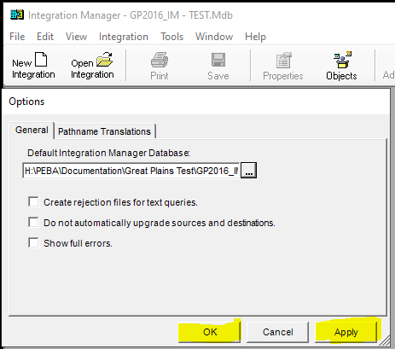

1. Close Integration manager using the X then reopen the application and the correct database will display in the title bar.

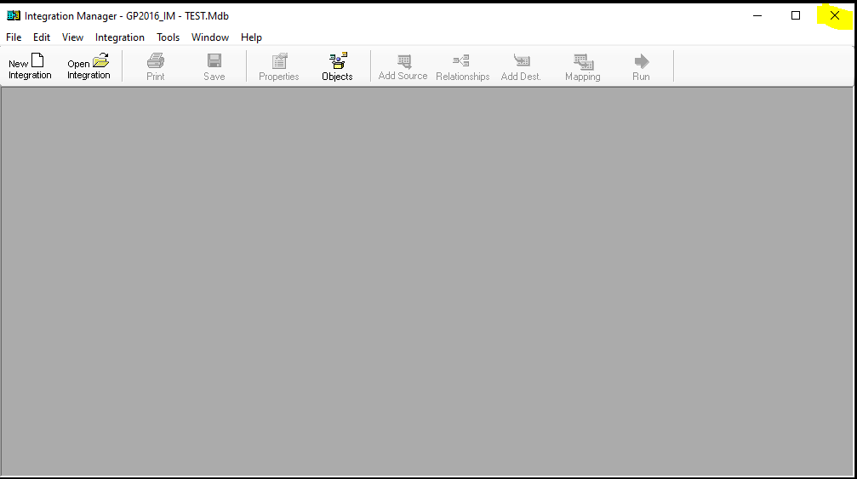

Press New Integration button

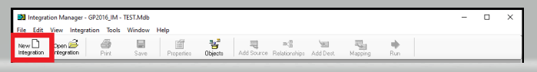

* A new integration build is automatically opened, which includes assigning of a default integration name (Integration 2) and the folder creation for Sources, Destination and Destinations Mapping. Note: as you work through the process of the build you will define additional information under each of these folders.
* A properties Window is automatically opened which requires input of information.

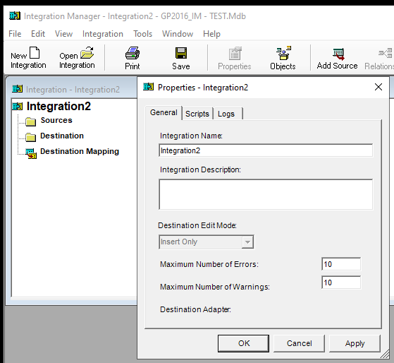

On Properties – Integration 2 window

**General Tab**

Update the Integration Name: Enter the integration name that finance will choose when they use the integration you are building. See Appendix A for listing of Integrations and names in Production and in Test

Add a description of what this integration will do:

Update the Maximum Number of Errors: from 10 to 9999

Update the Maximum Number of Warnings: from 10 to 9999

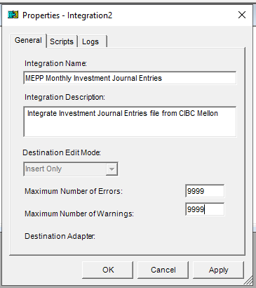

On the Scripts Tab – do nothing



On the Logs Tab – do nothing



Click Apply, then Click OK – the integration name is now updated

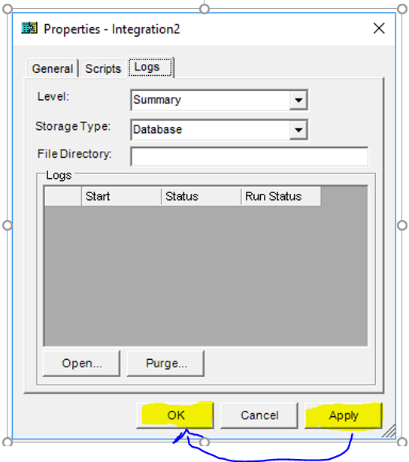

The name of your Integration is now displayed in the integration and on the title of the window.

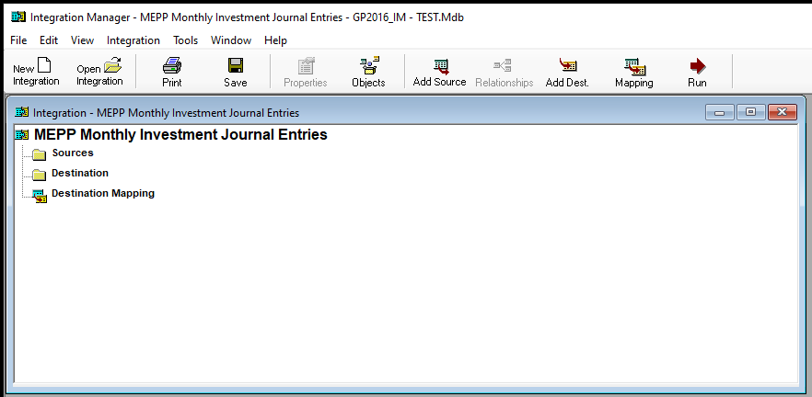

**Add Sources**

Either use opposite mouse button on the source folder or click the add source button in the tool bar

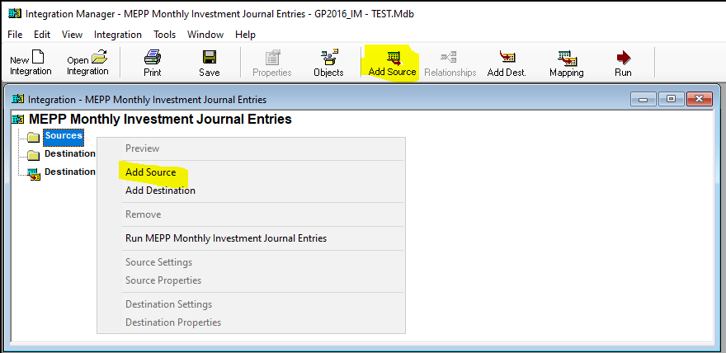

An Add Source Window will open, under ODBC/Text Folder select Text then Select Define New Test a Properties – Query 26 window will open – this window will require you to input information related to the source file that holds the details that you will be integrating into Great Plains

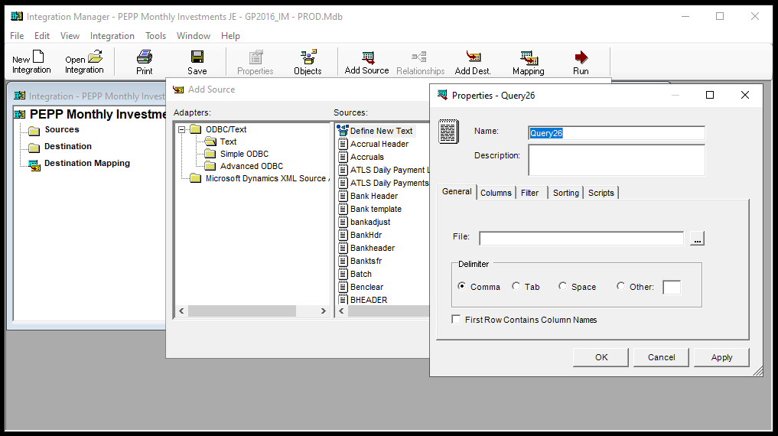

Properties – Query 26 window

General Tab

Enter the name of your Source file

Select the path to the file location of your source file

Check the first row contains column names check box

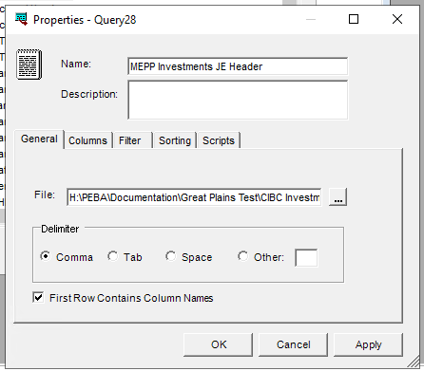

Columns Tab – do nothing (column names displayed should be Batch ID; TransactionDate; Account; DebitAmount; CreditAmount, data type should report string and Show indicator should be checked for all Column names)

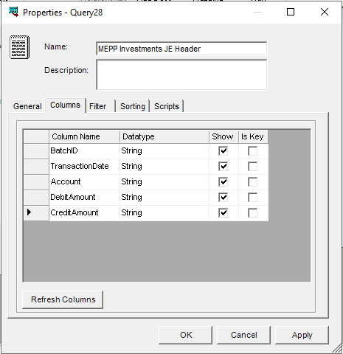

Filters Tab – do nothing

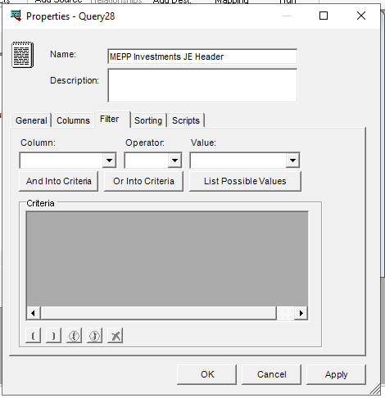

Sorting Tab - For Journal Entry Integrations apply a sorting of Group By, BatchID and TransactionDate

To add the Group By sorting simply click in the empty field and a selection list will be populate for you to make your selections.

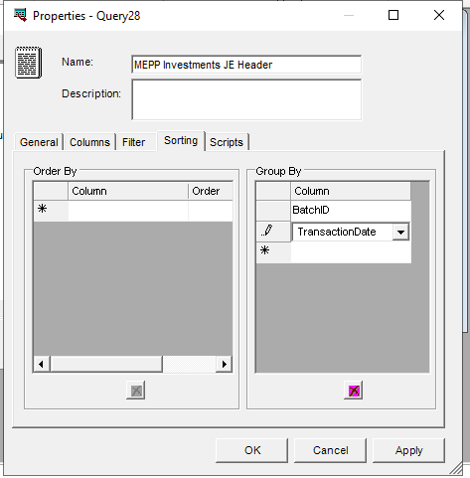

Scripts Tab – do nothing

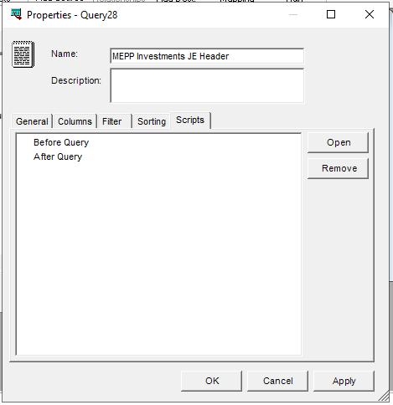

Click Apply and OK to the message then click OK – the source build is now displayed under sources in your integration

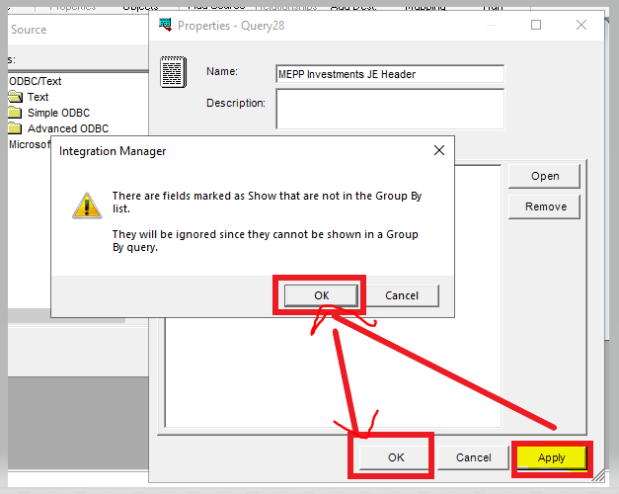

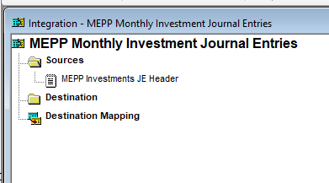

Repeat the above steps to add you Lines Source – **differences** in the build are the name field should report Lines instead of header and nothing is required for the sorting tab (see difference screen prints below) When apply and OK is press the Lines Source build is displayed in the integration

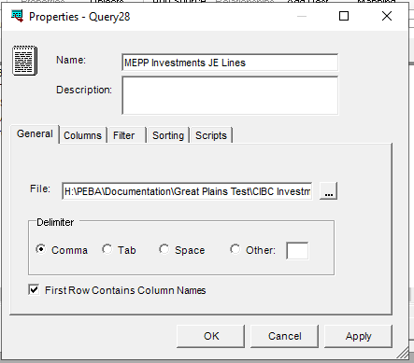

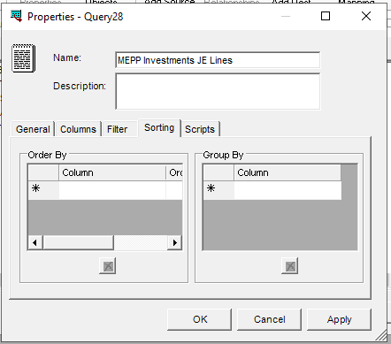

When apply and OK is pressed the Lines Source build is displayed in the integration and you will receive a relationships message – Press OK to continue

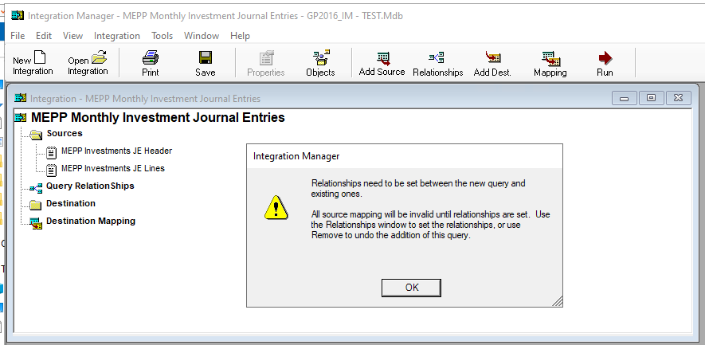

Click on the Query Relationships title to open the window and build the relationships between the source file header and details.

To build the relationship simple click the title in the header table and drag you click to the lines table you will see a + sign in the lines table when you see the plus time unclick and the relationship line will display.

Build the relationship to both items from the Header table. Close the relationship window

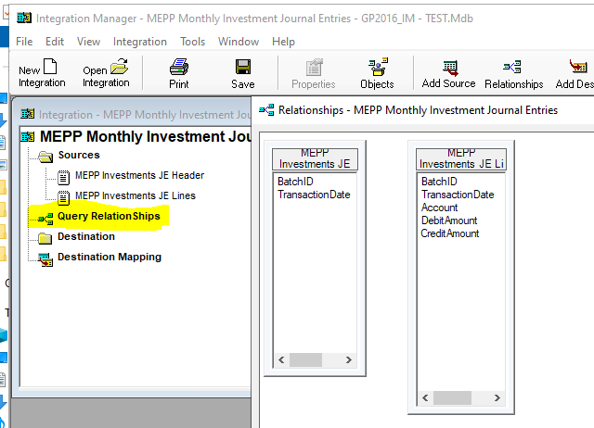

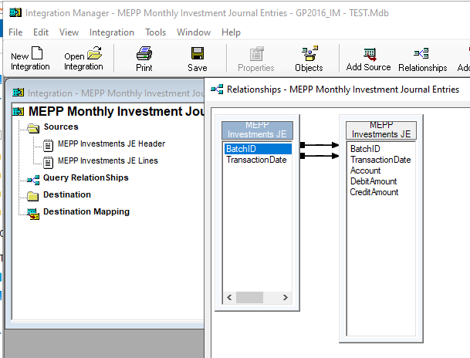

Close the Relationships window by clicking the X in the right top corner

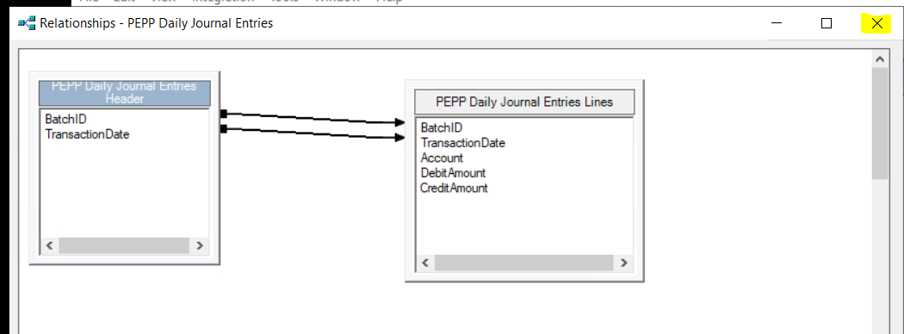

Build the destination for the integration – using opposite mouse on the destinations folder select Add destination or using the Add dest button in the tool bar

IN the Adapters section of the window Open the folder Microsoft Dynamics GP -> Financial and select General Journal in the destinations. Press the “Open” button – General Journal now displays under destination

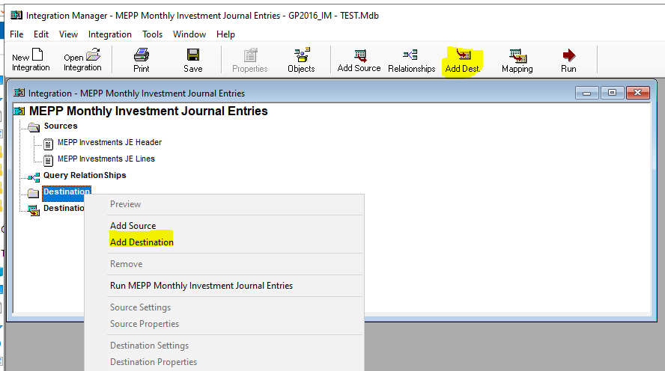

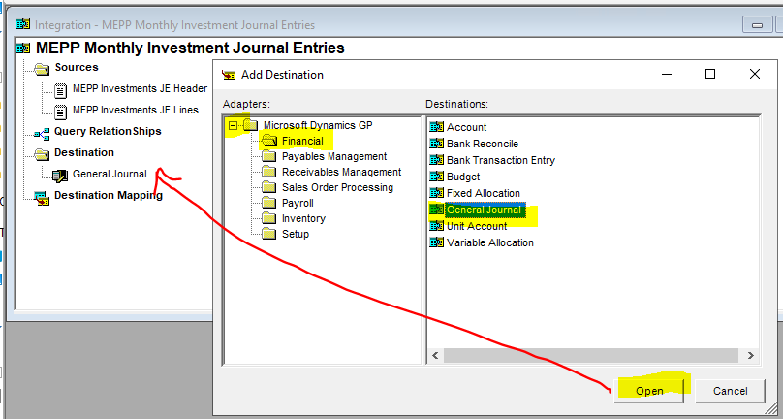

**Build the Destination Mapping** - This is the place that GP will look for the information for the fields on the GP window that need to be filled in for the type of transaction the integration is creating.

Click “Mapping” button in the menu bar or double click the destination mapping folder in the integration.

When the Integration Mapping window opens, you may need to make the window bigger to see all the folder in the left top portion of the window. To do this simply click on the bottom right corner of the window and pull to expand the window.

Select the General Journal Folder and select the fields tab

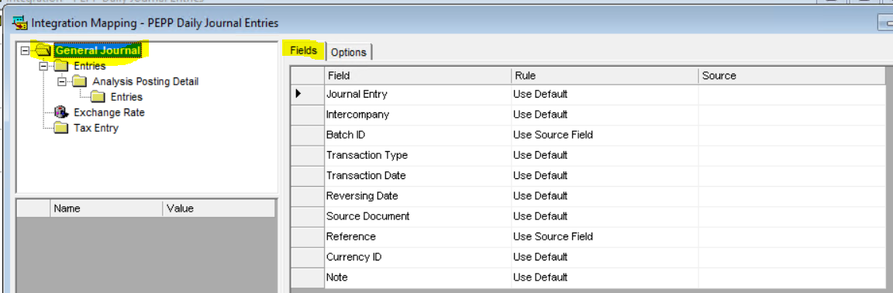

Apply the following Rules: Ensure the Source object is the Header object, if the Header object is not displayed pick it from the drop-down list.

|  |  |  |
| --- | --- | --- |
| Field | Rule | Source |
| Journal Entry | Use Default |  |
| Intercompany | Use Default |  |
| Batch ID | Use Source Field | Batch ID |
| Transaction Type | Use Default |  |
| Transaction Date | Use Source Field | TransactionDate |
| Reversing Date | Use Default |  |
| Reference | Use Source Field | Batch ID |
| Currency ID |  |  |

*To change the rule, click in the rule field and select from the drop-down list

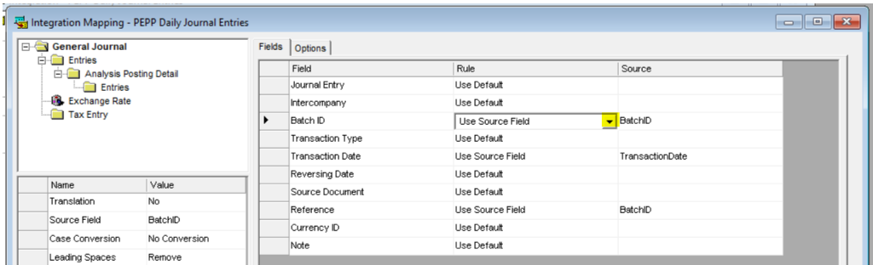

*to add a source, click in the source field and ensure that the source object is Header and choose the correct source from the list

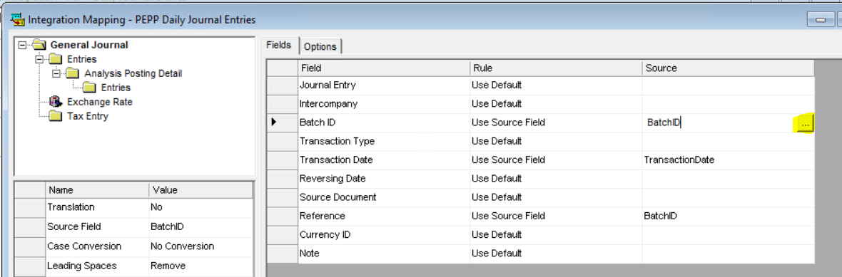

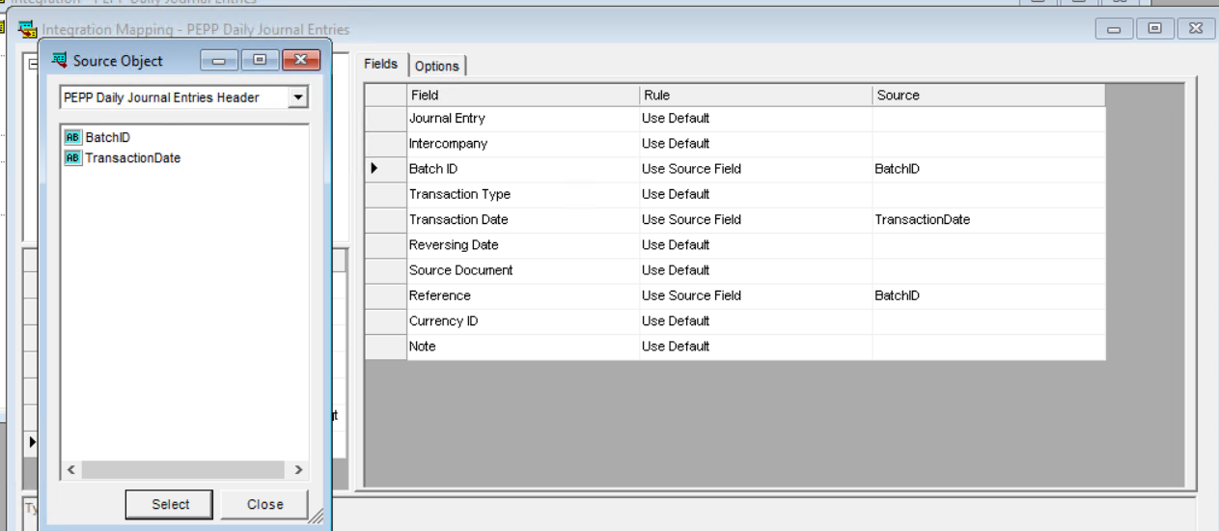

Select the General Journal Folder and the Options Tab

Apply the following rules

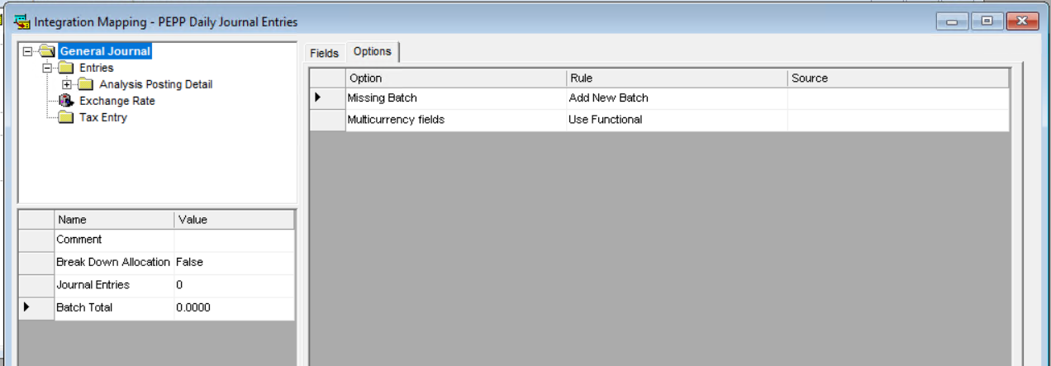

Open folder General Journal->Entries-> on the fields tab apply your source fields – the name of the source fields will vary depending on the integration name you are building. These source field values will come from the “lines” source so be sure that the drop down in the source object is Lines.

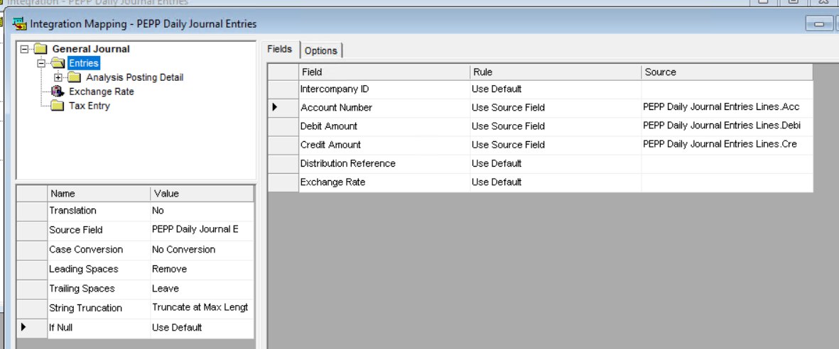

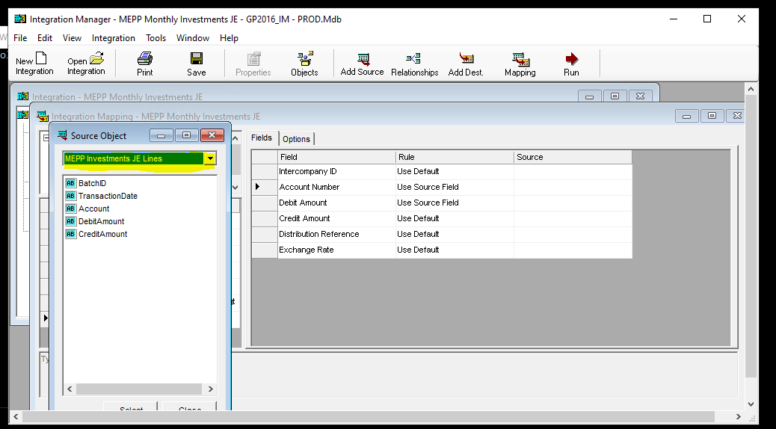

General Journal->Entries->fields tab options should automatically populate

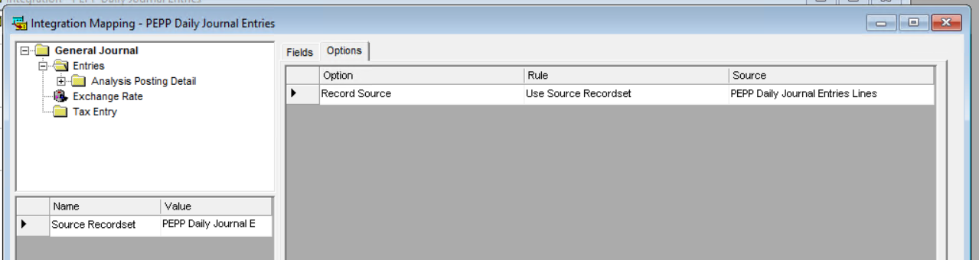

Close the mapping window by pressing the x

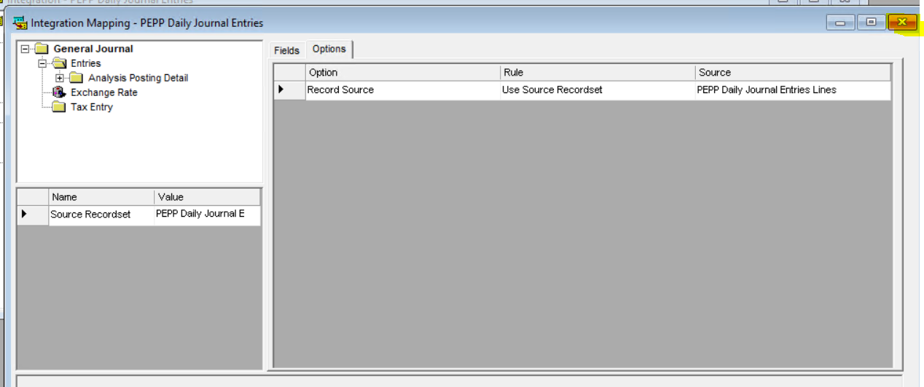

Open the Destination Mapping again and confirm that all your settings are still applied. There is a known issue when building integrations that the account Number source field does not always hold your setting the first time it is applied. Update it again if it is not displaying.

Example: Account Number source field did not hold, reapply and it will stay.

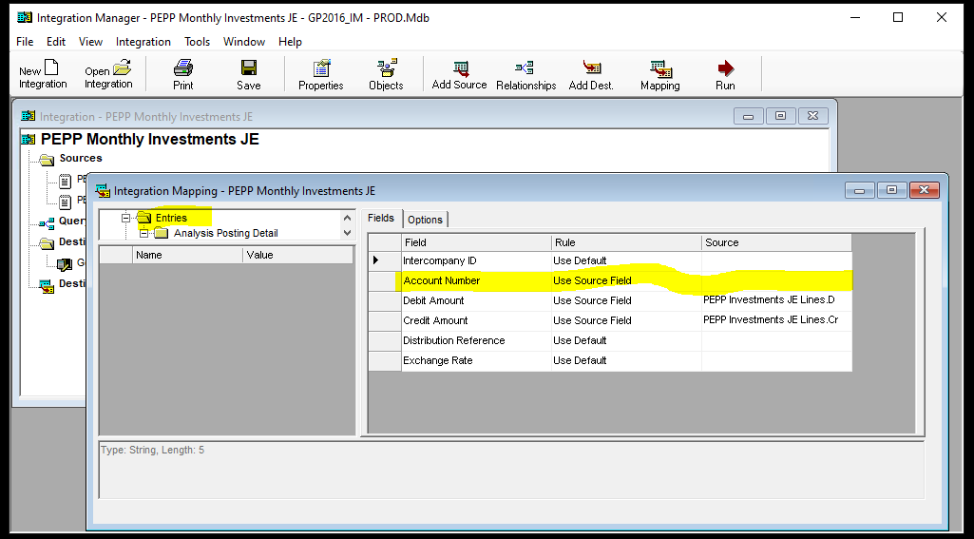

Press Save to save your integration Press the X in the top right-hand corner to close your integration

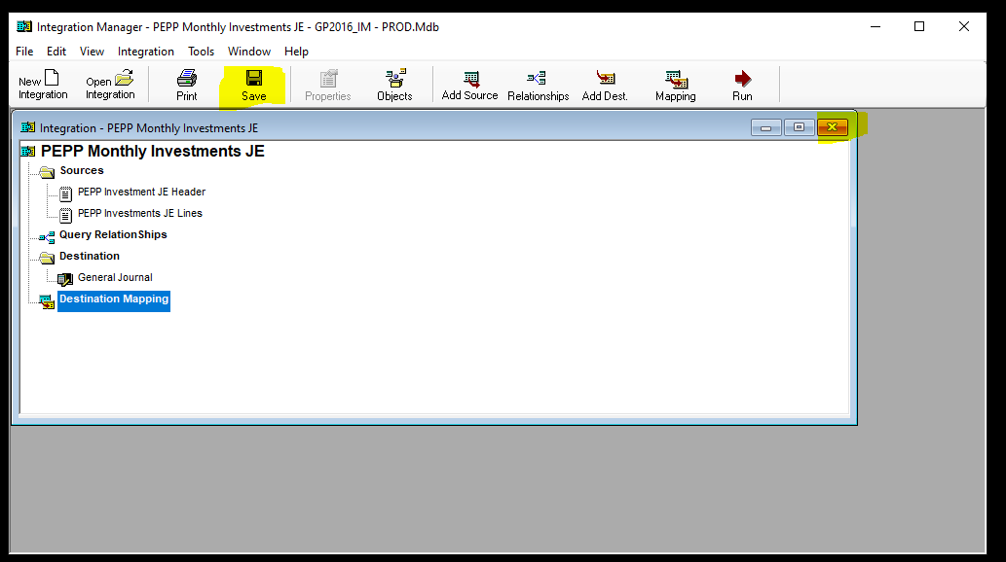

Have Finance confirm the integration is built and have them test it and report issues with it.

**Appendix A:**

|  |  |  |  |
| --- | --- | --- | --- |
| **Integration Name** | **Integration Description** | **In TEST** | **In Production** |
| MEPP Daily Journal Entries | MEPP Daily Journal Entries | √ | √ |
| PEPP Daily Journal Entries | PEPP Daily Journal Entries | √ | √ |
| CIBC Monthly Journal Entries | CIBC Monthly Journal Entries | √ | √ |

**Integration Manager - Payment Integration Build with No Script:**

|  |  |
| --- | --- |
| **Procedure Number:** |  |
| **Procedure Name:** |  |
| **Purpose of the Procedure:** |  |
| **Original Date:** |  |
| **Revised Date:** |  |

|  | **Name/Title** | **Signature** | **Date** |
| --- | --- | --- | --- |
| **Reviewed by** | <Person who reviews the work> |  | <dd/mm/yyyy> |
|  |  |  |  |
|  |  |  |  |
| **Approved by** | <Senior Management / Business Area Manager> |  | <dd/mm/yyyy> |

**Overview:**

**Dynamics Great Plains/Integration Manger:**

**Payment Integration Build (No Scripting):**

|  |  |
| --- | --- |
| **Procedures Documentation** |  |
| **Department:** | Business Application and Quality Assurance |
| **Prepared by:** | Regina Noels |
| **Date:** | December 12, 2020 |
| **Version:** | Draft 1.0 |

**Document Administration:**

1. **Revision History:**

| **Version** | **Date** | **Author** | **Change Description** |
| --- | --- | --- | --- |
| Draft 1.0 | December 10, 2020 | Regina Noels | Initial Draft |

1. **Distribution:**

Information contained within this document is deemed confidential and is intended for use by the specific departments, business work groups, or project team members identified in the chart below. Please do not distribute without the express consent of PEBA

1. **Contributors:**

|  |  |  |
| --- | --- | --- |
| **Name** | **Title** | **Company/Department** |
| Brian |  | Encore |
| Regina | Business Analyst | Application Management and Quality Assurance Services, PEBA |
| Janine Klotz |  |  |
| Dan Gudmundson |  |  |

1. **Approval**

|  |  |  |
| --- | --- | --- |
| **Name** | **Title** | **Company/Department** |
| Regina Noels | Business Analyst | Application Management and Quality Assurance Services, PEBA |
| Janine Klotz | Senior Manager | Finance and Planning. PEBA |
| Michael Mead |  | Application Management and Quality Assurance Services, PEBA |

1. **Purpose of Document:**

The Procedures document is a mandatory document in the Execution phase of the PEBA Change Management Process. It defines the specific procedures for this initiative at the date of testing and delivery into production. This document can be used on a go forward basis in the event that upgrades are made to our financial services dynamics’ great plains/integration manger applications or if modifications are required to the existing integration build.

**Background:**

* **Executive Summary**

Public Employees Benefits Agency uses Dynamics Great Plains application as our accounting application for recording of financial account activities. Integration Manager is part of the Dynamics suite of products which provides the ability to created custom define integrations which will automatically create journal entries in Great Plains by mapping a file from a business application to the Bank Transaction entry window in Great Plains. Using the automatic process of creating journal entries rather then a manual process reduces the risk of data entry errors. In the past we have enlisted the help of Encore to created integrations which include scripting as part of the integrated process which have caused some issues. As part of the MEPP Renewal Project implemented in Spring 2019 PEBA has decided to move forward with replacing some of these previously built scripted integrations with non-scripted integrations with the help of Encore which we can maintain inhouse on a go forward basis. As of October 2020, we have production built the Payment integrations for all plans in PENFAX v5.

**Overview:**

* **In Scope:**

|  |  |  |
| --- | --- | --- |
| **ID** | **In Scope** | **Priority**  **H, M, L** |
| HLR01 | Define the file requirements for a Payment integration file | H |
| HLR02 | Define the Naming Convention of the Integration file | H |
| HLR03 | Define the PEBA LAN Location of the file | H |
| HLR03 | Define the Integration Build Steps | H |

* **Out of Scope:**

|  |  |
| --- | --- |
| **ID** | **Out of Scope** |
| OS01 | n/a |

* **Assumptions:**
  1. Maintenance (adds/deletes) of procedures are completed regularly.
  2. PENFAX Scheduled Batch process is reviewed with changes to ensure this batch remains scheduled at the appropriate time.
  3. MEPP Daily Payment Integration file have been delivered to PEBA Dyntest as part of the MEPP renewal project and to PEBA GP production in May 2019 when MEPP renewal project went live.
  4. JEA has built Daily Payment Files for SPAF; PSSP; STC; WCB; ATLS; LCB; JPCS
  5. PEBA has built the SGIP Daily payment integration when the SGIP plan was delivered to production in but no mapping has been done for these plans and no GP integrations have been built for these plans. Any journal entry accounting entries for these plans is done manually.
  6. PEPP Daily Payments Integration file has been delivered to PEBA Dyntest in 2019 for testing of the PEPP renewal Project. The Integration build will move forward into production when PEPP renewal project in December 2020.

* **Constraints:**
  1. Availability of internal resources (SMEs) to complete required documentation.
  2. Integration builds can not be exported from one region to another due to unexplained errors which encore is not able to resolve so they have to be built net new in each region.

* **Dependencies:**
  + - * 1. Upgrades to applications will require review of these procedures’ documents.
        2. Upgrades to applications will require review to see if new integration manager database version is required.

* **Risks:**

Upgrades to application miss procedures documentation updates.

* **Related Documents and/or Links:**

**Terms and Abbreviations:**

| Term | Definition |
| --- | --- |
| GL | General Ledger |
| GP | Dynamics Great Plains |
| GPIF | Great Plains Integration File |
| MEPP | Municipal Employees Pension Plan |
| PEBA | Public Employees Benefits Agency |
| PEPP | Public Employees Pension Plan |
| SME | Subject Matter Expert |

**Environment:**

This section describes the technical requirements to support the Great Plains Integrations and Great Plains Application

**Regions and databases:**

| **#** | **Application** | **Region** | **Access** | **Date Release/Refreshed** | **Database used** |
| --- | --- | --- | --- | --- | --- |
| 1 | GP | Production | Finance, IT and Encore | 2016 |  |
| 2 | GP | Remote Desktop to Dyntest or Dyntest2-M920 | Finance,  IT, QA and Encore |  |  |
| 4 | Integration Manager | Production |  | 2016 | GP2016_IM - PROD |
| 5 | Integration Manager | Remote Desktop to Dyntest or Dyntest2-M920 | Finance,  IT, QA and Encore |  | GP2016_IM-Test |
| 6 | Production remote access | DYNAMICS7 | IT, Encore |  |  |

**PEBA LAN folders:**

Request for Lan folders are sent to Managers

| **#** | **Plan** | **Integrations from** | **Region** | **Folder Location** | **Integration Source File Name*this is a constant name and can not be changed\*** |
| --- | --- | --- | --- | --- | --- |
| 1 | MEPP | PENFAX | Test | H:\PEBA\Documentation\Great Pains Test\Penfax V5 Integrations | MEPPDailyPayments.csv |
| 2 | MEPP | PENFAX | Production | H:\Corporate Services\Financial Services\GP Integrations | MEPPDailyJournalEntries.csv |
| 3 | PEPP | PENFAX | Test | H:\PEBA\Documentation\Great Pains Test\Penfax V5 Integrations | PEPPDailyJournalEntries.csv |
| 4 | MEPP | CIBC | Test | H:\PEBA\Documentation\Great Pains Test\CIBC Investment Integrations | MEPPInvestmentJE.csv |
| 5 | PEPP | CIBC | Test | H:\PEBA\Documentation\Great Pains Test\CIBC Investment Integrations | PEPPInvestmentJE.csv |

**GP Test Accounts:**

Test accounts are shared by Finance and QA the Account user ID’s and Passwords are maintained by QA and stored in the QA Test systems spreadsheet

**Application and Components:**

**Applications:**

| **#** | **Application** | **Current Version** | **Date Release** | **Question/Issue** |
| --- | --- | --- | --- | --- |
| 1 | GP | 16.00.0439 | 2016 |  |
| 2 | Integration Manager | 16.00.0406 | 2016 |  |
|  |  |  |  |  |

**Components:**

| **#** | **GP Components** | **Current Version** | **Date Release** | **Question/Issue** |
| --- | --- | --- | --- | --- |
| 1 | Mekorma |  | 2016 |  |
| 2 | Doc link |  | 2019 |  |
|  | F9 |  |  |  |

**Application Companies and Checkbooks/Plans by Company:**

| **#** | **Companies** | **Checkbooks/Plans** | **Question/Issue** |
| --- | --- | --- | --- |
| 1 | December 31 Funds/Plans | Benefits; LIQ, RAF, SGIP, WCB, MEPP/expenditure |  |
| 2 | March 31 Funds/Plans | ATB, Judges, PSSP, RAF, SPAF, STC |  |
| 3 | PEBA Revolving Fund | expenditure |  |
| 4 | Public Employees Pension Plan | PEPP |  |

**Application Release Schedules:**

| **#** | **Release Schedules** |  |  |  | **Question/Issue** |
| --- | --- | --- | --- | --- | --- |
| 1 | What are they and what is the frequency |  |  |  |  |
| 2 |  |  |  |  |  |
|  |  |  |  |  |  |

* 1. Release Schedules Dependencies

When GP is upgraded the applications, do all applications components within GP get upgraded as well?

* 1. Release Schedules Constraints

What other projects are in progress Availability of SME(s) for coordination and testing?

**Support Services:**

You have noted the vendor’s name in the contact, but I would put as much information in here that you can about what the maintenance arrangement is with the vendor; how you log tickets; how you prioritize, etc.

When a refresh of test environment is completed any existing integration builds that have any script builds in the integration have to be configured to comment out the script that points to the production region and add a comment to point to the test region. If this is not done then when an integration is tested it will update data in the production environment.

**Sign Off:**

* + - 1. Janine Klotz, Senior Manager, Finance and Planning, PEBA
      2. Regina Noels, Business Analyst, Application Management and Quality Assurance Services, PEBA

| **#** | **Project** | **Region** | **Date** |  | **SIGN OFF** |
| --- | --- | --- | --- | --- | --- |
| 1 | MEPP Renewal | Test | 2018 |  | Regina/Janine |
| 2 | MEPP Renewal | Production | 2019 |  | Regina/Natalia/Janine |
| 3 | PEPP Renewal | Test | 2019/2020 |  | Regina/Natalia/Brittany |
| 4 | CIBC Investments | Test | Oct 2020 |  | Regina/Janine |

**Open Items/Questions/Notes:**

| **#** | **Date Raised** | **Status** | **Question/Issue** |
| --- | --- | --- | --- |
| 1 |  |  |  |

**GP Integration File Output Specifications and File Lay out Specifications by Project:**

This section is divided into GP Integration File Output Specifications by project and GP Integration File Layout

Defining the details of the file output specifications and the file lay out specifications is a joint effort between Finance/QA/Vendor

* **ID**: A unique identification number given to a requirement in order to make it traceable throughout the development process.
* **Specification**: Provides a description to explain the business requirement. It should be correct, feasible, prioritized within its section, unambiguous, verifiable and highlight any related requirements.
* **Priority**: Ranking of business priority for the requirement:
  + **H** = High = Critical and needs to be delivered;
  + **M** = Medium = Seen as adding value to the offering and would be good to include;
  + **L** = Low = Not critical to the delivery of the project and can be delivered at a later stage.

**MEPP Renewal Project- MEPP Daily Journal Entries Extract GP Integration File Output Specifications**

This batch process will include journal entries that do not debit or credit the 05-11101-00 Bank – GRF account.

| **ID** | **Specification** | | **Priority** |
| --- | --- | --- | --- |
| 9.1.01 | Filename | PLANDailyJournalEntries_MMDDYYYY.csv where PLAN = Plan ID which is equal to Plan short name – **Note**: JEA has hard coded a plan ID equal to plan short name configuration – see PEBA -1433 changes to short name do not get updated in the extract files.  Example: MEPPDailyJournalEntries_09302020.csv | H |
| 9.1.02 | File Header | File header record is not required on the output file. The first row of the file should identify the name of the field(s) that will be integrated into Dynamics GP. They are BatchID, TransactionDate, Account, DebitAmount and CreditAmount. | H |
| 9.1.03 | File Data -Content | Body of file records will be sourced from PENFAX V5 Journal entries that do not that do not debit or credit the 05-11101-00 Bank – GRF account | H |
| 9.1.04 | File Data -Zero activity | n/a | L |
| 9.1.05 | File Data - Accounts | MEPP Accounts Mapping Document completed | H |
| 9.1.06 | File Trailer | File trailer record is not required on the output file. | H |
| 9.1.07 | File Format | File must be in ‘csv’ format with comma as the delimiter. No quotations are required around the data within the file unless the data, for a specific field, contains a comma “,” as part of the data, in this case quotations around that data would be required. | H |
| 9.1.08 | File Delivery Method | File is produced in the PENFAX scheduled batch process | H |
| 9.1.09 | File Delivery Frequency | The batch process will run every morning at 12:30am. If the prior day was a business day which are identified as being a weekday that is not on the list of blackout dates (i.e. statutory holidays), then the process will include transactions for all previous days until it reaches the first business day and include them in the extract file. For example, it will run at 12:30 am on Saturday and include Friday's transactions, and then not again until 12:30 am on Tuesday where it will include Monday's transactions plus any that occurred on Sunday or Saturday. If there are no journal entries for a given day, an empty file will be produced. | H |

**MEPP Daily Journal Entries Extract GP Integration File Layout - Body (Content) Records**

All required fields in the body records are mandatory.

| **Field Number** | **Field** | **Type** | **Max Length** | **Data source: from PENFAX** | **Comments** |
| --- | --- | --- | --- | --- | --- |
| 1 | BatchID | Format name = %-GL-MMDDYYYY where % equals 4 digits plan code and date equals the transaction date | 16 | coded | Example: MEPPGL-10232020 |
| 2 | TransactionDate | Format Date (MM/DD/YYYY) | 10 | Equal to the Journal Entry Date column on the General Ledger screen in PENFAX | E.g. 09/30/2020 |
| 3 | Account | Format as they were provided to JEA (i.e. Include dashes) include hyphens; E.g. 05-41201-60 | 11 | Equal to the Entity Account column on the General Ledger screen in PENFAX | Based on PEBA’s mapping documentation |
| 4 | DebitAmount | Numeric (2 decimals) | 20 | Equal to the Debit Amount column on the General Ledger screen in PENFAX | *see note below |
| 5 | CreditAmount | Numeric (2 decimals) | 20 | Equal to the Credit Amount column on the General Ledger screen in PENFAX |

* All amounts in Canadian currency.

Report one (1) dollar amount per line either as debit or credit.

Report one (1) offsetting 0.00 amount per line either as debit or credit.

Report only positive amounts in the file.

**PEPP Renewal Project- PEPP Daily Journal Entries Extract GP Integration File Output Specifications:**

This batch process will include journal entries that do not debit or credit the 05-11101-00 Bank – GRF account.

| **ID** | **Specification** | | **Priority** |
| --- | --- | --- | --- |
| 9.2.01 | Filename | PLANDailyJournalEntries_MMDDYYYY.csv where PLAN = Plan ID which is equal to Plan short name – **Note**: JEA has hard coded a plan ID equal to plan short name configuration – see PEBA -1433 changes to short name do not get updated in the extract files.  Example: MEPPDailyJournalEntries_09302020.csv | H |
| 9.2.02 | File Header | File header record is not required on the output file. The first row of the file should identify the name of the field(s) that will be integrated into Dynamics GP. They are BatchID, TransactionDate, Account, DebitAmount and CreditAmount. | H |
| 9.2.03 | File Data -Content | Body of file records will be sourced from PENFAX V5 Journal entries that do not that do not debit or credit the 02-11101-00 Bank account | H |
| 9.2.04 | File Data -Zero activity | n/a | L |
| 9.2.05 | File Data - Accounts | MEPP Accounts Mapping Document completed | H |
| 9.2.06 | File Trailer | File trailer record is not required on the output file. | H |
| 9.2.07 | File Format | File must be in ‘csv’ format with comma as the delimiter. No quotations are required around the data within the file unless the data, for a specific field, contains a comma “,” as part of the data, in this case quotations around that data would be required. | H |
| 9.2.08 | File Delivery Method | File is produced in the PENFAX scheduled batch process | H |
| 9.2.09 | File Delivery Frequency | The batch process will run every morning at 12:30am. If the prior day was a business day which are identified as being a weekday that is not on the list of blackout dates (i.e. statutory holidays), then the process will include transactions for all previous days until it reaches the first business day and include them in the extract file. For example, it will run at 12:30 am on Saturday and include Friday's transactions, and then not again until 12:30 am on Tuesday where it will include Monday's transactions plus any that occurred on Sunday or Saturday. If there are no journal entries for a given day, an empty file will be produced. | H |

**PEPP Renewal Project - PEPP Daily Journal Entries Extract GP Integration File Layout - Body (Content) Records:**

All required fields in the body records are mandatory.

| **Field Number** | **Field** | **Type** | **Max Length** | **Data source: from Penfax** | **Comments** |
| --- | --- | --- | --- | --- | --- |
| 1 | BatchID | Format name = %-GL-MMDDYYYY where % equals 4 digits plan code and date equals the transaction date | 16 | coded | Example: MEPPGL-10232020 |
| 2 | TransactionDate | Format Date (MM/DD/YYYY) | 10 | Equal to the Journal Entry Date column on the General Ledger screen in PENFAX | E.g. 09/30/2020 |
| 3 | Account | Format as they were provided to JEA (i.e., Include dashes) include hyphens; E.g. 05-41201-60 | 11 | Equal to the Entity Account column on the General Ledger screen in PENFAX | Based on PEBA’s mapping documentation |
| 4 | DebitAmount | Numeric (2 decimals) | 20 | Equal to the Debit Amount column on the General Ledger screen in PENFAX | *see note below |
| 5 | CreditAmount | Numeric (2 decimals) | 20 | Equal to the Credit Amount column on the General Ledger screen in PENFAX |

* All amounts in Canadian currency.

Report one (1) dollar amount per line either as debit or credit.

Report one (1) offsetting 0.00 amount per line either as debit or credit.

Report only positive amounts in the file.

**CIBC Custodian Project- Investment GP Integration File Output Specifications**:

| **ID** | **Specification** | | **Priority** |
| --- | --- | --- | --- |
| 9.5.01 | Filename | PLANInvestmentJE_MMDDYYYY.csv where PLAN = PEPP or MEPP  Example:  PEPPInvestmentJE_09302020.csv  MEPPInvestmentJE_09302020.csv | H |
| 9.5.02 | File Header | File header record is not required on the output file. | H |
| 9.1.03 | File Data -Content | Body of file records will be sourced from IAS using the NEXEN report called General Ledger Detail. Reference Section 4.2. | H |
| 9.1.04 | File Data -Zero activity | NEXEN/IAS General Ledgers with zero activity will be omitted from the file. | H |
| 9.1.05 | File Data - Accounts | PEPP and MEPP accounts; A NEXEN group account will be used to capture accounts. | H |
| 9.1.06 | File Trailer | File trailer record is not required on the output file. | H |
| 9.1.07 | File Format | File must be in ‘csv’ format with comma as the delimiter. No quotations are required around the data within the file unless the data, for a specific field, contains a comma “,” as part of the data, in this case quotations around that data would be required. | H |
| 9.1.08 | File Delivery Method | Secure file delivery of 2 files (one for PEPP and one for MEPP) via SFTP to PEBA required. NEXEN Scheduling and Distribution functionality will be used. | H |
| 9.1.09 | File Delivery Frequency | Prior Month end Period, When Accounting is Final | H |

**GP Integration File Layout - Body (Content) Records:**

All required fields in the body records are mandatory.

| **Field Number** | **Field** | **Type** | **Max Length** | **Data source: Column Name from NEXEN General Ledger Detail Report** | **Comments** |
| --- | --- | --- | --- | --- | --- |
| 1 | BatchID | Format “PLANMMDDYYYY” E.g. MEPP09302020 | 16 | Reporting Account Number |  |
| 2 | TransactionDate | Date (MM/DD/YYYY) | 10 | End Date | Last day of the month being reported; E.g. 09/30/2020 |
| 3 | Account | Text in the following format: TT-TTTTT-TT; include hyphens; E.g. 05-41201-60 | 11 | Gen Ledger Acct | Based on PEBA’s Chart of Accounts which will be mapped to NEXEN/IAS GL Accounts |
| 4 | DebitAmount | Numeric (2 decimals) | 20 | GL Activity | *see note below |
| 5 | CreditAmount | Numeric (2 decimals) | 20 | GL Activity |

* All amounts in Canadian currency.

Report one (1) dollar amount per line either as debit or credit.

Report one (1) offsetting 0.00 amount per line either as debit or credit.

Report only positive amounts in the file.

DebitAmount column represent increases in Asset/Expense GLs or decreases in Liability/Income/Capital GLs.

CreditAmount column represent decreases in Asset/Expense GLs or increases in Liability/Income/Capital GLs.

**GP Journal Entry Integration Build:**

**Request the PEBA Lan Folder be created if it has not already been created**

This is the folder where you will save your source file in so it can be linked to your integration build. Folders are noted in item 5.2 above must be created if they do not already exist **PEBA LAN folders**

**Create the source journal entry file**

This is the file which will be linked to your integration build that will hold the journal entry details that will integrate into GP. This file must be saved to the appropriate folder noted in item 5.2 above

**PEBA LAN folders**

To create a source file, you can copy an existing source file; then rename the file to suit your build purposes; then modify the details of the file based on the file output specifications and file lay out specification for the project that get outlined in item 9 above. GP Integration File Output Specifications and File Lay out Specifications by Project (Example: When building the MEPPInvestmentJE source file I copied the MEPPDailyJournalEntries.csv file to the folder H:\PEBA\Documentation\Great Plains Test\CIBC Investment Integrations, then had finance modify the details of the file to add records as per item 9.5 and 9.6 above

**Begin Building the integration.**

Integrations can not be copied from one environment to another. They have to be built new in each PEBA environment. You must build the integration first in the test environment, have finance test it and once they provide signoff and approve for move to production you can build in production after it passes through the appropriate PEBA change management process.

**Test Integration Build**

Make a back up of the current integration manager database, if one has not yet been made

The integration databases are identified in item 5.1 above Regions and databases

Open H:\PEBA\Documentation\Great Plains Test. 1. Make a copy of file GP2016_IM-TEST.Mdb and save to the save folder. 2. Rename the copy to include BAK and the date that you made the copy “GP2016_IM - TEST - BAK_YYYYMMDD. Mbd”. 3. Move any older BAK files into the Archive folder as we should only ever have one BAK up file of the current database.

**67 copy the current database and save to the same folder**



68 Rename the copy to be BAK_YYYYMMDD



69 Move any old BAK files into the Archive folder



Use Remote Desktop to log into either Dytest or Dyntest2-M920 machine.

User name is PEBA LAN user name.

Password id PEBA LAN password

Use the show/hide Options selections on the bottom left corner to enter your user name.

If you do not have access to the test machines send a request to IT Help with a CC to Michael.



Select Ok to the Security Disclaimer



Search for the GP application and open it.

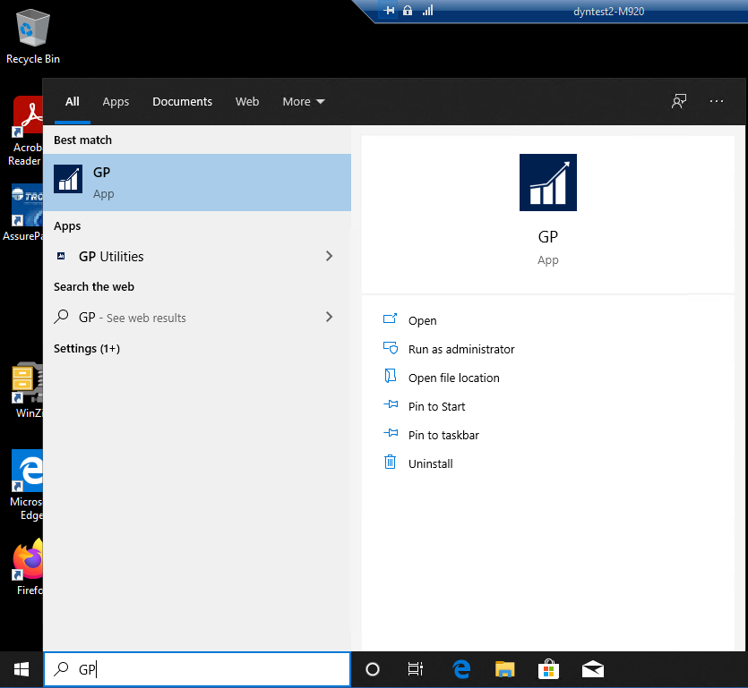

Log into GP

Use accountant_test Test Accounts and the company for the plan you are building the integration for Application Companies and Checkbooks/Plans by Company

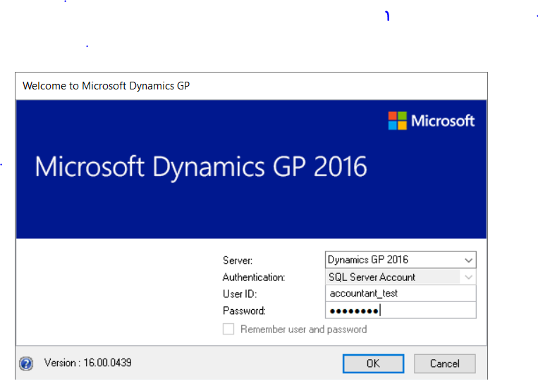

Search for Integration Manager application and open it



Be sure that you are pointed to the correct data base before proceeding with the integration build

The database is configured by individual user id, so every employee who logs into the application has to point to the correct database. The data base is reported in the title of the window. **For a test build** if it does not read “GP2016_IM-TEST.Mdb do not proceed until you have changed the data base as instructed below.



**To point to the correct database**, 1. select tools, options; 2. using the search file path search button navigate to the correct database and select it; 3. once selected press the apply button and the ok button on the options window; 4. close Integration Manager application and re-open to see the database change to the correct one.

1. Select Tools, Options



2. Using the search file path search button navigate to the correct database and select it



3. Press “Apply” button and “Ok” button



4. Close Integration manager using the X then reopen the application and the correct database will display in the title bar



Press New Integration button



* A new integration build is automatically opened, which includes assigning of a default integration name (Integration 2) and the folder creation for Sources, Destination and Destinations Mapping. Note: as you work through the process of the build you will define additional information under each of these folders.
* A properties Window is automatically opened which requires input of information.



On Properties – Integration 2 window

**General Tab**

Update the Integration Name: Enter the integration name that finance will choose when they use the integration you are building for this documentation I am building the MEPP Monthly Investment Journal Entries.

Add a description of what this integration will do:

Update the Maximum Number of Errors: from 10 to 9999

Update the Maximum Number of Warnings: from 10 to 9999



On the Scripts Tab – do nothing



On the Logs Tab – do nothing



Click Apply, then Click OK – the integration name is now updated





Add Sources

Either use opposite mouse button on the source folder or click the add source button in the tool bar



An Add Source Window will open, select Text under ODBC/Text Folder then Select Define New Test a Properties – Query 28 window will open – this window will require you to input information related to the source file that holds the details that you will be integrating into Great Plains

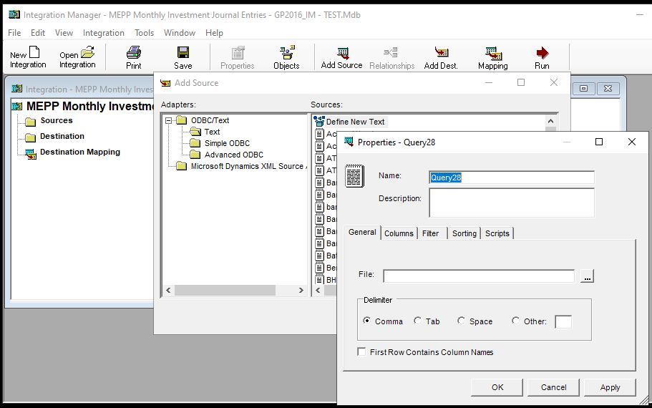

Properties – Query 28 window

General Tab

Enter the name of your Source file

Select the path to the file location of your source file

Check the first row contains column names check box



Columns Tab – do nothing (column names displayed should be Batch ID; TransactionDate; Account; DebitAmount; CreditAmount, data type should report string and Show indicator should be checked for all Column names)



Filters Tab – do nothing



Sorting Tab - For Journal Entry Integrations apply a sorting of Group By, BatchID and TransactionDate

To add the Group By sorting simply click in the empty field and a selection list will be populate for you to make your selections.



Scripts Tab – do nothing



Click Apply and OK to the message then click OK – the source build is not displayed under sources in your integration





Repeat the above steps to add you Lines Source – **differences** in the build are the name field should report Lines instead of header and nothing is required for the sorting tab (see difference screen prints below) When apply and OK is press the Lines Source build is displayed in the integration





When apply and OK is press the Lines Source build is displayed in the integration and you will receive a relationships message – Press OK to continue



Click on the Query Relationships title to open the window and build the relationships between the source file header and details. To build the relationship simple click the title in the header table and drag the lines table you will see a + sign in the lines table when you see the plus time unclick and the relationship line will display. Build the relationship to both items from the Header table. Close the relationship window





Build the destination for the integration – using opposite mouse on the destinations folder select Add destination or using the Add dest button in the tool bar navigate to Microsoft Dynamics GP -> Financial and select General Journal “Open” – General Journal now displays under destination





**Build the Destination Mapping** - This is the place that GP will look for the information for the fields on the GP window that need to be filled in for the type of transaction the integration is creating.

Click “Mapping” button in the menu bar or double click the destination mapping folder in the integration.

When the Integration Mapping window opens the default, selected tab is Fields and the default selected row is the first row (arrow in first column)

You need to apply mapping at folder level General Journal and folder level Entries



If you need to make a rule change you must select the field under the rule column in line with the field you want to apply the rule to. This will open up a drop-down selection box so you can select the rule you want to apply. Rules that can be applied are Use Default; Use Source Field; Use Input; Use Constant; Use Script



If your rule is to use Source Field then you also have to set the source field to use in the source column. First select the rule Use source field, then select the field under source to enable an object selection button, press the selection button to open the object window and select your source object in the objects window. The source field is updated with your selection.

If the rule comes from the source file then you have to add the source field. (I.E. Batch ID, comes from the Use Source Field, and the Source field is “BatchID”)

**Note**: When a source field is required when you click in the field a search button is seen, clicking on that search button, opens a Source Objects window, where you can pick the file part in the top (either header or lines) and the field in the bottom. Be sure to pick the correct top source because both may have the same field.





When using Use Source Field Rule, additional rules for that field are auto populated on the left side of the window. These rules can be changed if required.



Entries folder rules





On the Integration Mapping window – Fields Tab apply the following Field Rules for each type of Integration. For Journal Entry Integrations set Field Rules to the following:





* When the Integration Mapping window opens the default, selected tab is Fields and the default selected row is the first row (arrow in first column)
* You need to apply mapping at folder level General Journal and folder level Entries

**Production Build:**

* Ensure that the Test build is tested and signed off by business area for move to production
* Ensure that production change flows through change management process and is approved by CAB for implement into production.
* Date of implementation must be defined
* Time of implementation must be defined
* Time for IT to take a back up of the production integration manager data base must be defined Environment
* Time for IT to logs QA into dynamics7 to build the integration must be defined
* It Logs QA into GP
* QA builds integration as per Test build directions - using production folders and production files

**Julian Date Calendar:**

|  |  |
| --- | --- |
| **Procedure Number:** |  |
| **Procedure Name:** |  |
| **Purpose of the Procedure:** |  |
| **Original Date:** |  |
| **Revised Date:** |  |

|  | **Name/Title** | **Signature** | **Date** |
| --- | --- | --- | --- |
| **Reviewed by** | <Person who reviews the work> |  | <dd/mm/yyyy> |
|  |  |  |  |
|  |  |  |  |
| **Approved by** | <Senior Management / Business Area Manager> |  | <dd/mm/yyyy> |

**Overview**

|  |  |  |  |  |  |  |  |  |  |  |  |  |  |
| --- | --- | --- | --- | --- | --- | --- | --- | --- | --- | --- | --- | --- | --- |
| Julian Date Calendar – Non Leap Year | | | | | | | | | | | | | |
| DAY | JAN | FEB | MAR | APR | MAY | JUN | JUL | AUG | SEP | OCT | NOV | DEC | DAY |
| 1 | 001 | 032 | 060 | 091 | 121 | 152 | 182 | 213 | 244 | 274 | 305 | 335 | 1 |
| 2 | 002 | 033 | 061 | 092 | 122 | 153 | 183 | 214 | 245 | 275 | 306 | 336 | 2 |
| 3 | 003 | 034 | 062 | 093 | 123 | 154 | 184 | 215 | 246 | 276 | 307 | 337 | 3 |
| 4 | 004 | 035 | 063 | 094 | 124 | 155 | 185 | 216 | 247 | 277 | 308 | 338 | 4 |
| 5 | 005 | 036 | 064 | 095 | 125 | 156 | 186 | 217 | 248 | 278 | 309 | 339 | 5 |
| 6 | 006 | 037 | 065 | 096 | 126 | 157 | 187 | 218 | 249 | 279 | 310 | 340 | 6 |
| 7 | 007 | 038 | 066 | 097 | 127 | 158 | 188 | 219 | 250 | 280 | 311 | 341 | 7 |
| 8 | 008 | 039 | 067 | 098 | 128 | 159 | 189 | 220 | 251 | 281 | 312 | 342 | 8 |
| 9 | 009 | 040 | 068 | 099 | 129 | 160 | 190 | 221 | 252 | 282 | 313 | 343 | 9 |
| 10 | 010 | 041 | 069 | 100 | 130 | 161 | 191 | 222 | 253 | 283 | 314 | 344 | 10 |
| 11 | 011 | 042 | 070 | 101 | 131 | 162 | 192 | 223 | 254 | 284 | 315 | 345 | 11 |
| 12 | 012 | 043 | 071 | 102 | 132 | 163 | 193 | 224 | 255 | 285 | 316 | 346 | 12 |
| 13 | 013 | 044 | 072 | 103 | 133 | 164 | 194 | 225 | 256 | 286 | 317 | 347 | 13 |
| 14 | 014 | 045 | 073 | 104 | 134 | 165 | 195 | 226 | 257 | 287 | 318 | 348 | 14 |
| 15 | 015 | 046 | 074 | 105 | 135 | 166 | 196 | 227 | 258 | 288 | 319 | 349 | 15 |
| 16 | 016 | 047 | 075 | 106 | 136 | 167 | 197 | 228 | 259 | 289 | 320 | 350 | 16 |
| 17 | 017 | 048 | 076 | 107 | 137 | 168 | 198 | 229 | 260 | 290 | 321 | 351 | 17 |
| 18 | 018 | 049 | 077 | 108 | 138 | 169 | 199 | 230 | 261 | 291 | 322 | 352 | 18 |
| 19 | 019 | 050 | 078 | 109 | 139 | 170 | 200 | 231 | 262 | 292 | 323 | 353 | 19 |
| 20 | 020 | 051 | 079 | 110 | 140 | 171 | 201 | 232 | 263 | 293 | 324 | 354 | 20 |
| 21 | 021 | 052 | 080 | 111 | 141 | 172 | 202 | 233 | 264 | 294 | 325 | 355 | 21 |
| 22 | 022 | 053 | 081 | 112 | 142 | 173 | 203 | 234 | 265 | 295 | 326 | 356 | 22 |
| 23 | 023 | 054 | 082 | 113 | 143 | 174 | 204 | 235 | 266 | 296 | 327 | 357 | 23 |
| 24 | 024 | 055 | 083 | 114 | 144 | 175 | 205 | 236 | 267 | 297 | 328 | 358 | 24 |
| 25 | 025 | 056 | 084 | 115 | 145 | 176 | 206 | 237 | 268 | 298 | 329 | 359 | 25 |
| 26 | 026 | 057 | 085 | 116 | 146 | 177 | 207 | 238 | 269 | 299 | 330 | 360 | 26 |
| 27 | 027 | 058 | 086 | 117 | 147 | 178 | 208 | 239 | 270 | 300 | 331 | 361 | 27 |
| 28 | 028 | 059 | 087 | 118 | 148 | 179 | 209 | 240 | 271 | 301 | 332 | 362 | 28 |
| 29 | 029 |  | 088 | 119 | 149 | 180 | 210 | 241 | 272 | 302 | 333 | 363 | 29 |
| 30 | 030 |  | 089 | 120 | 150 | 181 | 211 | 242 | 273 | 303 | 334 | 364 | 30 |
| 31 | 031 |  | 090 |  | 151 |  | 212 | 243 |  | 304 |  | 365 | 31 |

|  |  |  |  |  |  |  |  |  |  |  |  |  |  |  |
| --- | --- | --- | --- | --- | --- | --- | --- | --- | --- | --- | --- | --- | --- | --- |
| Julian Date Calendar – Leap Year | | | | | | | | | | | | | | |
| DAY | JAN | FEB | MAR | APR | MAY | JUN | JUL | AUG | SEP | OCT | NOV | DEC | DAY |
| 1 | 001 | 032 | 061 | 092 | 122 | 153 | 183 | 214 | 245 | 275 | 306 | 336 | 1 |
| 2 | 002 | 033 | 062 | 093 | 123 | 154 | 184 | 215 | 246 | 276 | 307 | 337 | 2 |
| 3 | 003 | 034 | 063 | 094 | 124 | 155 | 185 | 216 | 247 | 277 | 308 | 338 | 3 |
| 4 | 004 | 035 | 064 | 095 | 125 | 156 | 186 | 217 | 248 | 278 | 309 | 339 | 4 |
| 5 | 005 | 036 | 065 | 096 | 126 | 157 | 187 | 218 | 249 | 279 | 310 | 340 | 5 |
| 6 | 006 | 037 | 066 | 097 | 127 | 158 | 188 | 219 | 250 | 280 | 311 | 341 | 6 |
| 7 | 007 | 038 | 067 | 098 | 128 | 159 | 189 | 220 | 251 | 281 | 312 | 342 | 7 |
| 8 | 008 | 039 | 068 | 099 | 129 | 160 | 190 | 221 | 252 | 282 | 313 | 343 | 8 |
| 9 | 009 | 040 | 069 | 100 | 130 | 161 | 191 | 222 | 253 | 283 | 314 | 344 | 9 |
| 10 | 010 | 041 | 070 | 101 | 131 | 162 | 192 | 223 | 254 | 284 | 315 | 345 | 10 |
| 11 | 011 | 042 | 071 | 102 | 132 | 163 | 193 | 224 | 255 | 285 | 316 | 346 | 11 |
| 12 | 012 | 043 | 072 | 103 | 133 | 164 | 194 | 225 | 256 | 286 | 317 | 347 | 12 |
| 13 | 013 | 044 | 073 | 104 | 134 | 165 | 195 | 226 | 257 | 287 | 318 | 348 | 13 |
| 14 | 014 | 045 | 074 | 105 | 135 | 166 | 196 | 227 | 258 | 288 | 319 | 349 | 14 |
| 15 | 015 | 046 | 075 | 106 | 136 | 167 | 197 | 228 | 259 | 289 | 320 | 350 | 15 |
| 16 | 016 | 047 | 076 | 107 | 137 | 168 | 198 | 229 | 260 | 290 | 321 | 351 | 16 |
| 17 | 017 | 048 | 077 | 108 | 138 | 169 | 199 | 230 | 261 | 291 | 322 | 352 | 17 |
| 18 | 018 | 049 | 078 | 109 | 139 | 170 | 200 | 231 | 262 | 292 | 323 | 353 | 18 |
| 19 | 019 | 050 | 079 | 110 | 140 | 171 | 201 | 232 | 263 | 293 | 324 | 354 | 19 |
| 20 | 020 | 051 | 080 | 111 | 141 | 172 | 202 | 233 | 264 | 294 | 325 | 355 | 20 |
| 21 | 021 | 052 | 081 | 112 | 142 | 173 | 203 | 234 | 265 | 295 | 326 | 356 | 21 |
| 22 | 022 | 053 | 082 | 113 | 143 | 174 | 204 | 235 | 266 | 296 | 327 | 357 | 22 |
| 23 | 023 | 054 | 083 | 114 | 144 | 175 | 205 | 236 | 267 | 297 | 328 | 358 | 23 |
| 24 | 024 | 055 | 084 | 115 | 145 | 176 | 206 | 237 | 268 | 298 | 329 | 359 | 24 |
| 25 | 025 | 056 | 085 | 116 | 146 | 177 | 207 | 238 | 269 | 299 | 330 | 360 | 25 |
| 26 | 026 | 057 | 086 | 117 | 147 | 178 | 208 | 239 | 270 | 300 | 331 | 361 | 26 |
| 27 | 027 | 058 | 087 | 118 | 148 | 179 | 209 | 240 | 271 | 301 | 332 | 362 | 27 |
| 28 | 028 | 059 | 088 | 119 | 149 | 180 | 210 | 241 | 272 | 302 | 333 | 363 | 28 |
| 29 | 029 | 060 | 089 | 120 | 150 | 181 | 211 | 242 | 273 | 303 | 334 | 364 | 29 |
| 30 | 030 |  | 090 | 121 | 151 | 182 | 212 | 243 | 274 | 304 | 335 | 365 | 30 |
| 31 | 031 |  | 091 |  | 152 |  | 213 | 244 |  | 305 |  | 366 | 31 |

**Monitoring PENFAX 5 Data posting Batches:**

|  |  |
| --- | --- |
| **Procedure Number:** |  |
| **Procedure Name:** |  |
| **Purpose of the Procedure:** |  |
| **Original Date:** |  |
| **Revised Date:** |  |

|  | **Name/Title** | **Signature** | **Date** |
| --- | --- | --- | --- |
| **Reviewed by** | <Person who reviews the work> |  | <dd/mm/yyyy> |
|  |  |  |  |
|  |  |  |  |
| **Approved by** | <Senior Management / Business Area Manager> |  | <dd/mm/yyyy> |

**Overview:**

|  |  |
| --- | --- |
| **Title:**  **Quality Assurance procedures for monitoring Data Posting Batches** | **Current Version: 1** |
| **Document Owner:**  **Michael Mead**  **Pana Wiegers** | **Document author:**  **Yusuf** |

|  |  |  |  |
| --- | --- | --- | --- |
|  |  |  |  |
| Reviewed by |  | <Tile> | <dd/mm/yyyy> |
| Approved by |  | <Tile> | <dd/mm/yyyy> |
|  |  |  |  |
| Date Issued | 08/10/2019 | Date Revised | <dd/mm/yyyy> |

**Running the Process in PENFAX V 5 Production:**

1. Log into PENFAX 5 – PROD

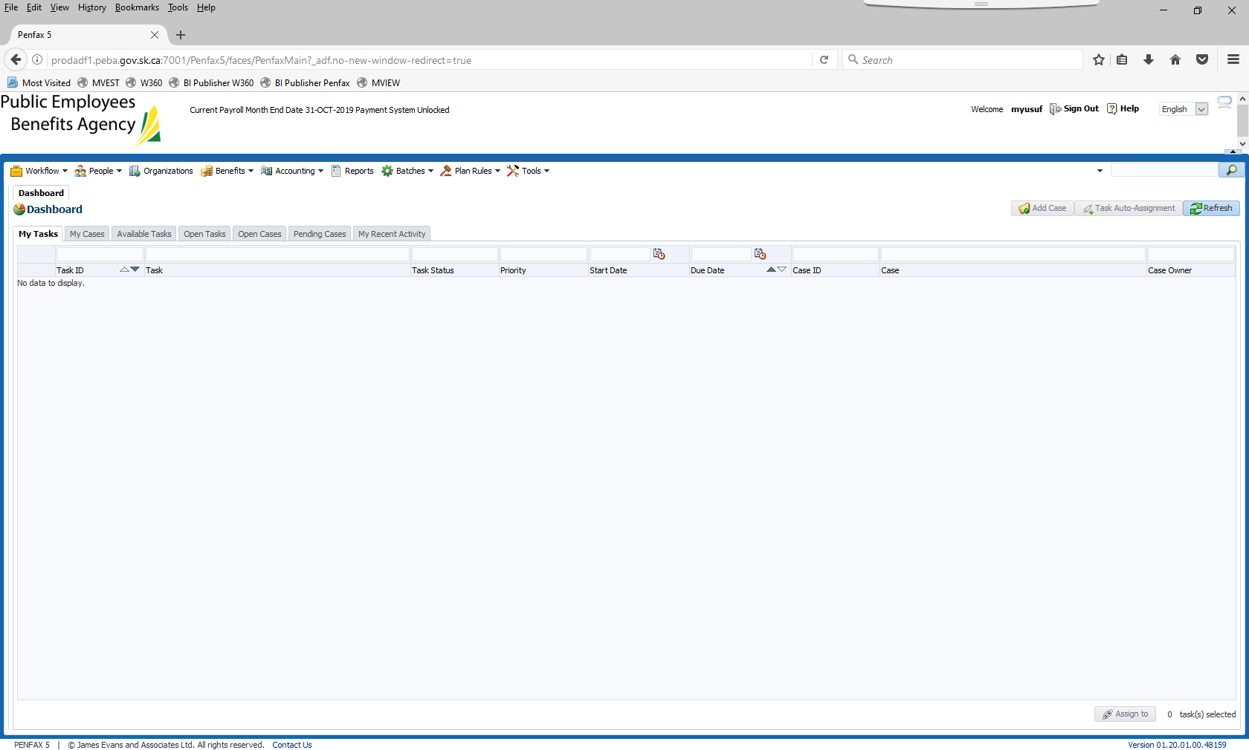

1. Go to Batches, and select Data Posting Batches from dropdown

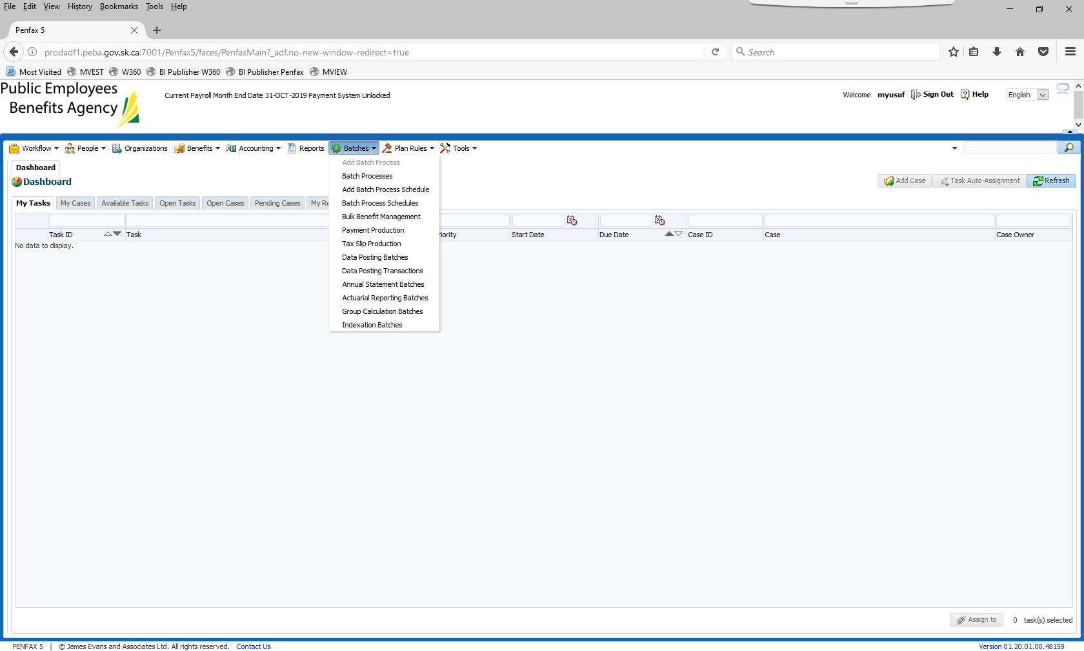

1. Select Batch Status = Submitting

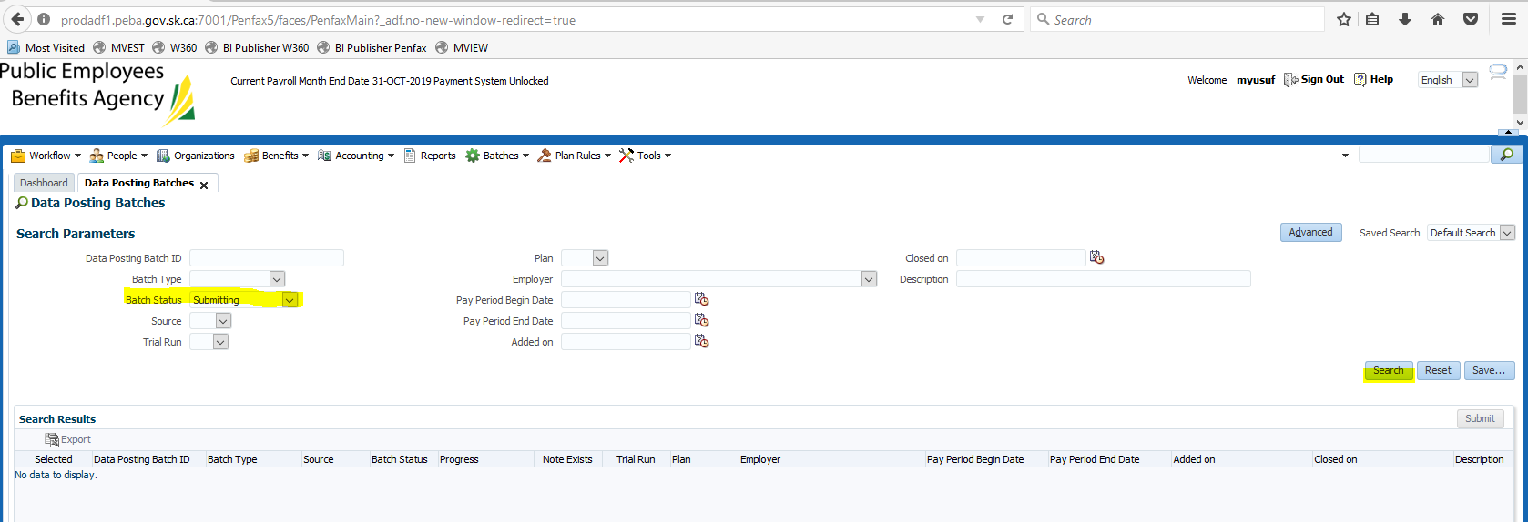

1. Click Search and check if there are any records

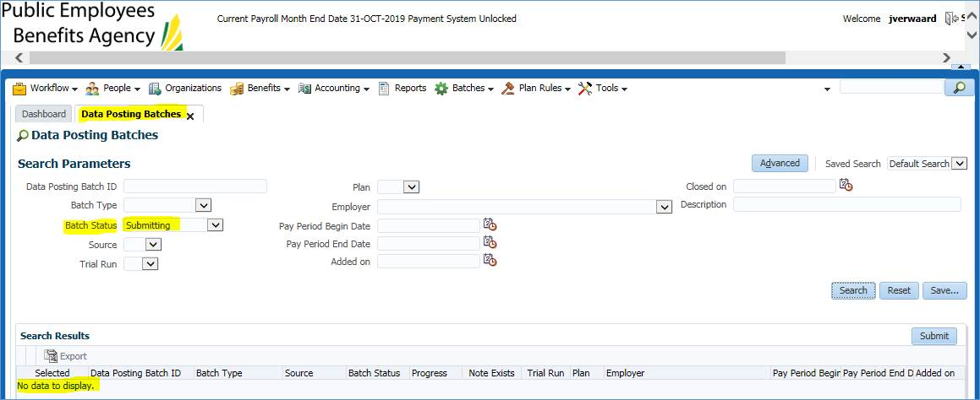

1. Select Batch Status = Validating

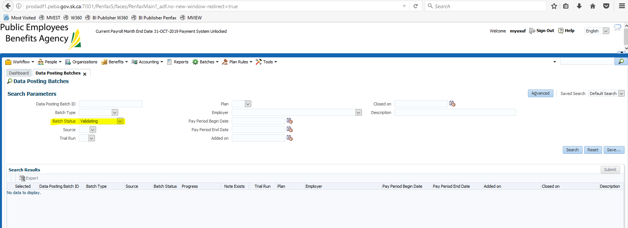

1. Click Search and check if there are any records

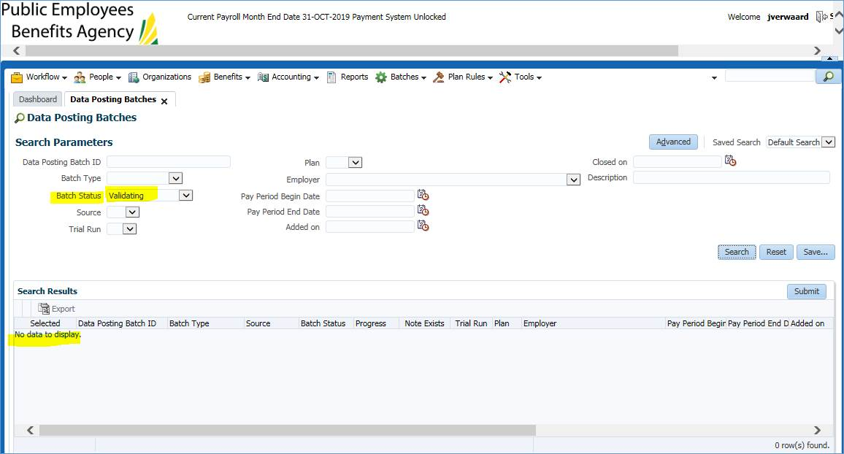

If you see any records, it is possible someone in MEPP is actually processing files so wait a minute to run the search again and if it’s still there, notify us.

**If more information is needed with respect to business process, please contact Jeroen.**

**MORe Usage Report - Monthly and Quarterly:**

|  |  |
| --- | --- |
| **Procedure Number:** |  |
| **Procedure Name:** |  |
| **Purpose of the Procedure:** | Procedure document for the MORe Usage Report – Monthly & Quarterly |
| **Original Date:** |  |
| **Revised Date:** |  |

|  | **Name/Title** | **Signature** | **Date** |
| --- | --- | --- | --- |
| **Reviewed by** | <Person who reviews the work> |  | <dd/mm/yyyy> |
|  |  |  |  |
|  |  |  |  |
| **Approved by** | <Senior Management / Business Area Manager> |  | <dd/mm/yyyy> |

**Overview:**

**Generating the Monthly MORe Usage Report**

**MORe Usage Report – Monthly & Quarterly**

The report is also sent by e-mail to Kevin Sockett for inclusion in his Commission reports.

There may also be a request for a Quarterly report which would use the same procedures as above but, in the calendar, portion put in the months to be reported on.

1. Go to the Google Analytics website <http://www.google.com/analytics/>
2. Click the *SIGN IN* link

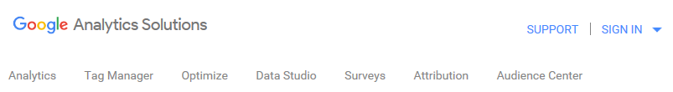

1. Select *Analytics*

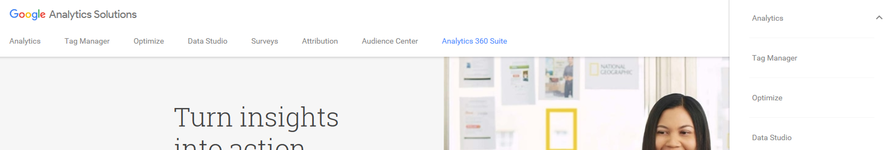

1. Sign in to the website using the below:
   * Username = pebamepp@gmail.com
   * Password = peba-mepp

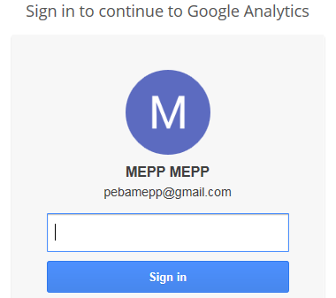

1. Click the *Customization* link at the top left and select Custom Reports
2. Click the *MORe Monthly Usage* link, this will take you to the report that has been set up

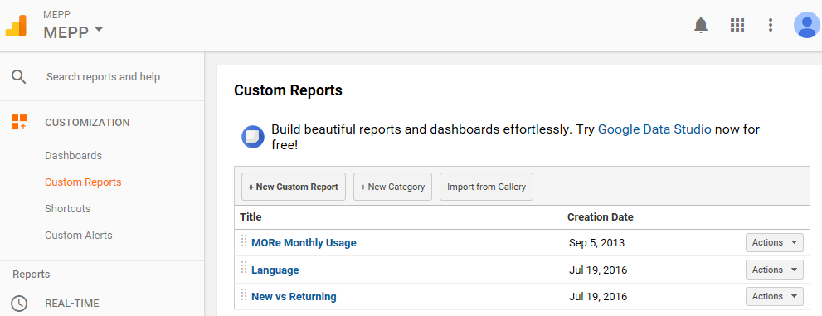

1. To adjust the calendar, click on drop down arrow

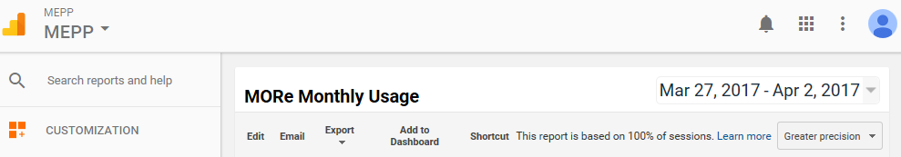

1. Set the report to run for the previous month and click the *Apply* button

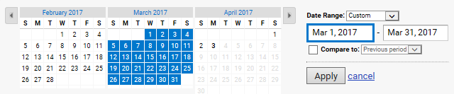

1. Select Sessions vs New Users (if not already selected)

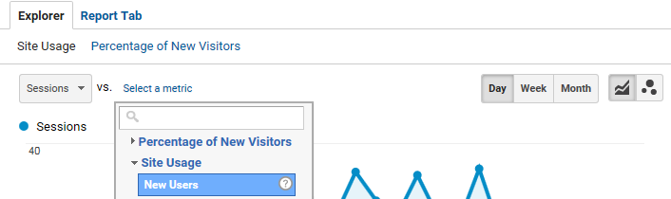

1. The report generates:

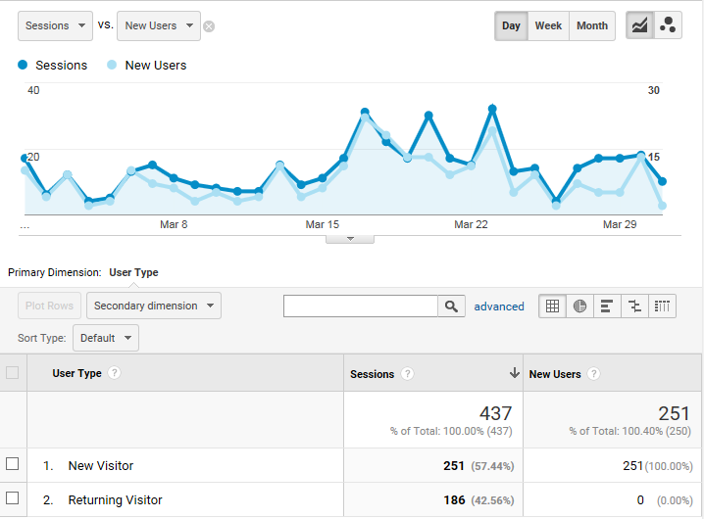

At the bottom, the report shows the visits (Sessions) broken down in New and Returning Visitors.

1. Click on the *Export* dropdown button and select *PDF*

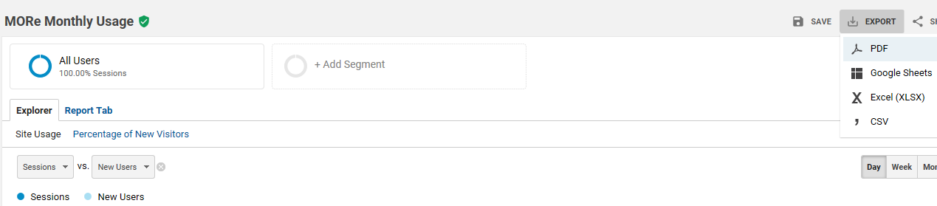

1. On the pop-up at the bottom, click the *Open* button

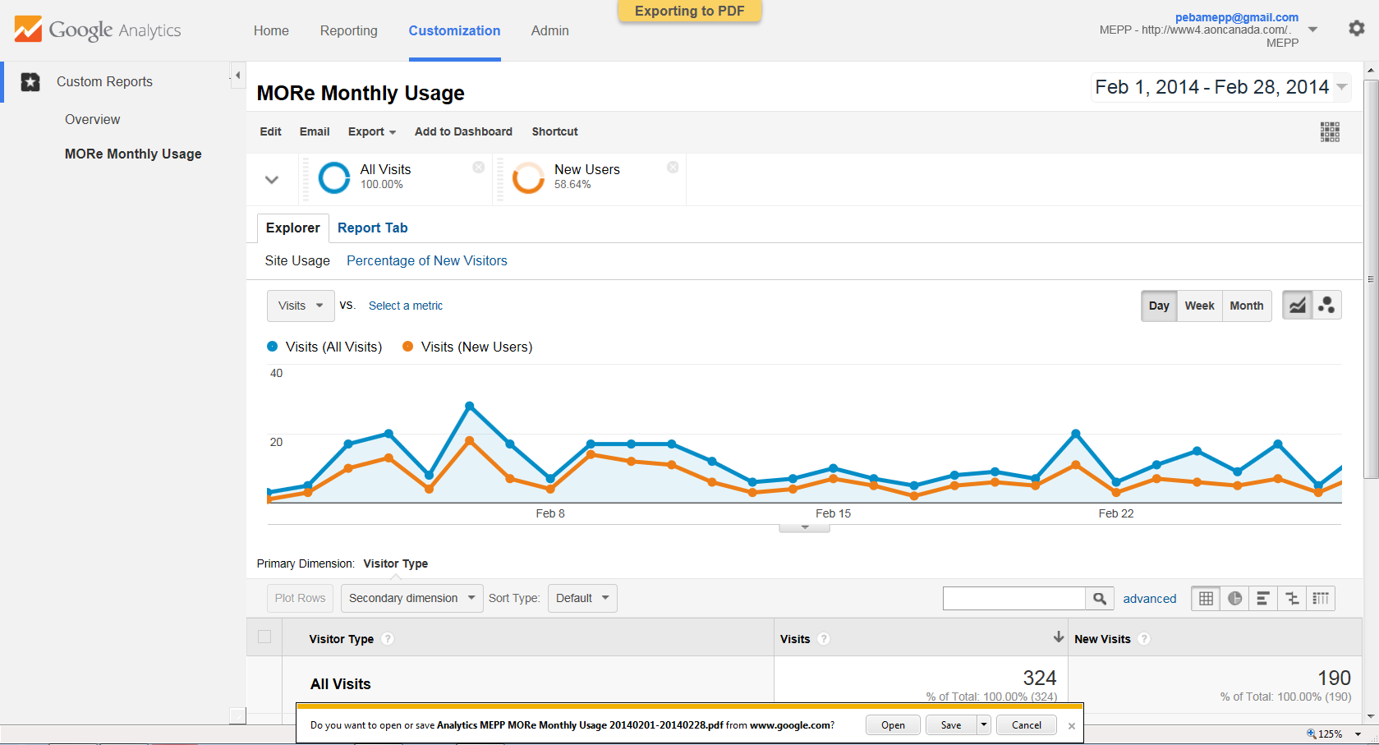

1. Verify the report opens in the PDF Reader

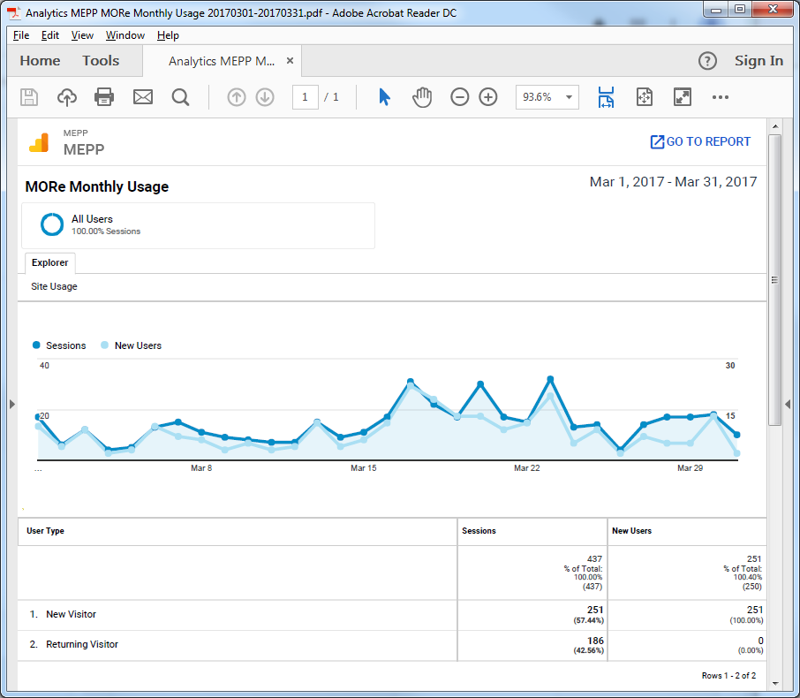

1. Click File > Save As and save the report as *MEPP MORe Monthly Usage <Month Year>* in these two locations:

* H:\Quality Assurance\MEPP\MORe\Pension Retirement Calculator\Google Analytics Reports
* H:\Pension Programs\Dropbox\MEPP

1. Click the blue icon at the top-right and sign out of the Google Analytics website

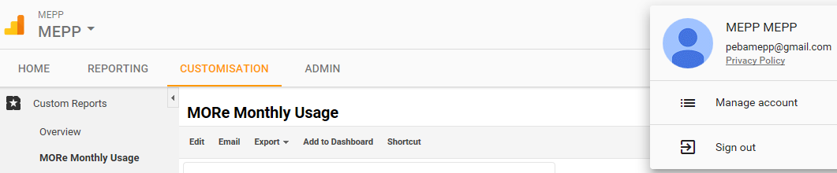

1. Sent the link of the report to the following people.

* Shane Harding
* Debby Parks
* Dawn Jones

**PEPP Capstock report:**

|  |  |
| --- | --- |
| **Procedure Number:** |  |
| **Procedure Name:** |  |
| **Purpose of the Procedure:** |  |
| **Original Date:** |  |
| **Revised Date:** |  |

|  | **Name/Title** | **Signature** | **Date** |
| --- | --- | --- | --- |
| **Reviewed by** | <Person who reviews the work> |  | <dd/mm/yyyy> |
|  |  |  |  |
|  |  |  |  |
| **Approved by** | <Senior Management / Business Area Manager> |  | <dd/mm/yyyy> |

**Overview:**

1. Login in PENFAX V5 Production:
2. Select Batches -> Batch Processes

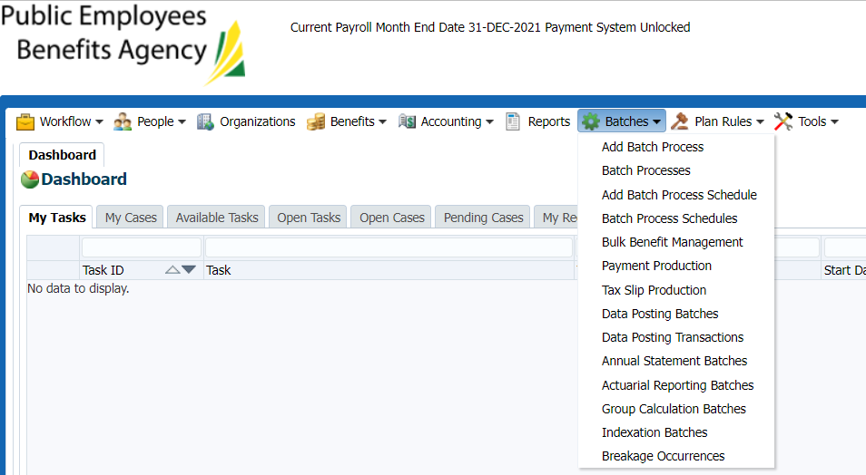

1. Select Batch Process Type: Process Investment Transaction -> Search

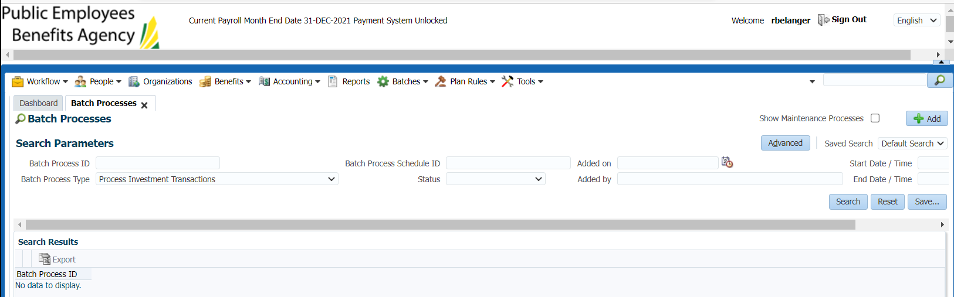

1. Select the latest Batch Process ID (should be previous day ID) -> Go to Files -> Open the CAPSTOCK Report.csv

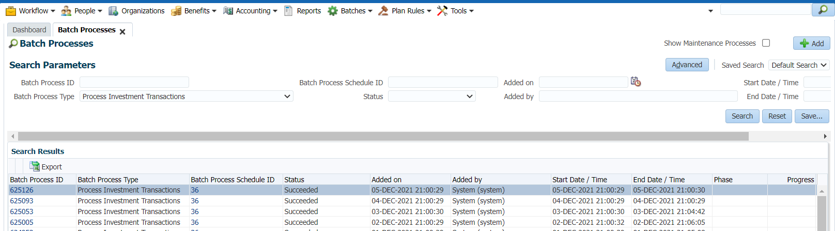

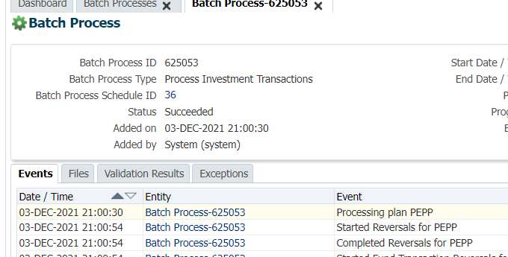

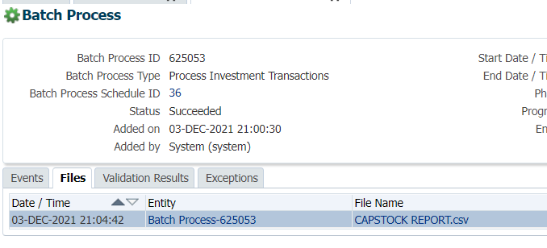

1. Download the File from PENFAX- Note the date is CURRENT DATE (Dec. 6, 2021)

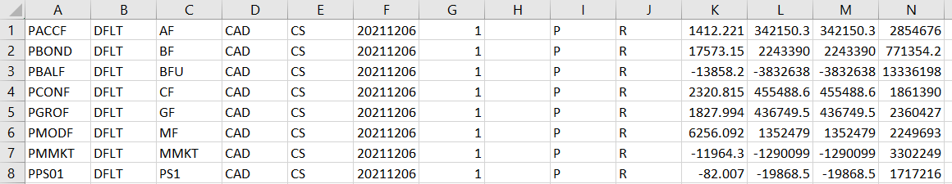

1. Save As file (CSV Format) in two locations:

File Name: capstock 20211203 <<Previous business day>>

1. Save File Here: H:\PEBA\Projects\Active\PEPP Renewal\Design Build\Document Production\New Extracts\D - Capstock Export

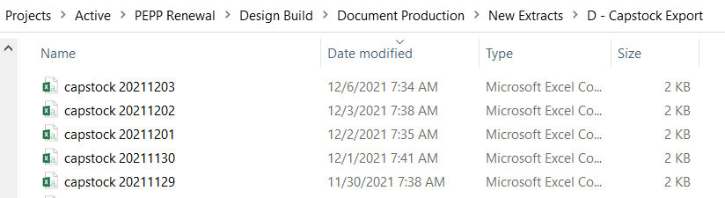

1. As well Save in the business folder: H:\Investment Services\Capstock

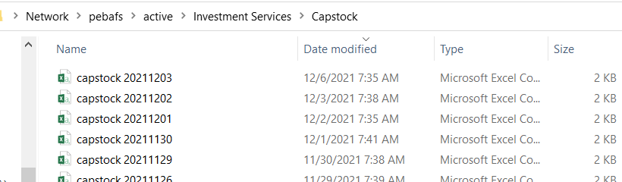

1. Send an email to the following people:

Momin, Asifali PEBA <Asifali.Momin@peba.gov.sk.ca>; Etafa, Samuel PEBA <Samuel.Etafa@peba.gov.sk.ca>; Textor, Regan PEBA <Regan.Textor@peba.gov.sk.ca>; Osibogun, Remilekun PEBA <Remilekun.Osibogun@peba.gov.sk.ca>; Bissonnette, Derek PEBA <Derek.Bissonnette@peba.gov.sk.ca>; Hutch, Gary PEBA <Gary.Hutch@peba.gov.sk.ca>; Fang, Song PEBA <Song.Fang@peba.gov.sk.ca>; Krenbrink, Michelle PEBA [Michelle.Krenbrink@peba.gov.sk.ca](mailto:Michelle.Krenbrink@peba.gov.sk.ca)

**CC:** [bussupport@peba.gov.sk.ca](mailto:bussupport@peba.gov.sk.ca), Sheryl Britton



**POP Morning Check:**

|  |  |
| --- | --- |
| **Procedure Number:** |  |
| **Procedure Name:** |  |
| **Purpose of the Procedure:** |  |
| **Original Date:** |  |
| **Revised Date:** |  |

|  | **Name/Title** | **Signature** | **Date** |
| --- | --- | --- | --- |
| **Reviewed by** | <Person who reviews the work> |  | <dd/mm/yyyy> |
|  |  |  |  |
|  |  |  |  |
| **Approved by** | <Senior Management / Business Area Manager> |  | <dd/mm/yyyy> |

**Overview:**

POP Morning Check

1. Log into **POP Production PENFAX** with username and password from the

Test Passwords spreadsheet

* + <http://prodapp2.peba.gov.sk.ca/forms/frmservlet?config=pop>

1. Enter *pop;pop;rac* in Username;Password;Database

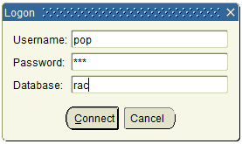

1. Click *Connect*
2. Go to *Plan* > *Control Totals*
3. Verify the *Fund in Balance* field says **Y** and Last Balance Date = last business day

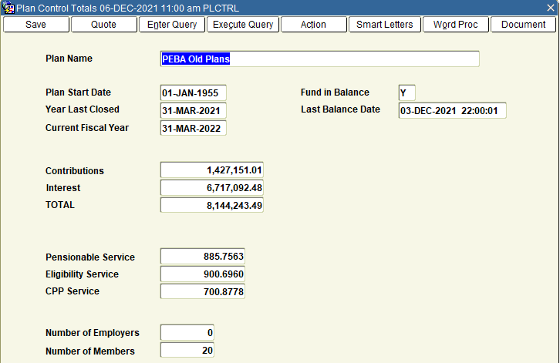

1. Log out of POP PENFAX

Check TEST POP PENFAX

Follow same procedure as above, however Log in to POP TEST

1. Enter testuser; testuser; ract12c in Username;Password;Database
2. Click Connect

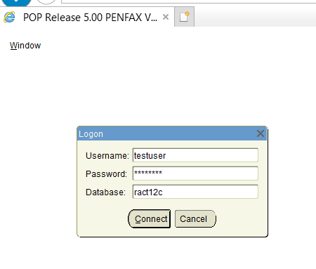

1. Verify Fund is in Balance by following steps 4 and 5 above

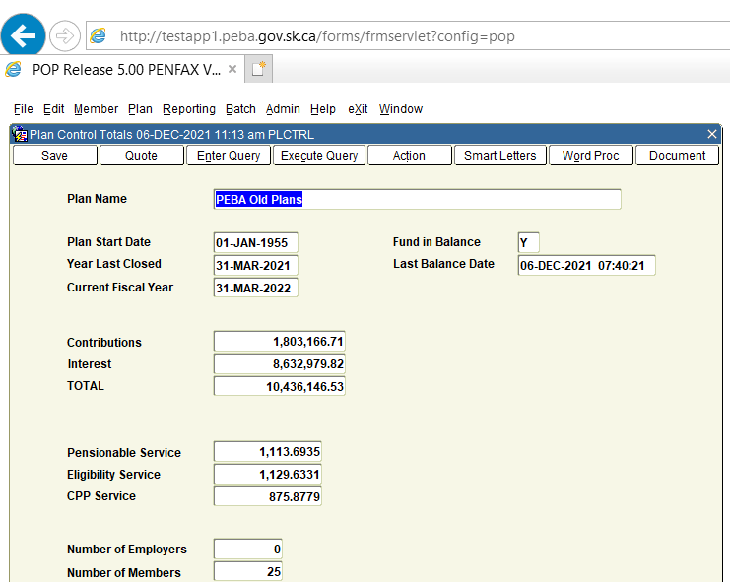

1. Each Monday an Audit is run in POP PENFAX TEST
2. Log into POP TEST PENFAX with the user login (batch/batch/popbatch)
3. Click **Connect**

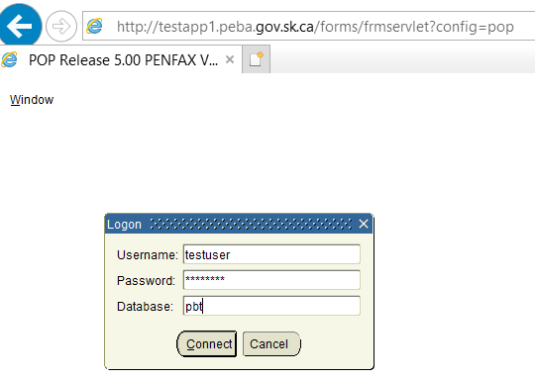

1. Go to **Batch > Audit**

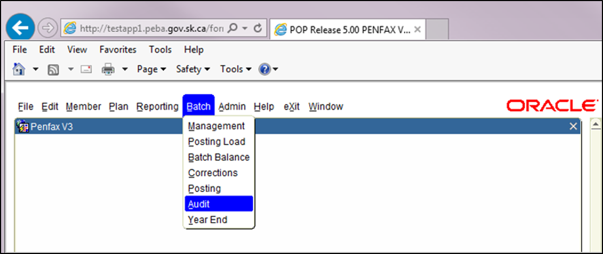

1. Click **Submit**

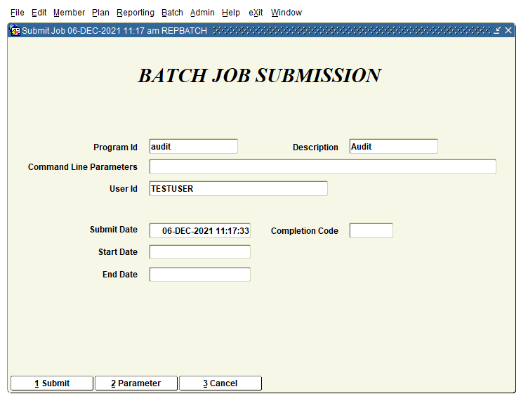

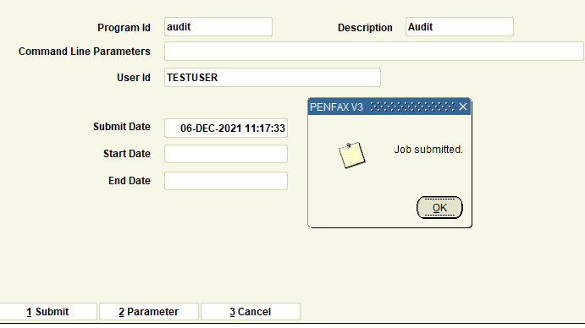

1. Audit in POP takes very short time, so in some cases the screen below will have no jobs listed

If the Audit job appears click **Refresh.**

1. Go to **Plan > Control Totals**
2. Verify the **Fund in Balance** field says **Y** and log out of POP (click *eXit* under**File**)

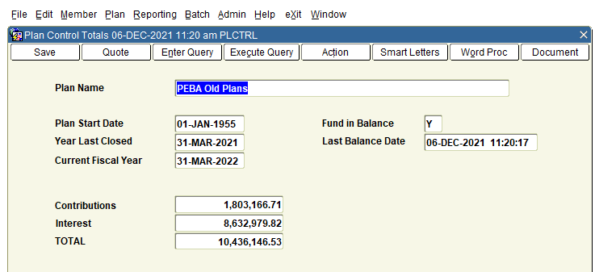

**Procedure document for Identify Invalid Pending Transactions:**

|  |  |
| --- | --- |
| **Procedure Number:** |  |
| **Procedure Name:** |  |
| **Purpose of the Procedure:** | Procedure document for Verify Invalid Pending Transactions |
| **Original Date:** |  |
| **Revised Date:** |  |

|  | **Name/Title** | **Signature** | **Date** |
| --- | --- | --- | --- |
| **Reviewed by** | <Person who reviews the work> |  | <dd/mm/yyyy> |
|  |  |  |  |
|  |  |  |  |
| **Approved by** | <Senior Management / Business Area Manager> |  | <dd/mm/yyyy> |

**Overview**

This process is for to identify Invalid pending transactions that Member submitted on the Planet Member.

IT run this query at 2:05 PM and we will verify this query result after we get the file from IT.

**Quick Steps to follow**:

1. IT will run the query and send to Service Desk at 2:00 PM daily.

* Query 1 (Identify Pending Invalid Transactions)

select * from p_account_instructions p where p.account_instruct_status_code='PENDING'

* Query 2

IT will run Query 2, which will identify incorrect transactions created since the previous query run.

select a.inv_account_sid,a.account_instruction_sid,account_instruct_type_code,b.fund_sid,b.fund_desc,b.allocation  
from p_account_instructions a  
join p_acct_instruct_allocations b   
on a.account_instruction_sid = b.account_instruction_sid  
where a.account_instruct_type_code in ('INTERFUND','ASSETREB')  
and ( SELECT abs(nvl(SUM(t.transaction_amount), 0))  
FROM p_fund_transactions t  
WHERE t.account_instruction_sid = a.account_instruction_sid) > 0;

1. Get the file from IT via Service Desk-Download and open the file.

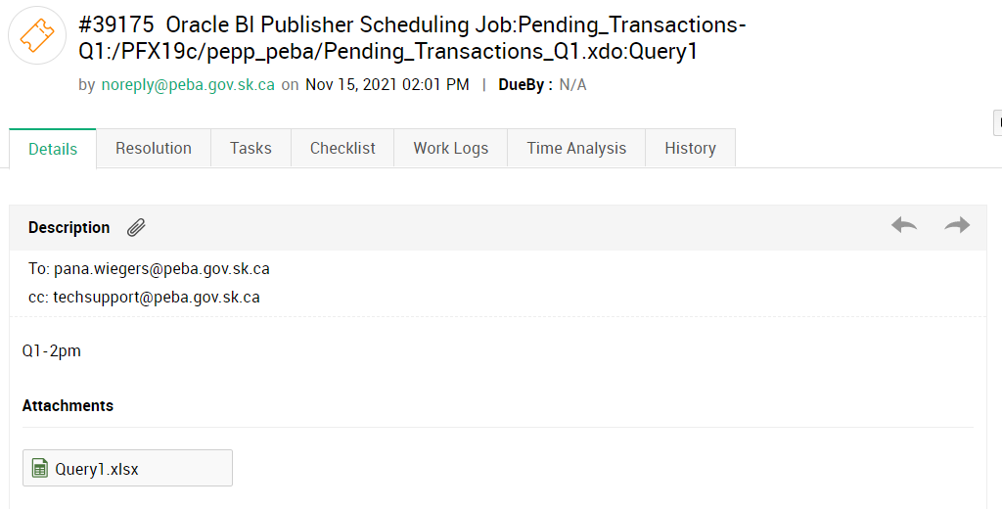

**Query 1 file Output:**

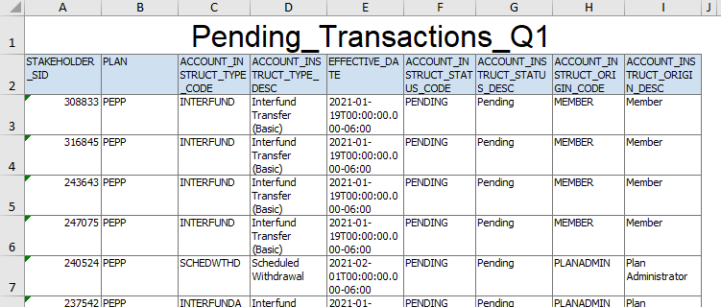

* Open the File
* Apply the filter on Column D -> Select Interfund Transfer (Basic) -> OK

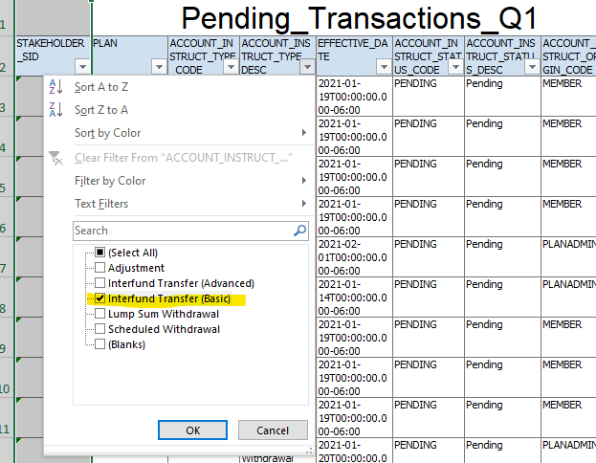

* Check the column A

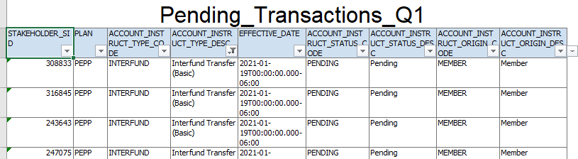

* Take the Stakeholder ID one by one & search in PENFAX V5 Production and follow the 1-6 steps.
  1. Login in PENFAX V5 Production <http://prodadf1.peba.gov.sk.ca:7001/Penfax5/login.html>
  2. Enter Username & Password -> Sign In

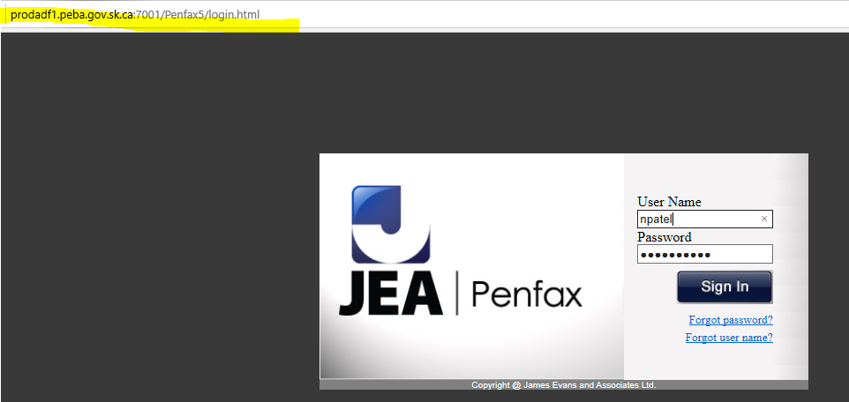

* 1. Enter Stakeholder ID (250469) -> Search

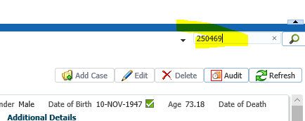

* 1. Go to Investments -> Account Summary
* Verify Currently member’s funds are in *Accelerated Growth Fund (AF)*

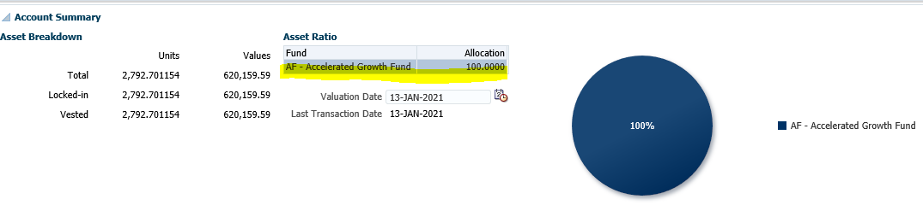

* 1. Investments -> Account Instructions
* Click on the **Pending** Instruction
* Verify interfund transfer to *Money Market Fund (MMF)*

**Note:** Member transfers their funds from AF to MMF which is valid transaction

If the member transfers their funds from AF to AF (back to the same fund) which is Invalid transaction.

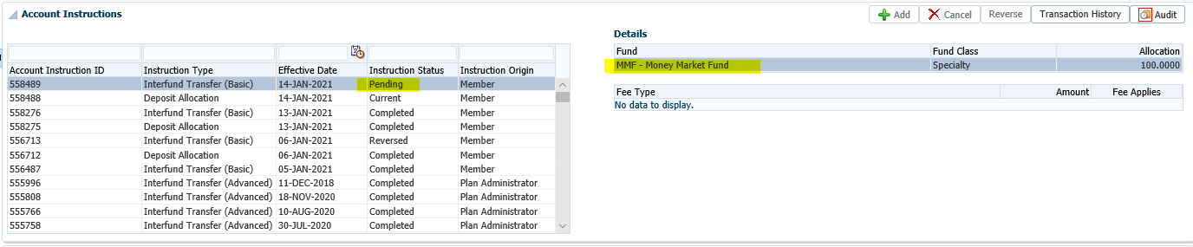

* 1. Investments -> Account Summary
* Also make sure their funds are not in **two asset allocations** fund under the asset ratio section
  1. Investments -> Account Instructions>deposit allocation (status = current)

verify current deposit allocation does not break the 2 assets allocation rule either

**Description**

We have two Fund Class

1. **Speciality (2 Funds):**
   1. Money Market Fund (MMF)
   2. Bond Fund (BF)
2. **Asset Allocation:**
   1. Other funds are included under Asset Allocation fund (AF, PS4 etc.)

* In the screenshot, we have only one Asset allocation fund (AF) under asset ratio which is correct.



* It should not be display 2 Asset allocation funds (AF, PS4) OR (AF, PS7) at the same time which is **incorrect.**

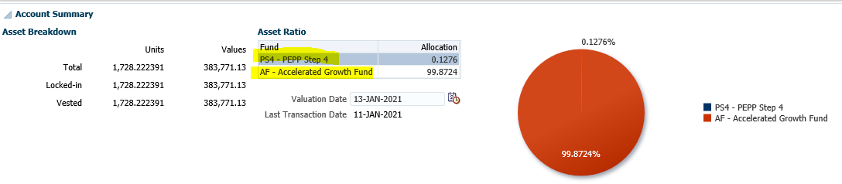

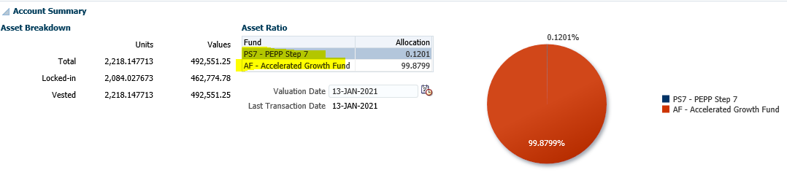

* Display the combination of 1 Speciality fund (MMF) & 1 Asset allocation fund (BFU) which is correct.

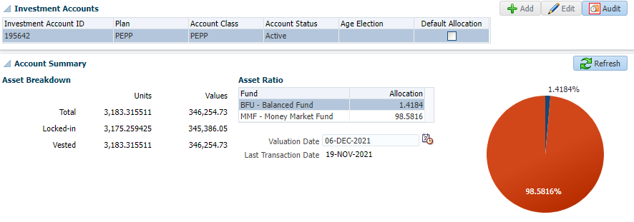

* Display 2 speciality fund (MMF, BF) which is correct**.**

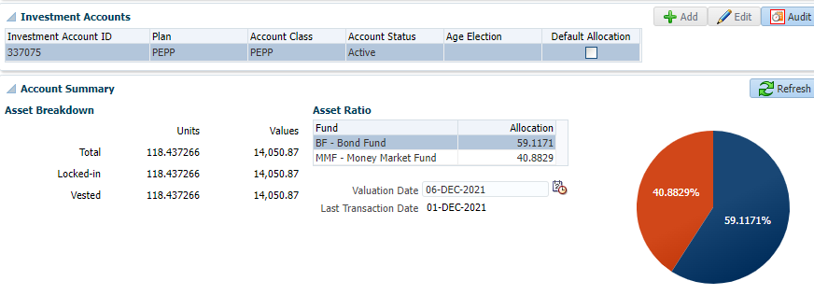

**Query 2 file Output:**



If the data is in Query 2 file then IT will give us the screenshot for the Query 2 data.

Query 2 – as expected nothing has been reported.

1. **Send an email to business after verification**

**TO**: Tech Support, PEBA <TechSupport@peba.gov.sk.ca>; Culetta, Heather PEBA <Heather.Culetta@peba.gov.sk.ca>; Toth, Leanne PEBA <Leanne.Toth@peba.gov.sk.ca>

**CC**: Britton, Sheryl PEBA <Sheryl.Britton@peba.gov.sk.ca>; [bussupport@peba.gov.sk.ca](mailto:bussupport@peba.gov.sk.ca)

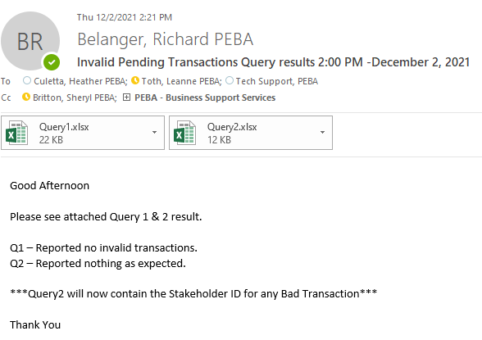

Invalid Transaction (Two Asset allocation)

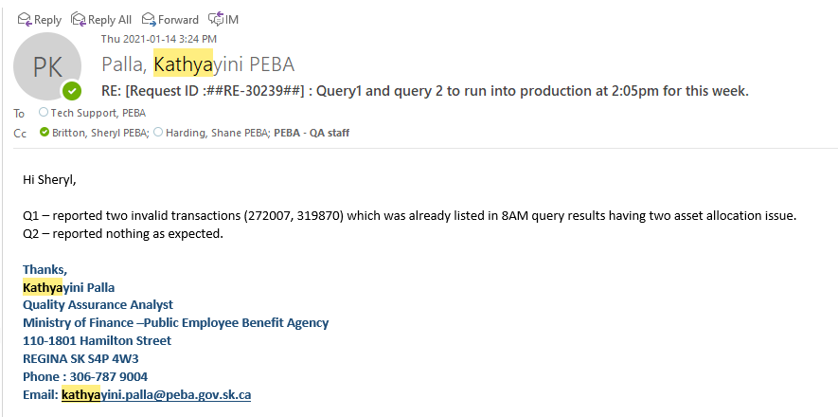

**Procedure document for MASS Email Import Process:**

|  |  |
| --- | --- |
| **Procedure Number:** |  |
| **Procedure Name:** |  |
| **Purpose of the Procedure:** | Procedure document for MASS Email Import Process |
| **Original Date:** |  |
| **Revised Date:** |  |

|  | **Name/Title** | **Signature** | **Date** |
| --- | --- | --- | --- |
| **Reviewed by** | <Person who reviews the work> |  | <dd/mm/yyyy> |
|  |  |  |  |
|  |  |  |  |
| **Approved by** | <Senior Management / Business Area Manager> |  | <dd/mm/yyyy> |

**Overview:**

**Every Friday, QA will have to:**

Last update: 27-Aug-21

Revised by: Niyati

1. Export e-Comm MEPP file from PENFAX V5
2. Download the MEPP lists from Quadrant website for backup purposes.
3. Import the exported E-Comm MEPP file to Quadrant

**Important Note:** when you upload the files, if more than 100 members are removed from the list, please ask another QA to verify before clicking ‘Confirm the File for Import’ button

**Export e-Comm MEPP file from PENFAX:**

1. Open the PENFAX V5 Production using the link below:

* <http://prodadf1.peba.gov.sk.ca:7001/Penfax5/login.html>
* please enter your credentials (If you do not have credentials please contact Pana & IT team)

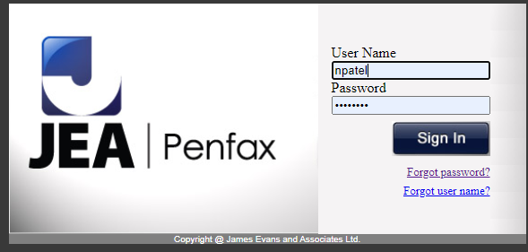

1. Click on Batches Tab >> Batch Processes

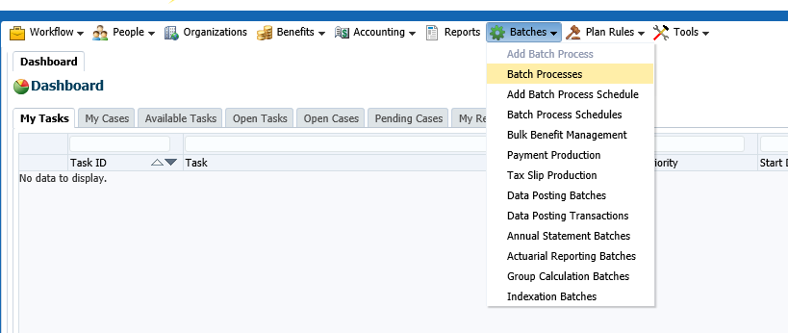

1. Click on the dropdown menu Batch Process Type and select **Export of members for e-Comm**.
2. Click on Search

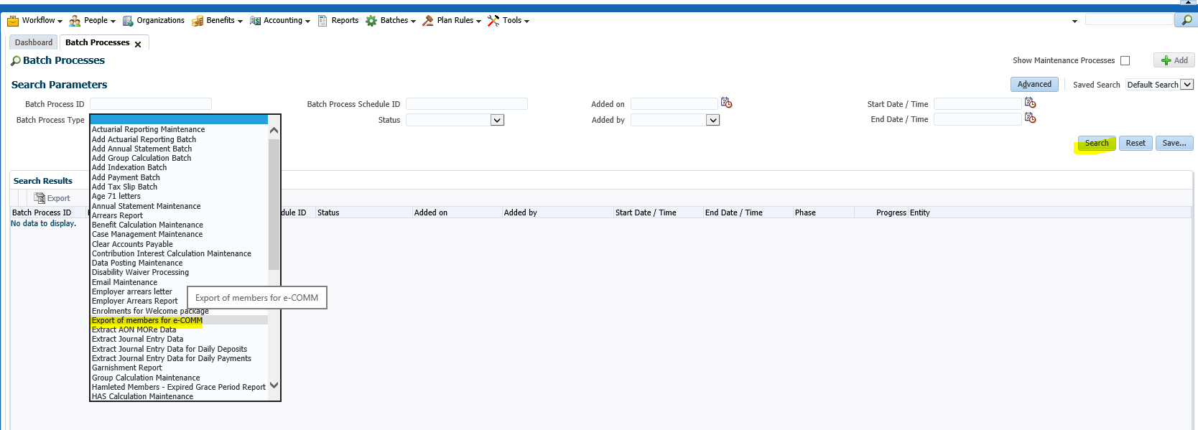

1. Under Search Results tab. Click on the latest Batch Process ID. For verification purpose please review Start Date/ Time and End Date / Time. Please ensure that you are clicking on the latest Batch Process ID.

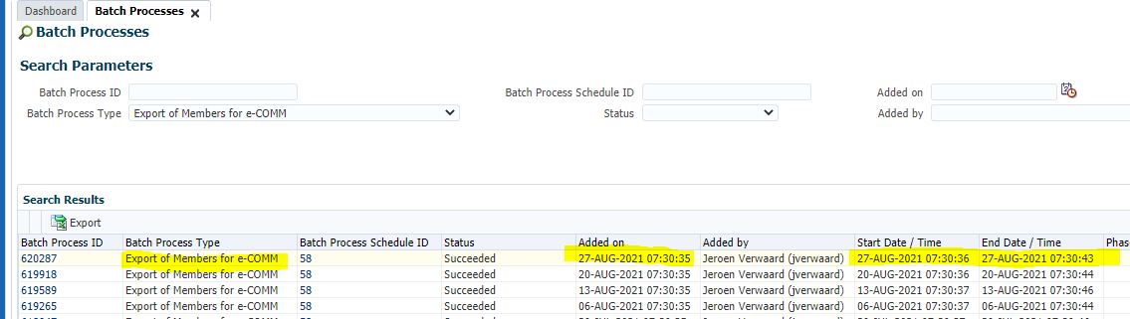

1. Click on Files Tab under Batch Process.
2. Click and open ECOMMYYYYMMDD.csv file under File Name field.

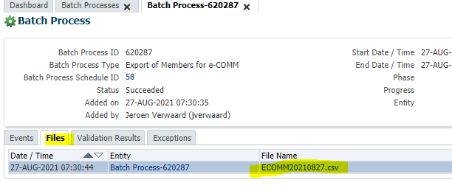

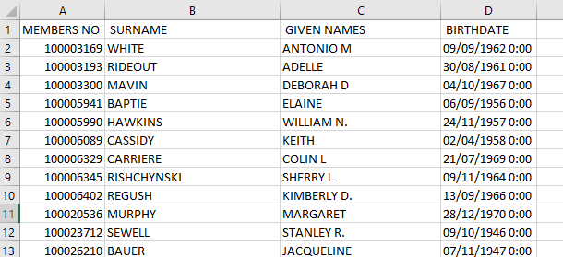

1. Remove Duplicates button on the Data tab, and remove duplicates by MemberNO

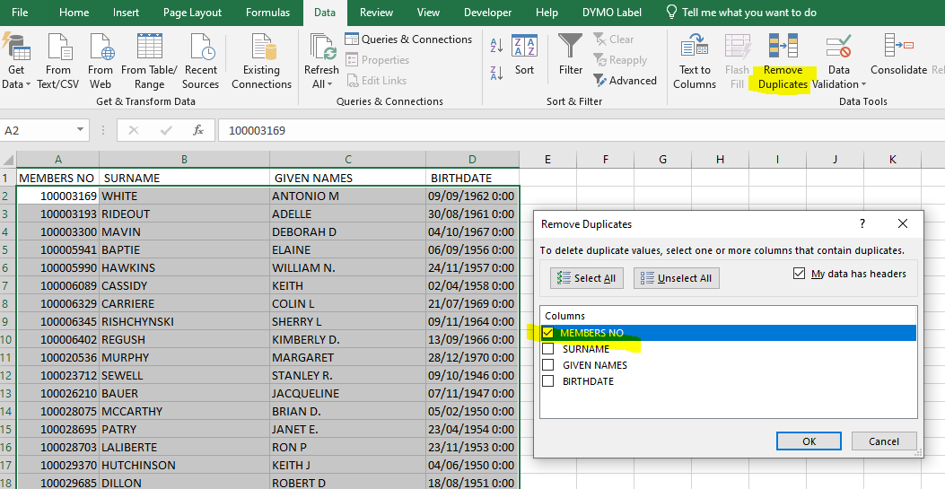

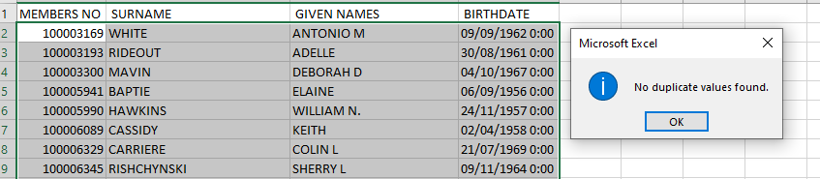

1. Save As file to:

**Path** - H:\Quality Assurance\PEBA\Mass Email\Queries\Query_Results\Import Files (Prod)\2020 <<Year>>

**File Name**: MEPP production import Files - Aug 27, 2021 <<Current Date>>

**Save AS Type**: CSV (MS-DOS)

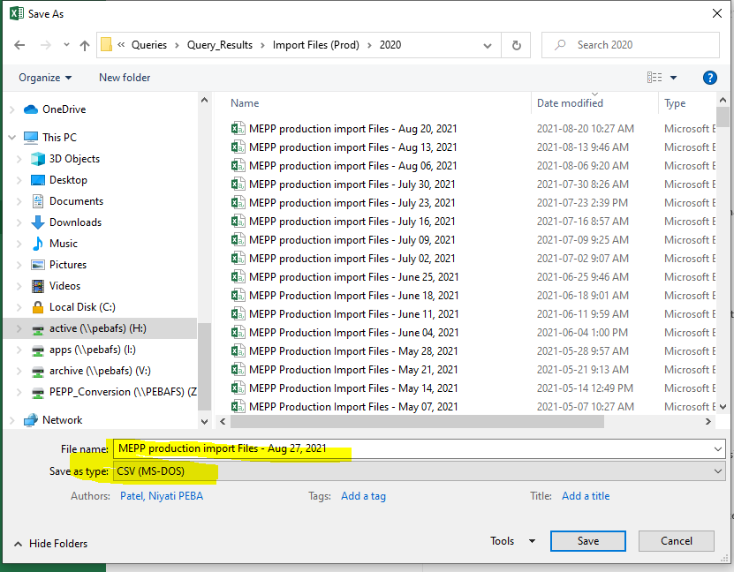

**Please note: if you do not save as a CSV MS-DOS file, the import file will be rejected**

**Creating a weekly backup files from Quadrant:**

The download of the lists will be used to restore the most recent MEPP e-Comm subscribed information.

1. Go to the Quadrant website <https://mailer.quadrant.net/admin/login/>
2. Sign in with your username and password

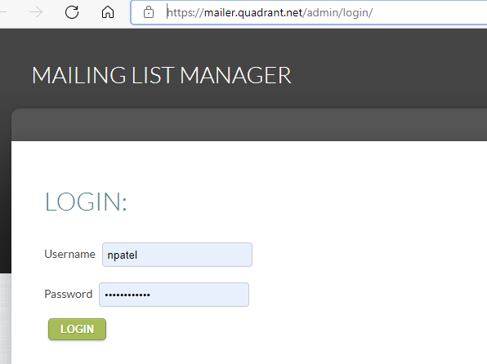

1. Verify you are on the **Mailing lists** tab

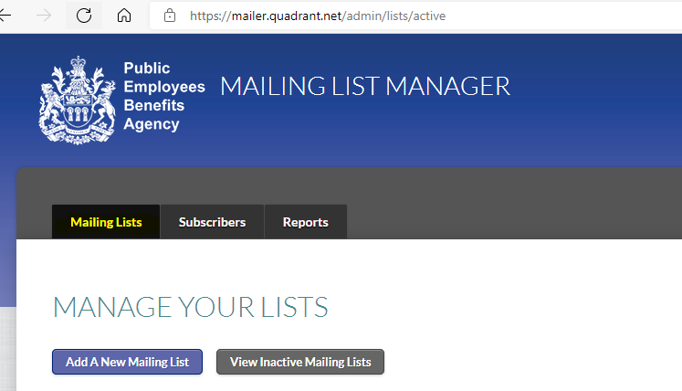

1. Click on the **Export** button for the **MEPP- Members (All)**

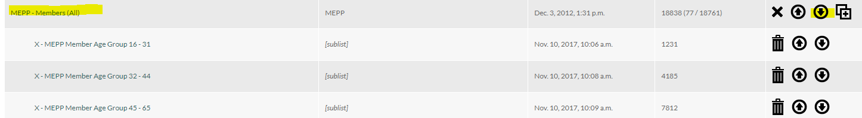

1. On the pop-up window, select **Open file** and save this Excel file to assigned folder

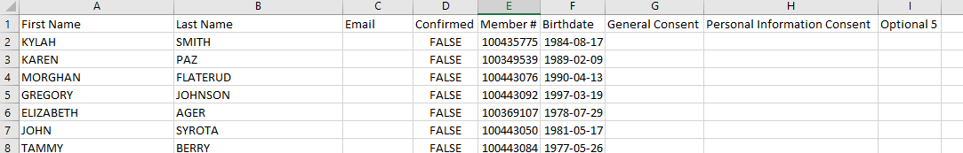

H:\Quality Assurance\PEBA\Mass Email\Reporting\Weekly Download\2021 <<YYYY>>

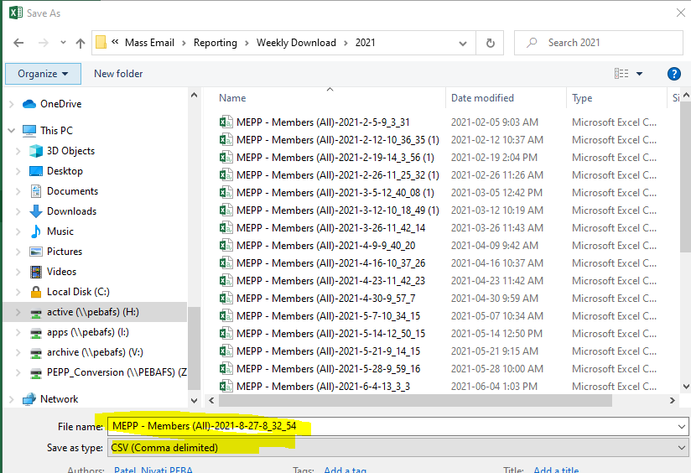

1. On the pop-up window, select **Open file** and save this Excel file to the assigned folder

H:\Quality Assurance\PEBA\Mass Email\Reporting\Weekly Download\YYYY\***MEPP – YYYYMMDD***

**Importing Files:**

**IMPORTANT**

After uploading each file, take a screenshot of the ‘Import Results’ page and save the Word document at this location H:\Quality Assurance\PEBA\Mass Email\Reporting\YYYY, using the following name convention: *Import Result Aug 27, 2021 <<Current Date>>*

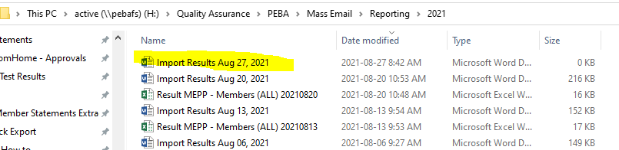

1. Go to the **Mailing Lists** tab on the Quadrant website; this screen allows you to import the data files that were queried and saved in CSV format
2. Import the Query data **– MEPP – Members (ALL)**

Take this (before Import) screenshot for the ‘Import Results’ Word document, and save it***.***

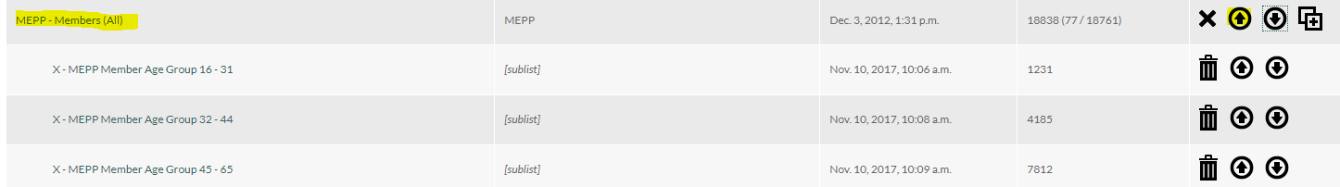

1. Click on the **Choose File** button

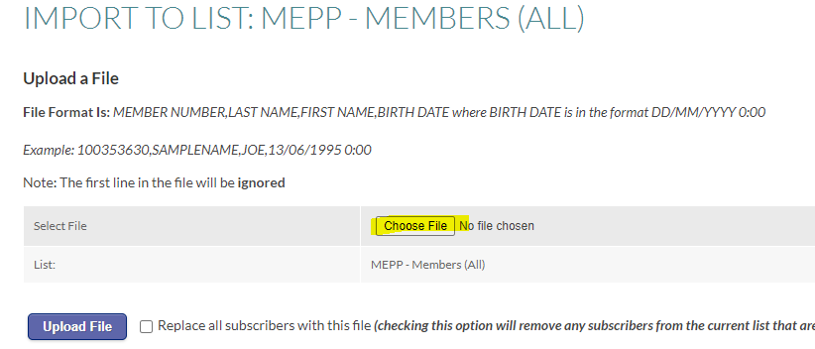

1. Select the **MEPP Production import files – <Current date>** CSV File and click the Open button

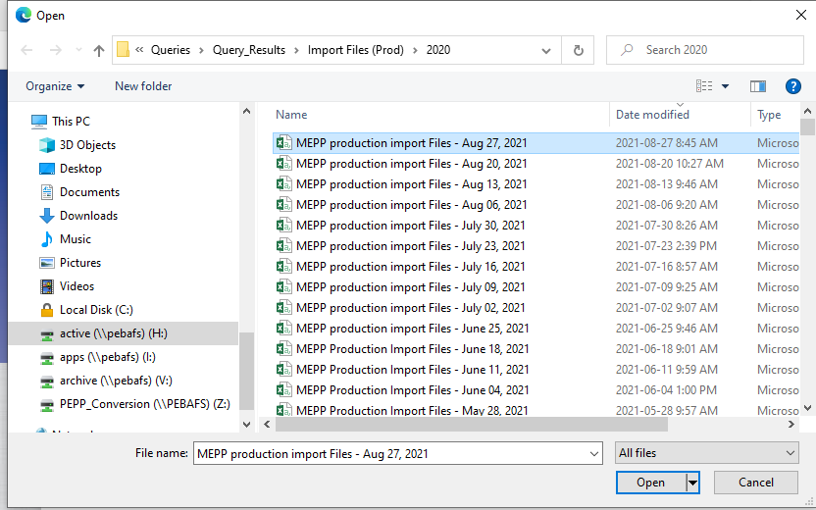

1. Click on the **Upload File** button
2. Uncheck **Replace all subscribers** option

Take this screenshot for the ‘Import Results’ Word document, and save it.

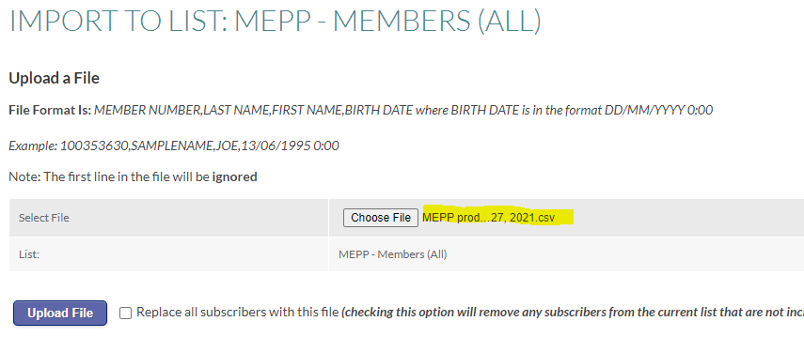

Take this screenshot for the ‘Import Results’ Word document, and save it.

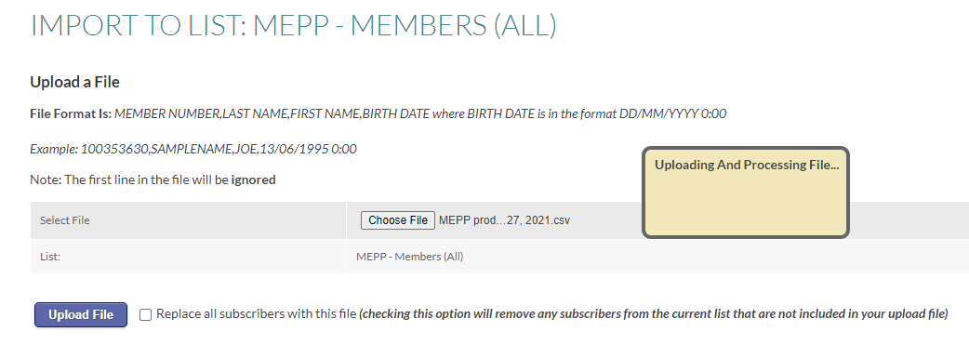

1. A message screen shows you how many subscribers will be imported, updated, removed and errored out before committing.

Please checked carefully for any discrepancies and make sure if import results look reasonable, especially **how many subscribers will be REMOVED**.

* If there are any errors, you will need to correct the errors before you import.
* If it looks unreasonable, i.e. **if there are more than 100 existing subscribers who will be removed, DO NOT click ‘Confirm the File For Import’ button**, and send the screenshot of ‘Import Results’ to Quadrant Support <support@quadrant.net> to investigate.

Example: *64501 existing subscribers will be removed from the list.* **This amount is unreasonable. Please make sure you upload the correct list.**

Take this screenshot for the ‘Import Results’ Word document, and save it.

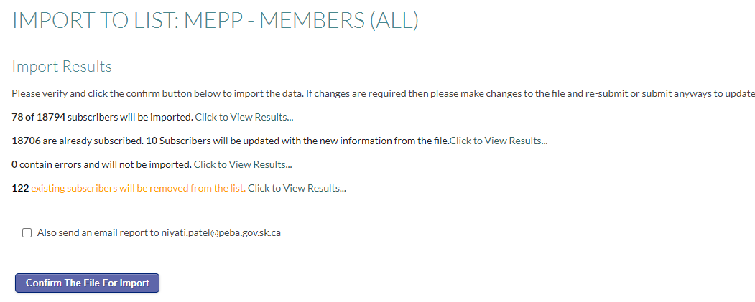

1. Save the removed subscribers list into Excel file



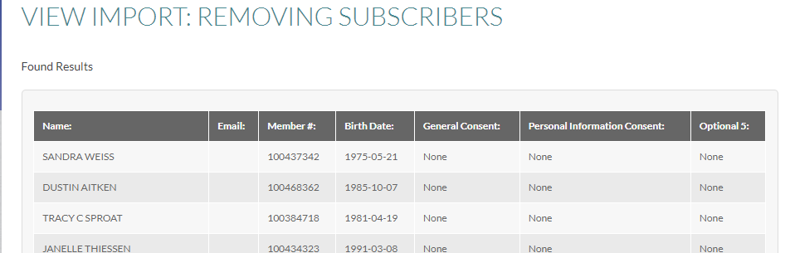

1. Using new web page, copy and paste the results into Excel and save it as Result PEPP – Members (ALL) YYYYMMDD under the following path

H:\Quality Assurance\PEBA\Mass Email\Reporting\2021

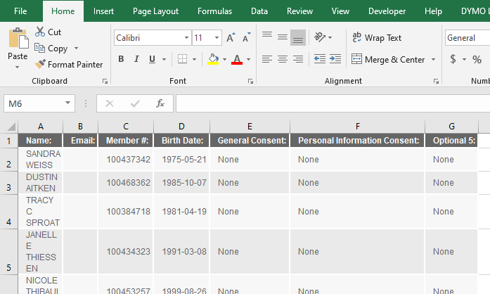

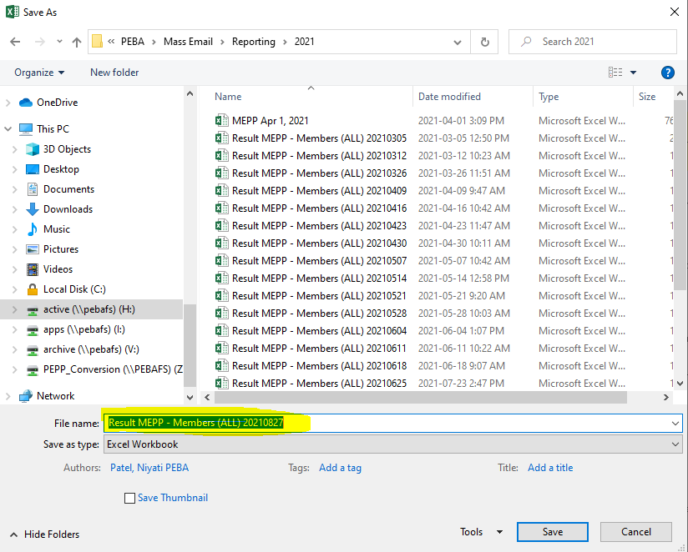

1. If there are no errors and the rest of results look reasonable, click on the **Confirm the File for Import** button

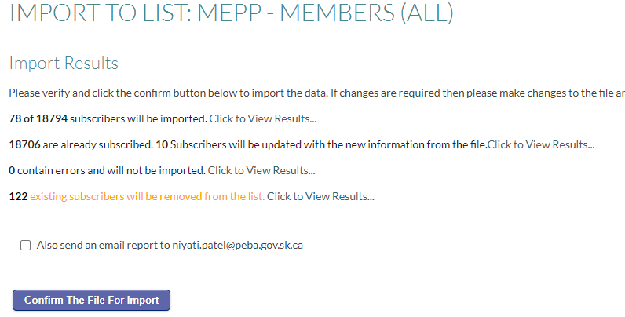

1. You will receive a confirmation message that the import was successful

Take this screenshot for the ‘Import Results’ Word document, and save it.

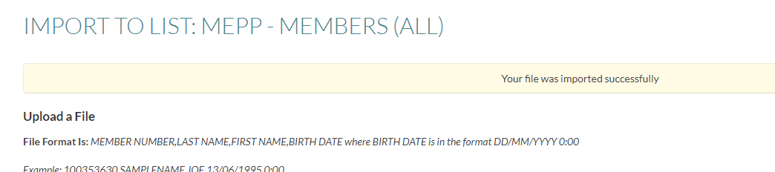

1. Go to Mailing lists

Take this (After Import) screenshot for the ‘Import Results’ Word document, and save it.

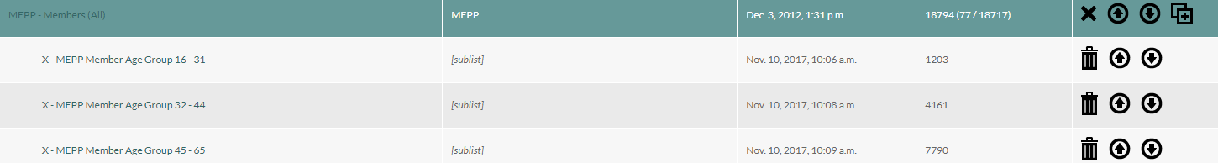

1. Log out of the Mailing List Manager

**Procedure document for two asset allocation funds:**

|  |  |
| --- | --- |
| **Procedure Number:** |  |
| **Procedure Name:** |  |
| **Purpose of the Procedure:** | Procedure document for verify two asset allocation funds |
| **Original Date:** |  |
| **Revised Date:** |  |

|  | **Name/Title** | **Signature** | **Date** |
| --- | --- | --- | --- |
| **Reviewed by** | <Person who reviews the work> |  | <dd/mm/yyyy> |
|  |  |  |  |
|  |  |  |  |
| **Approved by** | <Senior Management / Business Area Manager> |  | <dd/mm/yyyy> |

**Overview:**

Last update: 14-Jan-21

Revised by: Niyati Patel

1. IT runs the following Query at 8:00 AM daily in order to identify two asset allocation funds within the same account (PEPP or VPB).

Query Used:

SELECT *  
FROM (  
SELECT cfb.stakeholder_sid,  
cfb.inv_account_sid,  
count(1) aa_cnt  
FROM (SELECT ft.stakeholder_sid,ft.inv_account_sid, ft.fund_sid, SUM(ft.transaction_units) units  
FROM fund_transactions ft  
GROUP BY ft.stakeholder_sid, ft.inv_account_sid, ft.fund_sid) cfb  
JOIN p_funds f  
ON f.fund_sid = cfb.fund_sid  
WHERE cfb.units <> 0  
AND f.fund_class_code = 'AA'  
GROUP BY cfb.stakeholder_sid, cfb.inv_account_sid)  
WHERE aa_cnt > 1;

The query result will be sent to Service Desk

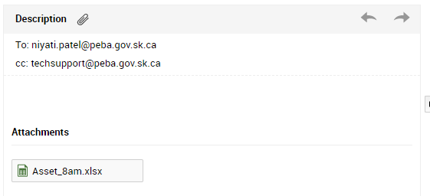

1. IT run this query to capture cases of 2 asset allocation funds both within the same investment account (PEPP or VPB) and between two accounts (PEPP and VPB) at 8:05 daily

Query Used:

select distinct pepp.STAKEHOLDER_SID

--, pepp.PEPP_INV_ACCOUNT, vpb.VPB_INV_ACCOUNT

from

(select distinct ia.STAKEHOLDER_SID, ia.INV_ACCOUNT_SID as PEPP_INV_Account, ia.INV_ACCOUNT_CLASS_DESC, ia.WARNING_MESSAGE as Default_Message, ia.INV_ACCOUNT_STATUS_DESC,

bl.fund_desc, bl.FUND_CLASS_DESC, bl.UNITS, bl.TOTAL_VALUE, bl.ALLOCATION

from PENFAX.p_inv_accounts ia

join PENFAX.p_inv_account_fund_balances bl on ia.INV_ACCOUNT_SID=bl.INV_ACCOUNT_SID

where

ia.INV_ACCOUNT_STATUS_CODE = 'A'

and bl.TOTAL_VALUE <> 0

and bl.FUND_CLASS_DESC = 'Asset Allocation'

--and ia.STAKEHOLDER_SID = '90589'

and ia.INV_ACCOUNT_CLASS_DESC = 'PEPP'

Order by ia.STAKEHOLDER_SID)pepp

join

(select distinct ia.STAKEHOLDER_SID, ia.INV_ACCOUNT_SID as VPB_INV_Account, ia.INV_ACCOUNT_CLASS_DESC, ia.WARNING_MESSAGE as Default_Message, ia.INV_ACCOUNT_STATUS_DESC,

bl.fund_desc, bl.FUND_CLASS_DESC, bl.UNITS, bl.TOTAL_VALUE, bl.ALLOCATION

from PENFAX.p_inv_accounts ia

join PENFAX.p_inv_account_fund_balances bl on ia.INV_ACCOUNT_SID=bl.INV_ACCOUNT_SID

where

ia.INV_ACCOUNT_STATUS_CODE = 'A'

and bl.TOTAL_VALUE <> 0

and bl.FUND_CLASS_DESC = 'Asset Allocation'

--and ia.STAKEHOLDER_SID = '90589'

and ia.INV_ACCOUNT_CLASS_DESC = 'VPB'

Order by ia.STAKEHOLDER_SID)vpb on vpb.STAKEHOLDER_SID = pepp.STAKEHOLDER_SID and vpb.FUND_CLASS_DESC = pepp.FUND_CLASS_DESC and vpb.FUND_DESC <> pepp.FUND_DESC

union

SELECT stakeholder_sid

FROM (

SELECT cfb.stakeholder_sid,

cfb.inv_account_sid,

count(1) aa_cnt

FROM

(SELECT ft.stakeholder_sid,ft.inv_account_sid, ft.fund_sid, SUM(ft.transaction_units) units

FROM PENFAX.p_fund_transactions ft

GROUP BY ft.stakeholder_sid, ft.inv_account_sid, ft.fund_sid) cfb

JOIN PENFAX.p_funds f

ON f.fund_sid = cfb.fund_sid

WHERE cfb.units <> 0

AND f.fund_class_code = 'AA'

GROUP BY cfb.stakeholder_sid, cfb.inv_account_sid)

WHERE aa_cnt > 1

Order by stakeholder_sid

1. The query result will be sent to Service Desk.

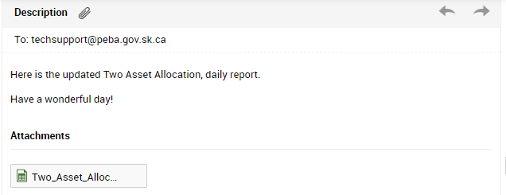

1. Verify random members from the query result.

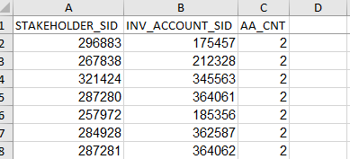

1. Forward the **8 AM query** email from service desk to the OSC team so that they can remove any members who showed on the query.

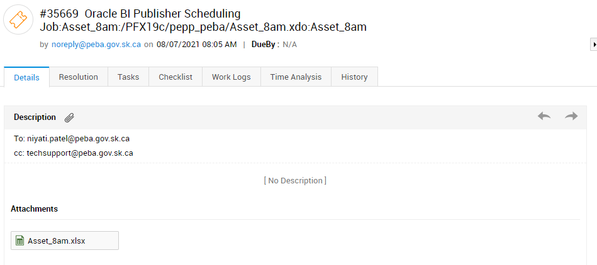

Forward Email to OSC Team:

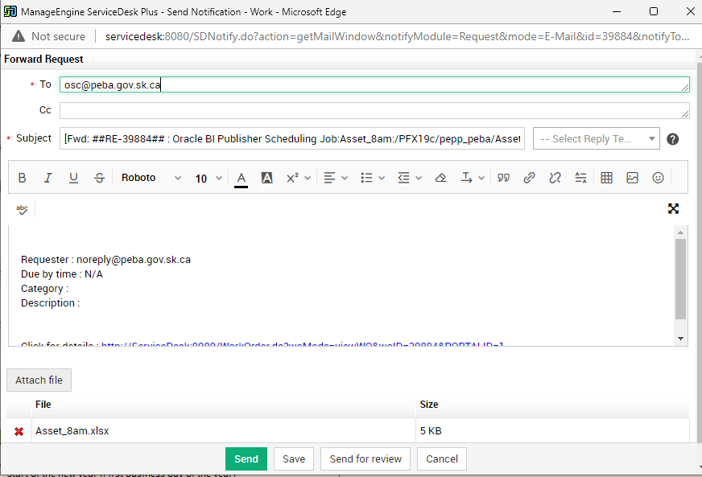

1. Save the report to - \\pebafs\active\Quality Assurance\Prod Apps\Prod Support\V5 Quality Assurance\Operations fixes - Prod\Two asset Allocations
2. Forward the **8:05 AM query** email from service desk to the ***Heather & Leanne*** so that they can advise the member to choose only 1 of the Asset allocation funds.

**How to fix Member in PENFAX**

1. Verify data in PENFAX V5 Production.
   1. Take the one stakeholder ID from the result (296883)
   2. Login into the PENFAX V5: [http://prodadf1.peba.gov.sk.ca:7001/PENFAX5/login.html](http://prodadf1.peba.gov.sk.ca:7001/Penfax5/login.html)
   3. Search the **Stackholder ID** in PENFAX V5

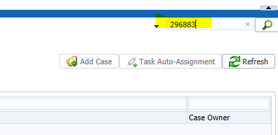

* 1. Go to Investments -> Account Summary
     + Verify that it should be display **2 asset allocation funds** in Asset Ratio which is **Invalid**.

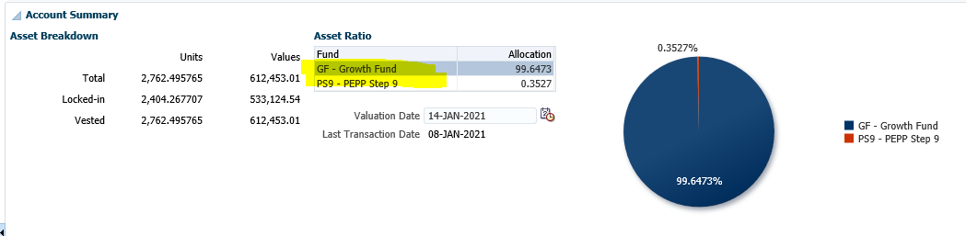

**Description**

We have two Fund Class

1. **Speciality (2 Funds)**
   1. Money Market Fund (MMF)
   2. Bond Fund (BF)
2. **Asset Allocation**
   1. Other funds are included under Asset Allocation fund (AF, PS4 etc.)
3. We need to fix this entry in PENFAX V5.
   1. **Stackholder ID:** 321424 with 2 asset allocation funds (PS1 & AF).

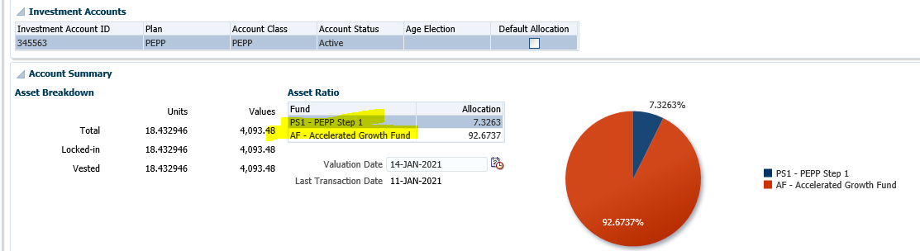

* 1. Account Activity -> See **latest contribution date** (08-Jan-2021)

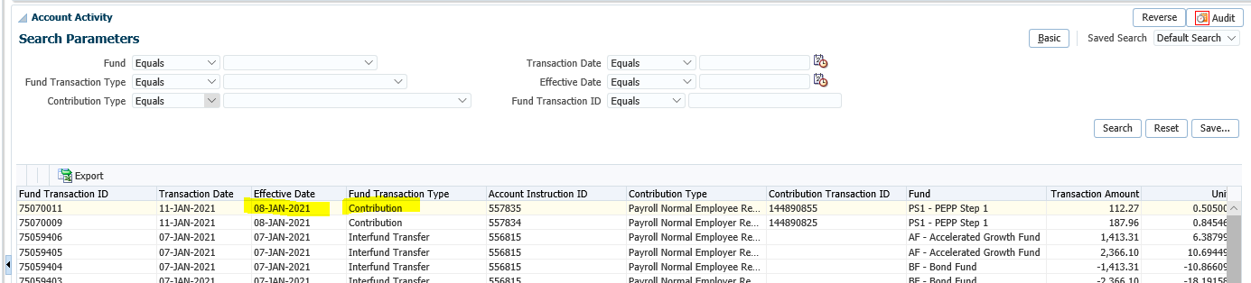

* 1. See last **deposit allocation** completed by **Member**

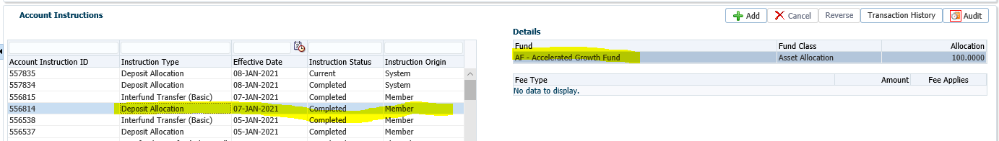

* 1. Add Deposit allocation for **AF – Accelerated Fund**
  + **Instruction Type:** Select *Deposit Allocation*
  + **Effective Date:** Same as latest contribution date which is *08-Jan-2021 (Step 2)*
  + Click on **Add** button
  + **Fund:** Select *AF – Accelerated Growth Fund (Step 3)*
  + **Allocation:** 100
  + Save

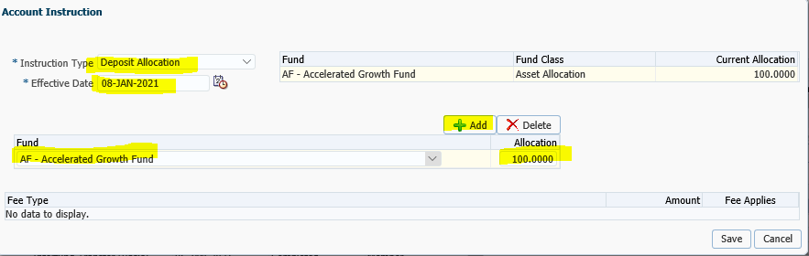

* 1. **Add Interfund Transfer (Advanced)**
* **Instruction Type:** Select *Interfund Transfer (Advanced)*
* **Effective Date:** Same as latest contribution date which is *08-Jan-2021 (Step 2)*
* Click on **Add** button
* **Transfer From:** Select current fund that system allocated (PS1)



* **Interfund Transfer Type:** Percent
* **Amount:** 100
* **Transfer To:** AF
* Save

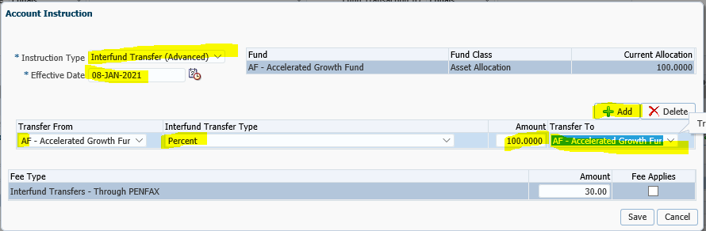

* 1. **Add Notes**
* Person Profile -> Add Notes -> Save

**Note:** *DAI added and Inter-fund performed to fix issue for 2 asset allocation funds resulting from employer payroll contributions being backdated. DO NOT COUNT FOR FURTHER INTER-FUND TRANSFER FEES*.

1. We need to verify the Previous day Members to see If any DAI & interfund is done by the system or not

**Note**: If any DAI & interfund is done by the system then we need to fix this member into the PENFAX Production.

1. Send an Email to the Team Member for the Verification.

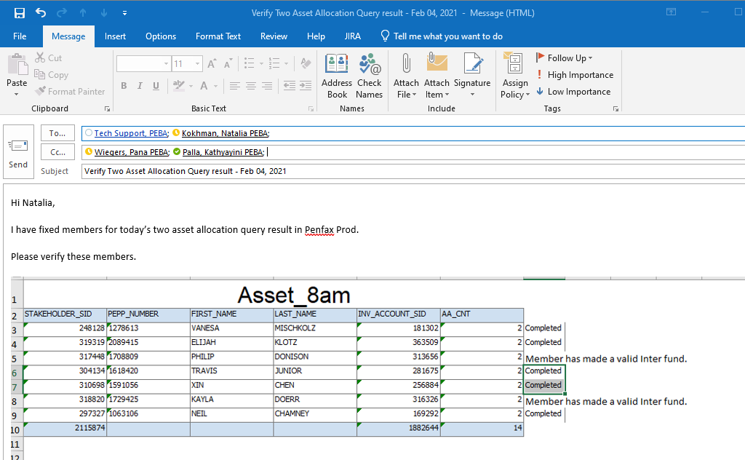

**Procedure document for Update Test Frate File:**

|  |  |
| --- | --- |
| **Procedure Number:** |  |
| **Procedure Name:** |  |
| **Purpose of the Procedure:** | Procedure document for Update Test Frate File |
| **Original Date:** |  |
| **Revised Date:** |  |

|  | **Name/Title** | **Signature** | **Date** |
| --- | --- | --- | --- |
| **Reviewed by** | <Person who reviews the work> |  | <dd/mm/yyyy> |
|  |  |  |  |
|  |  |  |  |
| **Approved by** | <Senior Management / Business Area Manager> |  | <dd/mm/yyyy> |

**Overview:**

Frate file needs to be sent to JEA team daily at 7:30 am. This process document will be helpful for QA team members to update the Frate file on JEA Jira.

**Quick Steps to follow**:

1. Pick up the previous date Frate file from the investment production

**H:\Investment Services\DailyFrate**

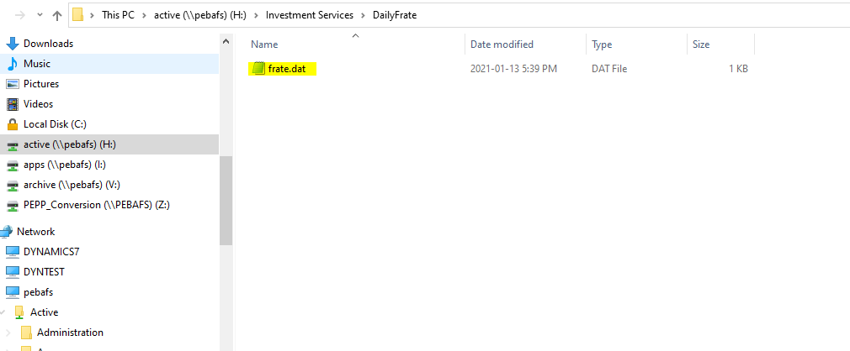

1. Copy it, and save it to “JEA FRate” folder:

H:\Quality Assurance\Prod Apps\PenfaxV5\PEPP\JEA FRate

1. Rename it to “Frate file for Jan 13th” (previous business day)

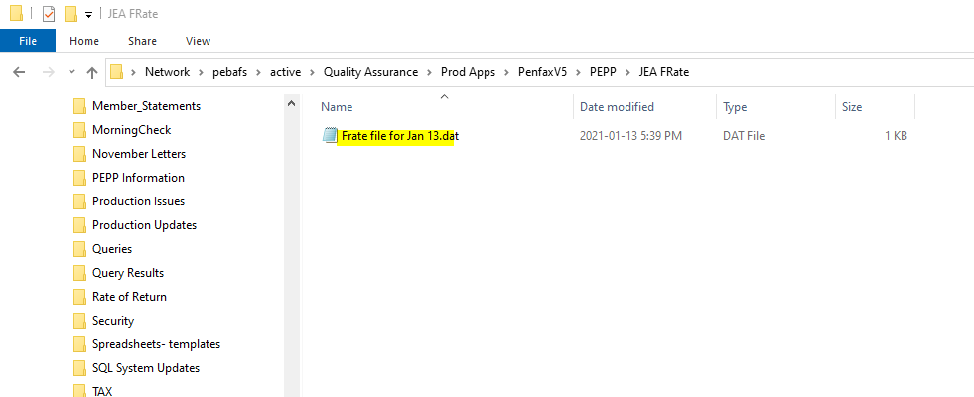

1. Login to JEA Jira. Enter JEA ticket no in search PEBA-5169. Select the first option.

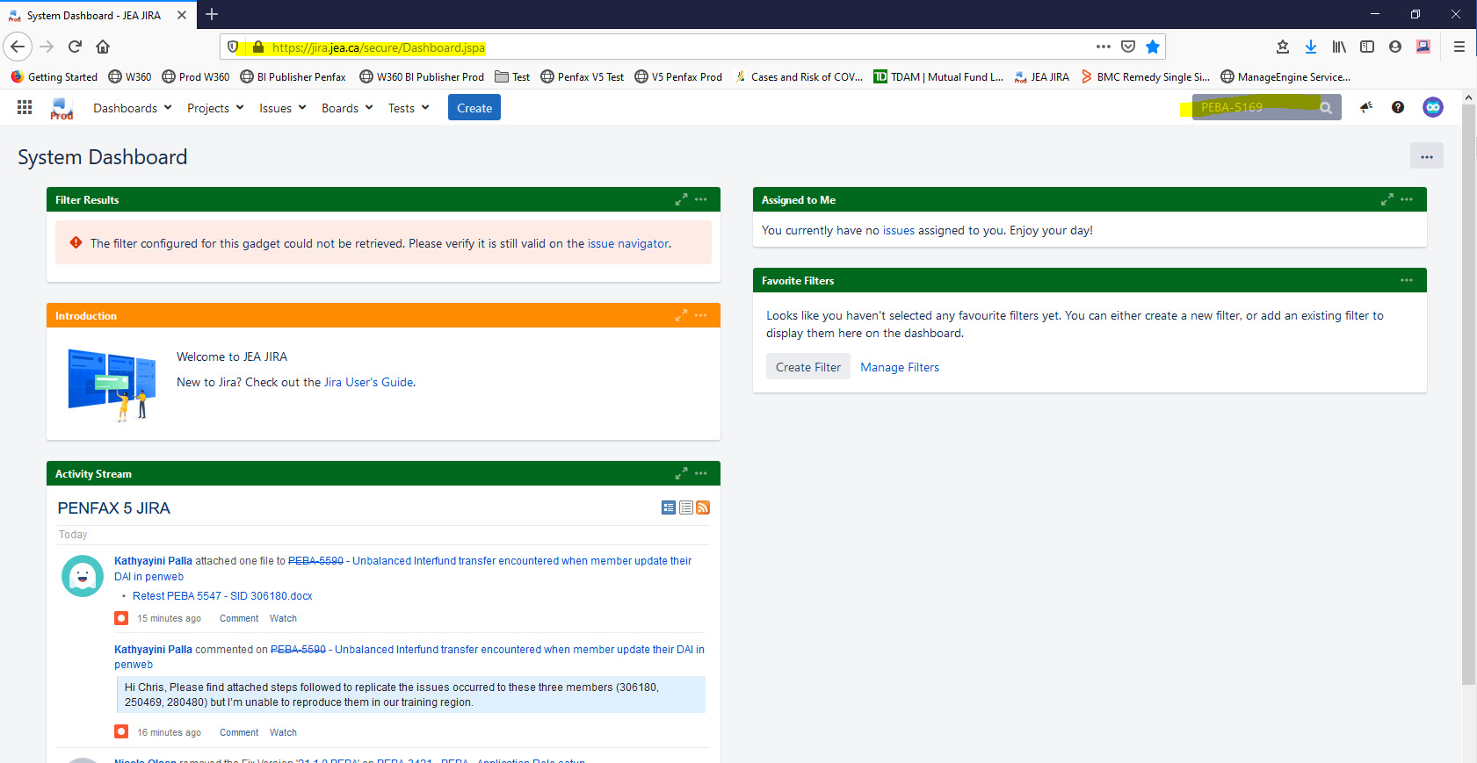

1. Use the browse function or drag & drop to attach the previous day Frate File.

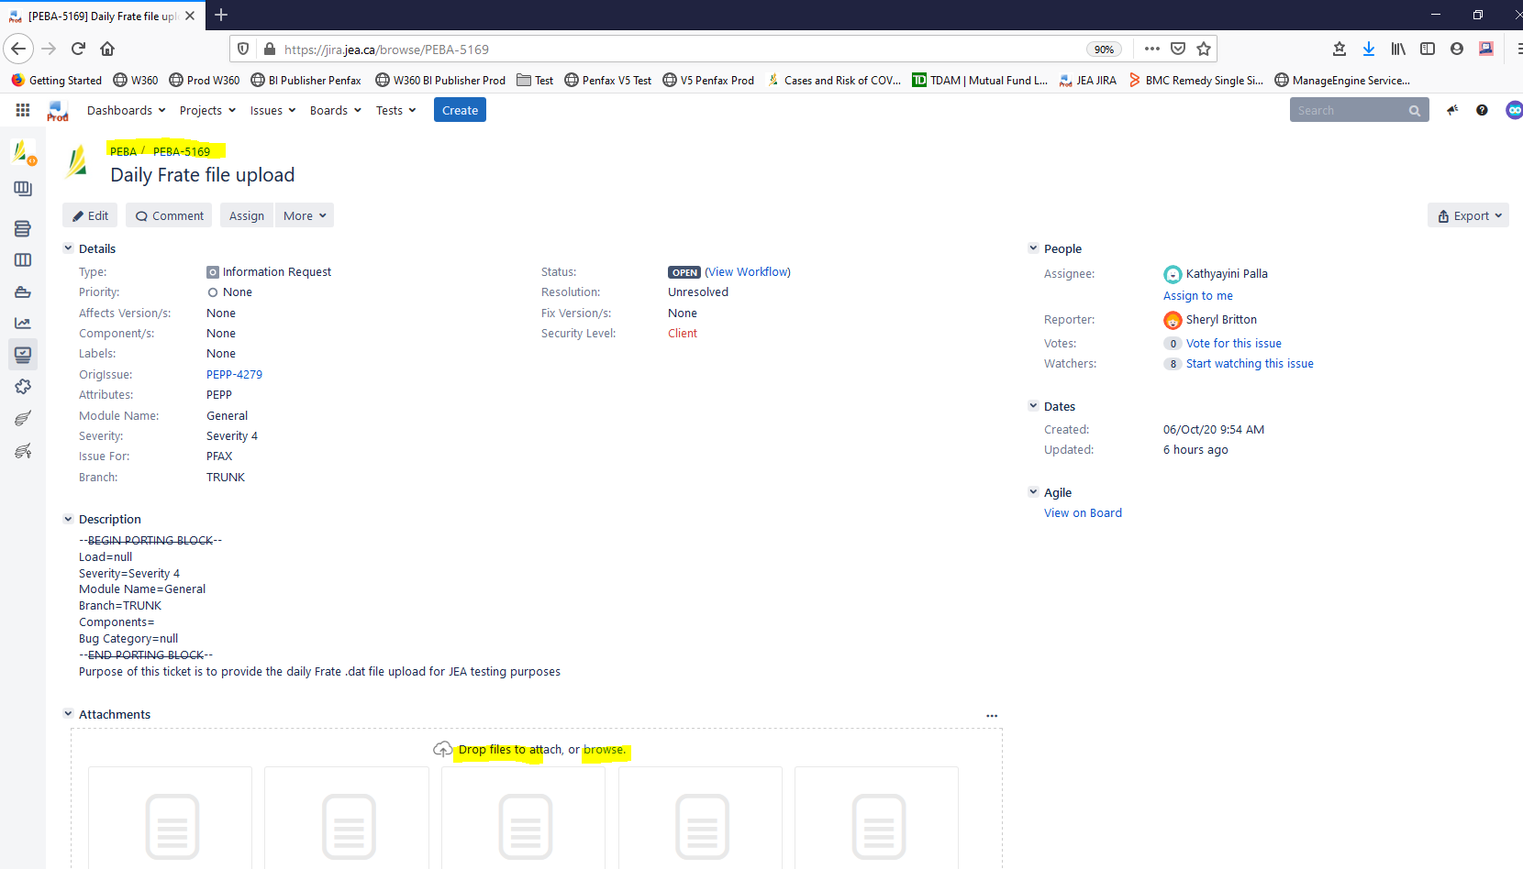

**Note:** Please re-login into the JEA website to ensure that the file is attached

Sort by Date and in Descending Order-See most recent file on top left

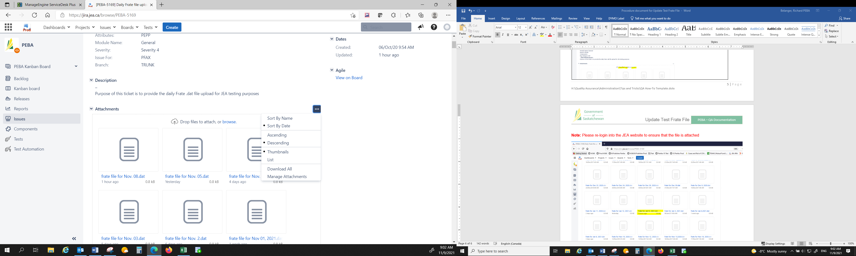

**Procedure document for Weekly Annuity rates Input:**

|  |  |
| --- | --- |
| **Procedure Number:** |  |
| **Procedure Name:** |  |
| **Purpose of the Procedure:** |  |
| **Original Date:** |  |
| **Revised Date:** |  |

|  | **Name/Title** | **Signature** | **Date** |
| --- | --- | --- | --- |
| **Reviewed by** | <Person who reviews the work> |  | <dd/mm/yyyy> |
|  |  |  |  |
|  |  |  |  |
| **Approved by** | <Senior Management / Business Area Manager> |  | <dd/mm/yyyy> |

**Overview**

**Procedural document to update weekly annuity rates in PENFAX production**

**Steps:**

1. Look out for the Email from PEPP administration with Weekly Monday rates subject” Annuity rate” on every Monday in Service Desk support

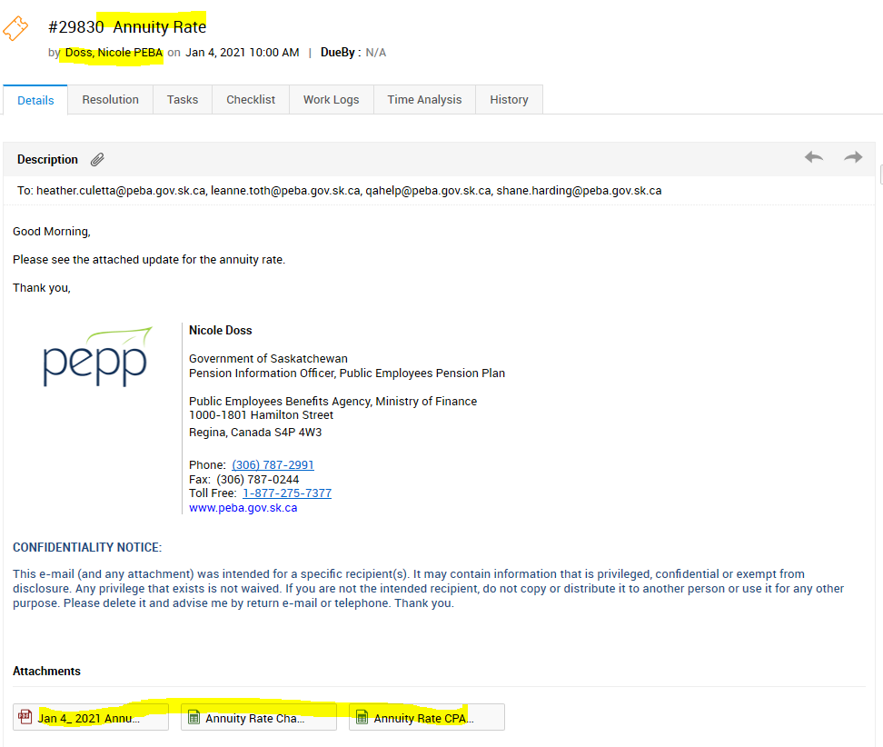

1. Pull out the following rates from the pdf/Excel spreadsheet from the email

2.a Default 7-year bond yield (%)

2.b Default long-term bond yield (%):

2.c default expense rate (%)

**Please note: the pdf file will have effective date of Friday, but PEPP will input an effective date for Monday**

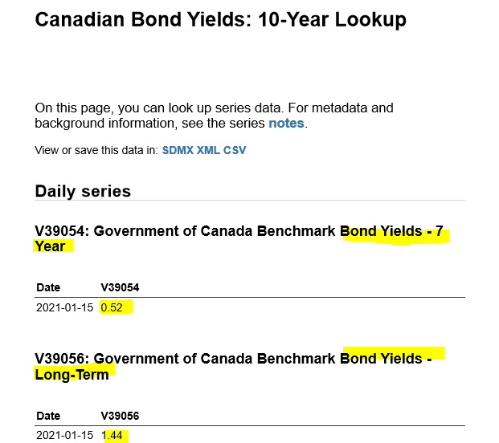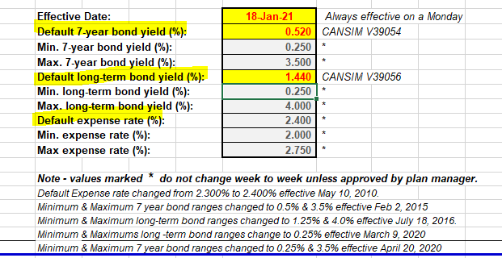

1. Input the default rates in PENFAX

Go to Penfax>Plan rules>interest rates

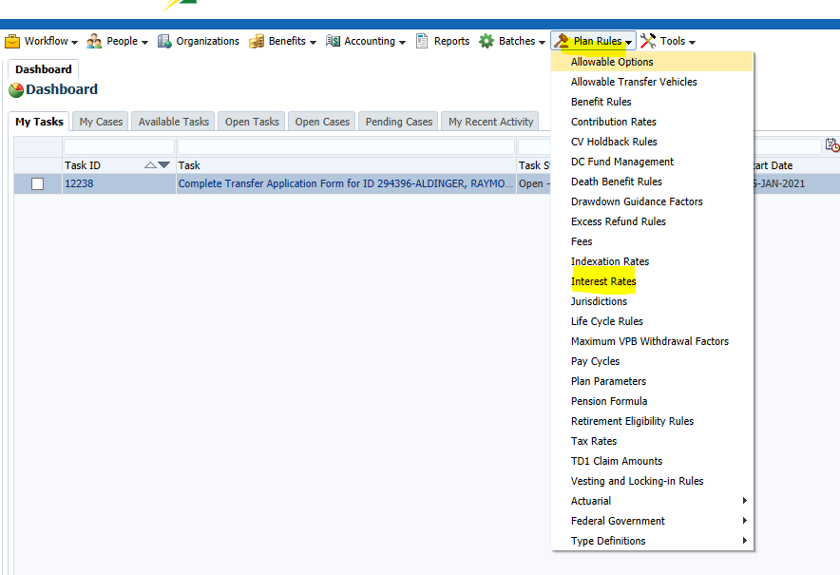

Select Plan=” PEPP” and Interest rate type=” Expense rate” and keep the rest of the fields as is.

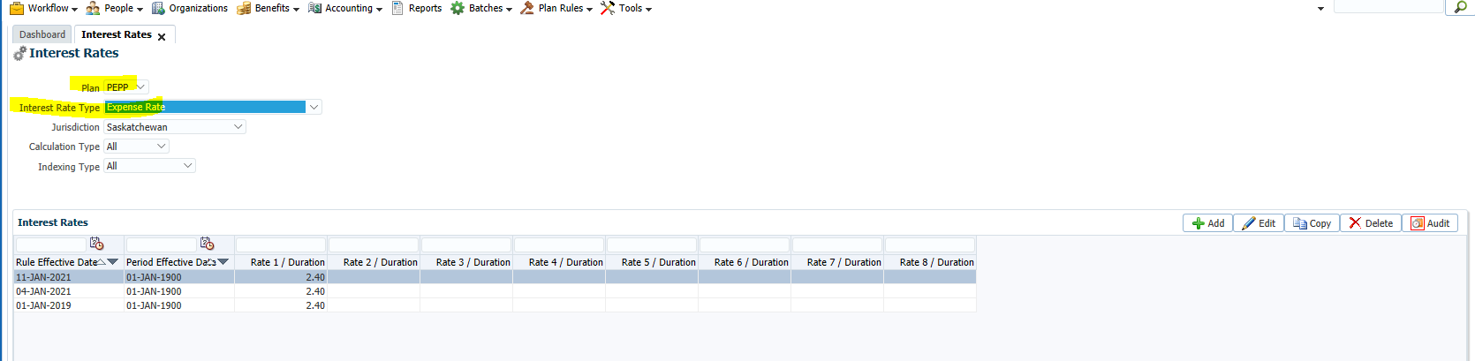

Select the top record from the Interest Rates table and click Copy

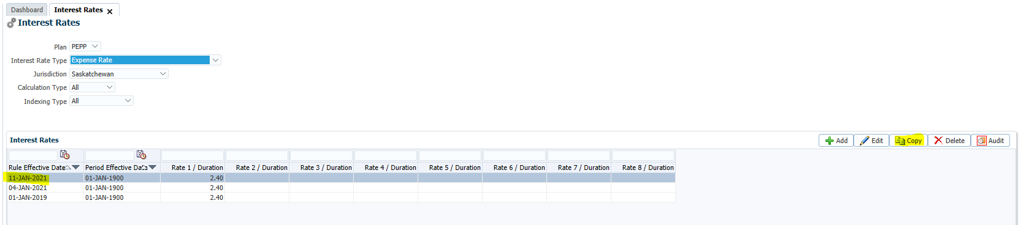

In the window pop-up enter the rule effective date= Effective date from spreadsheet

Enter the Expense Rate under Order 1 = “rate from spreadsheet “and click SAVE

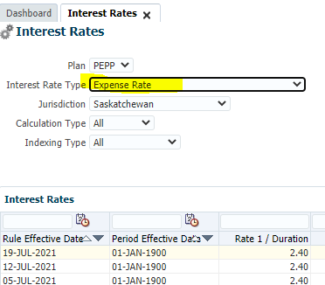

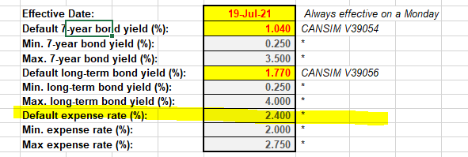

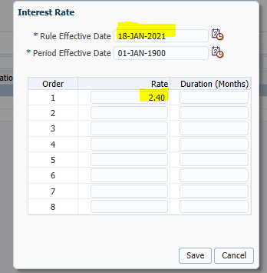

After SAVE the rate will be updated as

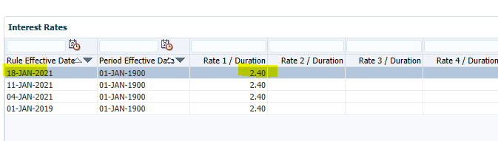

Now, Input the next rate - Government of Canada 7-year bond yield

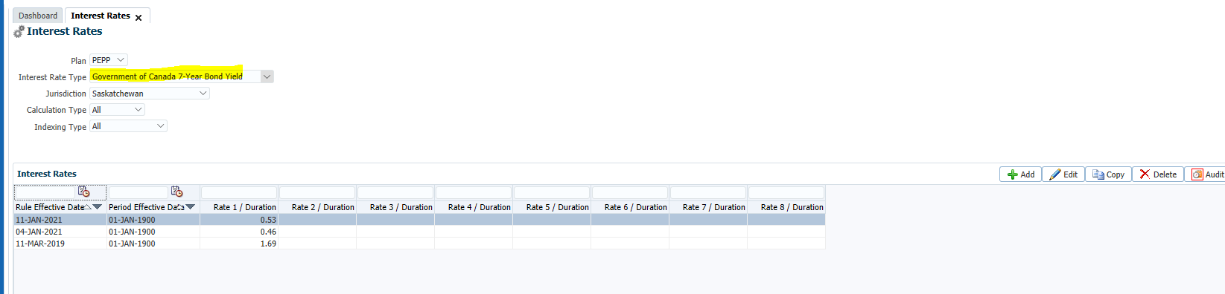

Select the top record from the Interest Rates table and click Copy

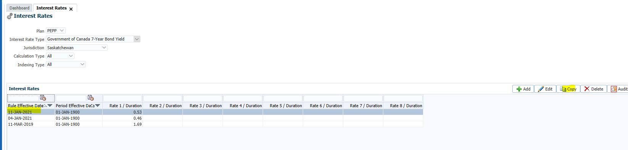

In the window pop-up enter the rule effective date= Effective date from spreadsheet

Enter the Government of Canada 7-year Bond yield under Order 1 = rate from spreadsheet and click SAVE

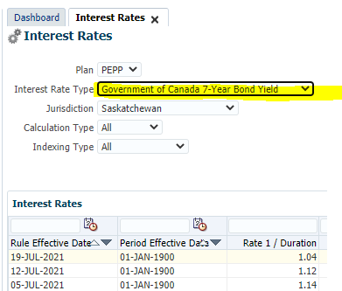

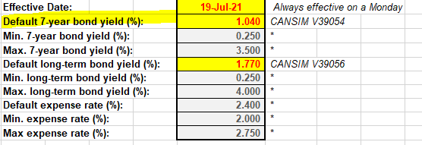

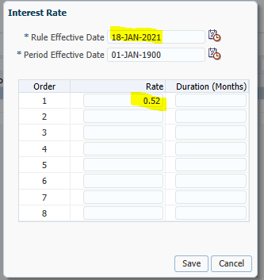

After SAVE the rate will be updated as

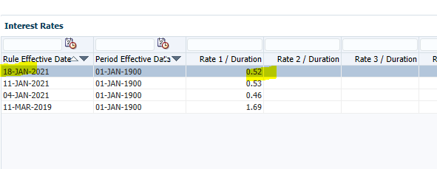

Similarly update the third Government of Canada long- term bond yield in PENFAX

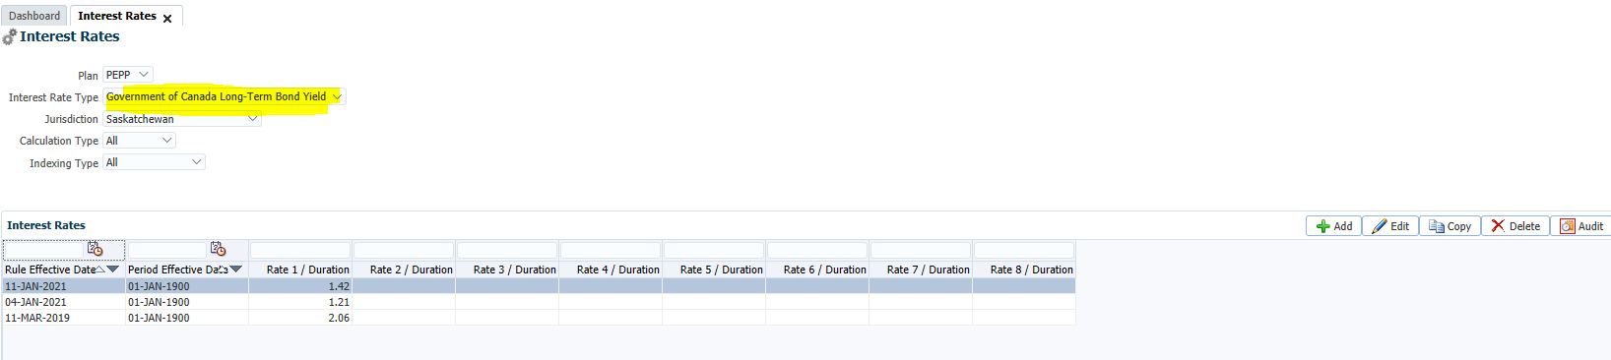

Select the top record from the Interest Rates table and click Copy

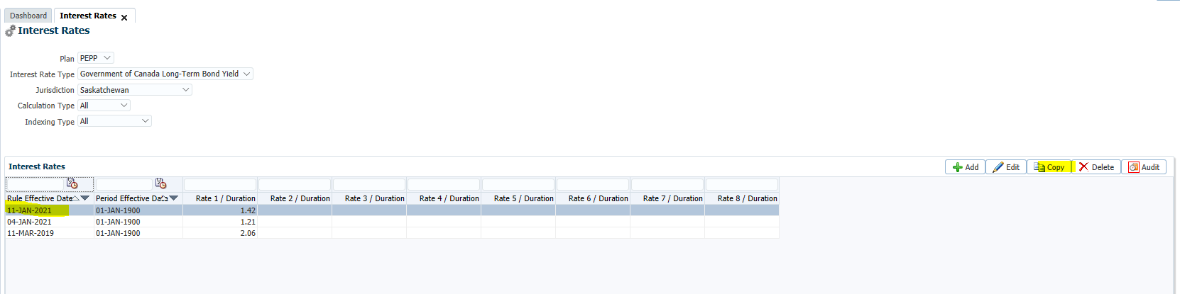

In the window pop-up enter the rule effective date= “Effective date from spreadsheet”

Enter the Government of Canada long-term Bond yield under Order 1 = “rate from spreadsheet “and click SAVE

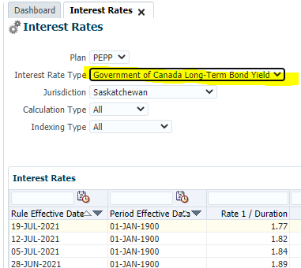

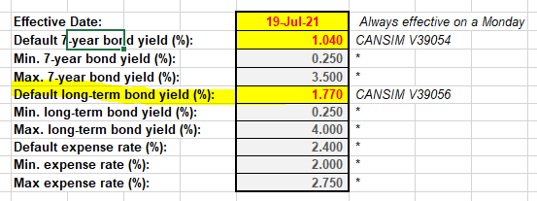

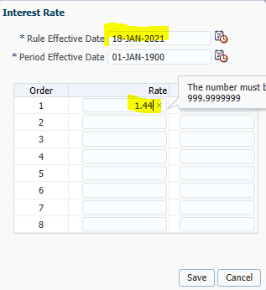

After SAVE the rate will be updated as

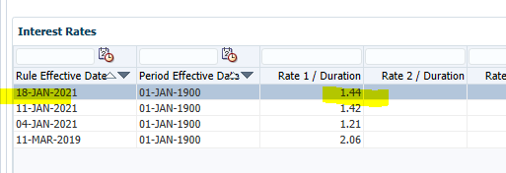

1. Once in a while please ensure that you verify the Min and Max values of Annuity rates in PENFAX

Pull out the MIN and MAX values of rates from the excel spreadsheet

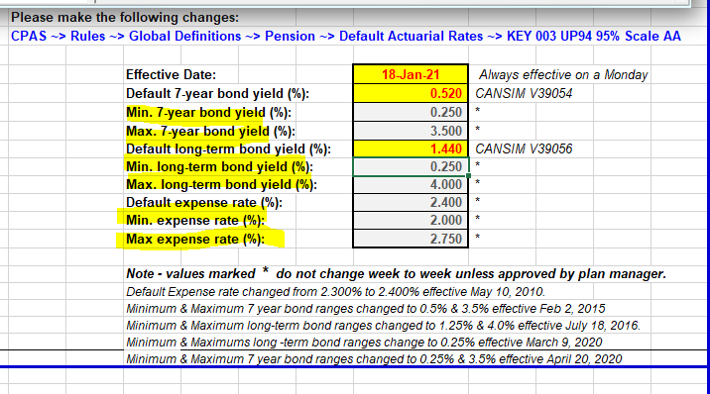

Go to Penfax>tools> validation rules

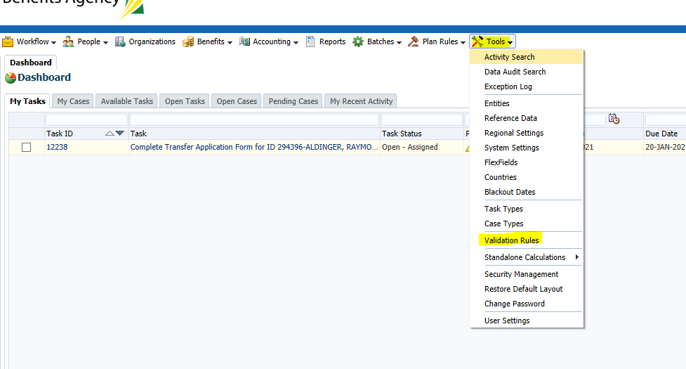

Select Entity= Dc benefit Calculation Interest rate

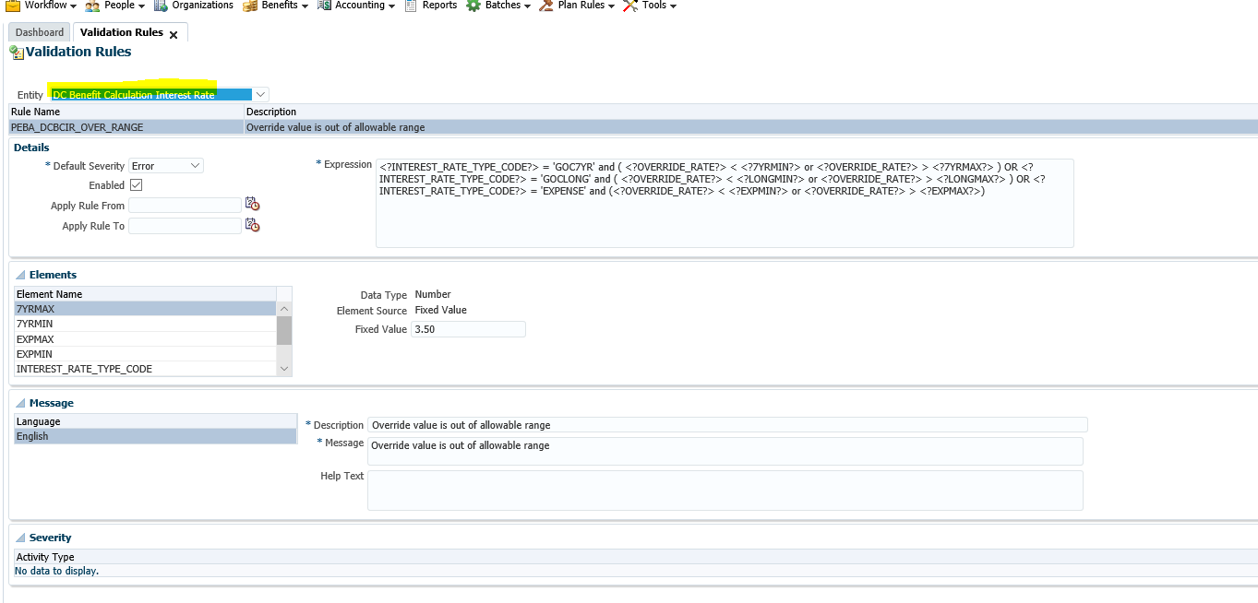

Under elements, verify the Min and Max values of all three Rates match to spreadsheet.

7yr max=3.5

7yr min=0.25

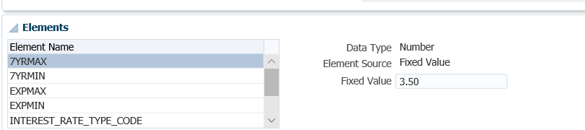

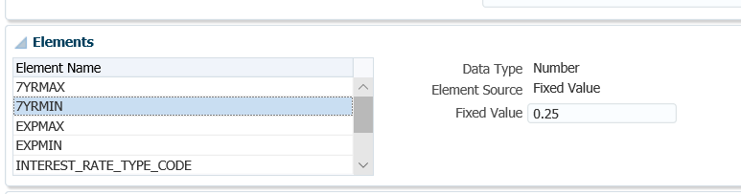

Long term bond min=0.25

Long term bond max= 4.00

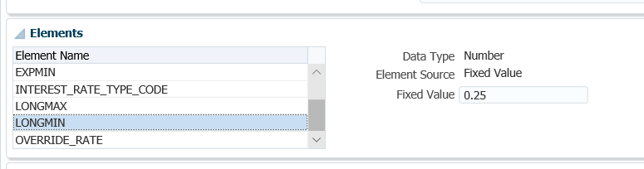

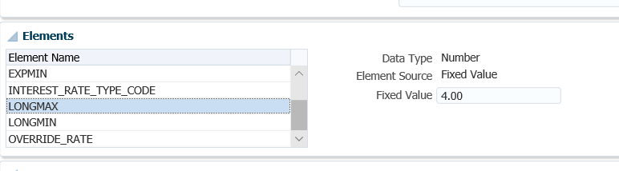

Expense rate min= 2.00

Expense rate max= 2.75

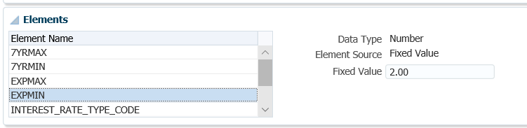

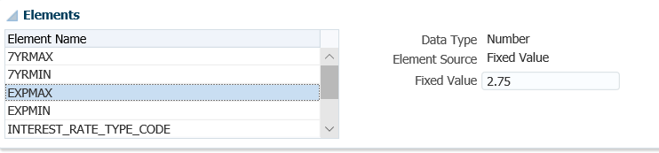

1. If the MIN and MAX value were updated in the spreadsheet sent to us, they will need to be updated in PENFAX. Update them as follows-

Select the element e.g. 7YRMAX and update the fixed value

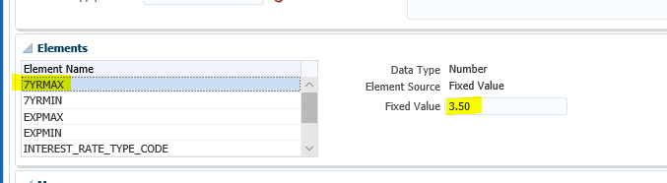

After updating the fixed value for the selected Element, click SAVE button on top right

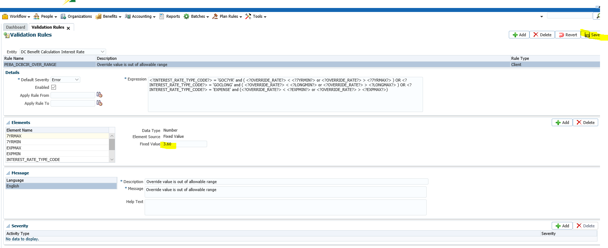

1. Send an email to the Requestor from ServiceDesk to verify updated Annuity rates in PENFAX Prod.

Please include **Heather** & **Leanne** in the email and they will verify the Annuity rates in PENFAX Production.

A reply will be sent back to Service Desk to confirm verification

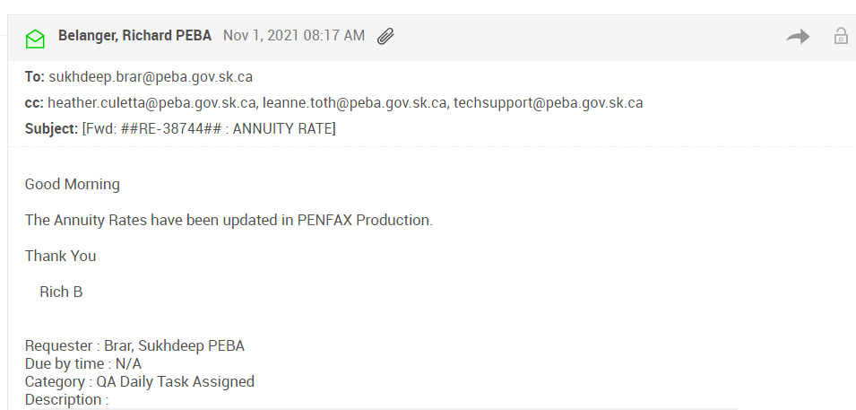

**Procedure document to Run PEPP PLANet Employer - Unprocessed files:**

|  |  |
| --- | --- |
| **Procedure Number:** |  |
| **Procedure Name:** |  |
| **Purpose of the Procedure:** | Procedure document to run  PEPP PLANet Employer - Unprocessed files Report |
| **Original Date:** |  |
| **Revised Date:** |  |

|  | **Name/Title** | **Signature** | **Date** |
| --- | --- | --- | --- |
| **Reviewed by** | <Person who reviews the work> |  | <dd/mm/yyyy> |
|  |  |  |  |
|  |  |  |  |
| **Approved by** | <Senior Management / Business Area Manager> |  | <dd/mm/yyyy> |
|  |  |  |  |

**Overview:**

1. Send an email to Techsupport on every Monday as follows:

**Note**: This report has to be ran via SQL by the IT Team on Every Monday.

**Email Description:**

*Tech Support can you please run the following report “*PEPP PLANet Employer - Unprocessed files” *for Production and email the team as follows:*

*To:*

[*Jenny.Davison@peba.gov.sk.ca*](mailto:Jenny.Davison@peba.gov.sk.ca)

[*Jennifer.Nelson@peba.gov.sk.ca*](mailto:Jennifer.Nelson@peba.gov.sk.ca)

*CC:*

[*dara.sewell-zumstien@peba.gov.sk.ca*](mailto:dara.sewell-zumstien@peba.gov.sk.ca)

[*techsupport@peba.gov.sk.ca*](mailto:techsupport@peba.gov.sk.ca)

*Select*

*JEA_DCT.ORGANIZATION_FILE.SID as FILE_ID,*

*FILE_TYPE.CODE,*

*"P_EMPLOYERS"."STAKEHOLDER_SID" as "STAKEHOLDER_SID",*

*"P_EMPLOYERS"."EMPLOYER_DESC" as "EMPLOYER_DESC",*

*"P_EMPLOYERS"."EMPLOYER_ID" as "EMPLOYER_ID",*

*"P_EMPLOYERS"."EMPLOYER_STATUS_CODE" as "EMPLOYER_STATUS_CODE"*

*,ORGANIZATION_FILE.source_SID*

*,ORGANIZATION_FILE.APP_CLIENT_ID*

*,ORGANIZATION_FILE.FILE_TYPE_SID*

*,ORGANIZATION_FILE.PROCESS_STATUS*

*,ORGANIZATION_FILE.CREATED_TIME_STAMP*

*,ORGANIZATION_FILE.CLOSED_TIME_STAMP*

*,ORGANIZATION_FILE.CREATED_BY*

*,ORGANIZATION_FILE.CLOSED_BY*

*,ORGANIZATION_FILE.APPROVED APPROVED_TIMESTAMP*

*,ORGANIZATION_FILE.APPROVER_SID VALIDATION_RESULT*

*,ORGANIZATION_FILE.VALID_COUNT*

*,ORGANIZATION_FILE.INVALID_COUNT*

*,ORGANIZATION_FILE.USER_NOTE*

*from JEA_DCT.ORGANIZATION_FILE*

*join JEA_IDP.ORGANIZATION on ORGANIZATION.SID = ORGANIZATION_FILE.organization_sid*

*join P_PENFAX.P_EMPLOYERS P_EMPLOYERS on P_EMPLOYERS.stakeholder_sid = ORGANIZATION.stakeholder_sid*

*join JEA_DCT.FILE_TYPE on FILE_TYPE.SID = ORGANIZATION_FILE.FILE_TYPE_SID*

*where ORGANIZATION_FILE.PROCESS_STATUS not in ('POSTED','ABANDON','CREATED') and ORGANIZATION_FILE.APP_CLIENT_ID = 'DCT_PEPP'*

*order by P_EMPLOYERS.STAKEHOLDER_SID*

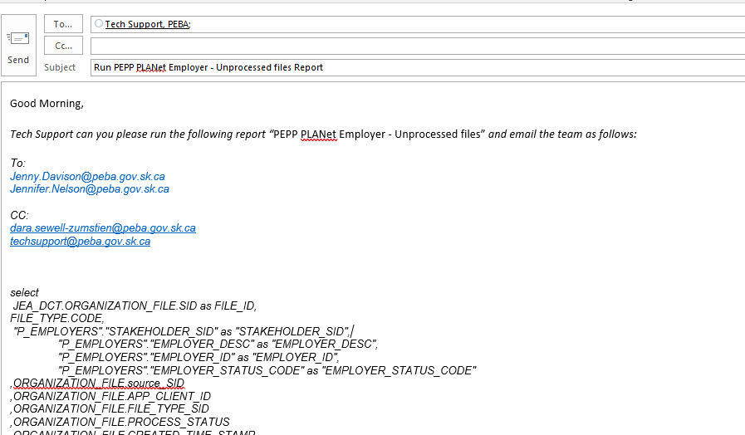

1. QA Daily Person will need to ensure we received the email message and review the report to ensure the business team received the report as scheduled.

**Procedure document to Run PEPP Service Standard Report:**

|  |  |
| --- | --- |
| **Procedure Number:** |  |
| **Procedure Name:** |  |
| **Purpose of the Procedure:** | Procedure document to Run PEPP Service Standard Report  Last update: 1-Feb-21  Revised by: Niyati Patel |
| **Original Date:** |  |
| **Revised Date:** |  |

|  | **Name/Title** | **Signature** | **Date** |
| --- | --- | --- | --- |
| **Reviewed by** | <Person who reviews the work> |  | <dd/mm/yyyy> |
|  |  |  |  |
|  |  |  |  |
| **Approved by** | <Senior Management / Business Area Manager> |  | <dd/mm/yyyy> |

**Overview:**

This report will run every **Monday** morning.

**Quick Steps to follow:**

1. Login into the PENFAX Production.

* URL: <http://prodadf1.peba.gov.sk.ca:7001/Penfax5/login.html>
* Enter the Username & Password

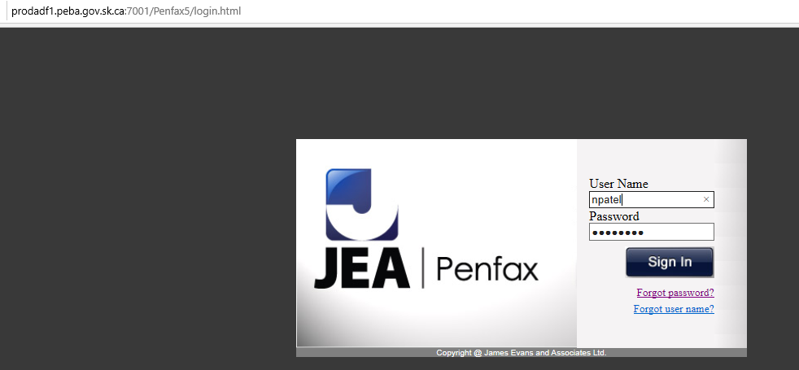

1. Go to Batches -> Batch Process

* Select **Batch Process Type**: Service Standard Numbers & Percentages by Case Type
* Click on Search

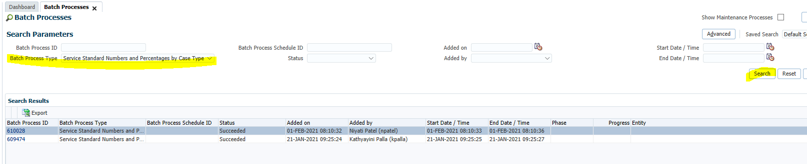

1. Click on **Add** button
   * Select **Batch Process Type**: Service Standard Numbers & Percentages by Case Type

* Select **Plan**: PEPP
* Select Reporting Period From Date: 23-Jan-2021 (Saturday)
* Select Reporting Period To Date: 29-Jan-2021 (Friday)

**Note**: The dates parameters for this report should be from **Saturday** to **Friday** for previous week.

**Ex.** If we will run this report on Monday (01 Feb, 2021) then we should use following Dates parameter.

* Reporting Period From Date: 23-Jan-2021 (Saturday)
* Reporting Period To Date: 29-Jan-2021 (Friday)

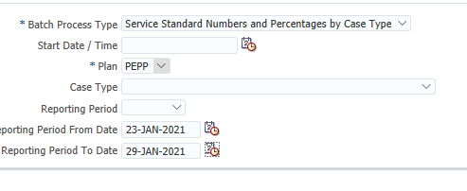

* Click on **Save** button
* Click on the **Refresh** button

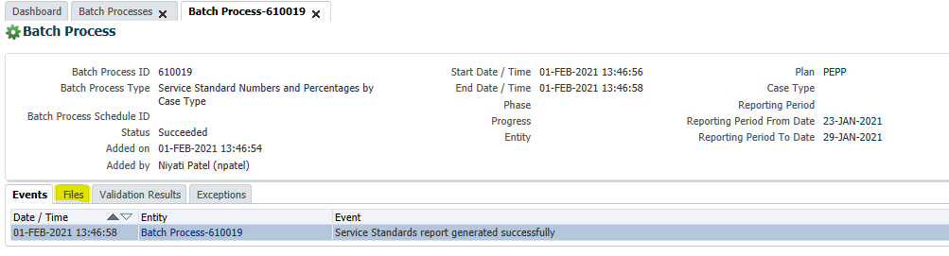

* Go to **Files**

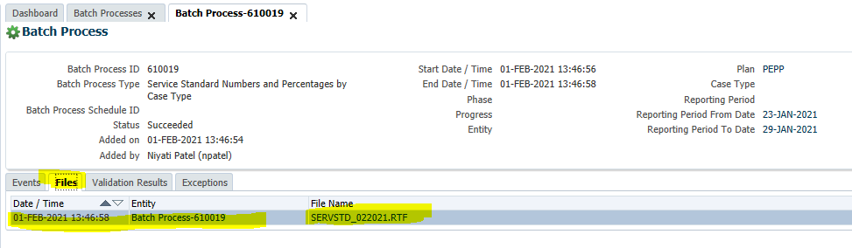

* Click on the file -> Open
* Save As to the following locations:
  + **Location:** 
    - *QA Dropbox (H:\Quality Assurance\Dropbox)*
    - *Pension Program Dropbox (H:\Pension Programs\Dropbox)*
  + **File Name:**
    - Standard Numbers and Percentages by Case Type - Feb 01, 2021 <<Current Date>>
  + **Save As Type:**
    - Word Document

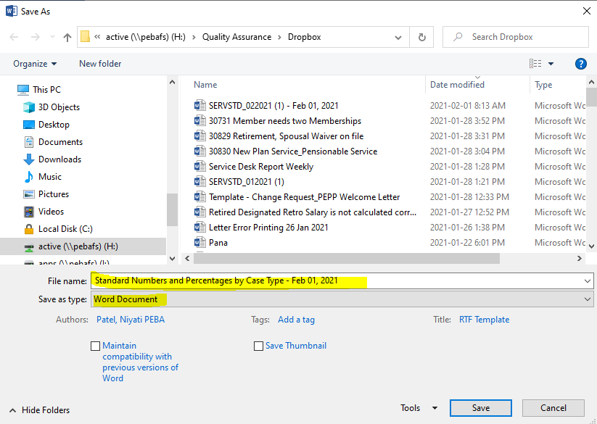

1. Send this report to business.

* **To:** Tech Support, Helmke Jolene PEBA,
* **CC:** Pana, PEBA Reception ‘reception@peba.gov.sk.ca’

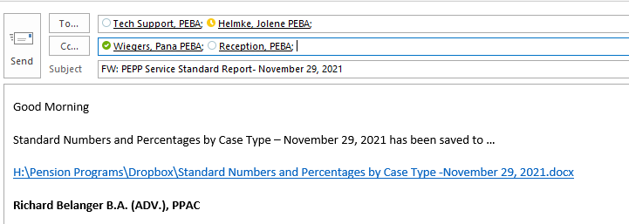

**How to Monitoring Data Posting Batches:**

|  |  |
| --- | --- |
| **Procedure Number:** |  |
| **Procedure Name:** |  |
| **Purpose of the Procedure:** |  |
| **Original Date:** |  |
| **Revised Date:** |  |

|  | **Name/Title** | **Signature** | **Date** |
| --- | --- | --- | --- |
| **Reviewed by** | <Person who reviews the work> |  | <dd/mm/yyyy> |
|  |  |  |  |
|  |  |  |  |
| **Approved by** | <Senior Management / Business Area Manager> |  | <dd/mm/yyyy> |

**Overview:**

How to Monitoring Data Posting Batches

1. Log into PENFAX 5 – PROD

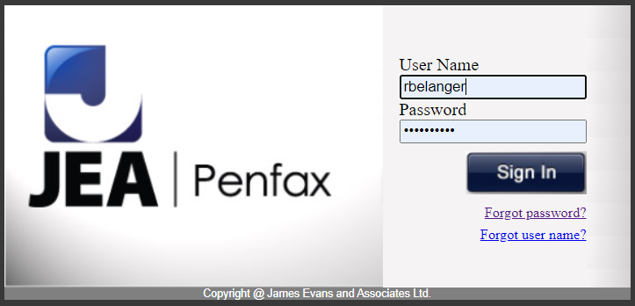

1. Go to Batches, and select Data Posting Batches from drop-down

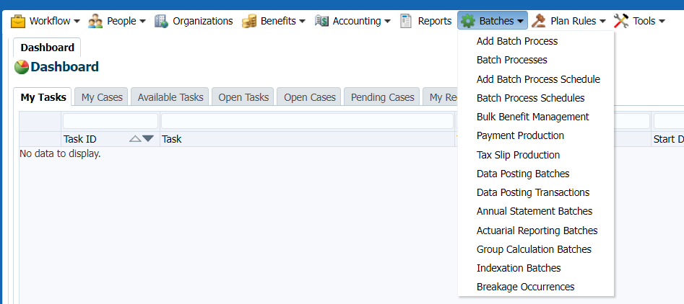

1. Select Batch Status = Submitting
2. Click Search and check if there are any records

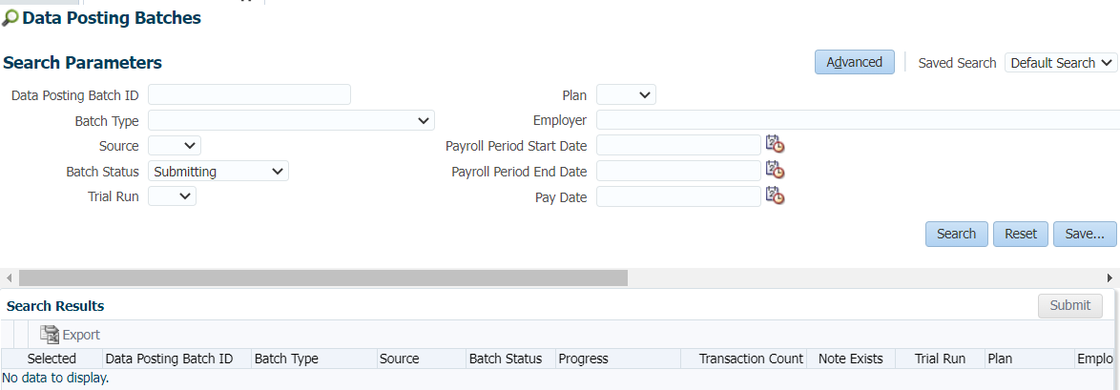

1. If there is a Batch “Submitting” Click Search again and the Batch should be gone, with No Data to Display message.

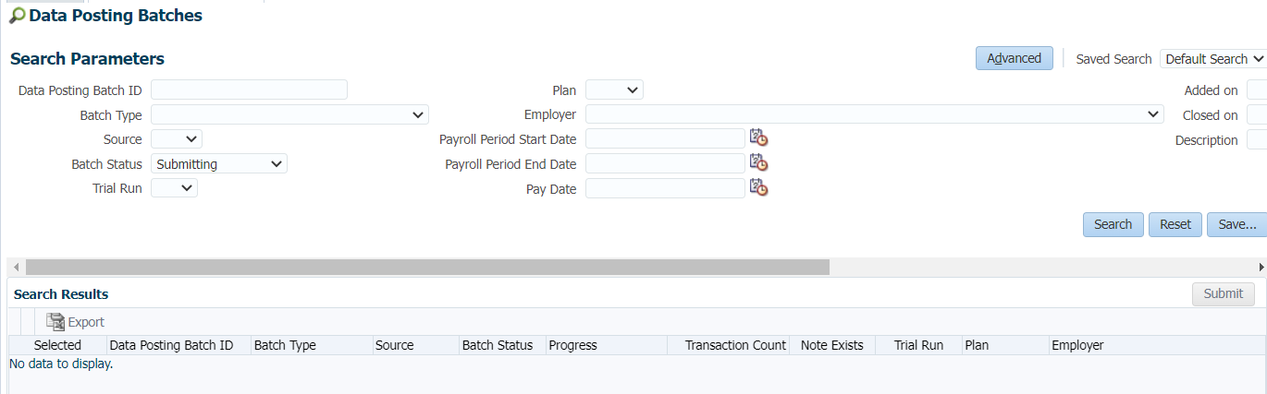

Check to see if any Batches are Validating

1. Select Batch Status = Validating
2. Click Search and check if there are any records
3. If there is a Batch “Validating” Click Search again and the Batch should be gone, with No Data to Display message.

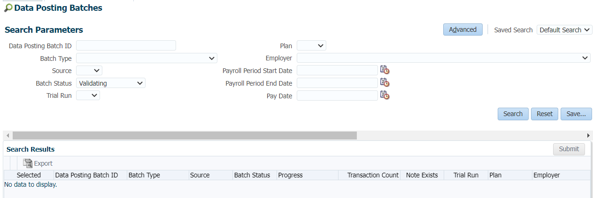

If you see any records, it is possible someone in MEPP is actually processing files so wait a minute to run the search again and if it’s still there, notify us.

If more information is needed with respect to business process, please contact Jeroen.

**How to Input Weekly Annuity Rates:**

|  |  |
| --- | --- |
| **Procedure Number:** |  |
| **Procedure Name:** |  |
| **Purpose of the Procedure:** | Procedural document to update weekly annuity rates in PENFAX production |
| **Original Date:** |  |
| **Revised Date:** |  |

|  | **Name/Title** | **Signature** | **Date** |
| --- | --- | --- | --- |
| **Reviewed by** | <Person who reviews the work> |  | <dd/mm/yyyy> |
|  |  |  |  |
|  |  |  |  |
| **Approved by** | <Senior Management / Business Area Manager> |  | <dd/mm/yyyy> |

**Overview:**

**Steps:**

1. Look out for the Email from PEPP administration with Weekly Monday rates subject” Annuity rate” on every Monday in Service Desk support



1. Pull out the following rates from the pdf/Excel spreadsheet from the email

2.a Default 7-year bond yield (%)

2.b Default long-term bond yield (%):

2.c default expense rate (%)

**Please note:** the pdf file will have effective date of Friday, but PEPP will input an effective date for Monday





1. Input the default rates in PENFAX

Go to Penfax>Plan rules>interest rates



Select Plan=” PEPP” and Interest rate type=” Expense rate” and keep the rest of the fields as is.



Select the top record from the Interest Rates table and click Copy



In the window pop-up enter the rule effective date= Effective date from spreadsheet

Enter the Expense Rate under Order 1 = “rate from spreadsheet “and click SAVE







After SAVE the rate will be updated as



Now, Input the next rate - Government of Canada 7-year bond yield



Select the top record from the Interest Rates table and click Copy



In the window pop-up enter the rule effective date= Effective date from spreadsheet

Enter the Government of Canada 7-year Bond yield under Order 1 = rate from spreadsheet and click SAVE







After SAVE the rate will be updated as



Similarly update the third Government of Canada long- term bond yield in PENFAX



Select the top record from the Interest Rates table and click Copy



In the window pop-up enter the rule effective date= “Effective date from spreadsheet”

Enter the Government of Canada long-term Bond yield under Order 1 = “rate from spreadsheet “and click SAVE







After SAVE the rate will be updated as



1. Once in a while please ensure that you verify the Min and Max values of Annuity rates in PENFAX

Pull out the MIN and MAX values of rates from the excel spreadsheet



Go to Penfax>tools> validation rules



Select Entity= Dc benefit Calculation Interest rate



Under elements, verify the Min and Max values of all three Rates match to spreadsheet.

7yr max=3.5

7yr min=0.25





Long term bond min=0.25

Long term bond max= 4.00





Expense rate min= 2.00

Expense rate max= 2.75





1. If the MIN and MAX value were updated in the spreadsheet sent to us, they will need to be updated in PANFAX. Update them as follows-

Select the element e.g. 7YRMAX and update the fixed value



After updating the fixed value for the selected Element, click SAVE button on top right



1. Send an email to the Requestor from ServiceDesk to verify updated Annuity rates in PENFAX Prod.

Please include **Heather** & **Leanne** in the email and they will verify the Annuity rates in PENFAX Production.

A reply will be sent back to Service Desk to confirm verification



**Dynamic Messaging Business Rules normal:**

|  |  |
| --- | --- |
| **Procedure Number:** |  |
| **Procedure Name:** |  |
| **Purpose of the Procedure:** |  |
| **Original Date:** |  |
| **Revised Date:** |  |

|  | **Name/Title** | **Signature** | **Date** |
| --- | --- | --- | --- |
| **Reviewed by** | <Person who reviews the work> |  | <dd/mm/yyyy> |
|  |  |  |  |
|  |  |  |  |
| **Approved by** | <Senior Management / Business Area Manager> |  | <dd/mm/yyyy> |

**Overview:**

**Dynamic Messaging Business Rules for PEPP Statement (September 2021):**

**Voluntary:**

If (2.5 + 2.9+ 2.13 + 2.17 + 2.21 = 0.00), then do not display footnote reference (1) and do not print footnote at bottom of page 1.

ELSE

Print footnote “1 Includes voluntary contributions made before 2001 and locked-in money transferred into PEPP. If you terminated your employment between June 29, 2015 and December 29, 2020, the Member and Employer money left in PEPP is also included.”

**Total Subject to Locking-in Requirements:**

If 21.3 <>”SK”, then print footnote at bottom of page 1:

“† PEPP is governed by Saskatchewan legislation. You have worked out of province and have a portion of your locked-in money governed by another province’s legislation. For details, refer to the Locked-in Requirements by Province section on page 3.”

AND

Print Locked-in Requirements by Province table on page 3.

If 21.3 is only one row AND 21.3 =”SK” then print footnote at bottom of page 1:

“† PEPP is governed by Saskatchewan legislation with restrictions intended to preserve money in your PEPP account so you have a stream of retirement income when you retire.”

AND

**DO NOT** print Locked-in Requirements by Province table on page 3.

**Default Fund Text:**

If ((F.3 = PS1 to PS13) AND (7.5 = “Y”)), then print

<< 1.4, our records indicate that you have not selected an investment option so you’re in the PEPP Steps Fund by default.

To confirm or change your investment option, log in to PLANet. Or, download the *Investment Option Change* form on our website and submit the completed form to PEPP.>>

ELSE

<<1.4, you should evaluate your PEPP investments annually. You’re unique and your situation may change over time. To help, PEPP has designed the *My PEPP Investor Profile* to guide you towards a fund that may suit you but it’s not a substitute for seeking independent financial advice. The profile is available on the website.

To change your investment option, log in to PLANet. Or, download the *Investment Option Change* form on our website and submit the completed form to PEPP.>>

**Personal Rate of Return:**

* If (3.3) **IS NULL**:

Print “N/A” in the detail line

Else

Print (3.3) in the detail line.

* If (3.4) **IS NULL**:

Print “N/A” in the detail line.

Else

Print (3.4) in the detail line.

* If (3.5) **IS NULL**:

Print “N/A” in the detail line.

Else

Print (3.5) in the detail line.

* If (3.7) **IS NULL**:

Print “N/A” in the detail line.

Else

Print (3.7) in the detail line.

* If (3.13) **IS NULL**:

Print “N/A” in the detail line.

Else

Print (3.13) in the detail line.

If (3.3 OR 3.4 OR 3.5 OR 3.7 OR 3.13) is NULL Then

**Print footnote under the table “**If you have been in PEPP for less than one or more of the return periods above, your personal rate of return for those period(s) will be “N/A”.”

ELSE

**Do not print footnote under the table**

If (3.3 AND 3.4 AND 3.5 AND 3.7 AND 3.13) is NULL Then

**Do not print footnote on bottom of page 1.**

ELSE

**Print footnote on bottom of page 1.**

**“\*** Your personal rate of return is impacted by account transactions (contributions, transfers, etc.), and changes in your fund’s unit value. Investment returns will fluctuate over time and past results are not indicative of future performance.”

**Beneficiary Messaging:**

Static message for all members: “It is your responsibility to ensure that your designation of beneficiary is up to date and reflects your intentions at all times.”

If beneficiary name = “None Listed” add this second sentence in bold font to the end of the static message

<<1.4, our records indicate that you currently have no beneficiary(ies) listed. To designate a beneficiary(ies), you can log in to PLANet at <https://planet.peba.gov.sk.ca/pepp/auth/app/login> (some legislative restrictions apply). Or, download the *Designation of Beneficiary* form on our website and submit the completed form to PEPP.>>

**Beneficiary(ies) Allocation:**

In the allocation column of the Beneficiary(ies) section:

If 11.3 is **NOT NULL AND** 11.6=” Y” then print “Distribute Evenly”

OR

If 11.3 is **NOT NULL AND** 11.7 is **NOT NULL** then print 11.7

**Dynamic Age Messaging:**

* If member’s age (10.4) is equal to or greater than **68** as of September 30, 2021:

**Display the information box (on page 2) with the messaging indicated below:**

<<The *Income Tax Act* (Canada) states that you must convert your account balance into retirement income by December 31 of the year you attain age 71. Please contact PEPP to discuss your options.>>

ELSE

Don’t display the box or messaging.

**Procedure document for PEPP Statement Verification v1.3:**

|  |  |
| --- | --- |
| **Procedure Number:** |  |
| **Procedure Name:** |  |
| **Purpose of the Procedure:** | Procedure document for PEPP Statement Verification |
| **Original Date:** |  |
| **Revised Date:** | October 26, 2021  Version: 1.2 |

|  | **Name/Title** | **Signature** | **Date** |
| --- | --- | --- | --- |
| **Reviewed by** | <Person who reviews the work> |  | <dd/mm/yyyy> |
|  |  |  |  |
|  |  |  |  |
| **Approved by** | <Senior Management / Business Area Manager> |  | <dd/mm/yyyy> |

**Overview:**

**Version Control:**

|  |  |  |  |
| --- | --- | --- | --- |
| **VERSION** | **DESCRIPTION** | **DATE** | **AUTHOR** |
| 1.0 | Initial draft | Oct 18, 2021 | Jeroen Verwaard |
| 1.1 | Screenshots and steps added | Oct 23, 2021 | Jeroen Verwaard |
| 1.2 | Added note to section 8 Department & Contribution Rates  Added item 7.2 in Beneficiaries section | Oct 26, 2021 | Jeroen Verwaard |

Ensuring information on the statement matches information captured on PENFAX.

**General Data Fields:**

1. PEPP Logo displays
2. PEPP Member Number displays correctly
3. Date Printed displays correctly
4. Statement Period displays correctly

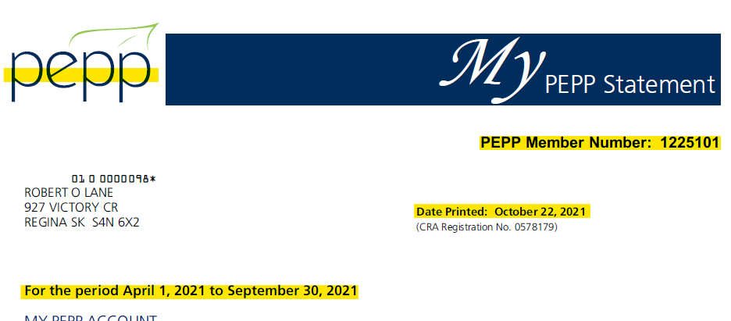

**Member Address:**

* 1. Name (including salutation if applicable)
  2. Address

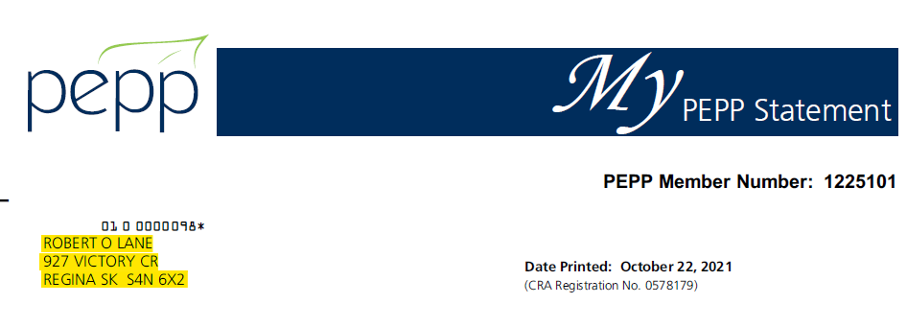

PENFAX details:

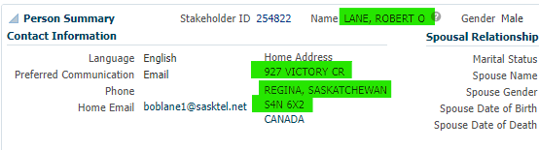

**Verify financial amounts on the statement:**

1. Opening balance matches last statement Closing balance

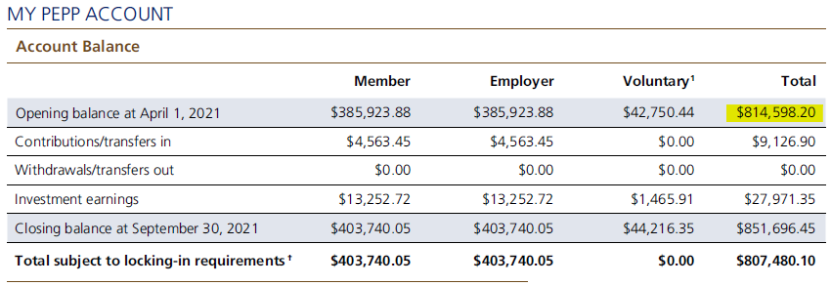

* 1. In PENFAX, go to Investments >> Account Summary
  2. Change the Valuation Date to one day prior to the Statement Period Begin Date (i.e. set to March 31 for the April – September Statement Period)
  3. Click Refresh

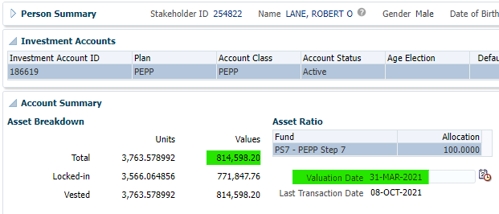

* 1. Total of all contributions received during the period are reported by source (Member, Employer, Voluntary, Total)

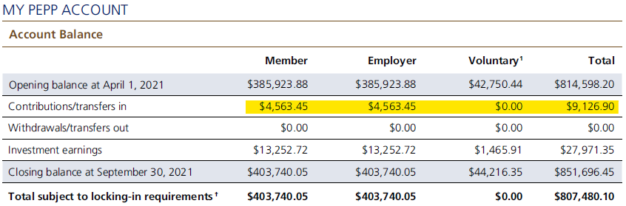

**NOTE**: Only when the Closing Balance Total is not matching do we have to look at the transactions by Member/Employer/Voluntary. When these do not match go into the Account Activity area on the Investments screen and change the dates to match the statement period and export the transactions to check

Example, verifying the Contributions Total to the system:

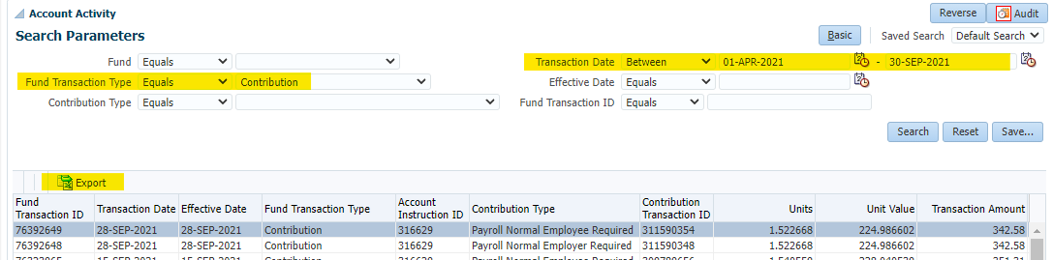

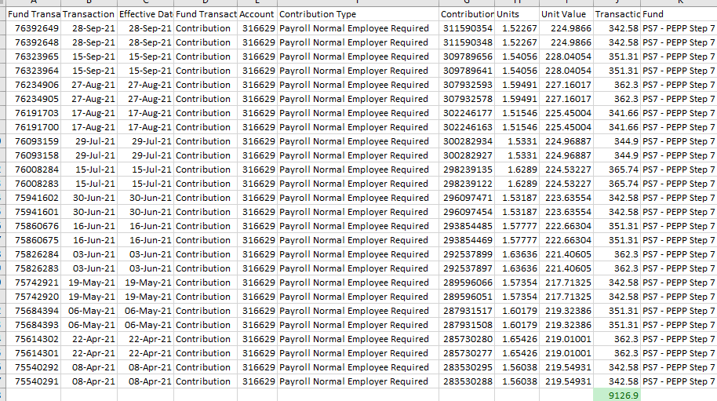

* 1. Total of all withdrawals processed during the period are reported by source (Member, Employer, Voluntary, Total)

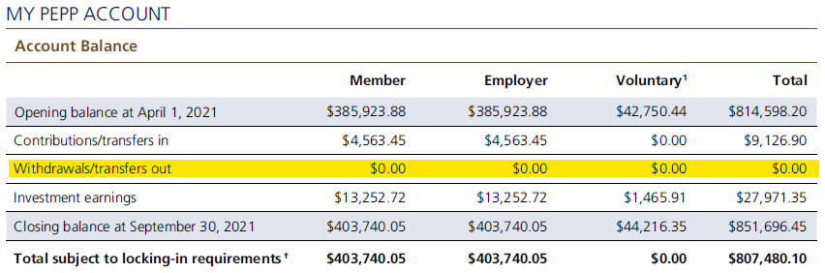

* 1. Closing balance matches PENFAX account value as of March 31, yyyy or September 30, yyyy

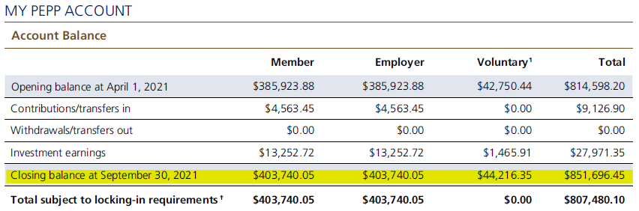

* + 1. In PENFAX, go to Investments >> Account Summary
    2. Change the Valuation Date to the Statement Period End Date (March 31 or September 30)
    3. Click Refresh
    4. Verify the statement value against the Total Values

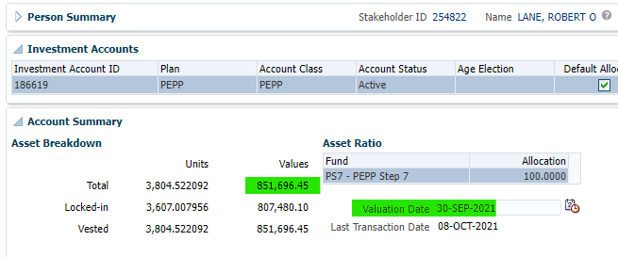

* 1. Locking-In Requirements Totals

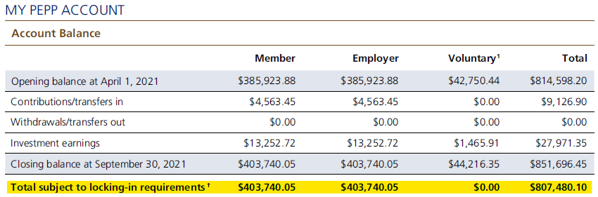

* + 1. In PENFAX, go to Investments >> Account Summary
    2. Change the Valuation Date to the Statement Period End Date (March 31 or September 30)
    3. Click Refresh
    4. Verify the statement value against the Locked-in Values

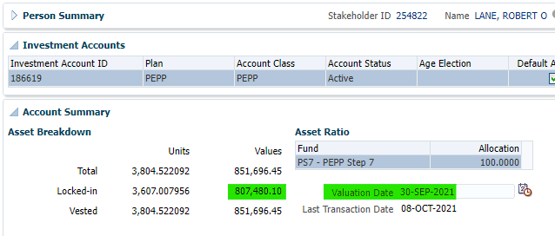

**Investment Summary:**

Investment Summary is reporting the closing number of units, unit value as of March 31 or September 30 and % of their investments

1. Verify the Investment Fund(s)
2. Verify the Closing number of Units
3. Verify the Unit value as of March 31 or September 30
4. Verify the % of their Investments

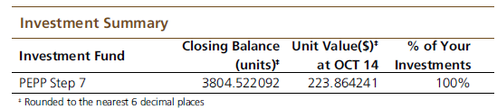

**NOTE:** The date used in for the Unit Value at <<DATE>> is not correct the in the statement run used for this document. This is to be fixed by Data Group to display the Statement Period End Date. Note that the actual Unit Value is correct (as of Sept 30 or March 31).

* + 1. In PENFAX, go to Investments >> Account Summary
    2. Change the Valuation Date to one day prior to the Statement Period End Date (March 31 or September 30)
    3. Click Refresh
    4. Verify the values

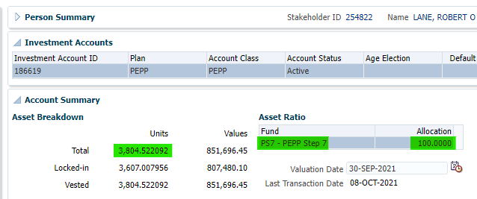

To verify the Unit Value, go to the PEPP website [Unit Values: Public Employees Pension Plan | Public Employees Benefits Agency (gov.sk.ca)](https://www.peba.gov.sk.ca/pensions/pepp/investment/unit-values.html) and select the Fund and Date (Statement Period End Date)

**Rate of Return:**

Verify the Rate of Return amounts on the statement matches the values in PENFAX. To get these values you have to export the returns and paste them into the calc spreadsheet.

* 1. Verify the 6-month return matches
  2. Verify the 1 year (12-month) return matches
  3. Verify the 2 year (24-month) return matches
  4. Verify the 4 year (48-month) return matches
  5. Verify the 10 year (120-month) return matches

Example:

\\pebafs\active\Quality Assurance\Prod Apps\QA Procedures\ROR Spreadsheet\10 year Personal Rate of Return - Member - 1225101.xlsx

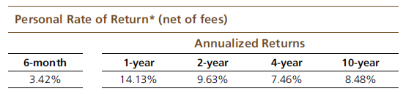

**Procedures:**

1. In PENFAX, go to the member’s Member Profile >> Investments
2. Scroll down to the Account Performance area
3. Select the Combine Funds tick-box
4. Select the Performance Frequency: Monthly
5. Enter the Number of Periods: 120
6. Enter the End Date: Statement Period End Date (either March 31, yyyy or September 30, yyyy)
7. Click the Refresh button

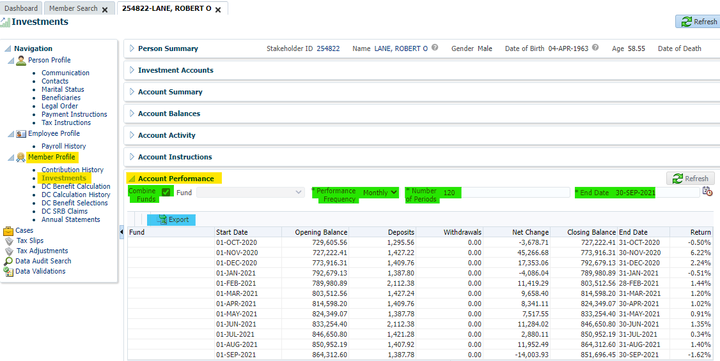

1. Click the Export button
2. Open the CSV file and copy the content

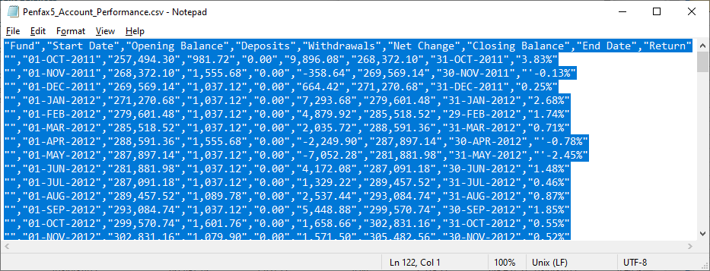

1. Open the Manual Calc spreadsheet
2. Enter the MKEY of the member you’re verifying in the header and tab, as well when saving the spreadsheet in the filename

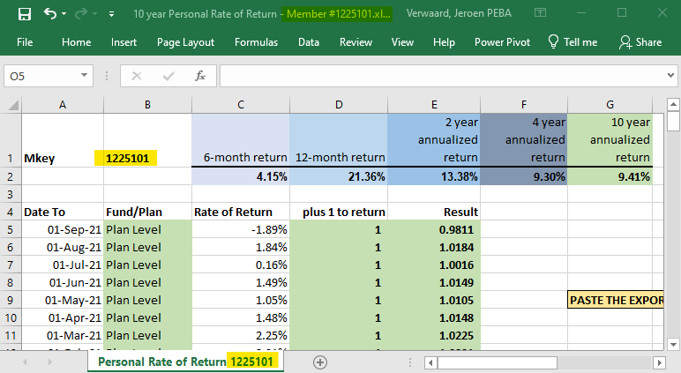

* Paste the records

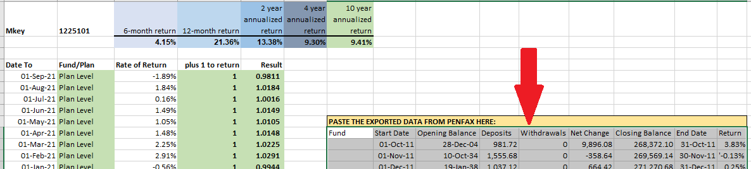

1. Negative returns have a ‘(apostrophe) in front of the value in the export, these need to be removed – use Search and Replace in the copied data

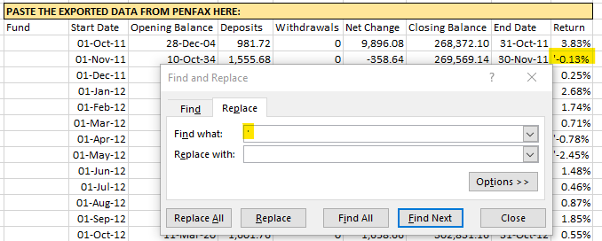

1. The data needs to be from Newest to Oldest before pasting it into the manual calc area so select the data (no headers), right click and select Sort

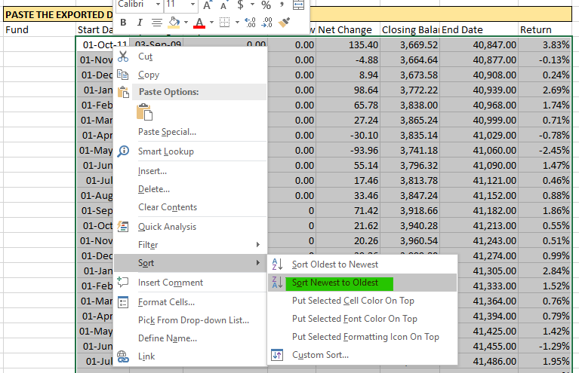

1. Copy the column of Start Date values and paste in cell A5
2. Copy the column of Return values and paste in cell C5

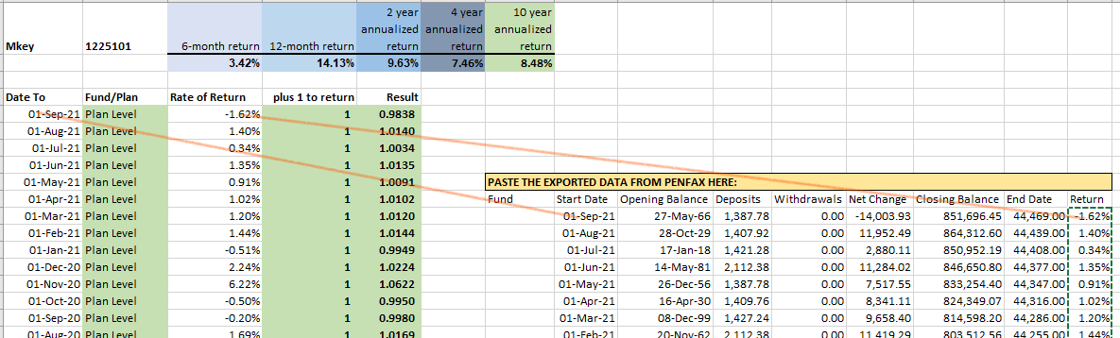

* Verify the ROR matches the statement

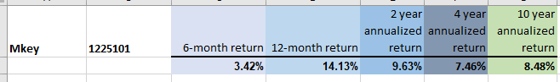

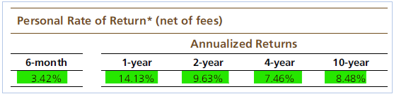

Save the Excel Spreadsheet.

**Member Personal Information:**

* + - 1. Verify the Enrolment Date
      2. Verify the Vested and Locked-in always displays “Immediate”
      3. Verify the E-mail Address

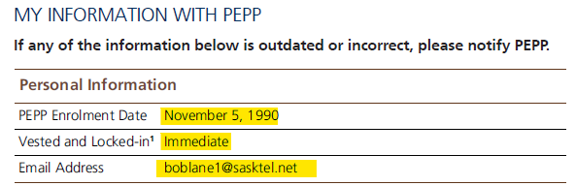

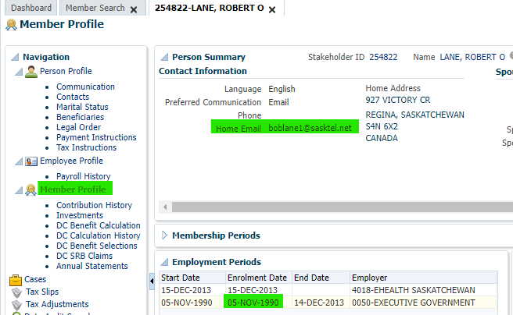

**Beneficiaries:**

1. All that have a percentage allocation greater than 0% on PENFAX should be reported on the statement. Make sure only PEPP Beneficiaries display and not for any other plans.
2. Note that the Beneficiaries are as of the Statement Period End Date, not the current date so it might look they are not correct so check the Designation date(s).

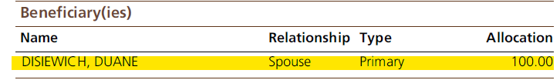

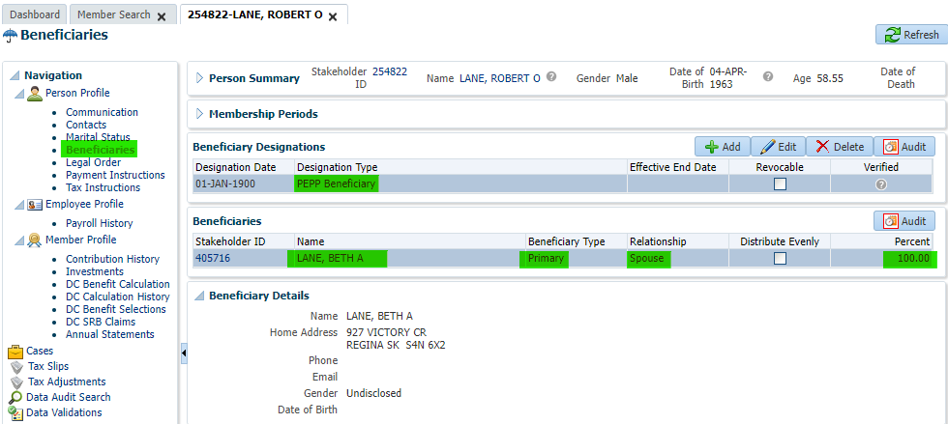

1. If the beneficiary is “none listed” there should be the following message:

*<<****Member First Name****>>, our records indicate that you currently have no beneficiary(ies) listed. To designate a beneficiary(ies) you can login to PLANet at*

*https://planet.peba.gov.sk.ca/pepp/auth/app/login (some legislative restrictions apply).*

*Or, download the Designation of Beneficiary form on our website and submit the*

*completed form to PEPP.*

i.e., Member Number 1174366

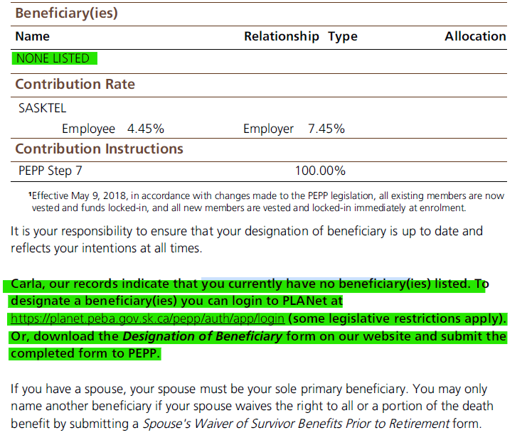

**Department & Contribution Rates:**

If member has an active employment status, the statement will display the department name and contribution rate

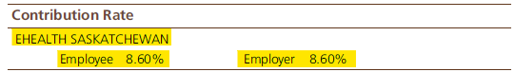

These details can be found in the Employee Profile >> Employment Period – for the active employment(s) and the Scope Code >> Employee & Employer Contribution Rate screens

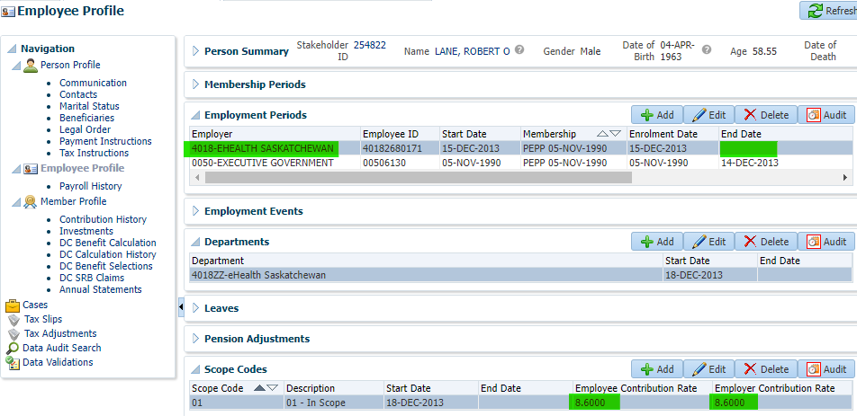

**NOTE:** When a member account has been terminated at the time of the batch run, there will be no Department and Contribution Rates displaying on the statement.

**Contribution Investment Instructions:**

Verify the Contribution Investment Instructions

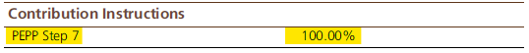

These details can be found in the Member Profile >> Investments >> Set the Valuation Date to the Statement Period End date (March 31 or September 30), click Refresh

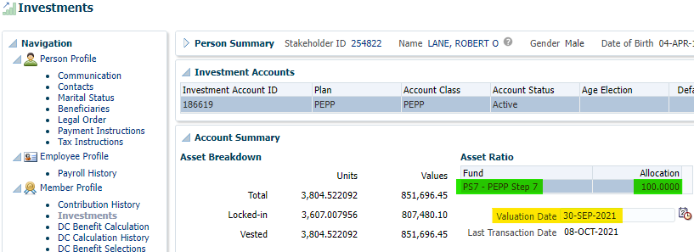

If you notice this seems incorrect, check the DAI instructions if anything seems to be of the ordinary (FYI there is no issue in the sample used in this document)

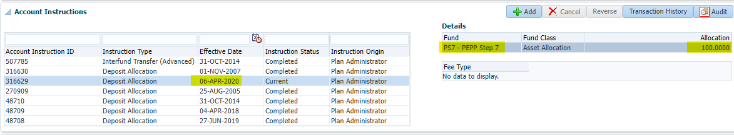

**PEPP Step Default message:**

If member is in the PEPP Steps fund by default, there should be the following message:

*<<****First Name****>>, our records indicate that you have not selected an investment option so you’re in the PEPP Steps Fund by default. To confirm or change your investment option, log in to PLANet. Or, download the Investment Option Change form on our website and submit the completed form to PEPP.*

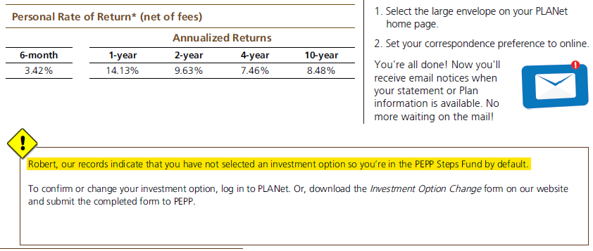

In PENFAX, the Default Allocation flag is found here: Member Profile >> Investments >> Investment Accounts:

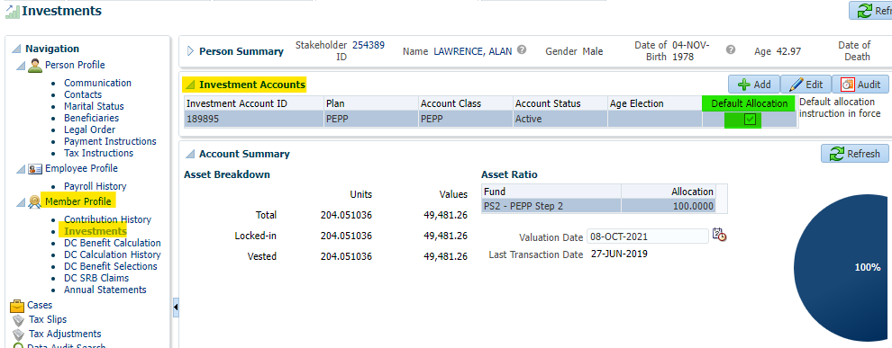

**Procedure document for PEPP Statements Testing Procedures:**

|  |  |
| --- | --- |
| **Procedure Number:** |  |
| **Procedure Name:** |  |
| **Purpose of the Procedure:** | Procedure document for PEPP Matters Newsletters |
| **Original Date:** |  |
| **Revised Date:** |  |

|  | **Name/Title** | **Signature** | **Date** |
| --- | --- | --- | --- |
| **Reviewed by** | <Person who reviews the work> |  | <dd/mm/yyyy> |
|  |  |  |  |
|  |  |  |  |
| **Approved by** | <Senior Management / Business Area Manager> |  | <dd/mm/yyyy> |
|  |  |  |  |

**Overview****:**

Last update: 17-Feb-21

Revised by: Jessie Liu

**Description:**

This report will be requested by Communications to provide them a mailing list

e.g.,

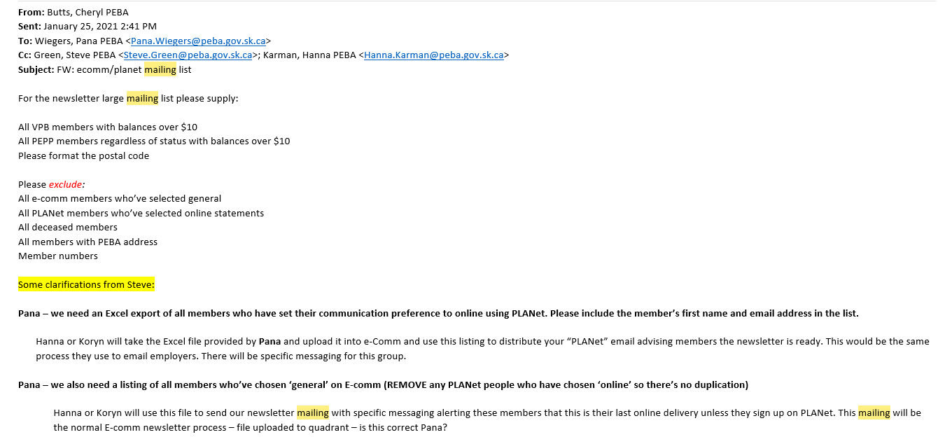

**QA Process:**

Below is a sample process. Please adjust your process steps based on Communication requests, e.g for April/Oct newsletter also refer to the document below:

H:\Quality Assurance\PEPP\CPAS\How To\QA other Processes\Procedure document for PEPP Perspective Newsletter for April and Oct Address list.docx

1. Extract the lists (PEPP or VPB) from PENFAX based on Communication request

Go to Batches >> Add Batch Process

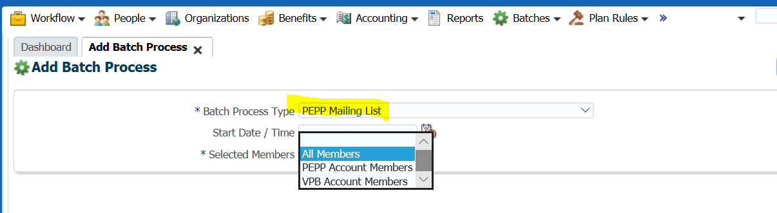

1. **Cheryl’s Request:**

* All VPB members with balances over $10
* All PEPP members regardless of status with balances over $10
  + - 1. Run the query from BI publisher for the members who has balance <=$10

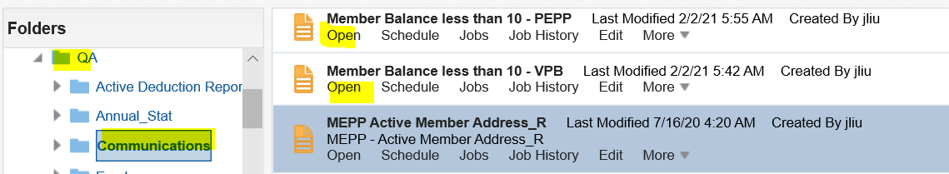

* + - 1. Remove the member from the list whose balance <=$10
      2. Cheryl’s request - exclude the members from the list

|  |  |
| --- | --- |
| Exclude | **QA Process** |
| ~~All e-comm members who’ve selected general~~ | ~~1. Download e-Comm list from e-comm~~  ~~2. Remove the members from the list who sign in e-comm and select General~~ |
| All PLANet members who’ve selected online statements | 1. Run the query from BI publisher      1. Remove the members who’ve selected PEPP online Statements from the list |
| All deceased members | 1. Run the query Member with date of death 2. Remove the members from the list |
| All members with PEBA address | Remove the members from the list who have PEBA address and S4P 4W3 |
|  | Verify if the members are in both PEPP and VPB. if they are, make sure they are not duplicate |
|  | Verify result set, make sure no duplicate records |
| Member numbers | After QA peer review, remove the member numbers |

1. In case Communication request QA upload the e-Comm list

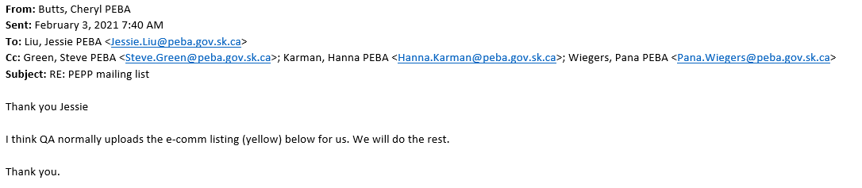

* 1. Generate the e-Comm list as per communication request

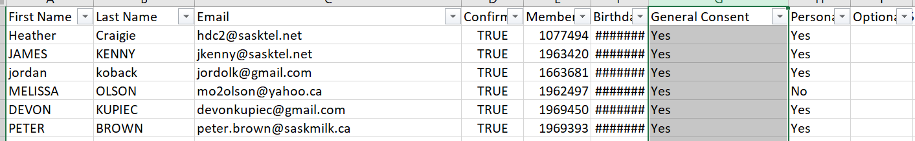

* 1. Format the e-Comm list as below format, and save as .csv file

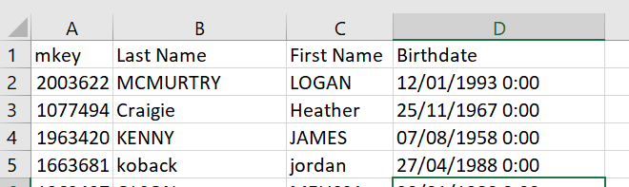

* 1. Log in e-Comm
  2. Click Mailing list >> Under PEPP-Member (ALL), create a sub list

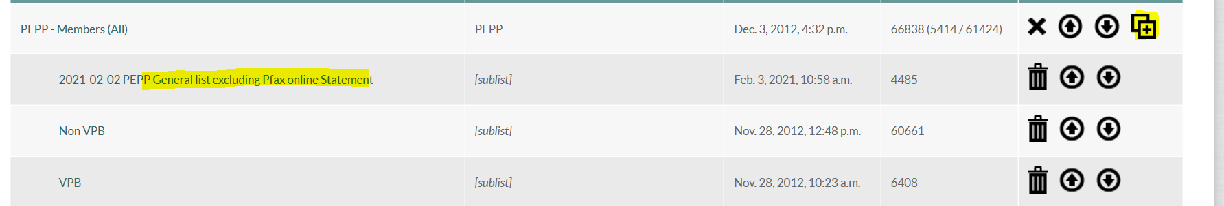

* 1. Name the sub list
  2. Upload the file into the sub list.

Please Note**: DO NOT** update PEPP Member (ALL), Non VPB, VPB list

* 1. Inform the requestor which list you are uploading

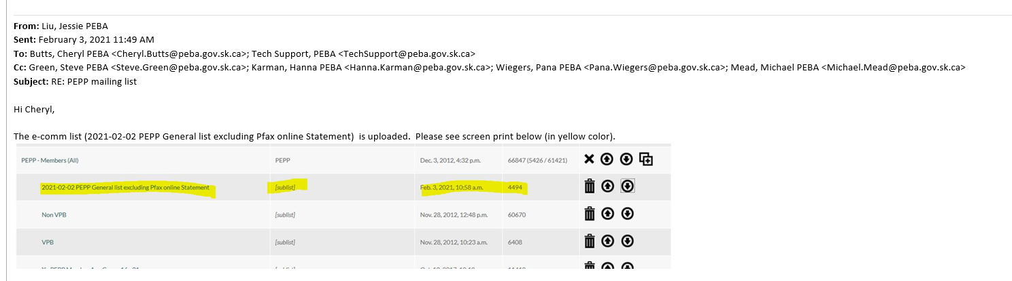

# Procedure document for the Monthly RT Extract

**R@E file from PENFAX:**

1. Login into the PENFAX Production
   * URL: <http://prodadf1.peba.gov.sk.ca:7001/Penfax5/login.html>
2. Go to Batches -> Batch Processes
   * Select **Batch Process Type:** PEPP Retire@Ease Extract
   * Click on **Search**

**Note**: Retire@Ease batch has been scheduled on 1st of every month so the R@E file should be available in PEPP Retire@Ease Extract batch.

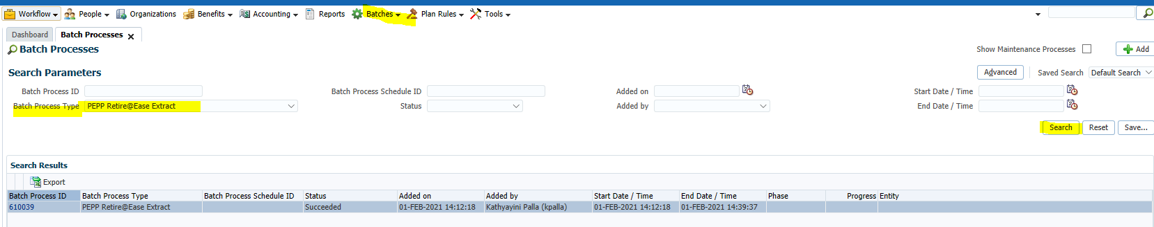

* + Click on the latest **Batch Process ID** (Current month) -> Go to **Files**

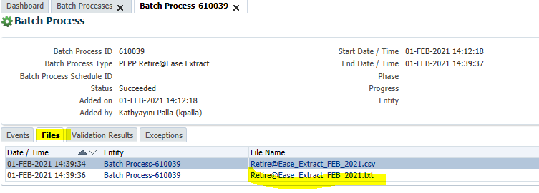

* + Save as TXT file to: H:\Quality Assurance\Prod Apps\Prod Support\V5 Quality Assurance\R@E Monthly Report\<<Current Month Year>>
  + Save as CSV file to: H:\Quality Assurance\Prod Apps\Prod Support\V5 Quality Assurance\R@E Monthly Report\<<Current Month Year>>
* Open the File -> Save as
* Save as Type: Excel Workbook

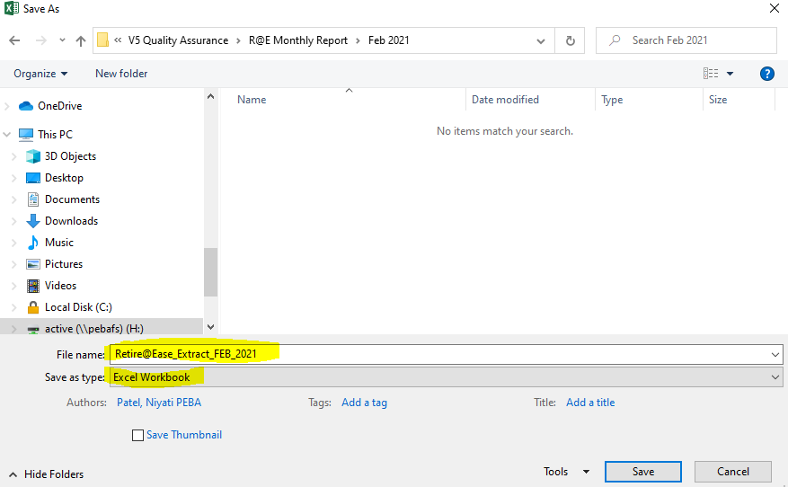

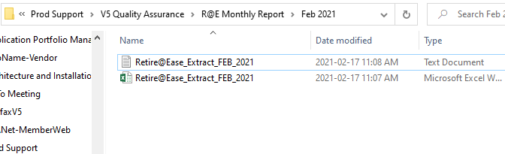

1. Update the Marital Status in the **TXT** file (Retire@Ease_Extract_FEB_2021)

* Manually add “U” to any records where the Marital status is blank.
  + Open the Retire@Ease_Extract_FEB_2021.txt file
  + Go to Edit -> Replace
    - **Find What:** <Space>NN00 & **Replace with:** UNN00
    - **Find What:** <Space>YN00 & **Replace with:** UYN00
    - **Find What:** <Space>NY00 & **Replace with:** UNY00

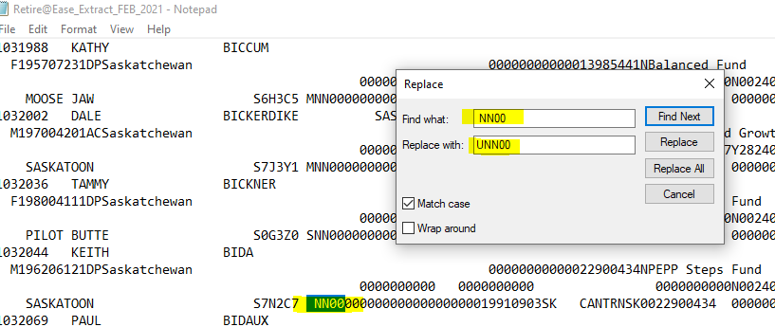

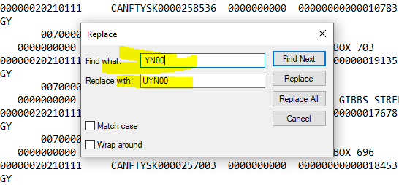

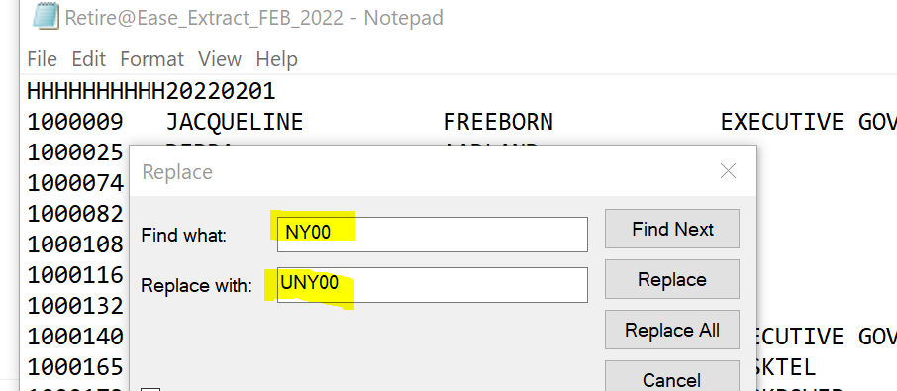

* Click on **Replace All**
* Save the txt file

**FTP File to Mercer:**

1. Create the Zip File

* Add Retire@Ease_Extract_FEB_2021.txt to Zip **with password**

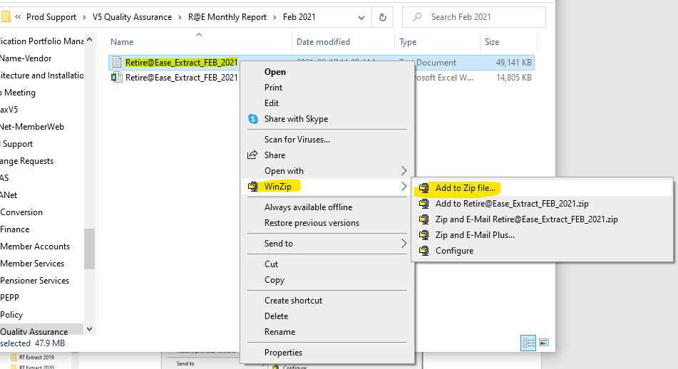

* Click on **Encrypt Files -> Add**

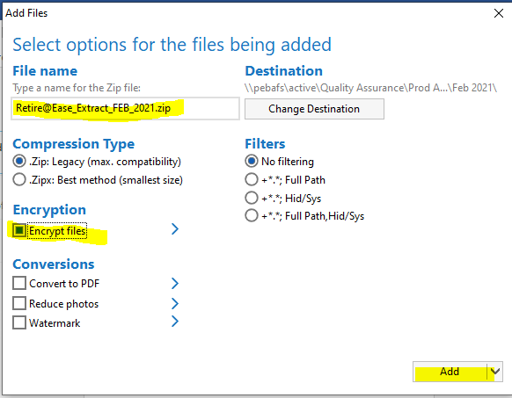

* Enter Password: Feb_2021<<Current Month_Year>> -> Ok

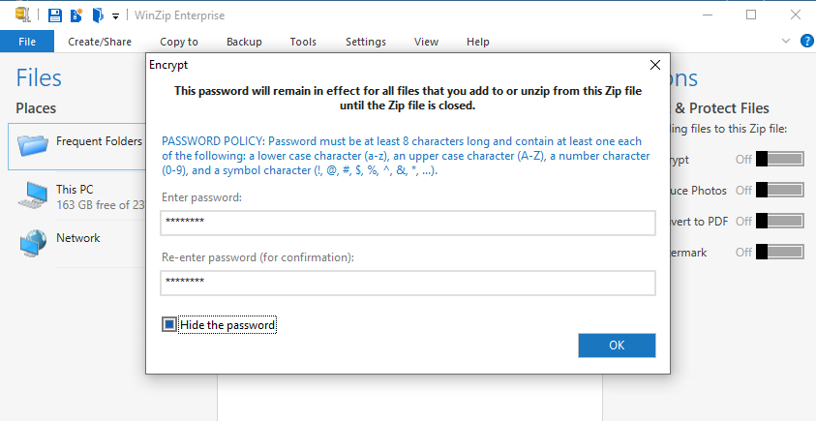

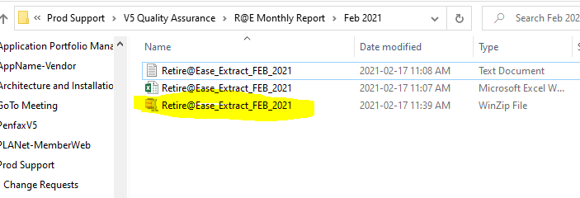

1. Upload R@E file to Mercer SharePoint

**[Jessie 2020-05-04] Mercer has moved to Sharepoint to upload/receive the files. See the screen print below.**

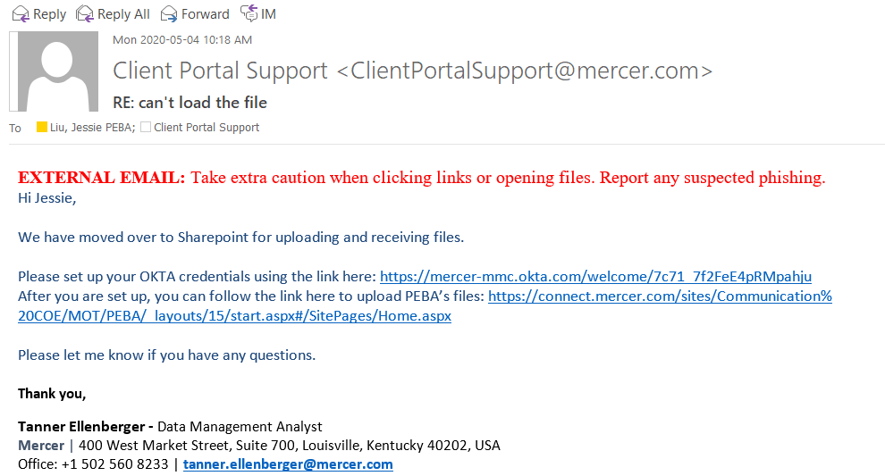

* Open the link & Sign in to the SharePoint

<https://connect.mercer.com/sites/Communication%20COE/MOT/PEBA/_layouts/15/start.aspx#/>

* Enter Username & Password
* Click on Sign In

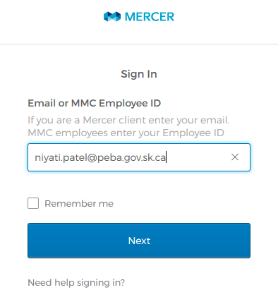

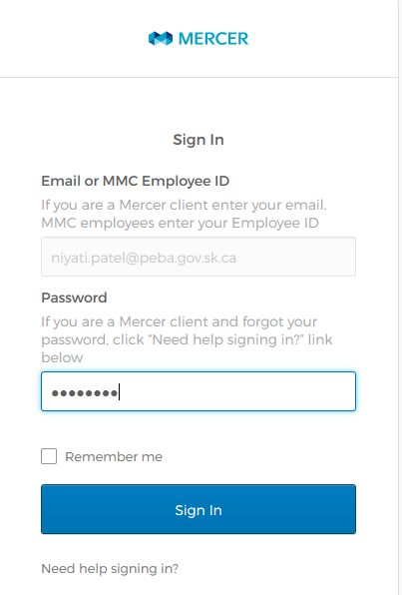

* Click on **Send me the code**
* Enter the Code & Click on Verify

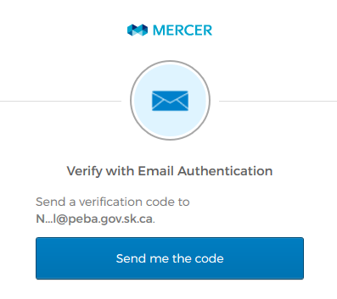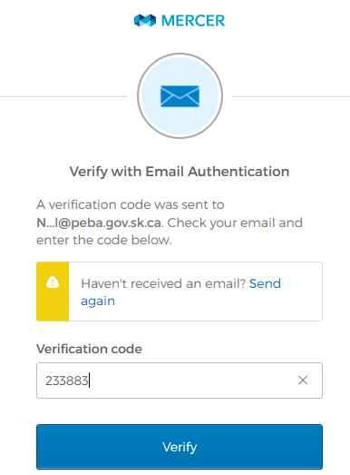

* Click on the **Documents**

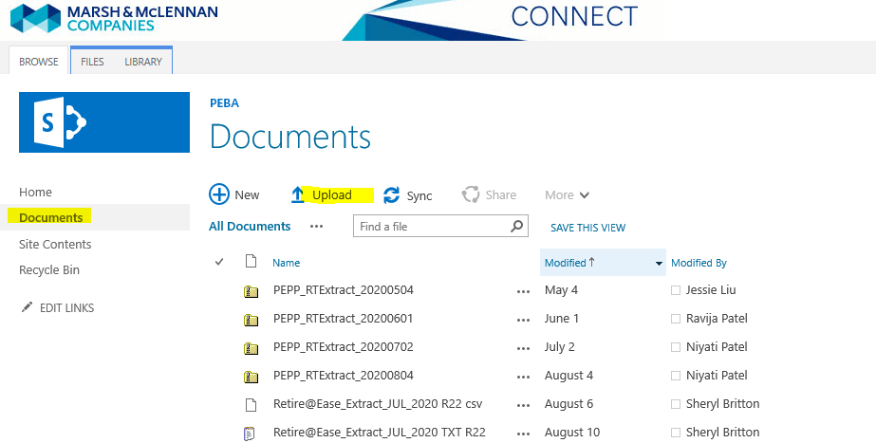

* Click on Upload -> Choose a Zip file -> Ok

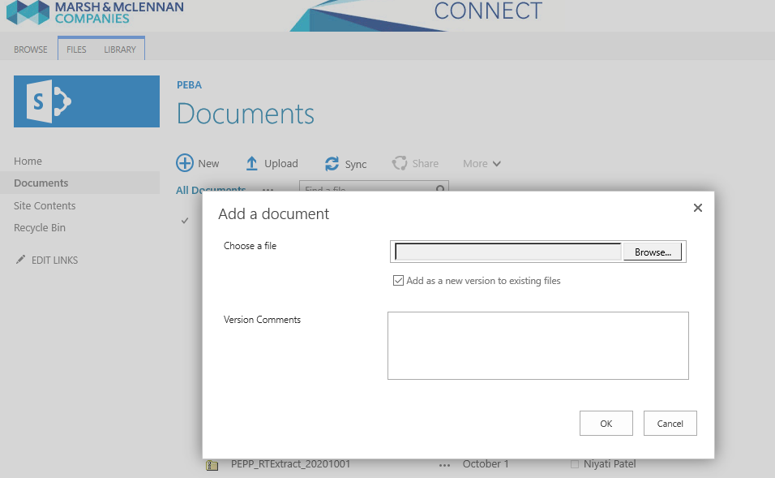

1. Send an email to the below people:
   * **TO**: ClientPortalSupport@mercer.com
   * **CC:** Tech Support, Mark.Henderson@mercer.com, Sheryl Britton, Barb Diebel, Marney Reeve, Heather Culetta, Leanne Toth, QA Team.

Sample email message:

Subject:

*RT Extract February 3, 2014*

Body:

*The RT extract file has been sent to you today.*

*Please advise when the file has been loaded onto the UAT website.*

*[Do not need to include in Mercer email now onwards – Sheryl confirmed by email*

**>> Additional section* for March and April email:**

*Please provide us with PEPP Statement Projection files for PEPP Retire@Ease Statements once the data is verified by PEBA.*

**>> Additional section* for December and January email:**

*Please provide us with VPB Statement Projection files for VPB Retire@Ease Statements once the data is verified by PEBA.*

---------------------------------------------------------------------------]

*This is a reminder that PEBA will require that files in addition to normal month-end R@E production update for PEPP/VPB Retire@Ease statements

**RT Extract Import Process:**

1. Make the file Password Protected
   * Go to H:\Quality Assurance\Prod Apps\Prod Support\V5 Quality Assurance\R@E Monthly Report\<<Current Month Year>>
   * Open the Retire@Ease_Extract_FEB_2021 Excel file

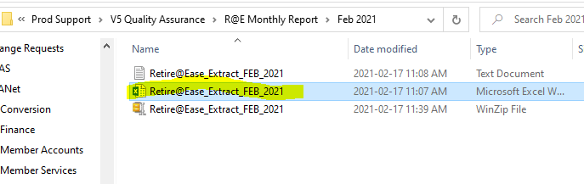

* File -> Select **Info** > **Protect Workbook**

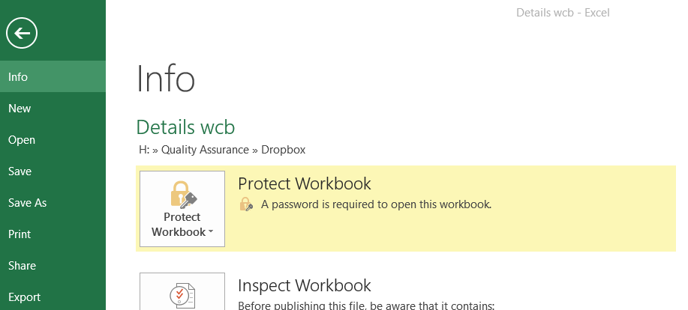

* **Select** **Encrypt with Password**:

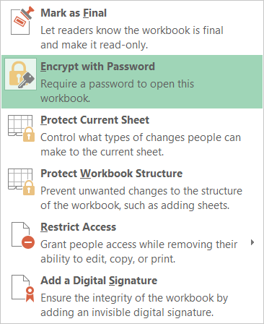

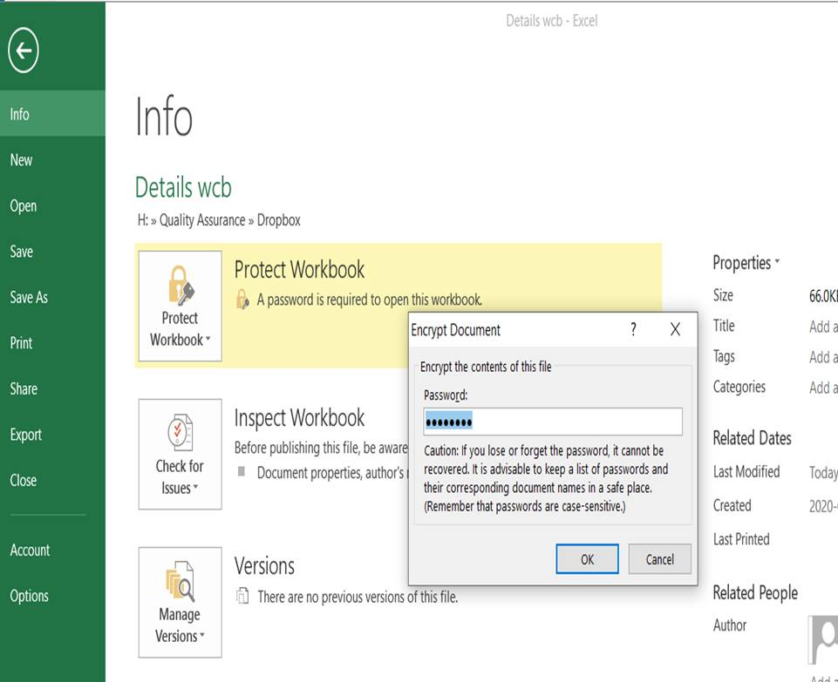

* Enter password and confirm the password (R@E_Pass#1) – Do not change this password to something different as Barb and Jeremy know what it is.
* Save as this file with the Password Protected for the **business:** H:\Pension Programs\PEPP\Reporting Projects\CPAS\R@E\Reports\RT Extract File
  + **File Name:** RT Extract <<Current Month Year>>
  + Click on **Save**
* Validate to ensure that opening the file would require a password.
* Insert the previous month file to the yearly folder.

1. Send RT Extract file to the following members with the Password.

TO: ~~Jeremy~~ & Barb, Tasha (Tasha.Lupanko@peba.gov.sk.ca)

CC: Sheryl & Pana

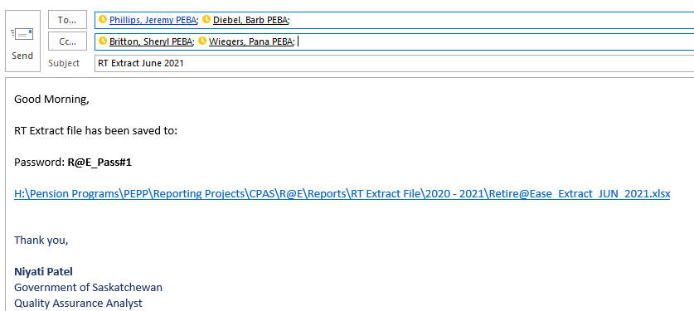

# General procedures to add a tax adjustment in PENFAX on a member’s account

Please note values used below are for sample scenario only and does not relate to any real business case where tax adjustments would be done.

* 1. Search the member in PENFAX via SID, name or PEPP number
  2. Select the Tax Adjustments link in the members Navigation pane

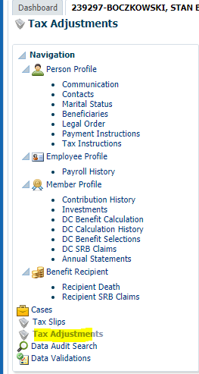

1. On the Tax Adjustments page press the Add button

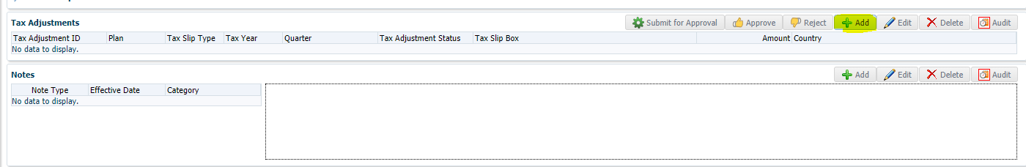

3.1) Enter the appropriate details in the Tax Adjustment Window

* **Plan:** Select the Plan
* **Tax Slip Type**: select **one** of these in the dropdown menu -NR4, RL2, T10, T4, T4A
* **Tax Year**: enter the year for which you are doing the adjustment for
* **Tax Slip Box**: select the appropriate tax slip Box for which you are doing adjustment

Note: if multiple boxes require adjustment, then multiple Tax Adjustment records must be entered, one for each incorrect box.

For example, if the payment history reported $1000.00 in Box 18 but should have been reported under Box 16, a Tax Adjustment is set up for “-1,000.00” for Tax Slip Box “18” and a second Tax Adjustment record is set up for “1,000.00” for Tax Slip Box 16. The resulting Tax Slip produced after adding this adjustment from this system will reflect “0.00” in Box 18 and “1,000.00” in Box 16 as a result of the tax adjustments.

When adding multiple Tax Adjustment records for the same **Tax Year** it is important to remember that Tax Adjustments are cumulative. For example, if a Benefit Recipient received an “Original” Tax Slip at yearend and later an error in the record was found which corrected the total amount of pension they received from the Plan, a Tax Adjustment record would be entered as a positive or negative amount for that box number. This adjustment is then added to the previously reported total (either increasing or decreasing the originally reported amount). This new resulting amount is then used to issue an “Amended” Tax Slip.

If a second error was then discovered which required another change to the amount of pension the Benefit Recipient was reported to have received, a second Tax Adjustment record is created for the difference between the last “Amended” Tax Slip reported amounts and what the values should be. A user should not enter a Tax Adjustment for the difference between the “Original” Tax Slip and what it should be as the system will sum up all adjustments for a given Tax Year when creating an “Amended” Tax Slip.

* **Amount** = enter the amount – **negative adjustments** would have as **a negative amount** and **Positive adjustments** would have as **a Positive amount**
* **Note**: Enter a note describing why you are doing the adjustment
* Verify the entered details, then Press “SAVE”

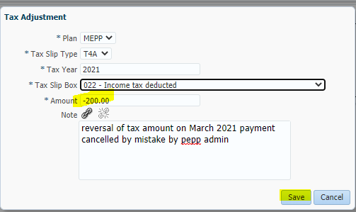

1. Press the Submit for Approval Button, and confirm submission by pressing “YES” -> The Tax Adjustment Status changes from New to Submitted for Approval

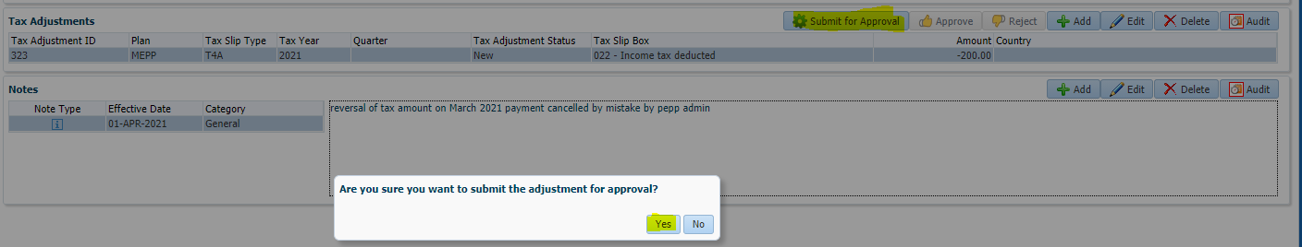

1. The Approver reviews and if all details are correct will press the “Approve” Button and confirm the approval by pressing “YES” -> The Tax Adjustment Status changes from Submitted for Approval to Approved – The adjustment will now be captured in the Tax reporting.

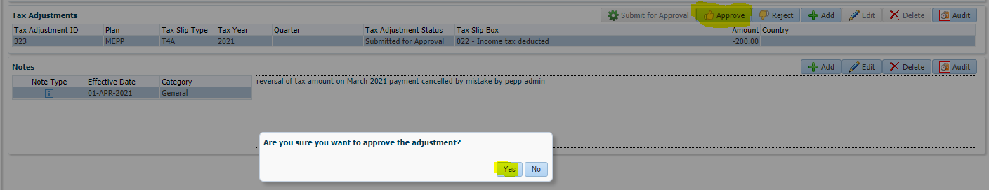

# Refund Tax Over Deduction to Members

**Overview:**

**Part I – Notification of Over Deduction:**

Tax overpayments can be identified by either the business operations area as part of their day to day processing or by Payroll Taxation as part of their tax reconciliation.

In the event that the overpayment is found by Payroll Taxation they will, inform Business area (PEPP business/pensioner services) to get a confirmation from them if member needs a refund or not. If a refund is expected, the procedure steps would be followed in this document. If refund is not expected than nothing to do since CRA will refund back the money when member files their tax with CRA

In the event that the overpayment is found by the business operations area they will, stop processing, and send email to [payrolltax@peba.gov.sk.ca](mailto:payrolltax@peba.gov.sk.ca) payroll taxation. Payroll taxation, should review for determination of refunding to member. When Payroll Taxation has completed their review business will process the refund as instructed.

In the even that the business operations area, encounters an issue with refunding the tax over deduction, or additional support with the process is required a ticket will be logged with Tech Support. When the incident from the Tech Support ticket has been analyzed by an Application and Product team member along with finance and the business area, the Application and Product team member will advise the business area to proceed based on the outcome of the analysis.

**Procedure - Step by Step Process to Refund Tax Over Deduction to Members Process:**

**Step 1: Calculation of the Tax Over Deduction Refund:**

The calculation of tax over deduction refund can come from either payroll taxation (A) or Business area(B);

A. Payroll taxation will provide the calculated refund amount in the attached spreadsheet to PEPP business/pensioner services that would then be used for further processing the refund outlined in Step 2

B. PEPP business/pensioner services will provide the calculated refund in the attached spreadsheet to Payroll taxation for their final sign off and after the sign off is provided, that would then be used for further processing the refund outlined in Step 2

|  |  |  |  |  |  |  |
| --- | --- | --- | --- | --- | --- | --- |
|  |  | Gross Amount  Paid  (G1) | Federal Tax  Calculated (C1) | Provincial Tax  Calculated  (C2) | Total Tax  Calculated (C3) | Net Calculated  (C4)= G1-C3 |
| Correct Payment Calculation |  | 3,222.12 | 322.81 | 154.56 | 477.37 | 2,744.75 |
|  |  |  |  |  |  |  |
|  | Payment  ID | Gross Amount  Paid  (G1) | Federal Tax  Withheld  (T1) | Provincial Tax  Withheld  (T2) | Total Tax  Withheld (T3) | Net  Paid  (N1)= A1-T3 |
| Incorrect Payment | 2266109 | 3,222.12 | 483.32 | 338.32 | 821.64 | 2,400.48 |
|  |  |  |  |  |  |  |
| Tax Over Deduction Refund |  | - | - 160.51 | - 183.76 | - 344.27 | 344.27 |

G1 – Enter amount from original payment processed in PENFAX

C1 & C2 – Enter Calculated Amount of Tax

C3 &C4 (Auto Calculates)

Payment ID – Enter the Original ID from PENFAX

T1 & T2 enter tax withheld on original payment

T3 & N1 (Auto Calculates)

Tax Over Deduction Refund (Auto Calculates)



**Step 2: Entering the Refund Payment into Penfax: *This part is performed by business area\***

1. Open the Stakeholder account and Select Benefit Recipient in the Navigation Pane, on the members account

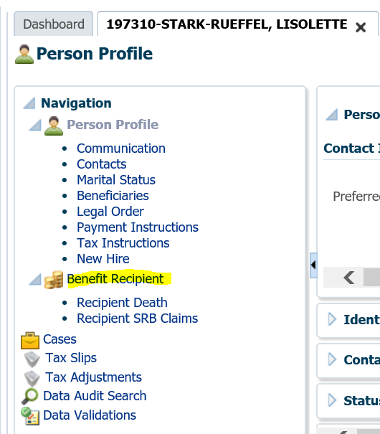

1. On the Benefit Recipient window, verify you have the correct stakeholder then select the Onetime Amounts Tab

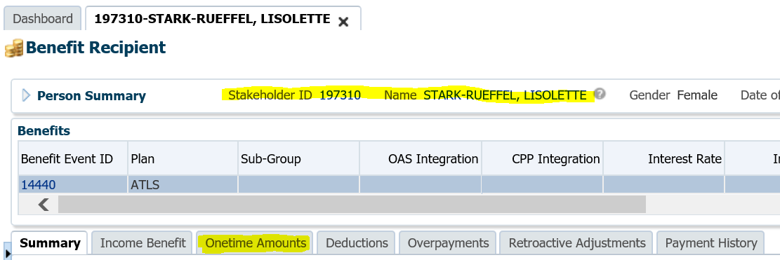

1. On the Onetime Amounts window, select the Add Button

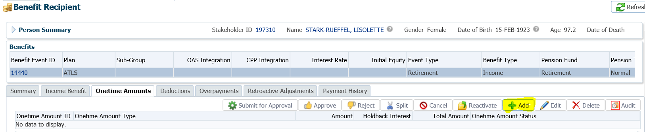

1. Enter and select the correct Payment information.

* Onetime amount type = *Replacement Payment*
* Amount = *Enter the amount from* the Payroll Taxation calculation
* Payable Date: *enter current date*
* Tax Year = *enter the year in which you are paying the refund amount*
* Payment Instruction = *select the most current payment instruction for the member*
* Tax Instruction = *not required*

Note: Enter a detailed note as to why you are making the payment and reference that a tax adjustment will be added for the recovery of the tax from Canada Revenue Agency (CRA).

* Press SAVE

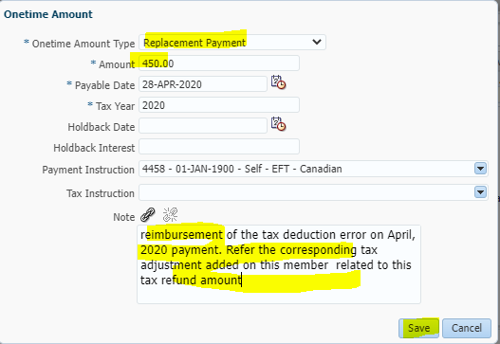

1. Verify your entry is correct then press “Submit for Approval” Enter Note: detailing what your payment is for -> the Onetime Amount Status of the payment will change from new to Submitted for Approval

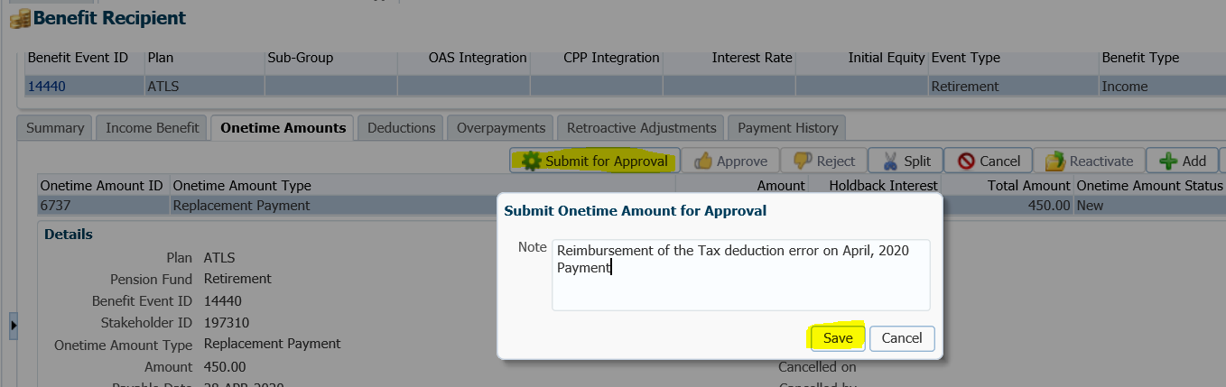

1. The approver will verify the entry details and Press Approve, add approver note and press Save. -> The Onetime Amount Status of the payment will change from Submitted for Approval to Approved, and the payment will be captured in the Ad hoc payment batch.

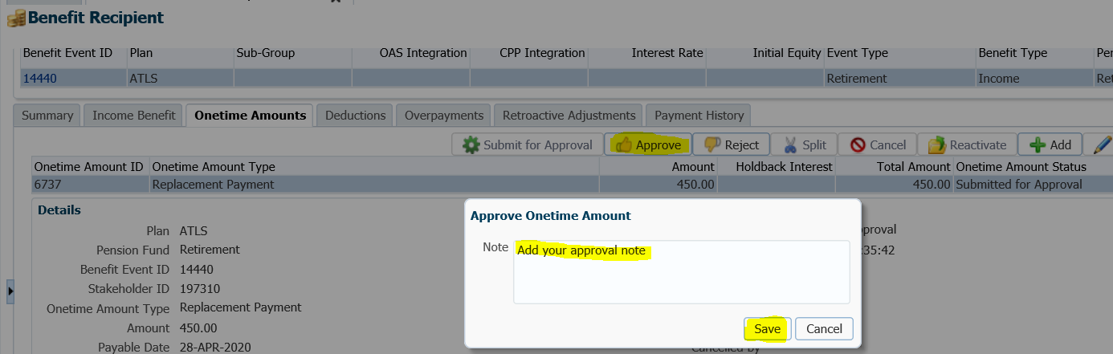

**Step 3– Processing the Refund Payment in Penfax** - \***This part is optional performed by business area\***

*You can do this part now or you can wait for the overnight batch process to pick up the payments you entered*

3a. Wait for Overnight Batch Process Instructions

1. The overnight batch process will capture the payments that were entered in the Ad Hoc payment batch
2. The next day business operations area will perform their standard payment batch verification
3. The next day Finance will perform their regular processing to issue the refund payment.

3b. Process Now Instructions:

1. Once all payments have been entered for the Plan, Navigate to Batches -> Payment Production -> and select Add Payment Batch

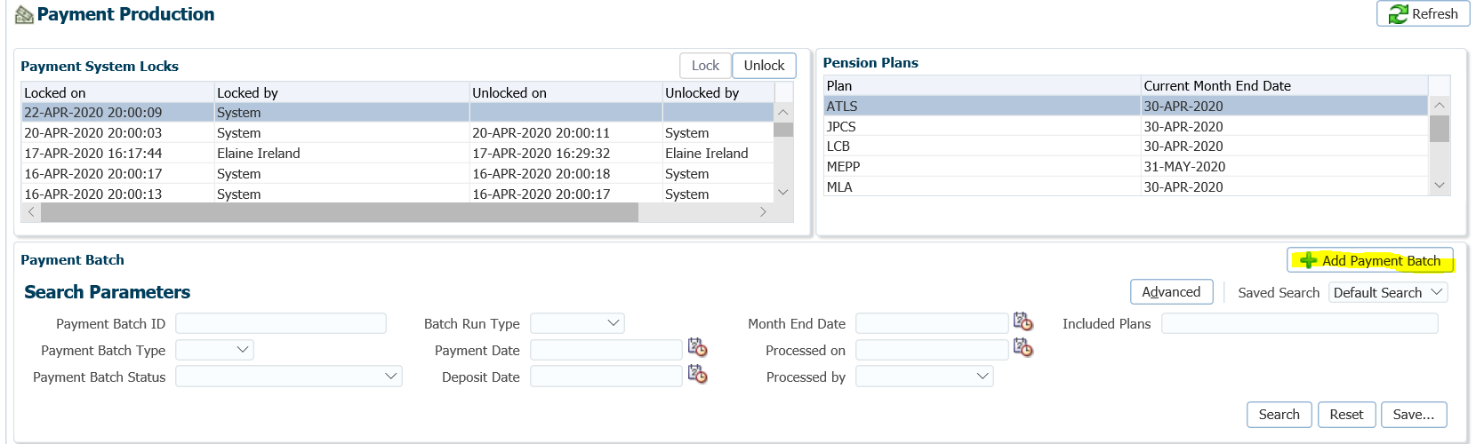

1. Enter the Payment Batch Details

* Payment Batch Type = Ad Hoc
* Batch Run Type = **Test**
* Payment Date = current date
* Deposit Date = current date

Select the payments in the list that = the Plan you are running the batch for, where Onetime Amount Type is “Replacement Payment” and Payable Date is the same date you entered in your payment batch parameter.

* Then press Save

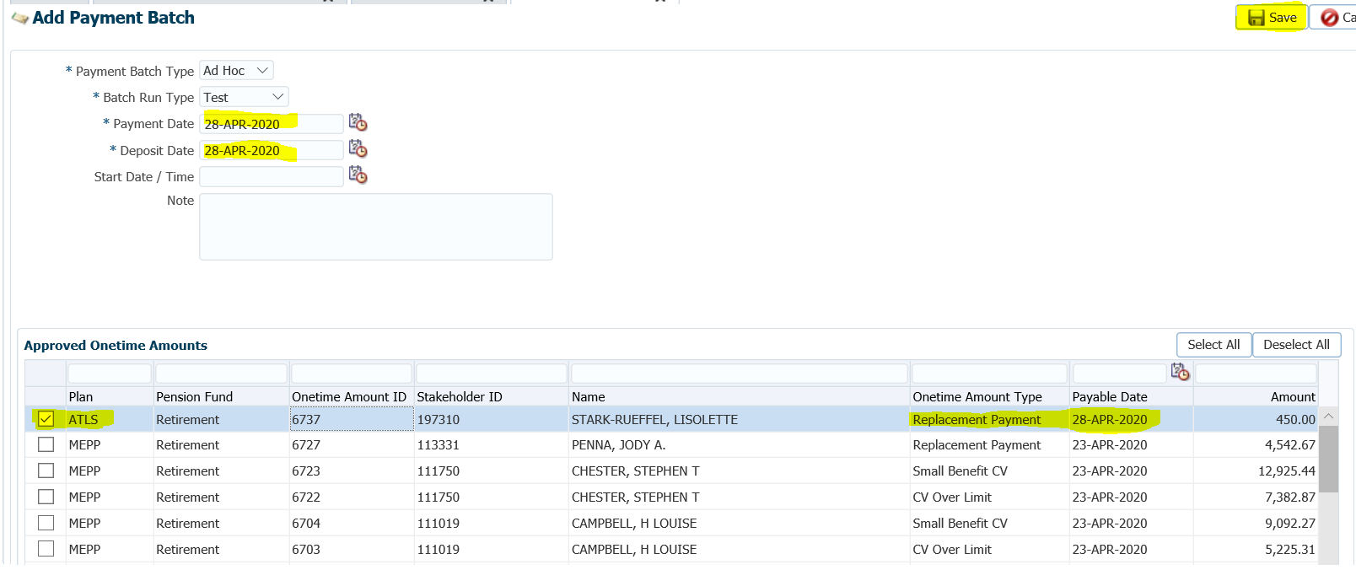

1. Perform your regular payment batch validations – and make any necessary corrections if required.

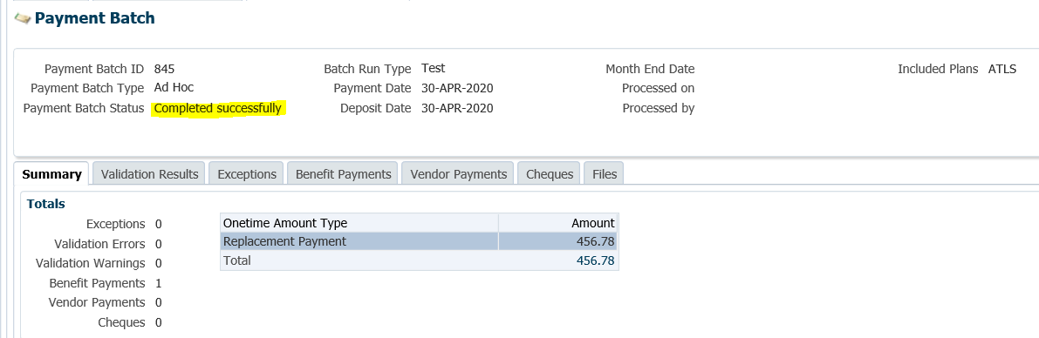

1. Repeat Step 2 with the following change:

* Batch Run Type = Production

1. Perform your payment validation and Press the Process Button

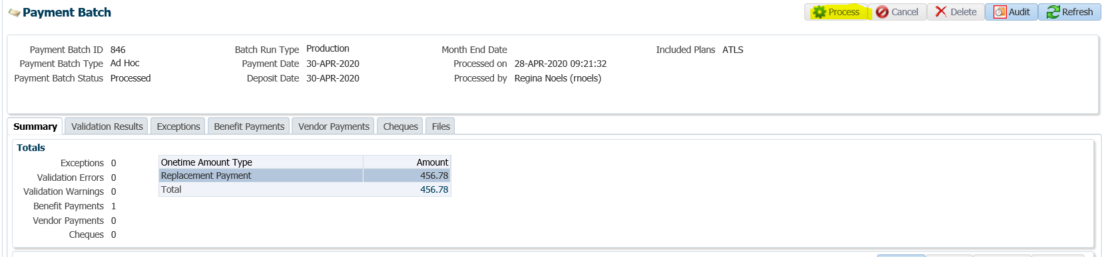

1. Business area advises Finance and Payroll Taxation that the Refund payment batch was processed. How do they do this? i.e., by email?
2. Finance will perform their regular processing to issue the refund payment.

**Step 4: Make the Tax Adjustment on the members account *This part is performed by Payroll Taxation\***

1. Select the Tax Adjustments link in the members Navigate pane

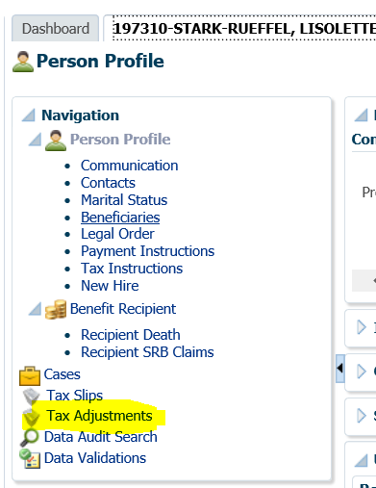

1. On the Tax Adjustments details press the Add button

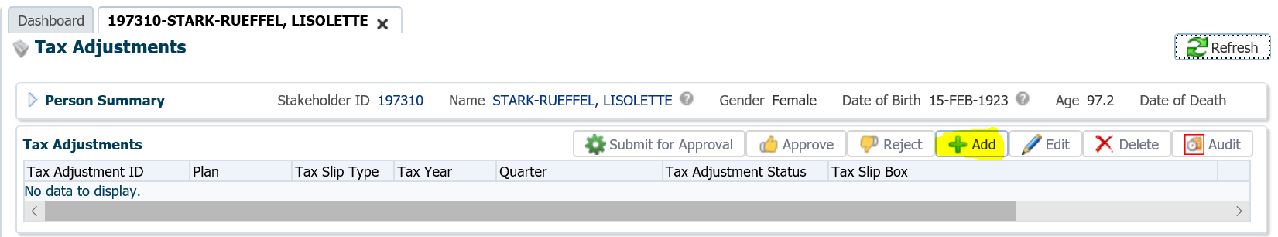

1. Enter the appropriate details in the Tax Adjustment Window

* Plan: Select the Plan
* Tax Slip Type: select the tax slip you refunded the monies for
* Tax Year***: enter the year the refund of monies was meant for (i.e. the year in which the member was overtaxed)
* Tax Slip Box: select the appropriate tax slip box for the tax slip you are adjusting
* Amount = enter the amount that we paid the member back in Part I above **as a negative amount**

**\*\*\*** sometimes multiple tax adjustment records are required for different tax years. **\*Important\***For situations where the tax years are different, please carefully do the adjustments.

Note: Enter a detailed note of what we are reversing

* Verify the entered details, then Press “SAVE”

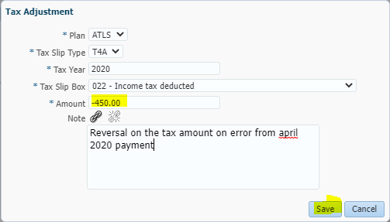

1. If required, repeat step 2 and 3 for additional tax adjustment records to be added
2. Press the Submit for Approval Button, and confirm submission by pressing “YES” -> The Tax Adjustment Status changes from New to Submitted for Approval

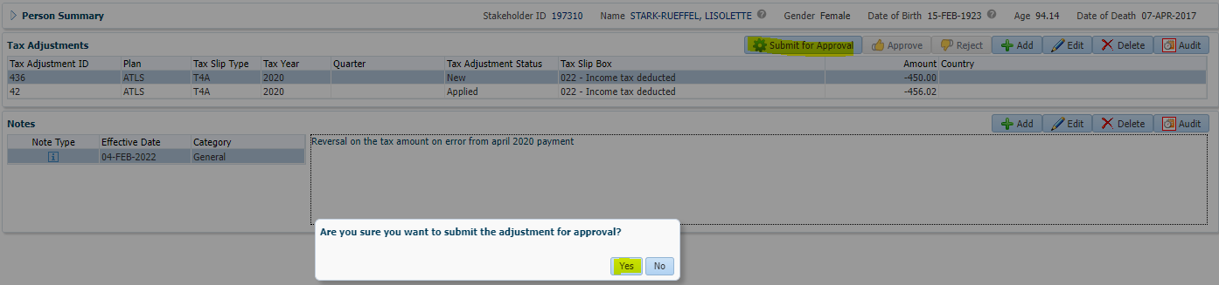

1. The Approver reviews and if all details are correct will press the “Approve” Button and confirm the approval by pressing “YES” -> The Tax Adjustment Status changes from Submitted for Approval to Approved – The adjustment will now be captured in the Tax reporting.

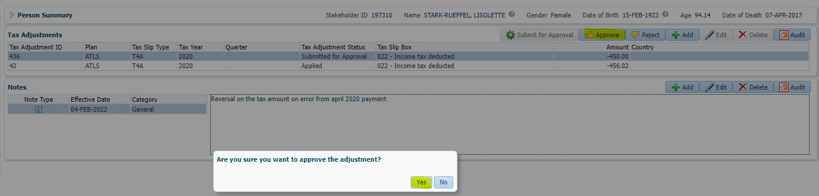

1. The Tax slip for the member can now be run by Payroll Taxation –
   1. Run a test tax slip first to Verify that the tax adjustment is picked up on the tax slip
   2. Run the production tax slip and process to move it to the members account

**Step 5: Add the overpayments for the Tax recovery from CRA *This part is performed by business area* so that the tax recovery from CRA can be tracked**

1. Open the Stakeholder account and Select Benefit Recipient in the Navigation Pane, on the members account. select overpayments tab and click ADD

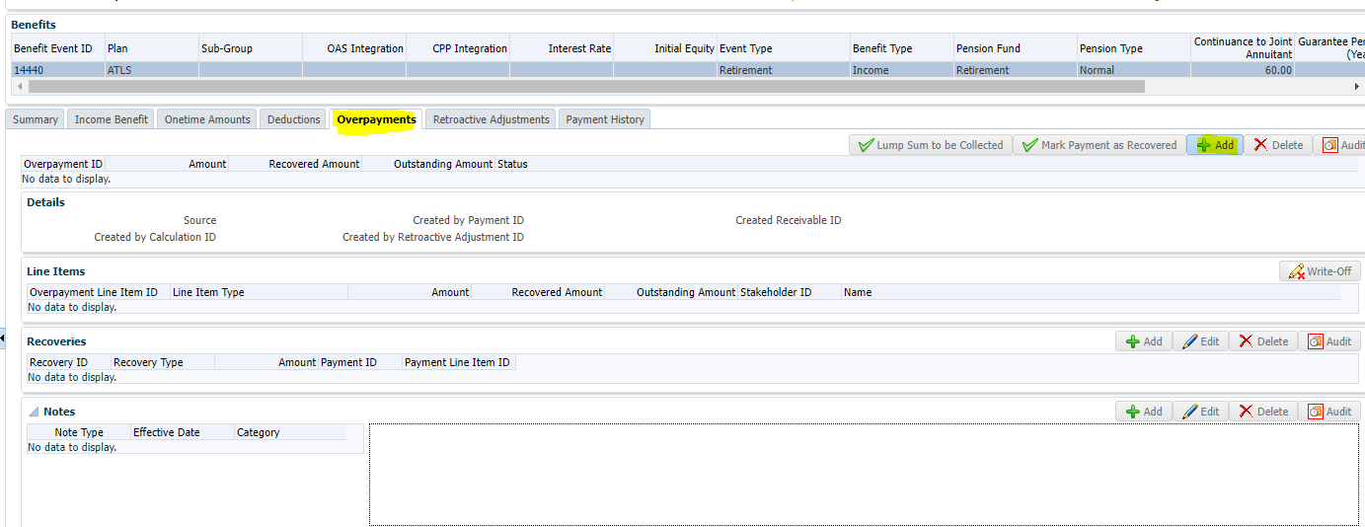

1. Enter the appropriate details in the overpayment Window (screen print example below)

* Line Item type: select appropriate type based on the tax we being recovered from CRA I.E. federal income tax/federal lumpsum tax, etc.
* Amount: enter the amount you over payed to CRA (will be same as the refund payment you processed)

Note: Enter a detailed note of what was this overpayment about

* Verify the entered details, then Press “SAVE”

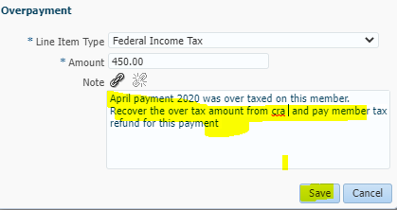

1. Overpayment record is saved successfully with status “outstanding”

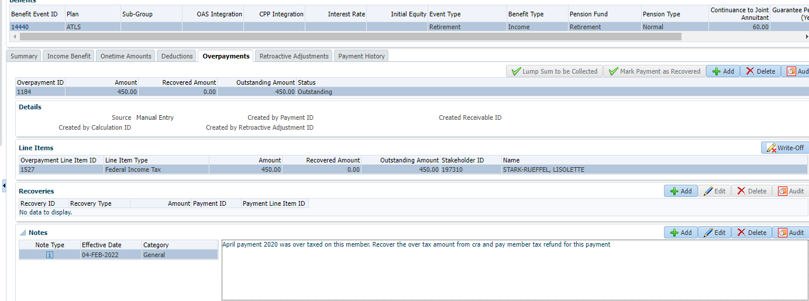

1. if required, repeat step 1 and 2 for additional overpayment records to be added

**Step 6: Add the overpayment recoveries *This part is performed by Payroll Taxation* so that the tax recovery can be completed**

1. Open the Stakeholder account and Select Benefit Recipient in the Navigation Pane, on the members account.
2. Select the overpayment Id row for which you want to add recoveries to, then select the line item that you are recovering for
3. Under the Recoveries section of the overpayment id selected in above step, click Add button

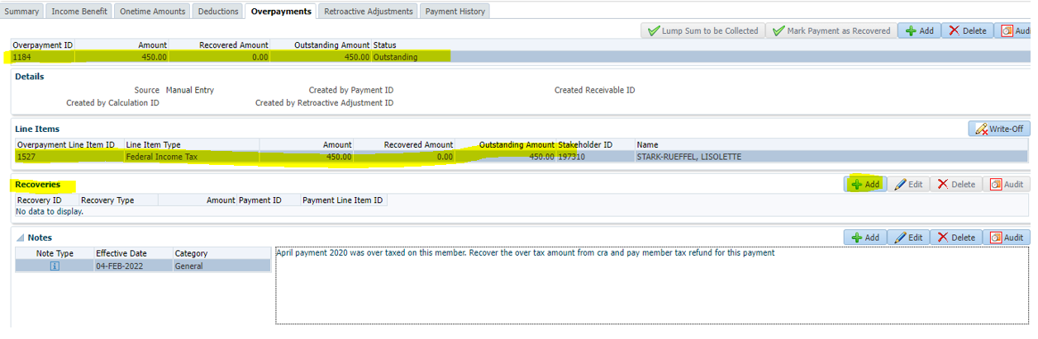

* 1. Enter the appropriate details in the recovery Window (see screen print below)
  + Recovery type: select appropriate record
  + Amount: enter the amount you over payed to CRA that has been now recovered (directly or was recovered in next CRA remittance)

Note: Enter a detailed note of what was this overpayment recovered about

* 1. Verify the entered details, then Press “SAVE”

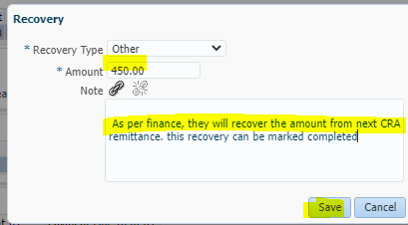

1. Both the Line item record and the main overpayment id record will report the recovered amount, you added. If there are no other line items to be recovered or if all line items have been recovered then the status of the overpayment record will move from “Outstanding” to “Closed”

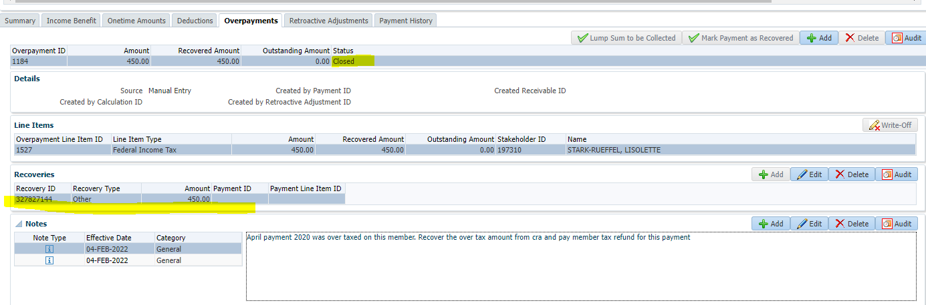

1. If required, repeat step 2, 3 and 4 for additional recovery records to be added

**\*\*This concludes all the steps for the procedure outlined in this document \*\***

# Procedures for Payments Cancelled in Error

Note: if the overpayments will not be written off at the time this error is discovered notify payroll taxation right away otherwise, notify them after you have completed the overpayment write off. *see notification required at the end of this document for details of what to send*

Payment cancelled in error (screen print of payment history)

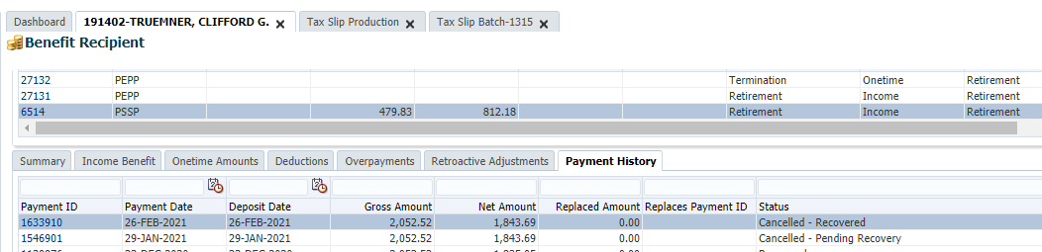

Payment History Tab will report Status “Cancelled – Pending Recovery” - This status cannot be changed

* Add a detailed note to the members account - to explain the payment was cancelled in error

Example of notes:

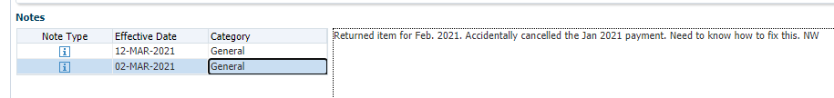



How to proceed with Overpayments tab – for the Overpayment ID created by the Payment Cancellation process.

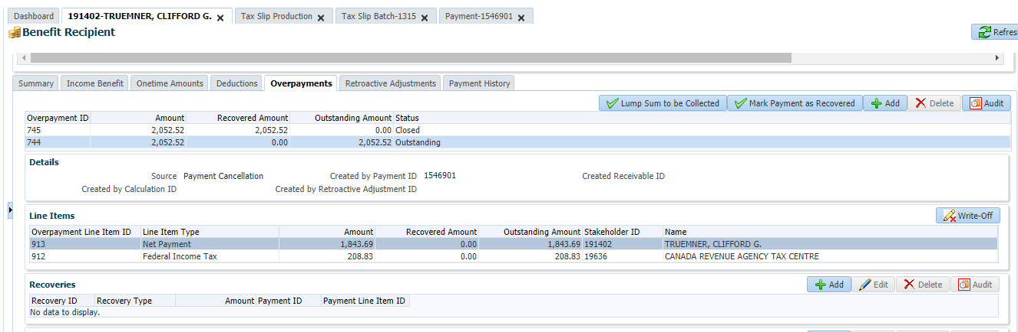

Write off each overpayment line item, so that the overpayment will close.

* 1. Select the line item
  2. Press the Write Off Button
  3. Add your write-off note

Example of a note: “January's payment was cancelled in error this overpayment is created in error and will not be recovered and must be written off”

* 1. press Save (see screen print below)

Repeat a) to d) for any line items that exist for the overpayment

After all line items have been written off the Overpayment status will be reported as closed.

**IMPORTANT NOTE: Do not press** Mark Payment as Recovered or this will impact tax reporting.

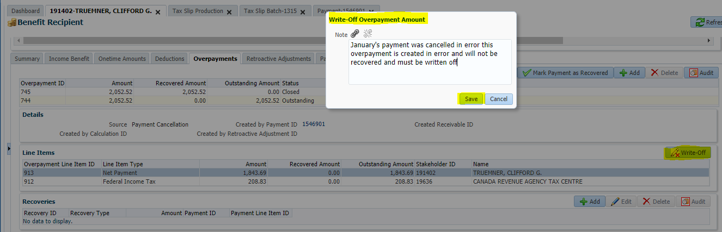

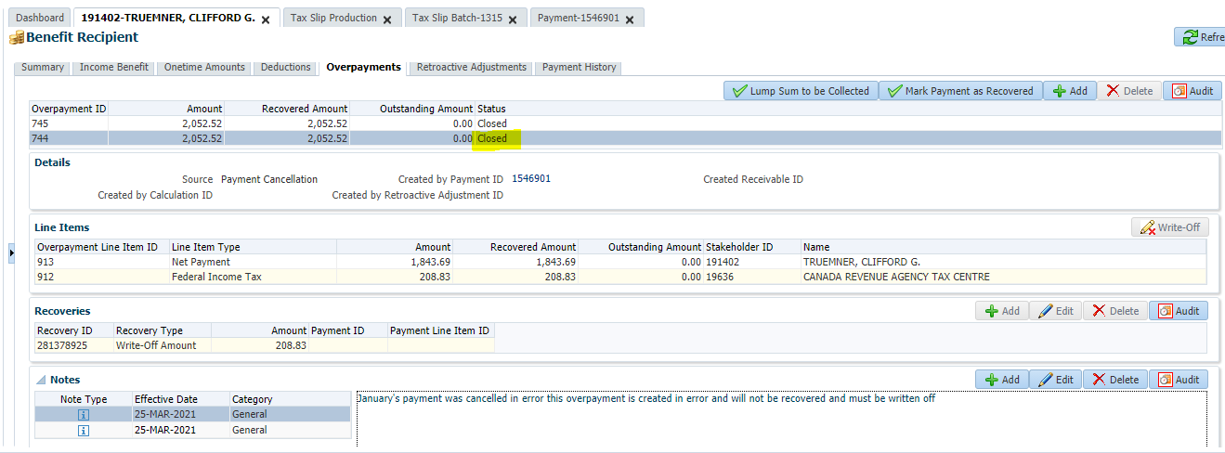

The payment history will still report the payment as Cancelled – Pending Recovery – **this will not change and is correct**

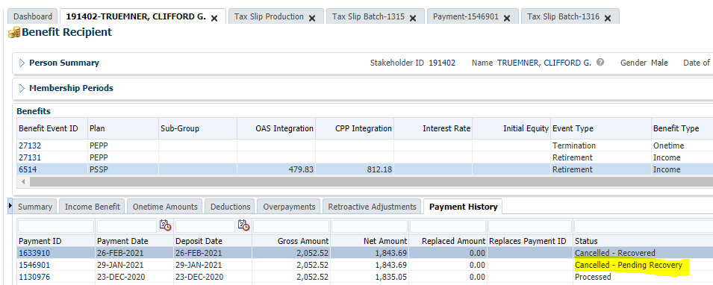

**IMPORTANT NOTE** - Send an email to Payroll Taxation “payrolltax@peba.gov.sk.ca advising of the error.

Provide: Stakeholder ID; Stakeholder Name; Payment ID; advise payment was cancelled in error; advise overpayments have been written off.

* Payroll Taxation can run a test tax slip batch for the member to ensure that the correct payments are reporting on their tax slip.

# TO ADD new TD1 claim amounts in TD1 claim amount tables in PENFAX V5

This procedure document defines on how to add TD1 claim amounts/TD1 claim code amounts in PENFAX V5. The document is broken into two parts – step1-8 that defines on adding/updating TD1 claim amounts/TD1 claim code amounts existing in the PENFAX V5 system already and step 9-12 on adding new TD1 claim amounts/TD1 claim code amounts which were not existing before.

**Step 13 is mandatory** after tax changes are applied on TD1 claim amounts table

Step 1- Step 8 below are only required if the “TD1 claim amounts” and “TD1 claim code amounts” to be added **already** exist in the table

**Step 1**. Login to PENFAX and navigate to Plan rules>TD1 claim amounts

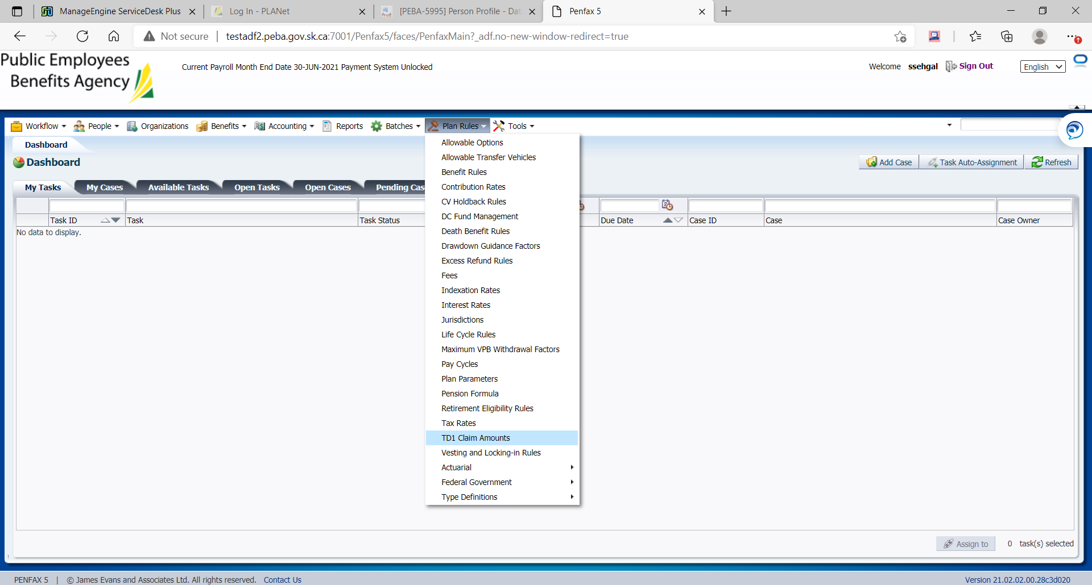

**Step 2**. Select TD1 jurisdiction = “Jurisdiction”

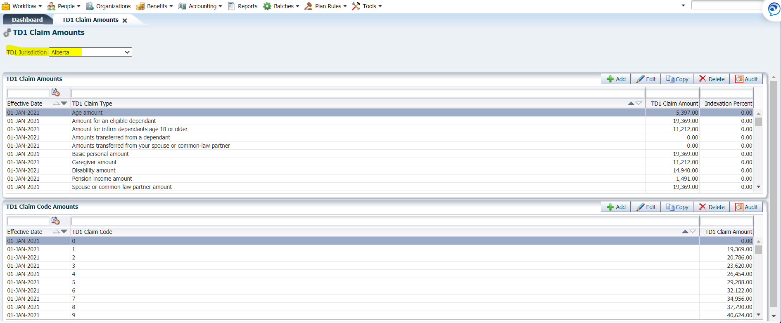

**Step 3**. Under “TD1 claim amounts” section select the appropriate record to be added/updated and click “copy’

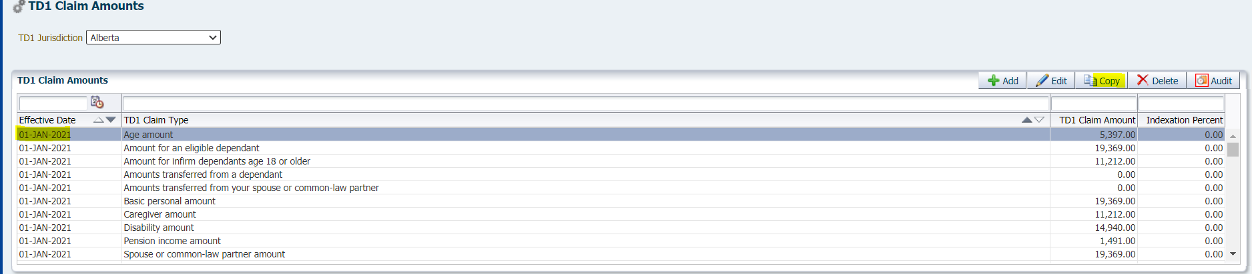

**Step 4.** In the pop-up window, add the following parameters as deemed to be updated/added and click Save

Effective date= date the tax rates should be effective for

TD1 claim amount

Indexation percent

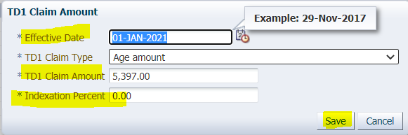

**Step 5.** Repeat the step 3 and step 4 for as many records that are required to be added/updated. Note that if CRA change was only for one of the TD1 claim type even then all the records should be added with a new effective date keeping the values same as before

**Step 6.** If TD1 claim code amounts update/add is also required , then Under TD1 claim code amounts

section select the appropriate record to be added/updated and click “copy’

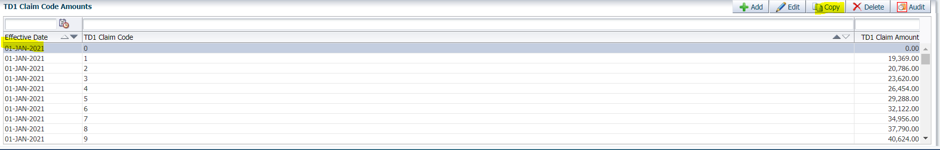

**Step 7.** In the pop-up window, enter the following parameters and click SAVE

Effective date= date the tax rates should be effective for TD1 claim amount

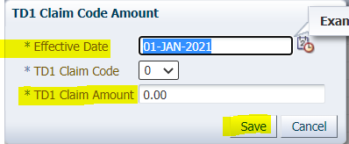

**Step 8.** Repeat the step 6 and step 7 for as many records that are required to be added/updated. Note that if CRA change was only for one of the TD1 claim code even then all the records should be added with a new effective date keeping the values same as before

Step 9- Step 12 below are only required if the “TD1 claim amounts” and “TD1 claim code amounts” to be added **DO NOT** exist in the table

**Step 9.** Select the TD1 jurisdiction= “jurisdiction’ and Click ADD under “TD1 claim amounts” section

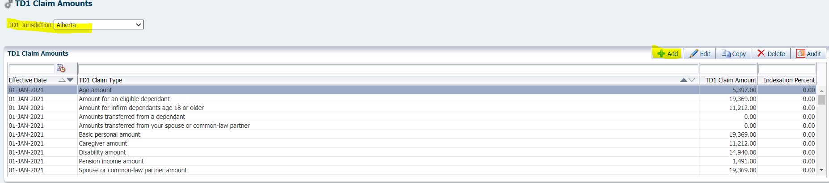

**Step 10.** In the pop-up window add all the mandatory fields and click save

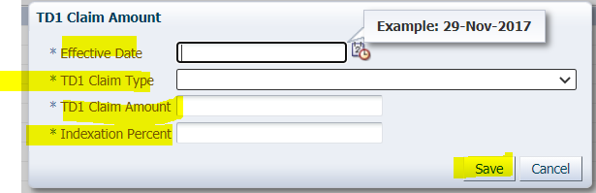

**Step 11**. Click ADD under “TD1 claim code amounts” section

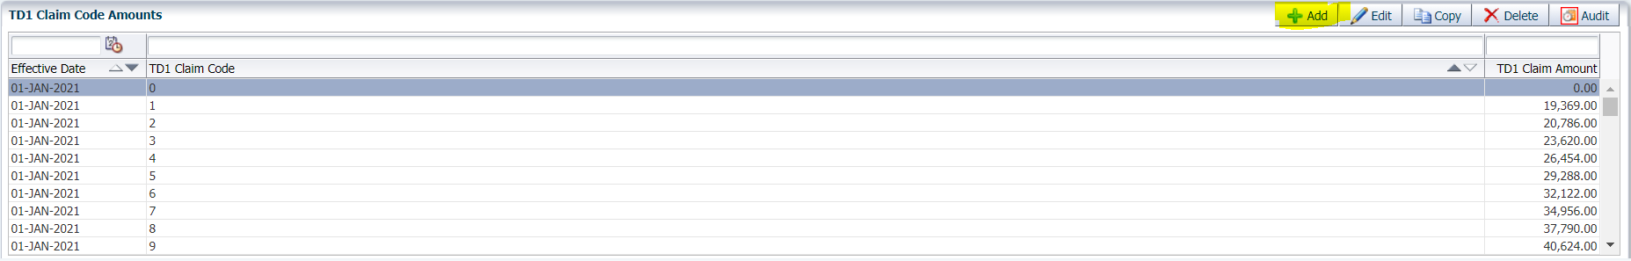

**Step 12.** In the pop-up window add all the mandatory fields and click SAVE

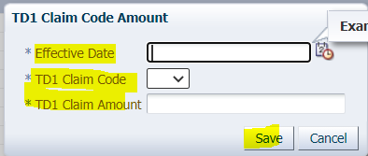

**Step 13.** The tax exemption indexation batch (effective date = < effective date of tax changes applied above) should always be run post making the changes to TD1 claim amounts table

# TO ADD new tax rates in tax tables in PENFAX V5

This procedure document defines on how to add tax rates/tax parameters in PENFAX V5. The document is broken into two parts – step1-8 that defines on adding/updating tax rates/tax parameters existing in the PENFAX V5 system already and step 9-12 on adding new tax rates/tax parameters which were not existing before

Step 1- Step 8 below are only required if the “tax rate” and “tax parameter” to be added **already** exist in the table

**Step 1**. Login to PENFAX and navigate to Plan rules> tax rates

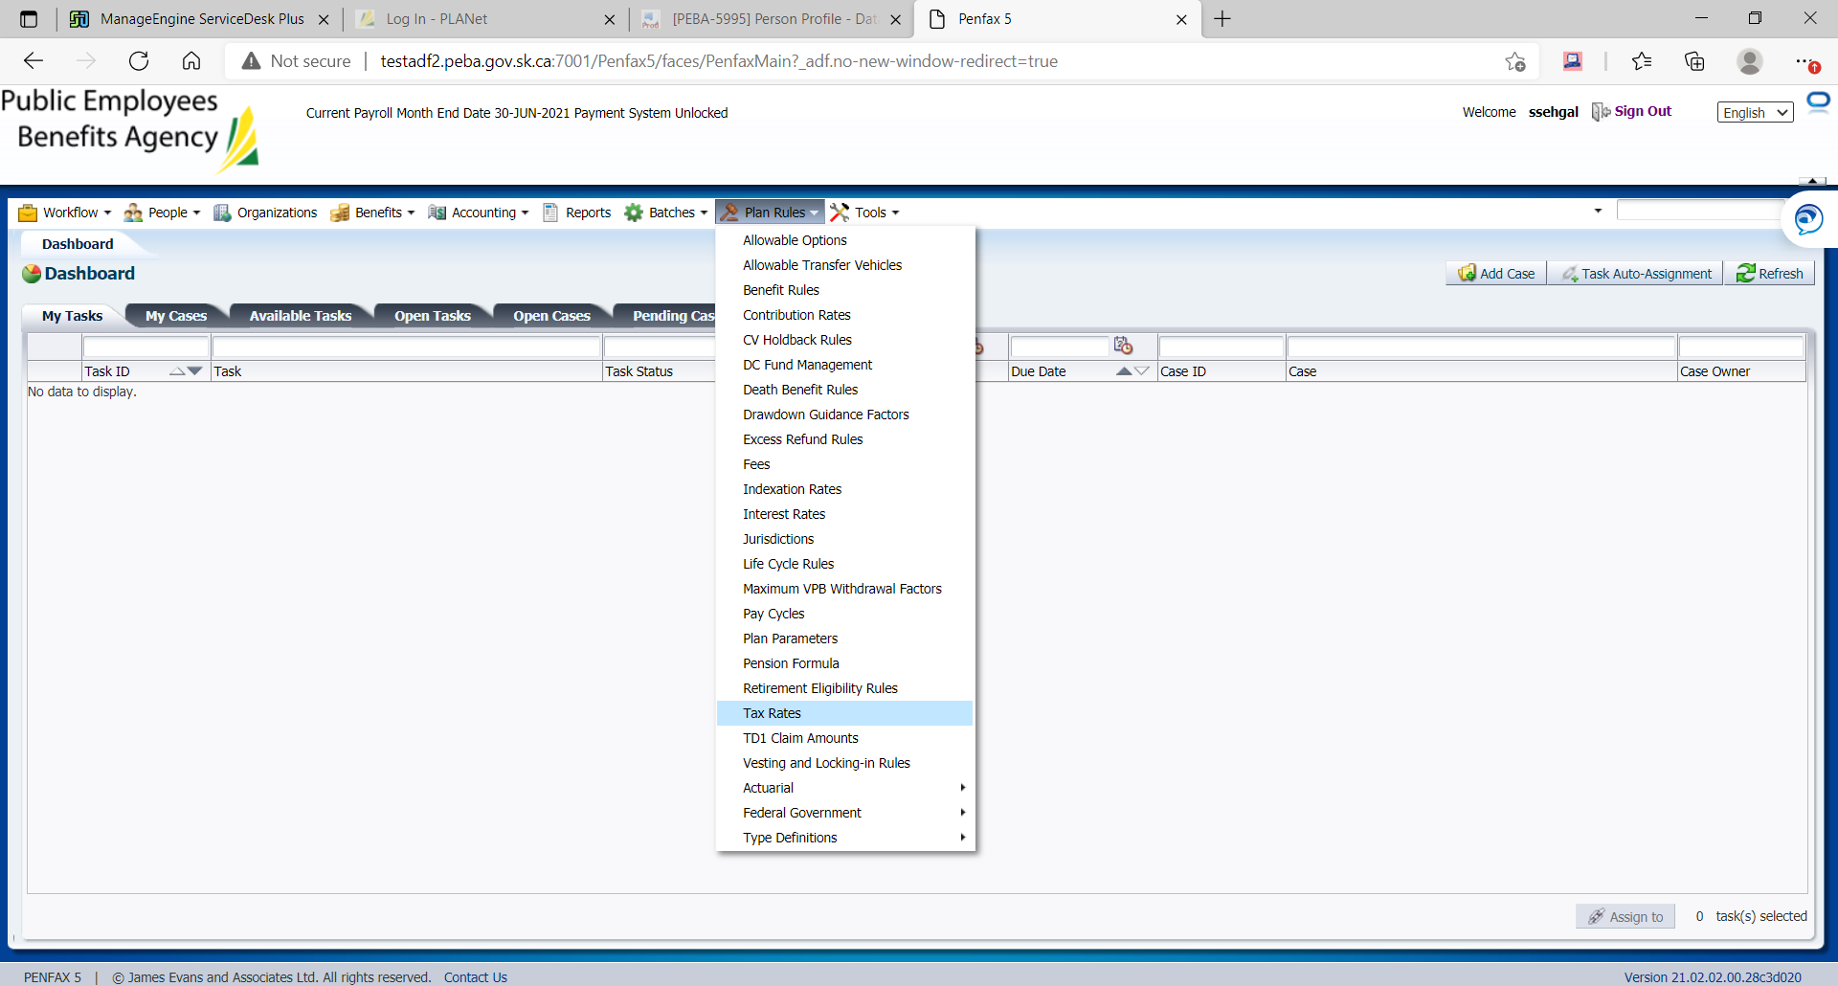

**Step 2.** Select tax Type = “Jurisdiction”

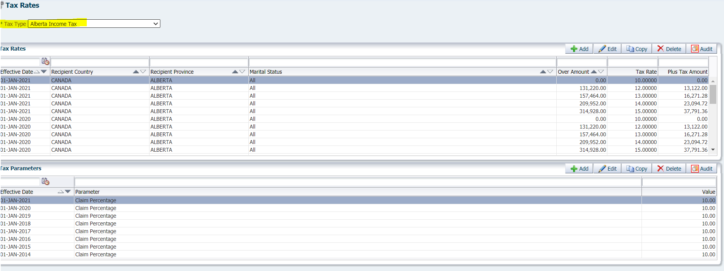

**Step 3.** Under tax rate section select the appropriate record to be added/updated and click “copy’

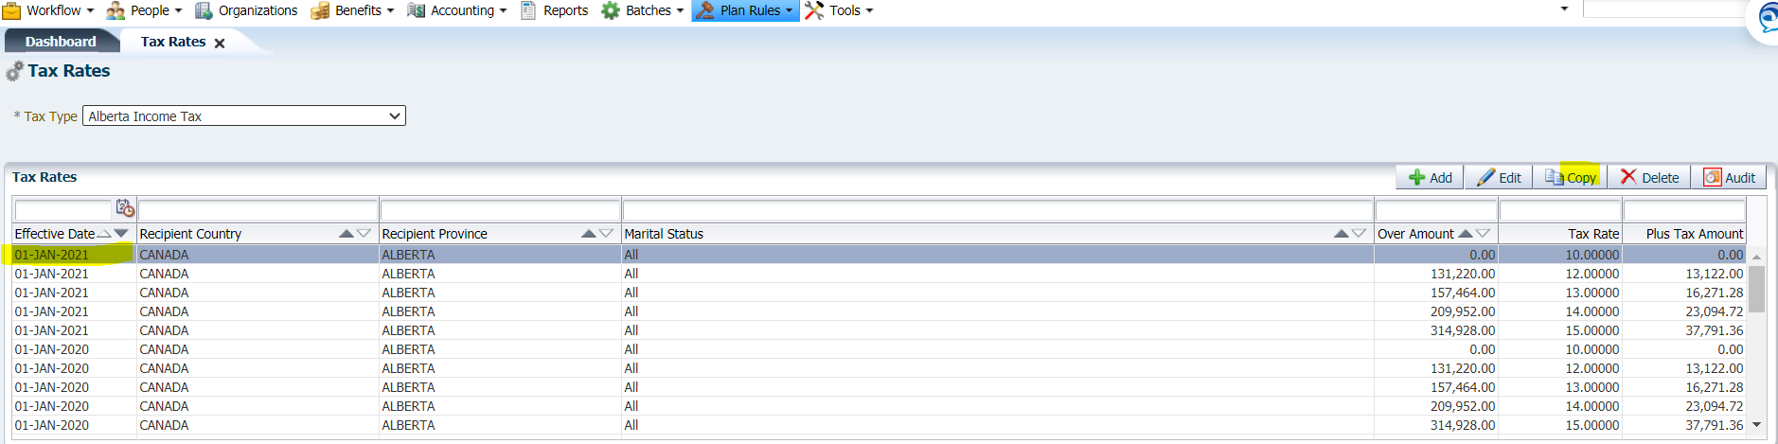

**Step 4.** In the pop-up window, add the following parameters as deemed to be updated/added and click Save

Effective date= date the tax rates should be effective for

Over amount

Tax rate

Plus, tax amount

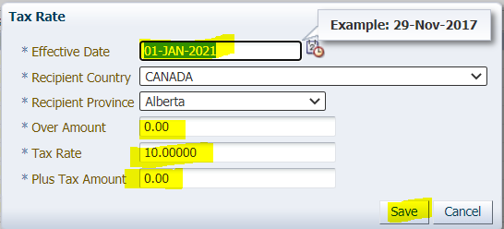

**Step 5.** Repeat the step 3 and step 4 for as many records that are required to be added/updated. Note that if CRA change was only for one of the tax rate brackets even then all the records should be added with a new effective date keeping the values same as before.

**Step 6.** If Tax parameter update/add is also required , then Under tax parameter section select the appropriate record to be added/updated and click “copy’

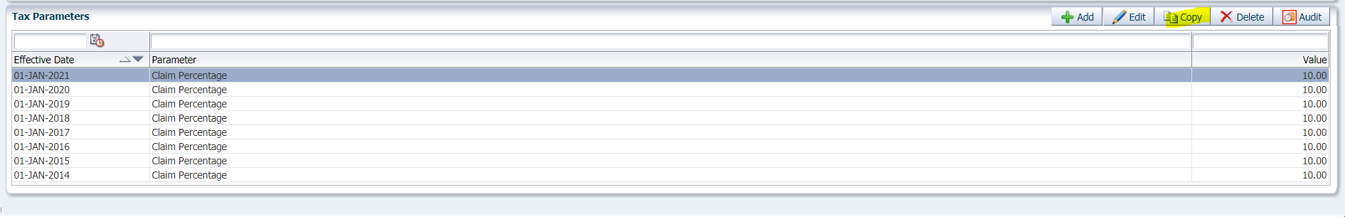

**Step 7.** In the pop-up window, enter the following parameters and click SAVE

Effective date= date the tax rates should be effective for value

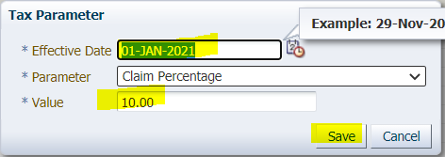

**Step 8.** Repeat the step 6 and step 7 for as many records that are required to be added/updated. Note that if CRA change was only for one of the tax parameters even then all the records should be added with a new effective date keeping the values same as before.

Step 9- Step 12 below are only required if the “tax rate” and “tax parameter” to be added **DO NOT** exist in the table

**Step 9.** Select the tax type= “jurisdiction’ and Click ADD under “tax rates” section

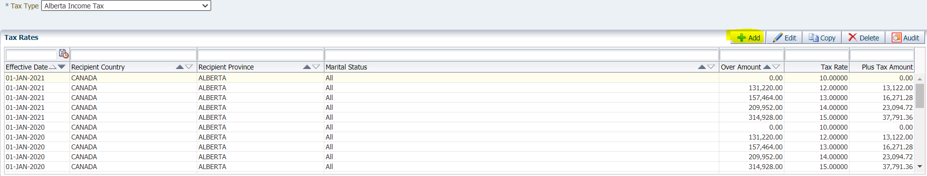

**Step 10.** In the pop-up window add all the mandatory fields and click save

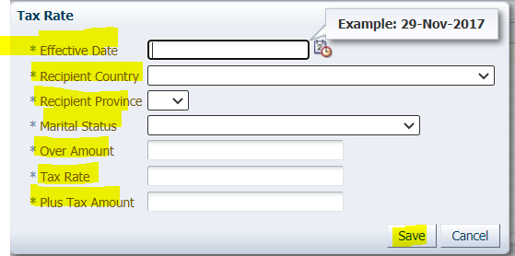

**Step 11.** Click ADD under “tax parameter” section

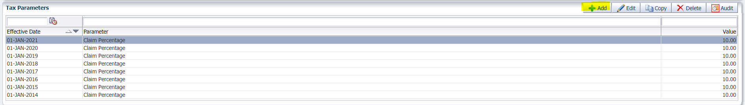

**Step 12.** In the pop-up window add all the mandatory fields and click SAVE

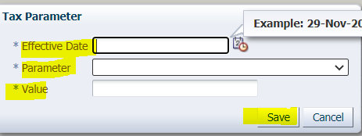

# Procedure document for the Terminated, Retired and Deceased Members with Balance report

**Description:**

The purpose is to report Members with the status Terminated (TR), Retired (MP) or Deceased (DE) who have a balance in their plan(s).

**Running the SQL Query in BI Publisher Production:**

Below are the query details that was used to create this report. Run this report from BI Publisher production environment.

Select t1.STAKEHOLDER_SID,t1.FIRST_NAME,t1.LAST_NAME,t1.PLAN,t1.START_TS,t1.MEMBER_STATUS_CODE,t1.TOTAL_VALUES,t1.ACCOUNT_STATUS,t1.INV_ACCOUNT_CLASS_CODE

from

(WITH CurrentPlanStatus AS

(

Select pMEM.STAKEHOLDER_SID,pMEM.FIRST_NAME,pMEM.LAST_NAME, pINV.PLAN,

pMEM.START_TS, pMEM.END_TS,

ROW_NUMBER () OVER (PARTITION BY pMEM.STAKEHOLDER_SID ORDER BY pMEM.START_TS DESC) AS START_TIME,

pMEM.MEMBER_STATUS_CODE,

pINV.TOTAL_VALUES,

pINV.INV_ACCOUNT_STATUS_DESC AS ACCOUNT_STATUS,

pINV.INV_ACCOUNT_CLASS_CODE

from PENFAX.P_MEMBER_SEARCH pMEM

INNER JOIN PENFAX.P_INV_ACCOUNTS pINV

ON pMEM.STAKEHOLDER_SID = pINV.STAKEHOLDER_SID

WHERE pINV.PLAN = 'PEPP' AND pINV.TOTAL_VALUES > 0

AND pINV.INV_ACCOUNT_CLASS_CODE = 'ACCUM'

AND pINV.INV_ACCOUNT_STATUS_DESC = 'Active'

GROUP BY pMEM.STAKEHOLDER_SID,pMEM.FIRST_NAME,pMEM.LAST_NAME, pINV.PLAN,pMEM.START_TS, pMEM.MEMBER_STATUS_CODE, pINV.TOTAL_VALUES, pINV.INV_ACCOUNT_STATUS_DESC, pINV.INV_ACCOUNT_CLASS_CODE, pMEM.END_TS

ORDER BY pMEM.START_TS DESC

)

Select

STAKEHOLDER_SID,FIRST_NAME,LAST_NAME,PLAN,START_TS,MEMBER_STATUS_CODE,TOTAL_VALUES,ACCOUNT_STATUS,INV_ACCOUNT_CLASS_CODE

FROM CurrentPlanStatus

WHERE MEMBER_STATUS_CODE IN ('TER' , 'RETIRED' , 'DTH') AND START_TIME=1)t1

WHERE NOT EXISTS (select pMS.STAKEHOLDER_SID from PENFAX.P_MEMBER_SEARCH pMS where pMS.STAKEHOLDER_SID =t1.STAKEHOLDER_SID

and(pMS.MEMBER_STATUS_CODE in('DEF','ACT') and pMS.END_TS is null))

Login to BI Publisher Production

URL: http://prodbi1.peba.gov.sk.ca:7003/xmlpserver/servlet/catalog

Enter the Username & Password

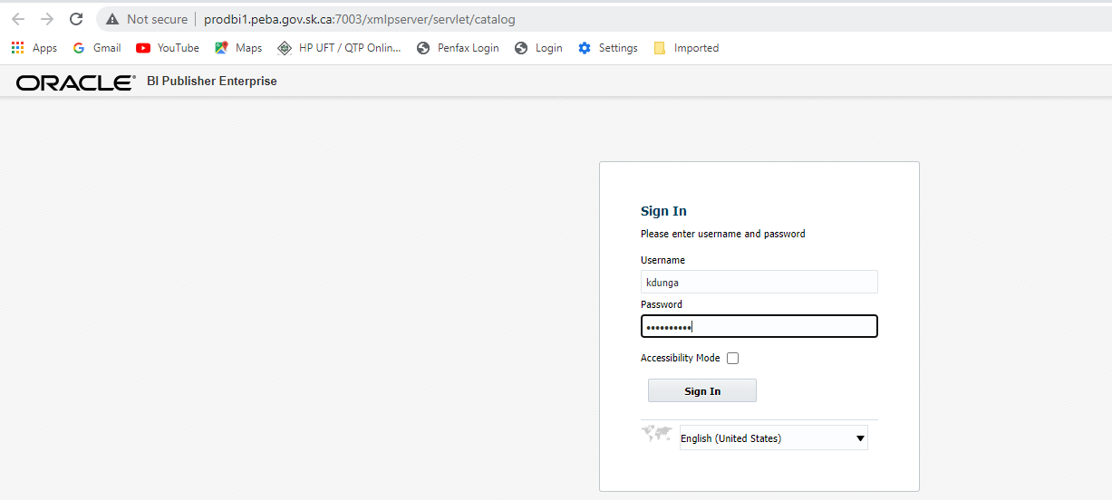

Click on Catalog and Select /Shared Folders/QA/PEBA_PROD_PFX19C/PEPP/PEPP_A33848

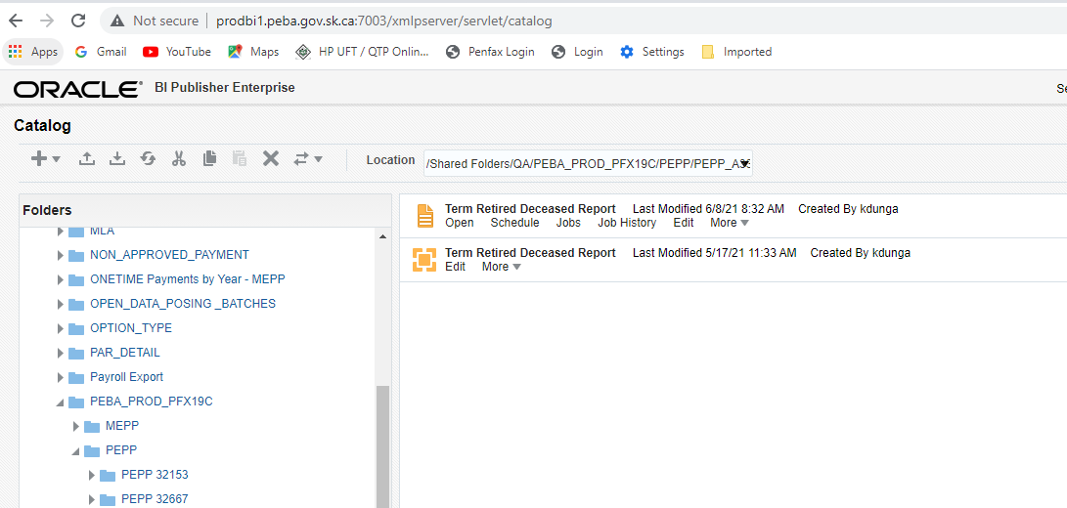

Run the Report as and when requested by the business.

Save file to H:\Pension Programs\Dropbox\PEPP and name it **Term Retired Deceased with Balances - <<DATE>>.xlsx**

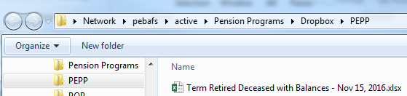

Send an email to PEPP Member Services supervisor Heather Culetta informing them that the file has been saved to their drop-box copying Tech Support and Pana

Sample email:

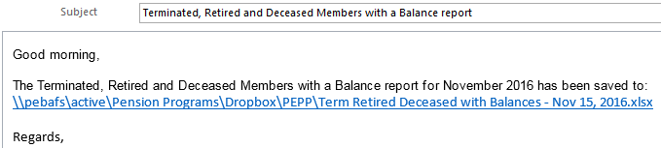

Update the Request details with the Service Desk ticket number in the QA Report Bank

Link : \\pebafs\active\Quality Assurance\Prod Apps\PenfaxV5\PEBA\Reports\QA Report Bank\QA Report Bank.xlsx

# Procedure document for Provincial HST Attribution Percentages

**Description:**

This report will be requested by Investment Services annually. Report provides the provincial breakdown of the unitholders of PEPP and MEPP as at September 30. It highlights the member assets held by province, territory and a total for all out of country jurisdictions plus any other (i.e. no address). Please note for MEPP we will be able to provide the info as of December 31.

**Note: Reminder Email**

**QA team member to confirm two weeks in advance with business, if they need the results as of September 30.**

**For example, in year 2022**

**Please email investment services on September 15 to confirm if they need this report. In reminder email include**

**Krenbrink, Michelle PEBA** [Michelle.Krenbrink@peba.gov.sk.ca](mailto:Michelle.Krenbrink@peba.gov.sk.ca)**,**

**Textor, Regan PEBA** [Regan.Textor@peba.gov.sk.ca](mailto:Regan.Textor@peba.gov.sk.ca)

**And cc QA team.**

**QA Process** :

**Step 1**. Send a reminder email, and get the business confirmation.

**Step 2.** Once the date is confirmed. Please log into the BI publisher (Production environment)

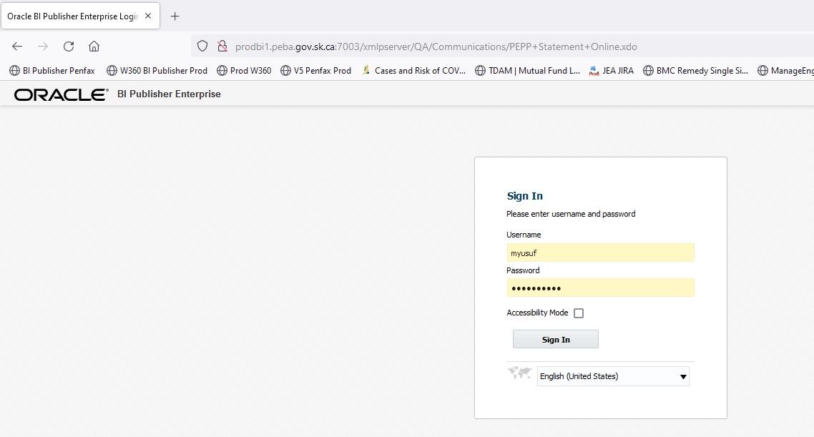

**Step 3.** Navigate to the following location to execute the reports. Click on Catalog and Select /Shared Folders/QA/PEBA_PROD_PFX19C/PEPP/PEPP_A38726

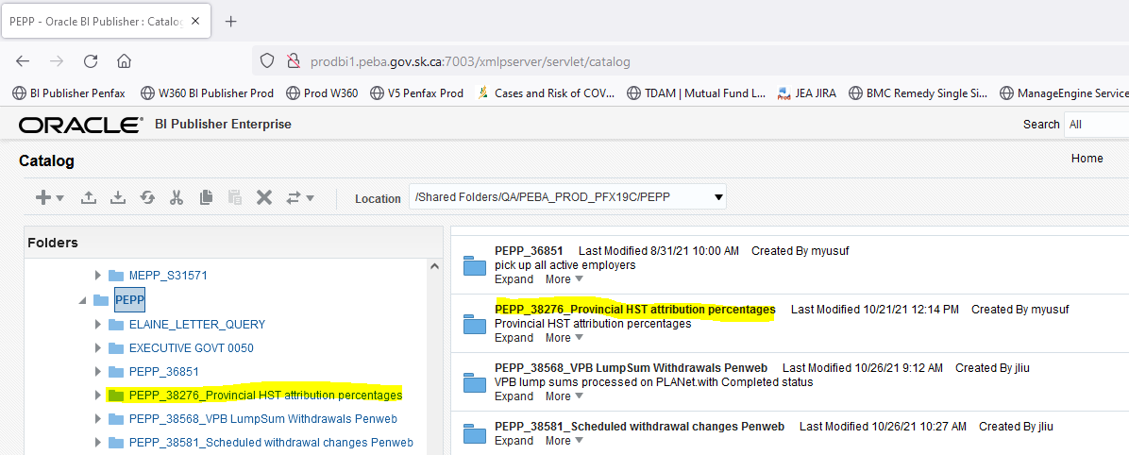

Click on folder icon PEPP_A38276

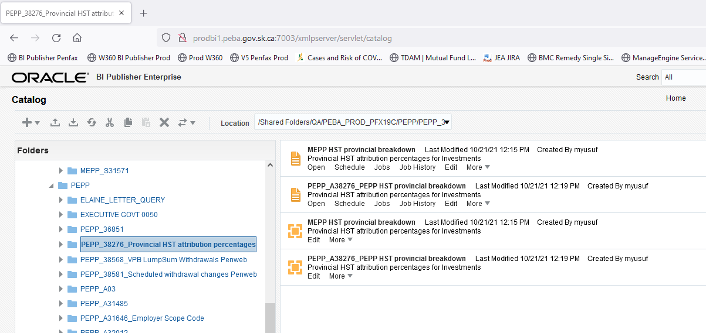

Both the reports are saved in the above-mentioned folder.

**Step 4**. Run the Report as and when requested by the business.

Note: QA Team member need to update/change data model as per the business requirement. For example

4a. MEPP HST Provincial Breakdown report

Query Details

Query Used for year 2021:

select distinct STAKEHOLDER_SID, COUNTRY_CODE, substr(PROVINCE_CODE,4,3)as Province,

(PRIOR_YEAR_CONT_INT_BALANCE_1+ CURR_YEAR_CONTRIB_1+ curr_year_interest_1+ PRIOR_YEAR_CONT_INT_BALANCE_2+CURR_YEAR_CONTRIB_2+CURR_YEAR_INTEREST_2)as Balance

from penfax.p_ann_stmts

where FISCAL_YEAREND_DATE = '31-dec-2020'

--and STAKEHOLDER_SID = '125994'

order by STAKEHOLDER_SID

4b. PEPP HST Provincial Breakdown report

Query Details for year 2021:

SELECT

penfax.p_persons.stakeholder_sid,

penfax.p_inv_accounts.plan,

penfax.p_inv_accounts.total_units,

penfax.p_inv_accounts.total_values,

penfax.p_inv_accounts.last_transaction_ts,

penfax.p_inv_accounts.fund_valuation_date,

penfax.p_inv_accounts.inv_account_status_code,

penfax.p_inv_accounts.inv_account_class_desc,

penfax.p_persons.curr_province_code,

penfax.p_persons.curr_country_code

FROM

penfax.p_persons

INNER JOIN penfax.p_inv_accounts ON penfax.p_persons.stakeholder_sid = penfax.p_inv_accounts.stakeholder_sid

WHERE

( penfax.p_inv_accounts.plan = 'PEPP'

AND penfax.p_inv_accounts.fund_valuation_date IS NOT NULL )

OR ( penfax.p_inv_accounts.fund_valuation_date = '21-OCT-21' )

Note: Report should be run on or before Sept 30, 2021. Please modify the dates accordingly

**Step 5.** After running the both the reports please create the pivot tables for each plan and attach the raw data for business to review.

For MEPP: Create the following Pivot Table.

Total Member count 15709

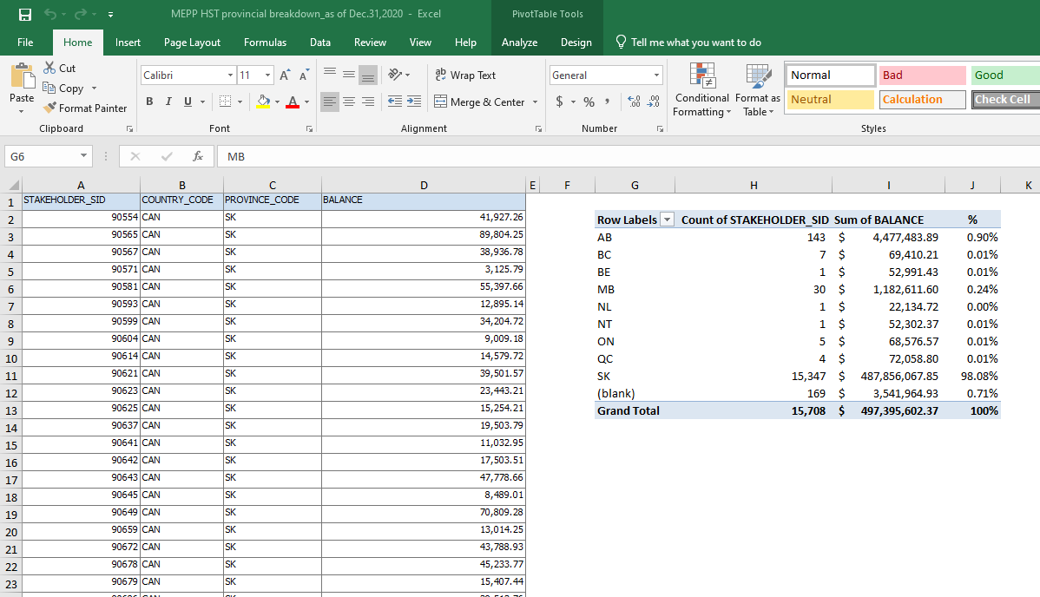

For PEPP: Create the following Pivot Table.

Table 1: In Screenshot you will be able to see the selection for pivot tables

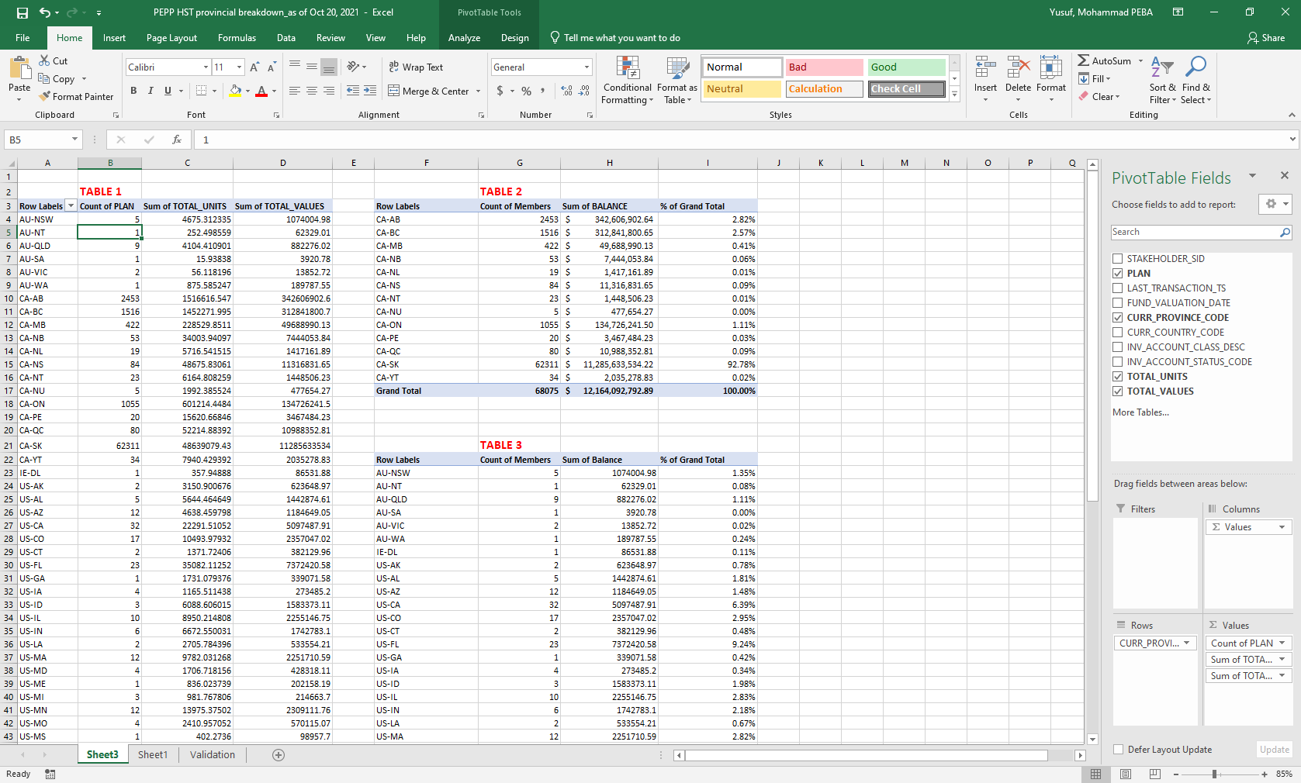

Table 2 and Table 3: Both tables were created using the filtration process of Table 1

Raw data was attached on Sheet 2. In total PEPP had 68568 members

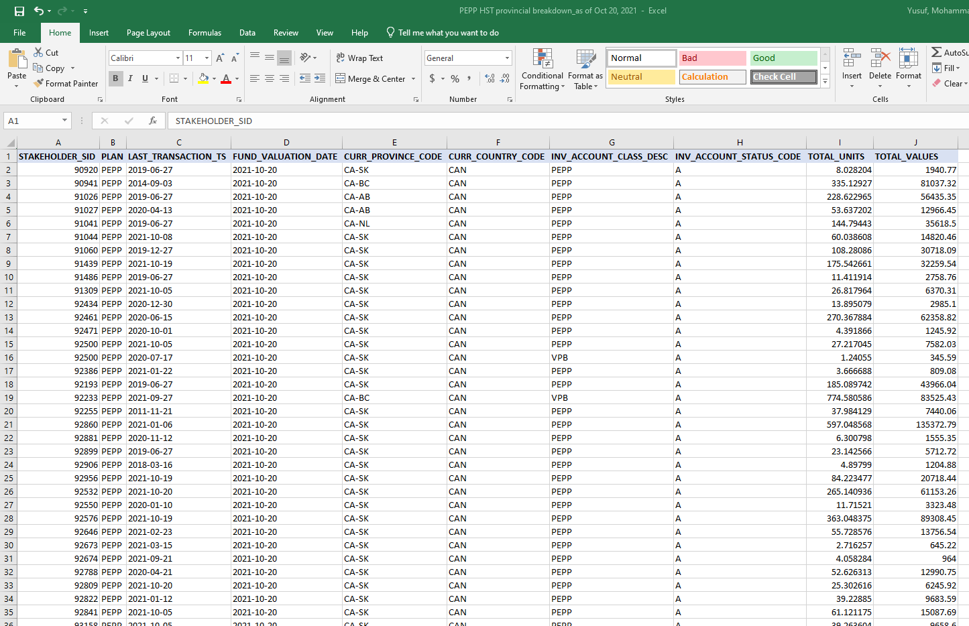

For PEPP report cross validation was conducted using business daily funds and summary totals report. Can request business folks (PIO) to send this report to validate total Units and dollar amount

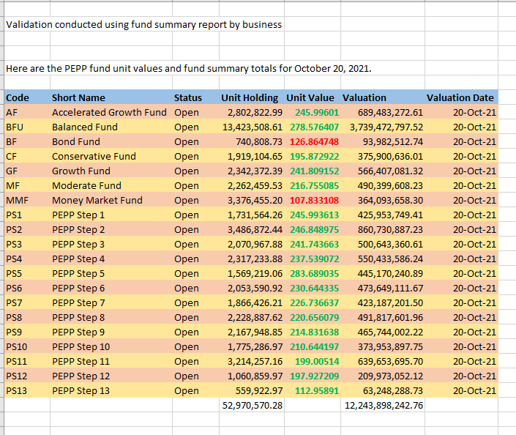

Totals from Table 1 Pivot table

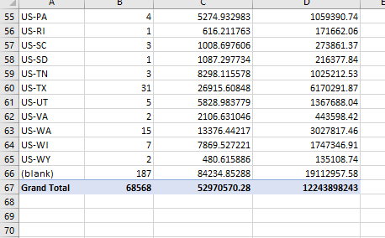

Send both the reports for QA team peer review

**Important Note:**

MEPP Report was completed by Natalia and PEPP Report was completed by Yusuf

Results to Business:

Send an email to Investment Services Director Michelle Krenbrink and Regan Textor informing them that the file is ready and attached. In email please cc Tech Support and QA team

Sample email sent to business previously

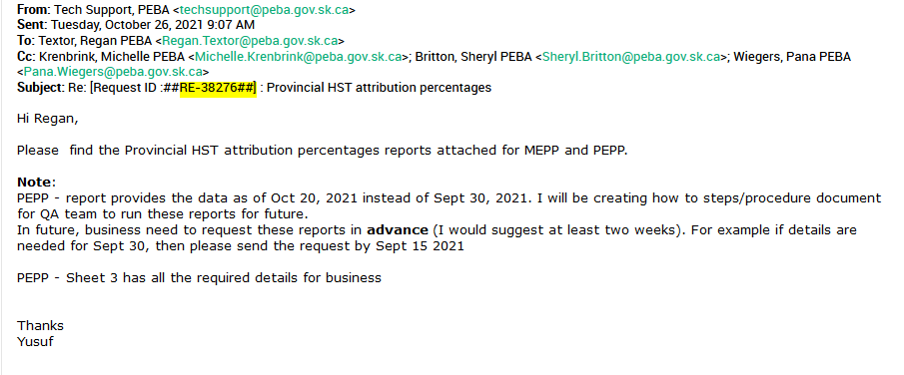

If more information or sample reports are needed, please refer to service desk ticket # 38276

# Procedure document for PEPP Matters Newsletters

**Description:**

This report will be requested by Communications to provide them a mailing list e.g.



**QA Process:**

Below is a sample process. Please adjust your process steps based on Communication requests, e.g for April/Oct newsletter also refer to the document below:

H:\Quality Assurance\PEPP\CPAS\How To\QA other Processes\Procedure document for PEPP Perspective Newsletter for April and Oct Address list.docx

* + 1. Extract the lists (PEPP or VPB) from PENFAX based on Communication request

Go to Batches >> Add Batch Process



* + 1. **Cheryl’s Request**
* All VPB members with balances over $10
* All PEPP members regardless of status with balances over $10
  + 1. Run the query from BI publisher for the members who has balance <=$10



* + 1. Remove the member from the list whose balance <=$10
    2. Cheryl’s request - exclude the members from the list

|  |  |
| --- | --- |
| Exclude | **QA Process** |
| ~~All e-comm members who’ve selected general~~ | ~~1. Download e-Comm list from e-comm~~  ~~2. Remove the members from the list who sign in e-comm and select General~~ |
| All PLANet members who’ve selected online statements | 1. Run the query from BI publisher      1. Remove the members who’ve selected PEPP online Statements from the list |
| All deceased members | 1. Run the query Member with date of death 2. Remove the members from the list |
| All members with PEBA address | Remove the members from the list who have PEBA address and S4P 4W3 |
|  | Verify if the members are in both PEPP and VPB. if they are, make sure they are not duplicate |
|  | Verify result set, make sure no duplicate records |
| Member numbers | After QA peer review, remove the member numbers |

* + 1. In case Communication request QA upload the e-Comm list



* + 1. Generate the e-Comm list as per communication request



* + 1. Format the e-Comm list as below format, and save as .csv file



* + 1. Log in e-Comm
    2. Click Mailing list >> Under PEPP-Members (ALL), create a sub list



* + 1. Name the sub list
    2. Upload the file into the sub list.

Please Note**: DO NOT** update PEPP Members (ALL), Non VPB, VPB list

* + 1. Inform the requestor which list you are uploading



# Procedure document for the Monthly Tax Jurisdiction report

**Description:**

The purpose is to report to validate Members Address with that of Members TAX Jurisdiction.

When a member changes their address to another province using PLANet, it does not update the Tax Jurisdiction on the member’s account and therefore the member is taxed incorrectly. This query will need to be run monthly and the report needs to be sent to Pension Services in the morning so they have time to correct the Tax Jurisdictions *prior* to the running of the Monthly Auto Withdrawal batch job.

**Running the SQL Query in BI Publisher Production:**

Below are the query details that was used to create this report. Run this report from BI Publisher production environment.

SELECT PENFAX.P_INV_ACCOUNTS.PLAN,

trunc(add_months(sysdate,-1),'MM')as month_start,Last_day(sysdate - 30) as month_end,

PENFAX.P_INV_ACCOUNTS.STAKEHOLDER_SID,

PENFAX.P_INV_ACCOUNTS.INV_ACCOUNT_CLASS_DESC,

PENFAX.P_INV_ACCOUNTS.INV_ACCOUNT_STATUS_CODE,

PENFAX.P_INV_ACCOUNTS.INV_ACCOUNT_CLASS_CODE,

PENFAX.P_ACCOUNT_INSTRUCTIONS.ACCOUNT_INSTRUCT_STATUS_DESC,

PENFAX.P_ACCOUNT_INSTRUCTIONS.ACCOUNT_INSTRUCT_TYPE_DESC,

PENFAX.P_ACCOUNT_INSTRUCTIONS.SCHEDULED_WITHDRAWAL_AMOUNT,

PENFAX.P_ACCOUNT_INSTRUCTIONS.SCHEDULED_WITHDRAWAL_FREQ_DESC,

PENFAX.P_PAYMENTS.TAX_PROVINCE_CODE,

PENFAX.P_PAYMENTS.TAX_PROVINCE_DESC,

PENFAX.P_PAYMENTS.MEMBER_STAKEHOLDER_SID,

PENFAX.P_PAYMENTS.PAYMENT_DATE,

PENFAX.P_PAYMENTS.PAYMENT_STATUS_CODE,

PENFAX.P_PAYMENTS.PAYMENT_RECIP_TYPE_DESC,

PENFAX.P_PAYMENTS.RECIPIENT_PROVINCE_DESC,

Case when PENFAX.P_PAYMENTS.TAX_PROVINCE_DESC = PENFAX.P_PAYMENTS.RECIPIENT_PROVINCE_DESC then 'MATCH'

else 'FALSE'

End Province_Match

FROM PENFAX.P_INV_ACCOUNTS

INNER JOIN PENFAX.P_ACCOUNT_INSTRUCTIONS

ON PENFAX.P_INV_ACCOUNTS.INV_ACCOUNT_SID = PENFAX.P_ACCOUNT_INSTRUCTIONS.INV_ACCOUNT_SID

INNER JOIN PENFAX.P_PAYMENTS

ON PENFAX.P_ACCOUNT_INSTRUCTIONS.STAKEHOLDER_SID = PENFAX.P_PAYMENTS.MEMBER_STAKEHOLDER_SID

WHERE PENFAX.P_INV_ACCOUNTS.PLAN = 'PEPP'

AND (PENFAX.P_INV_ACCOUNTS.INV_ACCOUNT_CLASS_DESC = 'VPB' AND PENFAX.P_INV_ACCOUNTS.INV_ACCOUNT_STATUS_CODE = 'A')

AND PENFAX.P_ACCOUNT_INSTRUCTIONS.ACCOUNT_INSTRUCT_STATUS_DESC = 'Current'

AND PENFAX.P_ACCOUNT_INSTRUCTIONS.ACCOUNT_INSTRUCT_TYPE_DESC = 'Scheduled Withdrawal'

AND PENFAX.P_ACCOUNT_INSTRUCTIONS.SCHEDULED_WITHDRAWAL_AMOUNT IS NOT NULL

AND PENFAX.P_PAYMENTS.PAYMENT_DATE between trunc(add_months(sysdate,-1),'MM') and last_day(add_months(sysdate,-1))

--and PENFAX.P_INV_ACCOUNTS.STAKEHOLDER_SID = '92233'

AND PENFAX.P_PAYMENTS.PAYMENT_STATUS_CODE = 'PROC'

group by

PENFAX.P_INV_ACCOUNTS.PLAN,

trunc(add_months(sysdate,-1),'MM'),last_day(add_months(sysdate,-1)),

PENFAX.P_INV_ACCOUNTS.STAKEHOLDER_SID,

PENFAX.P_INV_ACCOUNTS.INV_ACCOUNT_CLASS_DESC,

PENFAX.P_INV_ACCOUNTS.INV_ACCOUNT_STATUS_CODE,

PENFAX.P_INV_ACCOUNTS.INV_ACCOUNT_CLASS_CODE,

PENFAX.P_ACCOUNT_INSTRUCTIONS.ACCOUNT_INSTRUCT_STATUS_DESC,

PENFAX.P_ACCOUNT_INSTRUCTIONS.ACCOUNT_INSTRUCT_TYPE_DESC,

PENFAX.P_ACCOUNT_INSTRUCTIONS.SCHEDULED_WITHDRAWAL_AMOUNT,

PENFAX.P_ACCOUNT_INSTRUCTIONS.SCHEDULED_WITHDRAWAL_FREQ_DESC,

PENFAX.P_PAYMENTS.TAX_PROVINCE_CODE,

PENFAX.P_PAYMENTS.TAX_PROVINCE_DESC,

PENFAX.P_PAYMENTS.MEMBER_STAKEHOLDER_SID,

PENFAX.P_PAYMENTS.PAYMENT_DATE,

PENFAX.P_PAYMENTS.PAYMENT_STATUS_CODE,

PENFAX.P_PAYMENTS.PAYMENT_RECIP_TYPE_DESC,

PENFAX.P_PAYMENTS.RECIPIENT_PROVINCE_DESC

order by PENFAX.P_INV_ACCOUNTS.STAKEHOLDER_SID

1. Login to BI Publisher Production

URL: http://prodbi1.peba.gov.sk.ca:7003/xmlpserver/servlet/catalog

Enter the Username & Password

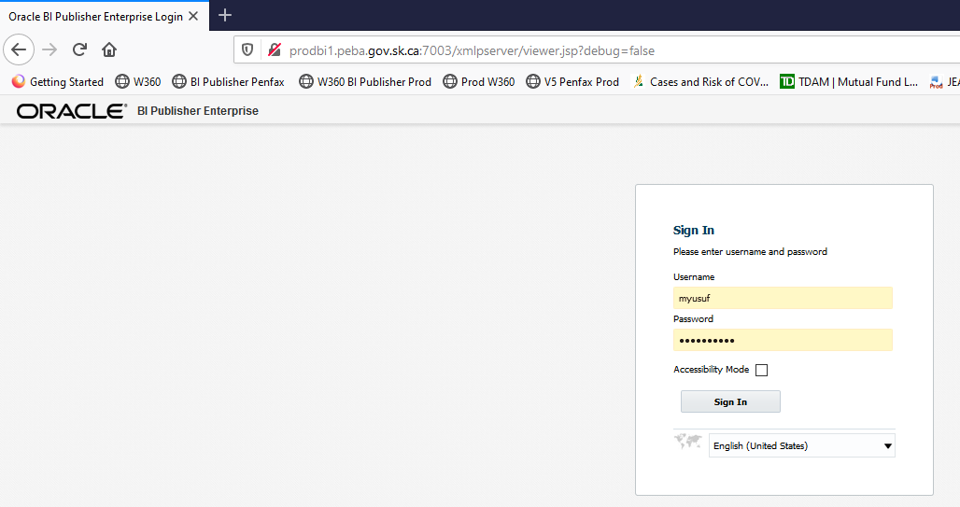

1. Click on Catalog and Select /Shared Folders/QA/PEBA_PROD_PFX19C/PEPP/PEPP_A33847

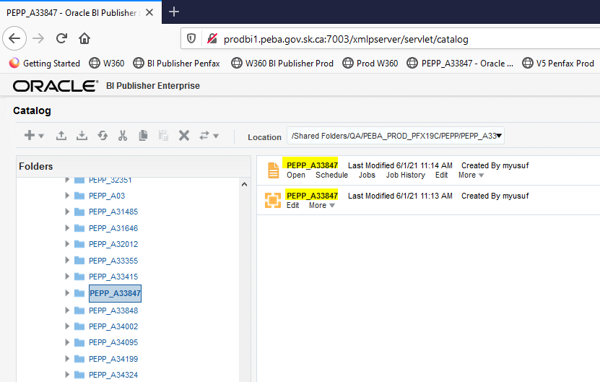

Note: Query Dates Need to be changed to the Prior month.

For example: To execute June report, used the **date parameters** from '01-MAY-2021' AND '31-MAY-2021'

Update Date, and save the Data model.

Click on View data

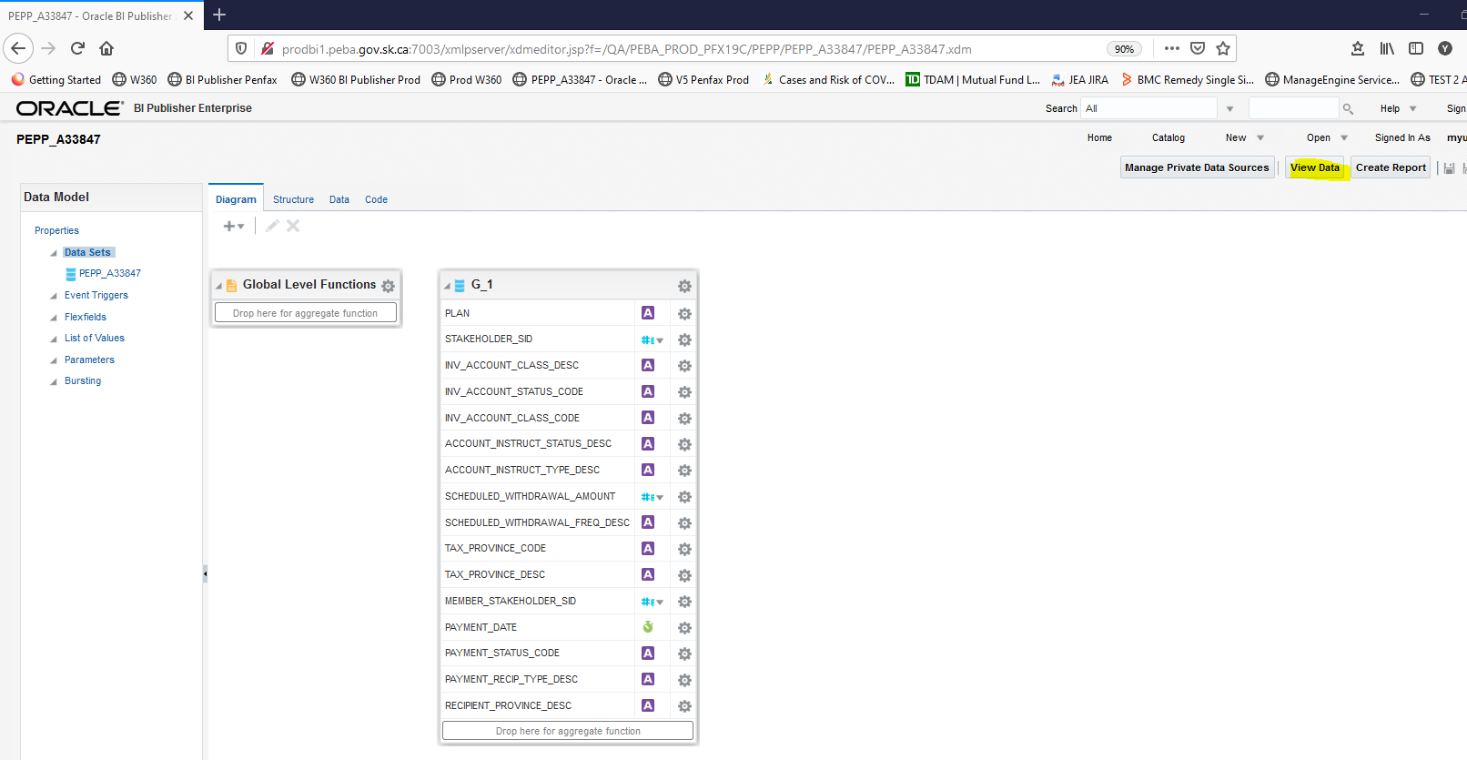

Click on View. Then, click on Save as Sample Data

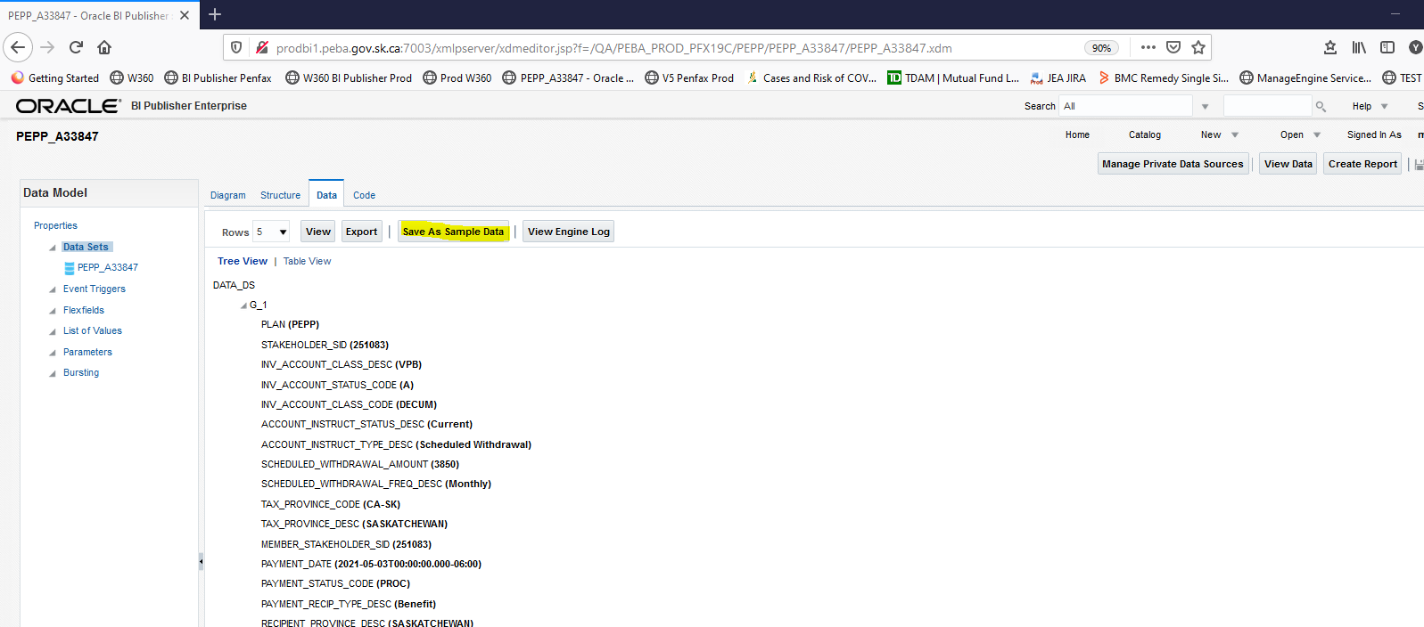

1. Run the Report. Go Back to the folder and click on Report PEPP_A33847

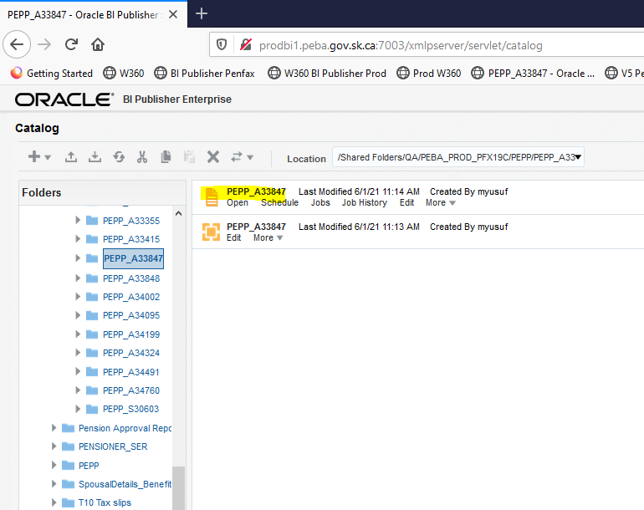

1. Save file in Excel format to H:\Pension Programs\Dropbox\PEPP and name it **Monthly Tax Jurisdiction report - <<DATE>>.xlsx**

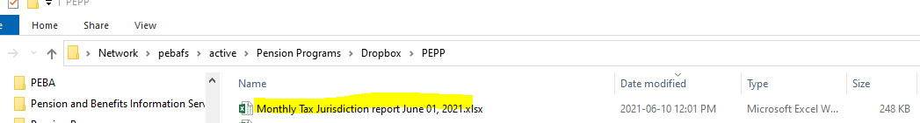

1. Send an email to PEPP Member Services supervisor Heather Culetta informing them that the file has been saved to their drop-box copying Tech Support and Pana

Sample original email sent for verification:

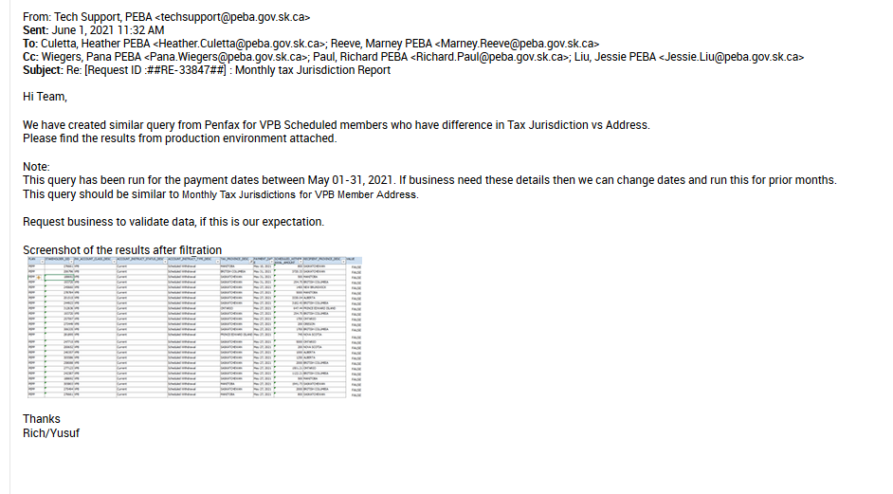

1. Update the Request details with the Service Desk ticket number

# Procedure document for Payment Approval Report

Last update: 1-Nov-21

Revised by: Yusuf

**Description:**

This report will be requested by the MEPP Manager (Shane Harding). This report will be listing that identified any one-time payments during the reporting period where the Approve System User was equal to the Submit_System_User. This report will be reviewed by management to determine whether proper Separation of Duty occurred, and for follow-up where there are instances where the approver / submitting party is the same.

**Note:**

**This report will be QA quarterly scheduled task. In case you need more details, please refer to the original service desk ticket MEPP_A37829**

**QA Process:**

**Step 1**. Login to BI Publisher Production

URL: http://prodbi1.peba.gov.sk.ca:7003/xmlpserver/servlet/catalog

Enter the Username & Password

BI publisher (Production environment)



**Step 2.** Navigate to the following location to execute the reports. Click on Catalog and Select /Shared Folders/QA/PEBA_PROD_PFX19C/PEPP/MEPP_A37829

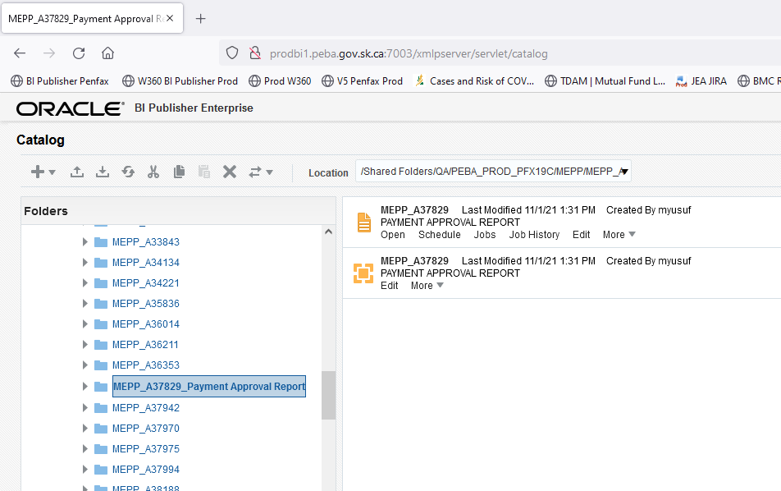

Click on folder icon MEPP_A38276_Payment Approval Report

**Step 3**. Run the Report as and when requested by the business.

Note: QA Team member need to update/change data model as per the business requirement. For example: The Payable date in Data model

Query Details

SELECT

p_onetime_amounts.plan_desc AS plan_desc,

p_onetime_amounts.benefit_event_sid AS benefit_event_sid,

p_onetime_amounts.stakeholder_sid AS stakeholder_sid,

p_onetime_amounts.onetime_amount_type_desc AS onetime_amount_type_desc,

p_onetime_amounts.amount AS amount,

p_onetime_amounts.payable_date AS payable_date,

p_onetime_amounts.tax_year AS tax_year,

p_onetime_amounts.upd_amount AS upd_amount,

p_onetime_amounts.paid_by_payment_sid AS paid_by_payment_sid,

p_onetime_amounts.upd_payable_date AS upd_payable_date,

p_onetime_amounts.approve_system_user_desc AS approve_system_user_desc,

p_onetime_amounts.approve_system_user_sid AS approve_system_user_sid,

p_onetime_amounts.submit_system_user_sid AS submit_system_user_sid,

p_onetime_amounts.submit_system_user_desc AS submit_system_user_desc

FROM

p_penfax.p_onetime_amounts p_onetime_amounts_1,

p_penfax.p_onetime_amounts p_onetime_amounts

WHERE

p_onetime_amounts.onetime_amount_sid =

p_onetime_amounts_1.onetime_amount_sid

AND p_onetime_amounts.submit_system_user_sid = p_onetime_amounts_1.approve_system_user_sid

AND p_onetime_amounts.payable_date BETWEEN '01-JAN-21' AND '31-DEC-21'

AND p_onetime_amounts.plan IN ('MEPP', 'LCB', 'PCSP', 'PSSP', 'SGIP', 'SPAF', 'STC', 'JPCS')

AND p_onetime_amounts.onetime_amount_status_code = 'PAID'

After updating the Payable date, Go to Data tab and click on View.

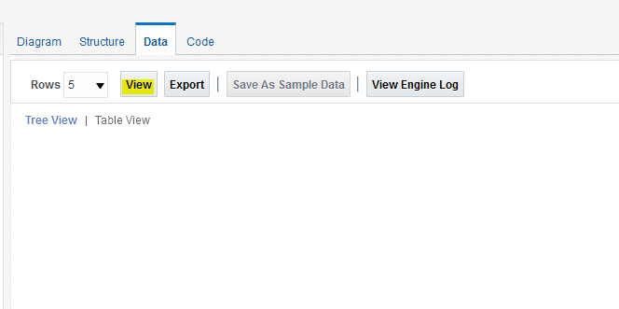

Once the results are populated, click on Save as Sample Data

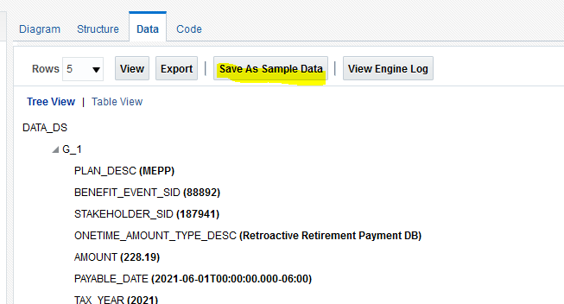

**Step 4.** Run the report. Save file to H:\Pension Programs\Dropbox\MEPP and name it **Payment Approval Report - <<DATE>>.xlsx**

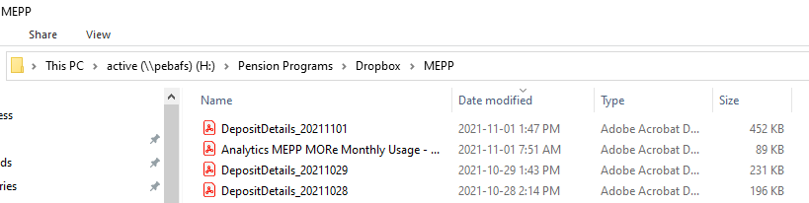

**Step 5**: Send an email to MEPP Member Services Shane Harding, Debby Parks, Dawn Jones informing them that the file has been saved to their drop-box copying Tech Support and Pana.

Sample email:

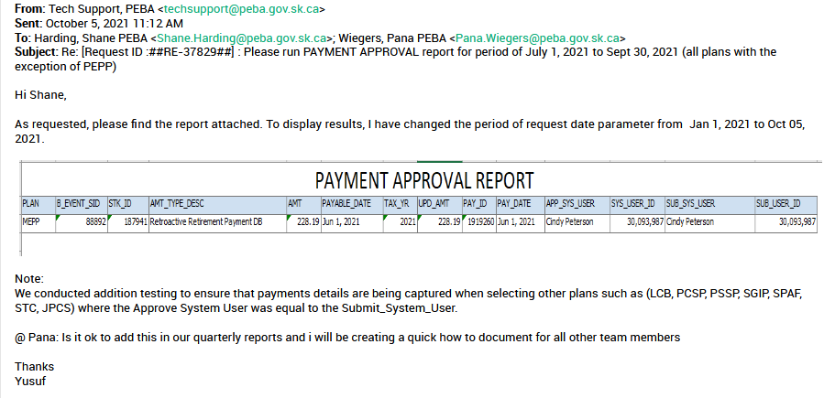

# Procedure document for VPB Payment Test Data Refresh

**Description:**

This task will support business to run their payroll in Training region before the final execution in production environment. Please note that it is for the PENFAX **Training Environment** only.

**Note: This report will be QA monthly scheduled task for training region.** Please do not forget to add Sheryl & Pana for all communications

**If you need more information please refer to Service Desk Ticket # 35249 – Original request number raised by business**

**QA Process**:

**Step 1**. Process will be initiated by Sheryl Britton requesting IT team. Look for the email to IT team for data cut and refresh details.

Sample email sent by Sheryl to IT team:

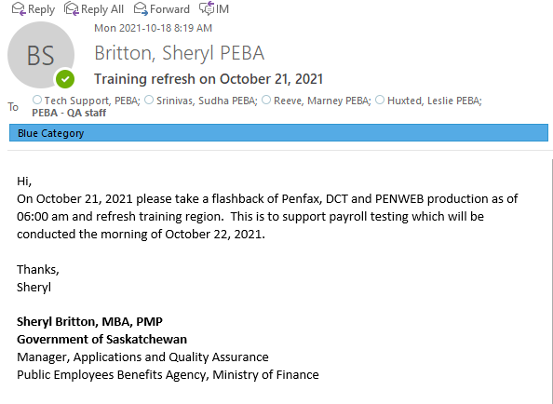

**Step 2**. Keep an eye for this email. Before starting the process PEBA IT team will be sending out an email.

Sample email from PEBA IT Team

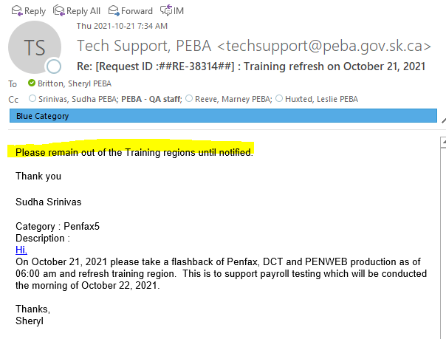

**Step 3**. Once PEBA IT Team confirms that the refresh is complete. QA team member can initiate their process.

Sample email from PEBA IT Team confirming that refresh is done

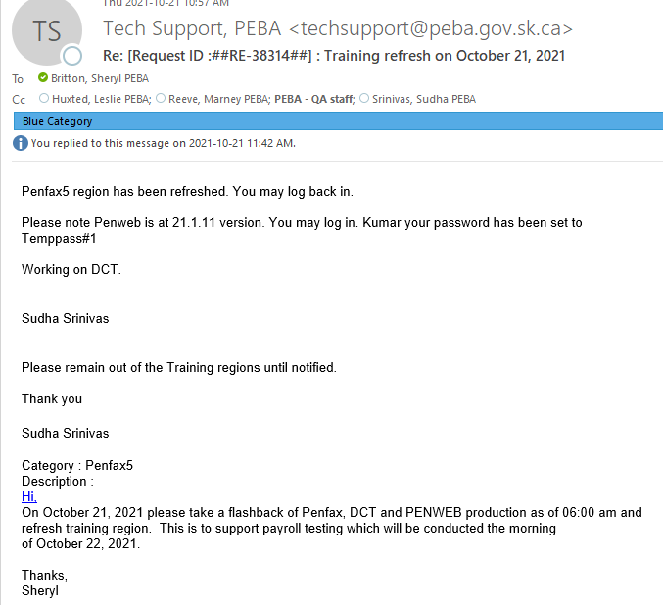

**Step 4**. Login into the PENFAX Training region

URL : <http://testadf3.peba.gov.sk.ca:7001/Penfax5/login.html>

Enter Username and password

**Step 5.** Click on Plan Rules -> Plan Parameters

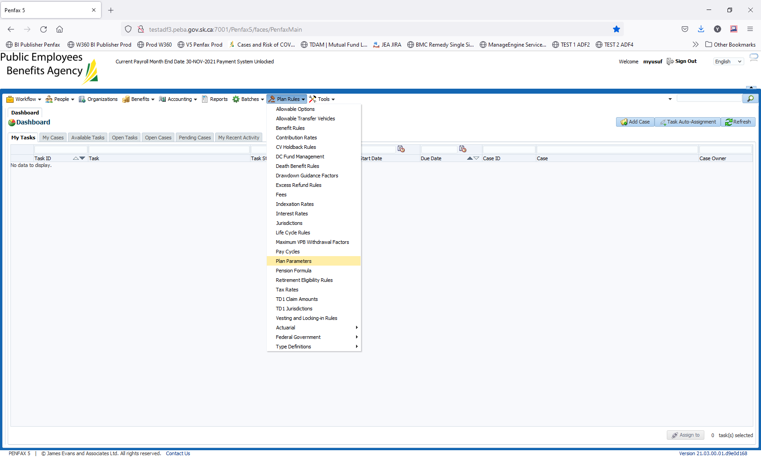

**Step 6.** Select PEPP plan. Using scroll bar navigate to DC Investment Management – Scheduled Withdrawal Business Days before End of Month

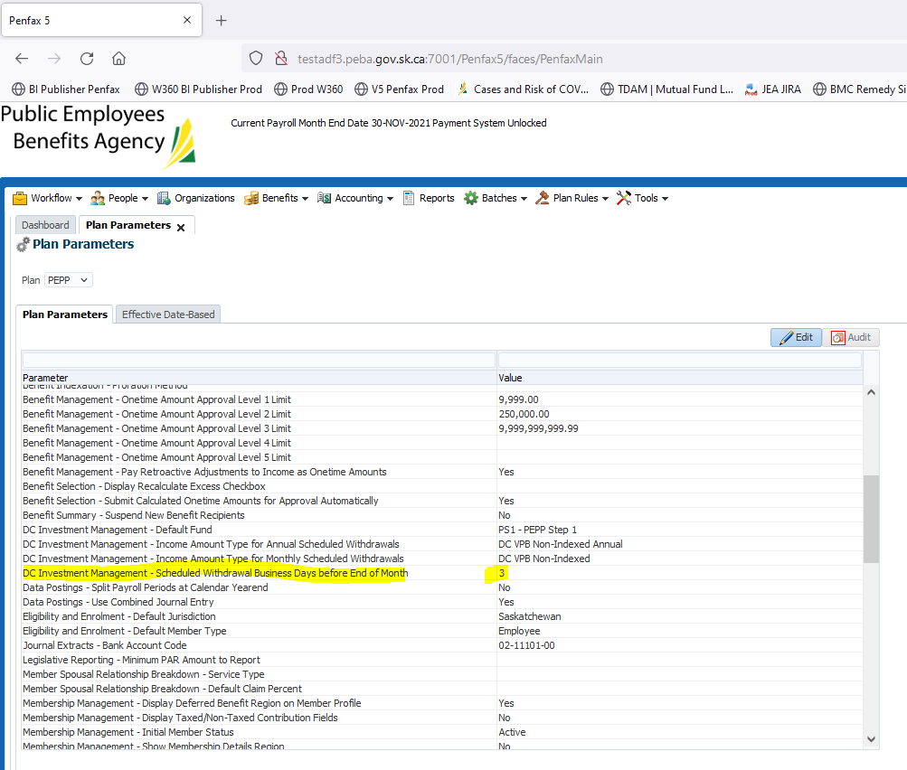

**Step 7**. Click on Edit, and change this 3 to 6.

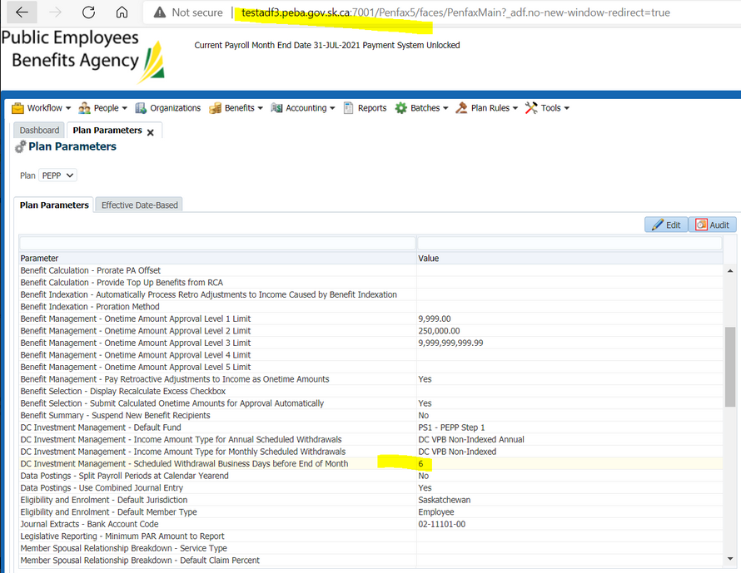

**Step 8:** After changing the parameter from 3 to 6, please send out an email to business (Marney Reeve, Leslie Huxted, Sheryl Britton, and Pana) confirming that change has been completed.

Sample email sent after completion

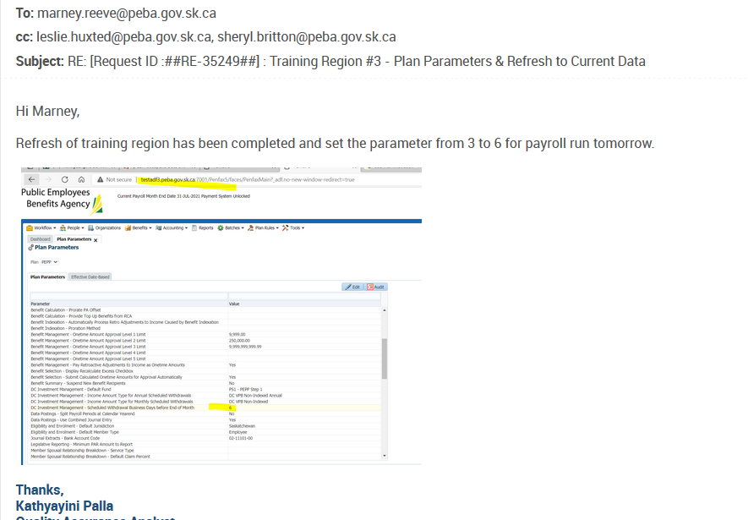

# Procedure document for PEPP Statement/Newsletter Email Blast on e-Comm

**Description:**

This report will be requested by Communications to perform an email blast advising members their member statement is available online

e.g.

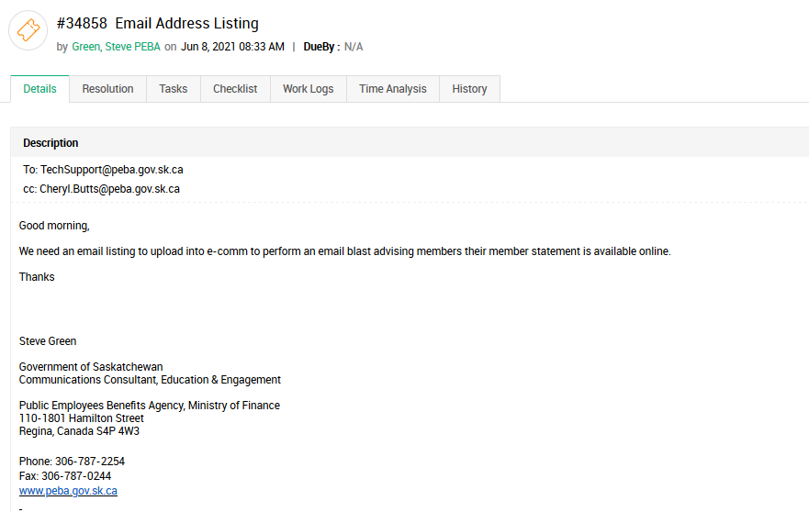

**QA Process:**

Below is a query details that was used to create this report. Run this report from BI Publisher production environment.

Query Used:

select m.alternate_id as mkey,

s.stakeholder_sid,

p.curr_first_name,

p.curr_last_name,

w.email_address,

p.date_of_birth,

(pepp.inv_account_class_desc||'-'|| pepp.inv_account_status_desc) as pepp_account,

(vpb.inv_account_class_desc ||'-'||vpb. inv_account_status_desc) as vpb_account,

(s.corr_pref_func_code ||'-'|| s.corr_pref_type_code) as member_correspondence

from (select *

from p_penfax.p_correspondence_preferences

where corr_pref_func_code = 'STM'

and corr_pref_type_code ='ONLINE'

-- and stakeholder_sid = 315724

)s

join (select stakeholder_sid, email_address, effective_date

from p_penfax.p_emails e

where email_type_code = 'PENWEB'

and email_status_code ='VAL'

and effective_date = (select max(effective_date) from p_penfax.p_emails

where stakeholder_sid = e.stakeholder_sid and email_type_code = 'PENWEB' and email_status_code='VAL')

--and stakeholder_sid = 315724

)w on w.stakeholder_sid = s.stakeholder_sid

join (select stakeholder_sid, alternate_id

from p_penfax.p_alternate_ids

where alternate_id_type_code = 'PEPPID'

and end_date is NULL

and current_flag='Y')m on s.stakeholder_sid = m.stakeholder_sid

join p_penfax.p_persons p on p.stakeholder_sid = s.stakeholder_sid

left join (select stakeholder_sid, inv_account_class_desc, inv_account_status_desc from p_penfax.p_inv_accounts

where plan='PEPP'

--and inv_account_status_code = 'A'

and inv_account_class_desc='PEPP'

)pepp on pepp.stakeholder_sid = s.stakeholder_sid

left join (select stakeholder_sid, inv_account_class_desc, inv_account_status_desc from p_penfax.p_inv_accounts

where plan='PEPP'

--and inv_account_status_code = 'A'

and inv_account_class_desc='VPB'

)vpb on vpb.stakeholder_sid = s.stakeholder_sid

Order by 1

Navigate to QA Folder ->Communications -> PEPP Statement Online

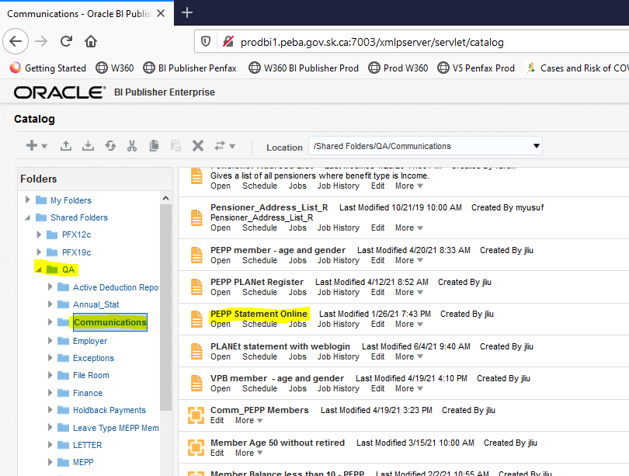

Run this report. (Format type Excel xls)

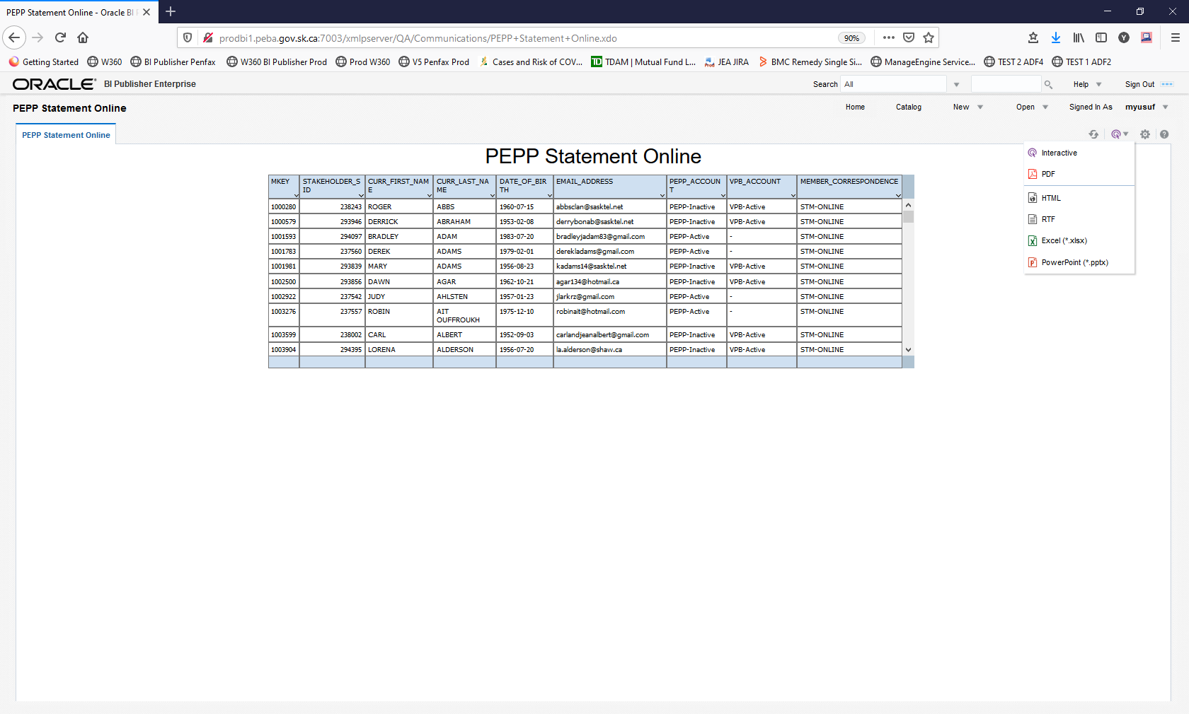

Sample Screenshot of the results received after running this report

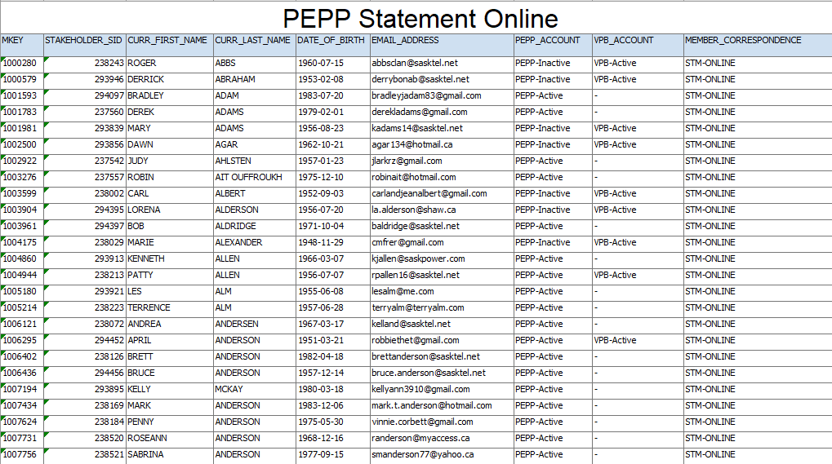

**STATEMENTS**: To generate Statements, we would need members who have Active PEPP Accounts.

In Excel sheet, Go to Data Tab and select Filter

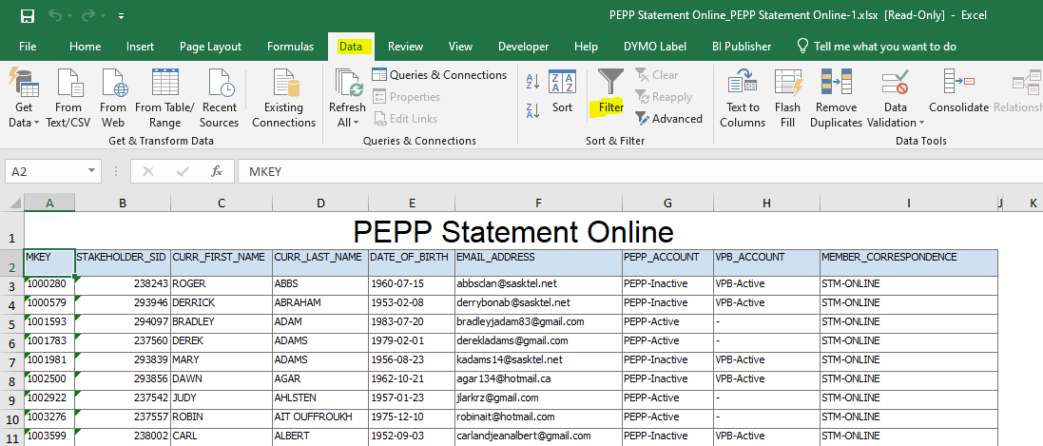

In Column G (PEPP Account), select PEPP-Active

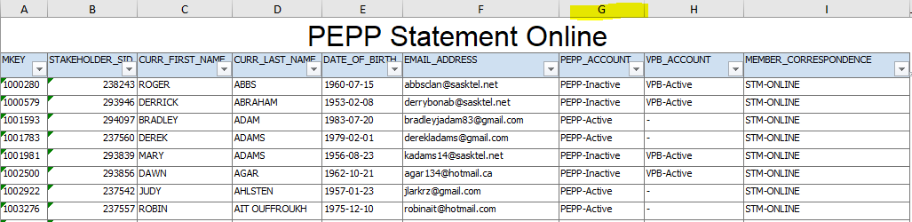

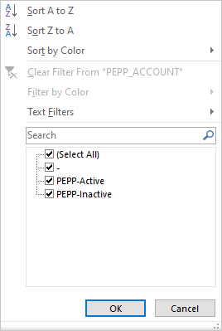

Select this list, save it on another excel sheet. Sample Screenshot

* After saving the list ensure that there are no duplicates based on MKEY

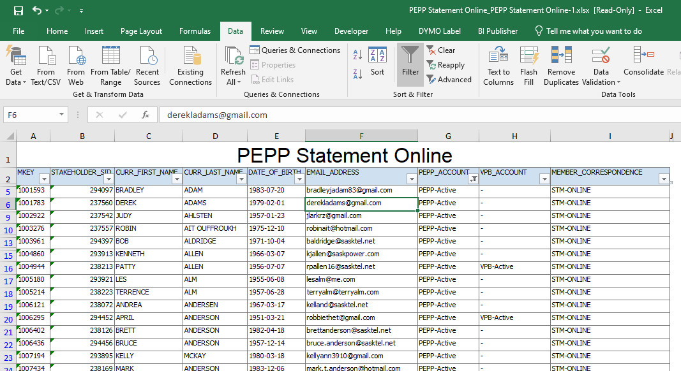

**Please note to save this new result as CSV (MS-DOS). (*.csv)**

Once saved in CSV format, please delete all columns except these three

EMAIL, First Name, and Last Name

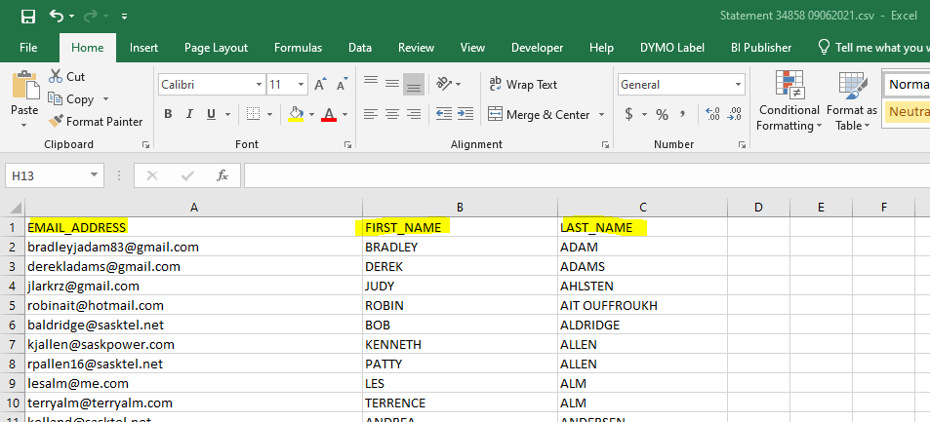

Send file back to communications team to upload file on e-Comm. Last time email was sent to Carla, Steve and Cheryl and CC Techsupport.

**Newsletter**: To generate Newsletter, we would need all members who have signed up online irrespective of there Account Status.

After generating the BI Publisher report as on Page 6.

* Ensure there are no duplicate members/MKEY

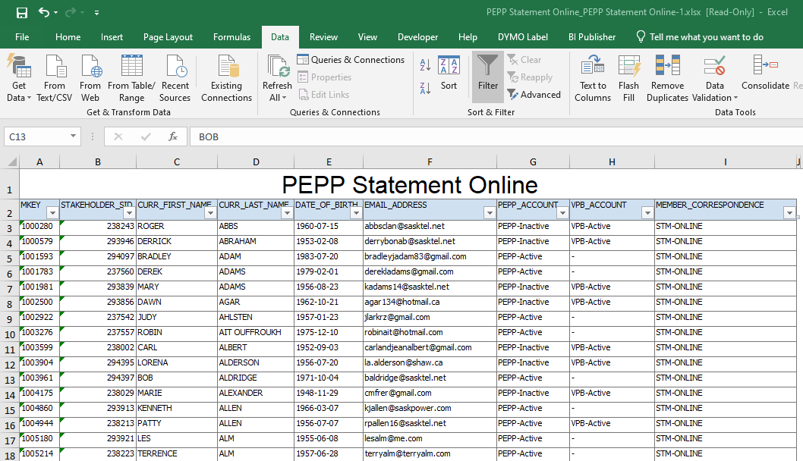

Remove all columns except one: EMAIL.

Save this file **new as CSV (MS-DOS). (*.csv)**

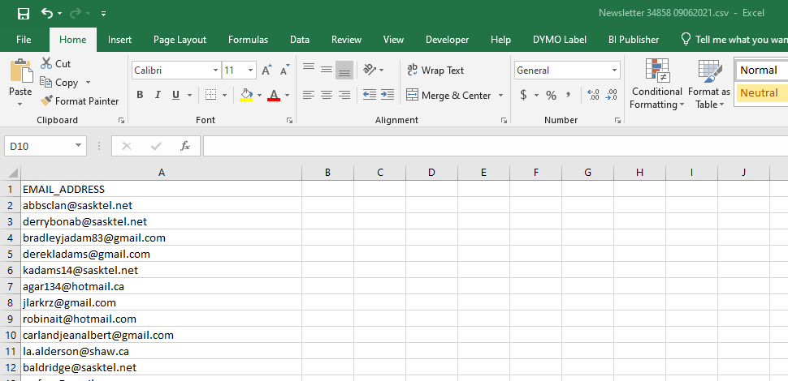

Send file back to communications team to upload file on E-Comm. Last time email was sent to Carla, Steve and Cheryl and CC Techsupport.

Sample email sent last time:

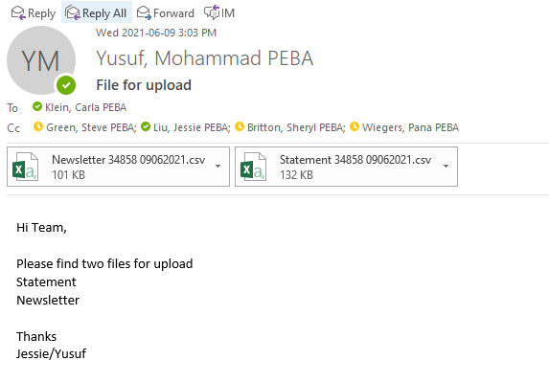

# Procedure document for E&E team for distinct Employer Remittance Info.

Last update: 7-Oct-21

Yusuf

**Description:**

The purpose of this report is to provide distinct employers who submitted the remittance by cheque in last quarter. This report will be executed for Dara Sewell-Zumstien for PEPP and MEPP plans only.

Note: As per the last email, Dara needs this only for MEPP plan. Please do not replicate the process for PEPP plan

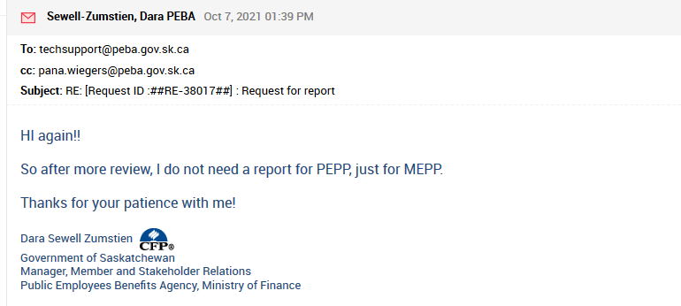

**Running the Query from PENFAX Application:**

Open the Remittance screen using Account tab in PENFAX.   
Navigation step below

Accounting 🡪 Remittance Management 🡪 Remittances

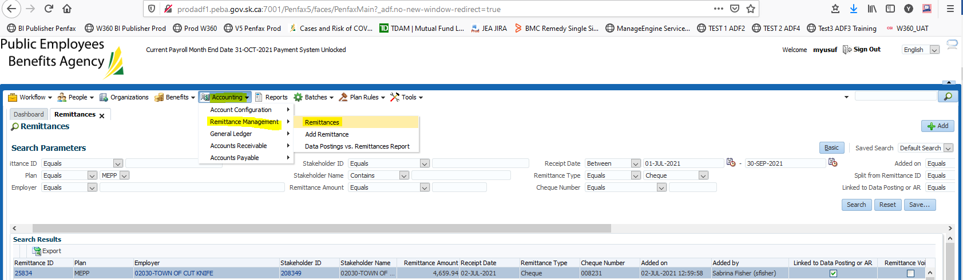

Click on the Advanced tab to select the date parameter.  
Need to select the Receipt date parameter

For example, we will be selecting dates from July 01, 2021 to Sept 30, 2021

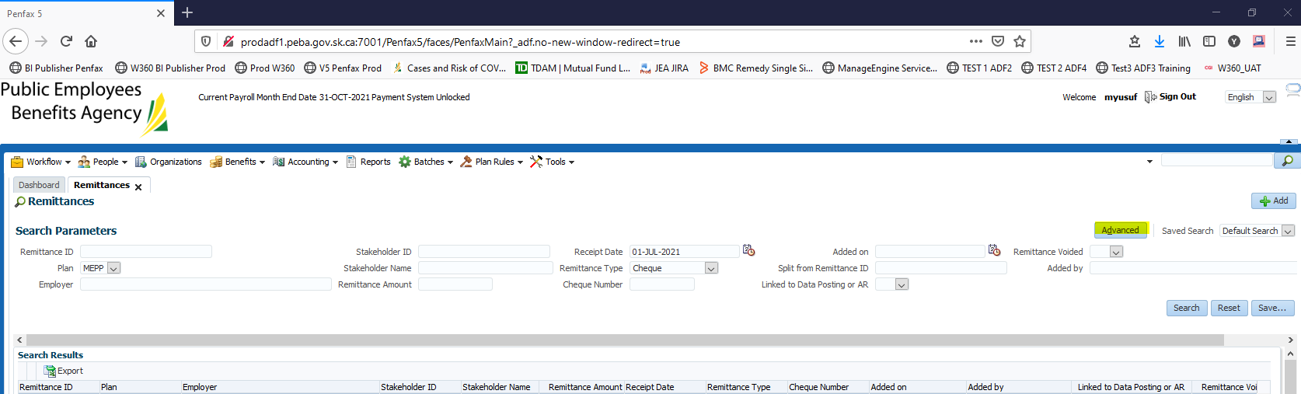

Select between

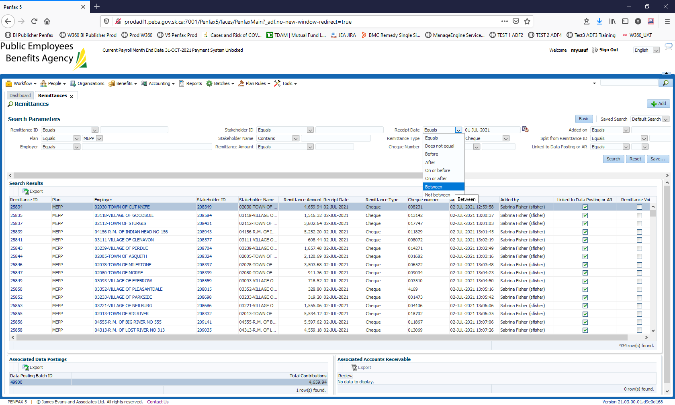

Enter **Cheque** for Remittance Type parameter.   
For Plan parameter: QA will need to select PEPP and second time MEPP without changing other parameters.

For MEPP

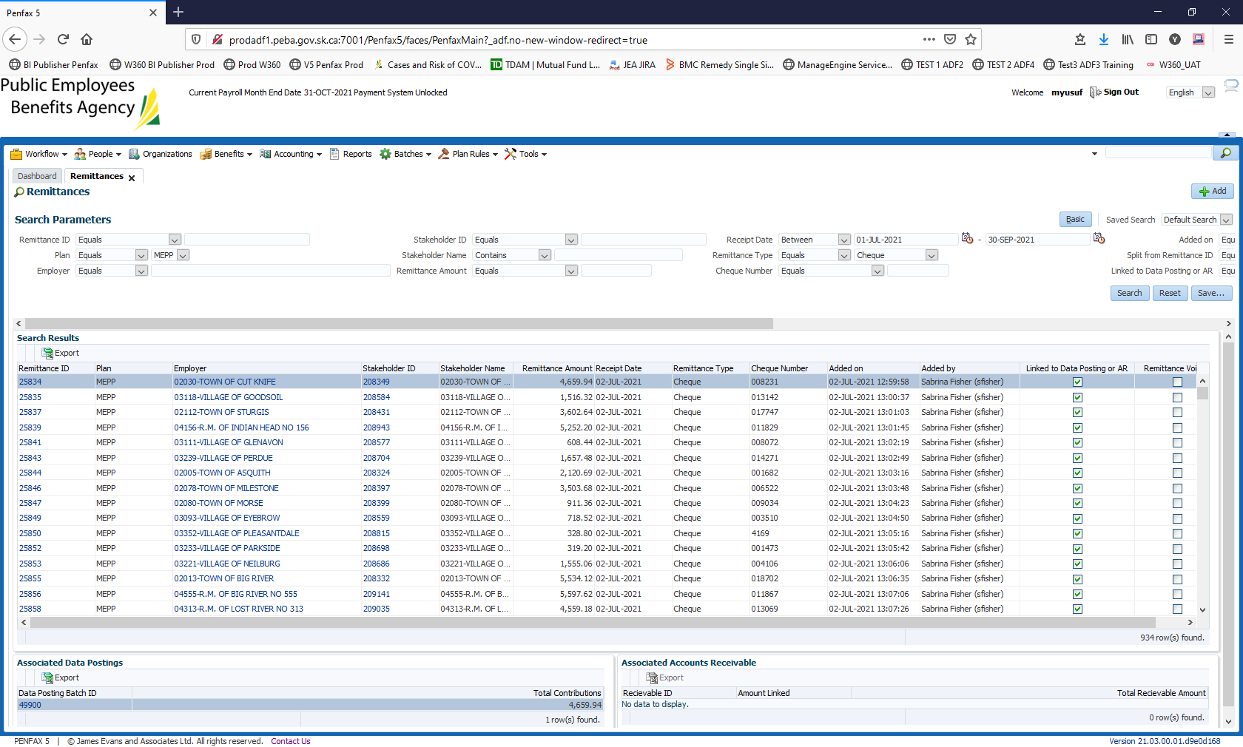

Export all the results in Excel worksheet. Total number of rows in excel is 934, but she needs only distinct employers.

On excel sheet, go to Data tab and enable filters

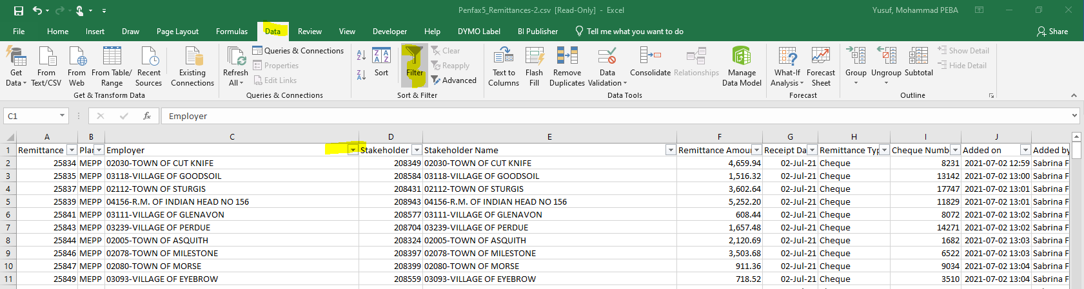

Click on remove duplicates

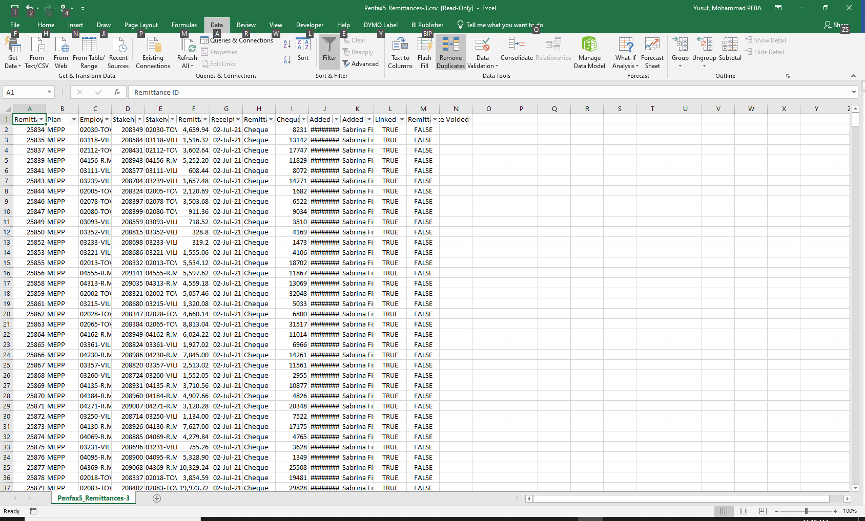

Then click on unselect all, and then only select Employer checkbox. Click OK

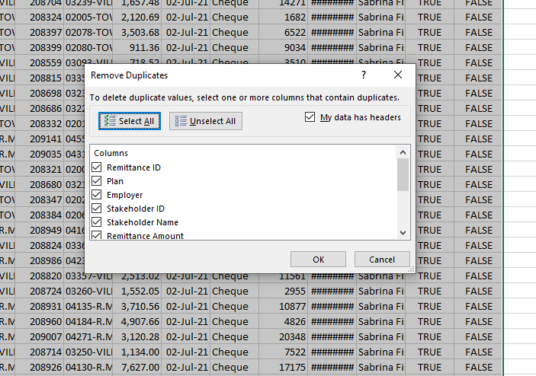

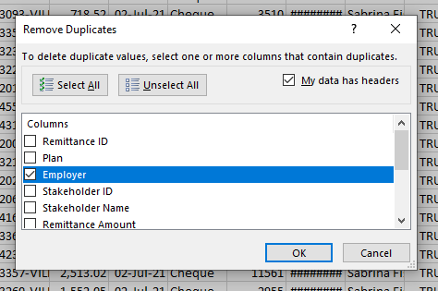

You will receive a message stating how many duplicates have been removed. Click OK

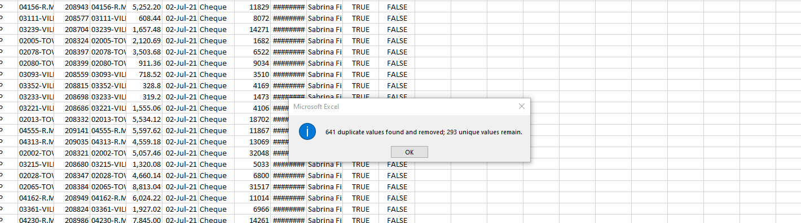

Now you would have the count of distinct employers who used cheque for remittance in last quarter for MEPP Plan i.e.,293

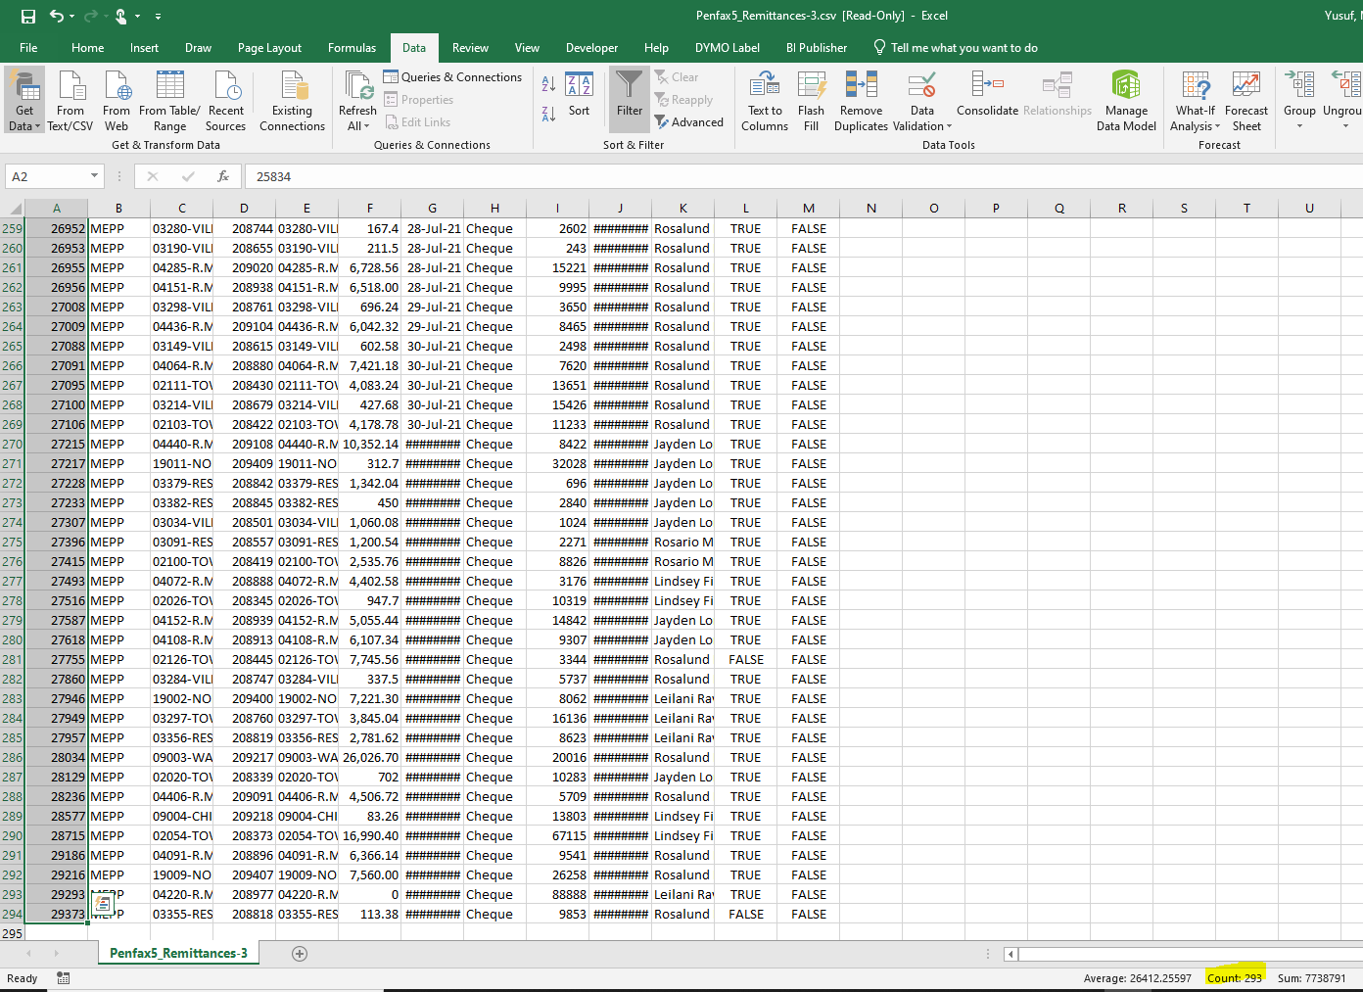

** From this point follow the same steps to generate PEPP employer Numbers

For PEPP

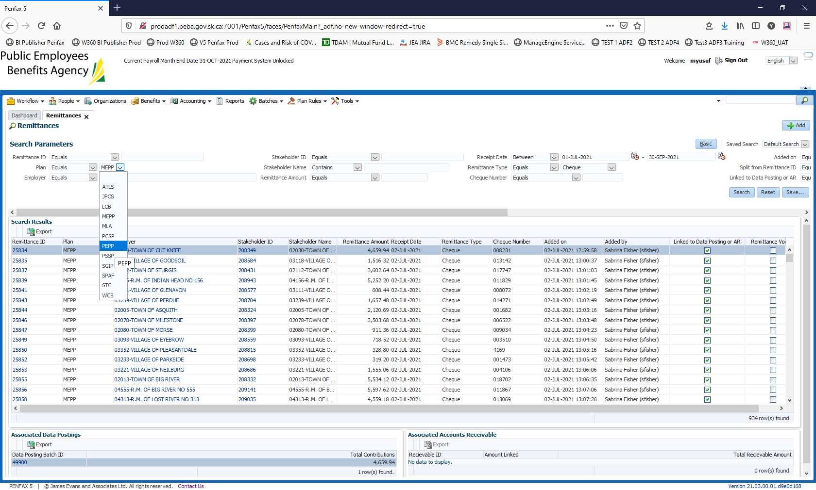

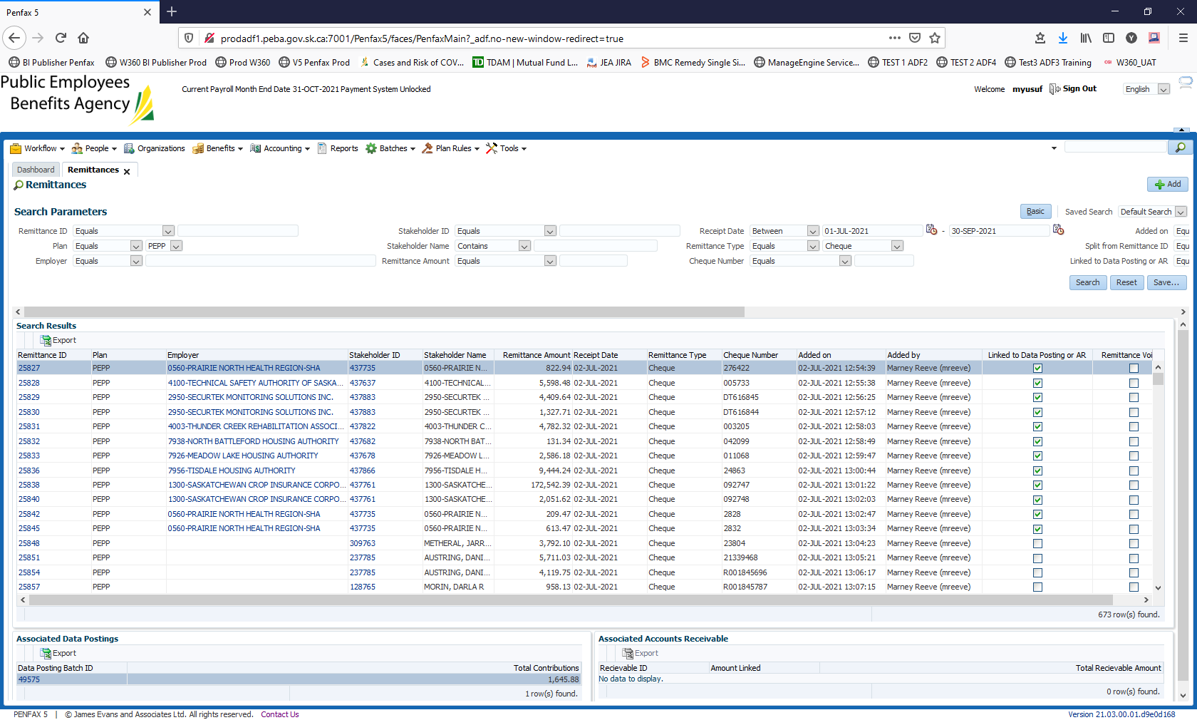

Export 637 number of unique rows. Go to Data Tab and remove all duplicates by employer.

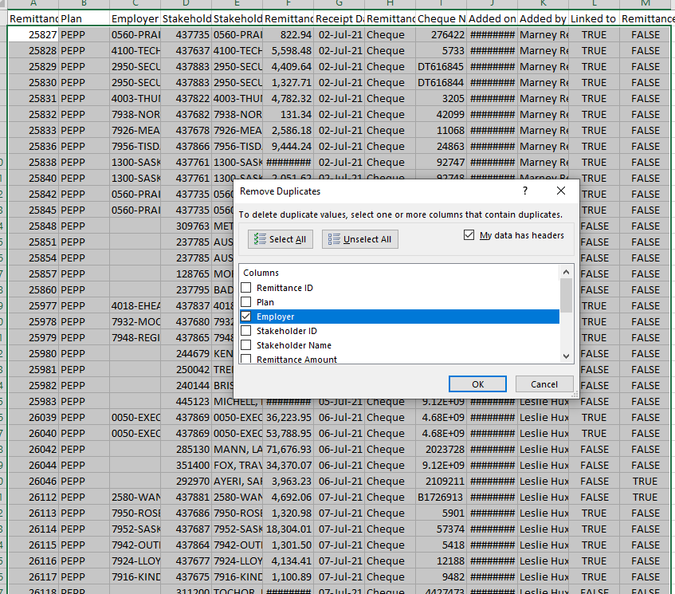

Click Ok

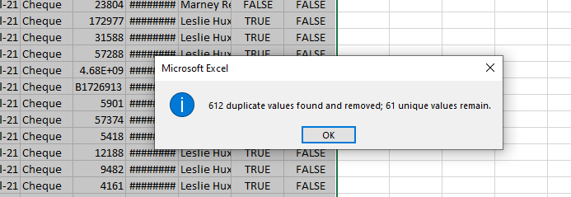

Remove any blank row, if that remittance is attached to member instead of employer. For example, I will be removing the row ten from my results

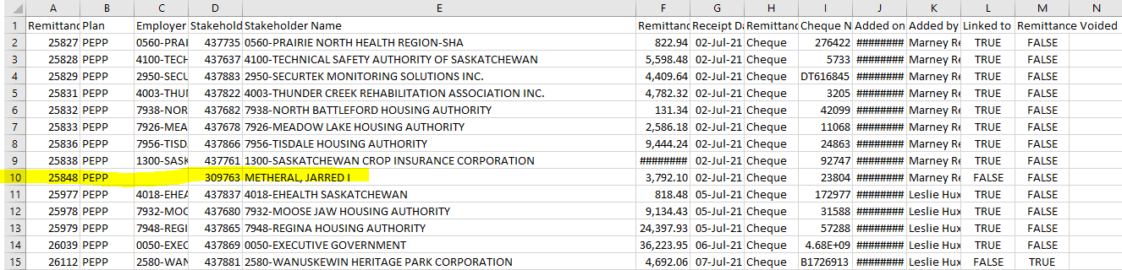

Then provide the correct count to business. In this case it is 60

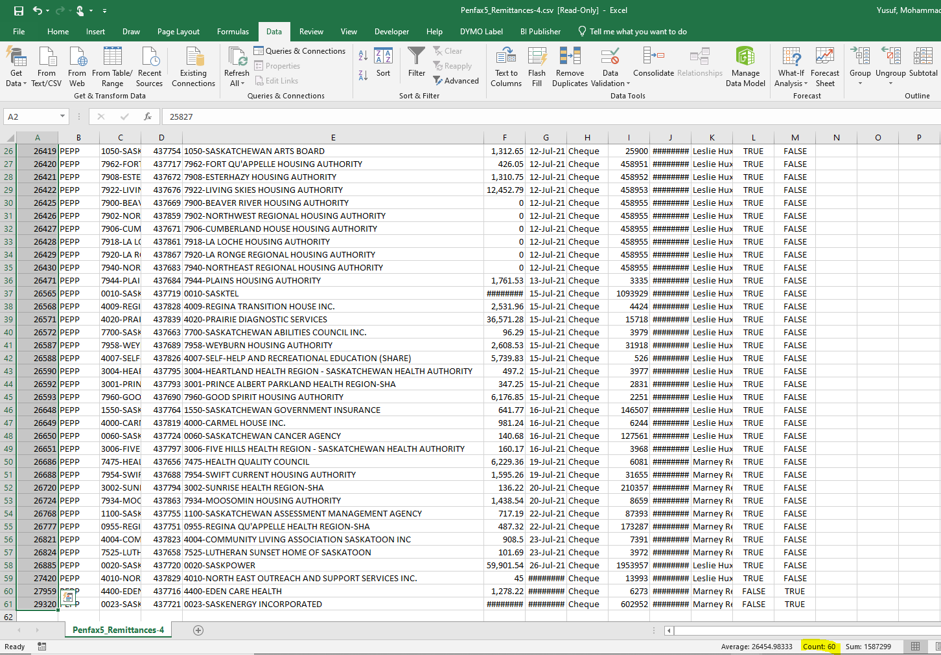

Please report these numbers to Dara Sewell-Zumstien. No other information is required to be sent.

**Note: In the end please send both the files (PEPP and MEPP) to Dara. After column E, remove all columns**.

Example from MEPP

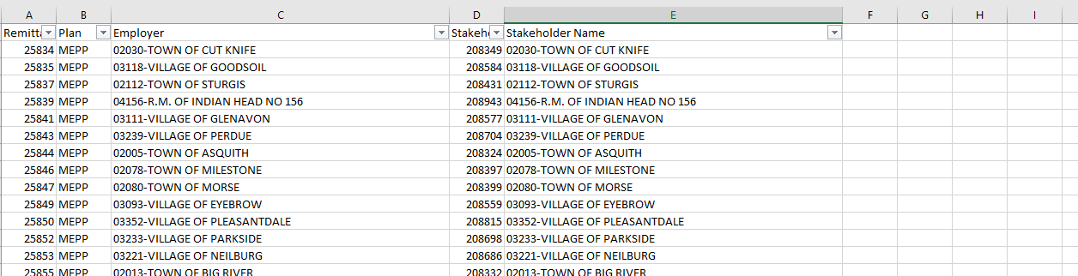

Example from PEPP

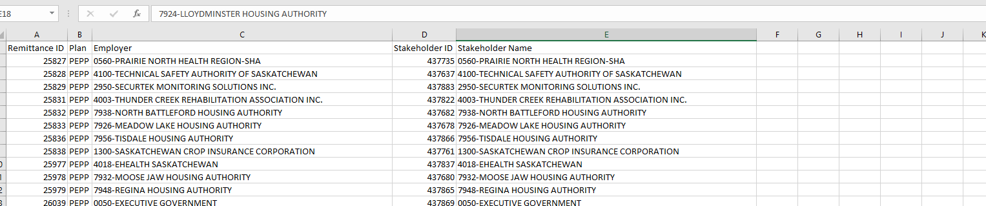

Sample email:

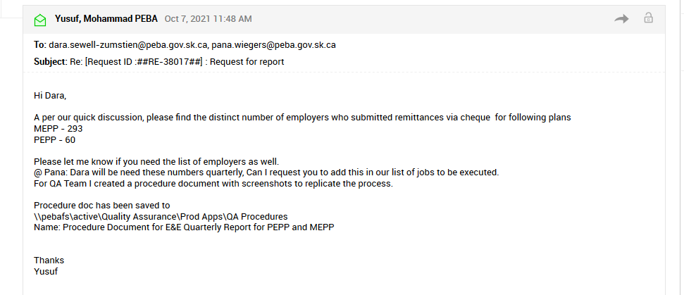

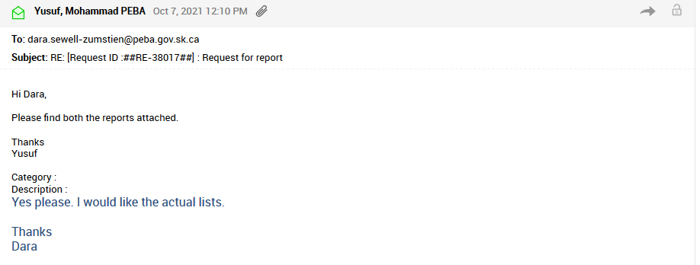

Please do not forget to attach both the reports for business.

Service Desk Ticket numbers associated with this request

Original Ticket # 31838  
Ticket # 38017

# Add Employers to PENFAX & PLANet

|  |  |
| --- | --- |
| **Title:** Add Employers to PENFAX & PLANet | **Current Version:** 1.0 |
| **Document Owner:**  Debby Parks | **Document author:**  Jeroen Verwaard |

|  | **Name/Title** | **Signature** | **Date** |
| --- | --- | --- | --- |
| **Reviewed by** | Rosie Marcelino |  | <02/May/2019> |
|  |  |  |  |
|  |  |  |  |
| **Approved by** | <Senior Management / Business Area Manager> |  | <dd/mm/yyyy> |
|  |  |  |  |

|  |  |
| --- | --- |
| **Date Issued**: 02/05/2019 | **Date Revised**: <dd/mm/yyyy> |

**Change / Revision History**

| Date | Author | Version | Change |
| --- | --- | --- | --- |
| 02/05/2019 | Jeroen Verwaard | 1.0 | Document Created |

**Purpose:**

To set up new Employers in PENFAX and have the ability to post PDRs and Forms from PLANet to PENFAX.

**Scope / Applicability:**

This document applies to MEPP staff, who will be responsible for adding and maintaining Employers on the system.

**Roles and Responsibility:**

Manager/Supervisor of the business area will notify MEPP administrator of the new Employer.

MEPP admin will perform the task and notify the manager/supervisor after the task has been completed.

**Procedures:**

[[

1. New Employer Setup in PENFAX
   1. Log into PENFAX
   2. Go to the Organizations menu item
   3. Click Add Organization

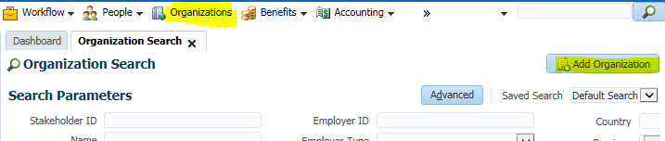

1. Set the effective date (if not today’s date)
2. Select the Organization Type = Employer
3. Select the Employer Type (whichever is applicable)
4. Enter the Name
5. Enter any other details if known (business numbers, contact information)

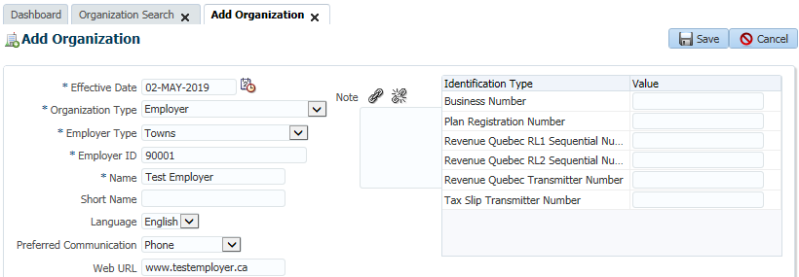

1. Click Save and the Organization Profile will appear

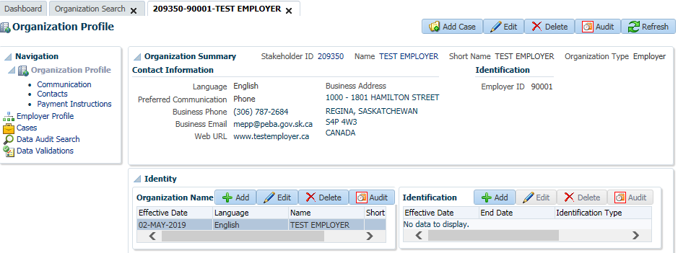

1. Click the Employer Profile link from the menu on the left side
2. Expand the Plan Affiliations area
3. Click the Add button

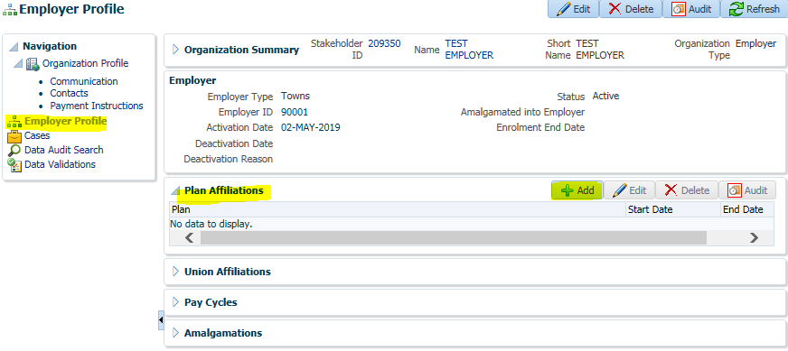

1. Select the Plan: MEPP
2. Select the Start Date and click Save

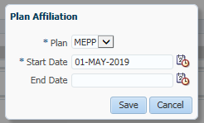

1. Expand the Pay Cycles area
2. Click the Add button

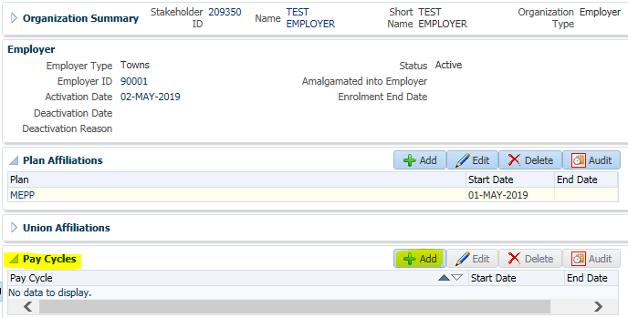

1. Enter the Pay Cycle type and the Start Date

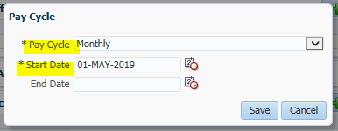

1. Click Save

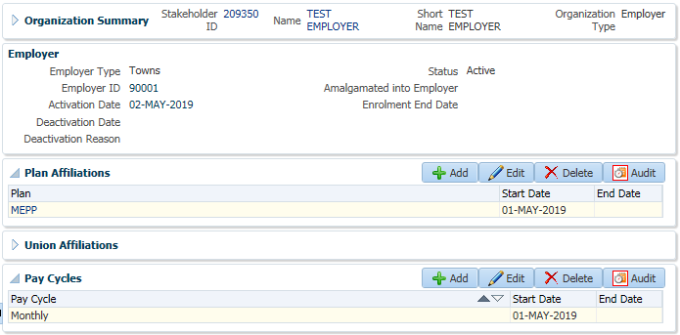

**New Employer Setup in PLANet:**

The PENFAX overnight maintenance batch will add the new employer record to PLANet and all that is left is to add the File Types (for processing Contributions and Forms) to the Employer.

* 1. Log into PLANet and go to Admin >> Security

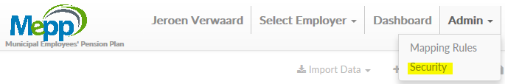

* 1. Select Organizations in the left side pop-up menu

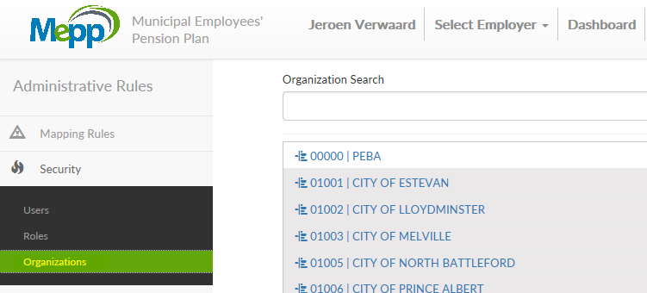

* 1. Search for the newly added employer, or if you didn’t wait for the overnight maintenance process, click the Add Organization button
  2. Enter the Organization Code, this is the Employer Number you entered in PENFAX

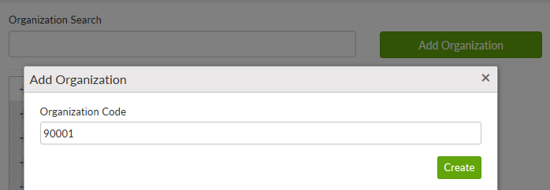

* 1. Click Create
  2. Search for the employer and click the record – if you waited for the next day the Organization Name would appear already

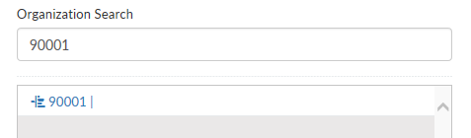

* 1. Click in the Short Description field in the Organization Name area and enter the Employer’s name
  2. Click Save

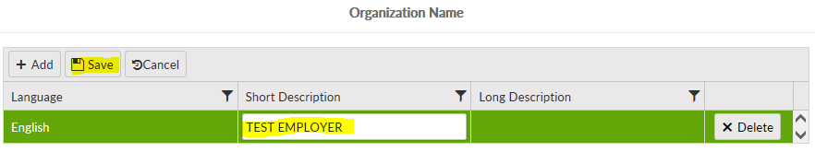

1. Click Add in the Organization Files area and select the File Types that will be available to process for
2. In the Encoding field, select UTF-8
3. Click Save

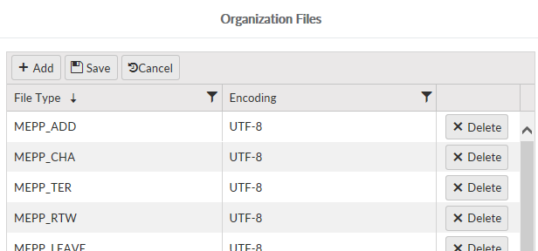

1. Go to the Dashboard
2. Select the new employer and verify you can select the file types added

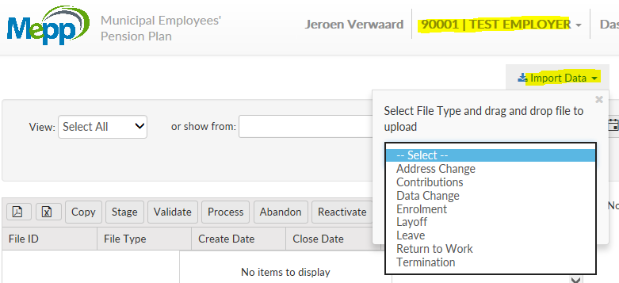

**Document Review Frequency:**

The Document Owner is responsible to ensure this procedure is reviewed at least once a year.

Any suggestions for improvements can be submitted to the Document Owner for review and consideration. Approved changes will be prioritized and included in the next release of this document.

**BCP requirements:**

* 1. Do you need this procedure during disaster recovery or business continuity planning?

(Yes / No)

* Yes
  1. Please share the list of things you would need for fulfilling the procedures

(e.g. printer, system, internet, phone, process document, etc.)

* PLANet application up and running
* Process Document available

**Document References:**

Not applicable.

# Quality Assurance Procedures for Commuted Value Updates(Average Industrial Wage Update)

|  |  |
| --- | --- |
| **Title: Quality Assurance Procedures for**   **Commuted Value Updates** | **Current Version: 1.0** |
| **Document Owner:**  **Michael Mead** | **Document author:**  **Jeroen Verwaard** |

[

|  | **Name/Title** | **Signature** | **Date** |
| --- | --- | --- | --- |
| **Reviewed by** | Jeroen Verwaard |  | 21/05/2019 |
|  |  |  |  |
|  |  |  |  |
| **Approved by** | <Senior Management / Business Area Manager> |  | <dd/mm/yyyy> |
|  |  |  |  |

|  |  |
| --- | --- |
| **Date Issued**: 21/05/2019 | **Date Revised**: 05/01/2022 |

**Change / Revision History:**

| **Date** | **Author** | **Version** | **Change** |
| --- | --- | --- | --- |
| 21/05/2019 | Jeroen Verwaard | 1.0 | Document created |
| 05/01/2022 | Jeroen Verwaard | 1.0 | Minor addition to Purpose section |

1. **Purpose:**

The Average Industrial Wage is used to calculate the Disability Waiver for MEPP Members. This rate needs to be updated annually and will be available and send to us between mid-February and the end of March. The MEPP team will provide these.

1. **Scope / Applicability:**

This document applies to Quality Assurance staff, who will be responsible for updating the system. The document also applies to the MEPP Supervisor or Pension Specialists who are responsible for reviewing and ensuring the rates are updated correctly.

1. **Roles and Responsibility:**

MEPP Supervisor or Pension Specialist will notify QA of the new rate, this will be done using an email to the QA Help mailbox, usually in early March. QA will enter

1. **Procedures:**

**4.1 Process for receiving email from MEPP Member Accounting**

The MEPP Member Accounting business area will send an email to the QA Help mailbox informing of the new rate of the current calendar year.

Please Note: If the rates not received, kindly send a quick reminder email to Kim Stevenson, copying Pana Weigers and QA team.

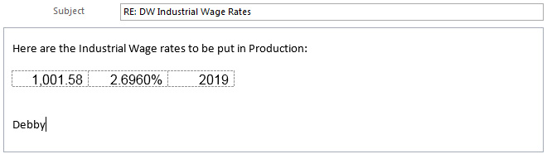

**4.2 Process for adding the rate into PENFAX - TEST**

This rate needs to be entered in all available PENFAX 5 environments – Production, Test and User Training. First in TEST, which needs to be reviewed and approved by the MEPP Supervisor or one of the Pension Specialists.

* Log into PENFAX 5 - TEST
* Go to Plan Rules >> Actuarial >> Projection Rates

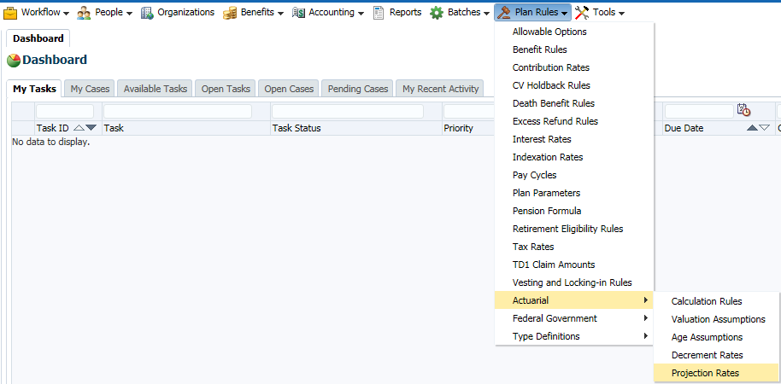

* Select the Plan: MEPP
* Click the Add button

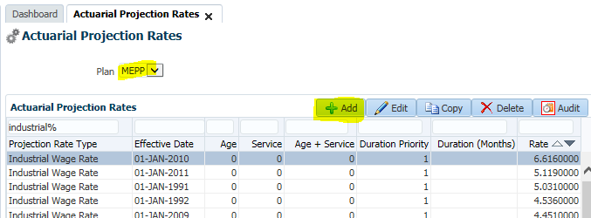

* On the pop-up, select:
  1. Projected Rate Type: Industrial Wage Rate
  2. Effective Date: 01-JAN-<CURRENT YEAR>
  3. Leave the values for Age/Service/Age+Service/Duration Priority/Duration (Months) as is
  4. Enter the Rate

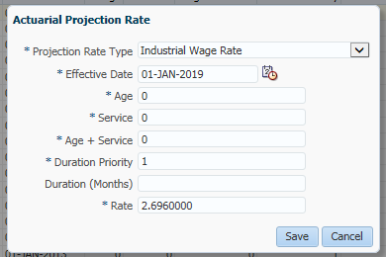

* Click Save
* Verify the record displays:

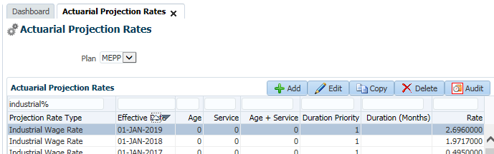

* Reply back to the e-mail to notify the rate has been updated and have the MEPP Supervisor or Pension Specialist review and approve the record
* Once approved, add the rate change into the Production and User Training environments and notify MEPP that is has been completed

1. **Document Review Frequency:**

The Document Owner is responsible to ensure this procedure is reviewed at least every year.

Any suggestions for improvements can be submitted to the Document Owner for review and consideration. Approved changes will be prioritized and included in the next release of this document.

1. **BCP requirements:**

Do you need this procedure during disaster recovery or business continuity planning?

* No

Please share the list of things you would need for fulfilling the procedures

* PENFAX 5 system up and running

1. **Document References:**

N/A

# PENFAX 5 - MEPP – Blackout Dates

**Description:**

QA is responsible for maintaining (adding) Blackout Date records in PENFAX. No processing gets done in PENFAX on any of the Canadian Federal Statutory (Public) Holidays. Any scheduled batches will not run on these dates.

Every year prior to the new year, we add the dates for the system for the new year

**Adding a new Blackout Date:**

1. Log into PENFAX
2. Go to the Tools menu
3. Select Blackout Dates

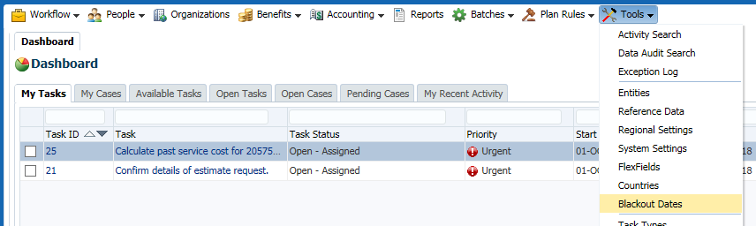

1. On this screen you can filter by Jurisdiction and the Blackout Dates if needed

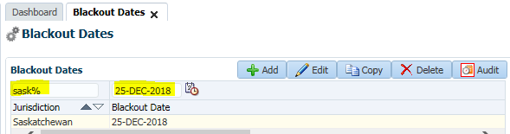

1. Click the Add button

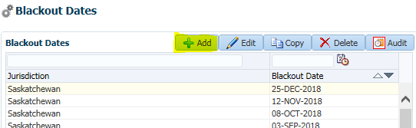

1. Enter the new record and click Save

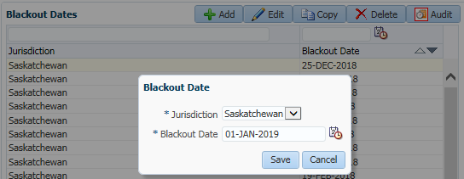

1. Verify the record displays

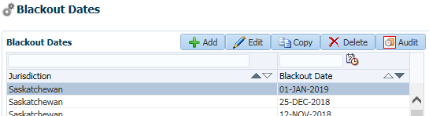

**Note:** You can also use the Copy function if you want, but for Blackout Dates this is not really used as there is not much information to enter. You would select the record you want to copy, change the date/year and click Save.

**Maintaining Blackout Dates:**

1. If you need to change an existing record (in case it was entered incorrectly) click the Edit button

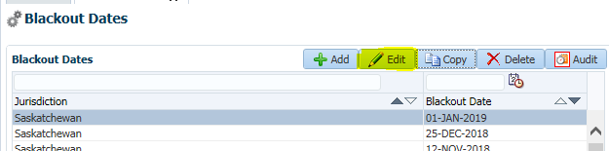

1. Change the details and click Save

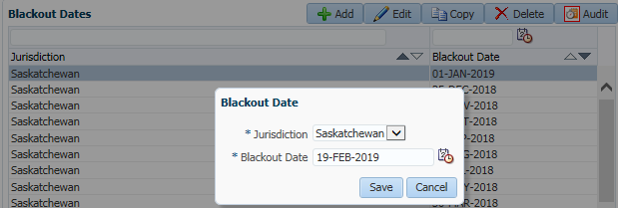

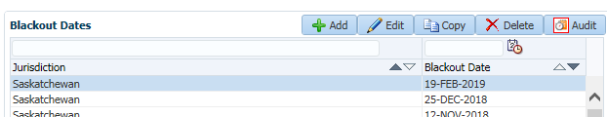

1. If you want to see who made changes to any of the records, click the Audit button and verify the username(s)

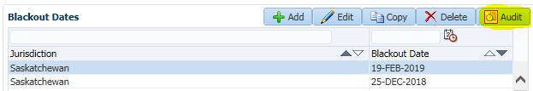

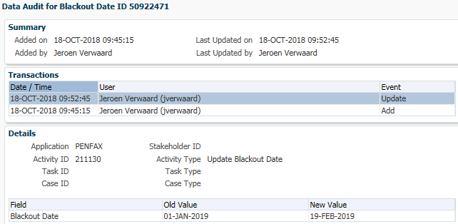

1. When you want to remove a record all together, select that record and click the Delete button

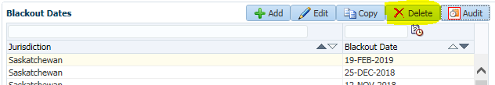

1. Click Yes

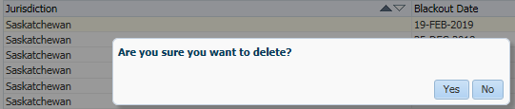

1. Verify the record is deleted

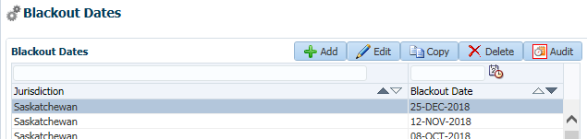

# Quality Assurance Procedures for Commuted Value Holdback Rules

|  |  |
| --- | --- |
| **Title: Quality Assurance Procedures for Commuted Value Holdback Rules** | **Current Version: 1** |
| **Document Owner:**  **Michael Mead** | **Document author:**  **Richard Belanger** |

|  | **Name/Title** | **Signature** | **Date** |
| --- | --- | --- | --- |
| **Reviewed by** | <Person who reviews the work> |  | <dd/mm/yyyy> |
|  |  |  |  |
|  |  |  |  |
| **Approved by** | <Senior Management / Business Area Manager> |  | <dd/mm/yyyy> |

|  |  |
| --- | --- |
| **Date Issued**: <dd/mm/yyyy> | **Date Revised**: <dd/mm/yyyy> |

**Change / Revision History**

| **Date** | **Author** | **Version** | **Change** |
| --- | --- | --- | --- |
| 05/11/2018 | Richard Belanger | 1 | Document created |

1. **Purpose:**

Each year the Manager of MEPP receives direction from our Actuary to update the solvency rate in PENFAX for calculating the percentage of holdback which will be applied when a member withdraws their monies from the Plan.

1. **Scope / Applicability:**

This document applies to Quality Assurance staff, who will be responsible for updating the system. The document also applies to the MEPP Assistant Manager who will be responsible for reviewing and ensuring the rate is updated correctly. And the two MEPP Supervisors who will perform the Assistant Manager’s duties in their absence.

It must be noted that this is not a mandatory annual update and any increase or decrease in the rate depends on the health of the Plan. The timing of the update can fluctuate depending on the actuary’s advice.

1. **Roles and Responsibility:**

The manager of MEPP will communicate the rate received from the actuary to Quality Assurance via the QA Help email.

The designated QA member will review the email ensuring a reasonable rate, and an effective date.

If there is any uncertainty regarding the rate and effective date, the manager of MEPP must be contacted by Quality Assurance to ensure the validity of the rate and effective date before updating the rate.

When it has been established the rate is valid the designated QA staff will update the rate.

1. **Procedures:**

**4.1 Process for receiving email from MEPP Manager**

The MEPP manager will send an email to the QA Help mailbox informing that a new rate will be taking affect as well as the effective date. There is no set schedule for these updates.

Example from 2018:

H:\PEBA\Projects\Active\MEPP Renewal\Business Validation\QA\Procedures\Update to Solvency Ratio in Penfax.msg

* 1. **Process for Logging into PENFAX V5.0:**

Log into PENFAX via the Log In screen

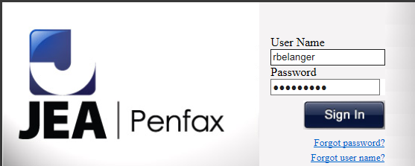

* 1. **Process for Navigating to Plan Rules:**

On the Dashboard in V5.0 navigate to the menu selection of Plan Rules

Navigate to Plan Rules on the top of the Dashboard

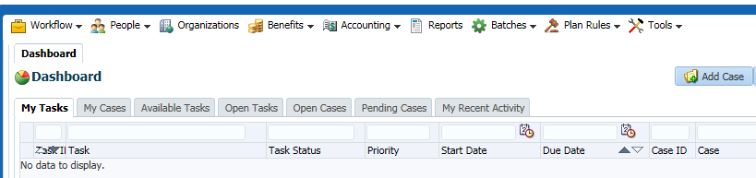

* 1. **Process for Selecting CV Holdback Rules:**

On Plan Rules click on the dropdown arrow and choose CV Holdback Rules

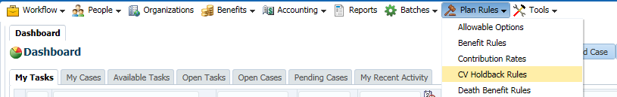

* 1. **Process for Selecting MEPP Plan:**

On the Plan dropdown select MEPP

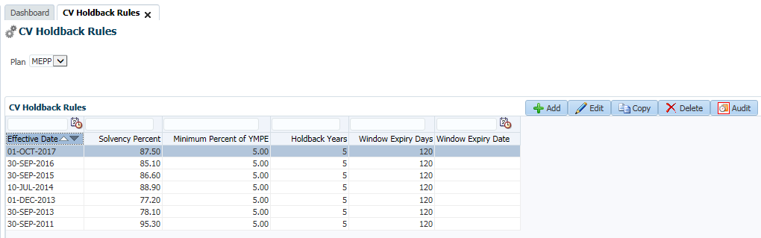

* 1. **Process for Copying Previous Rate**

The most efficient way to update is to highlight the most recent rate and click Copy, this will keep all of the previous information, so all that needs to be updated is the Effective Date and Solvency Percentage.

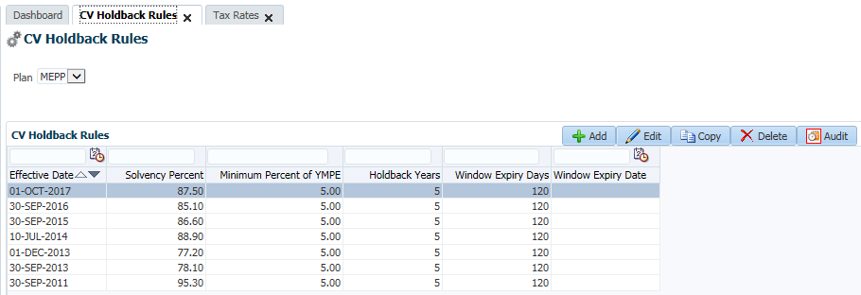

* + 1. Click Copy

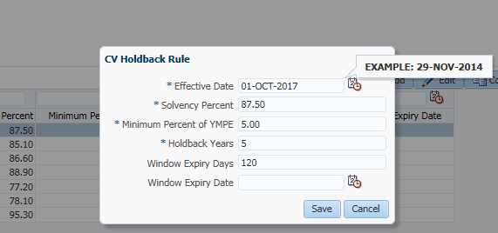

* + 1. Input the new Effective Date and the new Rate

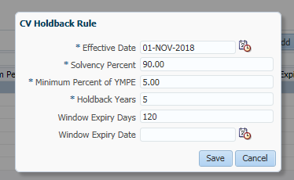

* + 1. Click Save



* + 1. View the new Rate updated in the CV Holdback Rules window

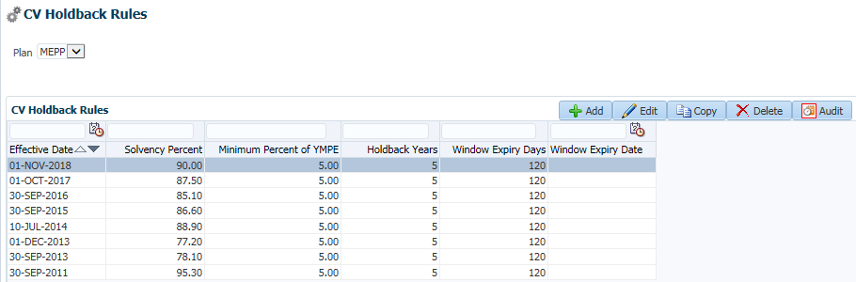

* + 1. Inform Business of Update

Once the rate has been updated, inform the MEPP Assistant Manager to review and accept the changes. If the Asst. Mgr. is away on the day of the update, one of the two MEPP Supervisors will have the capability to review and accept the changes.

When the update has been accepted inform MEPP staff of the update, as well include all of Quality Assurance, including the supervisor and manager.

1. **Document Review Frequency:**

The Document Owner is responsible to ensure this procedure is reviewed at least <frequency> every year.

Any suggestions for improvements can be submitted to the Document Owner for review and consideration. Approved changes will be prioritized and included in the next release of this document.

1. **BCP requirements:**

a. Do you need this procedure during disaster recovery or business continuity planning?

(Yes / No)

b. Please share the list of things you would need for fulfilling the procedures

(e.g. printer, system, internet, phone, process document, etc.)

1. **Document References:**

This includes any policy or procedure or guidelines or manual that needs to be referred for the process. If no reference documents required, you may add it as N/A

# Quality Assurance Procedures for Commuted Value Updates

|  |  |
| --- | --- |
| **Title: Quality Assurance Procedures for**   **Commuted Value Updates** | **Current Version: 1.2** |
| **Document Owner:**  **Michael Mead** | **Document author:**  **Richard Belanger** |

|  | **Name/Title** | **Signature** | **Date** |
| --- | --- | --- | --- |
| **Reviewed by** | Jeroen Verwaard |  | 06/05/2019 |
|  |  |  |  |
|  |  |  |  |
| **Approved by** | <Senior Management / Business Area Manager> |  | <dd/mm/yyyy> |

|  |  |
| --- | --- |
| **Date Issued**: <dd/mm/yyyy> | **Date Revised**: <07/08/2019> |

**Change / Revision History**

| **Date** | **Author** | **Version** | **Change** |
| --- | --- | --- | --- |
| 05/11/2018 | Richard Belanger | 1 | Document created |
| 06/05/2019 | Jeroen Verwaard | 1.1 | Minor updates to document layout throughout |
| 07/08/2019 | Roshni Arun | 1.2 | Added minor information about frequency of the one of the processes in the document (updating of Optional forms Interest Rates) |

1. **Purpose:**

Each month, **LifeWorks** sends the Commuted Value (CV) rates that have been calculated by the Canadian Institute of Actuaries (CIA) for the following month. As these dates are Effective Date driven they may be updated when the e-mail is received. At most it will be three days prior to the end of the month.

These rates are used to calculate benefits for members terminating employment with a MEPP Employer. As these terminations are date sensitive the correct rate in effect for the month must be updated in the system.

1. **Scope / Applicability:**

This document applies to Quality Assurance staff, who will be responsible for updating the system. The document also applies to the MEPP Assistant Manager who will be responsible for reviewing and ensuring the rates are updated correctly. And the two MEPP Supervisors who will perform the Assistant Manager’s duties in their absence.

1. **Roles and Responsibility:**

**LifeWorks** will send the new rate to the QA Help/TechSupport mailbox when the rates have been verified by the actuary.

The designated QA member will review the email ensuring a reasonable rate, and an effective date.

If there is any uncertainty regarding the rate and effective date, the QA member must reply to the person from LifeWorks who sent the email to get confirmation of the rate, and/or date if necessary.

When it has been established the rate is valid the designated QA staff will update the rate.

1. **Procedures** **– (Process for receiving email from JEA):**

LifeWorks will send an email to the QA Help/TechSupport mailbox informing that a new rate will be taking affect as well as the effective date. These can be expected starting three days before the end of the month.

Example from November 2018:

Business Validation\QA\Procedures\CIA Transfer Rates for November 2018.msg

Rates used in this document-Excerpt from this email below…

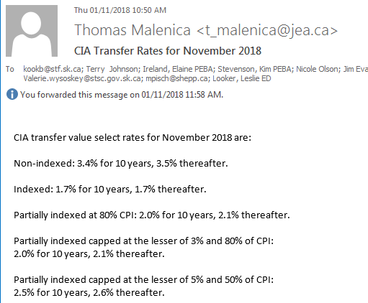

There is more information contained within these emails, as can be seen. The information that MEPP uses however, is found in the first line of the email.

**Please Note: If no Email received for CIA - CV Rates, please send an** Email to [megan.bishop@lifeworks.com](mailto:megan.bishop@lifeworks.com) Copy to TechSupport, Pana, Tyler, Sheryl, Kelly, Regina Noels

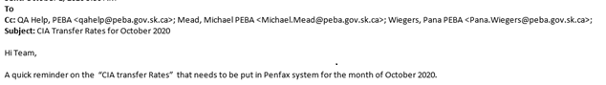

**Note**: After sending email, if still no response received from Megan or Lifeworks team, then please send an email to [Kelly.Snowden@peba.gov.sk.ca](mailto:Kelly.Snowden@peba.gov.sk.ca) Copy to TechSupport, Pana, Tyler, Sheryl, Regina Noels

**Please Note: We are supposed to receive CIA rates from LifeWorks and not from any other Vendor, if no Email received for CIA - CV Rates, from LifeWorks please send an** Email to [Kelly.Snowden@peba.gov.sk.ca](mailto:Kelly.Snowden@peba.gov.sk.ca) Copy to Pana, Sheryl & TechSupport.

**Very Important Note: Please don’t input the CIA rates received from JEA.**

**Note:** This updated rate will have to be entered into following **TEST** environments

* *~~V5 PEPP Test~~*
* *~~V5 PEPP Train~~*
* *~~V5 MEPP TEST~~*
* *~~V5 MEPP Train~~*
* *PEBA TEST 1*
* *PEBA-TEST2*
* *PEBA-Training*

And send an email with the print screen to the following people for rates verification prior to adding it to **V5 MEPP** **Production** environment.

* *Kelly Snowden*
* *Shane Harding*
* *Michelle Love*
* *Debby Parks*
* *Rosario Marcelino*
* *Dawn Jones*
  1. **Process for Logging into PENFAX V5.0**

Log into PENFAX via the Log In screen



* 1. **Process for Navigating to Plan Rules**

On the Dashboard in V5.0 navigate to the menu selection of Plan Rules

Navigate to Plan Rules on the top of the Dashboard

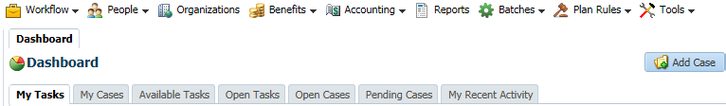

* 1. **Process for Selecting Interest Rates**

On Plan Rules click on the dropdown arrow and choose Interest Rates

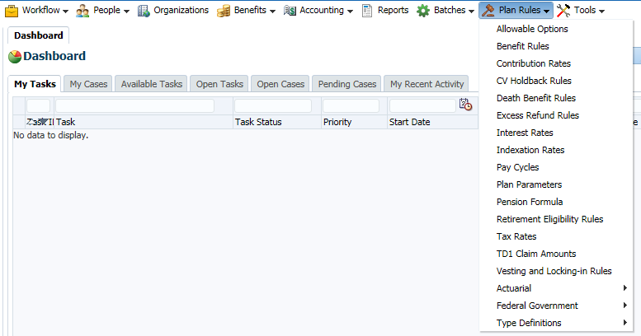

***\*\*\*Throughout this document please note the Calculation Type and Indexing Type dropdowns for each Interest Rate Type. They must be set as seen to ensure the rates are being applied correctly\*\*\****

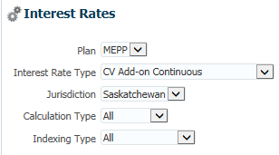

* 1. **Process for Selecting MEPP Plan**

On the Plan dropdown select MEPP

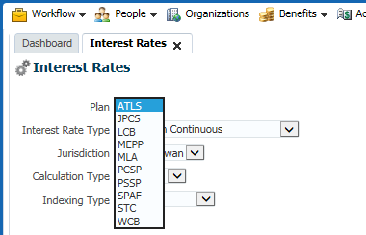

* 1. **Process for Copying Previous Rate**

The most efficient way to update is to highlight the most recent rate and click Copy, this will keep all of the previous information, so all that needs to be updated is the Effective Date and the Rate.

1. Select the most recent record
2. Click Copy

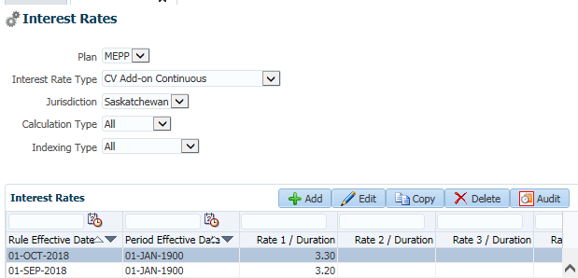

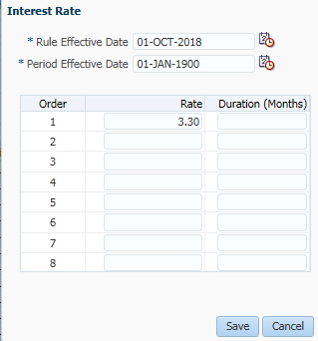

1. Input new Effective Date and new Rate by overwriting the existing entries
2. Click Save

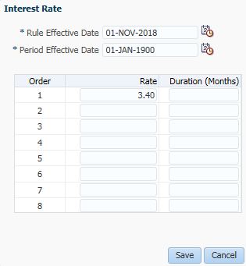

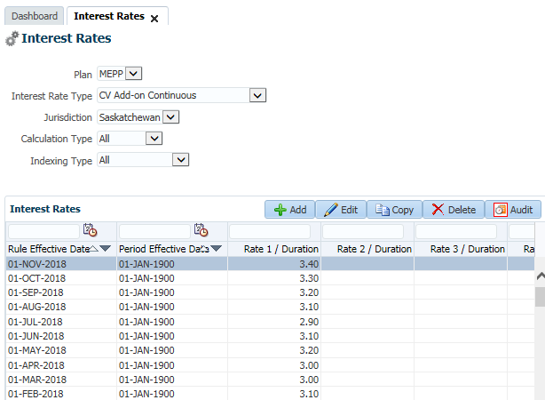

* 1. **Update Commuted Value Rates**

Using the path to Interest Rates and the copy method seen above, update the Commuted Value Rates

* 1. **Add-On Continuous Rate**

(Used to calculate interest on CV after 120 Days)

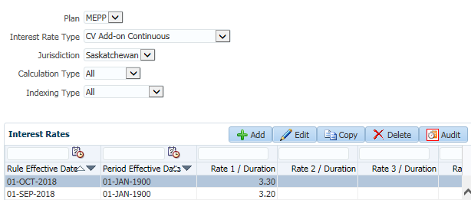

Record added:

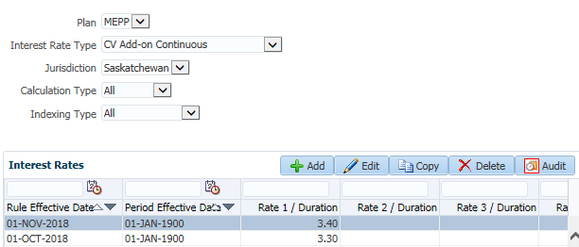

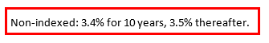

* 1. **Discount Rate**

(Rate used to determine the non-Indexed CV)

Select Indexing Type = None

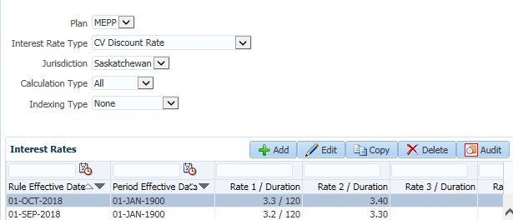

Record added:

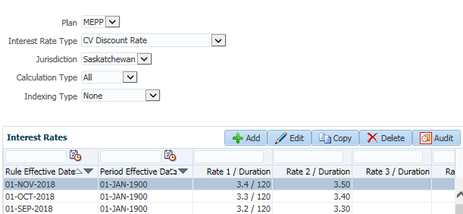



* 1. **Discount Special**

(Rate used to determine the Indexed CV)

Select Indexing Type = Normal Indexing

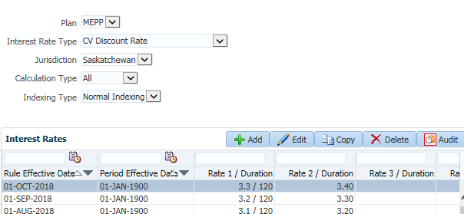

Record added:

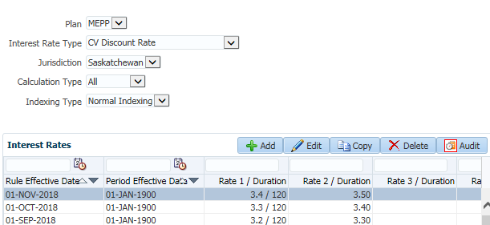



The two rates which follow, generally keep the same rate throughout the year.The Rate is established for the year in January. ~~If there is a change to the rate during the year, it will be communicated by the MEPP Manager, with the new rate and effective date.~~ **The rates for Optional Forms Interest Rate will be updated on a yearly basis. Based on MEPP Assistant Manager’s (Kim Stevenson) advice, these rates have to be updated the beginning of every year (January YYYY). The rates are to be provided from MEPP Assistant Manager’s (Kim Stevenson)**

* 1. **Optional Forms Interest Rate - None**

(Rate used to determine Former Plan Annuities & Optional Forms of New Plan Pension)

Select Indexing Type = None

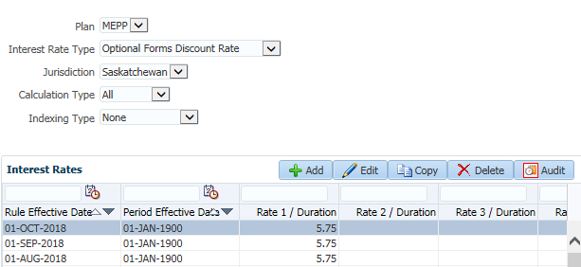

Record added:

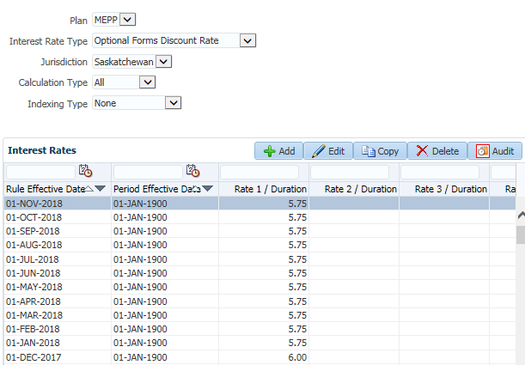

**4.11 Optional Forms Indexing Rate – normal Indexing:**

(Rate used to determine Optional Forms Indexing)

Select Indexing Type = Normal Indexing

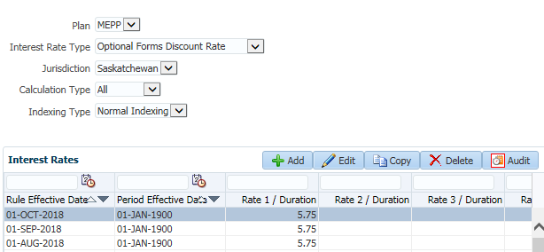

Added record:

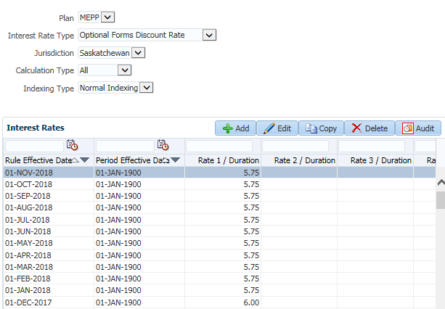

Send the email with screen shots and paths to Kim Stevenson, Elaine, Michelle Love, Debby Parks for rates verification.

**Document Review Frequency:**

The Document Owner is responsible to ensure this procedure is reviewed at least <frequency> every year.

Any suggestions for improvements can be submitted to the Document Owner for review and consideration. Approved changes will be prioritized and included in the next release of this document.

**BCP requirements:**

a. Do you need this procedure during disaster recovery or business continuity planning?

(Yes / No)

b. Please share the list of things you would need for fulfilling the procedures

(E.g. printer, system, internet, phone, process document, etc.)

**Document References:**

This includes any policy or procedure or guidelines or manual that needs to be referred for the process. If no reference documents required, you may add it as NA

# PENFAX 5 - MEPP - Countries Maintenance

**Description:**

QA is responsible for adding/deleting and editing Country & Province records in PENFAX. This needed for when a stakeholder lives outside of Canada and this country is not in the database yet, or there are changes to the record or underlying regions (provinces/states).

**Adding a new country:**

1. Log into PENFAX
2. Go to the Tools menu
3. Select the Countries option

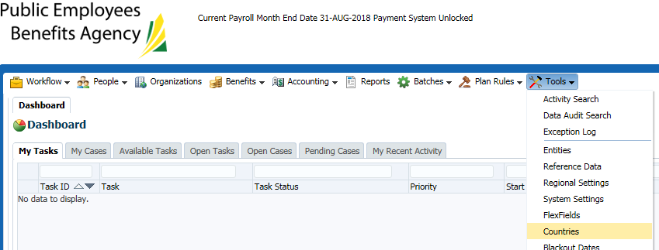

1. **Click the Add button**

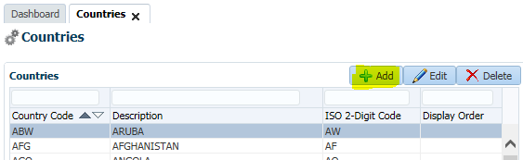

**When a new country needs to be added, the International Organization for Standardization website will provide the official country name and codes. Go to the ISO website** [**https://www.iso.org/obp/ui/#search**](https://www.iso.org/obp/ui/#search) **and search for ISO # 3166.**

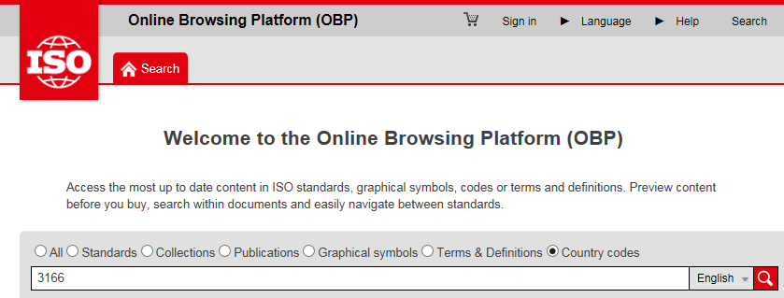

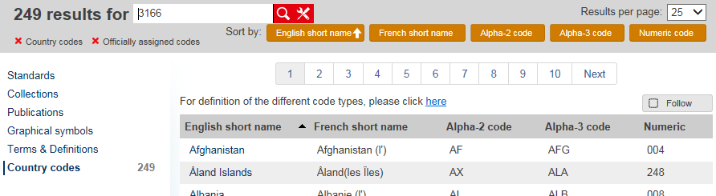

**NOTE: Currently all the countries are in PENFAX so for illustration purposes a fake country will be added.**

1. **Enter the details and click Save**
   1. **Note: we currently do not use the Display Order**

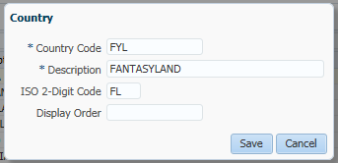

1. **Verify the Country has been added**

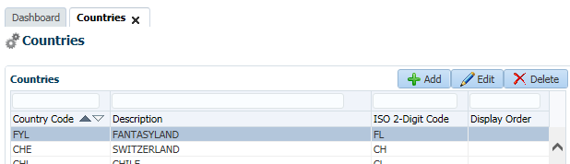

1. **Go to a Person Profile and verify you can add this country in the Contact Information page**

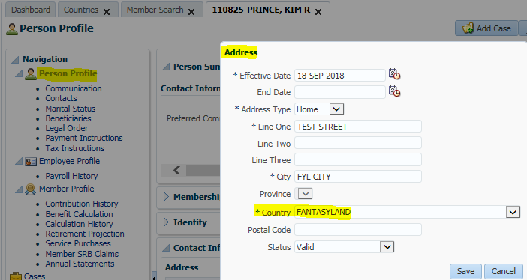

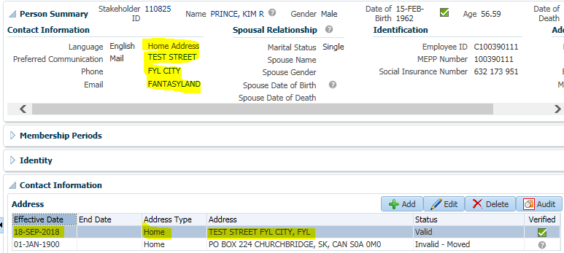

**Editing a country:**

1. Go to the Tools menu
2. Select the Countries option
3. Find the country you want to edit
4. Click the Edit button

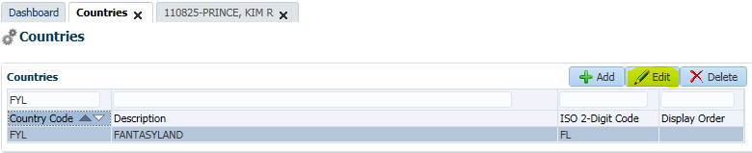

1. Make changes and click Save
   * **Note**: you cannot edit the Country Code, if it is incorrect you need to delete the record and add a new one

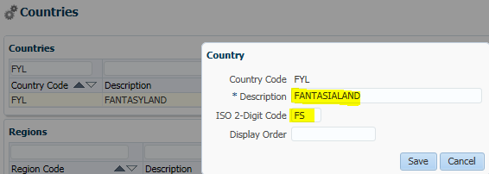

1. Verify the change(s)

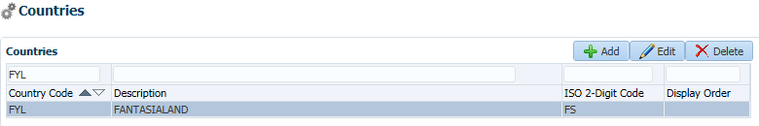

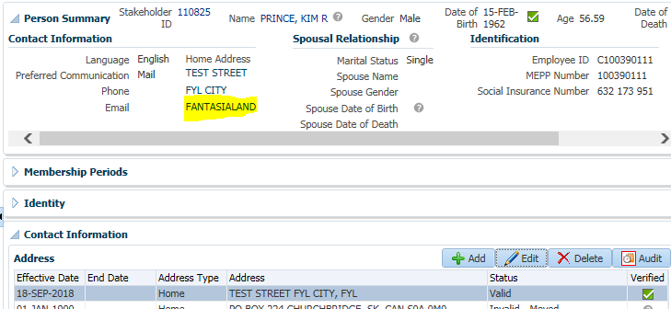

**Adding a new Region:**

1. Go to the Tools menu
2. Select the Countries option
3. Select the Country for which you need to add a region
4. Click the Add button

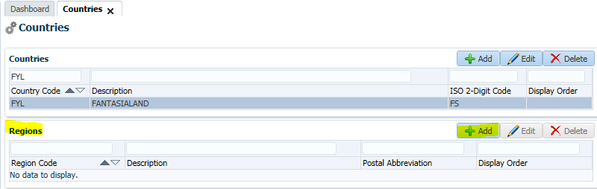

1. Enter the details and click Save
   * **Note**: we currently do not use the Postal Abbreviation or Display Order

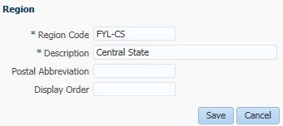

1. Add others if needed

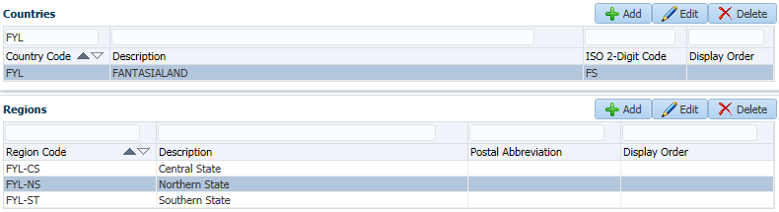

1. Verify the regions can be selected when adding or editing a person’s address

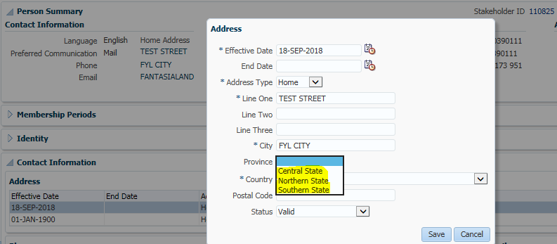

1. If possible, you can generate a letter/statement with the new address on it to confirm

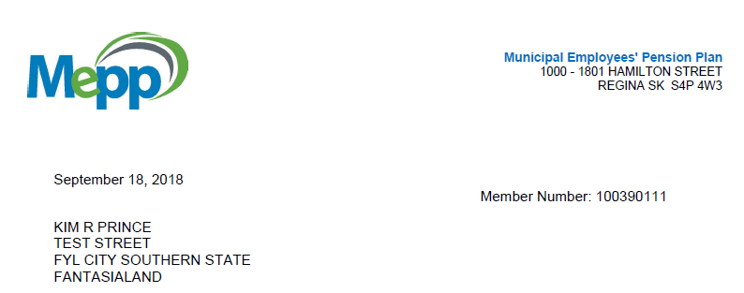

# Quality Assurance procedures for Federal Government Rules Update

|  |  |
| --- | --- |
| **Title: Quality Assurance procedures for Federal Government Rules Update** | **Current Version: 1** |
| **Document Owner:**  **Michael Mead** | **Document author:**  **Richard Belanger** |

|  | **Name/Title** | **Signature** | **Date** |
| --- | --- | --- | --- |
| **Reviewed by** | <Person who reviews the work> |  | <dd/mm/yyyy> |
|  |  |  |  |
|  |  |  |  |
| **Approved by** | <Senior Management / Business Area Manager> |  | <dd/mm/yyyy> |

|  |  |
| --- | --- |
| **Date Issued**: <dd/mm/yyyy> | **Date Revised**: <dd/mm/yyyy> |

**Change / Revision History**

| Date | Author | Version | Change |
| --- | --- | --- | --- |
| 06/11/2018 | Richard Belanger |  | Document Created |

1. **Purpose:**

Each year the federal government updates the annual money purchase (MP), defined benefit (DB), registered retirement savings plan (RRSP), deferred profit-sharing plan (DPSP) and the tax-free savings account (TFSA) limits, as well as the year's maximum pensionable earnings (YMPE).

1. **Scope / Applicability:**

This document applies to Quality Assurance staff, who will be responsible for updating the system. The document also applies to the MEPP Assistant Manager who will be responsible for reviewing and ensuring the rates are updated correctly. And the two MEPP Supervisors who will perform the Assistant Manager’s duties in their absence.

1. **Roles and Responsibility:**

JEA will send the document for the upcoming year. The information in the document is gathered from the CRA website. Within the document sent by JEA are links to the various pages within the CRA site which contain the information in question.

The designated QA member will review the document and verify the document to the CRA site.

If there is any uncertainty regarding the rule updates, the QA member must reply to the person from JEA who sent the document to get confirmation of the information sent.

When it has been established the document is valid the designated QA staff will update the rules.

1. **Procedures:**
   1. **Process for Receiving Document from JEA**

JEA compiles government rules information and sends it to PEBA in the PENFAX RULES UPDATE INSTRUCTIONS EFFECTIVE JANUARY 1, 20XX.

JEA will send the email to the QA Help mailbox as well as the MEPP manager, informing that the Federal Government Rules update document is available. Generally, it is attached to the email sent by JEA.

2019 Document:

Penfax 5 Rules Update Instructions 2019 v1_1.pdf

* 1. **Process for Logging into PENFAX V5.0**

Log into PENFAX via the Log In screen



* 1. **Process for Navigating to Plan Rules**

On the Dashboard in V5.0 navigate to the menu selection of Plan Rules



* 1. **Process for Selecting Federal Government Rules**

On Plan Rules click on the dropdown arrow and choose Federal Government>Rules

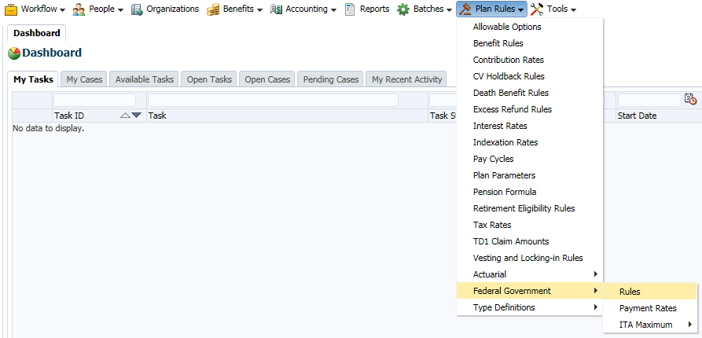

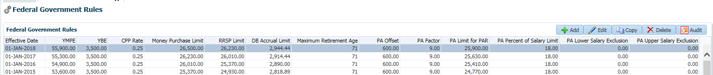

Detail of above screen shot seen above

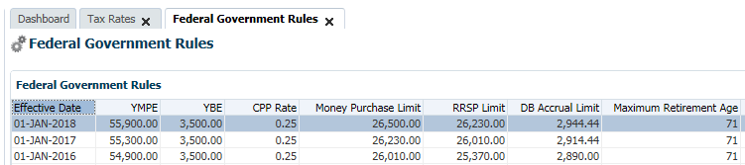

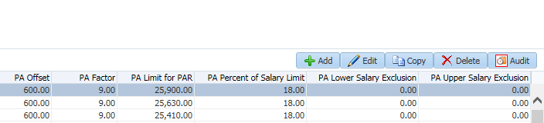

1. **Process for adding Federal Gov't Rules:**

As with most screens which experience frequent to somewhat frequent changes and updates the Federal Gov’t Rules screen can use the Copy function.

* 1. Highlight most recent entry and click Copy

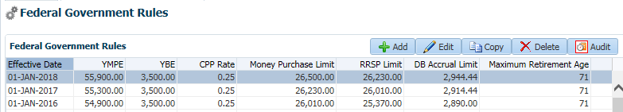

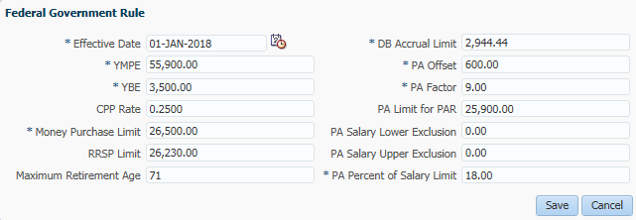

* 1. Input new values to the popup which are found within the JEA document.
  2. Click Save

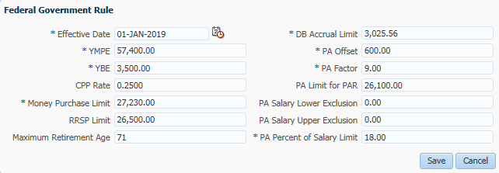

The non-highlighted amounts have been in effect for over twenty years, so updates are non-existent unless there are major legislation changes to the CRA.

* 1. See Updated Screen



Detail from screen shot seen above

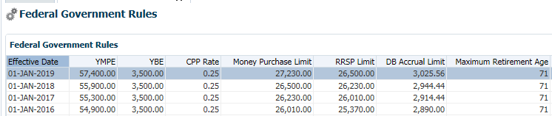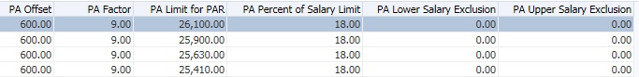

1. **Document Review Frequency**

The Document Owner is responsible to ensure this procedure is reviewed at least <frequency> every year.

Any suggestions for improvements can be submitted to the Document Owner for review and consideration. Approved changes will be prioritized and included in the next release of this document.

1. **BCP requirements:**

Do you need this procedure during disaster recovery or business continuity planning?

(Yes / No)

* 1. Please share the list of things you would need for fulfilling the procedures

(e.g. printer, system, internet, phone, process document, etc.)

1. **Document References:**

This includes any policy or procedure or guidelines or manual that needs to be referred for the process. If no reference documents required, you may add it as NA

We will receive the update from JEA or internally from our Finance department (Payroll Taxation team – currently Jordon Loverin) when available, if we have not contact JEA or Finance to find out what the new values are.

# Federal Government - Payment Rates

* + 1. **Canada Pension Plan (CPP)**

<https://www.canada.ca/en/services/benefits/publicpensions/cpp/cpp-benefit/amount.html>

The website link above takes the user to the ***Canada Pension Plan – How much could you receive***page at this location the rate for the new year will be seen. This rate will be on effect for the entire calendar year

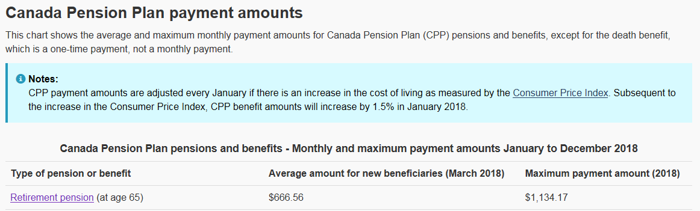

Excerpt from 2018 JEA document…

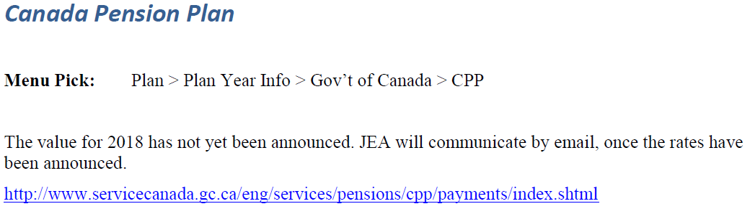

To see these rates…Plan Rules>Federal Government>Payment Rates

For CPP choose CPP from the dropdown

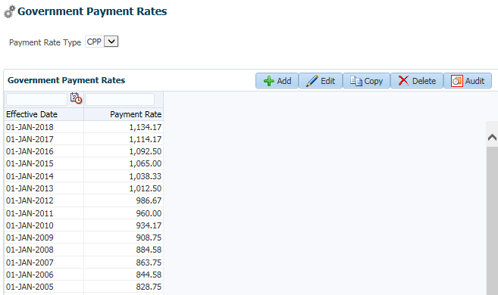

To update the rate for the next year when JEA has informed us the rate is available.

1. Highlight the most recent entry on the screen

2. Click Copy

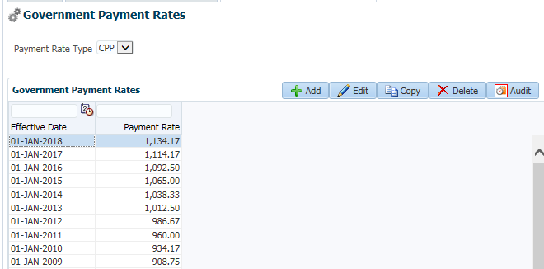

3. The entries for the previous year will appear in the pop up

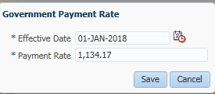

* **Effective Date-** The date the new rate will take effect, January 1 of the new year

* **Payment Rate-** Rate will be updated to the new value

4. Simply overwrite the date and amount within the popup

5. Click Save

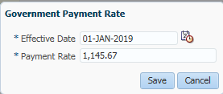

See the newly updated rate

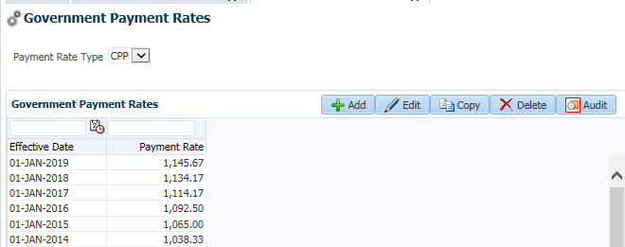

**\*\*\*Please note these rates are fictional and being used for the purpose of this procedure document.**

* + 1. **Old Age Security (OAS)**

<http://www.servicecanada.gc.ca/eng/services/pensions/oas/payments/index.shtml>

The website link above takes the user to the ***Old Age Security payment amounts*** page at this location the rate for the three-month period will be seen.

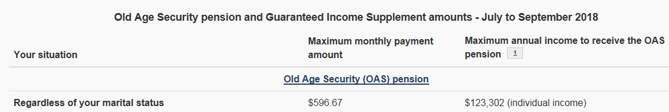

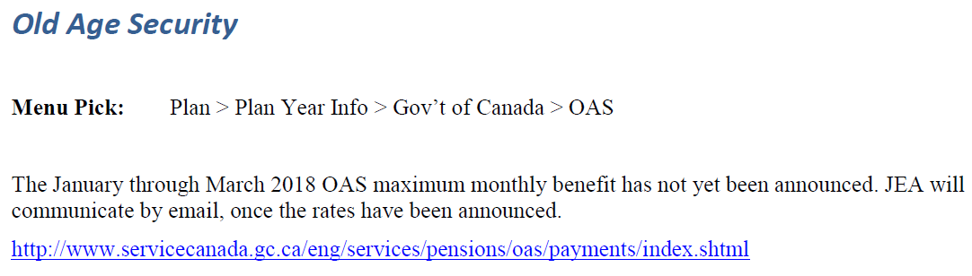

The OAS amounts are updated on a Quarterly basis as:

- January 1 to March 31

- April 1 to June 30

- July 1 to September 30

- October 1 to December 31

As well as the website, JEA sends an email prior to the effective date of the new amount.

To see these rates…Plan Rules>Federal Government>Payment Rates

For OAS choose OAS from the drop-down

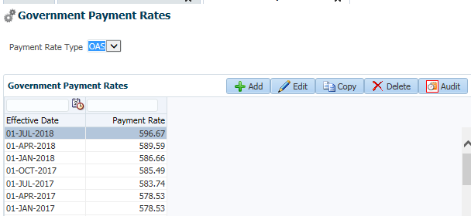

To update the rate for the quarter when JEA has informed us the rate is available, or viewing the website above.

1. Highlight the most recent entry on the screen
2. Click Copy



The entries for the previous quarter will appear in the pop up

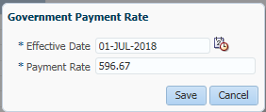

* **Effective Date-** The date the new rate will take effect, the First of the new quarter

* **Payment Rate-** Rate will be updated to the new value

1. Simply overwrite the date and amount within the popup
2. Click Save

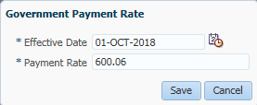

See the newly updated rate

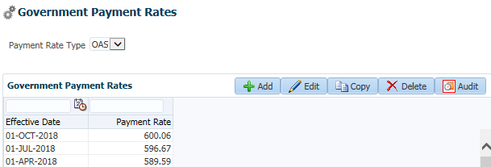

**\*\*\*Please note these rates are fictional and being used for the purpose of this procedure document.**

# Processing MEPP Pension Indexation in PENFAX 5

**Indexation Rates:**

**Done by:** Application & Product Support

**Process:** Enter indexation rates as required (normally the rates are provided by the MEPP Manager (currently Shane Harding). Current process is to enter the rates in Production, sent it to the MEPP team for review, and when OK’d have IT refresh the Test environment with the updated rates. A Change Request (CR) will have to be created and approved by MEPP prior to entering the rates into the system.

1. Go to PENFAX Production >> Plan Rules > Indexation Rates

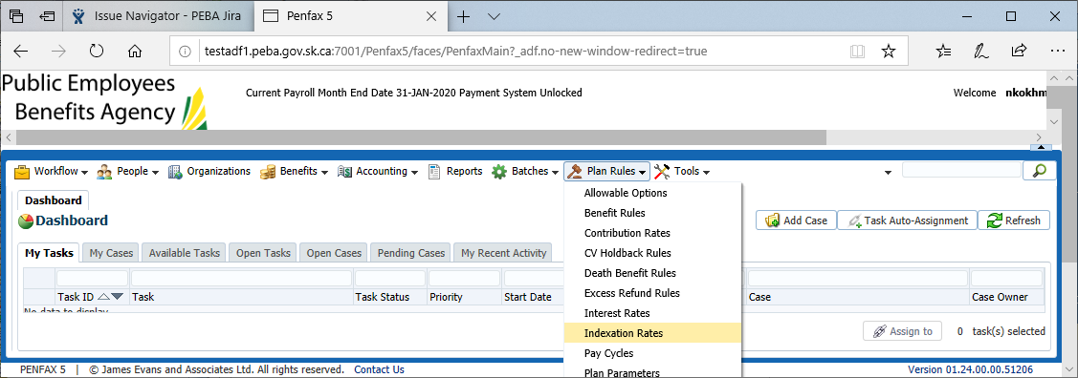

Add new records by clicking on *Add* or *Copy* button

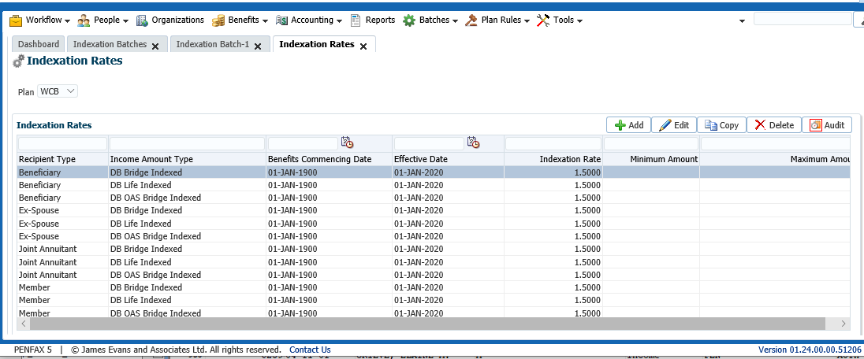

1. Ask the MEPP/Pensioner Services team to verify the values
2. Ask IT to refresh one of the PENFAX 5 Test environments with the Production data

**Pre-Indexing Query:**

**Done by:** Business Intelligence (BI) team

**Process:** Run the Indexing query to capture the amounts before the indexation is processed and save the result

select distinct br.STAKEHOLDER_SID, ia.BENEFIT_RECIPIENT_SID, br.BENEFIT_RECIPIENT_TYPE_DESC, br.FIRST_NAME, br.LAST_NAME, br.DATE_OF_BIRTH, br.DATE_OF_DEATH,

cia.INCOME_AMOUNT_TYPE_DESC, sum(ia.Amount), ia.END_DATE,

br.PLAN_DESC, br.BENEFIT_EVENT_SID, br.EVENT_DATE, br.BENEFIT_EVENT_TYPE_DESC, br.BENEFIT_TYPE_DESC, br.BENEFIT_RECIPIENT_STATUS_DESC

from penfax.p_income_amounts ia

left outer join penfax.p_benefit_recipient_search br on br.BENEFIT_RECIPIENT_SID = ia.BENEFIT_RECIPIENT_SID

left outer join penfax.p_curr_income_amounts cia on br.STAKEHOLDER_SID = cia.STAKEHOLDER_SID

and cia.BENEFIT_RECIPIENT_SID = ia.BENEFIT_RECIPIENT_SID and cia.INCOME_AMOUNT_TYPE_CODE = ia.INCOME_AMOUNT_TYPE_CODE

where

(ia.END_DATE IS NULL or ia.END_DATE > '2021-03-31')

and br.DATE_OF_DEATH is null

and br.PLAN_DESC in ('ATLS', 'JPCS','LCB', 'MLA', 'PCSP', 'PSSP', 'STC')

and cia.INCOME_AMOUNT_TYPE_DESC not like '%Non-Indexed%'

group by br.STAKEHOLDER_SID, ia.BENEFIT_RECIPIENT_SID, br.BENEFIT_RECIPIENT_TYPE_DESC, br.FIRST_NAME, br.LAST_NAME, cia.INCOME_AMOUNT_TYPE_DESC,

br.PLAN_DESC, br.BENEFIT_EVENT_SID, br.EVENT_DATE, br.BENEFIT_EVENT_TYPE_DESC, br.BENEFIT_TYPE_DESC, br.BENEFIT_RECIPIENT_STATUS_DESC, ia.END_DATE, br.DATE_OF_BIRTH, br.DATE_OF_DEATH

order by br.STAKEHOLDER_SID, br.BENEFIT_EVENT_SID,cia.INCOME_AMOUNT_TYPE_DESC

1. Ask the BI team to run the query in the Test environment once the refresh is done
2. Send the report to the MEPP/PS team for review before running the Indexation batch

**NOTE:** for the MEPP and/or WCB indexing, ask BI to run the specific query for this. The changes to the query should for just the MEPP plan be:

(ia.END_DATE IS NULL or ia.END_DATE > '2021-12-31')

and br.DATE_OF_DEATH is null

and br.PLAN_DESC in ('MEPP')

and cia.INCOME_AMOUNT_TYPE_DESC in ('DB Life Indexed', 'DB Life Non-Indexed', 'DB Bridge Indexed', 'DB Bridge Non-Indexed')

Check for other types as well, for 2021 these were included:

('DB Life Indexed', 'DB Life Non-Indexed', 'DB Bridge Indexed', 'DB Bridge Non-Indexed', 'DB Excess Life Non-Indexed Bump-up', 'DC Excess Life Indexed', 'DC Life Indexed')

**Indexation Batch:**

**Done by:** Application & Product Support

**Process:** Run the Indexation batch (in PENFAX 5 – TEST)

Once we have the OK from MEPP regarding the pre-indexing report:

1. Go to Batches > Add Batch Process > Add Indexation Batch

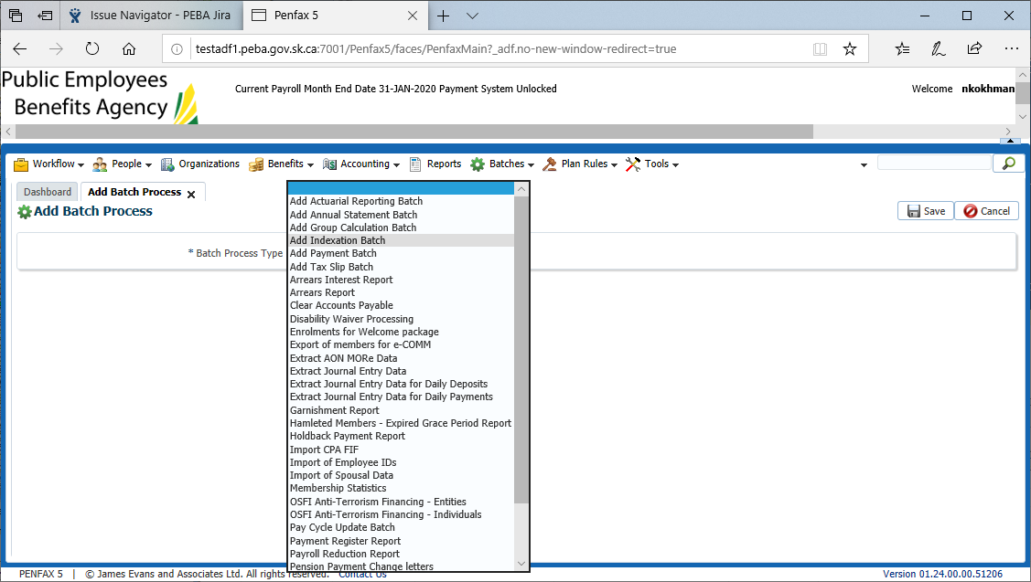

1. Select the plan being indexed from the dropdown list (one at a time) and enter *Indexation Effective Date*\*
   1. *Indexation Effective Date = January 1st - for MEPP and WCB
   2. *Indexation Effective Date = April 1st - for all other plans

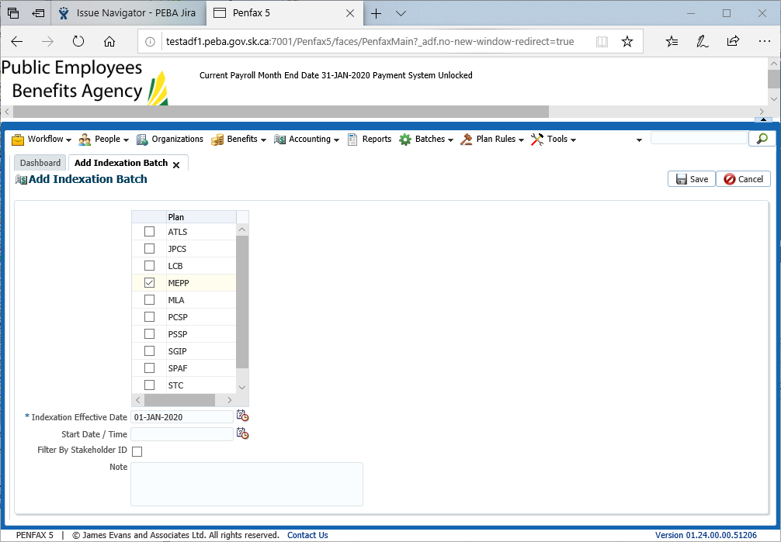

1. Start the batch with pressing *Save* button
2. When the batch is finished the status will change to *Completed*

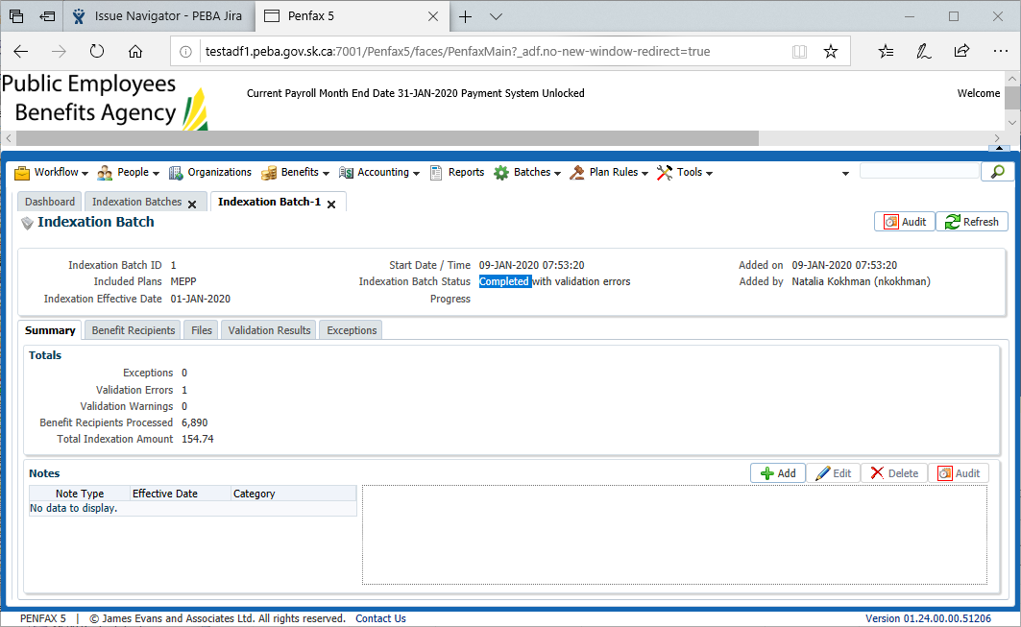

1. Look through *Validation Results* and *Exceptions* tabs of the batch. In case there is anything there send the details to Shane/Dawn for review

**Post-Indexing Query:**

**Done by:** Business Intelligence (BI) team

**Process:** Re-run the Indexing query to capture the amounts after the indexation is processed and save the result

select distinct br.STAKEHOLDER_SID, ia.BENEFIT_RECIPIENT_SID, br.BENEFIT_RECIPIENT_TYPE_DESC, br.FIRST_NAME, br.LAST_NAME, br.DATE_OF_BIRTH, br.DATE_OF_DEATH,

cia.INCOME_AMOUNT_TYPE_DESC, sum(ia.Amount), ia.END_DATE,

br.PLAN_DESC, br.BENEFIT_EVENT_SID, br.EVENT_DATE, br.BENEFIT_EVENT_TYPE_DESC, br.BENEFIT_TYPE_DESC, br.BENEFIT_RECIPIENT_STATUS_DESC,

a.end_date, a.address_type_code,a.address_status_code, a.address_line_one, a.address_line_two, a.address_line_three, a.city, a.province_code, a.country_code, a.postal_code

from penfax.p_income_amounts ia

left outer join penfax.p_benefit_recipient_search br on br.BENEFIT_RECIPIENT_SID = ia.BENEFIT_RECIPIENT_SID

left outer join penfax.p_curr_income_amounts cia on br.STAKEHOLDER_SID = cia.STAKEHOLDER_SID

and cia.BENEFIT_RECIPIENT_SID = ia.BENEFIT_RECIPIENT_SID and cia.INCOME_AMOUNT_TYPE_CODE = ia.INCOME_AMOUNT_TYPE_CODE

--left outer join PENFAX.p_persons p on p.STAKEHOLDER_SID = br.STAKEHOLDER_SID

--full outer join penfax.p_addresses a on a.STAKEHOLDER_SID = br.STAKEHOLDER_SID

left outer join (select max(effective_date) as Address_Date, STAKEHOLDER_SID

from penfax.p_addresses

where ADDRESS_TYPE_CODE = 'HOME'

and (ADDRESS_STATUS_CODE ='VAL' or ADDRESS_STATUS_CODE is null)

and postal_code <> 'S4P 4W3'

and address_line_one not like '%1801 HAMILTON%' or address_line_one is null

and (address_line_two not like '%1801 HAMILTON%' or address_line_two is null)

Group by STAKEHOLDER_SID)a1 on a1.STAKEHOLDER_SID = br.STAKEHOLDER_SID

left outer join penfax.p_addresses a on a.STAKEHOLDER_SID = a1.STAKEHOLDER_SID and a.EFFECTIVE_DATE = a1.Address_Date

where

(ia.END_DATE IS NULL or ia.END_DATE > '2021-03-31')

and br.DATE_OF_DEATH is null

and br.PLAN_DESC in ('ATLS', 'JPCS','LCB', 'MLA', 'PCSP', 'PSSP', 'STC')

and cia.INCOME_AMOUNT_TYPE_DESC not like '%Non-Indexed%'

group by br.STAKEHOLDER_SID, ia.BENEFIT_RECIPIENT_SID, br.BENEFIT_RECIPIENT_TYPE_DESC, br.FIRST_NAME, br.LAST_NAME, cia.INCOME_AMOUNT_TYPE_DESC,

br.PLAN_DESC, br.BENEFIT_EVENT_SID, br.EVENT_DATE, br.BENEFIT_EVENT_TYPE_DESC, br.BENEFIT_TYPE_DESC, br.BENEFIT_RECIPIENT_STATUS_DESC, ia.END_DATE, br.DATE_OF_BIRTH, br.DATE_OF_DEATH,

a.end_date, a.address_type_code,a.address_status_code, a.address_line_one, a.address_line_two, a.address_line_three, a.city, a.province_code, a.country_code, a.postal_code

order by br.STAKEHOLDER_SID, br.BENEFIT_EVENT_SID,cia.INCOME_AMOUNT_TYPE_DESC

**NOTE:** for the MEPP and/or WCB indexing, ask BI to run the specific query for this. The changes to the query should for just the MEPP plan be:

(ia.END_DATE IS NULL or ia.END_DATE > '2021-12-31')

and br.DATE_OF_DEATH is null

and br.PLAN_DESC in ('MEPP')

and cia.INCOME_AMOUNT_TYPE_DESC in ('DB Life Indexed', 'DB Life Non-Indexed', 'DB Bridge Indexed', 'DB Bridge Non-Indexed')

Check for other types as well, for 2021 these were included:

('DB Life Indexed', 'DB Life Non-Indexed', 'DB Bridge Indexed', 'DB Bridge Non-Indexed', 'DB Excess Life Non-Indexed Bump-up', 'DC Excess Life Indexed', 'DC Life Indexed')

1. Ask the BI team to run the query in the PENFAX Test environment
2. Send the Pre and Post Indexing reports to the MEPP/PS team for review

**Verifications:**

**Done by:** MEPP/Pensioner Services team (currently Dawn & Cindy with Shane & Elaine as backup/resource)

**Process:** Verify the amounts by comparing the before- and after- indexing result:

* The proper Income Amount Types/Recipient Types are updated
* The rate is correct

**Production Indexing Run:**

Once the amounts are verified, the above processes can be run in Production:

* 1. Pre-Indexing Query
  2. Running the Indexation batch
  3. Post-Indexing Query

Indexing Query details: (Pre and Post): run the following reports from BI Publisher > QA > PENSIONER_SER

Note: before running update the Date and the Plan(s) in the data models

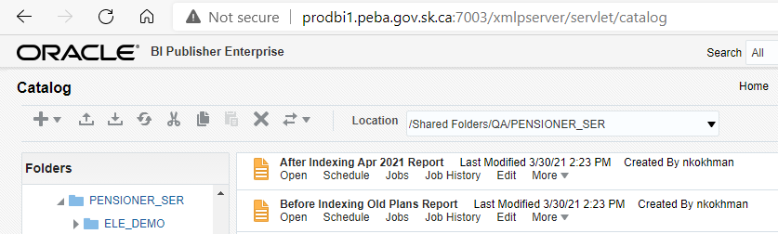

Data models:

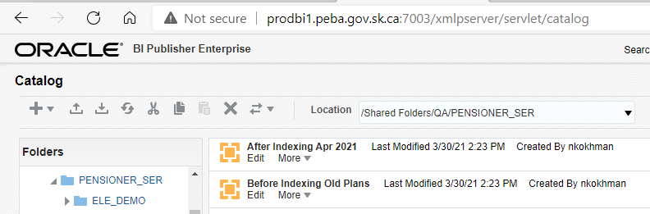

Notes: Followed the same process as above for indexing other plans ('ATLS','LCB','MLA','PCSP','PSSP','STC','JPCS').

- Attached quick screenshots for better understanding

- Please note that end date will change to March 31, yyyy

- Same above queries need to be run **Before** and **After** indexing

**Indexing Query**

**End date should be March 31, yyyy**

select distinct br.STAKEHOLDER_SID, be.PLAn,br.benefit_recipient_sid, be.BENEFIT_EVENT_SID, be.EVENT_DATE, prs.CURR_NAME, br.BENEFIT_RECIPIENT_TYPE_CODE, bt.DESCRIPTION as Benefit_Type, --br.BENEFIT_TYPE_CODE,

be.BENEFIT_EVENT_TYPE_CODE, br.BENEFIT_RECIPIENT_STATUS_CODE, iat.DESCRIPTION,

sum( ia.AMOUNT) as Benefit_Gross

from penfax.p_income_amounts ia

join penfax.p_benefit_recipients br on br.benefit_recipient_sid = ia.benefit_recipient_sid

join penfax.p_persons prs on prs.STAKEHOLDER_SID = br.STAKEHOLDER_SID

join penfax.p_benefit_events be on br.MEMBER_STAKEHOLDER_SID = be.MEMBER_STAKEHOLDER_SID and br.BENEFIT_EVENT_SID = be.BENEFIT_EVENT_SID

join penfax.INCOME_AMOUNT_TYPE_DESC iat on ia.INCOME_AMOUNT_TYPE_CODE = iat.INCOME_AMOUNT_TYPE_CODE

join penfax.Benefit_type_desc bt on br.BENEFIT_TYPE_CODE = bt.BENEFIT_TYPE_CODE

where

(ia.END_DATE IS NULL or ia.END_DATE > '20-03-31')

and prs.DATE_OF_DEATH is null

and be.PLAn in('ATLS','LCB','MLA','PCSP','PSSP','STC','JPSC')

group by br.STAKEHOLDER_SID, be.PLAn, be.BENEFIT_EVENT_SID, be.EVENT_DATE, prs.CURR_NAME, br.BENEFIT_RECIPIENT_TYPE_CODE, be.BENEFIT_EVENT_TYPE_CODE,

br.BENEFIT_RECIPIENT_STATUS_CODE, iat.DESCRIPTION, bt.DESCRIPTION, br.benefit_recipient_sid

order by be.Plan, br.STAKEHOLDER_SID, be.BENEFIT_EVENT_SID,iat.DESCRIPTION

Please note the MEPP team wanted report for all plans in one file, verify the results for each plan is included.

ATLS

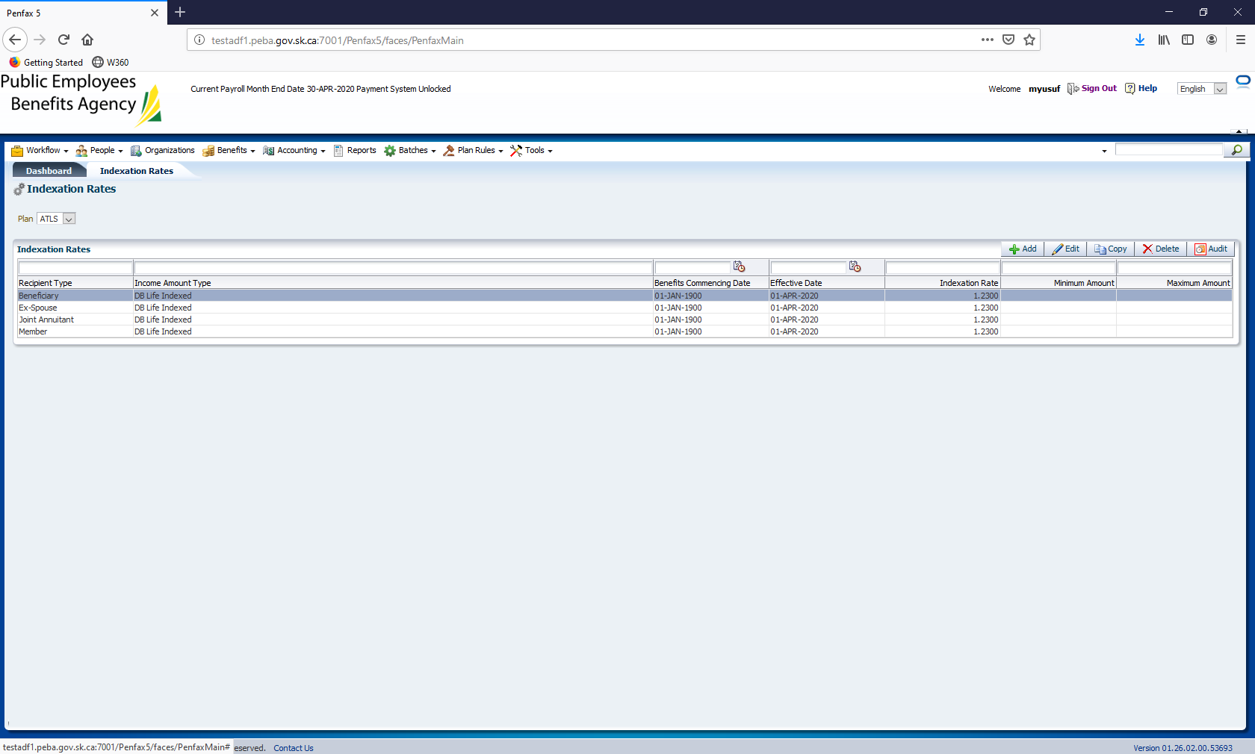

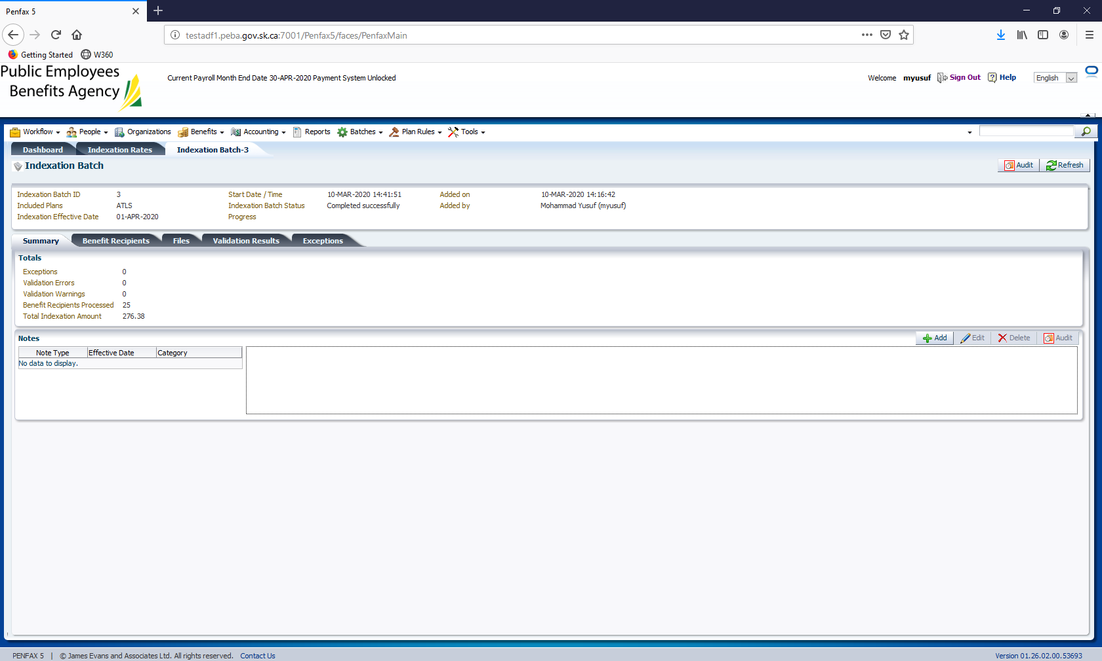

LCB

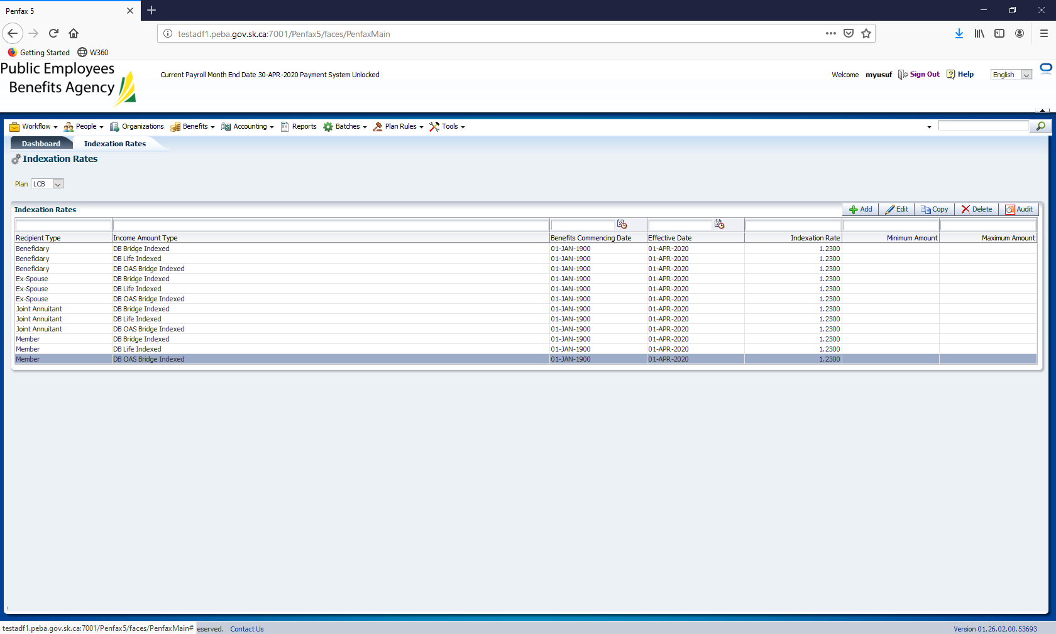

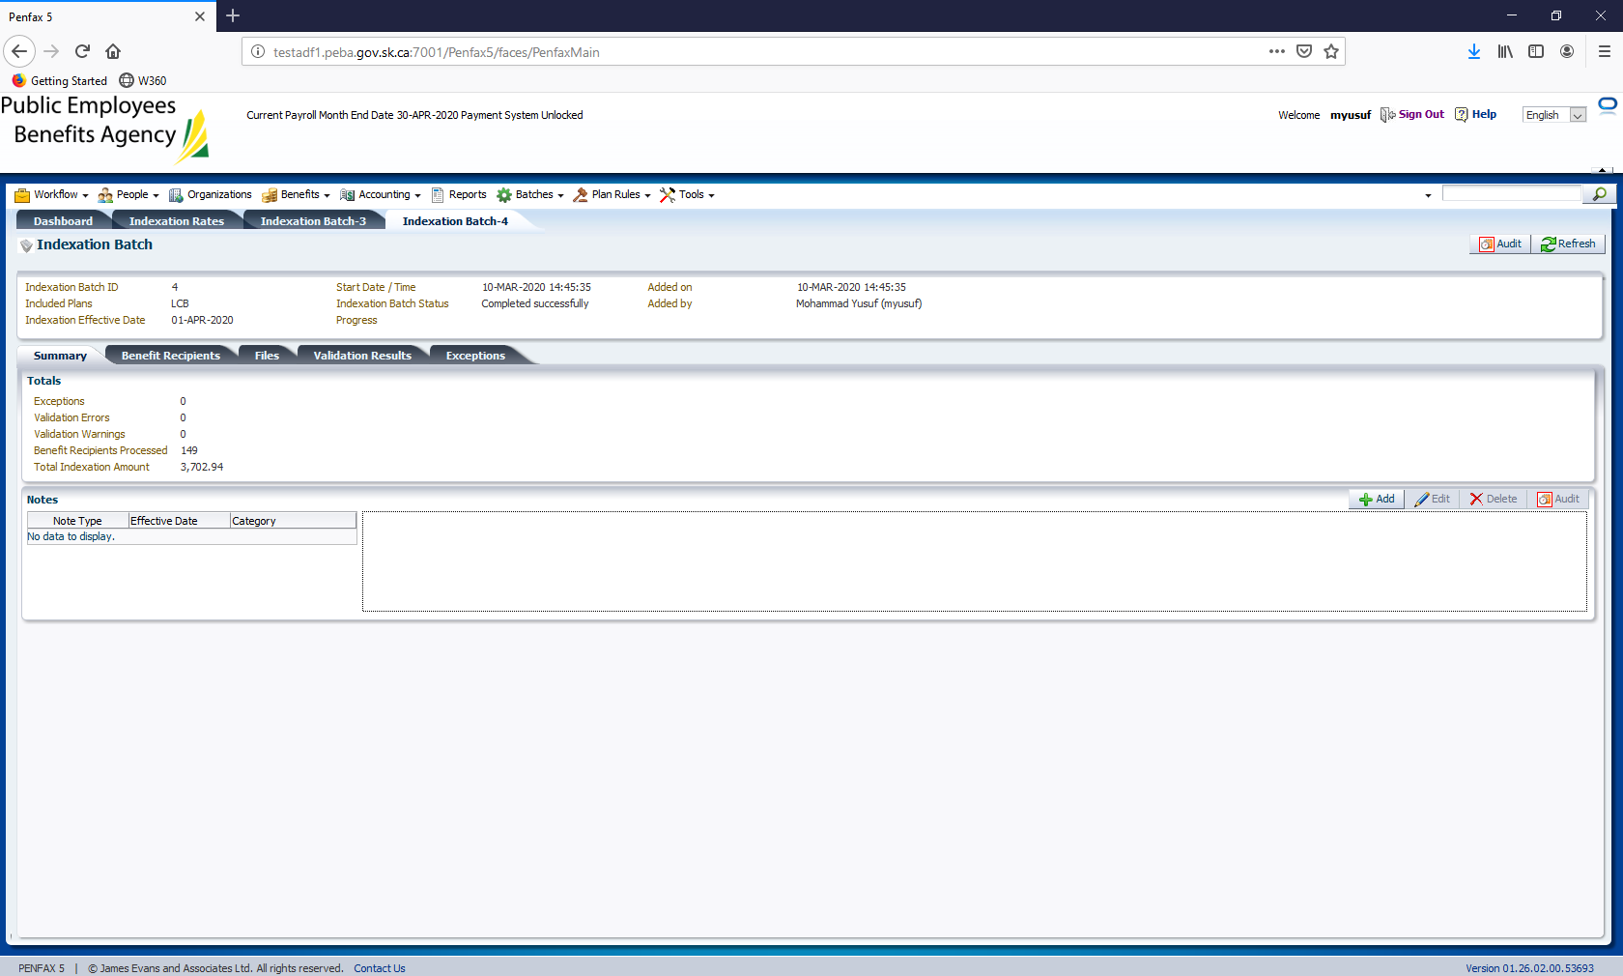

MLA

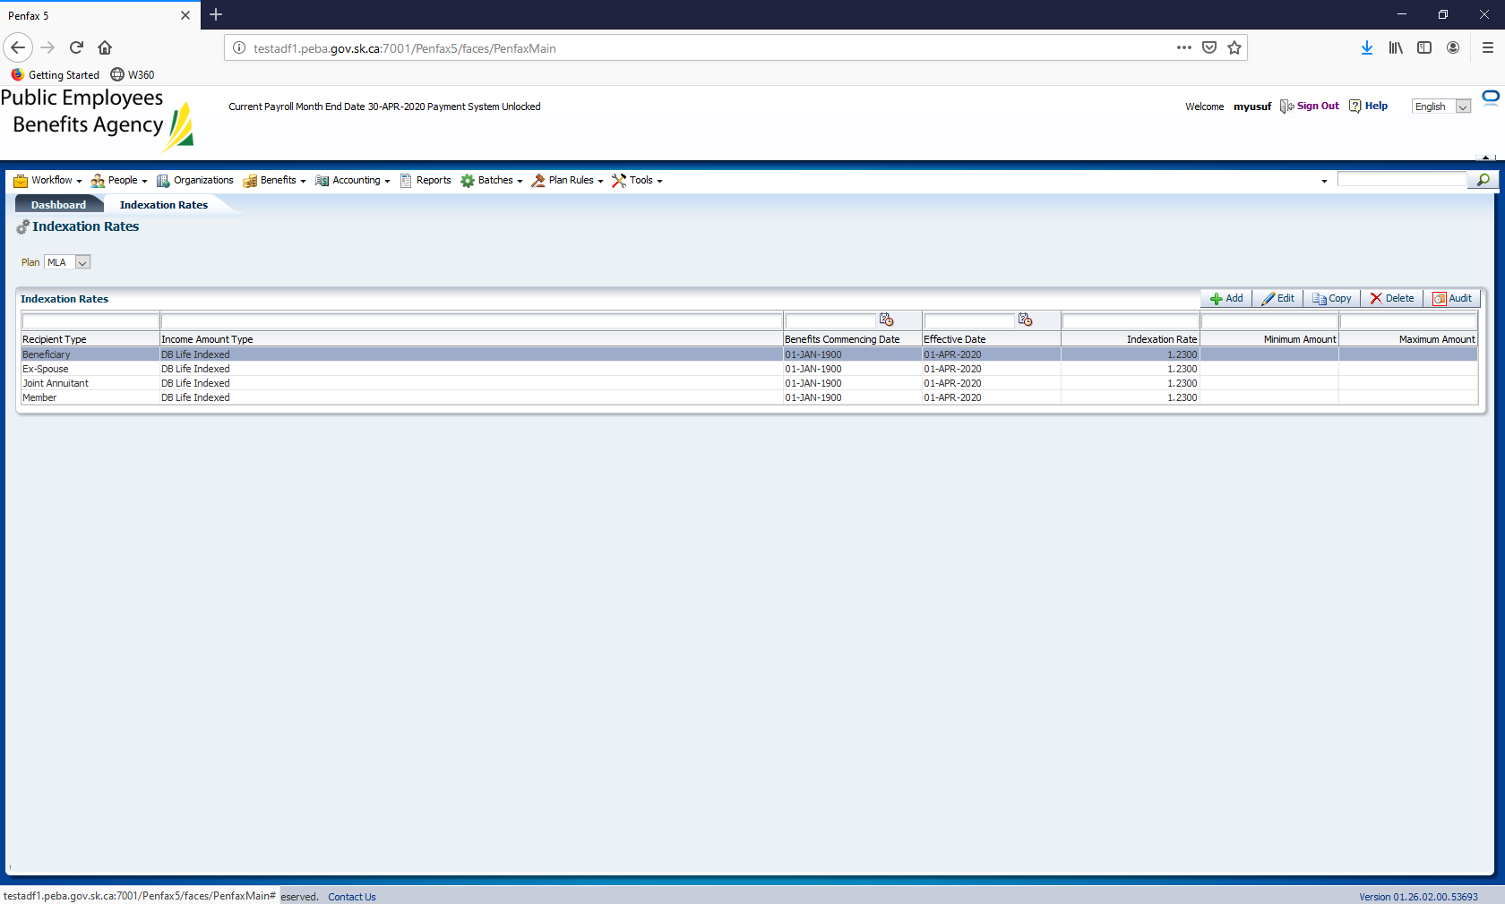

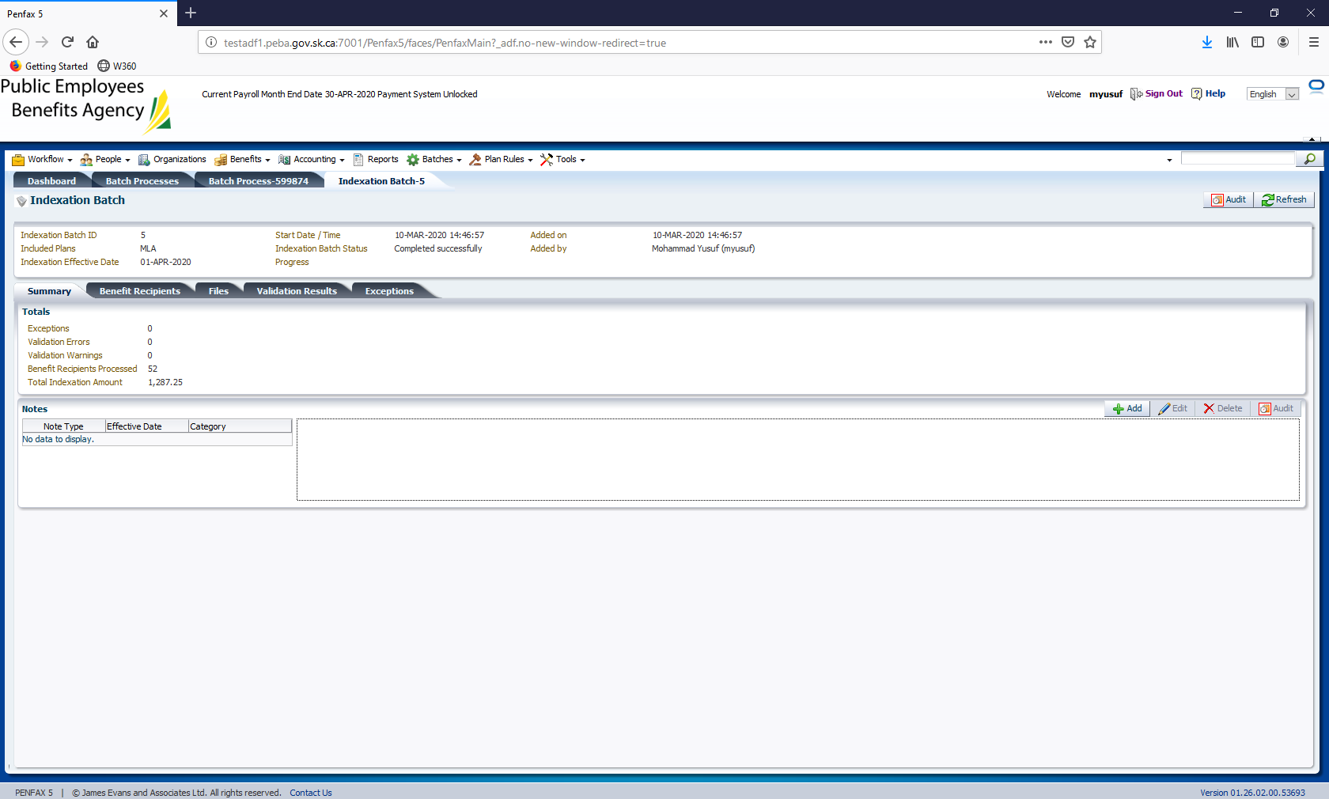

PSSP

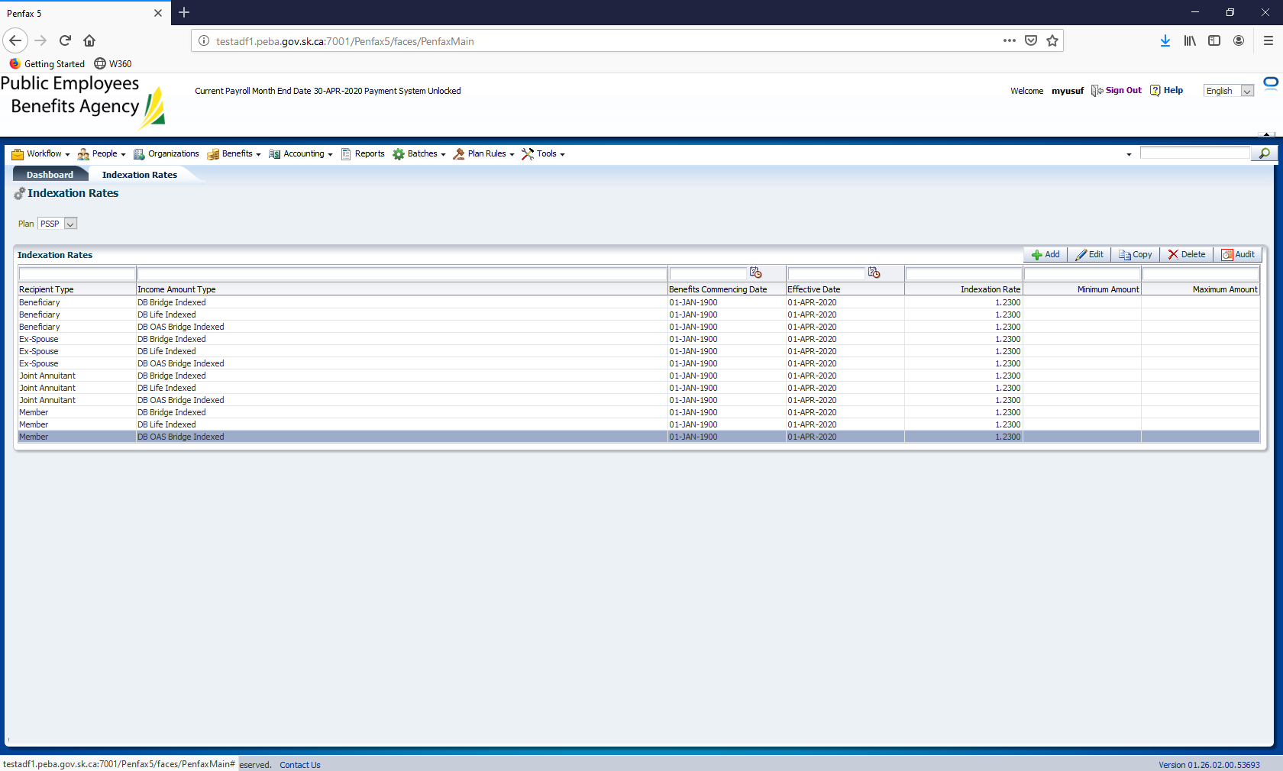

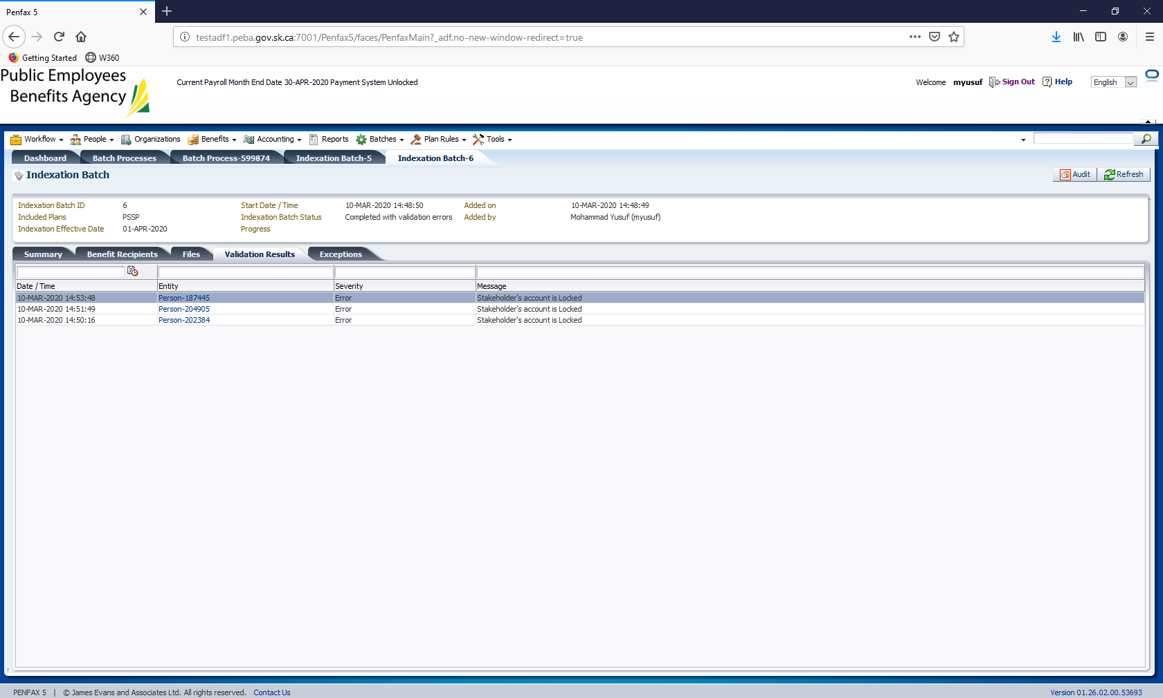

Anything that completes with exceptions or errors please send it to Shane/Dawn/Cindy for review such as in above screenshot

PCSP

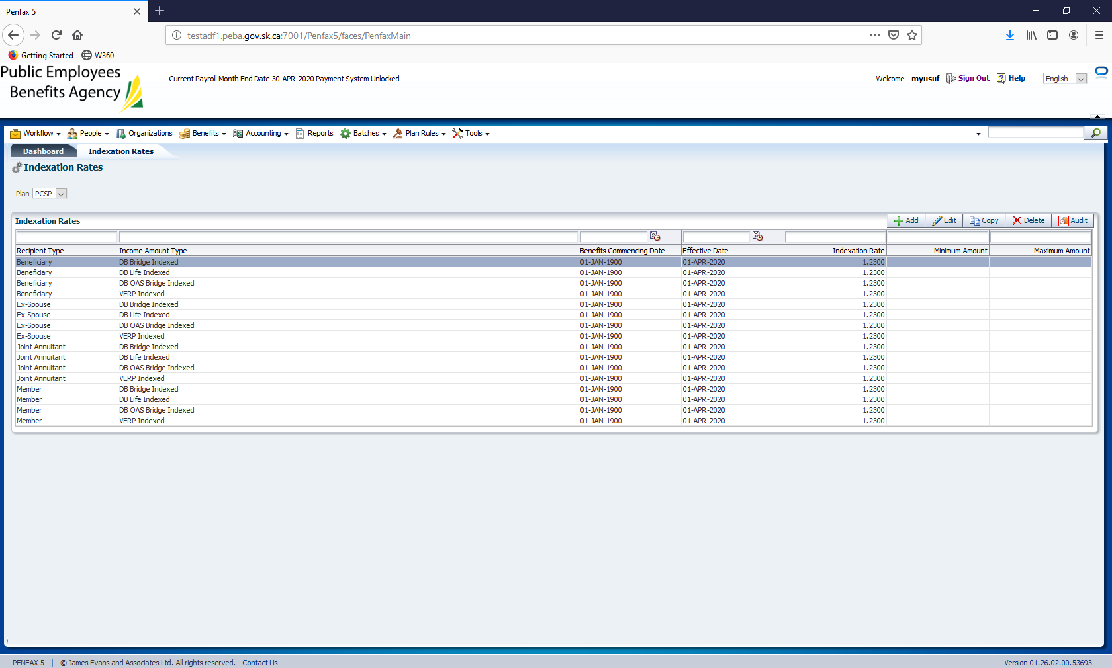

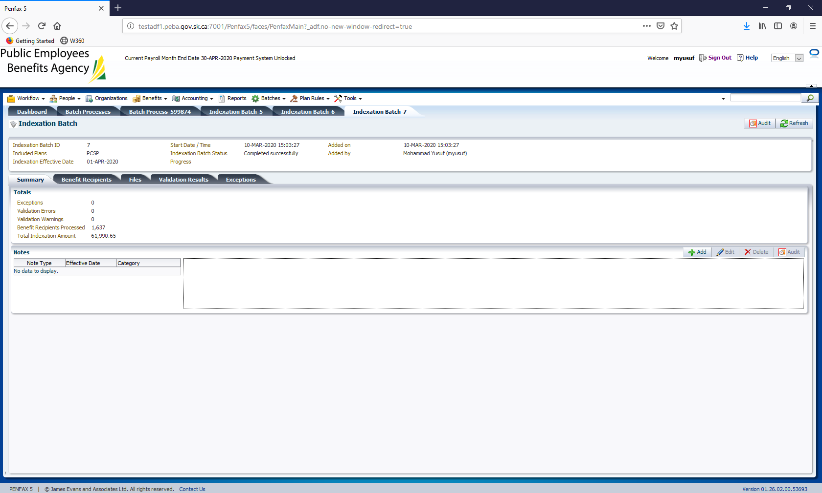

STC

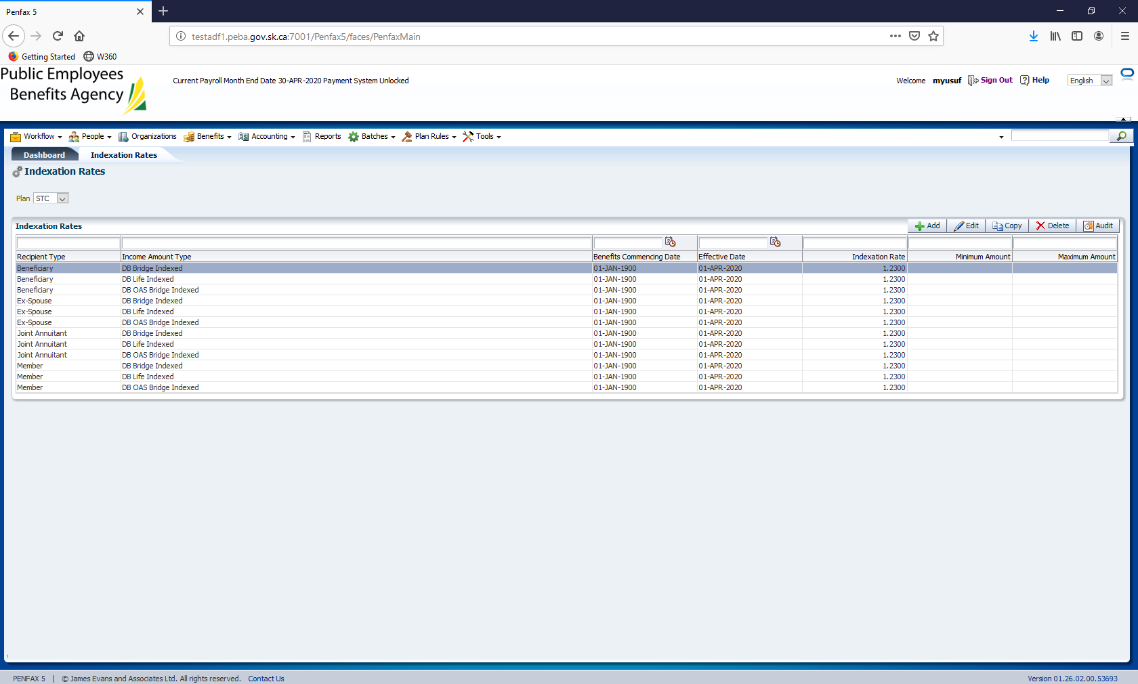

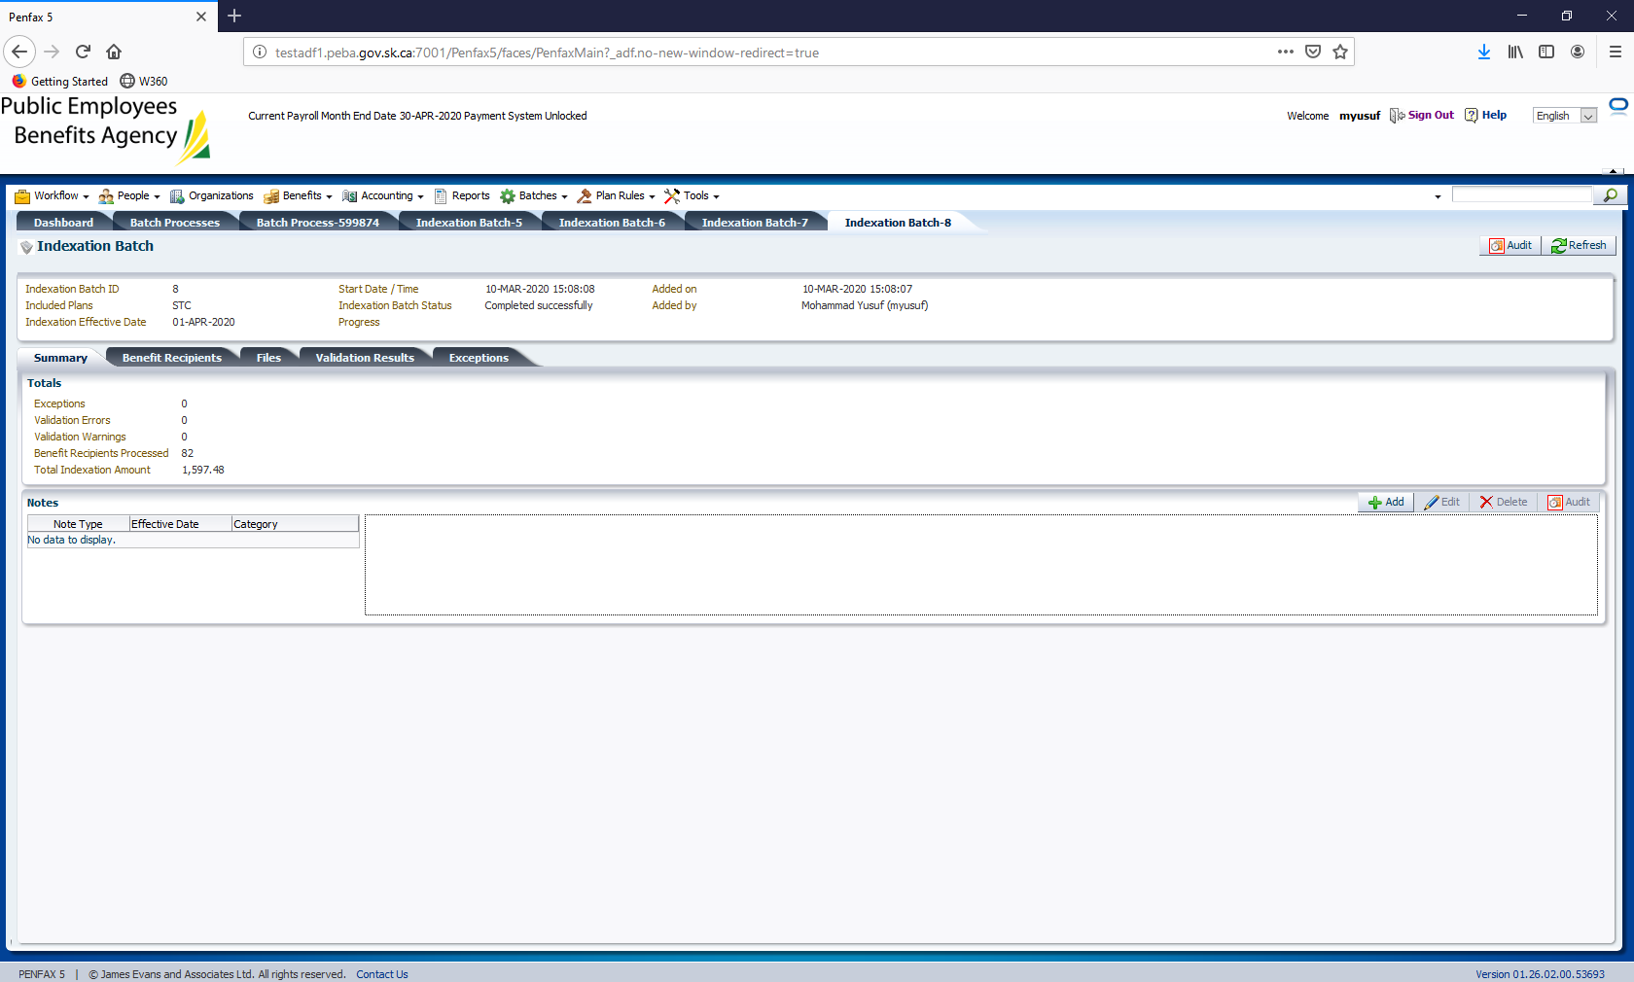

JPCS

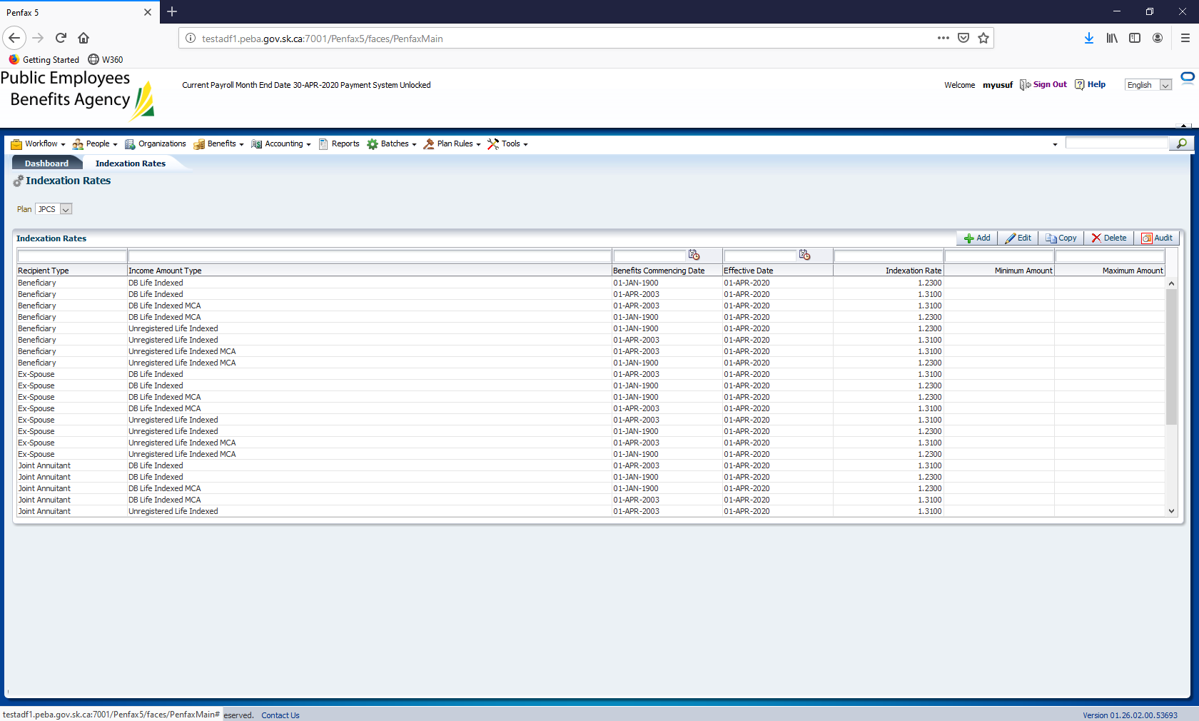

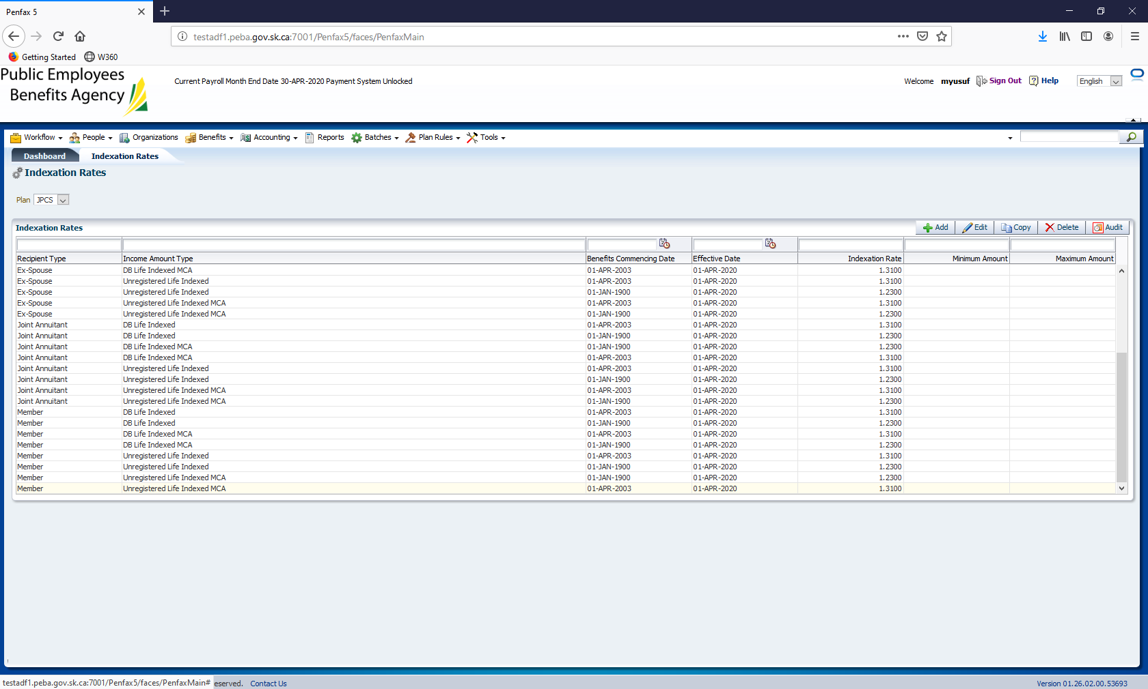

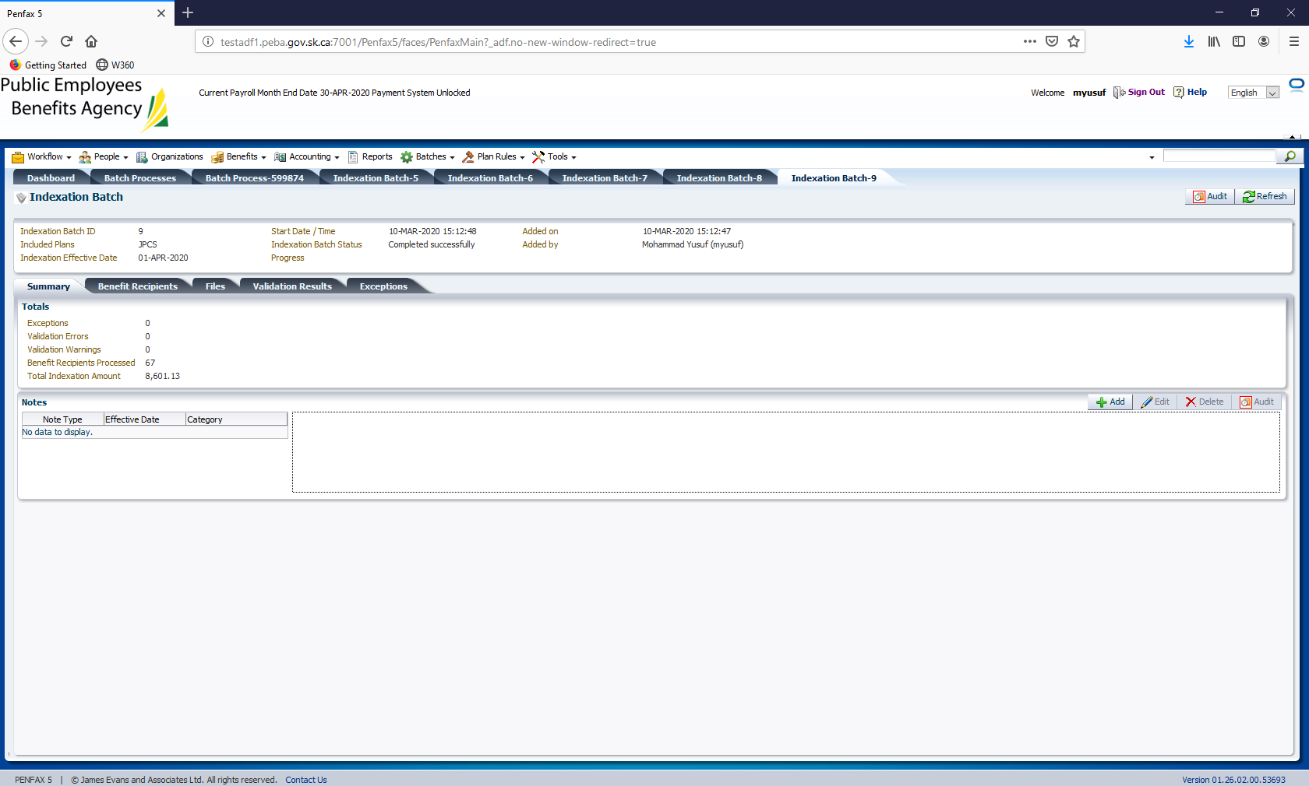

# How to update Blackout dates in PENFAX V5 Test

1. Log into PENFAX V5 Test using your username and password.

<http://prodadf1.peba.gov.sk.ca:7001/Penfax5/login.html>

1. Go to Tools – Blackout Dates

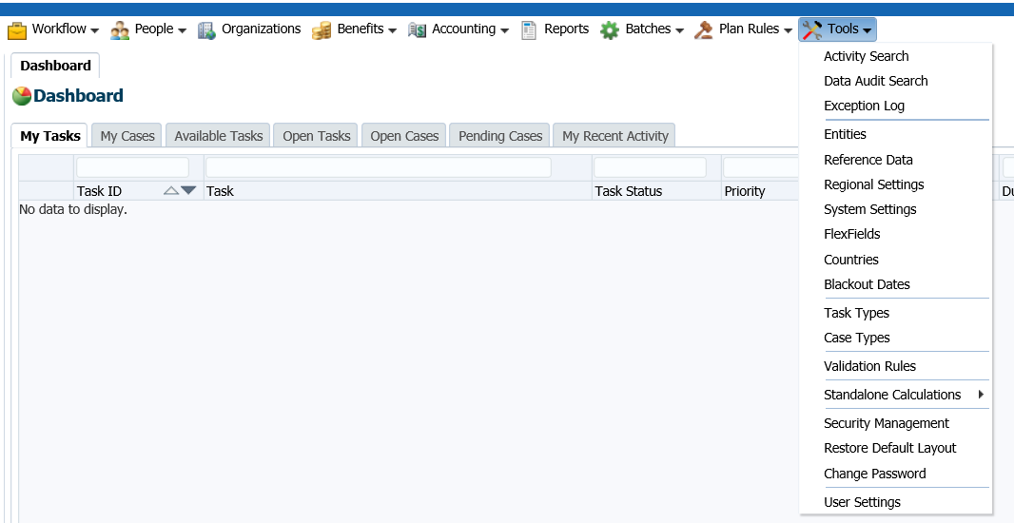

1. Now click on Add

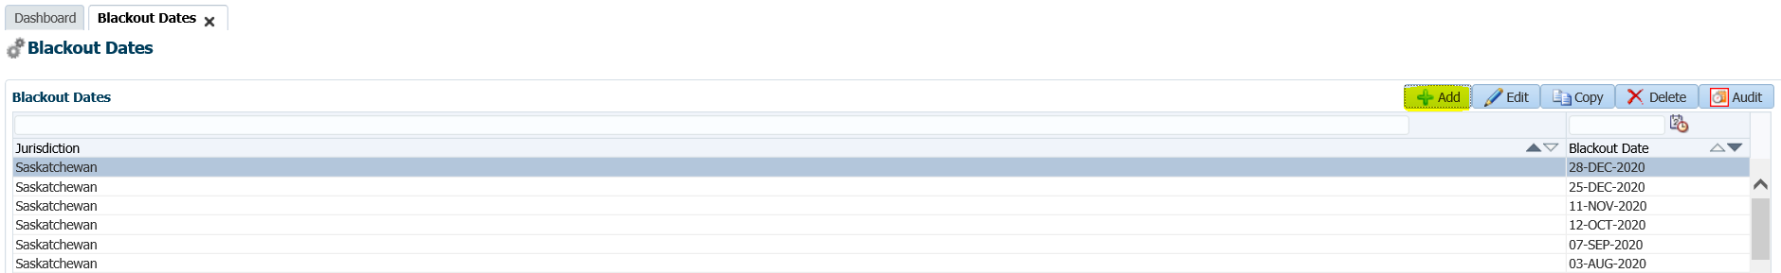

1. Fill out the jurisdiction as Saskatchewan and enter the blackout date. The dates can be found from the following link:

<https://www.saskatchewan.ca/business/employment-standards/vacations-holidays-leaves-and-absences/public-statutory-holidays/list-of-saskatchewan-public-holidays>

1. Click Save.

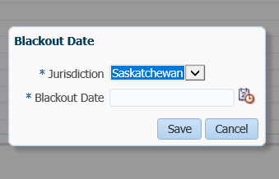

# How to Update the Commuted Value Age Assumptions effective date:

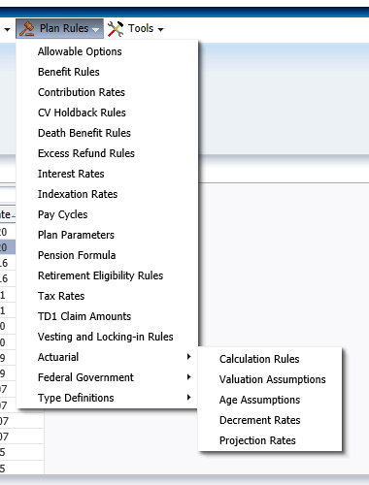

Select MEPP Plan

Locate the two records dated December 1,2020 by sorting on Effective Date.

Select record and update the Effective date as required.

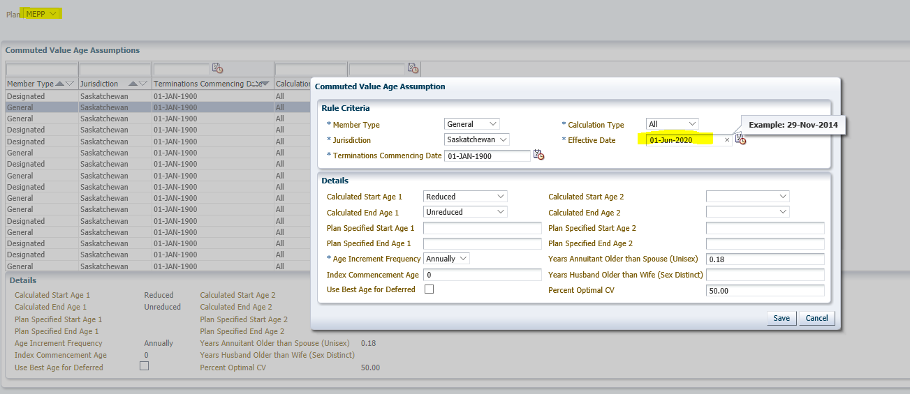

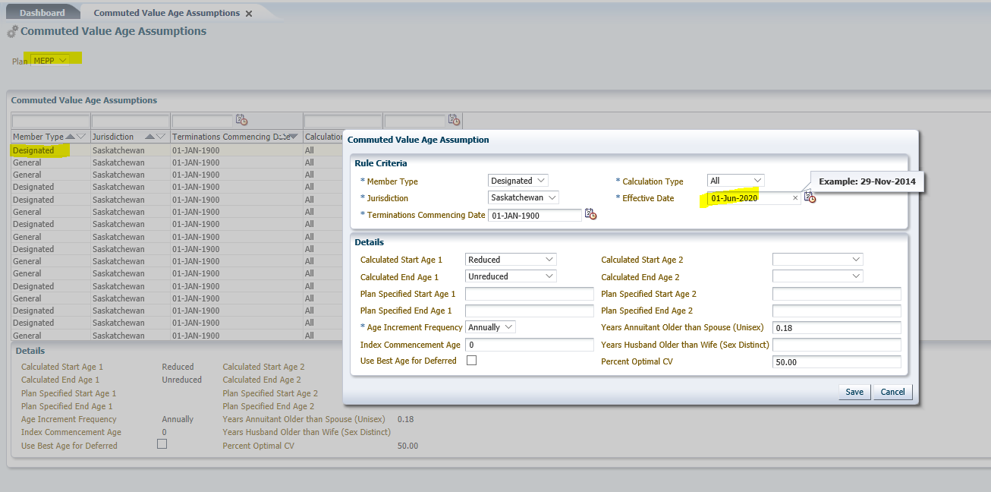

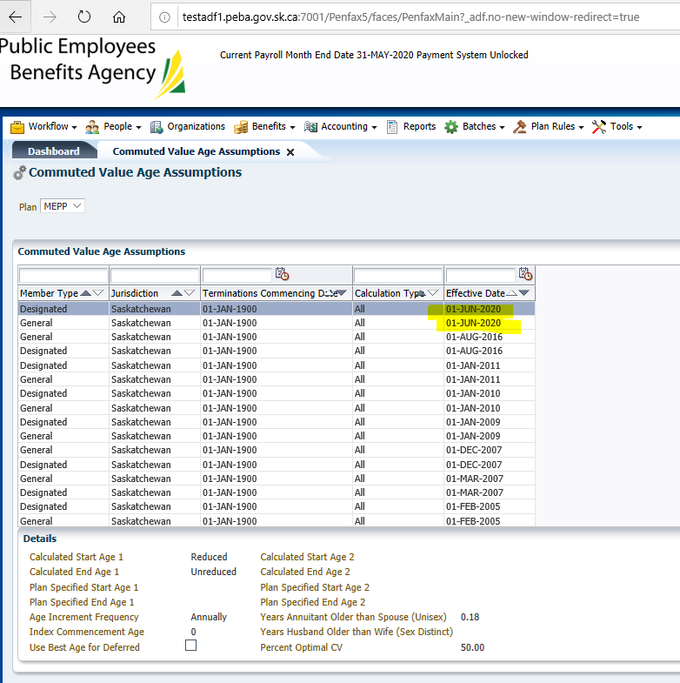

# How to Update TD1 rates in PENFAX V5:

TD1 rates in PENFAX V5 needs to be updated once a year.

1. Go to PENFAX V5 Test, <http://testadf1.peba.gov.sk.ca:7001/Penfax5/login.html>
2. login with your username and password.
3. Go to Plan Rules – TD1 Claim Amounts

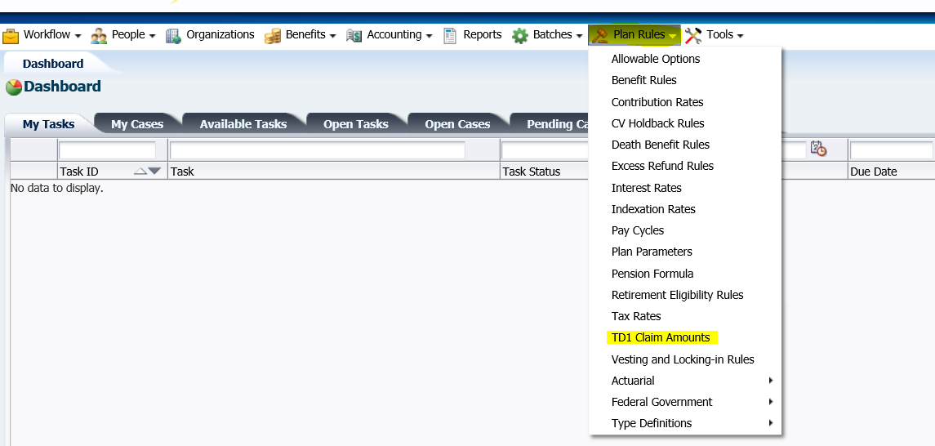

1. You get the following screen

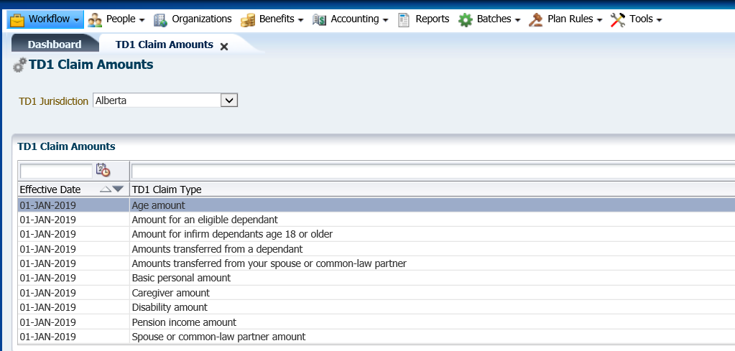

1. Select the jurisdiction you require. e.g. Alberta
2. Go to each claim type and click Edit.

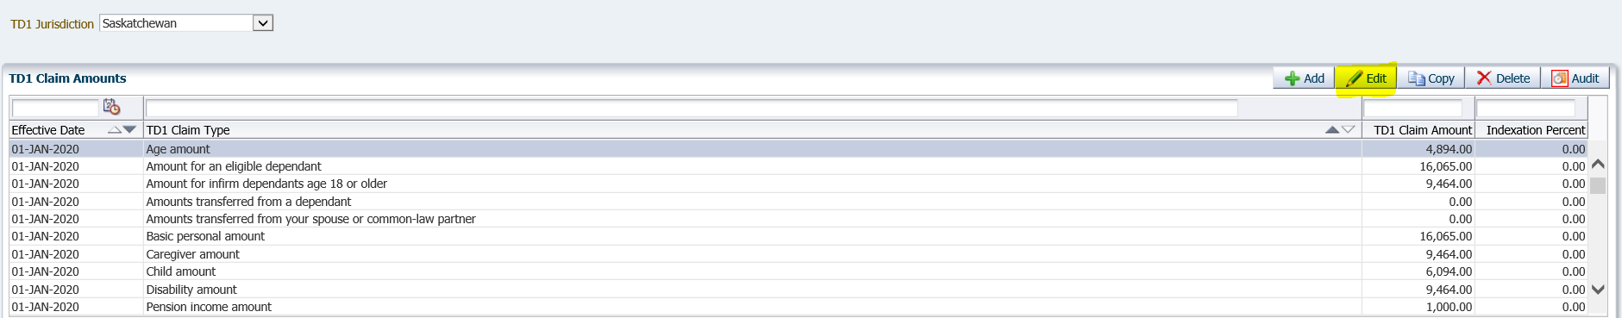

1. You get the following screen, fill in the details (details will be provided by Finance) and click Save.
2. Effective Date is the 1 January <current year> e.g. 01-JAN-2020
3. Similarly fill out all the remaining TD1 Claim Types. There are 12 in total and are listed below.

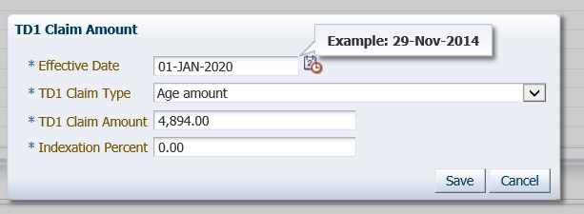

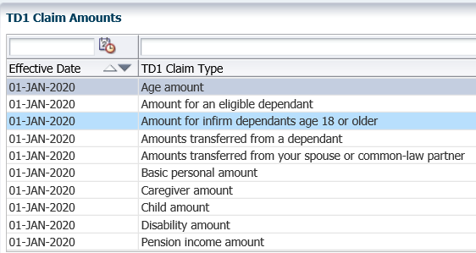

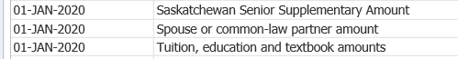

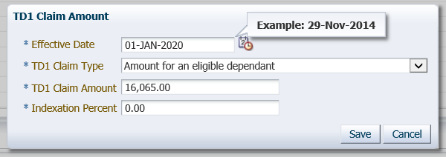

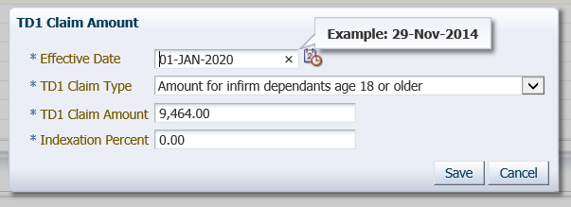

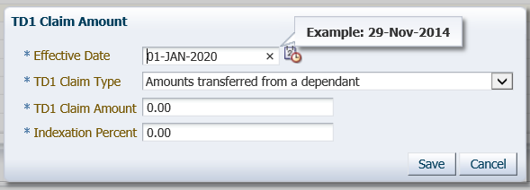

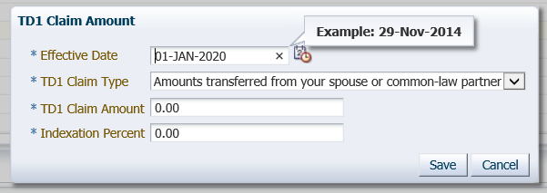

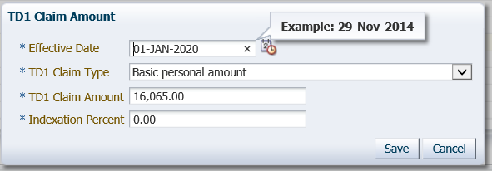

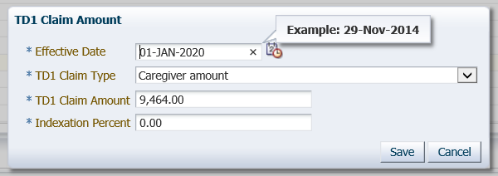

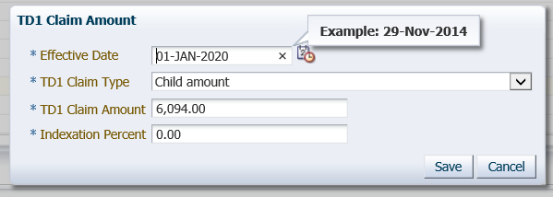

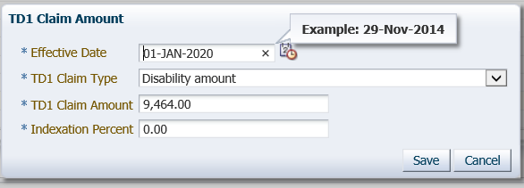

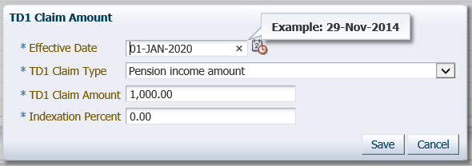

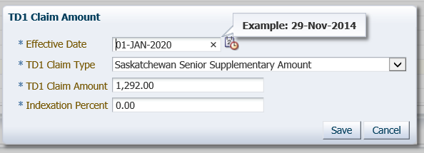

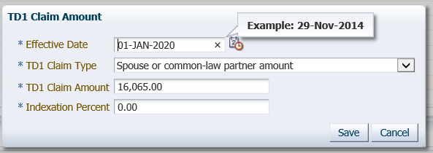

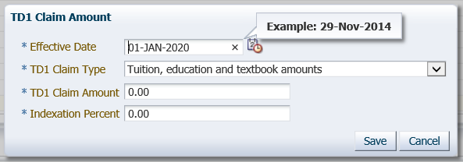

# Quality Assurance procedures for Interest Rates Update

|  |  |
| --- | --- |
| **Title: Quality Assurance procedures for Interest Rates Update** | **Current Version: 1** |
| **Document Owner:**  **Michael Mead** | **Document author:**  **Richard Belanger** |

|  | **Name/Title** | **Signature** | **Date** |
| --- | --- | --- | --- |
| **Reviewed by** | <Person who reviews the work> |  | <dd/mm/yyyy> |
|  |  |  |  |
|  |  |  |  |
| **Approved by** | <Senior Management / Business Area Manager> |  | <dd/mm/yyyy> |
|  |  |  |  |

|  |  |
| --- | --- |
| **Date Issued**: <dd/mm/yyyy> | **Date Revised**: <dd/mm/yyyy> |

**Change / Revision History**

| Date | Author | Version | Change |
| --- | --- | --- | --- |
| 05/11/2018 | Richard Belanger | 1 | Document created |
|  |  |  |  |
|  |  |  |  |
|  |  |  |  |

**Purpose**

Each year, the MEPP Manager receives the interest rates for the upcoming year. The rates received are in affect for the entire year.

**Scope / Applicability**

This document applies to Quality Assurance staff, who will be responsible for updating the system. The document also applies to the MEPP Assistant Manager who will be responsible for reviewing and ensuring the rates are updated correctly. And the two MEPP Supervisors who will perform the Assistant Manager’s duties in their absence.

**Roles and Responsibility**

JEA will send the new rate to the QA Help mailbox when the rates have been verified by JEA and the actuary.

The designated QA member will review the email ensuring a reasonable rate, and an effective date.

If there is any uncertainty regarding the rate and effective date, the QA member must reply to the person from JEA who sent the email to get confirmation of the rate, and/or date if necessary.

When it has been established the rate is valid the designated QA staff will update the rate.

**Procedures**

The two Rates which follow generally keep the same rate throughout the year. The Rate is established for the year in January. If there is a change to the rate during the year, it will be communicated by the MEPP Manager, with the new rate and effective date. For consistency’s sake, update these rates monthly with the others in this document.

**Process for receiving email from JEA**

MEPP manager will send an email to the QA Help mailbox informing that a new rate will be taking affect as well as the effective date.

Example from January 2017:

\Business Validation\QA\Procedures\MEPP Yearend Interest Rate.msg

**Process for Logging into PENFAX V5.0**

Log into PENFAX via the Log In screen



**Process for Navigating to Plan Rules**

On the Dashboard in V5.0 navigate to the menu selection of Plan Rules

Navigate to Plan Rules on the top of the Dashboard



**Process for Selecting Interest Rates**

On Plan Rules click on the dropdown arrow and choose Interest Rates



***\*\*\**Throughout this document please note the Calculation Type and Indexing Type dropdowns for each Interest Rate Type. They must be set as seen to ensure the rates are being applied correctly*\*\*\****



**Process for Selecting MEPP Plan**

On the Plan dropdown select MEPP



**Process for Copying Previous Rate**

The most efficient way to update is to highlight the most recent rate and click Copy, this will keep all of the previous information, so all that needs to be updated is the Effective Date and the Rate.

* Highlight most recent entry
* Click Copy

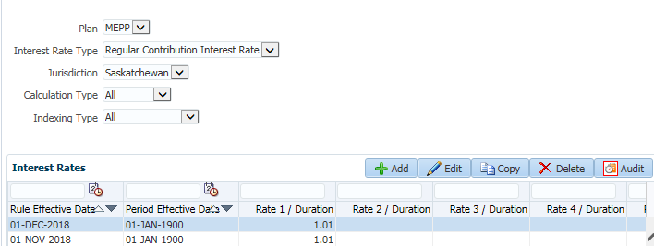

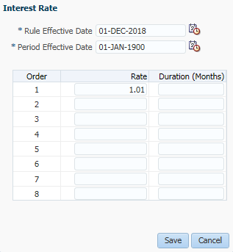

* Input new Effective Date and new Rate by overwriting the existing entries
* Click Save

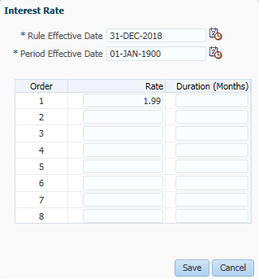

* See Rate Updated

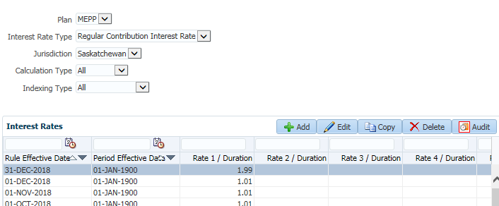

**Update Interest Rates:**

Using the path to Interest Rates and the copy method seen above, update the Interest Rates

* **Regular Contribution Interest Rate-** Rate used to update interest on Excess



Updated

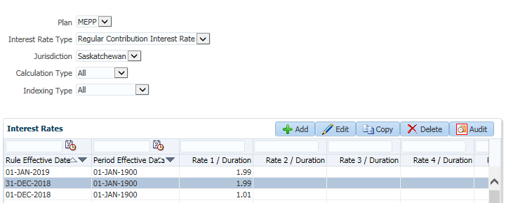

* **Contribution Interest Rate-** Rate used to determine all money buckets interest

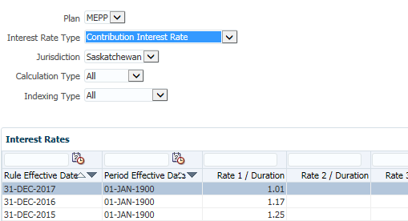

Updated

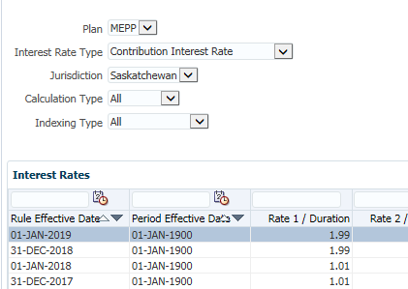

* CV Add-on Discrete interest rate table (instruction from KIM 2021-01-12)

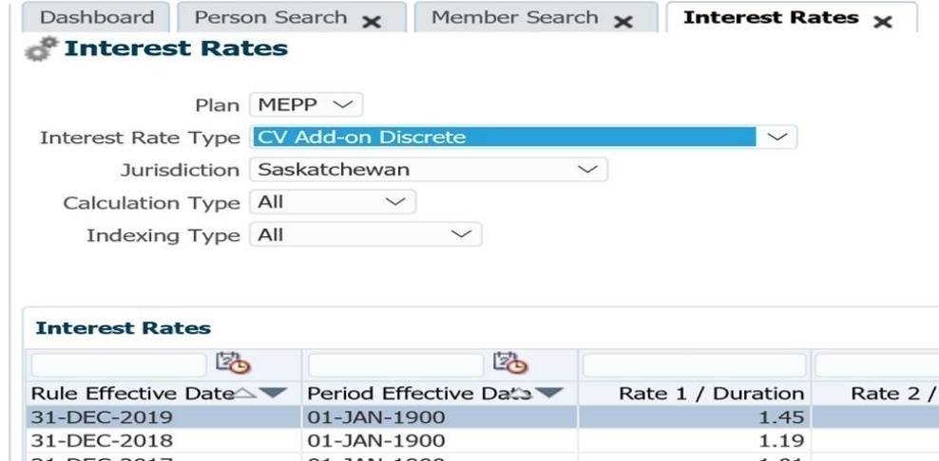

**Document Review Frequency:**

The Document Owner is responsible to ensure this procedure is reviewed at least <frequency> every year.

Any suggestions for improvements can be submitted to the Document Owner for review and consideration. Approved changes will be prioritized and included in the next release of this document.

**BCP requirements:**

a. Do you need this procedure during disaster recovery or business continuity planning?

(Yes / No)

b. Please share the list of things you would need for fulfilling the procedures

(e.g. printer, system, internet, phone, process document, etc.)

**Document References:**

This includes any policy or procedure or guidelines or manual that needs to be referred for the process. If no reference documents required, you may add it as NA

# OSFI Anti-Terrorism Financing Batch

Last update: 15-Jan-19

Revised by: Jeroen Verwaard

**Description:**

The Office of the Superintendent of Financial Institutions (OSFI) Anti-Terrorism Financing batch is required to be run every month by the QA team. This batch will search the stakeholders in the PENFAX system and identify any individual or entity whose name matches the records in the text file that gets downloaded from the Government of Canada Anti-Terrorism Financing website. The lists get updated every month.

When such individual or entity has been identified, this needs to be reported to management with highest priority so proper action can be taken.

For the Individual records, the report will look for stakeholders that are associated with the input plan. This being a member/benefit recipient of that plan, or being a spouse/beneficiary of a member/benefit recipient of that plan, or being named as an alternate payee stakeholder in the payment instructions for a member/benefit recipient of that plan, or the first + last name exists in the payment instructions override payee name.

For the Entity records, the report will look for organizations that are associated with the input plan. This being a benefit recipient of that plan, or being a beneficiary of a member/benefit recipient of that plan, or being named as an alternate payee stakeholder in the payment instructions for a member/benefit recipient of that plan, or the name exists in the payment instructions override payee name.

**OSFI Anti-Terrorism Financing – Individuals:**

* + - Go to the OSFI website <http://www.osfi-bsif.gc.ca/Eng/fi-if/amlc-clrpc/atf-fat/Pages/default.aspx>
    - Download (right-click >> save as) the most recent Anti-terrorism Financing list in TEXT format for both Entities and Individual

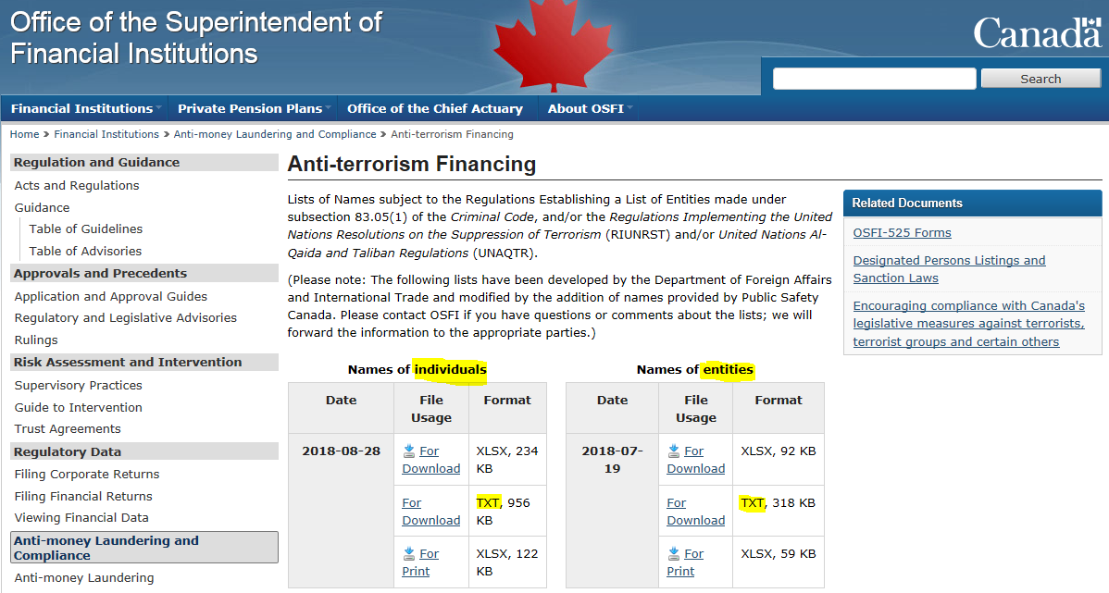

* + - **Save the files to <<insert pathname – To be determined>>**

**OSFI Anti-Terrorism Financing – Individuals:**

1. Log into PENFAX
2. Go to Batches >> Add Batch Process
3. Select Batch Process Type = OSFI Anti-Terrorism Financing – Individuals
4. Click Browse and select the Entities text file

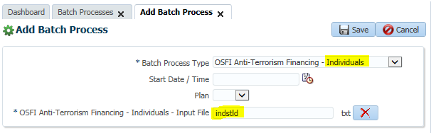

* You can set the start date and time to run the batch at a later date/time
* You can select a specific plan if you don’t want to run the batch for all persons, but this is most likely never done

1. Click Save
2. Click Refresh and verify the process is running

NOTE: This batch will take approximately **5 hours** to complete because it is checking every person in the database (including spouse/beneficiary stakeholders) -- Do not run this batch during business hours as it may slow down the system.

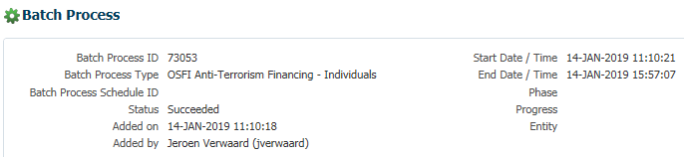

1. Click the Files tab and open the CSV file – if no entity exists in PENFAX that matches a name in the file, this report contains no records

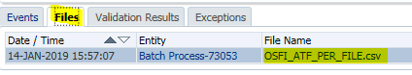

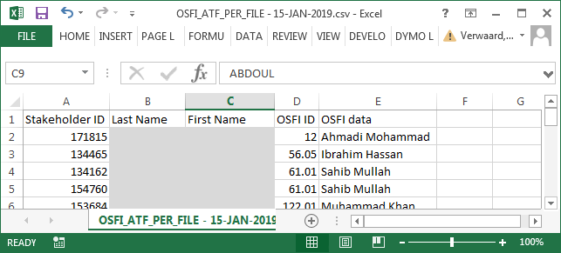

Actual names have been hidden

1. Check the Validation Results tab for records

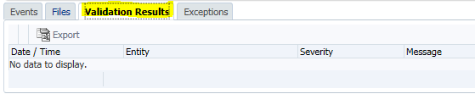

1. Check the Exceptions tab for records

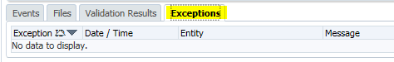

When the report contains any records, MEPP will have to be notified. The actual process has not been defined yet.

**OSFI Anti-Terrorism Financing – Entities:**

1. Log into PENFAX
2. Go to Batches >> Add Batch Process
3. Select Batch Process Type = OSFI Anti-Terrorism Financing – Entities
4. Click Browse and select the Entities text file

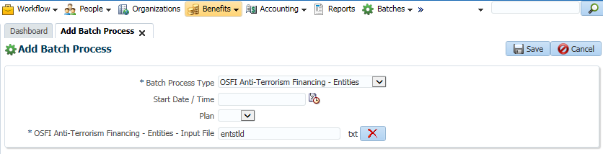

1. Click Save
2. Click Refresh and verify the process is running
3. Wait a couple minutes until the process has been completed

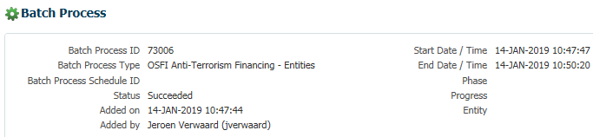

1. Click the Files tab and open the CSV file – if no entity exists in PENFAX that matches a name in the file, this report contains no records

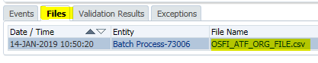

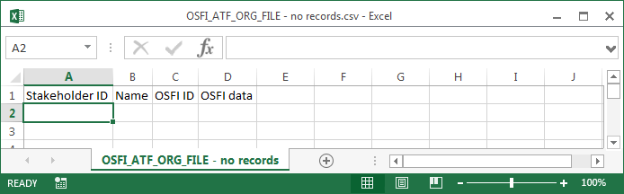

1. Check the Validation Results tab for records

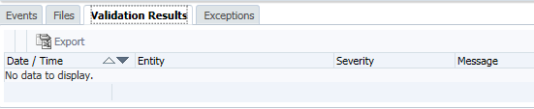

1. Check the Exceptions tab for records

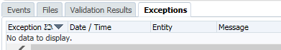

When the report contains any records, MEPP will have to be notified. The actual process has not been defined yet.

# PENFAX User Setup & Maintenance

|  |  |
| --- | --- |
| **Title:** PENFAX User Setup & Maintenance | **Current Version:** 1.0 |
| **Document Owner:**  Michael Mead | **Document author:**  Jeroen Verwaard |

|  | **Name/Title** | **Signature** | **Date** |
| --- | --- | --- | --- |
| **Reviewed by** | <Person who reviews the work> |  | <dd/mm/yyyy> |
|  |  |  |  |
|  |  |  |  |
| **Approved by** | <Senior Management / Business Area Manager> |  | <dd/mm/yyyy> |
|  |  |  |  |

|  |  |
| --- | --- |
| **Date Issued**: 01/05/2019 | **Date Revised**: <dd/mm/yyyy> |

**Change / Revision History**

| Date | Author | Version | Change |
| --- | --- | --- | --- |
| 01/05/2019 | Jeroen Verwaard | 1.0 | Document Created |

**Purpose:**

Users have to be set up or changes have to be made for existing users in the PENFAX system for internal staff.

**Scope / Applicability:**

This document applies to QA staff, who will be responsible for adding and maintaining PENFAX Users in the system.

**Roles and Responsibility:**

Manager/Supervisor of the business area will notify QA of the new users or change to users. QA will perform the tasks and notify the manager/supervisor and affected user after the task has been completed.

**Procedures:**

1. **New User Setup**

When we receive a new user setup form for PLANet, QA will be responsible for setting up internal staff. Employer staff will be set up by the MEPP team.

* Log into PENFAX
* Go to Tools >> Security Management

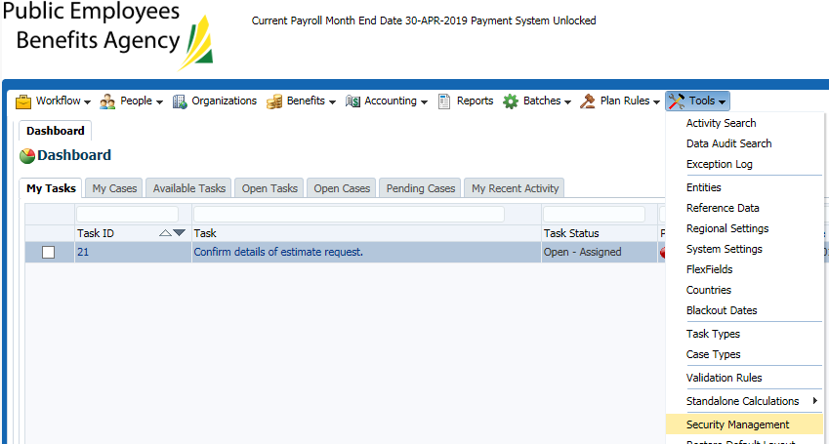

* On the Users tab, click the Add button

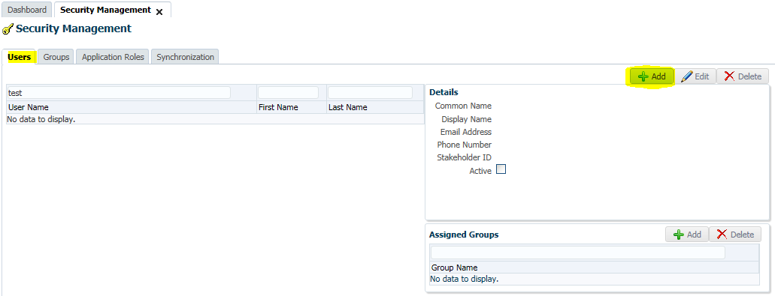

* Enter the Username, First Name, Last Name, Common Name (First + Last Name), email Address and Password. Make sure the “Active” checkbox is selected.
* If the user is also a member of the plan, enter the stakeholder ID if known or use the search function
* Click Save

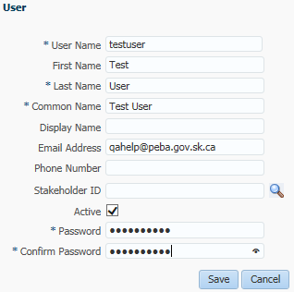

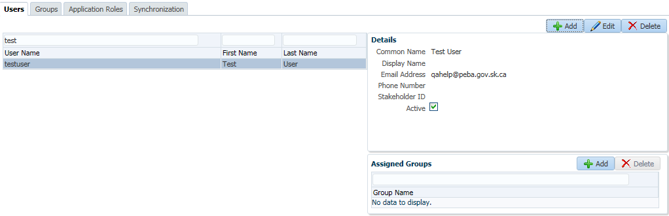

* Click the Add button in the Assigned Groups area
* Select the applicable Groups for the user

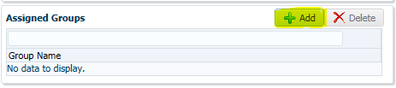

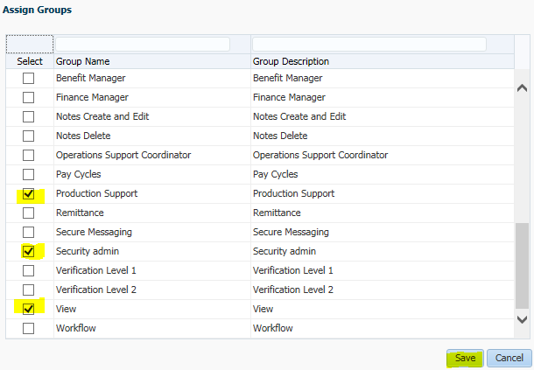

* Click Save
* Notify the requester of the added user and provide the username and password.

New users are not forced to change their password after the initial login but IT/PEBA policy does require this. Once the user is in the system, they have to go to the Tools menu and select “Change Password”.

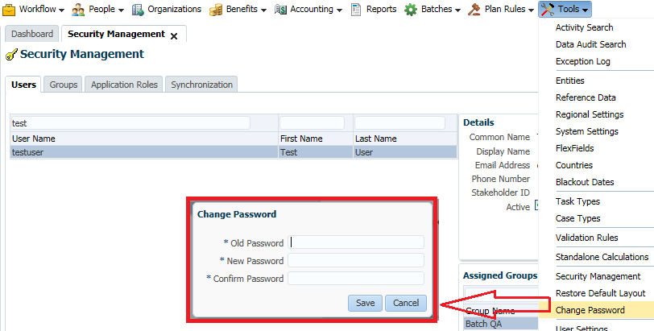

The password requirements are:

* Password should be at least 6 characters long
* The number of uppercase characters in a password cannot be less than 1
* The number of numeric or special characters in a password cannot be less than 1
* Use a password that was already used before

1. **Maintaining existing Users**

Maintaining existing users is when you need to make changes to the user’s details such as name, email address and user roles.

* Log into PENFAX
* Go to Tools >> Security Management
* On the Users tab, select the user and click the Edit button

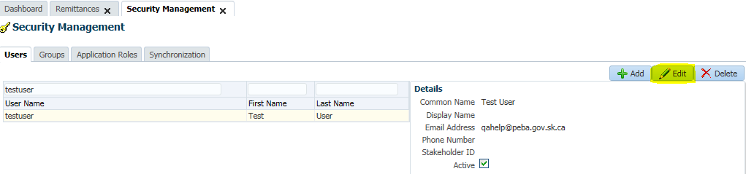

* Change any of the available fields, or click the Active tick box to de-active the account (temporarily)

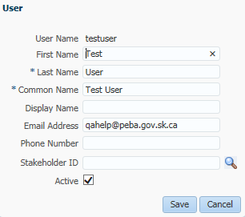

* Click Save

1. **Unlock Account**

When a user enters the incorrect password 3 times their account will become locked. At this point the user cannot use the “Forgot Password” procedure any longer until the account has been unlocked.

We cannot unlock an account in PENFAX, this request will have to send to IT Support.

1. **Reset Password**

When the user has forgotten their password, they can reset it on the PENFAX login page but there may be cases where you need to reset it for the user.

We cannot reset user passwords in PENFAX, this request will have to send to IT Support.

1. **Change User Role**

When we get the request from business to change the user role, we have to change this on the user profile. Be aware that users cannot have multiple user roles selected, doing this will cause issues with their access to PLANet.

1. Log into PENFAX
2. Go to Tools >> Security Management
3. On the Users tab, select the user and click the Add or Delete button to edit the roles the user has access to

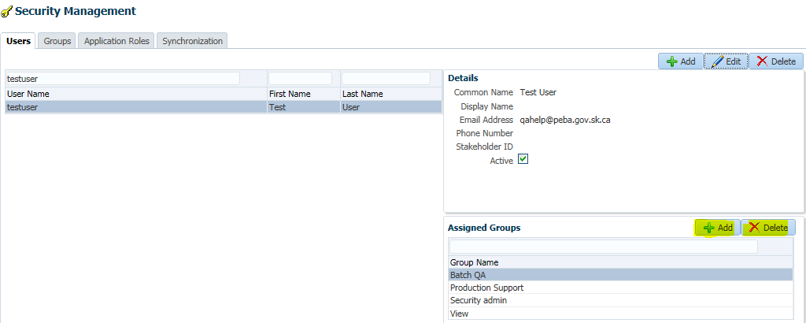

1. **Delete User**

When a user has been set up in error, the username is incorrect or a user no longer needs access to PENFAX, you can delete the entire user profile

1. Log into PENFAX
2. Go to Tools >> Security Management
3. On the Users tab, select the user and click the Delete button

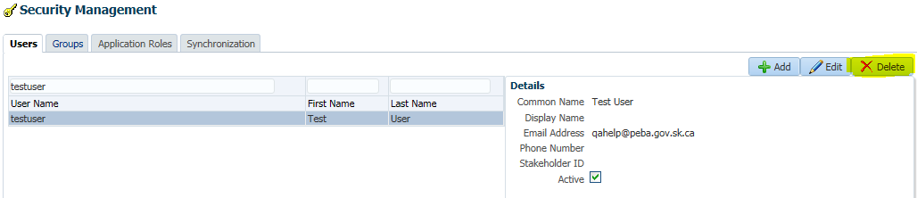

**Document Review Frequency:**

The Document Owner is responsible to ensure this procedure is reviewed at least once a year.

Any suggestions for improvements can be submitted to the Document Owner for review and consideration. Approved changes will be prioritized and included in the next release of this document.

**BCP requirements:**

Do you need this procedure during disaster recovery or business continuity planning?

(Yes / No)

* Yes

Please share the list of things you would need for fulfilling the procedures

(e.g. printer, system, internet, phone, process document, etc.)

* PENFAX 5 application up and running
* Process Document available

**Document References:**

Not applicable.

# MEPP Membership Quarterly Report Information Query

Kim Request: Could someone please create and run me a query in V5 where the member status = Active, Pending, Inactive, Hamlet, and Deferred. I would like the query in Excel and to contain the following information in it:

Member number

SIN Number

Last Name

First Name

Date of Birth

Gender

Member Status

Employer Name

Employer Number

Employer Type

Addition to the request on Aug 23, 2019

Please add Employment Periods (start date and end date) to this query.

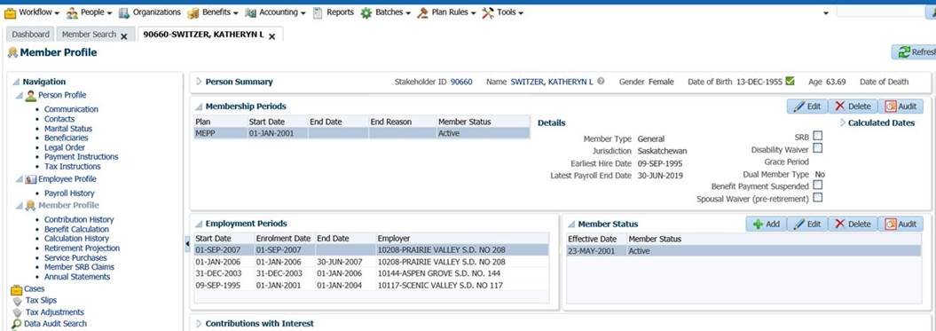

Result: Query was developed SQL developer due to some limitations such as MAX effective date.

Updated Query for MEPP Plan only

SELECT m.STAKEHOLDER_SID,

p.SIN,

p.CURR_FIRST_NAME,

p.CURR_LAST_NAME,

p.DATE_OF_BIRTH,

p.GENDER_CODE,

p.CURR_PHONE,

p.CURR_EMAIL_ADDRESS,

m.CURR_MEMBER_STATUS_CODE,

e.ER_STAKEHOLDER_DESC,

e.START_TS,

e.ENROLMENT_TS,

e.END_TS,

er.EMPLOYER_TYPE_CODE,

a.EFFECTIVE_DATE,

a.ADDRESS_TYPE_CODE,

a.ADDRESS_STATUS_CODE,

a.ADDRESS_LINE_ONE,

a.ADDRESS_LINE_TWO,

a.ADDRESS_LINE_THREE,

a.CITY,

a.PROVINCE_CODE,

a.COUNTRY_CODE,

a.POSTAL_CODE,

e.PLAN

FROM penfax.p_memberships m,

penfax.member_statuses s,

penfax.p_persons p,

penfax.p_addresses a,

penfax.p_employments e,

penfax.p_employers er

WHERE m.MEMBERSHIP_SID = s.MEMBERSHIP_SID

AND p.STAKEHOLDER_SID = m.STAKEHOLDER_SID

AND m.STAKEHOLDER_SID = a.STAKEHOLDER_SID

AND e.MEMBERSHIP_SID = m.MEMBERSHIP_SID

AND e.EMPLOYER_ID = er.EMPLOYER_ID

AND (s.MEMBER_STATUS_CODE IN ('ACT', 'PEND', 'IN')

AND a.EFFECTIVE_DATE =

(SELECT MAX(penfax.addresses.EFFECTIVE_DATE)

FROM penfax.addresses

WHERE penfax.addresses.STAKEHOLDER_SID = a.STAKEHOLDER_SID

)

AND e.PLAN = 'MEPP'

AND s.MEMBER_STATUS_SID =

(SELECT MAX(s1.MEMBER_STATUS_SID)

FROM penfax.member_statuses s1

WHERE s1.MEMBERSHIP_SID = s.MEMBERSHIP_SID

AND s1.EFFECTIVE_DATE =

(SELECT MAX(penfax.member_statuses.EFFECTIVE_DATE)

FROM penfax.member_statuses

WHERE penfax.member_statuses.MEMBERSHIP_SID = s1.MEMBERSHIP_SID

)

))

ORDER BY m.STAKEHOLDER_SID

Screenshot from SQL developer

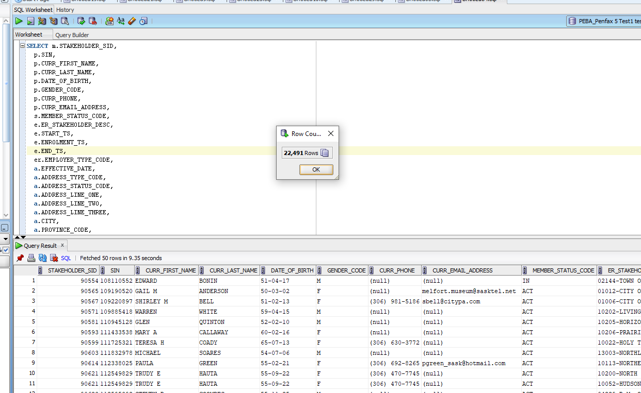

First: Modify this query as per the requirements by Kim or Elaine. Then copy and paste the query in SQL Developer and execute the query in PENFAX 5 Test environment. Verify the results with another QA or with the business, if they need additional changes.

**Note:** Please complete all the changes to query in test before asking IT to run it in production.

In the end, send the request to IT help and ask them to fetch results from production. Validate the data from production application and forward it to Business (Kim or Elaine).

Email sent to IT Help

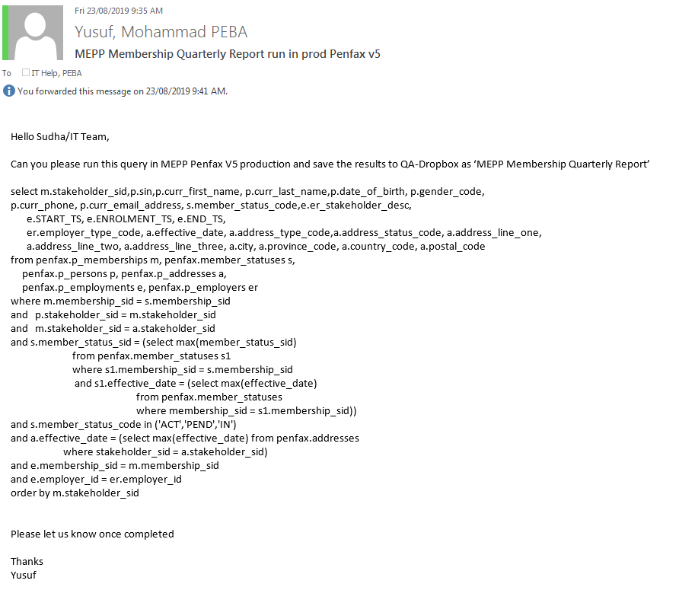

Results Sample Screenshot

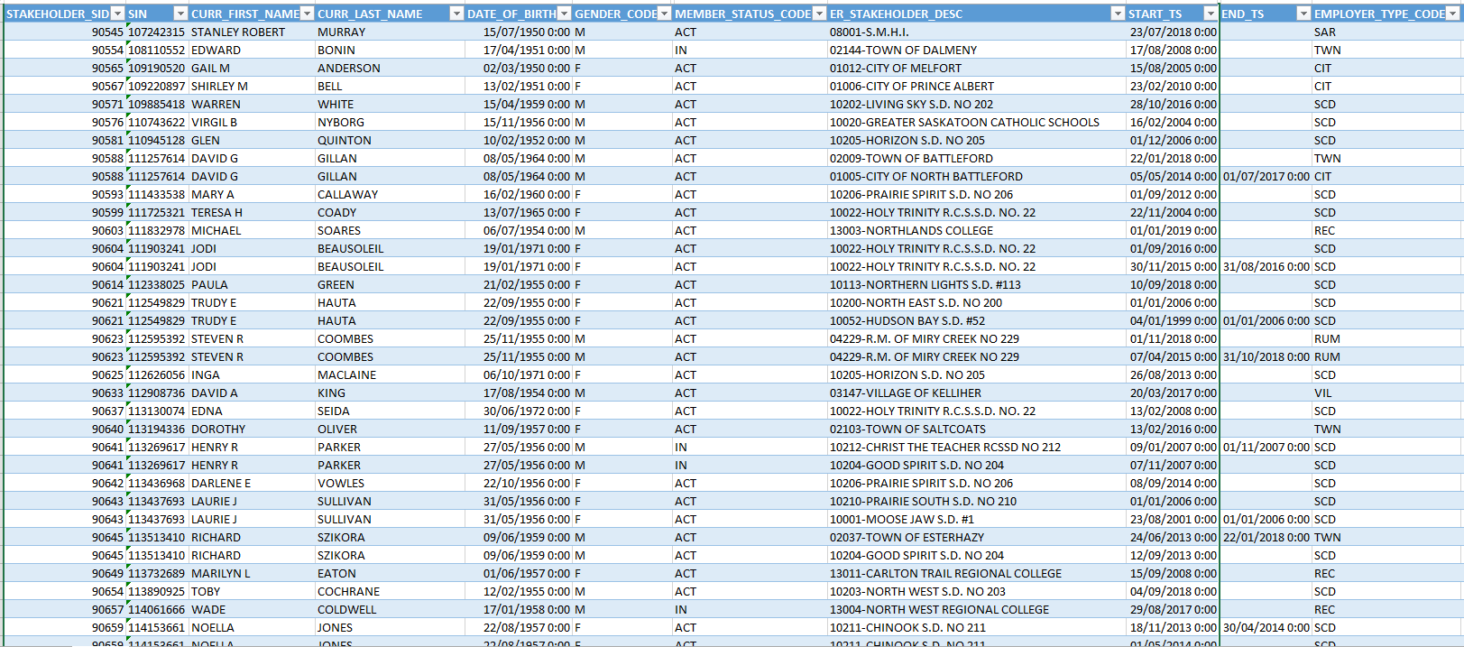

# Quality Assurance procedures for SPAF Quarterly Report

|  |  |
| --- | --- |
| **Title:**  **Quality Assurance procedures for SPAF Quarterly Report** | **Current Version: 1** |
| **Document Owner:**  **Michael Mead**  **Pana Wiegers** | **Document author:**  **Yusuf** |

|  |  |  |  |
| --- | --- | --- | --- |
|  |  |  |  |
| Reviewed by |  | <Tile> | <dd/mm/yyyy> |
| Approved by |  | <Tile> | <dd/mm/yyyy> |
|  |  |  |  |
| Date Issued | 08/10/2019 | Date Revised | <dd/mm/yyyy> |

**SPAF Quarterly Report:**

Elaine Request: Please provide me with the following information from PENFAX 5 for the SPAF Quarterly Report:

Plan

Sub-plan

Stakeholder Number

Benefit Event ID

Surname

Given Name

Recipient Type

Birthdate

Benefit Type

Death Date

Status

Income Amount

Income Amount Type

Benefit Event ID Event Date

Income Amount End Date

Where the Plan is SPAF,

the Death Date is null,

the Benefit type is Income,

the Income Amount End date is > 30-Jun-2019 or Null

**Note**: Amount End Date will need to be modified as per the quarter/results

Result: Query was developed in BI Publisher. QA can create a new data using the query below:

select "P_BENEFIT_RECIPIENTS"."PLAN" as "PLAN",

"P_INCOME_AMOUNTS"."INCOME_FREQUENCY_CODE" as "INCOME_FREQUENCY_CODE",

"P_BENEFIT_RECIPIENTS"."STAKEHOLDER_SID" as "STAKEHOLDER_SID",

"P_BENEFIT_RECIPIENTS"."BENEFIT_EVENT_SID" as "BENEFIT_EVENT_SID",

"P_PERSONS"."CURR_LAST_NAME" as "CURR_LAST_NAME",

"P_PERSONS"."CURR_FIRST_NAME" as "CURR_FIRST_NAME",

"P_BENEFIT_RECIPIENTS"."BENEFIT_RECIPIENT_TYPE_CODE" as "BENEFIT_RECIPIENT_TYPE_CODE",

"P_PERSONS"."DATE_OF_BIRTH" as "DATE_OF_BIRTH",

"P_BENEFIT_RECIPIENTS"."BENEFIT_TYPE_CODE" as "BENEFIT_TYPE_CODE",

"P_PERSONS"."DATE_OF_DEATH" as "DATE_OF_DEATH",

"P_BENEFIT_RECIPIENTS"."BENEFIT_RECIPIENT_STATUS_CODE" as "BENEFIT_RECIPIENT_STATUS_CODE",

"P_INCOME_AMOUNTS"."AMOUNT" as "AMOUNT",

"P_INCOME_AMOUNTS"."INCOME_AMOUNT_TYPE_CODE" as "INCOME_AMOUNT_TYPE_CODE",

"P_BENEFIT_RECIPIENTS"."EVENT_DATE" as "EVENT_DATE",

"P_INCOME_AMOUNTS"."END_DATE" as "END_DATE"

from "P_PENFAX"."P_INCOME_AMOUNTS" "P_INCOME_AMOUNTS",

"P_PENFAX"."P_PERSONS" "P_PERSONS",

"P_PENFAX"."P_BENEFIT_RECIPIENTS" "P_BENEFIT_RECIPIENTS"

where "P_BENEFIT_RECIPIENTS"."STAKEHOLDER_SID"="P_PERSONS"."STAKEHOLDER_SID"

and "P_BENEFIT_RECIPIENTS"."BENEFIT_RECIPIENT_SID"="P_INCOME_AMOUNTS"."BENEFIT_RECIPIENT_SID"

and "P_BENEFIT_RECIPIENTS"."PLAN" ='SPAF'

and "P_BENEFIT_RECIPIENTS"."BENEFIT_TYPE_CODE" ='I'

Running the report in PENFAX V 5 production BI Publisher:

Log into PENFAX 5 production, enter credentials.

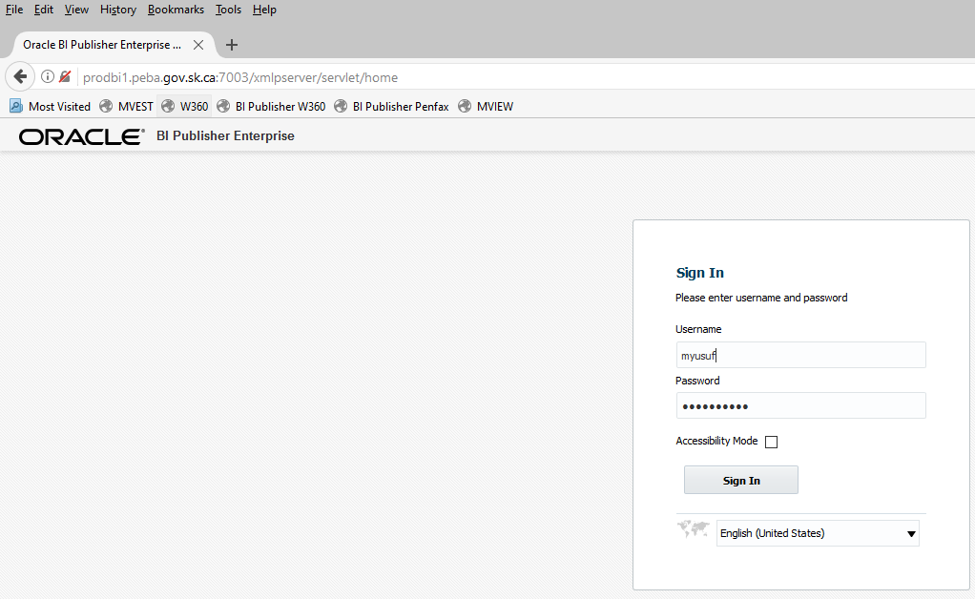

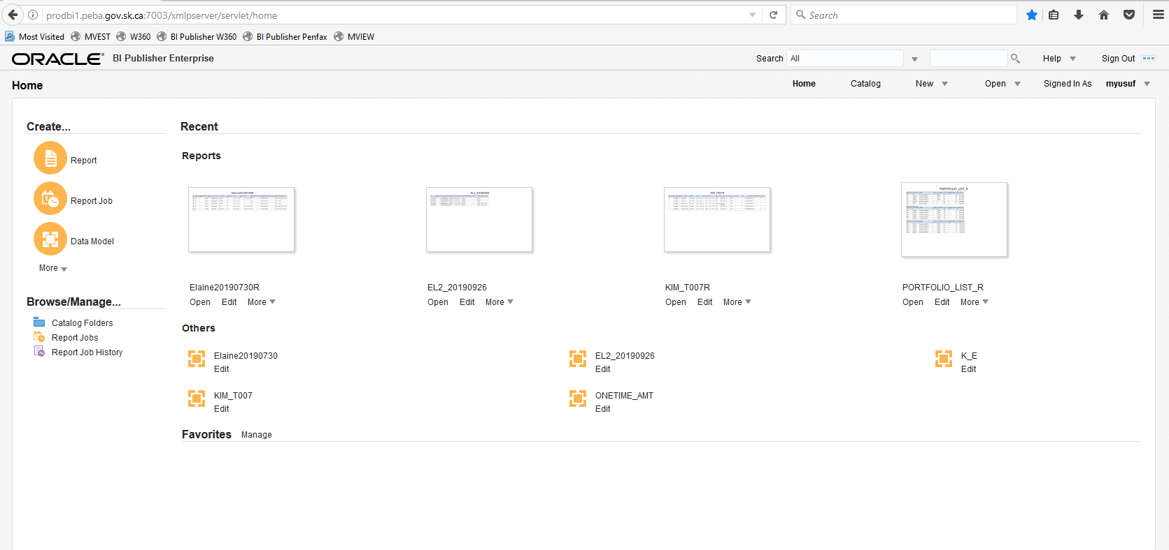

Click on Catalog, and navigate under Shared Folders

Navigate to the report: **Shared Folder-> QA-> PENSIONER_SER.** Click on Open

**Note**: Please note that Data Model is saved in the same location. If you required to change data model, please test the new business requirements in test instead of production.

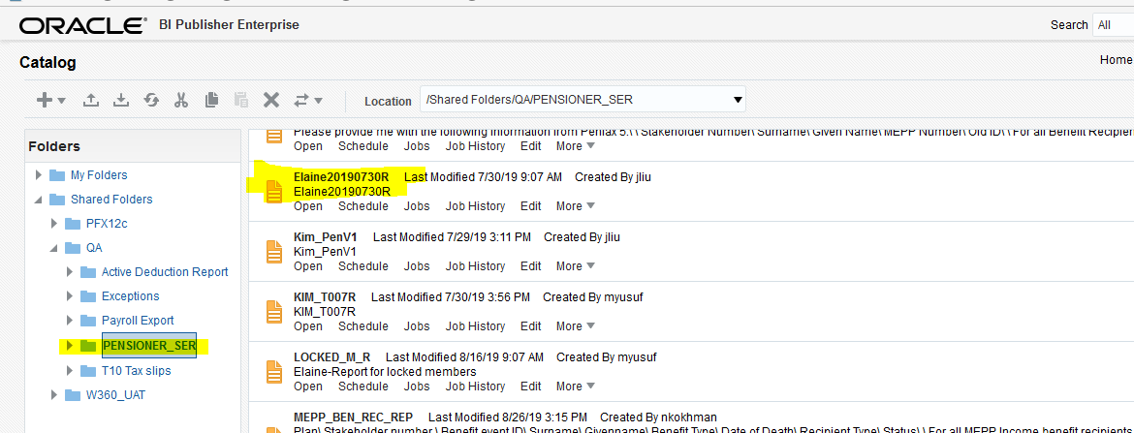

Using dropdown, select Excel option to generate report and saved it under Pensioner Services folder \\pebafs\active\Pension Programs\Dropbox\Retired Members

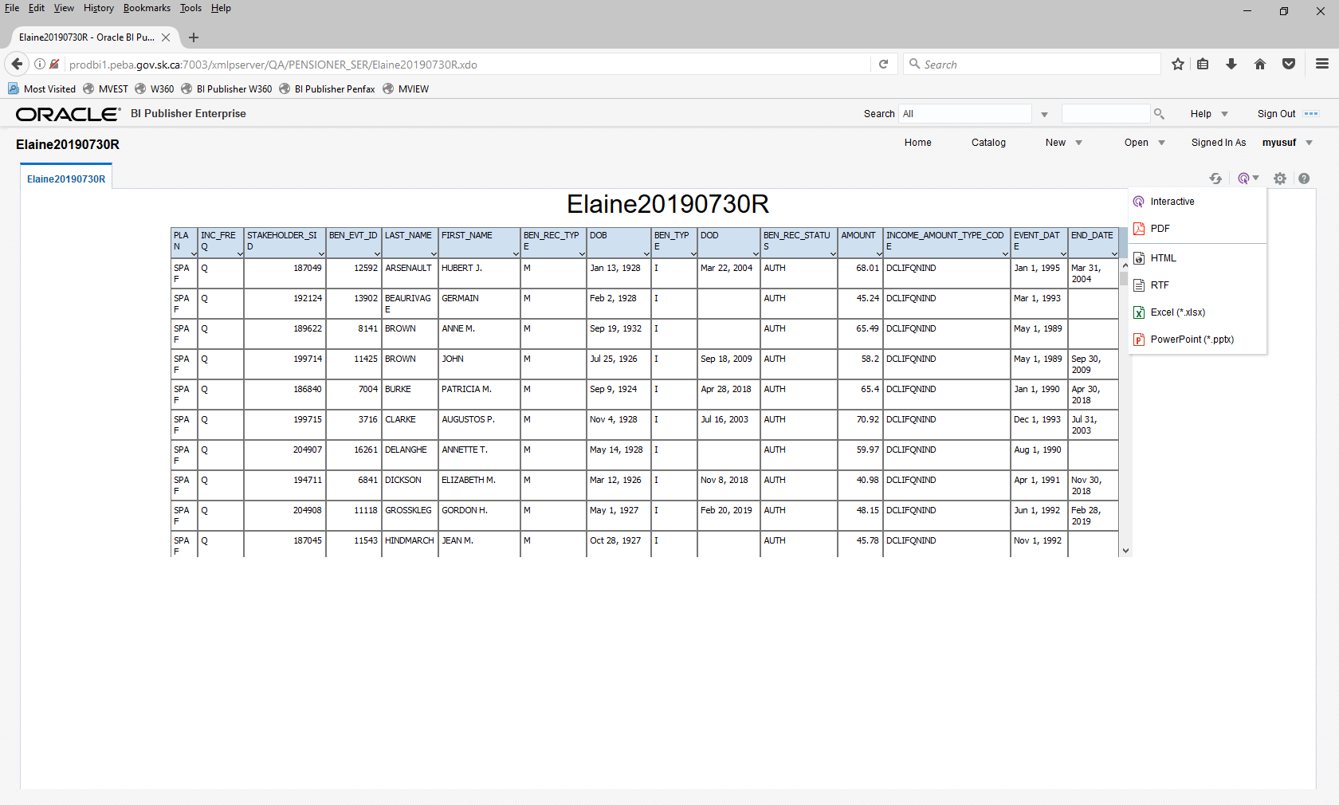

Click on OK, to generate the required workbook.

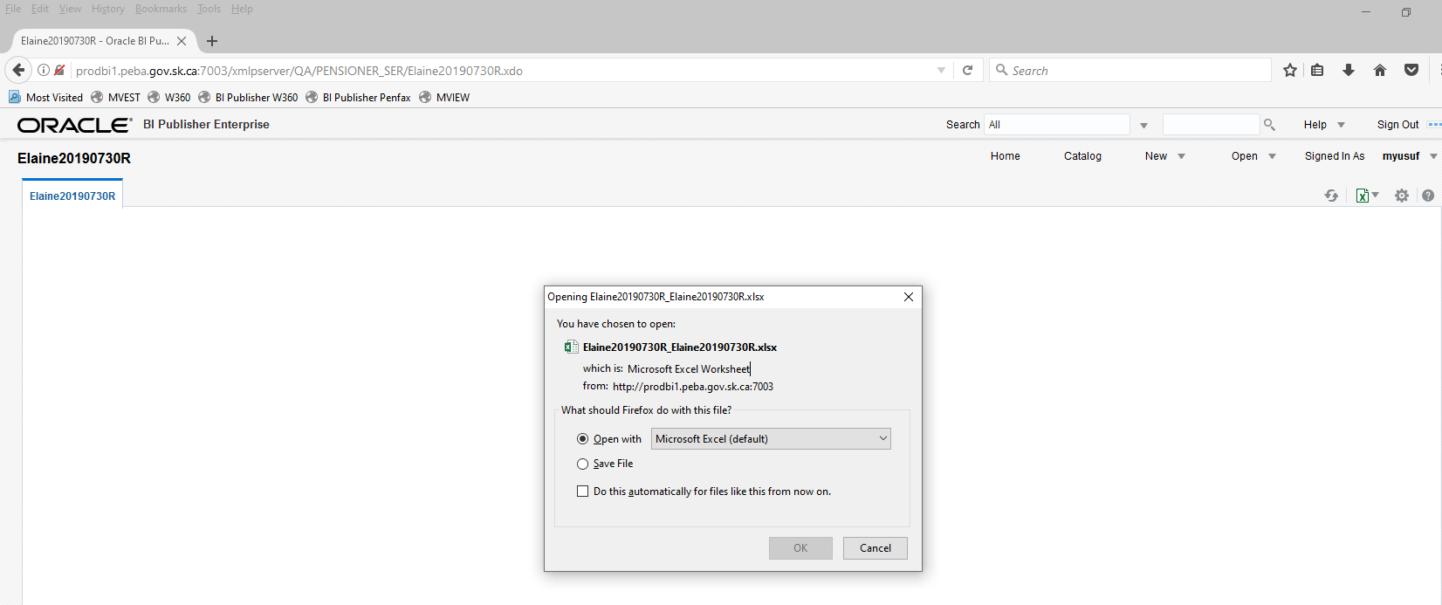

Report that was created for Business/Elaine.

Sample:

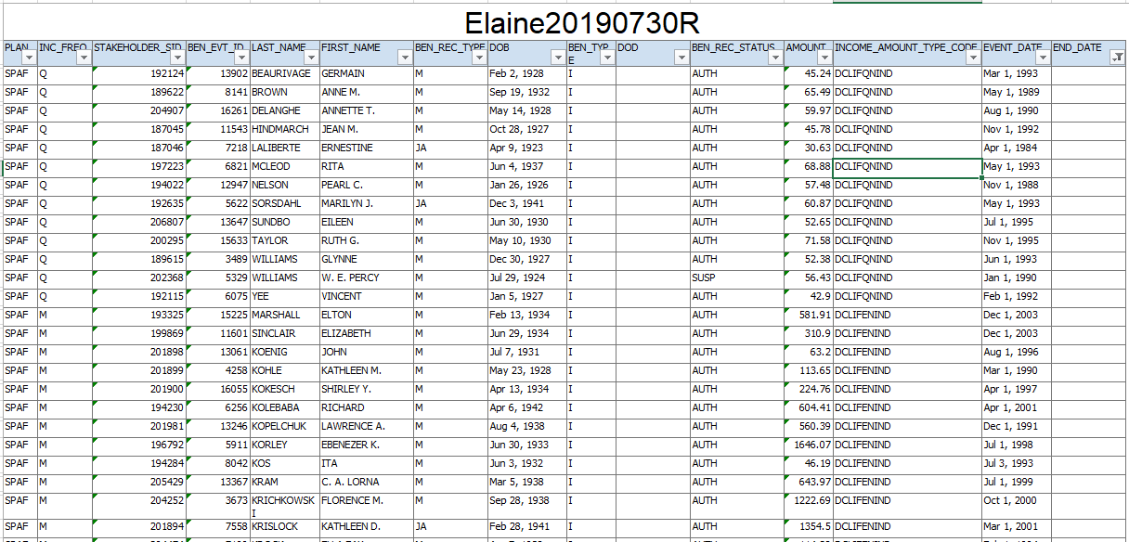

Query or results may need to be modified as per the business requirements. For example, if she needs the results where END_DATE > Sept 30, 2019. Then please filter the results as per the screenshot

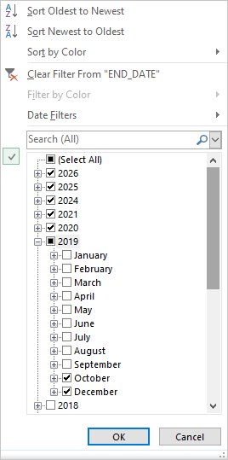

Data set that report used:

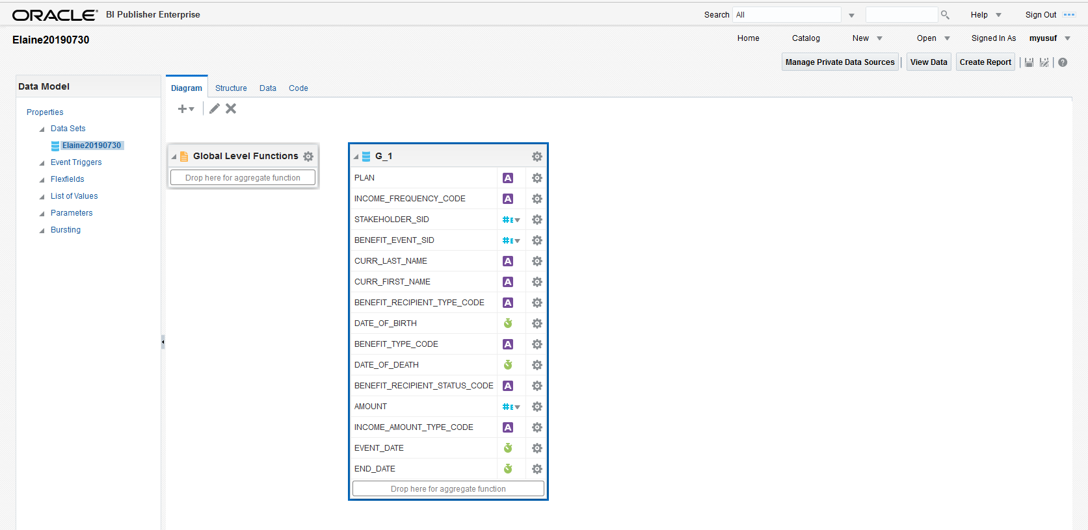

# Quality Assurance procedures – Updating Contribution Rates

|  |  |
| --- | --- |
| **Title:**  **Quality Assurance procedures – Updating Contribution Rates** | **Current Version: 1** |
| **Document Owner:**  **Michael Mead** | **Document author:**  **Richard Belanger** |

|  | **Name/Title** | **Signature** | **Date** |
| --- | --- | --- | --- |
| **Reviewed by** | <Person who reviews the work> |  | <dd/mm/yyyy> |
|  |  |  |  |
|  |  |  |  |
| **Approved by** | <Senior Management / Business Area Manager> |  | <dd/mm/yyyy> |
|  |  |  |  |

|  |  |
| --- | --- |
| **Date Issued**: <dd/mm/yyyy> | **Date Revised**: <dd/mm/yyyy> |

**Change / Revision History**

| Date | Author | Version | Change |
| --- | --- | --- | --- |
|  | Richard Belanger | 1 | Document created |
|  |  |  |  |
|  |  |  |  |
|  |  |  |  |

**Purpose:**

New contribution rates are received on a NON-regular basis. There is no schedule in place which states…on March 1, 2019 contribution rates will be 9.35%, for example. The Commission reviews the Plan’s health along with our actuary to determine the most efficient contribution rate to keep the Plan funded. As mentioned they are on an Ad hoc basis.

To update the rate, an email or some kind of official direction will be given to QA with the new rate and the effective date of the new rate, usually from the manager of MEPP.

In MEPP there are two types of Employee- General and Designated. Where Designated is emergency workers such as police and firefighters. The Designated members have different Plan rules as well as a different contribution rate than General members.

**Scope / Applicability:**

This document applies to Quality Assurance staff, who will be responsible for updating the system. The document also applies to the MEPP Assistant Manager who will be responsible for reviewing and ensuring the rates are updated correctly. And the two MEPP Supervisors who will perform the Assistant Manager’s duties in their absence.

**Roles and Responsibility:**

The Manager of MEPP will inform QA that a change in Contribution Rates is upcoming. The effective date as well as the new Contribution Rate will be included in the communication.

The designated QA member will review Rate as well as the effective date.

If there are any questions or concerns QA should address those with the Manager directly.

When it has been established the rates and dates are valid the designated QA staff will update the rates.

On July 1, 2018 the contribution rates increased for both general and designated members.

General Members: July 1, 2018 rate increased from 8.15% to 9.0%

Designated Members: July 1, 2018 rate increased from 11.35% to 12.5%

**Procedures:**

* **Process for updating General Contribution Rates**

To Update the rate, on the Dashboard toolbar go to Plan Rules>Contribution Rates, choose MEPP from the dropdown of available Plans.

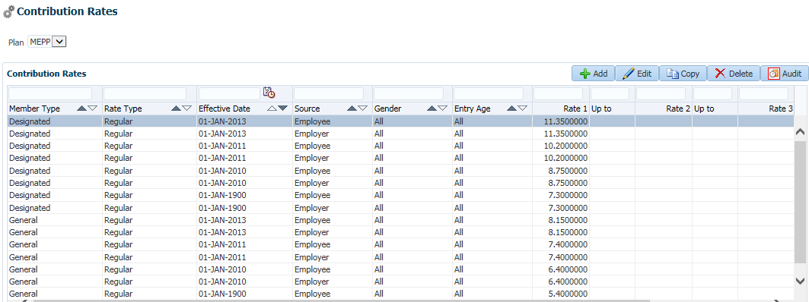

Set the Member Type as General in the field directly above and click Enter on your keyboard

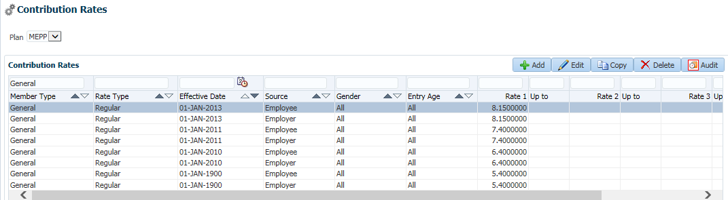

Highlight the most recent entry and click Copy

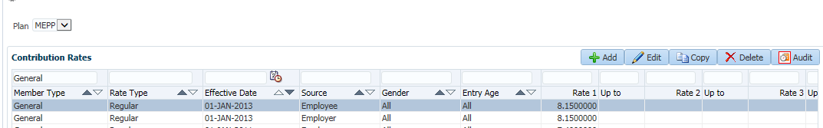

* + **Process for Inputting the Effective Date and Employee Source**

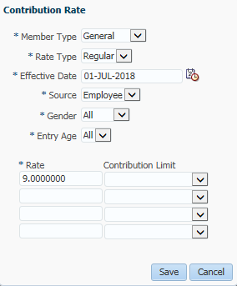

Click Save

* + **Process for Inputting the Effective Date and Employer Source**

Do the same for the Employer Source-Copy the last entry and simply change from Employee to Employer

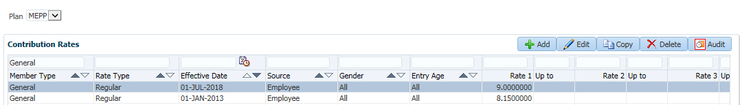

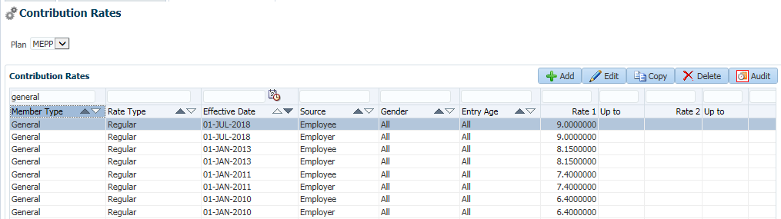

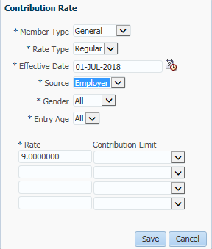

Click Save

See the new General Rate updated for Employee and Employer Contributions

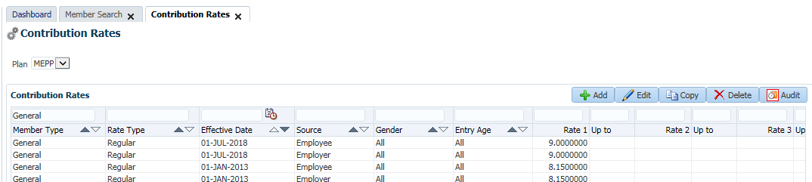

* + **Process for updating Designated Contribution Rates**

The exact same process is performed for Designated Members. The only difference will be the amount of the contribution percentage.

Follow the steps used to update the General Contribution Rate

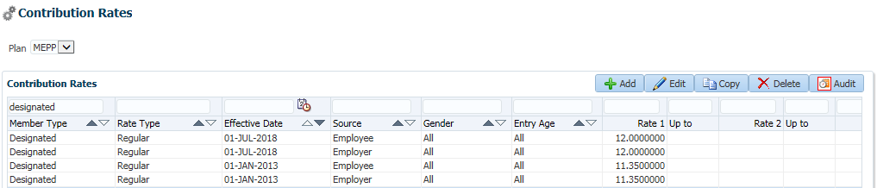

**Document Review Frequency:**

The Document Owner is responsible to ensure this procedure is reviewed at least <frequency> every year.

Any suggestions for improvements can be submitted to the Document Owner for review and consideration. Approved changes will be prioritized and included in the next release of this document.

**BCP requirements:**

Do you need this procedure during disaster recovery or business continuity planning?

(Yes / No)

Please share the list of things you would need for fulfilling the procedures

(e.g. printer, system, internet, phone, process document, etc.)

**Document References:**

This includes any policy or procedure or guidelines or manual that needs to be referred for the process.

If no reference documents required, you may add it as NA